FARMER ASSISTANCE WITH AIR CHECK-ER NETWORK

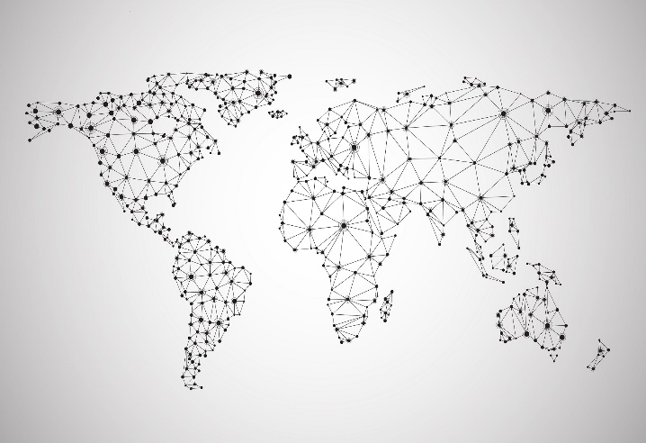EMOBILE PASTORALISM CHALLENGE – SPACE APPS CHALLENGES 2016

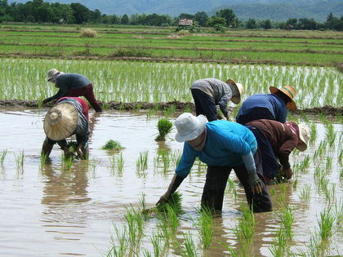

Day by day, the climate of the Earth is changing. The agriculture in some country will be badly impacted.

This product will help pastoralist communities around the world preserve their livelihood.

# What is it?

This is a network of some special sensors which can record all information related to land such as temperature, humidity or light intensity at every single point of the Earth. The data we collected will be processed and stored on the Cloud server. Everyone can access this data simply by using the Internet – especially Mobile apps.

# Why farmer need this?

With the data we collected, the expert who is studying about biological technology can find out if the air condition at this land is suitable for some kind of plants or not. The farmer can use these information to find the most suitable plants for their job and further.

Otherwise, the data is always updated in real-time. It will warning the farmer if there is any problem with the crop (such as air pollution, the humidity is too high or too low, plants does not watered, …) It can automatically active some equipment ( such as nebulizer, water pumps, lighting, ...) if necessary.

# How does it work?

There is a single box (12cm x 10 cm x 3cm) contains all of our sensors: air condition sensor, humidity sensor, light insensitive sensor and communications equipment. We called it a *sensor station*. Our systems include a network of sensor station from all over the world connected to the Cloud server using radio signal.

On the cloud server of our system, all the data will be processed and stored.

Otherwise, we have already built a Mobile Apps for farmers. This Apps will help them with their work like we have told above. We call it “Farmer assistance”.