**FE5222 ADP Project One**

Ho Ngok Chao, Gao Jichen, Cheng Tuoyuan

1. **Introduction**

In this project, we would implement the least square Monte Carlo (LSMC) method for American put options pricing, and employ the binomial Black-Scholes model with Richardson extrapolation (BBSR) as a benchmark. Results from both methods are compared and discussed in various scenarios. The effects of numerical parameters such as the number of simulation paths as well as the number of discrete time steps are further investigated and visualized.

As a simulation-based model, LSMC can be extended with factor models. It allows for path-dependent and early exercise features, and permits parallelization. Overall, it’s intuitive to understand, and transparent or flexible to implement. At the same time, the simulation per path and regression per time-step inside are time-consuming, which asks up to balance between MC simulation counts and time step counts.

As a tree-based model, BBS is improved from traditional binomial trees by applying BSM on option values at the m-2 step, which were difficult for traditional binomial trees to consider the time value of OTM options. BBSR further involved the Richardson extrapolation technique to cancel out higher-order error terms while keeping its simplicity and adding limited computational costs. Disadvantages from binomial trees were still inherited inside. Moreover, it’s not flexible enough to cope with incomplete market or extreme scenario tests.

1. **Materials and Methods**
   1. **LSMC**

Cashflow vector

Exercise value and continuation value

Least square regression

Backward induction and discounting

* 1. **BBSR**
* Binomial tree
* Black-Scholes binomial tree method

BBS method is a modification to the binomial method where the Black-Scholes formula replaces the usual “continuation value” at the time step just before option maturity. At time t_(N-1), the continuation value is equivalent to the price of a European put option, replace it with BS formula for put option, that is:

* Richardson extrapolation
  1. **Comparison and visualization**

To compare the two investigated models with respect to the pricing parameters and numerical parameters, we further performed pairwise pricing and visualized their differences (LSMC - BBSR) over two dimensional surfaces with color scales. To improve comparability, we kept the color bar from $-2.5 to $2.5.

Investigated pricing parameters with default values includes: Spot = $100, Strike = $100, volatility () = 0.2, interest rate () = 0.06, and time to maturity () = 1. They are explored using equal spaced sequences in corresponding plots but kept constant otherwise. Investigated numerical parameters with default values includes: number of Monte Carlo paths () = 1000, number of time steps () = 252. We calculated the LSMC outputs at different and , then charted the BBSR outputs evolution at different . Visualizations were implemented in RStudio via packages ‘tidyverse’ and ‘ggplot2’.

1. **Results and Discussion**
   1. **Grid comparison for pricing parameters**

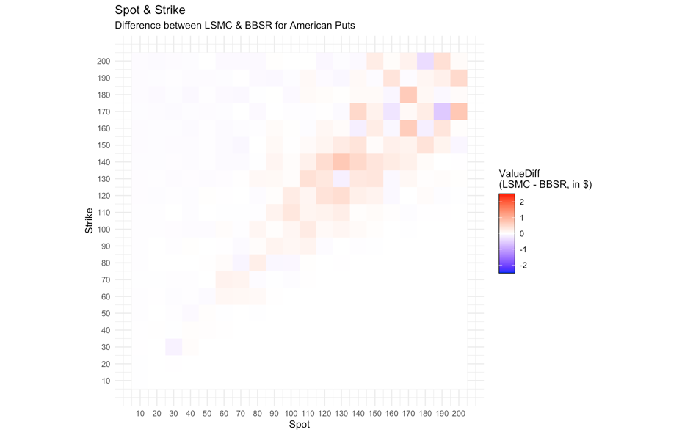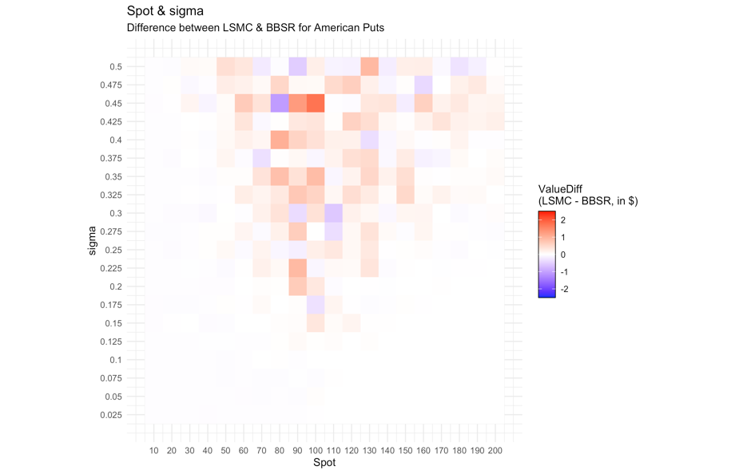

(a) (b)

Figure 1. The differences between LSMC and BBSR among various

(a) spot and strike, as well as (b) spot and volatility ().

From Fig.1(a), we observed that the LSMC outputs are deviated from BBSR less than $1 in absolute values within the inspected Spot-Strike pairs. The oscillation occurs mainly when the Spot is close to Strike and the differences are mainly positive. The calculation of payoffs might be alternating in such scenarios and thus affect errors among backward calculations, while the binomial trees are well arranged with approximately half leaves OTM and half leaves ITM at expiry.

From Fig.1(b), we observed that the LSMC outputs are deviated from BBSR less than 2$ in absolute values within the inspected Spot- pairs. The oscillation grows with and gets stronger when the Spot is around the Strike, with a slight skew towards higher spot. The GBM paths assumed implicitly inside could be wilder with higher , which affects payoff calculations which leads to the asymmetry.

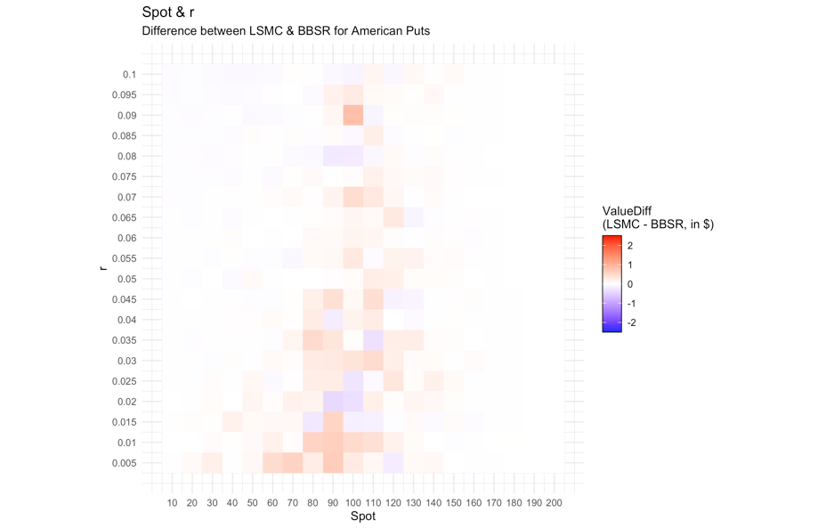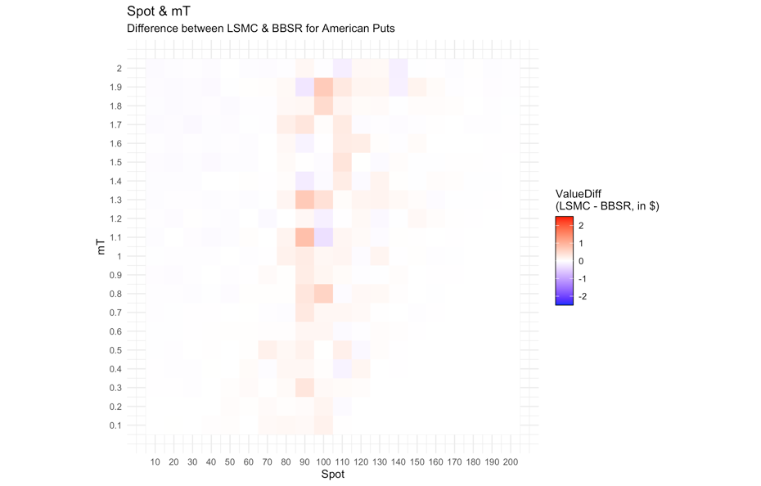

(a) (b)

Figure 2. The differences between LSMC and BBSR among various

(a) spot and interest rate (), as well as (b) spot and time to expiry ().

From Fig.2(a), we observed that the LSMC outputs are deviated from BBSR less than 1$ in absolute values within the inspected Spot-interest rate pairs. The oscillation shrinks with and gets stronger when the Spot is around the Strike. Higher could be bounding the discounted payoff and thus limiting the errors.

From Fig.2(b), we observed that the LSMC outputs are deviated from BBSR less than 1$ in absolute values within the inspected Spot-time to maturity pairs. The oscillation grows with and gets stronger when the Spot is around the Strike. Longer , given constant time steps , is involving wilder fluctuation per time step in the GBM paths and thus accumulates randomness.

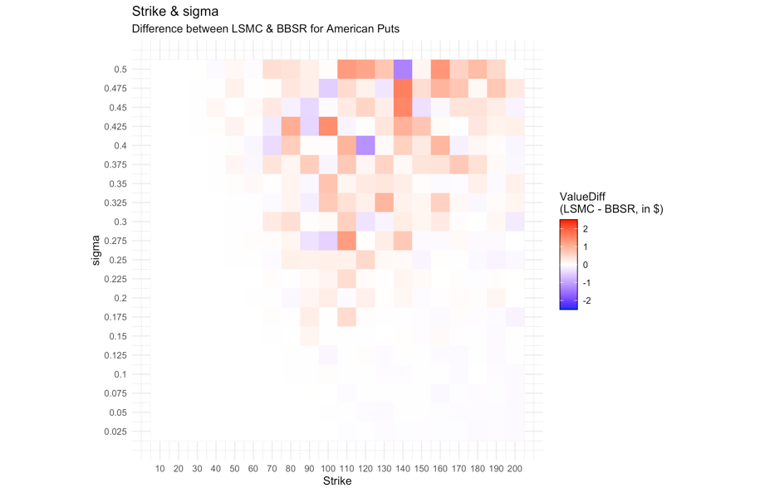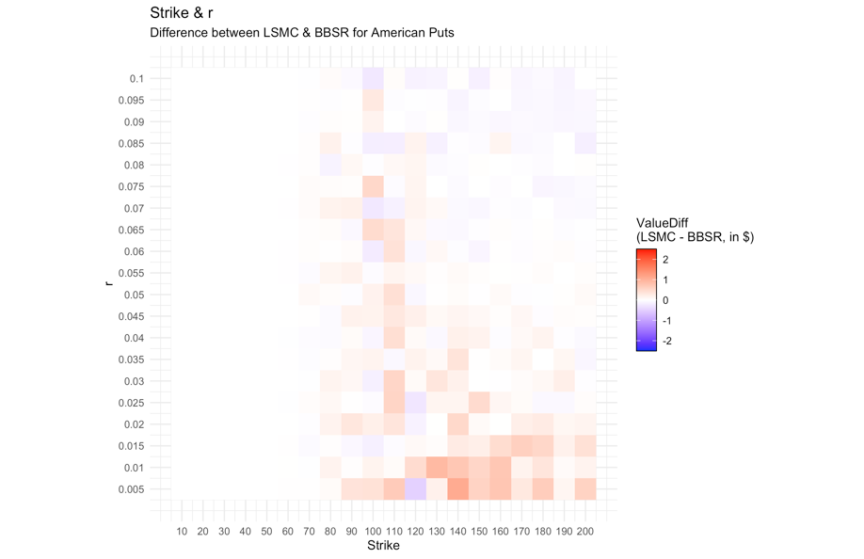

(a) (b)

Figure 3. The differences between LSMC and BBSR among various

(a) strike and , as well as (b) strike and interest rate.

From Fig.3(a), we observed that the LSMC outputs are deviated from BBSR less than 2$ in absolute values within the inspected Strike- pairs. The oscillation grows with sigma and gets stronger when the Strike is around the Spot, with a slight skew towards higher Strike. The GBM paths assumed implicitly inside could be wilder with higher which affects payoff calculations, while higher Strike as allowing more paths to be ITM could be inviting more randomness and thus the asymmetry.

From Fig.3(b), we observed that the LSMC outputs are deviated from BBSR less than 1$ in absolute values within the inspected Strike-interest rate pairs. The oscillation shrinks with and has a skew towards higher Strike. Higher could be bounding the discounted payoff and thus limiting the errors. Higher Strike as allowing more paths to be ITM could be inviting more randomness and thus the asymmetry.

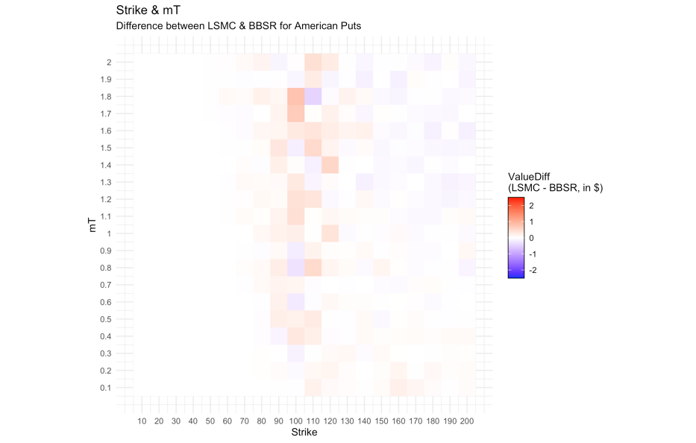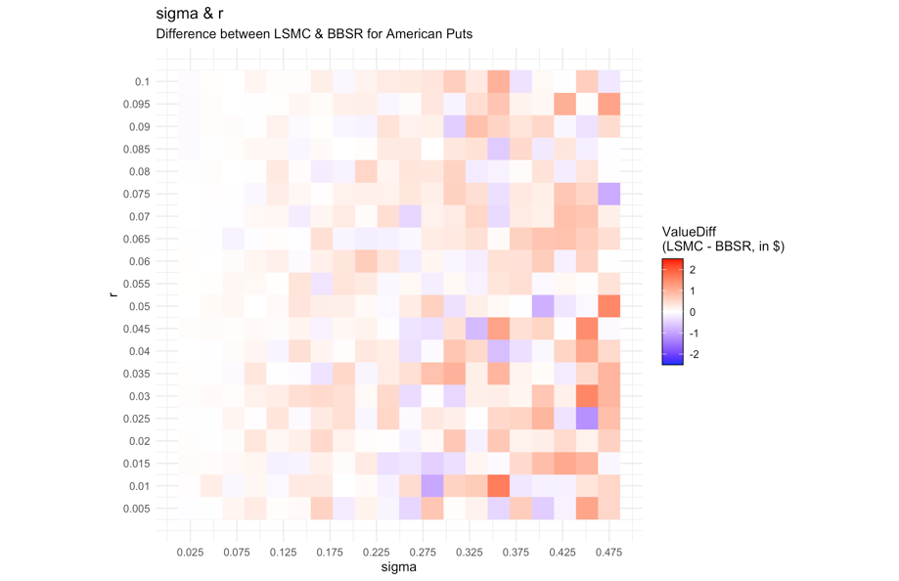

(a) (b)

Figure 4. The differences between LSMC and BBSR among various

1. strike and time to expiry, as well as (b) volatility and interest rate.

From Fig.4(a), we observed that the LSMC outputs are deviated from BBSR less than 1$ in absolute values within the inspected Strike-time to maturity pairs. The oscillation grows with and has a slight skew towards higher Strike. Longer , given constant time steps , is involving wilder fluctuation per time step in the GBM paths and thus accumulates randomness. Higher Strike as allowing more paths to be ITM could be inviting more randomness and thus the asymmetry.

From Fig.4(b), we observed that the LSMC outputs are deviated from BBSR less than 2$ in absolute values within the inspected -interest rate pairs. The oscillation shrinks slightly with increasing but grows significantly with . Higher could be bounding the discounted payoff and thus limiting the errors. Higher would affect the GBM paths with the payoff calculations and contributes to stronger oscillations.

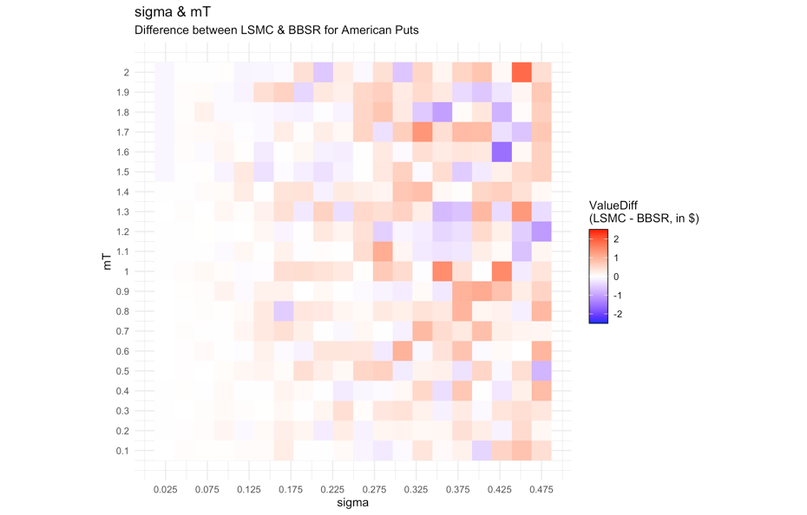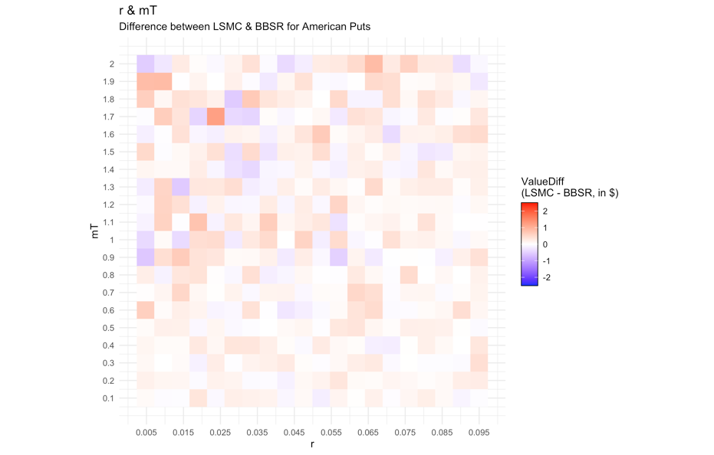

(a) (b)

Figure 5. The differences between LSMC and BBSR among various

(a) volatility and time to expiry, as well as (b) interest rate and time to expiry.

From Fig.5(a), we observed that the LSMC outputs are deviated from BBSR less than 2$ in absolute values within the inspected -time to maturity pairs. The oscillation grows gradually with increasing and grows rapidly with increasing . Increments in involves more randomness than increments in .

From Fig.5(b), we observed that the LSMC outputs are deviated from BBSR less than 1$ in absolute values within the inspected interest rate-time to maturity pairs. The oscillation grows with longer mT but shrinks slowly with increasing . Increments in involves more randomness than decrements in .

* 1. **Grid comparison for numerical parameters**

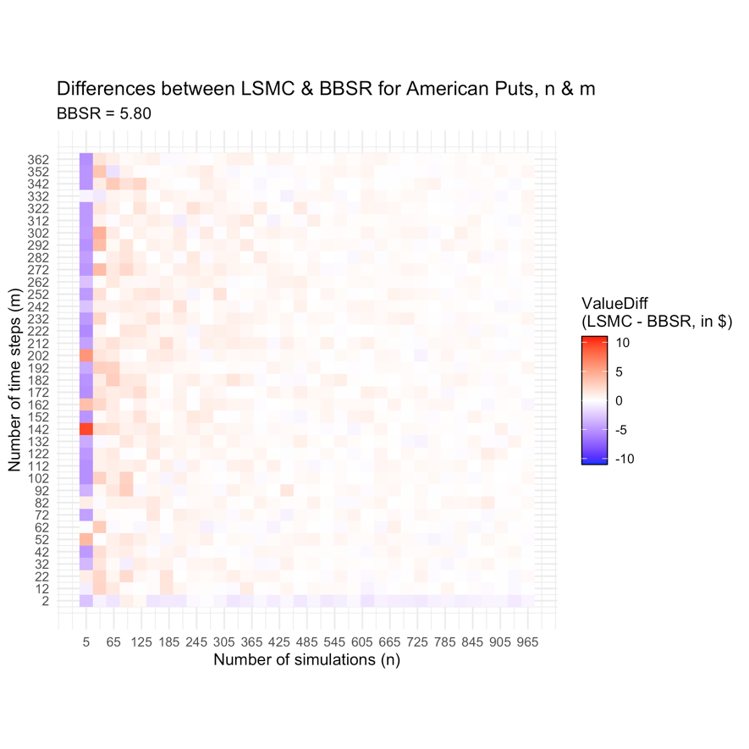

Figure 6. The LSMC results among various numbers of Monte Carlo simulations () and numbers of time steps (). We are assuming Spot = 100, Strike = 100, = 0.2, = 0.06, and =1. The white stripe in the color bar is set at the BBSR benchmark value $ 5.80.

From Fig.6, we noticed that the increase in number of simulations () until around 300 is significantly shrinking differences, while the effect from the increase in number of time steps (m) after 2 steps might be negligible in comparison. It is likely that BBSR has not yet converged at = 2. To make a trade-off between time steps and simulation paths to price with satisfactory accuracy and acceptable computational complexity, we may constrain from 5 to 10 and maximize within acceptable computation time.

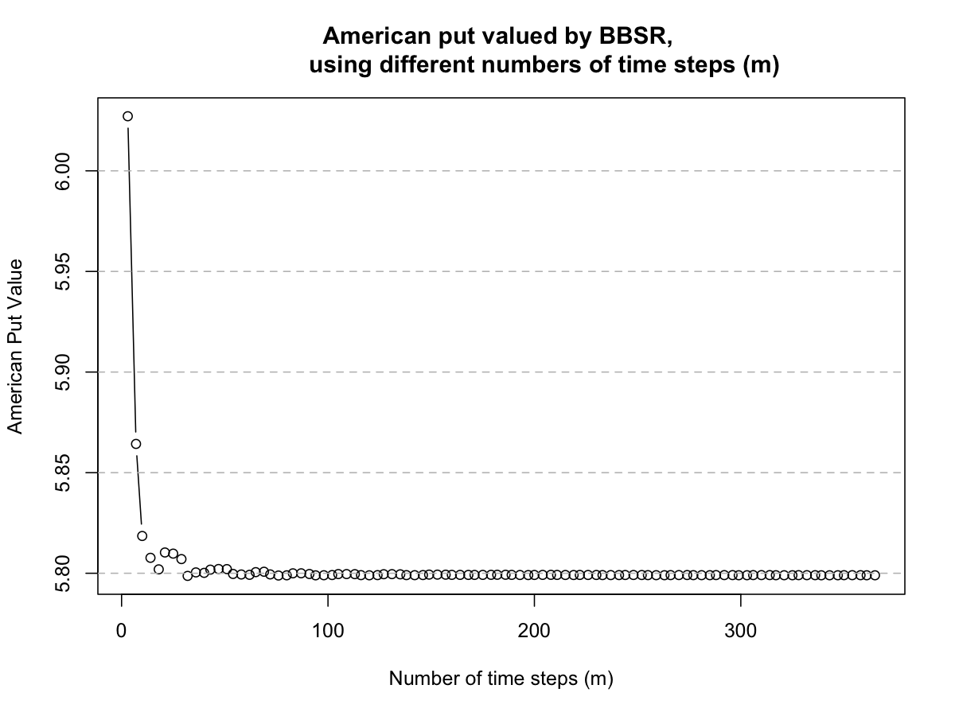

Figure 7. The BBSR results among various numbers of time steps ().

We are assuming Spot = 100, Strike = 100, = 0.2, = 0.06, = 1.

From Fig.7 we noticed that BBSR converges efficiently within a limited number of time steps, and remains stable afterward. It is serving as a good benchmark for vanilla American option pricing.

1. **Conclusion and Future Research**

Different basis functions

LSMC application on more path-dependent options

Comparison among trees

1. **References**
2. Haug, E.G., 2007. The complete guide to option pricing formulas. McGraw-Hill Companies.
3. Longstaff, F.A., and Schwartz, E.S., 2001. Valuing American options by simulation: a simple least-squares approach. The review of financial studies, 14(1), pp.113-147.
4. Wickham, H., Averick, M., Bryan, J., Chang, W., McGowan, L.D.A., François, R., Grolemund, G., Hayes, A., Henry, L., Hester, J. and Kuhn, M., 2019. Welcome to the Tidyverse. Journal of Open Source Software, 4(43), p.1686.
5. Wickham, H., 2016. ggplot2: elegant graphics for data analysis. springer.
6. Wilmott, P., 2007. Paul Wilmott introduces quantitative finance. John Wiley & Sons.
7. **Appendix:** 
   1. **LSMC in Python Jupyter notebook, by Ho Ngok Chao**
   2. **BBSR in Python Jupyter notebook, by Gao Jichen**
   3. **Comparison & Visualization in R Codes, by Cheng Tuoyuan**