Model: LSTM neural network

1. **Scenario 1: Training with only 5-day moving average**
2. Backtest on predicted result and actual data used for training

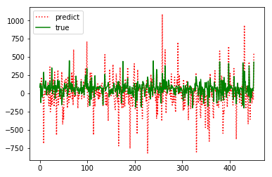

1. Backtest on predicted result and actual data used for testing

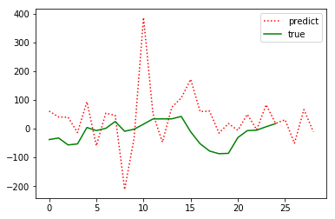

1. **Scenario 2: Training with 5-day moving average and common topics:**
2. Backtest on predicted result and actual data used for training

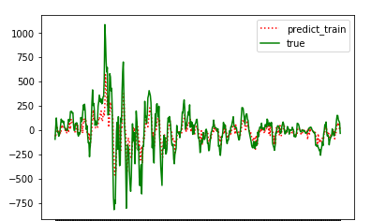

1. Backtest on predicted result and actual data used for testing

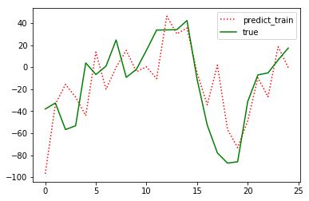

Parameters (based on test data):

|  |  |  |
| --- | --- | --- |
|  | Scenario 1 | Scenario 2 |
| MSE | 16833.9436718 | 865.74 |
| MAPE | 318.94 | 101.87 |
| Precision | 0.7368 | 0.67 |
| Recall | 0.9333 | 0.4 |
| F1 score | 0.8235 | 0.5 |