**Report of Experiment 1**

To estimate the strength of RMR strategy, four other strategies are compared in the tests.

1. Best-stock (‘BEST’): Buys the best stock over the period. It is a hindsight and help compare the best data with other strategies.
2. Passive aggressive mean reversion (‘PAMR’): Estimates the next price relative as the inverse of last price relative. Adopts the single-period mean reversion assumption, not satisfied with reality.
3. Online Moving Average Reversion (‘OLMAR’): Predicts the next price relative using moving averages and explores the multi-period mean reversion.
4. Market: Buys assets according to a pre-defined weight and holds until the end.

There are three assumptions as below for the experiment and they are also the basic principles for the portfolio selection strategy.

1. Transaction cost: There is no transaction cost or taxes in this PS model;
2. Market liquidity: One can buy and sell required quantities at last closing price of any given trading period;
3. Impact cost: Market behaviour is not affected by a PS strategy.

From the aspect of the performance measure, six methods are used to estimate the results of the experiment.

1. Portfolio Cumulative Wealth: Calculates the wealth accumulated during the trading period;
2. Annualized Percentage Yield (APY): Takes the compounding effect of the cumulative wealth;
3. Wining Ratio (WT): Denotes the percentage of cases the strategy beats the BAH strategy;
4. Sharpe Ratio: Evaluates the risk-adjusted return;
5. Maximum Drawdown (MDD): Measures the down side risk;
6. Calmar Ratios (CR): Indicates performance of the strategy concerning the drawdown risk.

With respect to the parameters in the experiments, we simply set the length of window and sensitivity empirically without tuning for each dataset separately. For all data set, the length of window and sensitivity are both 5.

Regarding the data set, six data sets are selected for the experiments. They have long period and short period and own various features. The details are as shown in the below table.

|  |  |  |  |  |
| --- | --- | --- | --- | --- |
| **Data set** | **Region** | **Time Frame** | **#days** | **#assets** |
| DJIA | US | 14/01/2001 - 14/01-2003 | 507 | 30 |
| SP500 | US | 02/01/1998 - 31/01/2003 | 1276 | 25 |
| TSE | CA | 04/01/1994 - 31/12/1998 | 1259 | 88 |
| MSCI | Global | 01/04/2006 – 31/03/2010 | 1043 | 24 |
| NYSE(O) | US | 03/04-1962 – 31/12/1984 | 5651 | 36 |
| NYSE(N) | US | 01/01/1985 – 30/06/2010 | 6431 | 23 |

In the experiment 1, we exert the six data sets to draw the plots and below are the two of them for the result analysis purpose. First plot is the portfolio cumulative wealth of DJIA and second is from MSCI. As we can see, the RMR strategy which is black line in the plot hovers over the other strategies and have good results. The result is identical to the original literature.

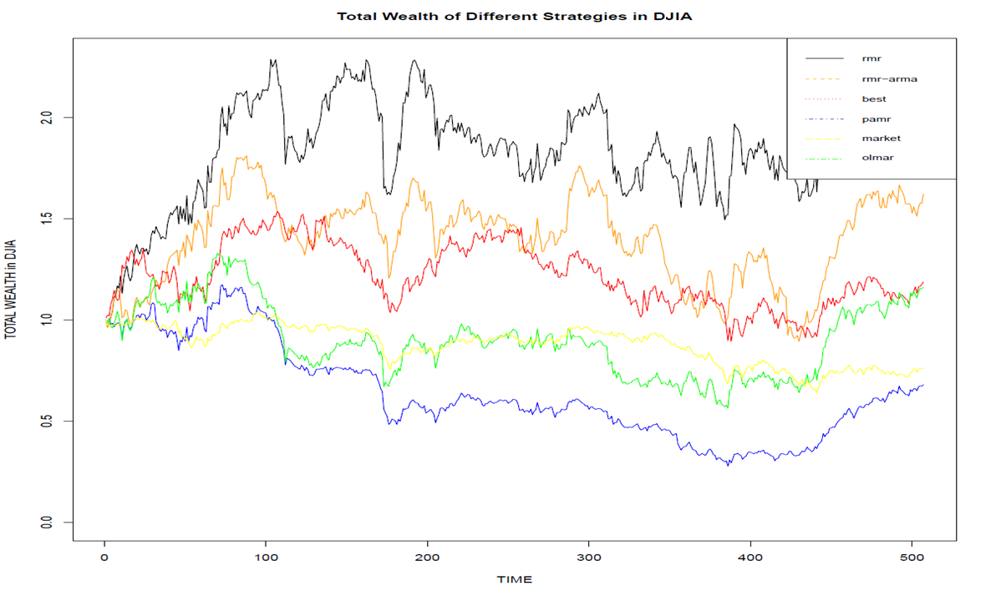

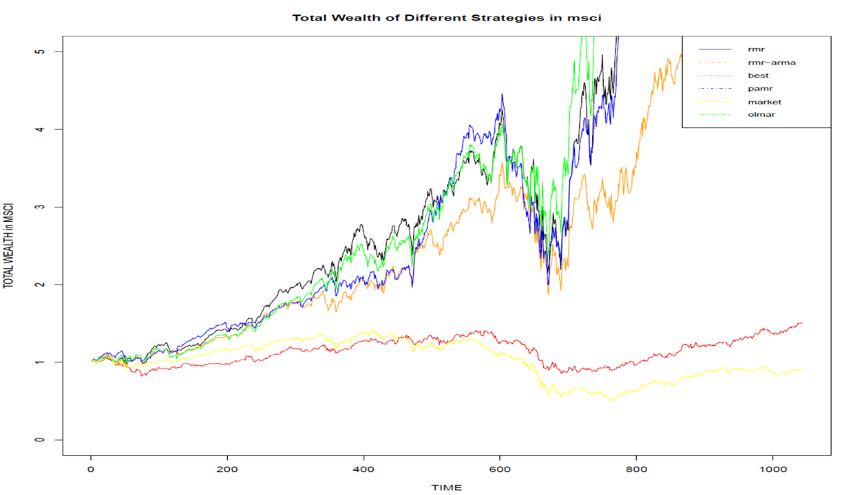

RMR strategy is promising and reliable PS technique to achieve high return. Compared with the existing mean reversion strategies (PAMR and OLMAR), RMR strategies obtained higher cumulative wealth on the datasets NYSE(O), NYSE(N) and DJA.

In addition, one innovation here is to adopt ARMA algorithm into the RMR strategy. And the above two plots with orange line indicate that the adapted strategy works well as well.