About PAMR, the whole name is Passive aggressive mean reversion. And it has three key points which are different from RMR. Firstly, it estimates the next price relative as the inverse of last price relative. Then it adopts the single-period mean reversion assumption, not satisfied with reality. Also, it Cannot exempt from the influence of noise and outliers.

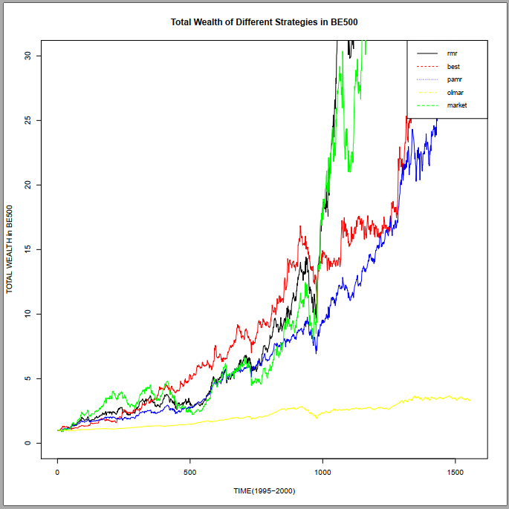

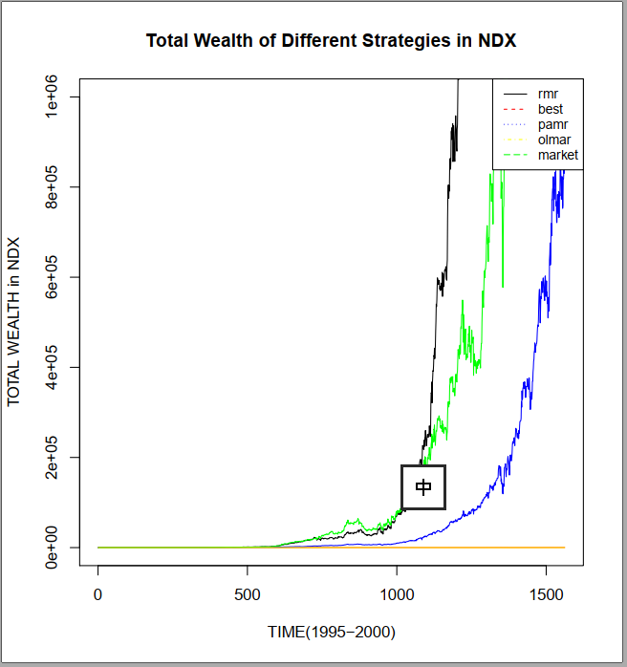

And after ploting all these 20 figures, we find that RMR did pretty well in some markets in certain period. It’s obvious in the total wealth of IBOV-p1, BE500-p1 and NDX-p1. However, there are some exceptions.

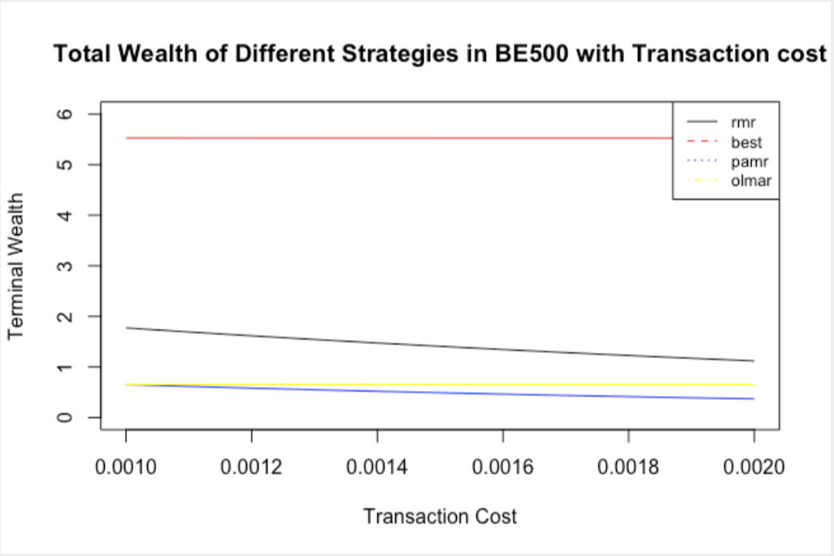

Then, As for improvements, one of them is adding trancation cost and analyzing performance of each strategy. We realize that BEST did very well when tc exists and RMR did OK when tc is small in the figure of tc cost.

Thus here are two main conclusions:

The first one is that because BEST strategy has the lowest turn-over rate, which means the lowest tansaction cost, BEST has very good performance when it comes to tc;

The second one is that RMR's performanc is largely affected by tansaction cost and it's suitable for market with low tc, like US.