

Faculty of Information and Communication Technologies

Web Application Development
Semester 1 - 2012

Assignment 3

Due date: 9:00pm Monday 28 March 2012

Prepared by: Minh Duc Nguyen
Student ID: 171001X
List of the entire files in the system
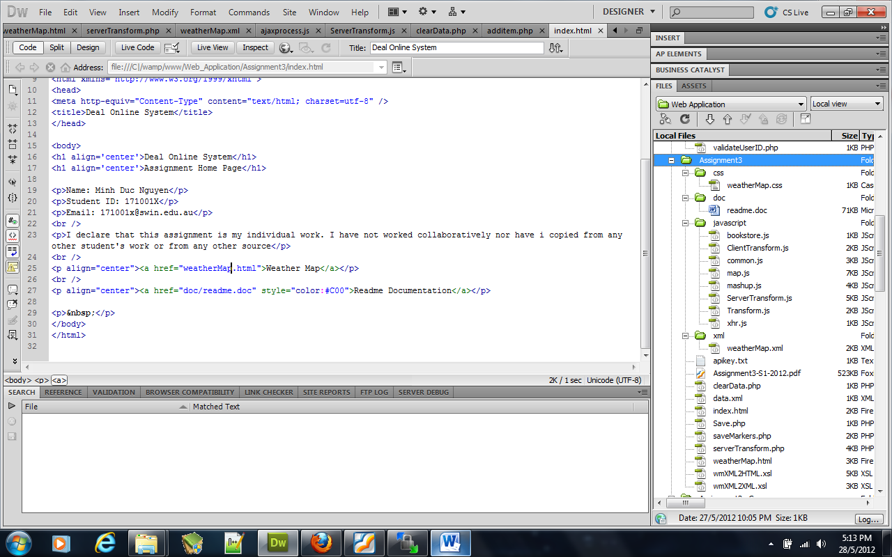

User Manual
- Index: contain links to
- weatherMap.html:
  - List all Australia’s States
  - Choose a State => click “Show Table”
    - Connect to Bom server and get weather information under XML format
    - Transform the returned data into XML file which is store in folder “xml/weatherMap.xml” not in Student folder “s171001x/data” using “wmXML2XML.xsl” file
    - Transform “xml/weatherMap.xml” into html format and display a list of Station information using “xmXML2HTML.xsl” file
    - The caption , local time and date of the selected State are also displayed
    - There is a link which opens and navigates to the point on the Google Map when user click on for each Station name.
      - Note: when the map is shown, the State list table is pushed down (not hide). It’s easy for checking the associate mashup and the state weather information.
    - File involved:
      - weatherMap.html
      - Javascript
        - xhr.js
        - map.js
        - ServerTransform.js
        - ClientTransform.js
        - Transform.js
      - PHP
        - serverTransform.php
      - XSL
        - wmXML2XML.xsl
        - wmXML2HTML.xsl
      - XML
        - xml/weatherMap.xml
      - CSS
        - css/weatherMapp.css //apply css for returned table in xsl file
  - Choose a State => click “Show All Station”
    - Connect to Bom server and get weather information under XML format
    - Transform the returned data into XML file which is store in folder “xml/weatherMap.xml” not in Student folder “s171001x/data” using “wmXML2XML.xsl” file
    - Read the “xml/weatherMap.xml” file and multiple markers on Google Map and display on Web Browser
      - Note: when new State is chosen and “Show All Station”, the old marker will be deleted
    - Every marker is clickable. The information of the State will be displayed when user click on the marker. The other marker popped up box will be closed.
    - File involved:
      - weatherMap.html
      - Javascript
        - xhr.js
        - map.js
        - ServerTransform.js
        - ClientTransform.js
        - Transform.js
      - PHP
        - serverTransform.php
        - saveMarkers.php
        - Save.php
        - clearData.php
      - XSL
        - wmXML2XML.xsl
        - wmXML2HTML.xsl
      - XML
        - xml/weatherMap.xml
        - data.xml

