PROGRESS TEST 2

Design a MICHO ordering system by ASP.net core: code API and razor page

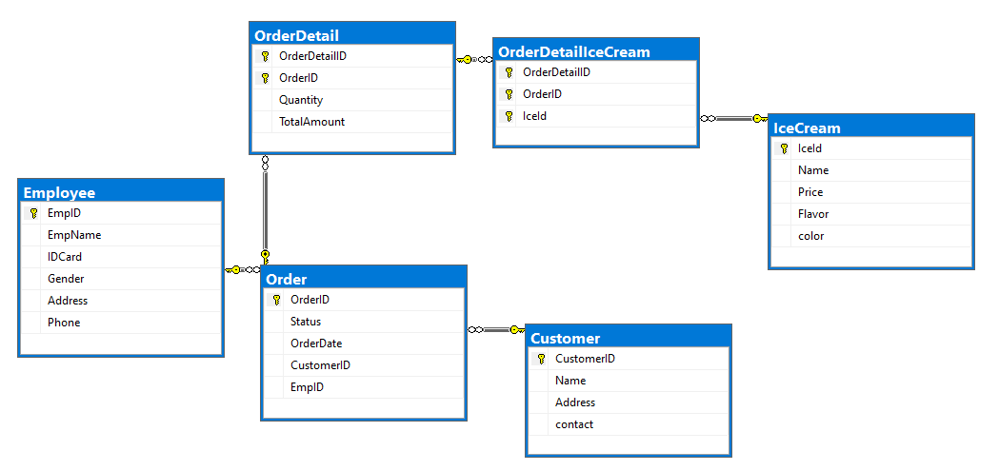

The features include:

1. Allow customer to place orders
2. Export invoice to customer
3. Generate sale report
4. Track peak order hours and best-selling products