BREAKDOWN

Okay so the graph you see is basically a roadmap of where our relationship is and where we want to it to be ideally.

If I break it down more, we would be at a point where we want to build and strengthen our relationship and search for methods that enable us to do so. If you take another look at the roadmap, you notice that searching could lead to two paths:

* Discouraged, where we feel everything, we’ve tried, and nothing seems to work and can’t seem to think of anything that will.
* Defeated, basically accepting that our relationship is never going to work, and nothing can get better.
* Trapped, no longer want to be in relationship so opt out.

A path we try to avoid although some of the thoughts may resonate with us at times, but I want to let you know say an act of dishonesty or mistrust doesn’t erase the qualities, character and loyalty of you or me. It’s a harsh lesson – people make mistakes, and mistrust can cloud judgment. It doesn’t make me or you a bad person; it just means there is work to be done and trust to rebuild.

Back to the paths:

* Relief, finally finding things that work for the betterment of our relationship.
* Hope, reaching a point of stability in partner where we feel truly understood and cared for and cater to one another’s needs.
* Security, sense of achievement in building a relationship that we both want and can help us position ourselves where God would want our relationship to be.

Yes, the three C’s basically to reach the green side of the path we need to achieve connection, communication and deal with conflict resolution and that is basically what the rest of this document talks about a more detailed plan on navigating our relationship from here on out if you we may.

Empty space so inserts random quote:

“It's the possibility of having a dream come true that makes life interesting.”  
― **Paulo Coelho, The Alchemist**

CONNECTION

The most important thing we can create in any relationship is a place where we can feel secure. Here, we feel supported. This space is essential for connection sharing our internal worlds. It's in this space of vulnerability and trust that we find not just better communication meaningful connection and stay away from disconnect and becoming strangers altogether.  
definitely moving from a negative to positive space can feel overwhelming but having a more negative to neutral and neutral to positive can seem more doable so in connecting and communication we’d strive to have check ins that engage exercises that cater to building those spaces:

E.1

Process or pause? How to check in with each other to decide together if you’re able to communicate vulnerably and be attuned to each other.  
**Qs: (take turns answering).**If I tend to need space and my partner does not, what explanations do I tell myself about this?   
Growing up, was I ever forced to have conversations when I wasn’t ready?  
How can my partner and I be more aware of our internal worlds without choosing to avoid communication.

Negative to Neutral, Neutral to Positive: How to frame healthy expectations to provide cushioning so normal relational conflict doesn’t continue to erode trust. the work is hard, and we need to recognize and celebrate the “little things” we achieve together. We cannot expect an overnight turnaround. Spend time together that’s distinctly not awful to retrain your nervous systems to see partners as safe allies. Practice slowing, stabilizing, and finding footing before preparing to try to understand.

*“it’s normal for partners to spend hours together analysing the relationship. It’s important to also share some intentional neutral-to-positive time in order to provide enough cushioning for the difficult emotional processing work. This can be something as simple as sitting together and watching a show on Netflix that you both like. I tell clients that anything non-harmful that feels “distinctly not awful” counts at the start. “-MORGAN JOHNSON from the book id been reading.*

**Qs: (take turns answering).:** When do I feel most neutral (or least awful) around my partner? When do/did I feel most positively toward them? When do I feel most neutral-to-positive as an individual lately?

1. Individually, generate a list of two or three things you can do by yourself that feel neutral-to-positive and share these with your partner.

-be more race

-book (engraved on heart)  
-

1. Together, list five things you can do with each other that feel neutral-to-positive. This can include “parallel play,” where you’re doing separate things nearby. (For example, “I work on my painting while you do some woodworking” or “You play a video game while I read my book.”)

- book

- bible study

- game

-tv movie

1. Agree on when and where you’ll hang out together and put this on your calendars.
2. Check in with each other weekly to consider whether you got in some neutral-to-positive time together more days than not. If not, what is getting in the way and how can you team up to address it?

Safe Spaces with Active Listening: Redirect parts of yourself that want to convince or change someone and challenge yourself to tune in to what those parts want, need, or long for.  
**Qs: (take turns answering).**Was it easy for me to feel seen and heard when growing up?

Who listened to me when I was upset?

What were their responses and pieces of advice?

Growing up, what did I learn about talking about feelings?

If it’s uncomfortable to feel feelings, what self-compassion can I offer myself to appreciate why it’s hard for me? (“It’s challenging for me to talk about feelings when I never saw anyone do it and was called a sissy if I ever showed soft emotions.”)  
What does my partner do and say that helps me to feel seen, heard, and understood?

Trustworthiness: actively show your partner that you’re someone they can trust.

Reflection:  
**Qs: (take turns answering).**When in this relationship have, I felt alone or/and unimportant when I really needed my partner? What are some small, daily examples? What are the bigger, devastating examples?  
When in previous love relationships have, I felt alone and overwhelmed?  
  
Because of my earliest relationships with caregiver(s), I’ll always be somewhat sensitive to ______. (feeling deserted, feeling deprived, feeling inadequate, etc.)

Because of experiences in previous love relationships, I’m particularly sensitive to ______. (feeling unseen/unheard, feeling judged/criticized, lying, etc.)

Because of my experience in our relationship, I’m especially sensitive to ______. (sensing you aren’t being fully honest, feeling rejected or inadequate, feeling like I am too much or over-the-top)

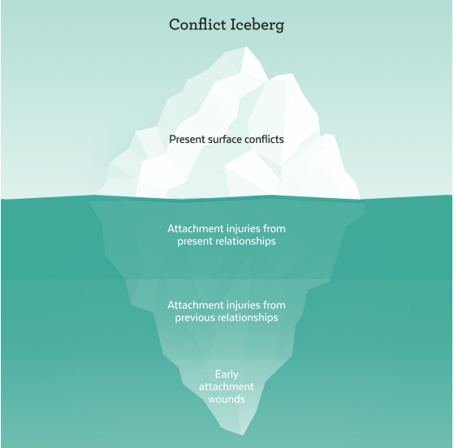

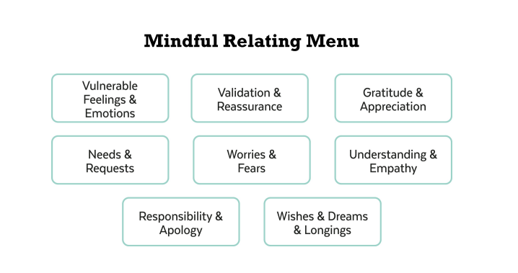

Mindful Relating: communicate with each other about a difficult topic without blaming or shaming.  
**Qs: (take turns answering)**  
What do I most hope to shift about the way I respond to my partner during times of conflict?  
Are there parts of me that doubt that this will be helpful?  
Growing up, did I frequently get the message that I was too much or not enough?  
When is it hardest for me to communicate vulnerably with my partner? When am I best able to communicate and attune? Why?

What sorts of things am I most likely to avoid that, in doing so, increases the risk for resentment? (Sometimes I fail to voice what I want because I expect my partner to read my mind; sometimes I get impatient or feel like a martyr and say, “I’ll just do it myself!” instead of allowing my partner space/time to complete a request I made.

1. Individually, read over this list of Resentment Seeds and make a note of which items ring true for your relationship.
2. Saying you’re “fine” and not speaking up when something is on your heart or mind.
3. Repeatedly hearing words (especially promises and apologies) that you don’t see your partner back up with action or followthrough.
4. Assuming compromise can’t be possible and defaulting to sacrificing important needs or parts of self or/and giving ultimatums
5. Not voicing gratitude and appreciation, especially for “little things” that are part of the routine.
6. Keeping silent about needs/longings/wishes to try to avoid disappointment or conflict.
7. Turning away from partners or lashing out when they need and reach for us.
8. Frequently giving up or showing up not for the purpose of lighting your partner’s fire but to selfishly get something in return.

Individually, read over this list of Resentment Antidotes and make a note of which items ring true for your relationship.

1. Speak up when something is on your heart/mind—don’t sweep it under the rug or expect mind-reading from partners.
2. Back up words/promises/apologies with action and followthrough.
3. Intentionally, consistently voice gratitude and appreciation.
4. Express fondness and admiration frequently
5. Notice and respond to your partner’s bids for connection with you even if they seem small.
6. Share about individual needs and longings clearly and directly.
7. Pursue individual passions, even if they’re not shared by a partner.
8. Talk openly together about power and fairness.
9. Do neutral-to-positive activities together on a regular basis.

Note: if we do go down this road one thing we have to see ourselves doing this as being a team no one person can do it and your input is of at most importance. At the same time as I said earlier having a more work and get through this than looking for out ,but if that were to be the case I would understand.

SPIRITUAL ASPECT

I read somewhere that it takes two to make a relationship work and three to keep that relationship. One thing we haven’t been able to do to the extent that we’re supposed to is keeping God at the centre (why Is center spelled re anyway),I should take full responsibility in that regard its in God’s model that I be liable for it .   
So in this regard prioritising activities such as:

* Bible Study: Yes I know we already had this to do but making it a habit will be essential here at school as well as at home
* Attend more services together self-explanatory but yes we should on days when neither of us are serving attend them together
* Prayer sessions where we have days we pray together definitely just as important as bible study

And of course it in all of this its important to take it slow and not rush into territory either one of us would find uncomfortable, I’m not saying being passive cause if we go we have to go all in Christ cantered approach for this all.

Id say there is an individual side where we are not only pursuing God together in the relationship but as well as personally and personally in terms of committing to certain actions especially in attending church at home has been lacking and is a major reason why and how I fall back in my walk so definitely taking steps to be more committed at home and not just here at school in order to grow

Going all in areas I know I must like intercessors its something I’ve been running away from or putting off even though there is that pull towards And maybe there's a bit of pressure too—I feel like I'm not qualified to compare myself to others but you know it doesn’t matter but you know excuses but definitely something to dive into

And most importantly practicing celibacy and having boundaries in place having an open discussion on the do’s and don’ts as well as expectations we both have in this regard.

### [1 Thessalonians 5:11](https://www.biblegateway.com/passage/?search=1+Thessalonians+5%3A11&version=ESV) **ESV**

Therefore encourage one another and build one another up, just as you are doing.

Leadership

Surely one thing about leadership is taking whoever is following you towards a vision and mission. I’d say knowingly some of the modern leadership characteristics I fall short in a sense I guess I find my strengths in being more of a team player but one of the ways I sought out to develop necessary traits is taking up these positions so that I grow in that regard which still needs work and one way I have been looking is having a form of mentor for enlightenment cause I do recognise my knowledge alone may not be enough and searching for wisdom and direction is important and being more intentional about it by actively having those conversations with family elders and reading more about it.

Okay back to the vision/mission, I know everyone’s purpose , calling is different and the more appealing ones do with wealth not saying its not an important part in world but the vision ,mission and the goal for me is building a family. A healthy one in all aspects, recognising what that means in all levels in which we would have to build and improve which include :

1. Leading by example showing the qualities necessary and removing qualities or thought patterns destructfull to our relationship.
2. In church we learn how leadership is more about serving so its serving the needs of the family tomorrow ,today.
3. Shared vision A healthy family is a collective effort. Working on what "healthy" means to us.

"It is better to lead from behind and to put others in front."

- **Nelson Mandela**

For any questions and information contact 098655580