STYLE GUIDE FOR EXTENDED ABSTRACTS
(ENTER YOUR ABSTRACT TITLE HERE)

A Memberª & Your Supervisor^{b}

ª Department of Materials Science, University of XYZ, City, Country
^{b} Department of Mechanical Engineering, ABC Research Centre, City 2, Country B

(This is where your summarised abstract is written) These notes are intended to assist you in the preparation of your extended abstract for the SAIMechE Conference on Mechanical, Manufacturing and Materials Engineering and have been prepared in the prescribed format. An extended abstract is a “mini-paper” and should include succinct descriptions of the objectives, investigative approach, important findings, and conclusions of your research. Use figures/drawings to illustrate where appropriate. It is not expected that you will use headings but should you need them, please limit yourself to first-level headings only. Range the heading to the left, in bold italics with a colon at the end. Then follow on in the same line as shown in these notes.

(This would be your first section, for instance Introduction) Page layout: Set your page size to A4 (210 x 297mm) in portrait orientation. Set all the margins to 25mm. Except for the title, author names and author affiliations, use a 2-column format with a 6mm space between the columns.

(Second section) Font: Use the Times New Roman font throughout. Use a 12 point size for the title and 10 point for all the other text.

(Third section)Title Section: Type the title of your paper in bold capitals, centred across the page. Use a maximum of 2 lines for the title. Leave a 1-line space after the title and type the initials and surnames of the authors, using a superscripted lowercase letter as a reference for the authors’ affiliation. Leave a single line space and type the author affiliations, one per line, starting with the corresponding superscripted letter. Include the city and country names in the affiliation. Where there is only one author or all the authors have the same affiliation details, it is not necessary to use the superscripted reference letter. Centre the author names and author affiliations across the page.

Main text: leave a 2-line space after the author affiliations and start the main text in 2-column format. Use full justification for the main text (even left and right margins).

Abstract length: Using this format for layout, your extended abstract must not be longer than 2 pages. This rule will be strictly applied as it will affect the publication of the abstracts for the conference.

Figures: Arrange the figures so that they fit in one column of the text. Number the figures sequentially, refer to them in the main text and place the caption below the figure in the bold text as shown in Figure 1. Do not depend on colour for differentiation as figures will be printed in black and white only.

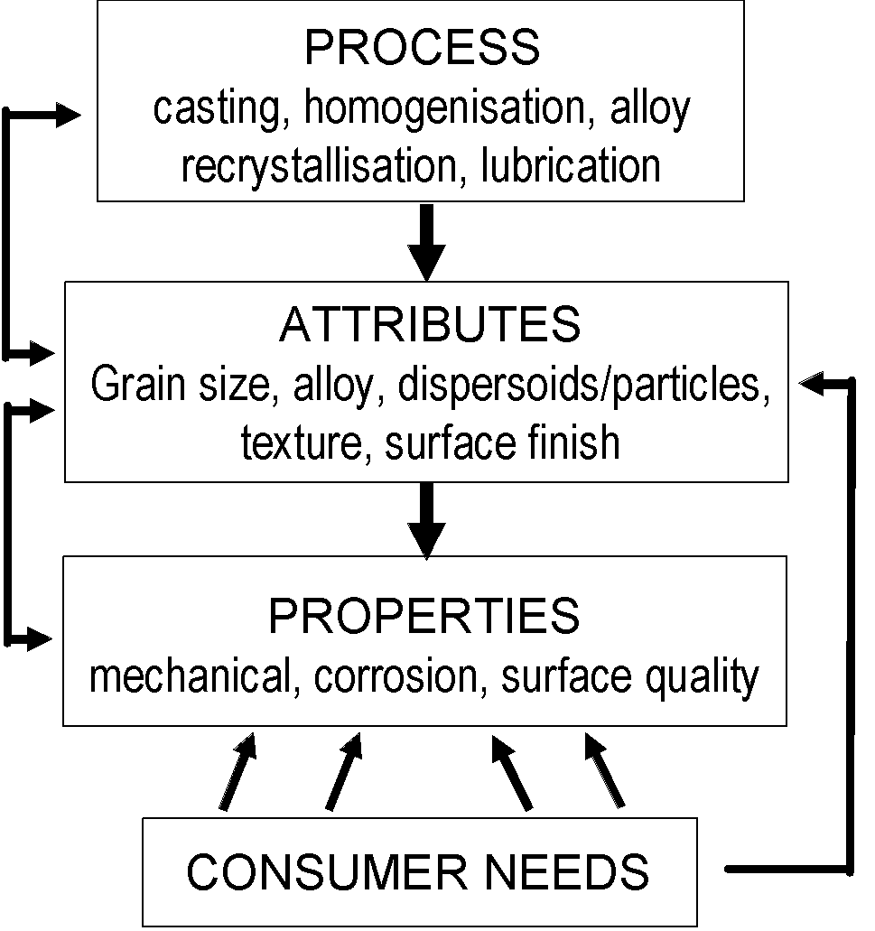

Figure 1: Graphical representation of relationships between process and property development.

Tables: Arrange your tables so that they fit into one column of the text. Number the tables sequentially and place the caption on the top of the table in bold text as shown in the table below.

Table 1: Sample table in the text
 | MIX 1 | MIX 2
Portland cement | 350 | 210
GGBS | - | 140
9.5mm quartz stone | 850 | 850
Graded quartz sand | 885 | 885
Water | 233 | 233

References: Number the references sequentially and place them as superscripts in the text, separated by a comma where necessary, eg^{2,3,4}. Place the list of references at the end of the text using the following general format:

References:
1. Taylor, HFW. Cement chemistry. Thomas Telford, London, 1997.
2. Kriejger, PC. Environment, pollution, energy and materials. Materiaux et Constructions, Vol. 6, No. 36, 1973, pp. 411-432.
Submission: Upload this document as a PDF using this link

