AI Product Case Study
Project 1 — AI-based Credit Default & Fraud Risk Scoring
Portfolio demo — Business Data Analyst (AI Products) | Prepared by Kevin Ngo

1. Business Context & Problem Statement
Retail/consumer lending teams approve personal loans and credit cards partly on manual credit checks and static bureau scores, which are slow to adapt to emerging risk patterns (e.g., customers with rising debt-to-income ratios or repeated late payments that don't yet trigger existing bureau flags). This creates two costs: approving loans that later default, and rejecting or slow-walking creditworthy customers because reviewers lack a consistent, data-driven risk signal.
Business objective: Reduce default losses on unsecured lending products while keeping the manual-review workload for credit officers manageable, without introducing unfair or non-explainable decisions.

2. Analytical Hypothesis & Success Criteria
- Hypothesis: A behavioral/financial-profile scoring model (utilization, DTI, payment history, tenure, income) can rank-order default risk better than static bureau-only rules, allowing risk teams to prioritize the ~15% of applications needing manual review.
- Success criteria (business): reduce default rate within the approved book by a target %, without increasing overall rejection rate beyond an agreed ceiling; keep flagged-for-review volume within credit ops' processing capacity.
- Success criteria (analytical): AUC materially above a random baseline (0.5) on held-out data; recall on the flagged segment sufficient to catch a meaningful share of actual defaulters; precision high enough that review capacity isn't wasted.
- Out of scope for this MVP: final approve/reject automation — output is a decision-support score, human officer retains final call (governance requirement).

3. Data Requirements
Data entities and attributes identified as necessary to test the hypothesis (mapped to a hypothetical bank data mart / Data Lake on AWS or Databricks):
Entity | Key attributes | Source system (illustrative)
Customer profile | age, income, tenure, employment segment | Core Banking / CRM
Credit bureau data | external score, existing loans, prior delinquency | Bureau feed (batch)
Account behavior | credit utilization, balances, avg transactions | Card/Loan servicing system
Payment history | late payments (12m), missed installments | Loan servicing / collections
Outcome label | default flag (90+ DPD within 12m) | Collections / write-off system

Data readiness risks identified: label definition (what counts as 'default') must be agreed with Risk before training; historical data must cover at least one full credit cycle to avoid bias toward benign macro periods; PII fields require masking/tokenization before being used in the model-training environment per data governance policy.

4. Prototype & Evaluation (MVP)
A synthetic dataset (8,000 records, ~14.8% base default rate) was generated to mirror the attributes above, and a baseline logistic regression scoring model was built to validate the analytical approach before proposing it to the AI Engineering team for a production-grade model (e.g., gradient boosting on Databricks/SageMaker).
Metric | Result | Business interpretation
AUC (test set) | 0.6742 | Model ranks risk meaningfully better than random (0.5); acceptable for an MVP baseline, expected to improve with real data + richer features
Review threshold | Top 15% of scores | Sized to match credit ops' current manual-review capacity
Precision (flagged) | 0.29 | ~29% of flagged cases are true defaulters — informs expected 'false alarm' rate for ops planning
Recall (flagged) | 0.294 | ~29% of actual defaulters are caught by the review queue at this threshold — a lever to negotiate with Risk (raise threshold = catch more, review more)

Key risk drivers (model coefficients, directional — for stakeholder explainability, not final production weights):
- Debt-to-income ratio: +1.058 (strongest positive driver)
- Credit utilization: +0.831
- Late payments (12m): +0.492
- Number of existing loans: +0.264
- Monthly income: -0.126 (higher income associated with lower risk)
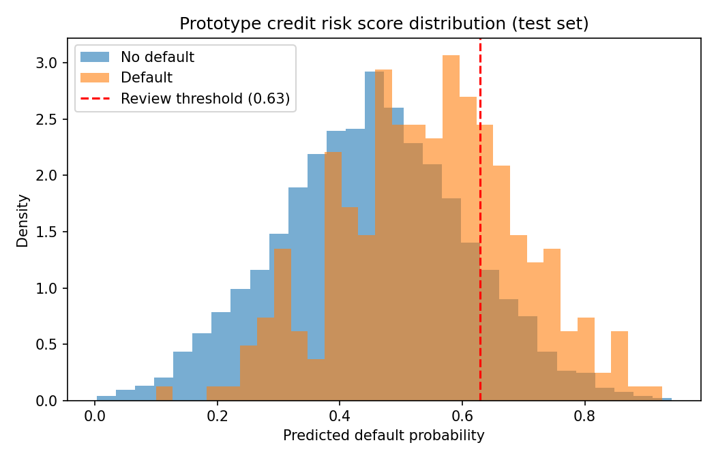
Figure 1. Distribution of predicted default probability for defaulters vs. non-defaulters on the held-out test set, with the proposed manual-review threshold marked.

5. Limitations & Risks (from a business lens)
- Synthetic data — directional patterns are illustrative only; real thresholds, coefficients, and AUC must be re-validated on actual historical loan data before any business decision is made.
- Precision (~29%) means most flagged cases won't actually default — acceptable for a review queue, not acceptable for auto-decline; any move toward automated rejection needs a materially higher-precision model and a fairness/bias review.
- Model risk & governance: per typical bank Model Risk Management policy, this would require independent validation, documented assumptions, and periodic re-calibration (data drift) before production use.
- Explainability: logistic regression was chosen for the MVP partly because coefficients are easy to explain to credit officers and auditors; a production model (e.g., XGBoost) would need SHAP-based explanations to preserve this.

6. KPI / Metrics Framework (Post-Deployment)
KPI | Definition | Cadence | Owner
Model AUC / KS (live) | Discrimination power on recent scored population | Monthly | Risk / Data Science
Actual vs. predicted default rate | Calibration check by score band | Monthly | Risk
Review queue precision | % of flagged cases that actually default within 12m | Monthly | Credit Ops
Approval rate shift | Change in overall approval rate vs. pre-AI baseline | Monthly | Business/Product
Officer override rate | % of AI recommendations overridden by credit officers | Monthly | Credit Ops
Fairness/bias check | Score parity across protected/demographic segments | Quarterly | Risk & Compliance

7. Stakeholders & Handover Plan
- Business/Credit Risk: define default label, risk appetite, and target review-queue capacity.
- Data Engineering: source and validate the data entities in Section 3 from Core Banking/Bureau feeds into the Data/AI platform (AWS/Databricks).
- AI Engineering: own production model architecture, feature pipeline, and scalable scoring service; BA owns business logic, thresholds, and orchestration requirements.
- Model Risk / Compliance: independent validation before go-live, per bank governance policy.
- Credit Ops: training on how to interpret and act on the score in the review workflow.

