AI Product Case Study
Project 2 — AI-driven Customer Segmentation & Cross-sell Targeting
Portfolio demo — Business Data Analyst (AI Products) | Prepared by Kevin Ngo

1. Business Context & Problem Statement
Marketing and relationship-banking teams run cross-sell campaigns (credit cards, loans, investment products) using broad demographic rules (age bracket, income tier) that don't capture actual behavior — how customers use the app, how much they hold in balances, or how deep their product relationship already is. This leads to generic offers sent to the wrong customers: wealthy but under-served customers get mass-market loan ads, while young digitally active customers who'd convert well on a credit card get nothing.
Business objective: Group the existing customer base into behaviorally distinct segments so Marketing/RM teams can target each with a relevant next-best-product offer, improving cross-sell conversion and reducing irrelevant outreach (which also drives opt-outs and app churn).

2. Analytical Hypothesis & Success Criteria
- Hypothesis: Customers cluster into distinguishable behavioral groups based on balance level, digital engagement, product depth, and tenure — and these clusters map to different, actionable cross-sell strategies better than static demographic segmentation.
- Success criteria (business): each identified segment must be (a) large enough to justify a dedicated campaign, (b) mapped to a specific product/offer, and (c) validated by Marketing/RM as a sensible customer group before use in campaign targeting.
- Success criteria (analytical): clusters should be behaviorally separable on the input features (not just noise) and stable enough to be re-usable for at least one full campaign cycle before re-segmentation.
- Out of scope for this MVP: individual-level propensity scoring per product — this AI solution informs segment-level targeting strategy; a follow-on propensity model would refine to individual offer sequencing.

3. Data Requirements
Data entities identified as necessary to build and validate the segmentation, mapped to a typical retail-banking data mart:
Entity | Key attributes | Source system (illustrative)
Customer demographics | age, tenure with bank | Core Banking / CRM
Account balances | average monthly balance across accounts | Core Banking (deposit ledger)
Digital engagement | mobile app activity score, login frequency | Digital banking platform logs
Transaction behavior | avg. transactions per month | Card/Payments processing
Product holding | has savings / credit card / investment product | Product Master / CRM

Data readiness risks identified: digital activity score needs a consistent definition across mobile/web channels; balance and product-holding snapshots must be taken at the same reference date to avoid mixing periods; customer consent/data-use basis for marketing analytics must be confirmed with Compliance before productionizing.

4. Prototype & Evaluation (MVP)
A synthetic dataset (6,000 customers) mirroring the attributes above was clustered using K-means (k=4, standardized features) to validate the segmentation approach as an MVP before proposing a production pipeline (feature store + scheduled re-clustering on Databricks) to AI Engineering.
Segment | Profile (from clustering) | % of base | Recommended action
A — Affluent newcomer | Highest balance (~52M), short tenure (~3y), low investment holding (15%) | 4.4% | Priority wealth/investment advisory outreach — highest-value, most under-served segment
B — Stable long-tenure | Moderate balance, longest tenure (~10y), moderate digital use, low investment holding (12%) | 14.6% | Relationship deepening: investment product introduction via RM, not mass digital push
C — Established digital user | Older (~46y), short-to-mid tenure, high digital activity, thin product depth (1.7 products) | 37.9% | Credit card / personal loan cross-sell via app-based offers
D — Young digital-first | Youngest (~27y), high digital activity, thin product depth (1.5 products) | 43.2% | Entry-level credit card + savings-goal features; highest volume, longest-term value-build segment

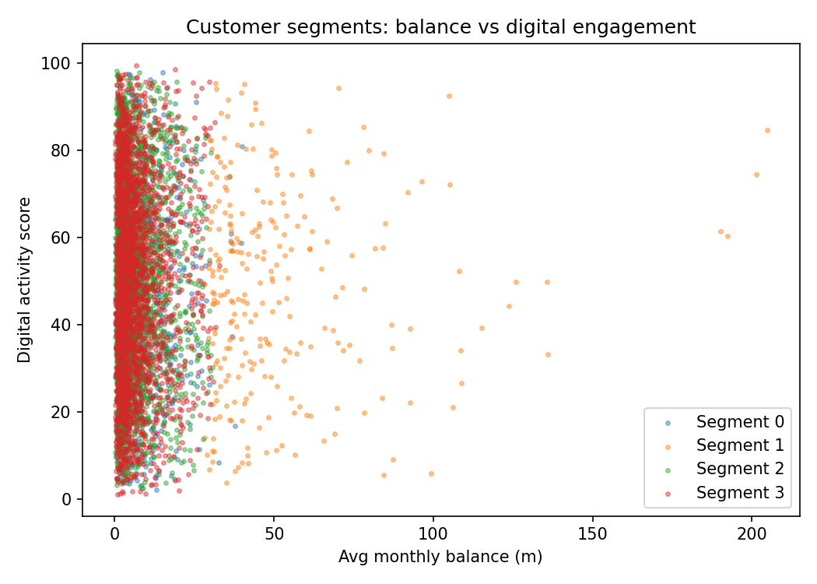
Figure 1. Customer segments plotted by average balance vs. digital engagement score, illustrating separation between the affluent segment (A) and the two high-digital-activity, low-product-depth segments (C, D).
Note on methodology: the raw K-means output initially produced generic statistical groupings; the business labels and recommended actions above were derived by cross-checking each cluster's profile against domain knowledge (e.g., a high-balance/low-tenure group is a different opportunity than a high-balance/long-tenure group, even though a purely statistical view might merge them) — this business interpretation step is the core BA contribution on top of the AI Engineering-built clustering output.

5. Limitations & Risks (from a business lens)
- Synthetic data — segment sizes, profiles, and the specific recommended actions are illustrative; real customer data must be re-clustered and the resulting segments re-validated with Marketing/RM before any campaign is built on them.
- Cluster instability: K-means results can shift with new data or a different k; a production version needs a defined re-segmentation cadence (e.g., quarterly) and a stability check before each campaign cycle.
- Feature drift/fairness: using balance and digital activity as primary drivers could inadvertently deprioritize lower-balance or less digitally active (e.g., older, rural) customers from receiving any tailored offer — worth an explicit equity check with Compliance.
- Consent & purpose limitation: customer data used for behavioral segmentation must have a valid marketing-analytics consent basis, and outputs should not be repurposed for credit decisions without separate governance approval.

6. KPI / Metrics Framework (Post-Deployment)
KPI | Definition | Cadence | Owner
Segment stability | % of customers remaining in same segment vs. prior period | Quarterly | Data/AI team
Campaign conversion rate by segment | Offer take-up rate, segment vs. segment and vs. non-segmented baseline | Per campaign | Marketing
Cross-sell product depth | Avg. number of products per customer, by segment, over time | Quarterly | Business/Product
Opt-out / complaint rate | Unsubscribe or complaint rate on segment-targeted offers | Per campaign | Marketing/Customer Experience
Revenue uplift | Incremental revenue attributable to segment-targeted vs. generic campaigns | Quarterly | Business/Finance

7. Stakeholders & Handover Plan
- Marketing/RM: validate segment definitions and recommended actions match how they'd actually run campaigns; own the offer content and channel execution.
- Data Engineering: build the feature pipeline (balance, digital activity, transaction, product-holding) into the Data/AI platform on a refreshable schedule.
- AI Engineering: own the production clustering pipeline architecture, scalability, and scheduled re-training; BA owns business labeling, action mapping, and KPI definition.
- Compliance/Data Governance: confirm consent basis for marketing-analytics use of transaction/digital-behavior data before go-live.
- Business unit training: brief RM/branch staff on segment definitions so frontline conversations align with the AI-driven campaign targeting.

