**Sample Test Cases for ATM:**

While testing the ATM machine, all levels of testing must be performed on it at the required stages.

This means initially Unit testing must be performed on isolated components, followed by integration testing, and later system and performance testing should be performed accordingly.

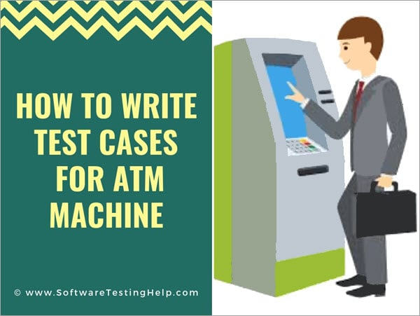

Hence, when a question is asked in the interview to write the test cases for ATM, it is asked to see your approach towards the topic. In such a short period of time and without the detailed requirements document no one can write a complete [test case document](https://www.softwaretestinghelp.com/test-case-template-examples/).

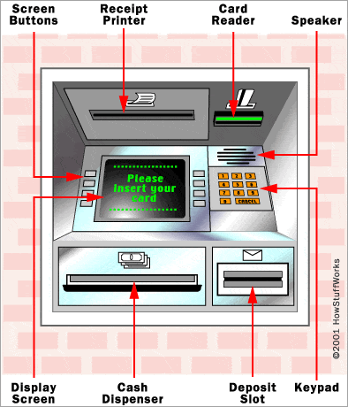

Hence while writing the answers for such questions, try to cover all the major aspects of the topic. Because such questions are asked to see how you think, how you will try to cover the major functionalities, your imagination power (because we don’t have the SRS in front of us), and your approach towards the topic.

In this article, we will see more than 25 test cases. Which include functional, UI, usability, performance, compatibility, and negative test cases. Thus, through these test cases, we tried to cover only the major aspects of the ATM machine.

The above image will help you to understand the terms related to an ATM more clearly.

**Test Cases for ATM**

**Given below are the various test cases for ATM.**

**#1)** Verify if the card reader is working correctly. A screen should ask you to insert the pin after inserting the valid card.

**#2)** Verify if the cash dispenser is working as expected.

**#3)** Verify if the receipt printer is working correctly. Which means it can print the data on the paper and the paper comes out properly.

**#4)** Verify if the Screen buttons are working correctly. **For touch screen:** Verify if it is operational and working as per the expectations.

**#5)** Verify if the text on the screen button is visible clearly.

**#6)** Verify the font of the text on the screen buttons.

**#7)** Verify each number button on the Keypad.

**#8)** Verify the functionality of the Cancel button on the Keypad.

**#9)** Verify the text color of the keypad buttons. The numbers should be visible clearly.

**#10)** Verify the text color and font of the data on the screen. The user should be able to read it clearly.

**#11)** Verify the language selection option. If the messages or data are displayed in the selected language.

**#12)** Insert the card, the correct pin, and print the receipt for available balance.

**#13)** Verify the receipt printing functionality after a valid transaction. Whether the printed data is correct or not.

**#14)** Verify how much time the system takes to log out.

**#15)** Verify the timeout session functionality.

**#16)** Verify the deposit slot functionality depending on its capability (Cash or cheque or both) by inserting a valid cheque.

**#17)** Verify using different cards (Cards of different banks).

**Verifying the Message**

**#18)** Insert the card and an incorrect PIN to verify the message.

**#19)** Verify the message when there is no cash in the ATM.

**#20)** Verify the messages after a transaction.

**#21)** Verify if a user will get a correct message if a card is inserted incorrectly.

**Messages for each and every scenario should be verified.**

**Cash Withdrawal**

**#22)** Verify the cash withdrawal functionality by inserting some valid amount.

**#23)** Verify if a user can perform only one cash withdrawal transaction per PIN insert.

**#24)** Verify the different combinations of operation and check if there will be a power loss in the middle of the operation.

**Negative Test cases**

**#25)** Verify the functionality by entering a wrong pin number for 3 or more times.

**#26)** Verify the card reader functionality by inserting an expired card.

**#27)** Verify the deposit slot functionality by inserting an invalid cheque.

**#28)** Verify the cash withdrawal functionality by inserting invalid numbers like 10, 20, 50 etc.

**#29)** Verify the cash withdrawal functionality by entering an amount greater than the per day limit,

**#30)** Verify the cash withdrawal functionality by entering an amount greater than per transaction limit.

**#31)** Verify the cash withdrawal functionality by entering an amount greater than the available balance in the account.

**Conclusion**

ATM machines must be tested for accuracy, reliability, and performance. It should get tested for its response time per transaction as it works for 24*7.

All the above-mentioned points should be considered while testing ATM machines. There should be a combination of both positive and negative test cases while writing test cases for any product.

***Hope this article would have been of immense help to you.***

***All the best!!***