In Vanilla.js applications, the very cool thing is the fact that we have access to the window object and the reason why it’s so cool is because in the window object, we can get a bunch of useful things. For example, we can get a query selector so we can select a node or get built-in fetch.

In NodeJS, there is no window. Because there is no browser, so there is no window object. So that if you try to access window, node will split back the error and most likely your app will crash. There are some globals like below:

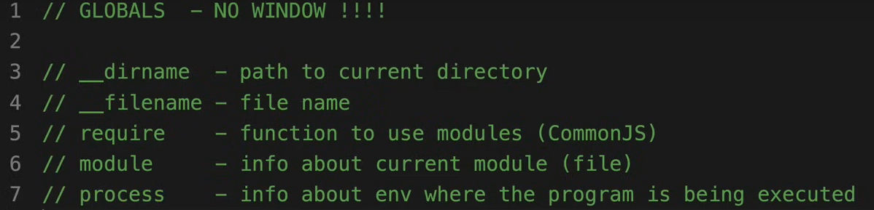

1. setInterval

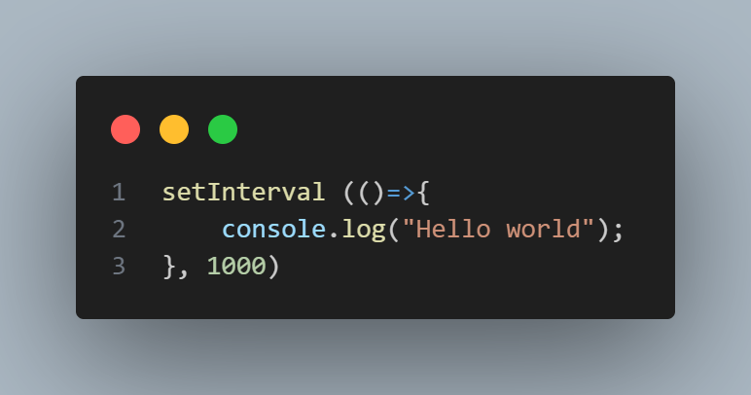

* It will print Hello world after every second.

1. Modules

Question: Is that all the application needs to be in this one file?

Answer: Yes and No

Yes 🡪 The application will be executed one file

No 🡪 The code need splitting in modules