Practical Exam   
Subject: WED201c  
Duration: 120 minutes

**Background:**

In this practical exam, you are given a folder “**Resource**”. You are going to use it to finish the exam.

**Objectives:**

1. Create a style sheet(.css), a file(.js), and link them to the HTML files. **(Without changing the html)**

2. Style the sheet using the properties color, background-color, text-align, text-transform, and/or display, … to complete all these requirements

3. Using javascript language to write some functions

**Before styling the index.html page ( view template 1.png)**

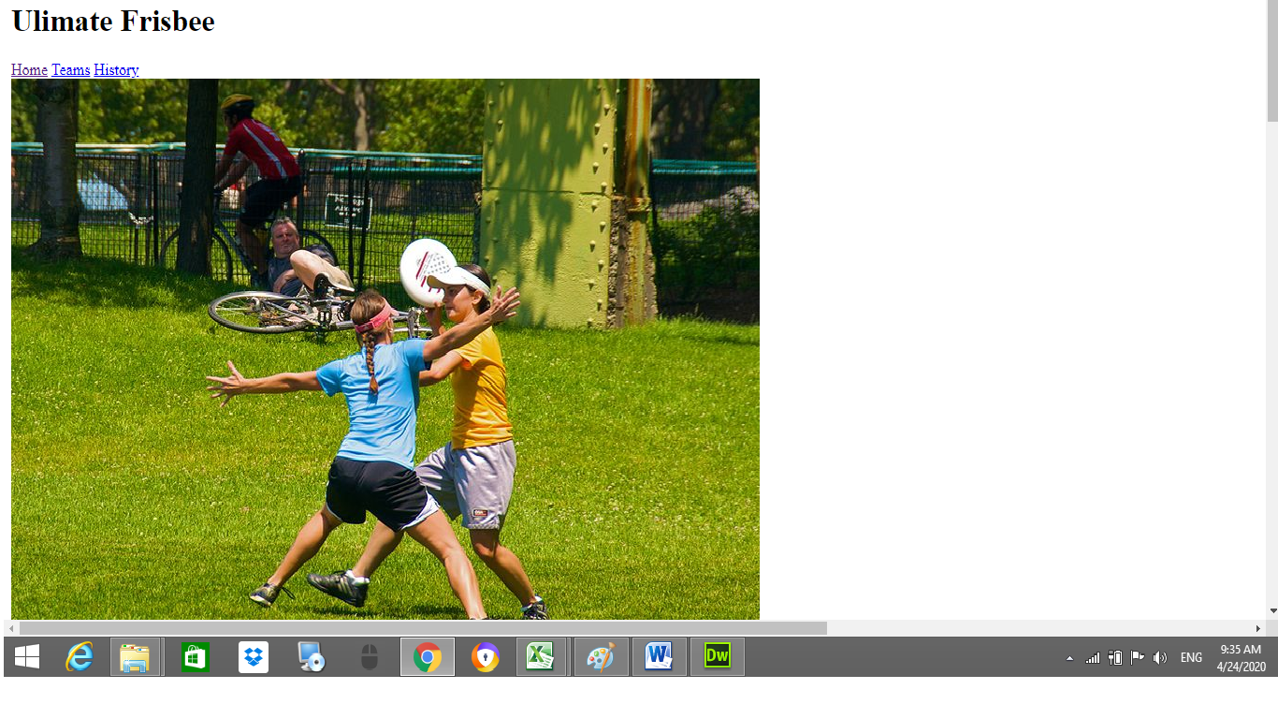

**After styling index.html page (*the table tags will be hidden when starting*, view template 2.png)**

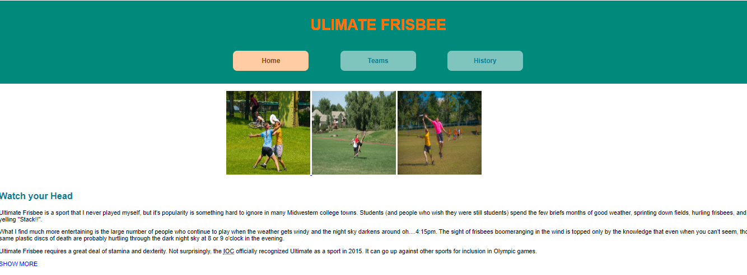

**After the user clicks “show more” (view template 3.png)  
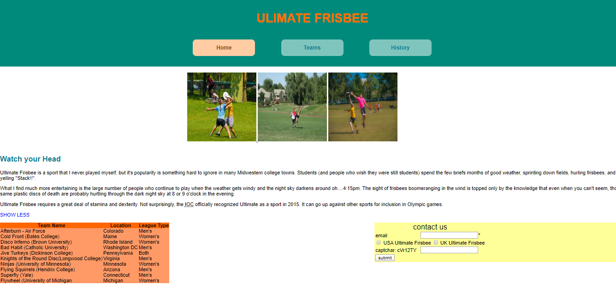**

**Requirements:**

1. Create a file called hw1.css and save it in the given **Resource/css folder.**
2. Create a file called mycode.js and save it in thegiven **Resource/js folder.**
3. In file hw1.css, using the properties color, background-color, text-align, text-transform, and/or display, … to style the page “index.html”. You can view the styled page in folder “**template**”
4. In file mycode.js, using javascript language to write two functions: show() and check()
   1. The function show() to display/hide two tables when the user clicks on the p tag(id=”showmore”) and change the inner text of this p tag (hint: template 2.png , template 3.png; two tables are styled by css, not javascript)
   2. The function check() to validate the form.

* If the email field is empty (condition 1), the web page displays a message “please fill your email”
* If all checkbox fields are empty (condition 2), the web page displays a message “please check your options”
* If the captcha field isn’t equal “***cVr12TY***” (condition 3), the web page displays a message “please check your captcha”
* If condition 1 and condition 2 and condition 3 are satisfied, the web page displays a message “thank you very much” and reset the form to default values

**Evaluation:**

**CSS: 5 points**

* H1 in header tag should be styled with any text color and aligned to the center of the header tag [0.5 point]
* Some <a> tags in the navigator(Home, Teams, History):  
   + Don’t have underline and be aligned to the center of its container [0.5 point]  
   + The margin of tags a should have and don’t overlap[0.5 point]
* The active link should be highlighted with any background color [0.5 point]
* All images should are styled to the center of its container and the size of images are the same [0.5 point]
* Two tables have to hide when the page starts [0.5 point]
* When two tables are displayed, the table ( id=”team”) is floated to the left and the table(id=”myform” ) is floated to the right of its container [1 point]
* Two tables should be styled with any background color [0.5 point]
* When you move your mouse over any row of the table(id=”team”), background-color of this row will be changed to other background-color[0.5 point]

**Javascript: 5 points**

* When the user clicks “SHOW MORE”, two tables will be displayed [0.5 point] and the inner text of the tag p(id=”showmore”) is changed to “SHOW LESS” [0.5 point]
* When the user clicks “SHOW LESS”, two tables will be hidden [0.5 point] and the inner text of the tag p is changed to “SHOW MORE” [0.5 point]
* Students validate condition 1 correctly [0.5 point]
* Students validate condition 2 correctly [0.5 point]
* Students validate condition 3 correctly [0.5 point]
* when condition 1 and condition 2 and condition 3 are satisfied, the message “thank you very much” is showed [0.5 point] and reset the form to default values [1 point]

Total: 10 points

**(Students do not change the path of all files in Resource folder)**

The End