SPAM MAIL PREDICTION

# TERMINOLOGY

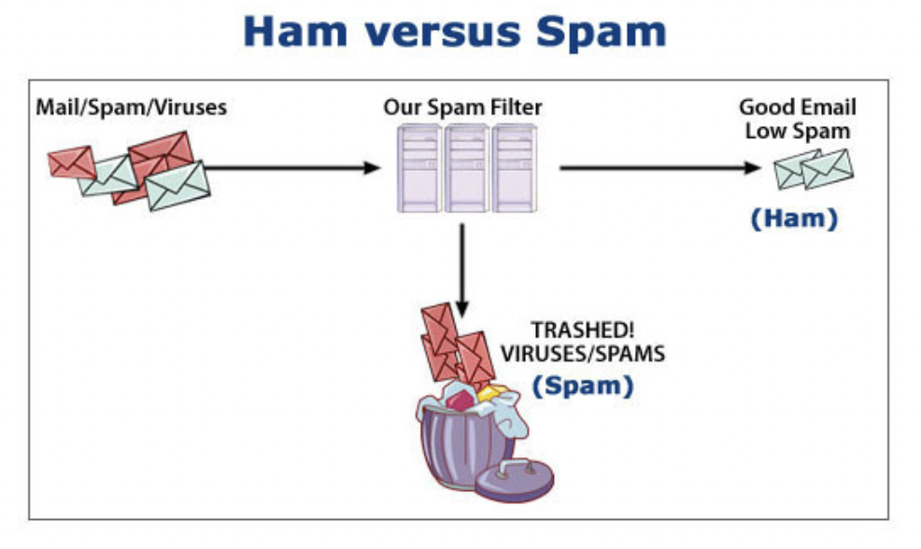

# FLOW

* Mail data -> Data pre-processing: Convert text and paragraph into more meaningful number that computer can understand