

**INTERNATIONAL SCHOOL**

**CAPSTONE PROJECT 1**

**CMU-CS 246 BIS**

**USER INTERFACE DESIGN DOCUMENT**

Version: 1.2

**SIMPLE CALCULATOR SYSTEM – SCS**

**Mentor: Nguyen Dang Quang Huy**

***Team Member*:**

Nhung, Ngo Thi Tuyet

Duyen, Huynh Thi My

An, Ngo Nguyen Truong

Loc, Truong Tan

Dung, Nguyen Van

**Approved by Huy Nguyen Dang Quang**

**UserInterface Review Panel Representative:**

Name Signature Date

**Capstone Project 1- Mentor:**

Name Signature Date

Da Nang, 01/2024

**PROJECT INFORMATION**

|  |  |
| --- | --- |
| **Project Acronym** | SCS |
| **Project Title** | SIMPLE CALCULATOR SYSTEM | | | |
| **Start Date** | 20 – Jan –2024 | **End Date** | 27 – Jan –2024 | |
| **Lead Institution** | International School, Duy Tan University | | | |
| **Team Member** | **Name** | **Email** | | **Phone** |
| 28209043094 | Ngo Thi Tuyet Nhung | nn8242115@gmail.com | | 0763770335 |
| 28209043472 | Huynh Thi My Duyen | myduyenhuynh1010@gmail.com | | 0913228912 |
| 28211134788 | Ngo Nguyen Truong An | ngonguyentruongan2907@gmail.com | | 0919499505 |
| 28219101466 | Truong Tan Loc | tanlocamsat@gmail.com | | 0393165051 |
| 28219050114 | Nguyen Van Dung | mynameisdungz@gmail.com | | 0906577651 |

**PROJECT PLAN DOCUMENT**

|  |  |  |  |
| --- | --- | --- | --- |
| **Document Title** | User Interface Document | | |
| **Author(s)** | Team 01 | | |
| **Date** | Jan 21th, 2024 | **File name:** |  |
| **URL** |  | | |
| **Access** | Project and CMU Program | | |

**SIGNATURE**

**Document Approvals:** The following signatures are required for approval of this document.

|  |  |  |  |
| --- | --- | --- | --- |
| **Mentor** | Huy, Nguyen Dang Quang | **Signature:** |  |
| **Date:** |  |
| **Team Leader** | Nhung, Ngo Thi Tuyet Nhung | **Signature:** |  |
| **Date:** |  |
| **Team member(s)** | Duyen, Huynh Thi My | **Signature:** |  |
| **Date:** |  |
| An, Ngo Nguyen Truong | **Signature:** |  |
| **Date:** |  |
| Loc, Truong Tan | **Signature:** |  |
| **Date:** |  |
| Dung, Nguyen Van | **Signature:** |  |
| **Date:** |  |

**DOCUMENT HISTORY**

|  |  |  |  |
| --- | --- | --- | --- |
| **Version** | **Person** | **Date** | **Description** |
| 1.0 | All members | Jan 20th, 2024 | Draft |
| 1.1 | All members | Jan 27th, 2024 | Final |

TABLE OF CONTENTS

I. INTRODUCTION 7

1. PURPOSE 7

2. SCOPE 7

3. SCOPE 7

II. LIST OF USER INTERFACE 8

1. BUSINESS FUNCTION DIAGRAM: 8

2. WEB APP: 8

III. DESCRIBE USER INTERFACE 10

1. HOME PAGE 10

2. OPERATOR 11

2.1 Addition 11

2.2 Subtraction 12

2.3 Multiplication 13

2.4 Division 14

2.5 Division to get remainder 15

## 

**TABLES**

**Table 1: List of Interface 9**

**Table 2: Describe User Interface Home page 10**

**Table 3: Describe User Interface Addition page 11**

**Table 4: Describe User Interface Subtraction page 12**

**Table 5: Describe User Interface Multiplication page 13**

**Table 6: Describe User Interface Division page 14**

**Table 7: Describe User Interface Division for remainder page 15**

# INTRODUCTION

## PURPOSE

* Document the design of user interface of functions of the Calculator System
* Be the primary document driving the implementation of the user interfaces.
* Introduce interface design for the reader. Including the background, content information display, command buttons.

## SCOPE

* This document helps to better understand the interface of the System, detailed specification components and function of the System.
* With this document, the development team can understand the structure and composition to create a consistent and complete system.
* Overview of the stages and modules of the software and create a complete interface.

## SCOPE

This document is intended for the following audiences:

* Technical reviewers including:
  + Product owner
* Implementers, including:
  + Developers.
  + Testers.

# LIST OF USER INTERFACE

## BUSINESS FUNCTION DIAGRAM:

*Figure 1: Business Function diagram*

## WEB APP:

|  |  |  |
| --- | --- | --- |
| **User Interface ID** | **UI Name** | **Description** |
| UI-01 | HomePage (Menu) | Displays operator function choices to click for using. |
| UI-02 | Find result of the addition | “+” will be used as the function to allow user to find result of the addition that they have input. |
| UI-03 | Find result of the subtraction | “-” will be used as the function to allow user to find result of the subtraction that they have input. |
| UI-04 | Find result of the multiplication | “*” will be used as the function to allow user to find result of the multiplication that they have input. |
| UI-05 | Find result of the division | “/” will be used as the function to allow user to find result of the division that they have input. |
| UI-06 | Find result of the division for remainder | “%” will be used as the function to allow user to find remainder of the division that they have input. |

*Table 1: List of Interface*

# DESCRIBE USER INTERFACE

## HOME PAGE

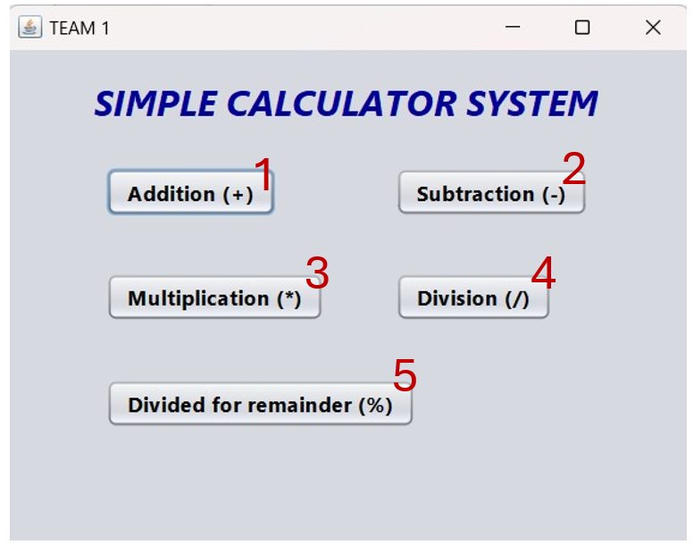

|  |  |  |  |
| --- | --- | --- | --- |
| **ID** | **Condition** | **Control Type** | **Target** |
| 1 | Press | Button | Click to go to the addition operator’s interface |
| 2 | Press | Button | Click to go to the substraction operator’s interface |
| 3 | Press | Button | Click to go to the multiplication operator’s interface |
| 4 | Press | Button | Click to go to the division operator’s interface |
| 5 | Press | Button | Click to go to the division for remainder operator’s interface |

Table 2: Describe User Interface Home page.

## OPERATOR

### Addition

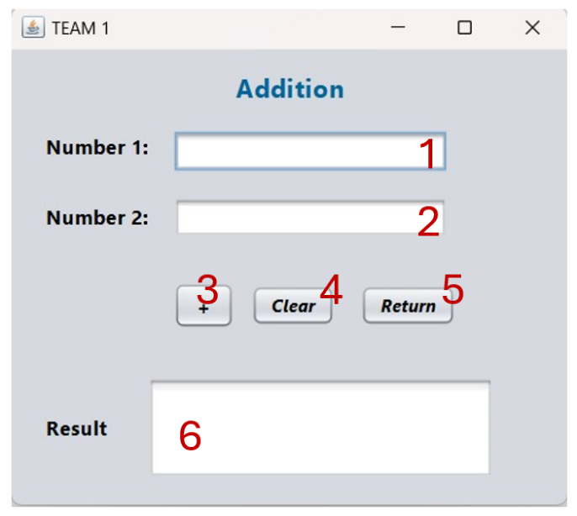

|  |  |  |  |
| --- | --- | --- | --- |
| **ID** | **Condition** | **Control Type** | **Target** |
| 1 | Press | Input text field | Enter first number |
| 2 | Press | Input text field | Enter second number |
| 3 | Press | Button | Click to do the operator |
| 4 | Press | Button | Click to clear all texts in text field |
| 5 | Press | Button | Click to return to Home page |
| 6 | Display | Display text field | Display the result (or notification for invalid input) |

Table 3: Describe User Interface Addition page

### Subtraction

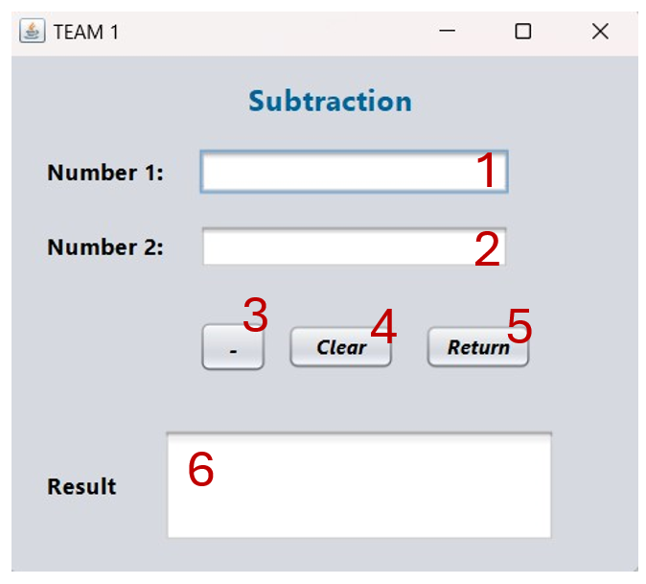

|  |  |  |  |
| --- | --- | --- | --- |
| **ID** | **Condition** | **Control Type** | **Target** |
| 1 | Press | Input text field | Enter first number |
| 2 | Press | Input text field | Enter second number |
| 3 | Press | Button | Click to do the operator |
| 4 | Press | Button | Click to clear all texts in text field |
| 5 | Press | Button | Click to return to Home page |
| 6 | Display | Display text field | Display the result (or notification for invalid input) |

Table 4: Describe User Interface Subtraction page

### Multiplication

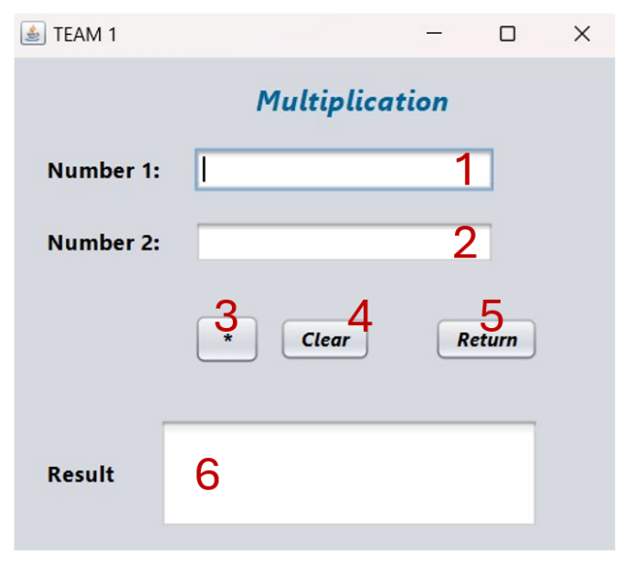

|  |  |  |  |
| --- | --- | --- | --- |
| **ID** | **Condition** | **Control Type** | **Target** |
| 1 | Press | Input text field | Enter first number |
| 2 | Press | Input text field | Enter second number |
| 3 | Press | Button | Click to do the operator |
| 4 | Press | Button | Click to clear all texts in text field |
| 5 | Press | Button | Click to return to Home page |
| 6 | Display | Display text field | Display the result (or notification for invalid input) |

Table 5: Describe User Interface Multiplication page

### Division

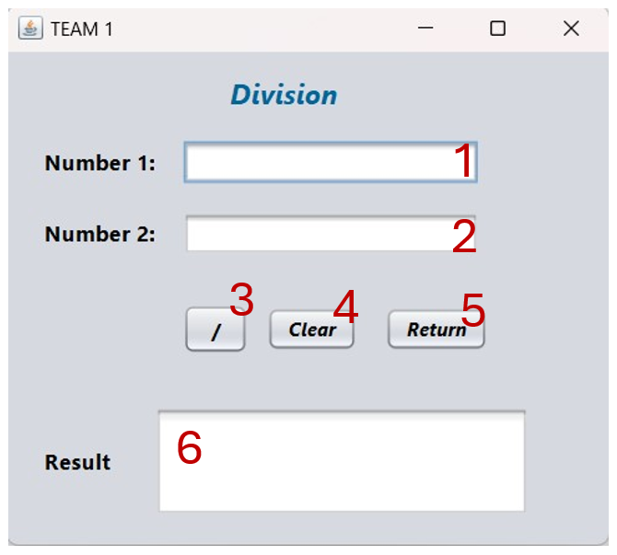

|  |  |  |  |
| --- | --- | --- | --- |
| **ID** | **Condition** | **Control Type** | **Target** |
| 1 | Press | Input text field | Enter first number |
| 2 | Press | Input text field | Enter second number |
| 3 | Press | Button | Click to do the operator |
| 4 | Press | Button | Click to clear all texts in text field |
| 5 | Press | Button | Click to return to Home page |
| 6 | Display | Display text field | Display the result (or notification for invalid input) |

Table 6: Describe User Interface Division page

### Division for remainder

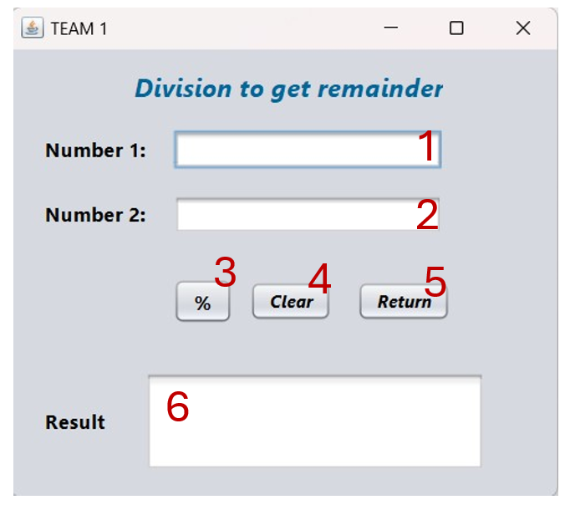

|  |  |  |  |
| --- | --- | --- | --- |
| **ID** | **Condition** | **Control Type** | **Target** |
| 1 | Press | Input text field | Enter first number |
| 2 | Press | Input text field | Enter second number |
| 3 | Press | Button | Click to do the operator |
| 4 | Press | Button | Click to clear all texts in text field |
| 5 | Press | Button | Click to return to Home page |
| 6 | Display | Display text field | Display the result (or notification for invalid input) |

Table 7: Describe User Interface Division for remainder page