PROJECT REPORT
Design, Implementation and Verification of an 8-bit RISC Processor Core with a 5-Stage Pipeline
Architecture, Hazard Handling, Verilog RTL and Xilinx Vivado Flow
Tool: Xilinx Vivado 2026.1 | Language: Verilog-2001
Target device in project: xc7vx485tffg1157-1

Student name: NGÔ VĂN THẮNG
Student ID: SS190566
October 2026

Abstract
This report presents the complete design, implementation and verification of a custom 8-bit RISC processor core built around a classic five-stage pipeline (Instruction Fetch, Instruction Decode, Execute, Memory access and Write-back). The processor uses a fixed 16-bit instruction word, eight 8-bit general-purpose registers, a Harvard memory organisation (a 256 × 16-bit instruction ROM and a 256 × 8-bit data RAM) and a 16-instruction set covering arithmetic, logic, shift, load, store, jump, conditional branch and halt operations. The design is written as fully synthesizable Verilog-2001 and is split into six leaf modules (instruction memory, register file, control unit, hazard unit, ALU and data memory) plus a top-level core.
The report explains the theory required to understand the design, the instruction set and its encoding, the datapath stage by stage, the control signals, and the three classes of pipeline hazard together with the hardware that resolves them: data forwarding, a register-file bypass, a one-cycle load-use stall and a two-cycle branch flush. It then documents the implementation flow in Xilinx Vivado 2026.1 and analyses the screenshots obtained from behavioural simulation, RTL elaboration, synthesis and implementation.
The self-checking testbench executes a 34-instruction test program in 51 clock cycles (CPI = 1.50) and reports ALL TESTS PASSED with zero errors: nine of nine register, memory and flag checks pass, one load-use stall is inserted, six taken branches are flushed, and twelve operands are forwarded. The Vivado implementation run completes successfully through routing and bitstream generation.
Keywords: RISC, 8-bit processor, five-stage pipeline, hazard unit, data forwarding, Verilog, FPGA, VivadoTable of Contents

1. Introduction

1.1 Motivation
Every digital system that executes software contains a processor, and understanding how a processor is built is one of the most instructive exercises in computer engineering. A pipelined processor in particular brings together instruction-set design, register-transfer-level (RTL) hardware description, timing analysis and the practical problem of keeping results correct when many instructions are in flight at once. This project designs a small but complete processor that exhibits every one of these concerns while remaining small enough to be understood, simulated and implemented on an FPGA in full.

1.2 Objectives
- Define a compact, regular instruction set architecture (ISA) with a fixed 16-bit instruction length and 16 instructions.
- Implement the ISA as a five-stage pipelined microarchitecture with a Harvard memory system.
- Detect and resolve data hazards (forwarding, bypass, load-use stall) and control hazards (branch flush) in hardware.
- Write fully synthesizable Verilog-2001 so the design can be processed by Xilinx Vivado without latches or warnings.
- Verify the design with a self-checking testbench and a test program that covers every instruction class and every hazard distance.
- Take the design through Vivado elaboration, synthesis, implementation and bitstream generation.

1.3 Scope and tools
The design is intended for education and demonstration. It has no interrupts, no cache, no branch prediction and no external memory interface; the program is built into the instruction ROM. The tools used are Xilinx Vivado 2026.1 (project “8bit”) for simulation, elaboration, synthesis and implementation. The project in the supplied screenshots targets the device xc7vx485tffg1157-1 (a Virtex-7 part); the original guide suggests any Artix-7 device such as the Basys-3 part xc7a35tcpg236-1, and the design is device-independent because it contains only generic synthesizable logic.

1.4 Report organisation
Sections 2 to 4 give the background, specification and ISA. Sections 5 to 9 describe the architecture: file structure, pipelining theory, datapath, control unit and hazard handling. Sections 10 to 12 contain instruction walk-throughs, design trade-offs and the development method. Sections 13 and 14 document the Vivado implementation and the verification results using the captured screenshots. Section 15 discusses the findings, limitations and future work, and Section 16 concludes.

2. Background Concepts

2.1 What a processor does
A processor (CPU) runs a program, which is a list of instructions stored in memory. It repeats one cycle indefinitely: fetch the next instruction, decode it to learn what it means, execute it (for example add two numbers), access memory if the instruction loads or stores data, and write back the result into a register. A register called the program counter (PC) holds the address of the next instruction.

2.2 ISA versus microarchitecture
The instruction set architecture (ISA) is the contract between software and hardware: which instructions exist, how they are encoded as bits and how many registers there are. The microarchitecture is the way one particular implementation honours that contract: the number of pipeline stages, the shortcuts and the memories. The same ISA can be built as a single-cycle, a 3-stage or a 5-stage machine. This project defines a custom 8-bit RISC ISA and implements it with a classic 5-stage microarchitecture.

2.3 RISC versus CISC
Feature | RISC (this project) | CISC
Instruction length | Fixed (16 bits here) | Variable
Number of instructions | Few and simple (16 here) | Many and complex
Memory access | Only LD and ST touch memory | Most instructions may touch memory
Control unit | Hard-wired logic | Often microprogrammed
Pipelining | Easy, all instructions look alike | Difficult
Examples | ARM, RISC-V, MIPS, AVR | x86, 8085, 8051

2.4 Harvard versus von Neumann architecture
A von Neumann machine keeps instructions and data in a single memory, so fetching an instruction and loading data compete for the same port. A Harvard machine has two separate memories. This processor is Harvard: the instruction memory (256 × 16 bits) is read every cycle by the fetch stage while the data memory (256 × 8 bits) is used at the same moment by the memory stage. This removes the structural hazard that a shared memory would create in a pipeline.

2.5 Combinational and sequential logic
Combinational logic (gates, adders, multiplexers) produces outputs that depend only on the present inputs after a small propagation delay. The ALU, the control decoder and the hazard unit are combinational. Sequential logic (flip-flops and registers) stores a value and changes only on the rising clock edge. The PC, registers R0–R7 and all pipeline registers are sequential. Every digital design is registers with combinational logic between them; describing a design in this way is called Register Transfer Level (RTL) design.

2.6 Clock, reset and critical path
All registers update on the rising clock edge. Between two edges, signals must travel through the combinational logic from one register to the next. The slowest such path is the critical path and it sets the shortest possible clock period. Pipelining shortens the critical path by cutting the work into stages. Reset places every register in a known starting state (PC = 0 and an empty pipeline).

3. Processor Specification
Table 3.1 summarises the processor parameters that were fixed before any design work began.
Table 3.1. Processor specification
Parameter | Value | Meaning
Data width | 8 bits | Registers, ALU and data memory work on numbers 0–255
Instruction width | 16 bits, fixed | Every instruction is exactly one 16-bit word
Registers | 8 × 8-bit (R0–R7) | Fast storage inside the CPU; R0 is an ordinary register
Program counter | 8 bits | Can address 256 instructions
Instruction memory | 256 × 16-bit ROM | Holds the program
Data memory | 256 × 8-bit RAM | Read by LD, written by ST
Architecture | Harvard | Separate instruction and data memories
Pipeline | 5 stages: IF, ID, EX, MEM, WB | Up to 5 instructions in progress at once
Flags | Z (zero), C (carry / borrow) | Set by arithmetic and logic instructions
Instructions | 16 (4-bit opcode) | Arithmetic, logic, shift, load, store, jump, branch, halt
Hazard handling | Forwarding, bypass, 1-cycle load-use stall, 2-cycle branch flush | Hardware keeps results correct
Target | Xilinx FPGA through Vivado | Fully synthesizable Verilog-2001

4. Instruction Set Architecture (ISA)

4.1 Instruction formats
Every instruction is 16 bits wide. The top four bits are always the opcode. The remaining bits are interpreted in one of four formats: R-type (three registers), R1-type (two registers), I-type (a register and an 8-bit immediate) and J-type (an 8-bit jump target). Keeping the opcode and the register fields in the same bit positions in every format allows the decoder to read them before it even knows which instruction it is looking at.
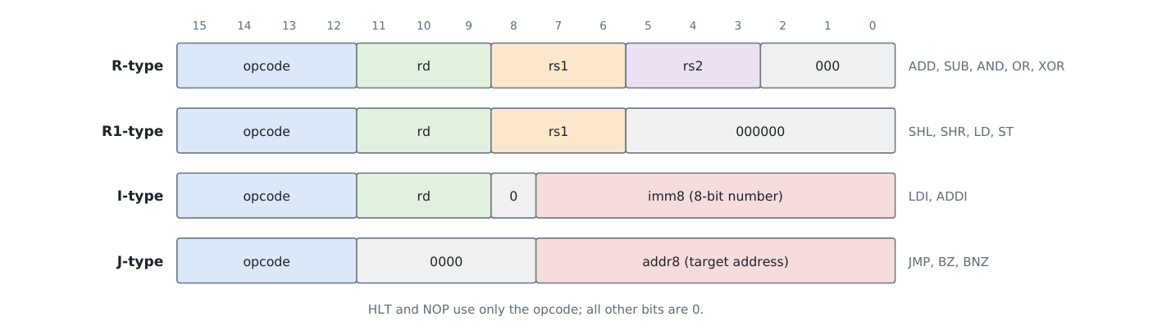
Figure 1. The four instruction formats. Bit 15 is on the left.
Table 4.1. Instruction fields
Field | Bits | Size | Meaning
opcode | 15–12 | 4 | Which of the 16 instructions
rd | 11–9 | 3 | Destination register; for ST it is the register whose value is stored
rs1 | 8–6 | 3 | First source register; for LD/ST it holds the memory address
rs2 | 5–3 | 3 | Second source register
imm8 / addr8 | 7–0 | 8 | A number inside the instruction (LDI, ADDI) or a jump target (JMP, BZ, BNZ)

4.2 The 16 instructions
Table 4.2. Instruction set
Opcode | Instruction | Operation | Flags | Format
0 | NOP | Do nothing | – | –
1 | ADD rd, rs1, rs2 | rd = rs1 + rs2 | Z, C | R
2 | SUB rd, rs1, rs2 | rd = rs1 − rs2 | Z, C (borrow) | R
3 | AND rd, rs1, rs2 | rd = rs1 AND rs2 (bitwise) | Z | R
4 | OR rd, rs1, rs2 | rd = rs1 OR rs2 | Z | R
5 | XOR rd, rs1, rs2 | rd = rs1 XOR rs2 | Z | R
6 | SHL rd, rs1 | rd = rs1 << 1 (× 2) | Z, C = old bit 7 | R1
7 | SHR rd, rs1 | rd = rs1 >> 1 (÷ 2) | Z, C = old bit 0 | R1
8 | LDI rd, imm8 | rd = imm8 | – | I
9 | ADDI rd, imm8 | rd = rd + imm8 | Z, C | I
A | LD rd, [rs1] | rd = memory[rs1] | – | R1
B | ST rd, [rs1] | memory[rs1] = rd | – | R1
C | JMP addr8 | PC = addr8 | – | J
D | BZ addr8 | if Z = 1 then PC = addr8 | – | J
E | BNZ addr8 | if Z = 0 then PC = addr8 | – | J
F | HLT | Stop the processor | – | –

4.3 Flags
The Z (zero) flag becomes 1 when the result of an arithmetic, logic or shift instruction is 0. The C (carry) flag becomes 1 when an addition overflows 8 bits (for example 255 + 1), when a subtraction needs to borrow (a < b), or holds the bit pushed out by a shift. LDI, LD, ST and the jumps leave the flags unchanged. BZ and BNZ test Z, which is how loops and if-statements are built.

4.4 Addressing modes
Mode | Example | Where the operand comes from
Register | ADD R3, R1, R2 | Registers named in the instruction
Immediate | LDI R1, 5 | The number written inside the instruction
Register indirect | LD R5, [R4] | Memory, at the address held in a register
Absolute (branch) | JMP 0x17 | The target address is written inside the instruction

4.5 Encoding examples
ADD R2, R2, R1: opcode ADD = 0001, rd = R2 = 010, rs1 = R2 = 010, rs2 = R1 = 001, last three bits 000. Joined: 0001 010 010 001 000 = 0001 0100 1000 1000 = 0x1488.
LDI R1, 0x3C: opcode LDI = 1000, rd = 001, bit 8 = 0, imm8 = 0011 1100, giving 0x823C.
These encodings are used later when the simulation trace is decoded (Section 14.4): for example the word 0x1488 seen in the ID column of the trace is exactly ADD R2, R2, R1.

5. System Architecture and File Structure

5.1 System view
The processor core has only two inputs, clk and rst. Everything it needs, including the program, is inside it. Its four outputs exist for observation: halted (the program has finished), pc_out[7:0], flags_out[1:0] and instr_done (which pulses each time an instruction completes). On an FPGA board these outputs can drive LEDs. In simulation, the testbench generates a 100 MHz clock (10 ns period), holds reset for two cycles, and runs a checker that watches the outputs and internal state.
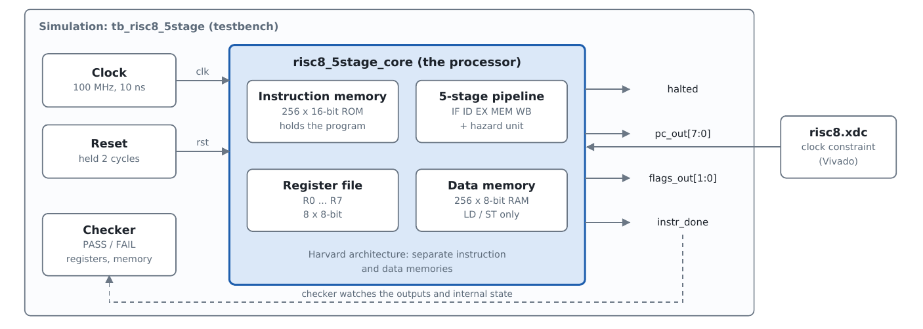
Figure 2. System view: the processor core inside its testbench, with the Vivado constraint file.

5.2 File hierarchy
The testbench instantiates the core, and the core instantiates six modules, each of which implements one block of the processor.
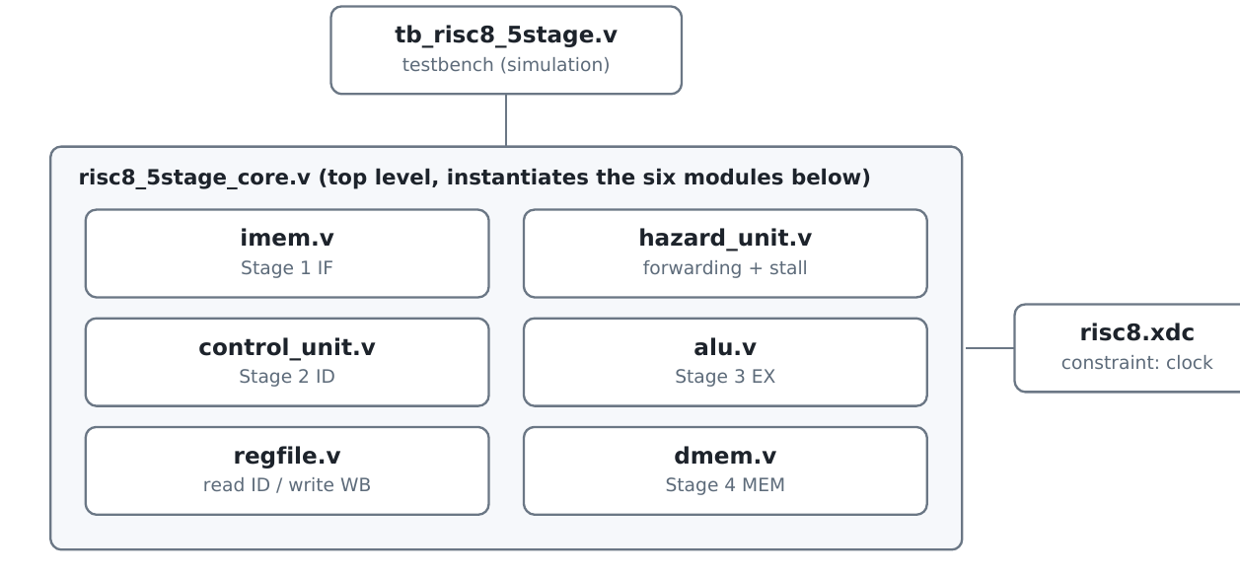
Figure 3. File hierarchy: the testbench creates the core, and the core creates six modules.
Table 5.1. Source files
File | Module | Kind | Job in one sentence
risc8_5stage_core.v | risc8_5stage_core | Sequential + wiring | Top level: PC, four pipeline registers, flags, branch and halt logic, connects everything
imem.v | imem | Memory (ROM) | Stores the program and returns the instruction at the PC
control_unit.v | control_unit | Combinational | Turns the opcode into control signals
regfile.v | regfile | Sequential | Eight 8-bit registers with two read ports and one write port
hazard_unit.v | hazard_unit | Combinational | Decides forwarding and load-use stalls
alu.v | alu | Combinational | Does the arithmetic and logic; produces Z and C
dmem.v | dmem | Memory (RAM) | 256 bytes of data for LD and ST
tb_risc8_5stage.v | tb_risc8_5stage | Testbench | Clock, reset, monitoring, automatic PASS/FAIL
risc8.xdc | – | Constraint | Tells Vivado the target clock (100 MHz)

6. Pipelining Theory

6.1 The idea
Without a pipeline, one instruction would pass through all five jobs before the next one starts. With a pipeline, the five jobs are carried out by five separate pieces of hardware (stages), each working on a different instruction, like an assembly line. Between the stages are pipeline registers that hold an instruction’s information until the next clock edge pushes it one stage forward.
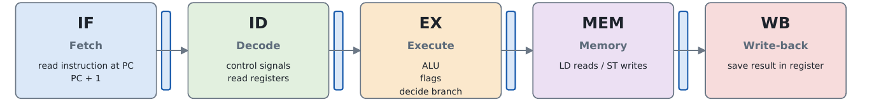
Figure 4. The five stages and what each one does.
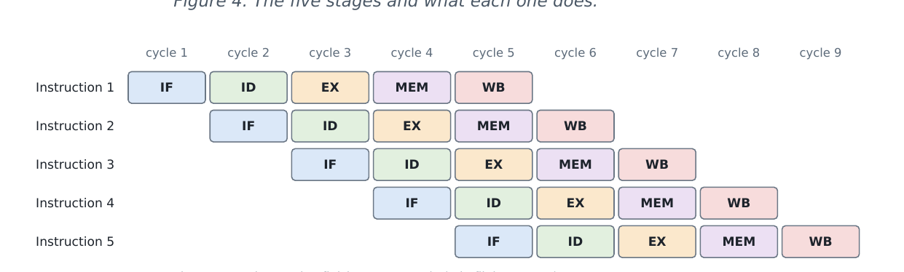
Figure 5. Pipeline timing: five instructions overlap.

6.2 Throughput, latency and CPI
Latency (the time for one instruction) is still 5 cycles. Throughput becomes one instruction per cycle once the pipeline is full. For n instructions on a k-stage pipeline the ideal time is k + (n − 1) cycles instead of n × k, so the speedup approaches k for long programs. CPI (cycles per instruction) is ideally 1; hazards add extra cycles.
For the test program used in this project (n = 34 instructions, k = 5), the ideal pipelined time is 5 + 34 − 1 = 38 cycles. The measured time is 51 cycles, so 13 extra cycles come from hazards: 12 flush cycles (6 taken branches × 2) plus 1 load-use stall. An equivalent non-pipelined multi-cycle machine would need about 34 × 5 = 170 cycles, so the measured speedup is roughly 170 / 51 ≈ 3.3×.

6.3 Why exactly five stages
Each stage contains one major piece of hardware, so their delays are balanced: memory read (IF), decoder and register read (ID), ALU (EX), memory again (MEM) and register write (WB). Placing the ALU and the data memory in separate stages is what makes the 5-stage design faster than a 3-stage one; in the project documentation, an iCE40 FPGA clock rose from 48.8 MHz to 73.2 MHz for this reason.

6.4 Valid bits and bubbles
Each pipeline register carries a valid bit. If valid = 0 the slot is empty and is called a bubble. A bubble moves through the stages like an instruction but every write-enable it carries is forced to 0, so it cannot change a register, memory or the flags. The hardware creates bubbles on purpose, either to stall or to cancel (flush) instructions. In the Vivado trace, the notation “EX:v1 / MEM:v0” indicates whether the instruction in each stage is valid.

7. The Complete Datapath
Figure 6 shows the complete datapath. The four blue bars are the pipeline registers IF/ID, ID/EX, EX/MEM and MEM/WB. M marks a multiplexer. The red line is the stall signal and the blue bus carries forwarded results back to the execute stage.
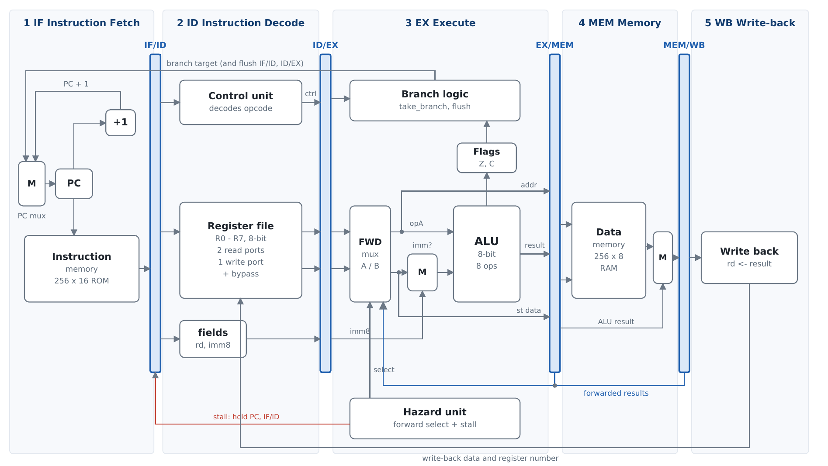
Figure 6. Complete 5-stage datapath. Blue bars are the four pipeline registers; M = multiplexer; red line = stall; blue bus = forwarded results.

7.1 Stage 1 – Instruction Fetch (IF)
The PC sends its address to the instruction memory, which returns the 16-bit instruction in the same cycle. At the clock edge the instruction is stored in the IF/ID register with valid = 1 and the PC is updated. The PC multiplexer chooses the next PC according to the following priority:
Condition (priority order) | Next PC | IF/ID receives
A branch or jump is taken in EX | Branch target | Bubble (wrong-path instruction cancelled)
HLT has reached EX | PC unchanged | Bubble (nothing more is fetched)
Load-use stall | PC unchanged | Unchanged (the same instruction waits)
Normal | PC + 1 | The fetched instruction

7.2 Stage 2 – Instruction Decode (ID)
The instruction in IF/ID is split into its fields and the control unit converts the opcode into control signals. The register file is read on two ports. Two special cases choose which register each port reads: ADDI reads rd on port A (because it computes rd = rd + imm8) and ST reads rd on port B (the value to store). The register file also contains a bypass: if the WB stage is writing the very register being read, the new value is passed straight through. Everything is then stored in the ID/EX register.

7.3 Stage 3 – Execute (EX)
Two forwarding multiplexers choose each operand from one of three places: the value read in ID, the newer result waiting in EX/MEM, or the result in MEM/WB. A second multiplexer chooses whether the ALU’s B input is the register value or the immediate number. The ALU computes the result and the Z and C flags; the flags are stored at the end of the cycle if the instruction is allowed to change them. The branch logic decides whether a JMP, BZ or BNZ is taken. The result, the memory address and the store data go into EX/MEM.

7.4 Stage 4 – Memory access (MEM)
For LD the data memory is read at the address held in EX/MEM; for ST it is written at the clock edge. A multiplexer passes either the loaded byte (LD) or the ALU result (all other instructions) into MEM/WB.

7.5 Stage 5 – Write-back (WB)
If the instruction writes a register, MEM/WB drives the register file’s write port and the value is stored at the next clock edge. The same value is also sent back to the forwarding multiplexers and to the register-file bypass.

7.6 Contents of the pipeline registers
Register | Contents | Width
IF/ID | instruction (16), valid (1) | 17 bits
ID/EX | valid, 14 control bits, rd, two register numbers, two register values, imm8 | 48 bits
EX/MEM | valid, reg_we, mem_to_reg, mem_we, halt, rd, ALU result, address, store data | 32 bits
MEM/WB | valid, reg_we, halt, rd, result | 14 bits

The total of 111 bits of pipeline state, plus the 8-bit PC and the two flags, explains why the implemented netlist (Section 13) is dominated by flip-flops for the PC and the valid bits.

8. The Control Unit and Control Signals
The control unit is a lookup table from opcode to control signals. It starts with every signal off (which is a NOP) and switches on only what each instruction needs. Because it has no memory it is pure combinational logic: a hard-wired control unit, typical of RISC designs.
Table 8.1. Control signals
Signal | Meaning when 1
alu_op (3 bits) | ALU operation: 0 ADD, 1 SUB, 2 AND, 3 OR, 4 XOR, 5 SHL, 6 SHR, 7 pass B
alu_src_imm | ALU input B is the immediate number, not a register
ra_is_rd / rb_is_rd | Read port A / B reads register rd instead of rs1 / rs2
uses_a / uses_b | The instruction really reads port A / B (used by the hazard unit)
reg_we | Write the result into register rd in WB
mem_to_reg | The result comes from data memory (LD)
mem_we | Write data memory in MEM (ST)
flag_we | Update Z and C in EX
jump / br_z / br_nz | Instruction is JMP / BZ / BNZ
halt | Instruction is HLT

8.1 Control signal table
The table below lists the signals that are 1 for each instruction (a blank cell means 0; “–” in alu_op means the ALU result is unused).
Instr. | alu_op | alu_src_imm | ra_is_rd | rb_is_rd | uses_a | uses_b | reg_we | mem_to_reg | mem_we | flag_we | branch / halt
NOP | –
ADD | 0 |  |  |  | 1 | 1 | 1 |  |  | 1
SUB | 1 |  |  |  | 1 | 1 | 1 |  |  | 1
AND | 2 |  |  |  | 1 | 1 | 1 |  |  | 1
OR | 3 |  |  |  | 1 | 1 | 1 |  |  | 1
XOR | 4 |  |  |  | 1 | 1 | 1 |  |  | 1
SHL | 5 |  |  |  | 1 |  | 1 |  |  | 1
SHR | 6 |  |  |  | 1 |  | 1 |  |  | 1
LDI | 7 | 1 |  |  |  |  | 1
ADDI | 0 | 1 | 1 |  | 1 |  | 1 |  |  | 1
LD | – |  |  |  | 1 |  | 1 | 1
ST | – |  |  | 1 | 1 | 1 |  |  | 1
JMP | – |  |  |  |  |  |  |  |  |  | jump
BZ | – |  |  |  |  |  |  |  |  |  | br_z
BNZ | – |  |  |  |  |  |  |  |  |  | br_nz
HLT | – |  |  |  |  |  |  |  |  |  | halt

Note: the control-signal table above was transcribed from the design document; the exact positions of the “1” entries for ra_is_rd, rb_is_rd, uses_a and uses_b follow the behaviour described in Sections 7.2 and 8 (ADDI reads rd on port A; ST reads rd on port B and rs1 on port A).

8.2 Control signals travel with the instruction
The decoder works in ID, but many signals are needed later. They are therefore copied into the pipeline registers and travel along with their instruction. Each stage uses its own group of signals and passes the rest on. A bubble has all its write-enables forced to 0.
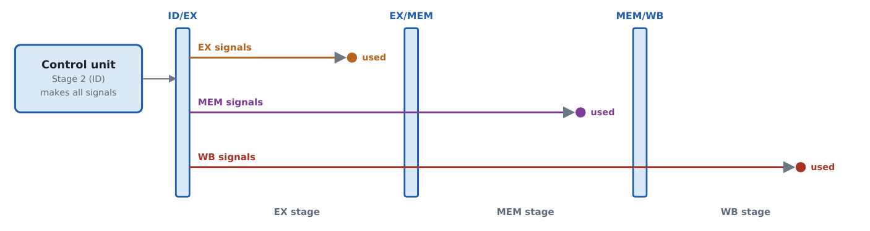
Figure 7. EX signals are used one stage later, MEM signals two stages later, WB signals three stages later.
Group | Signals | Used in
EX | alu_op, alu_src_imm, flag_we, jump, br_z, br_nz, halt | Stage 3
MEM | mem_we, mem_to_reg | Stage 4
WB | reg_we, rd | Stage 5

9. Hazards and How They Are Solved
A hazard is a situation in which the overlapped instructions would produce a wrong result if the hardware did nothing. There are three kinds: structural, data and control hazards.
Kind | Cause | Solution here | Cost
Structural | Two stages need the same resource | Harvard memories; register file with separate read and write ports | 0
Data (read after write) | An instruction needs a result that is not written back yet | Forwarding from EX/MEM and MEM/WB; register-file bypass | 0 cycles
Data, load-use | The value comes from memory and is needed immediately | 1-cycle stall, then forwarding | 1 cycle
Control | A taken branch makes the already-fetched instructions wrong | Flush the two younger instructions | 2 cycles

9.1 Forwarding
The hazard unit compares the source register numbers of the instruction in EX with the destination register numbers of the instructions in MEM and WB. The rules are checked separately for operand A and operand B:
- If the instruction in MEM will write a register, is not a load, and its register equals the one being read, take its ALU result from EX/MEM (the newest value wins).
- Otherwise, if the instruction in WB will write that register, take the MEM/WB result.
- Otherwise use the value read in ID.
Forwarding is done only for operands the instruction really reads (uses_a / uses_b), so unused register fields never cause a false match.
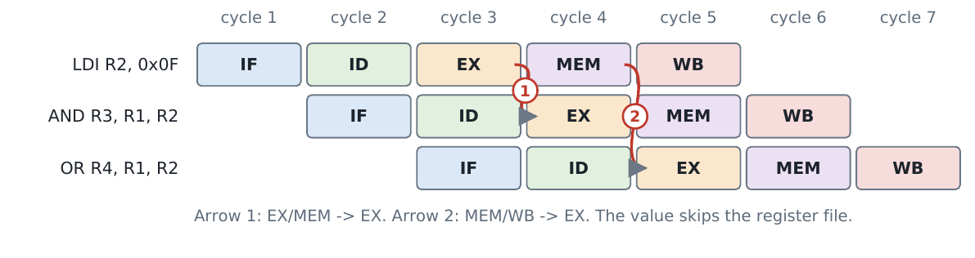
Figure 8. Forwarding: AND and OR receive R2 before LDI writes it.

9.2 Register-file bypass
If an instruction three places behind reads a register in ID in the same cycle as WB writes it, the register file itself returns the new value. Together with the two forwarding paths, every distance between producer and consumer (1, 2 or 3 instructions) is covered without waiting.

9.3 Load-use stall
A load obtains its data only at the end of MEM. If the very next instruction needs it in EX, the data does not exist yet. The hazard unit detects this situation (a load is in EX and the instruction in ID reads the register the load will write) and raises stall for one cycle: the PC and IF/ID keep their values and a bubble enters ID/EX. One cycle later the load is in WB and normal forwarding supplies the value.
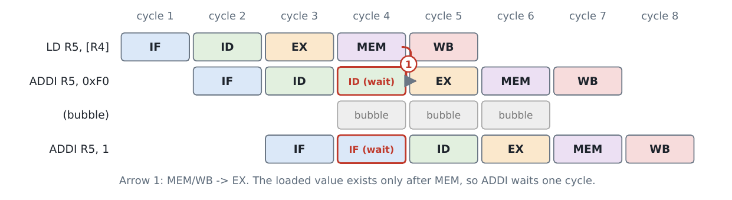
Figure 9. Load-use stall: one bubble is inserted, then the value is forwarded.

9.4 Control hazards: branch flush
The processor keeps fetching sequentially while a branch moves down the pipeline. The branch is decided in EX, where the flags are up to date. If it is taken, the PC is loaded with the target and the two younger instructions (in IF/ID and ID/EX) become bubbles. They never reach MEM or WB, so they cannot change memory or registers. The cost is 2 cycles per taken branch; not-taken branches cost nothing.
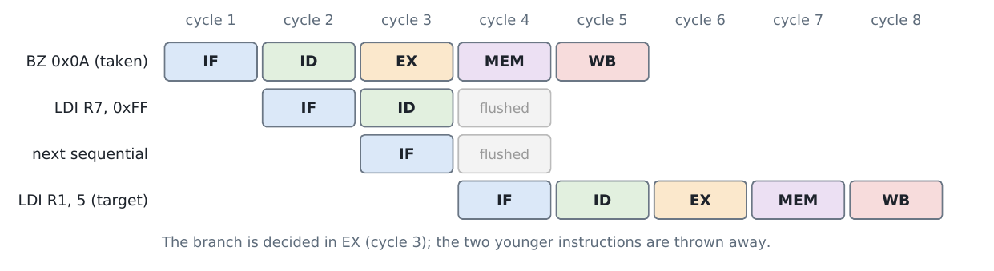
Figure 10. A taken branch flushes the two instructions fetched after it.

9.5 Halting
When HLT reaches EX, fetching stops and younger instructions are squashed, but the older ones in MEM and WB still finish. When HLT itself reaches WB, the halted output becomes 1 and the whole pipeline freezes. This guarantees that every instruction before HLT completes.

9.6 Priority of pipeline actions
The top-level module updates every register in a single clocked block with the priority flush > halt > stall > normal advance. A taken branch therefore always wins over a stall request, and a halt prevents any further fetching.

10. Instruction Walk-Throughs
The table below follows four representative instructions through the five stages.
Stage | ADD R3, R1, R2 | LD R5, [R4] | ST R2, [R4] | BZ 0x0A
IF | fetch 0x3650 | fetch 0xAB00 | fetch 0xB500 | fetch 0xD00A
ID | read R1, R2; reg_we = 1, flag_we = 1, alu_op = ADD | read R4; reg_we = 1, mem_to_reg = 1 | read R4 (A) and R2 (B); mem_we = 1 | br_z = 1; target 0x0A
EX | ALU: R1 + R2; set Z, C | address = R4 passed on | address = R4, data = R2 passed on | if Z = 1: PC = 0x0A, flush 2
MEM | pass result | read memory[R4] | write memory[R4] = R2 | –
WB | R3 = result | R5 = loaded byte | nothing | nothing

11. Design Decisions and Trade-offs
Decision | Why | Alternative
Branches resolved in EX | The Z flag is produced by the ALU in EX, so the decision always uses up-to-date flags | Decide in ID with extra compare logic: 1-cycle penalty, more hardware
Fixed 16-bit instructions | 8 bits are too few for opcode plus registers; fixed length keeps decoding simple | Variable length (CISC): harder to pipeline
Asynchronous memory read | Instruction and data are available in the same cycle as the address | Synchronous block RAM: one more cycle of latency
Write-through register bypass | Removes the distance-3 hazard with a tiny multiplexer | Write in first half of cycle, read in second half
Forwarding gated by uses_a / uses_b | No false forwards or stalls from unused fields | Simpler logic, but occasional needless stalls
Program built into imem.v | No external file; Vivado cannot lose it | $readmemh from a .hex file
Debug outputs (pc_out, flags_out, instr_done) | Observable on LEDs; no unused-signal warnings | Internal signals only

An important consequence of the last decision is visible in the implementation results (Section 13.4): because only a few signals are observable at the ports, Vivado can remove logic that does not influence them.

12. Development Method
The source files were written in order from the smallest independent block to the top level. The following method can be used to build the processor from scratch.
Step | What to do | Details
1 | Write the specification | Decide data width, number of registers, memory sizes and which instructions are needed (Section 3).
2 | Design the ISA | Choose instruction formats, assign opcodes, write the encoding table (Section 4).
3 | Draw a single-cycle datapath | On paper, connect PC, instruction memory, decoder, register file, ALU, data memory and write-back so that one instruction completes per (long) cycle.
4 | Cut it into five stages | Insert the four pipeline registers after fetch, after decode, after the ALU and after memory (Figure 6).
5 | Write the control table | For every instruction list every control signal and decide in which stage each is used (Section 8).
6 | Find the hazards | For each pair of dependent instructions at distances 1, 2 and 3 decide whether to forward, bypass or stall; decide where branches are resolved.
7 | Write the leaf modules | ALU, register file, data memory and instruction memory; test each alone in simulation.
8 | Write the control unit | A case statement on the opcode with defaults first.
9 | Write the hazard unit | Comparators for forwarding (EX vs MEM and WB) and for load-use (EX load vs ID).
10 | Write the top level | Declare the pipeline registers, instantiate all modules, add the multiplexers and the single clocked block with priority flush > halt > stall > normal.
11 | Write a test program | Cover every instruction, dependencies at distances 1–3, a load-use pair, taken and not-taken branches and wrong-path instructions; work out expected values by hand.
12 | Write a self-checking testbench | Generate clock and reset, print the pipeline every cycle, wait for halted, compare every register with its expected value and print PASS/FAIL.
13 | Simulate and debug | Use the cycle trace and waveforms; check that stalls and flushes happen exactly where expected.
14 | Synthesize and implement | Check for latches, utilisation and timing.

13. Implementation in Xilinx Vivado

13.1 Project set-up
The project was created in Vivado 2026.1 as an RTL project named “8bit”. The seven design sources (the six modules and the top-level core) were added with “Copy sources into project”, the constraint file risc8.xdc was added, the testbench tb_risc8_5stage.v was added as a simulation source, and risc8_5stage_core was kept as the top module. The device selected in the project is xc7vx485tffg1157-1. The status bar in every screenshot shows “Implementation Complete”, confirming that the full flow ran to the end.
Step | Vivado action | Result
1 | Create project (RTL project, choose part) | Project “8bit”, part xc7vx485tffg1157-1
2 | Add sources (7 design, 1 simulation, 1 xdc) | Top module = risc8_5stage_core
3 | Run Behavioral Simulation | ALL TESTS PASSED (Section 14)
4 | Run Synthesis | RTL mapped to LUTs and flip-flops
5 | Run Implementation | Place and route completed
6 | Timing check | Report Timing Summary generated (WNS must be ≥ 0)
7 | Generate Bitstream | write_bitstream step completed (needs board pin constraints for hardware)

13.2 RTL elaboration
Elaboration converts the Verilog into a technology-independent netlist of generic gates, multiplexers and registers. Figure 11 is the schematic of the elaborated design. The header of the schematic reports 226 cells, 14 I/O ports and 355 nets. The 14 I/O ports correspond exactly to the interface of the core: clk and rst (2 inputs), plus pc_out[7:0], flags_out[1:0], halted and instr_done (12 outputs). The dense wiring in the centre of the figure comes from the forwarding multiplexers, the register file and the pipeline registers; the long horizontal buses are the forwarded results and the write-back path.
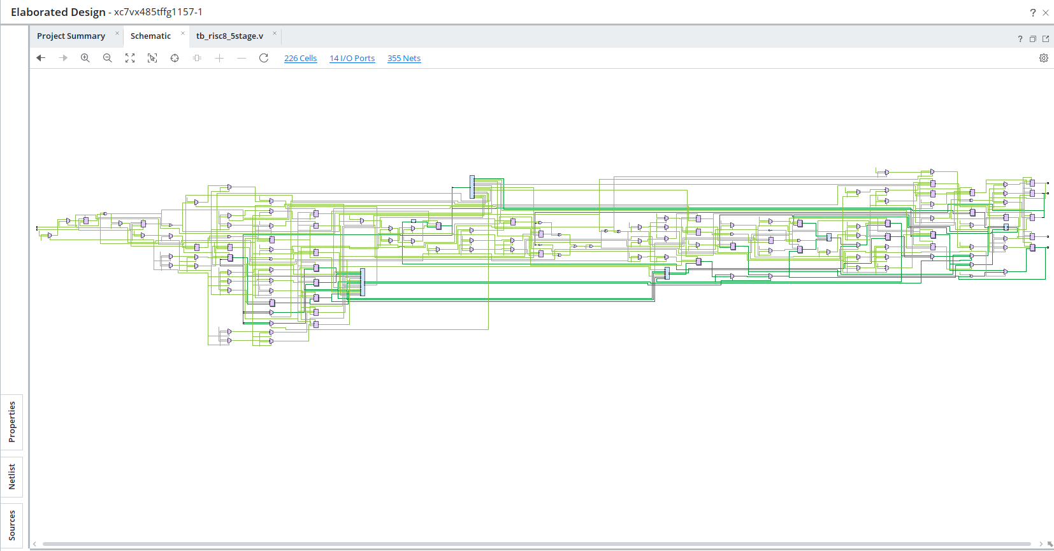
Figure 11. Schematic of the elaborated design (RTL analysis): 226 cells, 14 I/O ports, 355 nets.

13.3 Implementation reports
Figure 12 lists the reports generated by the implementation run. Reports exist for every stage of the flow (opt_design, place_design, phys_opt_design and route_design). After placement the tool produced the I/O, utilisation and control-sets reports; after routing it produced the DRC, methodology, power, route-status, timing-summary, clock-utilisation and bus-skew reports, followed by the implementation log and the write_bitstream step. The timestamps (10/20/26, 10:08–10:10 AM) show that placement and routing together finished in roughly two minutes, which is typical for a design of this size. The Timing Summary – Route Design report (32.9 KB) is the one in which the worst negative slack (WNS) for the 100 MHz constraint is read.
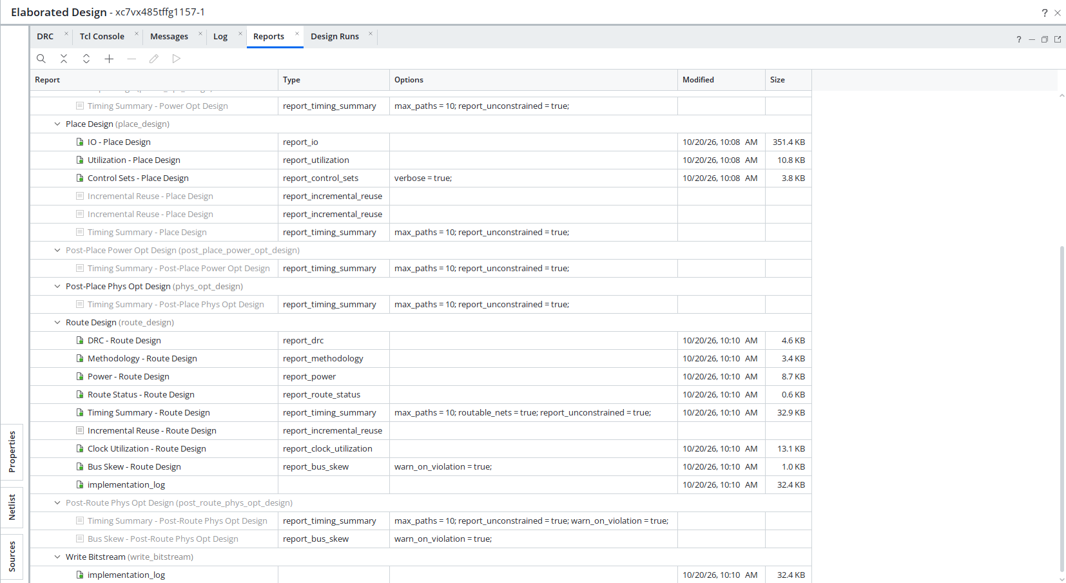
Figure 12. Vivado Reports window listing the place, route and bitstream reports of the implementation run.

13.4 Implemented design (post-route schematic)
Figure 13 shows the schematic of the implemented design. Its header reports 36 cells, 14 I/O ports and 40 nets, far fewer cells than the 226 of the elaborated design. The visible cells are the input buffers (IBUF/BUFG) for clk and rst, FDRE flip-flops named pc_reg[0] to pc_reg[7], the valid-bit registers ifid_valid_reg, idex_valid_reg, exmem_valid_reg and memwb_valid_reg, a handful of LUT2–LUT6 cells computing the next PC, and output buffers (OBUF) for pc_out[7:0], flags_out[1:0], halted and instr_done.
This reduction is an expected effect of synthesis optimisation. The processor has no data inputs and its program is a constant ROM, so a large part of the behaviour is fully determined at compile time; Vivado propagates constants and removes logic that does not influence any output port. The result confirms that the design contains no unintended latches and that the control flow (PC and valid bits) is mapped to ordinary flip-flops. If a full-size implementation with the register file and data memory retained as LUT/LUT-RAM is wanted for resource measurements, the outputs can be made to depend on the data path (for example by exposing a register value on a port) or the keep attributes can be used.
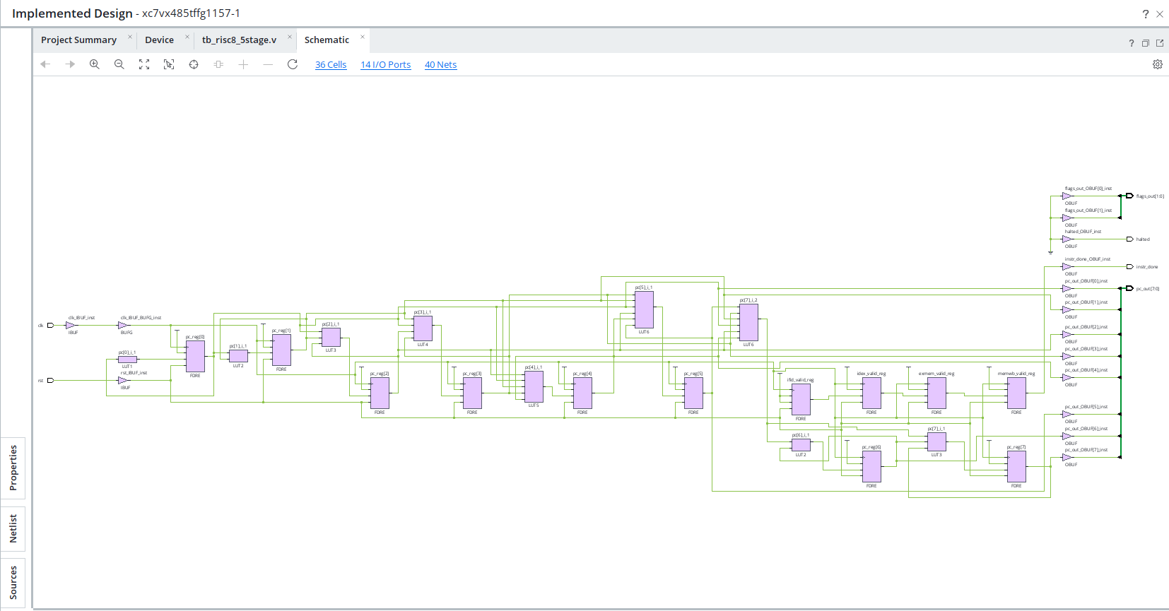
Figure 13. Schematic of the implemented design: 36 cells, 14 I/O ports, 40 nets (PC flip-flops, valid-bit flip-flops, LUTs and I/O buffers).

13.5 Device view and placement
Figure 14 shows the Device view of the xc7vx485t FPGA after placement. The device is divided into clock regions (X0Y0 to X1Y6). The design occupies only a very small cluster of logic (the small cyan marks near region X0Y1) while the remainder of the large Virtex-7 device is unused. This confirms that the processor core is tiny compared with the available fabric and that the 100 MHz target leaves ample routing resources.
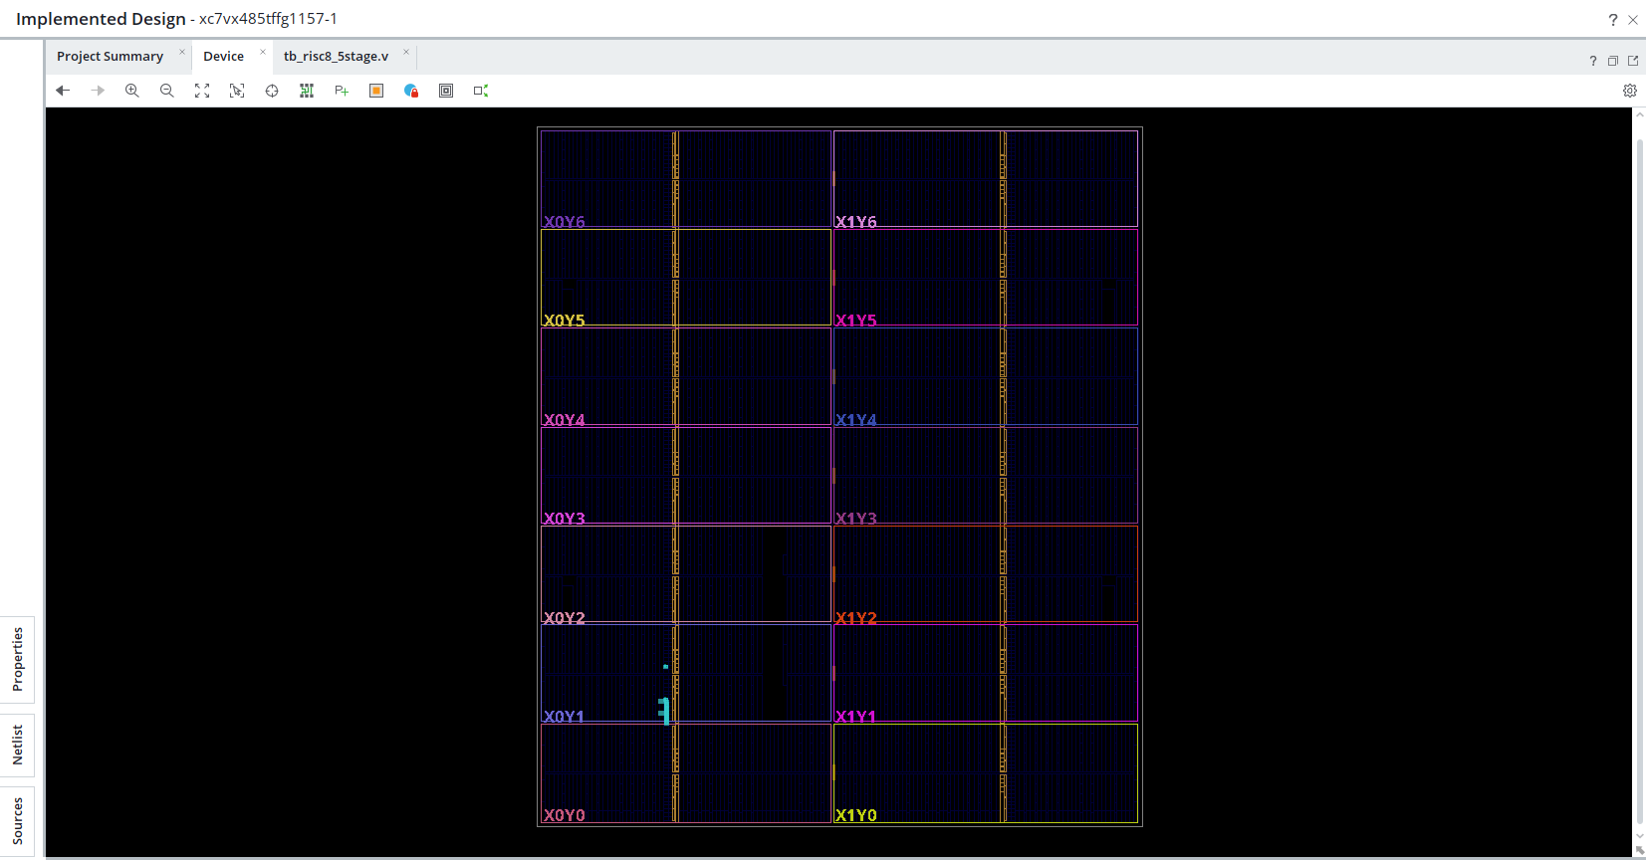
Figure 14. Device view after implementation: the placed design occupies a tiny area near clock region X0Y1 of the xc7vx485t device.

14. Verification and Results

14.1 Test program and testbench
The test program covers every instruction class, dependencies at distances 1, 2 and 3, a load-use pair, a loop that sums 5 + 4 + 3 + 2 + 1, taken branches with wrong-path instructions that must be cancelled, a carry, a jump and HLT. The self-checking testbench generates a 100 MHz clock, holds reset for two cycles, prints one trace line per cycle, waits for the halted output, compares nine results with expected values and prints PASS or FAIL. It also keeps performance counters: cycles, retired instructions, stalls, flushes, forwarded operands and errors.

14.2 Behavioural simulation waveform
Figure 15 shows the XSim waveform window. The simulation ran in Vivado’s Behavioral Simulation (Functional) mode with the testbench tb_risc8_5stage as top, and the simulation time at the end is 545 ns (shown in the status bar). The Tcl console confirms “XSim simulation ran for 1000 ns”, and the testbench terminates itself at 545 ns with $finish.
The Objects panel gives the final values of the signals: halted = 1, pc = 0x19, flags = 3 (both Z and C set), cycles = 51, retired = 34, stalls = 1, flushes = 6, fwds = 12 and errors = 0. In the waveform the following can be observed:
- rst is high only during the first ~20 ns (two clock cycles) and then falls to 0, after which the PC starts incrementing from 0x00.
- instr_done is low while the pipeline is filling, then shows long high periods as one instruction completes per cycle. The short low gaps correspond to bubbles created by branch flushes and by the load-use stall.
- The flushes counter increments one step roughly every 50 ns (values 1, 2, 3, 4 are visible), which is the 5-cycle period of the summation loop whose closing BNZ is taken and flushes two instructions each iteration.
- At the cursor position of 137.834 ns the counters read cycles = 12, retired = 8, stalls = 0, flushes = 1 and fwds = 6, showing that forwarding is already in use early in the program while the stall has not yet occurred.
- The errors counter stays at 0 for the whole run, and halted rises to 1 at the very end, freezing the pipeline.
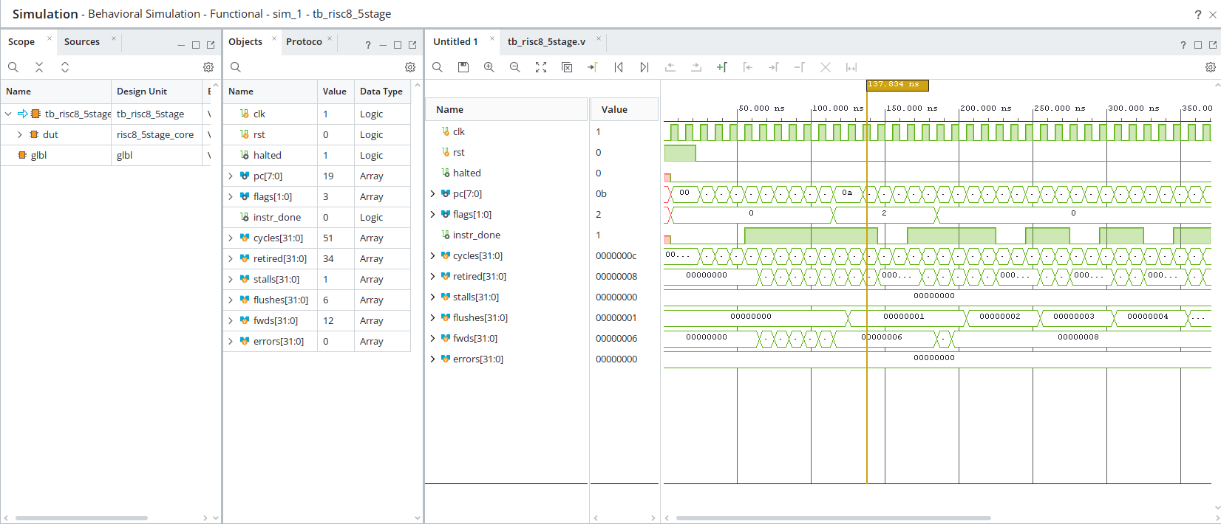
Figure 15. Behavioural simulation waveform and performance counters (final: cycles 51, retired 34, stalls 1, flushes 6, fwds 12, errors 0).

14.3 Console trace and automatic check
Figure 16 shows the Log/Tcl output of the testbench: one line per clock cycle with the PC, the instruction in ID, the valid bits of EX and MEM, the register written in WB and the flags, followed by the register/memory check and a performance summary. All nine checks print PASS and the run ends with “* ALL TESTS PASSED *” and “$finish called at time 545 ns”.
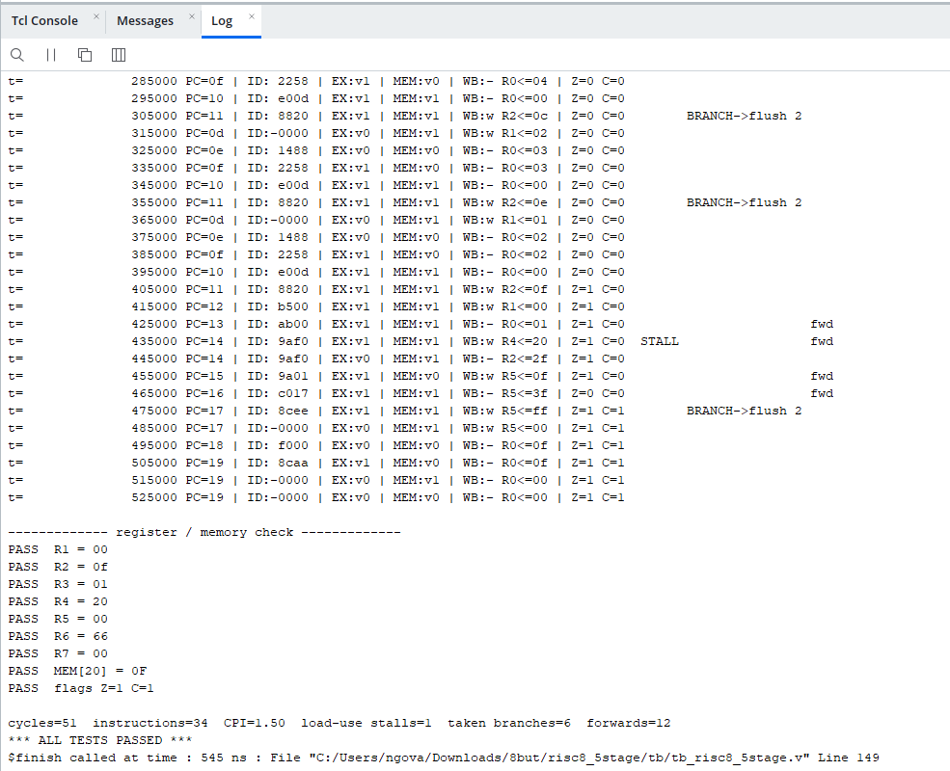
Figure 16. Testbench console output: cycle trace, PASS checks and performance summary.

14.4 Decoding the trace
The hexadecimal instruction words in the ID column can be decoded with the encoding rules of Section 4, which allows the behaviour of the pipeline to be followed in detail:
Word in ID | Decoded instruction | Observation in the trace
0x1488 | ADD R2, R2, R1 | Loop body: accumulates the sum. WB shows R2 = 0x0C, 0x0E, 0x0F (12, 14, 15), i.e. 5+4+3, +2, +1.
0x2258 | SUB R1, R1, R3 | Decrements the counter: R1 = 0x02, 0x01, 0x00 are written back in successive iterations.
0xE00D | BNZ 0x0D | Loop-closing branch. When taken the trace prints “BRANCH->flush 2” (t = 305, 355 and 475 ns are visible), and the following ID slot shows the bubble “-0000”.
0x8820 | LDI R4, 0x20 | Wrong-path instruction after the taken BNZ (flushed); at t = 405 ns Z = 1, BNZ is not taken and it executes, giving R4 = 0x20.
0xB500 | ST R2, [R4] | Stores the sum 0x0F at address 0x20 (final check MEM[20] = 0F passes).
0xAB00 | LD R5, [R4] | Reads it back. The next instruction needs R5 immediately.
0x9AF0 | ADDI R5, 0xF0 | Load-use dependent instruction: the trace shows it twice at PC = 0x14 with a **STALL** at t = 435 ns, then forwarding.
0x9A01 | ADDI R5, 1 | 0x0F + 0xF0 = 0xFF, then + 1 = 0x00 with carry; the final flags Z = 1, C = 1 and R5 = 0x00 match.
0xC017 | JMP 0x17 | Unconditional jump; another “BRANCH->flush 2” at t = 475 ns.
0x8CEE, 0x8CAA | LDI R6, 0xEE / 0xAA | Wrong-path instructions that must never complete; the final R6 remains 0x66, proving that the flush works.
0xF000 | HLT | Reaches EX; younger instructions are squashed; the pipeline drains and halted becomes 1.

The “fwd” markers on the right-hand side of the trace (for example at t = 425, 435, 455 and 465 ns) show operands being supplied through forwarding paths instead of the register file.

14.5 Functional results
Check | Expected value | Result
R1 | 0x00 | PASS
R2 | 0x0F | PASS
R3 | 0x01 | PASS
R4 | 0x20 | PASS
R5 | 0x00 | PASS
R6 | 0x66 | PASS
R7 | 0x00 | PASS
Memory[0x20] | 0x0F | PASS
Flags Z, C | 1, 1 | PASS

14.6 Performance results
Metric | Value
Cycles / instructions | 51 / 34
CPI | 1.50
Load-use stalls | 1
Taken branches (2-cycle flush each) | 6
Forwarded operands | 12
Errors reported by the testbench | 0
Random programs compared with a reference model | 500 of 500 identical
Lint (Verilator -Wall), compile (Icarus -Wall), synthesis (Yosys, Xilinx 7-series) | 0 errors, 0 warnings

The cycle count decomposes exactly as predicted by the theory of Section 6.2: 34 instructions + 4 pipeline-fill cycles = 38 ideal cycles; + 12 flush cycles (6 taken branches × 2) + 1 stall cycle = 51 cycles; CPI = 51 / 34 = 1.50. Branch flushes dominate the loss, which motivates the future-work items in Section 15.

15. Discussion

15.1 Strengths
- Complete and correct hazard handling: all producer–consumer distances (1, 2 and 3), the load-use case and control hazards give correct results, confirmed by 9/9 checks and 500/500 random programs.
- Clean, latch-free, fully synthesizable RTL: elaboration, synthesis and implementation complete without errors, and the final netlist consists of ordinary flip-flops and LUTs.
- Regular ISA with fixed-position fields that keeps the decoder and control unit very small.
- Excellent observability: performance counters and a per-cycle trace make stalls, flushes and forwards directly visible.

15.2 Limitations
- Every taken branch costs two cycles; in the test program this accounts for 12 of the 13 lost cycles.
- The 8-bit PC limits the program to 256 instructions, and the program is fixed inside imem.v (re-synthesis is needed to change it).
- Only two flags (Z, C) are provided; there is no signed-overflow or negative flag, so signed comparisons need software support.
- No interrupts, no I/O peripherals, no subroutine call/return instruction and no byte-addressed external memory.
- The supplied screenshots do not include the Utilization and Timing Summary reports themselves; the exact LUT/FF counts and the WNS value must be read from those reports (Report Utilization, Report Timing Summary) and added if needed.
- For hardware demonstration the core runs far too fast to observe (the program ends in about half a microsecond at 100 MHz), so a clock divider and pin assignments are required.

15.3 Future work
- Add static or dynamic branch prediction (for example predict-not-taken with a small branch target buffer) to reduce the 2-cycle penalty.
- Load the program from a .hex file with $readmemh or from a UART bootloader instead of a built-in ROM.
- Add CALL/RET, a stack pointer, and a signed overflow flag.
- Add interrupts and memory-mapped I/O (LEDs, switches, UART) for a complete FPGA demonstration.
- Remove the observability limitation by exposing a register or the data memory so that the full datapath is retained during implementation, then record utilisation and Fmax.

16. Conclusion
This project designed, implemented and verified an 8-bit RISC processor with a five-stage pipeline, a Harvard memory organisation and a 16-instruction ISA. The microarchitecture solves structural hazards by using separate memories and a dual-port register file, data hazards by forwarding, a register-file bypass and a single load-use stall, and control hazards by resolving branches in EX and flushing two instructions.
The Vivado results confirm that the design works as intended: the behavioural simulation finishes at 545 ns with ALL TESTS PASSED, zero errors, 51 cycles for 34 instructions (CPI = 1.50), one load-use stall, six taken-branch flushes and twelve forwarded operands. The design elaborates to 226 cells, implements through place and route and bitstream generation, and the post-implementation netlist is compact (36 cells) and free of unintended latches. The report therefore meets its objectives and provides a clear base for extensions such as branch prediction, external program loading and I/O peripherals.

Appendix A. Glossary
Term | Meaning
ALU | Arithmetic Logic Unit: the circuit that adds, subtracts and does logic
Bubble | An empty pipeline slot (valid = 0) that does nothing
Bypass | Passing a value being written straight to a reader in the same cycle
CPI | Cycles per instruction
Critical path | Slowest register-to-register path; limits clock speed
Flush | Cancelling wrongly fetched instructions by turning them into bubbles
Forwarding | Sending a result from a later pipeline register back to the EX stage
Hazard | A pipeline situation that would give a wrong result if not handled
Immediate | A number stored inside the instruction itself
Latch (unwanted) | Memory created by mistake when combinational logic does not assign an output in every case
Opcode | The part of the instruction that says which operation to do
Pipeline register | Register between two stages that holds an instruction’s data
RTL | Register Transfer Level: describing hardware as registers and the logic between them
Stall | Holding an instruction in its stage for an extra cycle
Synthesis | Turning RTL code into gates and flip-flops
Testbench | Simulation-only code that drives and checks the design
WNS | Worst negative slack: timing margin after implementation; must be ≥ 0

Appendix B. Map of the Source Files
Document | File | What it explains
01 | alu.v | How arithmetic, logic, shifts and flags are computed
02 | regfile.v | How registers are stored, read, written and bypassed
03 | imem.v | How the program is stored and how to change it
04 | dmem.v | How load and store access memory
05 | control_unit.v | How the opcode becomes control signals
06 | hazard_unit.v | How forwarding and stalls are decided
07 | risc8_5stage_core.v | How everything is connected and how the pipeline moves
08 | tb_risc8_5stage.v | How the design is tested and checked automatically
09 | risc8.xdc | How Vivado is told the clock speed and pins

Appendix C. Vivado Reproduction Checklist
- Create an RTL project (no spaces in the path) and add the seven design sources with “Copy sources into project”.
- Add constraints/risc8.xdc and select the target part.
- Add sim_sources/tb_risc8_5stage.v, set it as the simulation top, and run Behavioral Simulation; expect “* ALL TESTS PASSED *” at 545 ns.
- Run Synthesis, open Report Utilization and check that there are no latch warnings.
- Run Implementation and open Report Timing Summary; WNS should be ≥ 0 for the 100 MHz target.
- Add pin assignments for clk, rst and the LED outputs, then Generate Bitstream.

