
X.Link-GW-ZB485
User manual

IIOT Device Gateway, Ethernet 10/100Mbps, Zigbee Mesh 2.4GHz,
4 Channel RS485

Overview

The IIOT Gateway is a compact and versatile industrial data acquisition and communication device designed for smart factory and automation systems. It operates with a wide input voltage range from 8 to 28 VDC, ensuring stable performance in various industrial environments.
The device features four independent RS485 channels, each configurable as Modbus RTU Master or Slave, enabling seamless integration with multiple PLCs, sensors, and controllers. It also includes a 2.4 GHz Zigbee Mesh interface for wireless sensor networking and extended coverage in distributed systems.
For high-speed wired communication, the gateway provides a 100 Mbps Ethernet port, supporting industrial protocols such as Modbus TCP, MQTT, HTTP, and FTP. These communication options allow flexible data transmission to SCADA systems, cloud platforms, or local servers, making it ideal for applications in industrial automation, energy management, and remote monitoring.

Contents
Overview 1
1 Features 3
2 Specifications 3
3 Applications 4
4 Pin Configuration and Functions 5
5 Modbus Register 5
6 System requirements 8
7 Configuration software 9
8 Dimensions 10
9 Ordering information 13
About Us Error! Bookmark not defined.

Features
- High-performance MCUs based on Arm® Cortex® - M33 core with 2 Mbytes of Flash memory and 640 Kbytes of SRAM
- 8-Mbytes Quad-SPI (Winbond) Flash Memory
- Support up to 64-Gbytes SD Card
- Real Time Operating System
- 1 - Zigbee® mesh 2.4 GHz
- 3 - RS485 channel speeds up to 115200 bps
- 2 - CAN channel speeds up to 1 Mbps
- 1 - Ethernet speeds up to 100 Mbps
- 1 - USB type C configuration
- Firmware Over-the-Air (FOTA)
- Led indicator. 1-Led power, 1-Led status, 1-Led link
- Support MODBUS RTU master / slave
- Support MODBUS TCP
- Support MQTT/MQTTS HTTP/HTTPS FTP/FTPS

Specifications
 |  | MIN | MAX | UNIT
Voltage range | Power voltage | 8 | 28 | V
Voltage range | Isolated digital input voltage | 8 | 28 | V
Voltage range | Isolated digital output voltage | 8 | 28 | V
Current range
Current range | Isolated digital input current | 0.1 | 2 | A
Current range | Isolated digital output current | 0.1 | 2 | A
MTBF |  |  | 250000 | h
Temperature |  | -40 | 85 | °C
Humidity |  | 10 | 80 | %

Applications

- Remote Machine control and monitoring
- Remote Counter
- Remote Tower lamp control
- Industrial Automation
- Smart monitoring

Pin Configuration and Functions

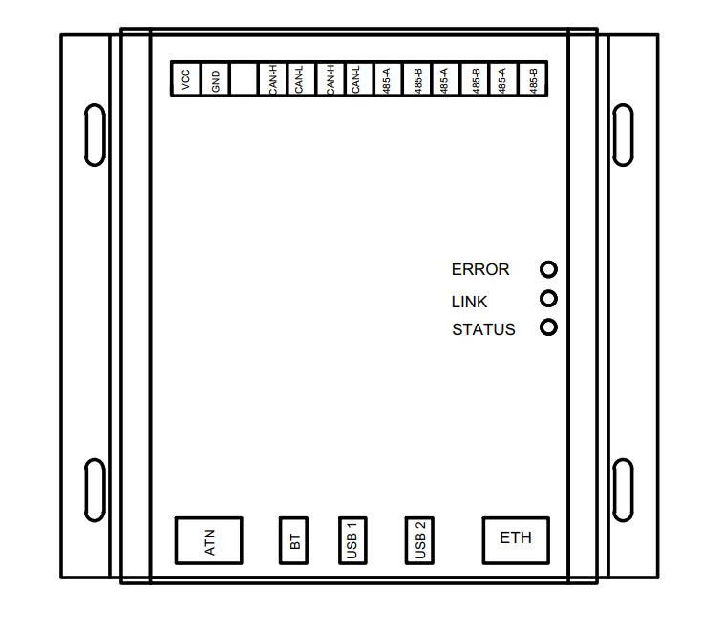

Modbus Register
Address | Size | Type | R/W | Units | Descriptions
10000 | 1 | Coil Register | R/W | bit | Output 0
10001 | 1 | Coil Register | R/W | bit | Output 1
10002 | 1 | Coil Register | R/W | bit | Output 2
10003 | 1 | Coil Register | R/W | bit | Output 3
10004 | 1 | Coil Register | R/W | bit | Output 4
10005 | 1 | Coil Register | R/W | bit | Output 5
10006 | 1 | Coil Register | R/W | bit | Output 6
10007 | 1 | Coil Register | R/W | bit | Output 7
10008 | 1 | Coil Register | R/W | bit | Reset counter 0
10009 | 1 | Coil Register | R/W | bit | Reset counter 1
10010 | 1 | Coil Register | R/W | bit | Reset counter 2
10011 | 1 | Coil Register | R/W | bit | Reset counter 3
10012 | 1 | Coil Register | R/W | bit | Reset counter 4
10013 | 1 | Coil Register | R/W | bit | Reset counter 5
10014 | 1 | Coil Register | R/W | bit | Reset counter 6
10015 | 1 | Coil Register | R/W | bit | Reset counter 7
20000 | 1 | Discrete Register | R | bit | Input 0
20001 | 1 | Discrete Register | R | bit | Input 1
20002 | 1 | Discrete Register | R | bit | Input 2
20003 | 1 | Discrete Register | R | bit | Input 3
20004 | 1 | Discrete Register | R | bit | Input 4
20005 | 1 | Discrete Register | R | bit | Input 5
20006 | 1 | Discrete Register | R | bit | Input 6
20007 | 1 | Discrete Register | R | bit | Input 7
30000 | 16 | Holding register | R/W | char | Device name
30016 | 16 | Holding register | R/W | Integer | DHCP Enable
30017 | 16 | Holding register | R/W | Integer | IP Address
30018 | 16 | Holding register | R/W | Integer | Subnet mash
30019 | 16 | Holding register | R/W | Integer | Default gateway
30020 | 16 | Holding register | R/W | Integer | MAC [0,1]
30021 | 16 | Holding register | R/W | Integer | MAC [2,3]
30022 | 16 | Holding register | R/W | Integer | MAC [4,5]
30023 | 16 | Holding register | R/W | char | MQTT HOST
30055 | 16 | Holding register | R/W | Integer | MQTT PORT
30087 | 16 | Holding register | R/W | Integer | User name
30119 | 16 | Holding register | R/W | Integer | Pass word
30151 | 16 | Holding register | R/W | Integer | Client ID
30152 | 16 | Holding register | R/W | Integer | Publish Times
30153 | 16 | Holding register | R/W | Integer | RS485-1 TCP PORT
30154 | 16 | Holding register | R/W | Integer | RS485-2 TCP PORT
30155 | 16 | Holding register | R/W | Integer | RS485-3 TCP PORT
30156 | 16 | Holding register | R/W | Integer | RS485-1 Baud rate
30157 | 16 | Holding register | R/W | Integer | RS485-2 Baud rate
30158 | 16 | Holding register | R/W | Integer | RS485-3 Baud rate
30159 | 16 | Holding register | R/W | Integer | CAN-1 Baud rate
30160 | 16 | Holding register | R/W | Integer | CAN-2 Baud rate
30161 | 16 | Holding register | R/W | Integer | Zigbee Point type
30162 | 16 | Holding register | R/W | Integer | Zigbee PAN ID
30163 | 16 | Holding register | R/W | Integer | Zigbee Channel
30164 | 16 | Holding register | R/W | Integer | Zigbee User Address
30165 | 16 | Holding register | R/W | Integer | Zigbee antenna selected
30166 | 16 | Holding register | R/W | Integer | Zigbee security
30167 | 16 | Holding register | R/W | Integer | Zigbee security code 0
30168 | 16 | Holding register | R/W | Integer | Zigbee security code 1
30169 | 16 | Holding register | R/W | Integer | Zigbee security code 2
30170 | 16 | Holding register | R/W | Integer | Zigbee security code 3
30171 | 16 | Holding register | R/W | Integer | Number of Zigbee IO device can connect
30172 | 16 | Holding register | R/W | Integer | Start address Zigbee IO device
40000 | 8 | Input register | R | string | Serial number
40016 | 16 | Input register | R | Integer | Counter 0
40017 | 16 | Input register | R | Integer | Counter 1
40018 | 16 | Input register | R | Integer | Counter 2
40019 | 16 | Input register | R | Integer | Counter 3
40020 | 16 | Input register | R | Integer | Timer 0 counter
40021 | 16 | Input register | R | Integer | Timer 1 counter
40022 | 16 | Input register | R | Integer | Timer 2 counter
40023 | 16 | Input register | R | Integer | Timer 3 counter

System requirements

- Windows® OS (XP, 7, 8 and 10), Linux® or MacOS™
- USB Type-A to Type-C cable
- USB Driver

Configuration software
- Software : X.LinkConfig

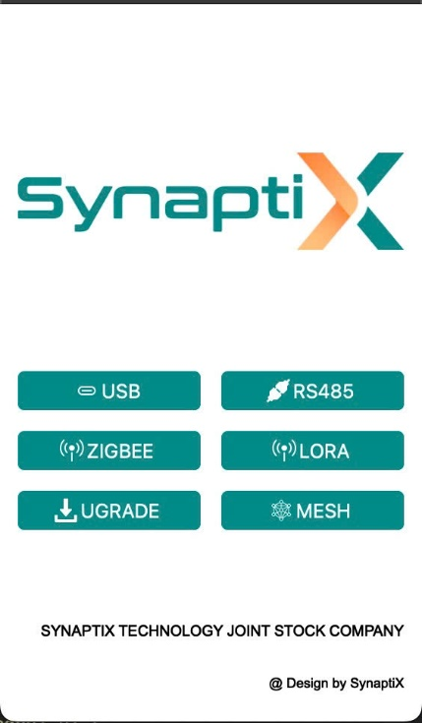
Main Selection Page

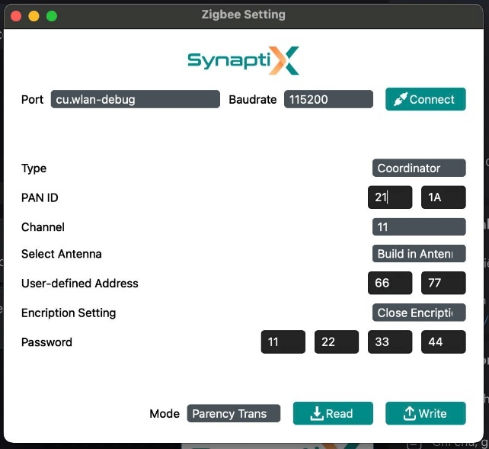
Zigbee Parameter Configuration Page

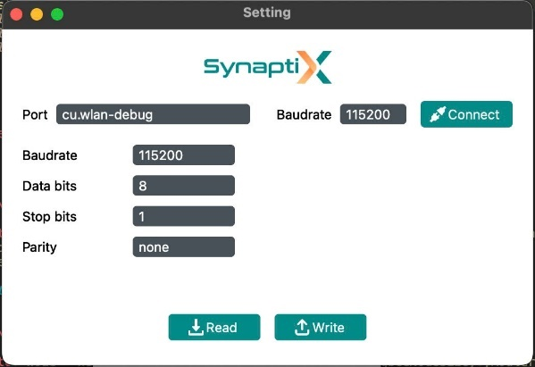
RS485 Configuration Page

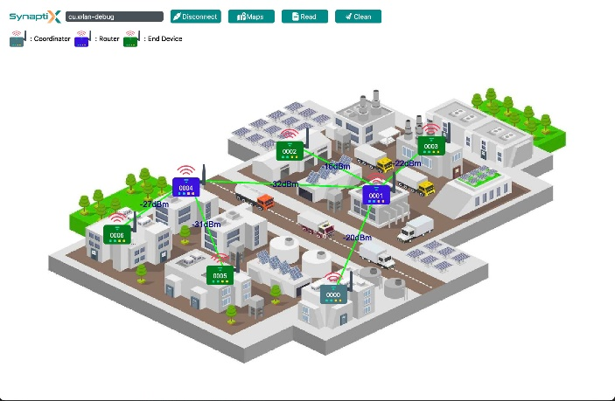
Checking Signal Device Page (Only using with Gateway)

Website Configuration Page
- Login Page
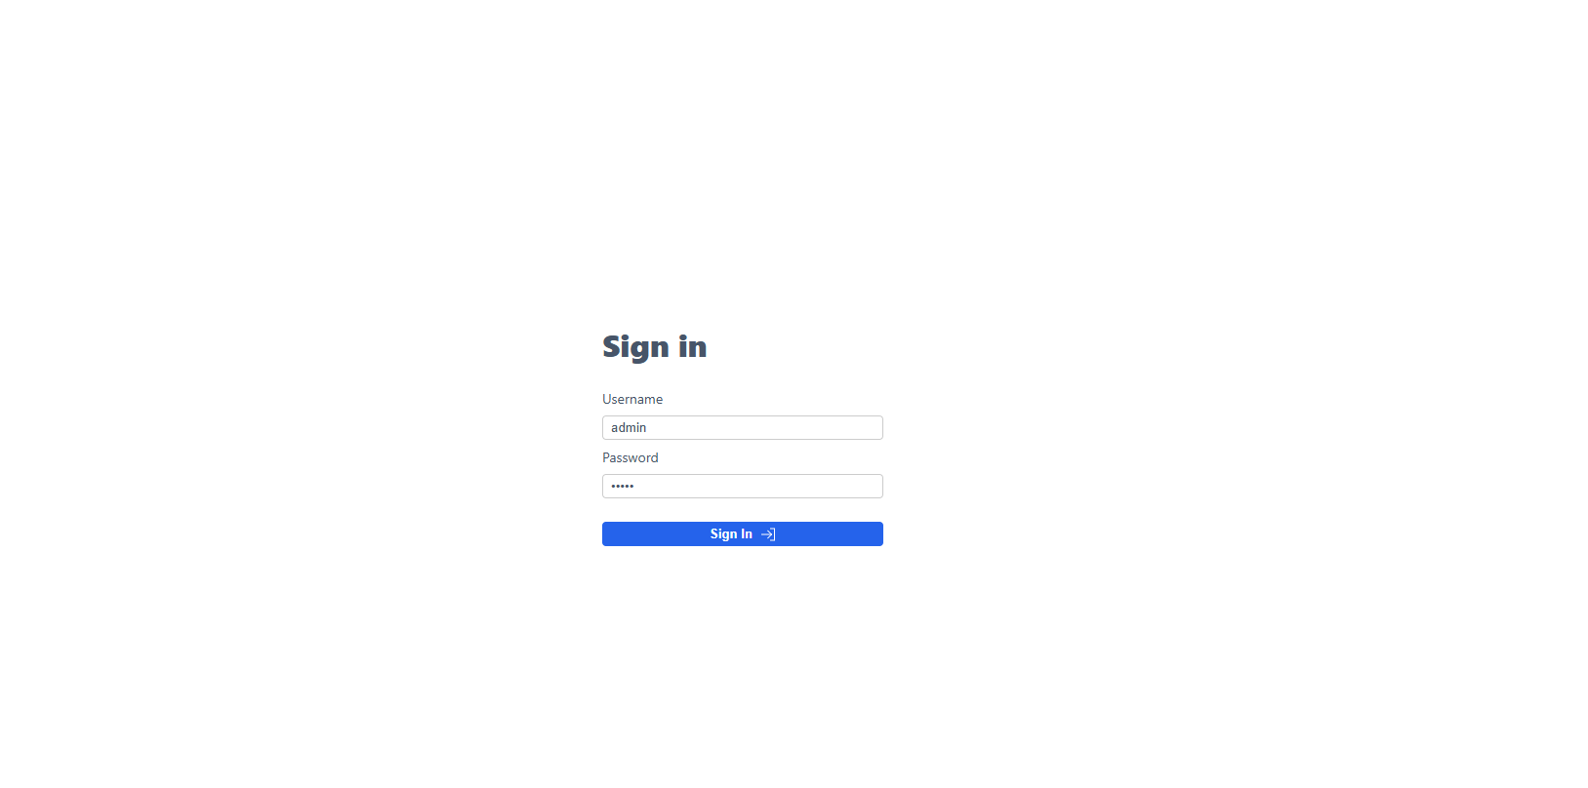
Default user : admin. Default password : admin
- Dashboard
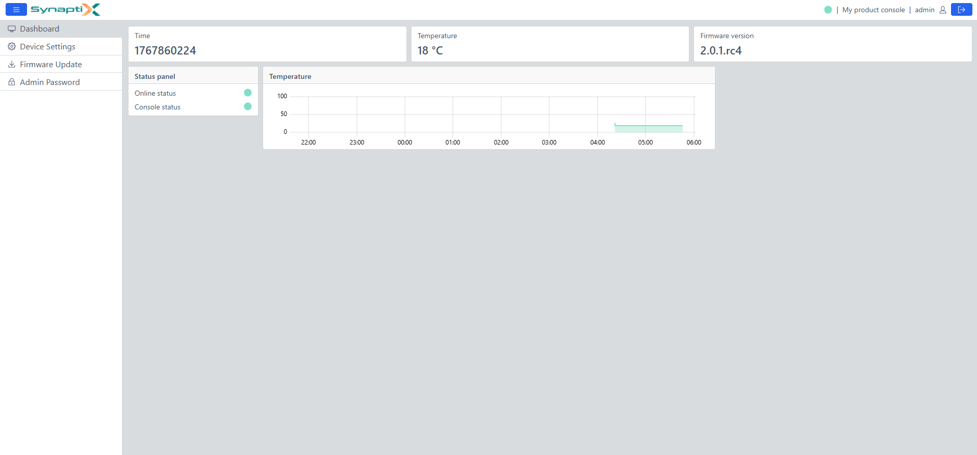
- Device Settings
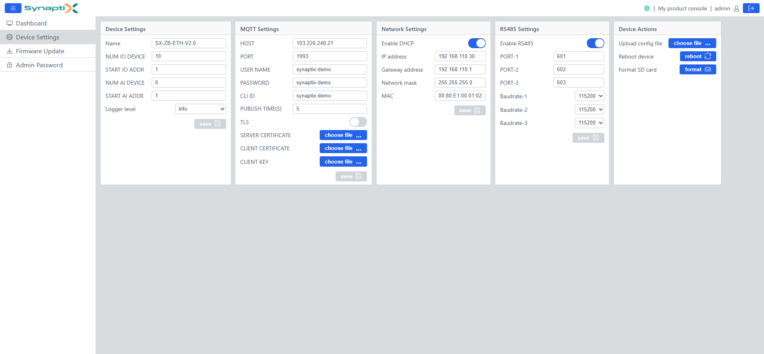
- Firmware Update
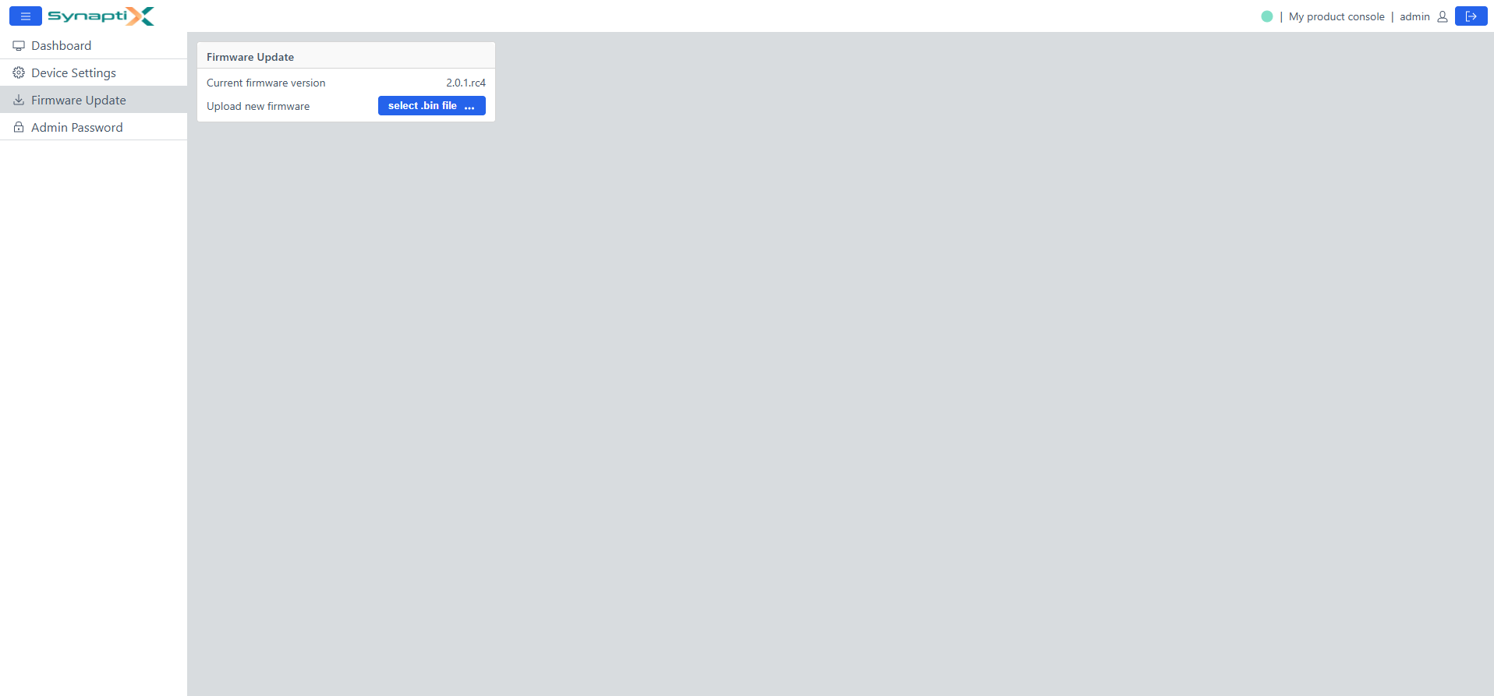

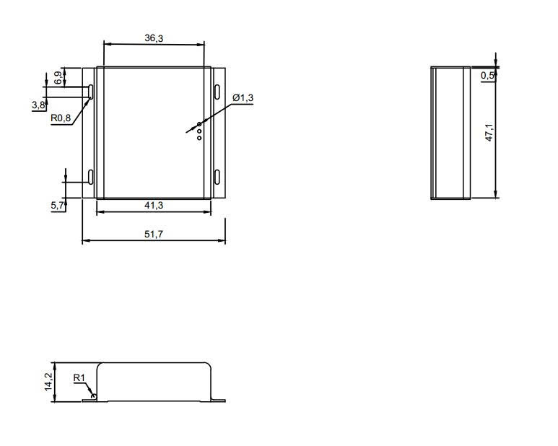
Dimension

Ordering information

Part number | RS-485 | RF type | Ethernet | USB
GW-ZB485 | 4 CH | Zigbee | 1 CH | 2 CH
GW-LR485 | 4 CH | LORA | 1 CH | 2 CH


Innovating Industrial IoT Solutions
_________________________________________________________________________
SYNAPTIX TECHNOLOGY JSC
Email : info@synaptix-io.com
Phone : +84-972141491
 Website : http://synaptix-io.com
Location : 2nd Floor, PZ4 Building, Vinhomes Smart city, Hanoi City

