
SYNAPTIX AUTOMATION SYSTEMS | INDUSTRIAL CONTROL DIVISION
SynaptiX IDE
Official Software User Manual & Engineering Reference
Industrial PLC Programming, Offline Simulation & Cloud IIoT Environment

Document Identification: | MAN-SPX-IDE-2026-V2.5 (Commercial Distribution)
Software Product & Version: | SynaptiX IDE v2.5.0 (Build Release 2026.10)
Target Controller Engine: | ARM Cortex-M33 Deterministic 10ms Scan Architecture
Applicable Standards: | IEC/IEEE 82079-1:2019, IEC 61131-3, SPLC-AF-003, IEC 60204-1
Classification / Distribution: | Official Commercial Release / Unrestricted for End Users
Date of Publication: | October 2026 — SynaptiX Systems Group

Document Control & Revision History
This document is maintained under strict engineering version control adhering to ISO 9001 and IEC/IEEE 82079-1:2019 principles. Any updates to the underlying software ABI, visual canvas layout, or communication schemas will be reflected in a corresponding manual revision.
Rev | Release Date | Author / Department | Approved By | Scope of Revision
v1.0.0 | Sep 2026 | SynaptiX Software Group | Engineering Director | Initial commercial draft; 4-stage logic canvas and basic tag management.
v2.0.0 | Oct 2026 | Industrial Systems Team | Lead Systems Architect | Added MQTT IIoT Gateway (PUB/SUB), IEC Timers/Counters, and 2-Phase Staged Deployment.
v2.5.0 | Oct 2026 | AI & Automation Group | VP of Engineering | Integrated Senior Industrial AI Copilot, Ghost Diff Preview, and Visual Ergonomics.
List of Figures
Figure ID | Figure Caption / Visual Description | Section
Figure 3.1 | SynaptiX IDE Application Anatomy and Primary Navigation Workspace | Section 3.1
Figure 4.1 | Unified 128-Tag Catalog — Signal Configuration, Engineering Units & Retain Memory | Section 4.1
Figure 5.1 | Visual 4-Stage Logic Editor Canvas with Orthogonal 90° Step Wiring | Section 5.1
Figure 6.1 | Industrial Automation Blueprints Gallery and 1-Click Instantiation | Section 6.1
Figure 8.1 | Hardware Connection, RTC Synchronization, and Two-Phase Staged Deployment Gate | Section 8.4
Figure 9.1 | Online Live Watch Telemetry Grid and Dynamic Sparkline Diagnostics | Section 9.1
[IMPORTANT] LEGAL NOTICE & SOFTWARE LICENSING
SynaptiX IDE is proprietary software protected under international copyright and industrial intellectual property treaties. Reproduction, reverse engineering, decompilation, or unauthorized dissemination of binary executables, byte-level ABI specifications, or technical documentation without explicit written consent from SynaptiX Automation Systems Group is strictly prohibited.

Table of Contents
This manual is structured into modular chapters allowing engineers and maintenance personnel to navigate directly to operational topics of interest.
Chapter & Title | Summary of Technical Contents
1. Introduction & Overview | Purpose, Target Audience, Safety Conventions, Key Capabilities
2. System Requirements & Installation | Hardware Specs, Portable Execution, USB CDC Setup, Auto-Updates
3. Workspace & User Interface Tour | Window Anatomy, Navigation Ribbon, Active Status Pills, Shortcuts
4. Tag Catalog & Memory Management | 128-Tag Architecture, DI/DO/AI Configuration, Retained Memory
5. Visual Logic Editor & Function Blocks | 4-Stage Pipeline, Orthogonal Wiring, IEC Timers/Counters, Rule Table
6. Industrial Automation Blueprints Library | 10 Factory Templates, 1-Click Instantiation, Pre-engineered Logic
7. Offline Simulation & Virtual Commissioning | Virtual I/O Test Bench, Step Cycle Execution, Event Trace Log
8. Hardware Connection & Two-Phase Staged Deployment | Modbus RTU over USB, SPLC-AF-003 Safety Staging, Atomic Commit
9. Live Watch & Online Diagnostics | Real-Time Telemetry Grid, Quality Badges, Sparklines, Tag Forcing
10. IIoT Gateway & MQTT Integration | Broker Setup, Outbound Telemetry PUB, Remote Ingestion SUB
11. Senior Industrial AI Copilot Integration | Consultative Q&A, FBD Logic Synthesis, Ghost Diff Preview
12. Troubleshooting & Operational Safety | Fault Diagnosis Table, Download Errors, IEC 60204-1 Mandates
13. Appendix & Industrial References | Glossary of Automation Terms, Technical Support Contacts

1. Introduction & Overview
1.1 Purpose of this Manual
This user manual provides comprehensive technical and operational instructions for SynaptiX IDE, the industrial-grade visual programming and engineering environment designed for micro-PLCs and edge automation controllers. This manual guides automation engineers, panel builders, and field maintenance technicians through every phase of the automation lifecycle: initial system configuration, signal conditioning, visual logic design, virtual commissioning, safe hardware deployment, and cloud IIoT connectivity.
1.2 Target Audience & Required Knowledge
This guide is prepared for technical personnel engaged in factory automation:
- Automation & Control Engineers: Designing machine automation routines, conveyor sequencing, and process interlocks.
- Electrical Technicians & Panel Builders: Commissioning 24VDC discrete sensors, 4–20mA/0–10V analog transmitters, and relay actuators.
- Plant Maintenance Staff: Monitoring online telemetry, diagnosing sensor faults, and performing tag overrides.
- System Integrators: Integrating edge PLC data into supervisory SCADA, MES, or cloud MQTT brokers.
Users are expected to have basic familiarity with electrical safety standards, relay ladder logic principles, and industrial field instrumentation.
1.3 Safety Symbols & Typographical Conventions
Safety notices conform to ANSI Z535 and ISO 3864 standards to emphasize critical procedures:
[DANGER] HIGH VOLTAGE & ELECTROCUTION RISK
Indicates an imminently hazardous electrical condition which, if not avoided, will result in death, severe personal injury, or permanent machine destruction. De-energize all high-voltage power supplies before servicing I/O terminals.

[WARNING] UNINTENDED MACHINE MOVEMENT
Indicates a condition where improper logic programming, forced tag overrides, or accidental actuator energization could cause unexpected robotic or mechanical movement. Ensure all personnel are clear before enabling outputs.

[IMPORTANT] DETERMINISTIC SCAN CYCLE INTEGRITY
Specifies essential timing, memory constraints, and deployment procedures required to guarantee deterministic 10ms controller execution.

[NOTE] PRACTICAL ENGINEERING RECOMMENDATION
Highlights engineering tips, keyboard shortcuts, and performance optimizations to streamline system configuration.

1.4 Key Product Capabilities
SynaptiX IDE combines visual low-code simplicity with deterministic bare-metal microcontroller execution:
- Visual 4-Stage Logic Pipeline: Rules are structured into Input Tag ➔ Trigger Condition ➔ Guard Interlock ➔ Output Action, eliminating confusing tangled wiring.
- Live Rule Compilation: Analyzes node graph topologies continuously in real-time, detecting syntax errors without requiring manual compile passes.
- Two-Phase Safe Staged Deployment: Enforces SPLC-AF-003 safety protocol. Logic uploads into an isolated staging buffer, undergoes CRC-16 integrity validation, and switches pointers in <10 µs via atomic token (0xA5A5).
- Integrated Real-Time Simulator: Fully interactive offline virtual test bench with digital toggles, analog sliders, and 10ms execution step logs.
- Industrial IoT & Cloud Gateway: Native MQTT v3.1.1/v5.0 client supporting Periodic, COV, and Event telemetry publishing, plus remote command ingestion.
- Industrial AI Copilot: Embedded generative engineering assistant providing consultative Q&A, FBD synthesis, and Ghost Diff preview.

2. System Requirements & Installation
2.1 Hardware & Operating System Requirements
SynaptiX IDE is engineered for ultra-low host resource utilization. It runs reliably on modern engineering laptops and ruggedized industrial panel PCs:
System Component | Specification Requirements
Operating System | Microsoft Windows 10 (64-bit, Version 19041+) or Windows 11 (64-bit)
Processor (CPU) | Intel Core i3 / AMD Ryzen 3 or higher (Dual-Core, 2.0 GHz minimum)
System Memory (RAM) | 512 MB minimum (1 GB recommended for large node graphs)
Storage Footprint | 150 MB free disk space (Self-contained single executable)
Display Resolution | 1280 × 720 minimum (1920 × 1080 Full HD recommended)
Communication Port | 1x Physical USB 2.0 / 3.0 Type-A or Type-C port (or USB-to-RS485 adapter)
Runtime Dependencies | None (All .NET 8.0 WPF desktop runtime components are statically bundled)
2.2 Installing and Launching SynaptiX IDE
SynaptiX IDE is delivered as a Portable Single-File Executable (`SimplePLC.Studio.exe`). It requires no installer, no administrative privileges, and leaves zero footprint in the Windows Registry:
- Step 1: Download the latest official executable package from your corporate releases portal.
- Step 2: Copy SimplePLC.Studio.exe to a permanent engineering folder (e.g., C:\SynaptiX\ or a maintenance USB flash drive).
- Step 3: Double-click SimplePLC.Studio.exe. The application launches within 2 seconds into the main workspace.
2.3 USB Interface & COM Port Preparation
The target industrial controller connects to the engineering workstation via USB acting as a standard Virtual COM Port (USB CDC):
- 1. Physical Connection: Connect the controller to the PC using an industrial shielded USB Type-C cable.
- 2. Driver Verification: Windows automatically binds the standard usbser.sys driver. Open Device Manager ➔ Ports (COM & LPT) to confirm the assigned port number (e.g., COM4).
- 3. Port Exclusivity: Ensure no third-party serial monitors or terminals (e.g., PuTTY, Arduino Serial Monitor) hold an active lock on the port.
2.4 Automatic Updates & Version Maintenance
SynaptiX IDE includes an automated release check mechanism. When connected to the internet, it queries the GitHub Releases API for new updates. If a newer production build is available, an Update Dialog provides a Markdown changelog and a 1-click upgrade button that hot-swaps the running executable without losing your active project configuration.

3. Workspace & User Interface Tour
3.1 Main Window Anatomy
The user interface adheres to ergonomic industrial automation standards, maximizing canvas area while keeping diagnostics, tags, and status visible at all times:

Figure 3.1: SynaptiX IDE Application Anatomy and Primary Navigation Workspace
3.2 Ribbon & Primary Navigation Bar
The top ribbon provides direct tab navigation between core workspaces:
- Logic Editor: The primary graphical canvas where control logic is created, wired, and compiled.
- Tag Catalog: The spreadsheet-style configuration editor for all 128 physical and virtual tags.
- Rule Table: Side-by-side view showing human-readable logic rules and compiled rule parameters.
- Blueprints: Pre-engineered factory automation templates (E-Stop, Motor Starters, OEE Counters).
- Simulator: Interactive offline test bench with toggle switches, analog potentiometers, and event logs.
- Deploy: Hardware connection management, RTC time synchronization, and two-phase download gate.
- Live Watch: Online telemetry grid, signal trend sparklines, and manual tag force overrides.
3.3 Active Context Status Pills & Header Indicators
The header bar hosts high-contrast context status pills showing system health:
- COM Port Pill: Displays connected COM port and baud rate. Turns bright green when synchronized, amber during handshake, gray when disconnected.
- Scan Cycle Pill: Shows the active scan frequency of the physical microcontroller (typically 10.0 ms / 100 Hz).
- AST Compiler Pill: Indicates live grammar state. Valid (Green) confirms clean compilation; Syntax Error (Red) pinpoints unlinked required pins.
- Rule Utilization Pill: Displays rule memory occupancy (e.g., 14 / 100 Rules Allocated).
3.4 Working with Project Files (.synx)
SynaptiX IDE stores entire engineering configurations inside a single portable `.synx` project file:
- New Project (Ctrl + N): Create a blank project with default I/O tag definitions.
- Open Project (Ctrl + O): Load an existing plant configuration file.
- Save Project (Ctrl + S): Serializes all tags, canvas coordinates, wires, and MQTT settings into XML/JSON format.
3.5 Keyboard Shortcuts Quick Reference
Keyboard Shortcut | Scope | Assigned Operation
Ctrl + N | Global | Create a New Project
Ctrl + O | Global | Open Existing Project File (.synx)
Ctrl + S | Global | Save Active Project Configuration
Ctrl + Z | Canvas | Undo last node placement, wiring, or parameter change
Ctrl + Y | Canvas | Redo previously undone operation
Delete / Backspace | Canvas | Delete selected node, wire, or comment box
F5 | Global | Launch Offline Simulation Mode
F6 | Global | Stop Simulation / Return to Design Canvas
F7 | Deploy | Open Two-Phase Staged Download Dialog
F9 | Live Watch | Toggle Online Live Watch Telemetry Mode
Ctrl + Space | Sidebar | Focus AI Copilot Chat Prompt Input
Space + Drag | Canvas | Pan canvas view smoothly in any direction
Mouse Wheel | Canvas | Zoom in / Zoom out of node canvas

4. Tag Catalog & Memory Management
4.1 The Unified 128-Tag Architecture
In SynaptiX IDE, all input terminals, output drivers, internal flags, and calculation registers are addressed through a Unified 128-Tag Architecture. This standardized structure eliminates memory fragmentation and ensures immediate reference across canvas nodes, MQTT payloads, and live watch tables.
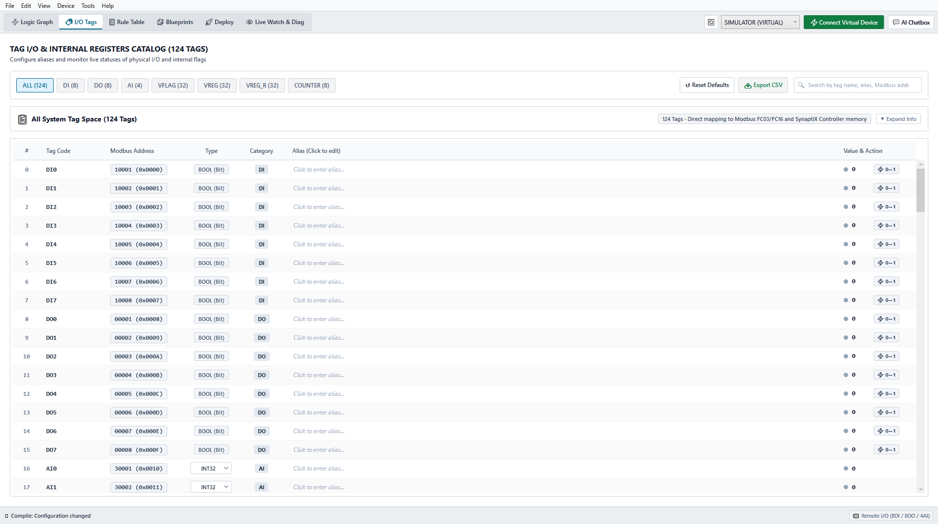
Figure 4.1: Unified 128-Tag Catalog — Signal Configuration, Engineering Units & Retain Memory
4.2 Tag Types & Operational Ranges
Tag Address | Group Name | Data Type | Hardware Location | Retention Behavior
DI0 – DI7 | 8x Digital Inputs | Boolean (0 or 1) | 24VDC Optocoupled Terminals | Volatile (Live sampled every 10ms)
DO0 – DO7 | 8x Digital Outputs | Boolean (0 or 1) | 24VDC Relay / Transistor Driver | Volatile (Driven every 10ms cycle)
AI0 – AI3 | 4x Analog Inputs | 16-bit Int (0–4095) | 12-bit ADC (4–20mA / 0–10V) | Volatile (Live sampled every 10ms)
VFLAG0 – 15 | 16x Virtual Flags | Boolean (0 or 1) | Controller RAM Bitfield | Volatile (Reset on power down)
VREG0 – 15 | 16x Volatile Registers | 16-bit Signed Int | Controller RAM Words | Volatile (Reset on power down)
VREG_R0 – 15 | 16x Retained Registers | 16-bit Signed Int | Non-Volatile Internal Flash | Persistent (Retained through power cuts)
4.3 Configuring Digital Inputs (DI) & Outputs (DO)
To configure a discrete terminal:
- 1. Tag Name: Enter a clear identifier (e.g., PB_START, SENSOR_PART_DETECT, SOLENOID_EJECT).
- 2. Hardware Dwell Filter: Specify software debounce in milliseconds (typically 20ms to 50ms for pushbuttons to filter contact chatter; 0ms to 5ms for PNP optical sensors).
- 3. Comments & Description: Add wire numbers and terminal block references for electrical panel traceability.
4.4 Analog Input (AI) Calibration: Scaling & Clamping
Raw analog input channels provide 12-bit resolution (0 to 4095 counts). SynaptiX IDE performs native linear conversion into real-world engineering units:
Linear Formula: Scaled Value = (Raw Counts × Gain) + Offset
- Gain Parameter: Set to 0.024414 (calculated as 100.0 / 4095) to convert 0–4095 counts to 0.0–100.0 Bar.
- Offset Parameter: Calibrates sensor zero-point drift (e.g., 4mA offset calibration).
- Clamping Bounds: Enabling clamping restricts output values strictly between configured Min and Max limits, preventing wild calculation spikes if sensor wiring is damaged.
4.5 Power-Loss Retained Registers (VREG_RETAIN)
Data that must survive a complete power outage must be mapped to `VREG_R0` through `VREG_R15`. The controller runtime writes changes into internal non-volatile flash utilizing wear-leveling algorithms (>100,000 cycles). Typical applications include total piece counters, shift accumulators, machine runtime hours, and operator recipe settings.

5. Visual Logic Editor & Function Block Programming
5.1 Visual Canvas Mechanics & Navigation
The Logic Editor offers an intuitive visual programming canvas that completely avoids tangled wire clutter:
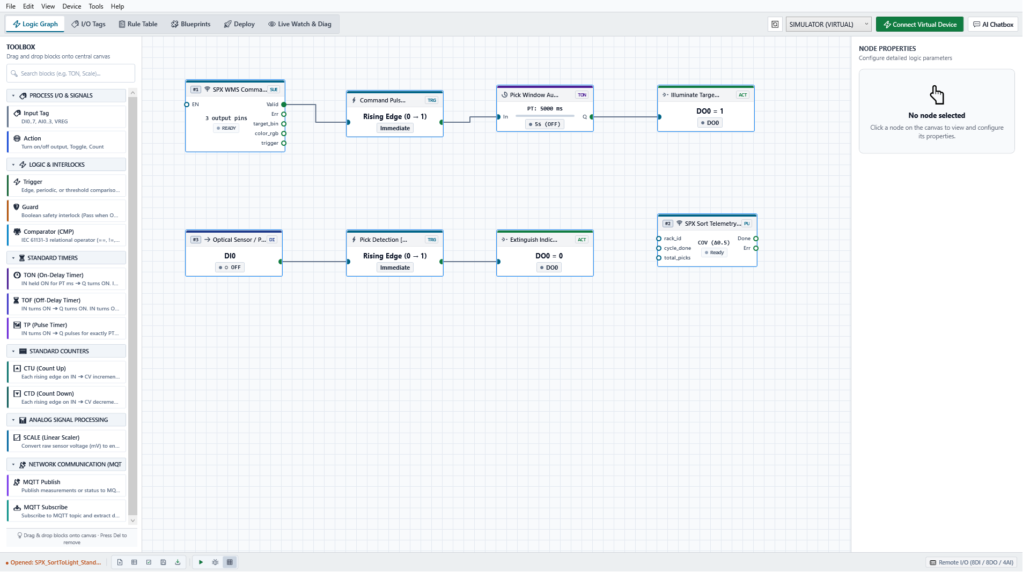
Figure 5.1: Visual 4-Stage Logic Editor Canvas with Orthogonal 90° Step Wiring
5.2 The 4-Stage Logic Pipeline Architecture
To enforce deterministic, structured automation logic, every rule in SynaptiX IDE progresses through 4 distinct stages:
- Stage 1 (Input Tag): Designates the source signal (Physical DI, AI, Virtual Flag, or Internal Register).
- Stage 2 (Trigger Condition): Defines the triggering event: Rising Edge (0➔1), Falling Edge (1➔0), Level True/False, or Numeric Compare (>, <, ==).
- Stage 3 (Guard Interlock): Mandatory safety interlock. The action will execute ONLY if the guard condition is TRUE (e.g., E_STOP_OK == 1 AND DOOR_CLOSED == 1).
- Stage 4 (Action): The resulting command executed on the target: SET (Latch ON), RST (Reset OFF), OUT (Direct Follow), or TGL (Toggle).
5.3 Placing and Connecting Nodes (Orthogonal 90° Step Wiring)
All wire connections use clean orthogonal right-angle routing (`StepConnection`). When input and output pins are vertically aligned, wires form perfectly straight horizontal rungs. Wires highlight in vibrant cyan on mouse hover and can be selected and deleted with a single keystroke.
5.4 Dedicated IEC 61131-3 Function Blocks
SynaptiX IDE includes dedicated, hardware-timed IEC Function Blocks:
- On-Delay Timer (TON): Delays energizing output Q until input IN remains TRUE for preset duration PT. Ideal for motor pre-lube or conveyor debounce.
- Off-Delay Timer (TOF): Maintains output Q energized for duration PT after input IN transitions to FALSE. Ideal for cooling fan post-run cycles.
- Pulse Timer (TP): Generates a fixed-duration pulse on output Q upon input rising edge, regardless of input hold duration. Ideal for lube or ejector solenoids.
- Up-Counter (CTU) & Down-Counter (CTD): Counts pulse edges up to preset PV. Can be bound directly to Retained Registers (VREG_R) for permanent production tallying.
- Linear Analog Scaler (SCALE): Scales dynamic analog values via hardware coefficients with signal clamping.
5.5 Dual-View Rule Table & Real-Time Rule Compilation
Switch to the Rule Table tab to inspect an automatically generated, human-readable narrative of all active rules alongside compiled parameters. Changes made on the canvas reflect instantly in the rule table in real-time.

6. Industrial Automation Blueprints Library
6.1 Overview of Pre-Engineered Blueprints
The Blueprints gallery contains factory-tested, standard-compliant logic templates for common machine automation scenarios:
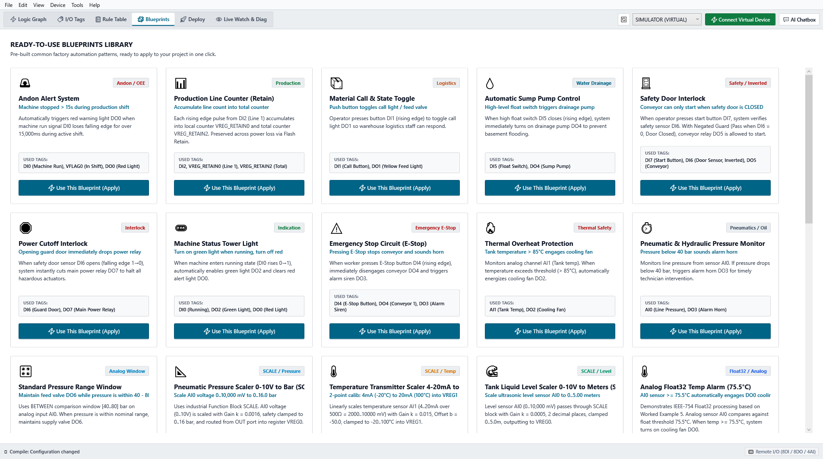
Figure 6.1: Industrial Automation Blueprints Gallery and 1-Click Instantiation
6.2 1-Click Instantiation & Automatic Tag Assignment
Clicking **Instantiate Blueprint** automatically allocates all necessary tags in the Tag Catalog, drops fully wired logic nodes onto the canvas, and generates descriptive documentation notes with zero manual configuration.
6.3 Standard Blueprint Profiles Catalog
Blueprint Name | Operational Rationale | Pre-Allocated I/O & Logic
E-Stop Safety Circuit | Meets basic machine safety; requires manual reset after emergency release. | DI0 (E-Stop NC), DI1 (Reset PB), DO0 (Master Contactor)
Motor Thermal Overheat | Trips motor contactor if overload contact opens or temperature exceeds limit. | DI2 (Thermal Relay), DO0 (Contactor), DO1 (Alarm Lamp)
High-Speed Part Counter | Optical sensor pulse counter bound to persistent flash memory. | DI3 (Sensor), CTU Block, VREG_R0 (Retained Total)
Andon OEE Tower Light | Drives Red/Amber/Green indicators for Machine Running, Idle, or Fault. | VFLAG0 (Run), VFLAG1 (Fault), DO2..DO4 (Tower Lamps)
Pneumatic Pressure Guard | Monitors line pressure; triggers dump valve and alarm if limits breached. | AI0 (Transmitter), DO5 (Dump Valve), VFLAG2 (Alarm)
Sump Pump Control | Dual float switch (Low/High level) hysteresis pump latching. | DI4 (Low Float), DI5 (High Float), DO6 (Pump Starter)
Periodic Lubrication | Fires lubrication solenoid for 5 seconds every 60 minutes of runtime. | TON Timer, TP Pulse Timer, DO7 (Lube Solenoid)

7. Offline Simulation & Virtual I/O Commissioning
7.1 Entering Offline Simulation Mode
Press `F5` or click **Simulator** in the navigation ribbon to enter virtual commissioning. The visual canvas transitions into high-contrast simulation styling, highlighting active wires with vivid animated data flow.
7.2 Virtual I/O Board Controls (Toggles, Sliders & Status LEDs)
The simulation interface provides an interactive hardware test bench:
- Digital Input Toggles (DI): Click to toggle inputs between 0 (0VDC) and 1 (24VDC) to simulate pushbuttons and limit switches.
- Analog Input Sliders (AI): Drag sliders to inject raw or scaled values to test analog thresholds and scaling.
- Digital Output Indicators (DO): Bright green visual LEDs illuminate whenever logic energizes physical relay coils.
7.3 Real-Time Event Trace Log & Time-Step Execution
Pause continuous simulation and click **Step Cycle (+10ms)** to execute the logic one deterministic 10ms scan cycle at a time. The Event Trace Log records edge transitions, timer ticks, and output actuations with high-precision timestamps for rigorous verification.

8. Hardware Connection & Two-Phase Staged Deployment
8.1 Connecting to the Physical Controller
Navigate to the **Deploy** view. Select your active serial COM port from the dropdown menu, select the baud rate (default: `115200 bps`), and click **Connect**. Once synchronized, the controller's hardware profile and status pills illuminate green.
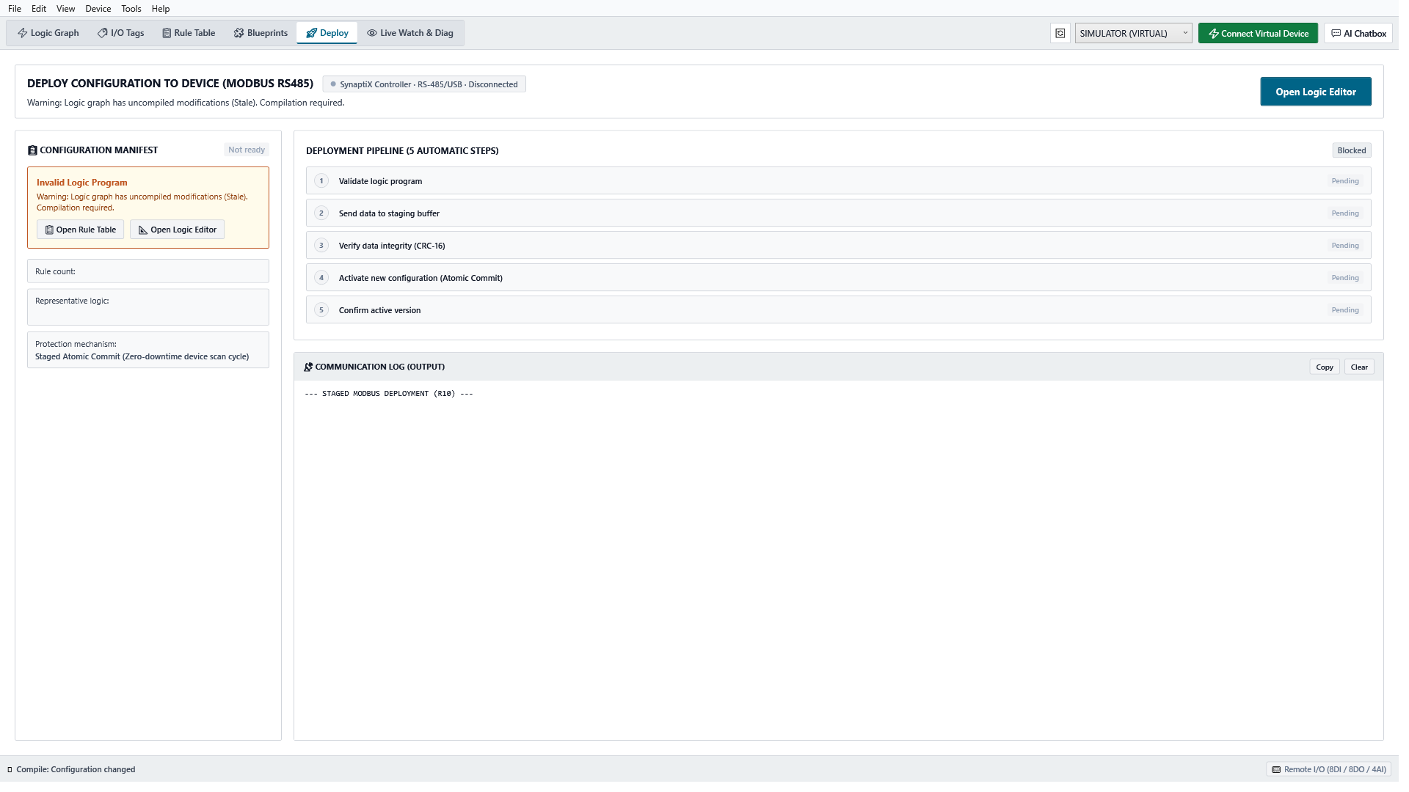
Figure 8.1: Hardware Connection, RTC Synchronization, and Two-Phase Staged Deployment Gate
8.2 Hardware Conformance & Device Information Inspection
Click **Device Info** to inspect hardware parameters: microcontroller CPU type (ARM Cortex-M33), firmware ABI version, physical channel counts (8 DI, 8 DO, 4 AI), and non-volatile flash wear statistics.
8.3 Real-Time Clock (RTC) Synchronization
Click **Sync RTC** to synchronize the controller's onboard battery-backed hardware clock with the engineering workstation's exact UTC time, guaranteeing synchronized event logging and alarm timestamps.
8.4 Two-Phase Safe Staged Deployment Procedure (SPLC-AF-003)
To eliminate catastrophic risks associated with half-written programs or intermediate machine flutter, SynaptiX IDE strictly adheres to standard **SPLC-AF-003**:
- Step 1 (AST Pre-Check): The IDE validates the entire canvas AST for syntactic correctness before initiating transfer.
- Step 2 (Phase 1 Staging): The IDE uploads all rule records into the controller's isolated scratchpad RAM buffer. The active machine continues running its previous program undisturbed.
- Step 3 (CRC-16 Verification): The controller calculates a CRC-16 checksum over the received staging buffer and returns it to the IDE. The IDE verifies this against its calculated checksum.
- Step 4 (Phase 2 Atomic Commit): Upon checksum confirmation, the engineer clicks Commit Changes. The IDE transmits the atomic activation code (0xA5A5). The controller swaps execution pointers in <10 µs at scan boundary, seamlessly activating the new logic.

9. Live Watch & Online Diagnostics
9.1 Activating Live Watch Mode
Press `F9` or click **Live Watch** in the ribbon to initiate online diagnostics. The IDE establishes continuous telemetry polling over the active serial or USB link.
Figure 9.1: Online Live Watch Telemetry Grid and Dynamic Sparkline Diagnostics
9.2 Telemetry Grid & Data Quality Status Badges
The Live Watch grid displays all active tags accompanied by real-time Quality Badges:
- GOOD (Green): Telemetry packet received and verified within expected scan interval (<50ms).
- STALE (Amber): Packet delayed or dropped; retaining last verified valid measurement.
- BAD / DISCONNECTED (Red): Communication link lost or sensor circuit break detected.
9.3 Real-Time Sparkline Trend Graphs
Click any analog channel (`AI0`–`AI3`) or register in the grid to display an inline **Sparkline Trend Graph** visualizing signal fluctuations over the past 60 seconds, enabling immediate identification of electrical noise or mechanical vibration.
9.4 Forcing Tags & Manual Output Overrides
[WARNING] MANUAL TAG FORCING HAZARD
Forcing a digital output or flag bypasses all canvas logic guards, permissive interlocks, and software safety routines. Always verify that all maintenance personnel are clear of mechanical moving parts before activating a force override.

To force a tag during plant servicing: click the Lock icon next to the target tag, choose FORCE ON, FORCE OFF, or enter a numeric value, and confirm. An amber `[FORCED]` badge illuminates. Click **Release Force** to return control to automatic logic.

10. IIoT Gateway & MQTT Integration
10.1 MQTT IIoT Architecture Overview
SynaptiX IDE embeds a complete Industrial Internet of Things gateway supporting MQTT v3.1.1 and v5.0 over standard TCP (`1883`) and encrypted TLS/MQTTS (`8883`). The gateway facilitates bidirectional communication between shop-floor micro-PLCs and enterprise cloud infrastructure (AWS IoT, EMQX, HiveMQ, Azure IoT Hub).
10.2 Configuring the System MQTT Broker
In the MQTT Configuration dialog:
- 1. Broker Host: Specify broker IP address or domain name (e.g., mqtt.plantfloor.local).
- 2. Port: Use 1883 for internal isolated LANs; use 8883 for encrypted TLS connections.
- 3. Client ID: Assign a unique device identifier or click Generate Unique GUID.
- 4. Authentication: Provide standard credentials if broker authentication is enforced.
- 5. Connection Test: Click Test Broker Connection to verify the TCP/TLS socket handshake.
10.3 Setting Up Telemetry Publishing (MQTT PUB)
To transmit real-time telemetry outward to supervisory dashboards:
- Publish Trigger Modes: Periodic (fixed interval, e.g., 1000ms), Change of Value (COV, transmits when reading shifts beyond deadband), or Event Triggered (transmits immediately when an alarm flag trips).
- Payload Formatting: Standard flat JSON format or customized enterprise JSON templates with dynamic tag tokens.
10.4 Setting Up Remote Ingestion & Control (MQTT SUB)
To receive cloud dispatch commands, recipe setpoints, or remote start/stop requests:
- Topic Binding: Subscribe to the target MQTT topic (e.g., factory/line1/cell04/commands).
- Atomic All-or-Nothing Parser: If incoming JSON packets are malformed or missing expected fields, the parser safely rejects the payload without applying corrupt partial updates.
- Canvas FBD SUB Pin: Drop an MQTT_SUB input node onto the logic canvas to route cloud commands through local hardware safety interlocks before energizing actuators.

11. Industrial AI Copilot Integration
11.1 Accessing the AI Assistant Panel
Click the **AI Copilot** tab on the right sidebar or press `Ctrl + Space` to expand the AI engineering assistant. The assistant continuously monitors canvas state and compiler diagnostics, offering contextual suggestion chips tailored to your active task.
11.2 Consultative Engineering Q&A Mode
The AI Copilot acts as a Senior Automation Specialist conversant in international standards:
- Standards Consultation: Ask questions regarding IEC 60204-1 safety circuit architecture, fail-safe wiring, and 4–20mA loop impedance formulas.
- Technical Clarifications: Receive clear explanations of timer and counter behavior with timing diagrams rendered directly in rich markdown.
11.3 Natural Language FBD Logic Synthesis
Engineers can describe complex automation logic in plain language:
Example Prompt: "Create a conveyor sorting circuit using DI0 for carton photo-eye, TON timer with 1500ms delay, and DO0 to trigger pneumatic pusher. Guard with DI1 safety curtain."
The AI parses the prompt, resolves required tags, and synthesizes a complete 4-stage logic graph.
11.4 Ghost Diff Canvas Preview & Human Affirmation Gate
To prevent unverified modifications to production logic, AI proposals are never applied directly to the canvas:
- Ghost Diff Preview: Synthesized nodes appear in translucent slate gray with dashed wire connections. Ghost connectors are hit-test isolated to prevent accidental wiring.
- Human Affirmation Gate: A floating bar prompts the engineer to Accept Proposal (atomically commits nodes and creates an undo snapshot Ctrl+Z) or Reject Proposal (cleanly discards all ghost elements, leaving the canvas untouched).

12. Troubleshooting & Operational Safety
12.1 Common Operational Faults and Solutions
Observed Symptom | Probable Root Cause | Recommended Corrective Action
COM Port Not Detected | USB cable disconnected or driver not initialized. | Verify physical cable; check Device Manager for USB Serial Device.
COM Port Access Denied | Port locked by another serial utility or terminal. | Close PuTTY, Arduino IDE, or background serial monitoring tools.
AST Syntax Error (Red Pill) | Unconnected node input pin or circular wire loop. | Locate red error badge on canvas; connect all mandatory input pins.
Output Fails to Energize | Guard condition FALSE or output is forced OFF. | Check Live Watch; ensure all series permissive guards evaluate to TRUE.
Analog Value Unstable | Electrical noise or unshielded sensor cable. | Use shielded twisted-pair cables; increase Hardware Dwell debounce.
Retained Tag Clears on Boot | Tag was assigned to VREG instead of VREG_R. | Reallocate tag to VREG_R0..15 in Tag Catalog and re-deploy.
12.2 Communication & Download Error Diagnostics
- CRC-16 Mismatch Alert: Indicates transmission line noise during download. The controller rejects the staging buffer automatically. Check USB cable shielding.
- Write Conflict Invariant: Occurs if two independent rules attempt to write contradictory states to the same physical DO output in the same scan cycle. Consolidate logic through an OR gate.
12.3 Industrial Safety Best Practices (IEC 60204-1)
[DANGER] HARDWIRED SAFETY CIRCUIT MANDATE (IEC 60204-1)
Under international standard IEC 60204-1, software-based controllers must NEVER be used as the sole safety mechanism for Emergency Stop functions or Personnel Protection Guards. Always wire Emergency Stop buttons through certified electromechanical safety relays that physically cut actuator coil power independently of software.

13. Appendix & Reference Information
13.1 Glossary of Terms
Automation Term | Technical Definition
ABI (Application Binary Interface) | The fixed 32-byte binary record structure executed directly by the controller runtime without a virtual machine.
AST (Abstract Syntax Tree) | The real-time in-memory graph representation of nodes and wires used by the continuous compiler.
Atomic Commit | An instantaneous pointer swap (<10 µs) executed at scan cycle boundary to switch logic programs without actuator glitching.
COV (Change of Value) | An MQTT publishing protocol where telemetry is transmitted only when measurements deviate beyond a deadband.
Dwell Time | Software or hardware debounce duration applied to digital inputs to filter out mechanical contact chatter.
FBD (Function Block Diagram) | Graphical programming standard defined under IEC 61131-3 where logic functions are represented as interconnected blocks.
Scan Cycle | The deterministic 10ms loop executed continuously by the controller: Read Inputs ➔ Evaluate Rules ➔ Drive Outputs.
13.2 Technical Support & Product Resources
For technical assistance, firmware conformance validation, or enterprise support licensing:
- Official Distribution Portal: https://github.com/hoanv-synaptix/SynaptiX-IDE-Releases
- Bug Reports & Feature Requests: Submit technical inquiries via the GitHub Release repository issue tracker.
- Commercial Support Division: SynaptiX Industrial Automation Systems Group.

