SPLC-DIAG-001 — SimplePLC Design Diagrams
Diagram pack for C# implementation review: system, Core, compiler, runtime, deploy and monitor
Document ID | Version | Status | Scope | Audience
SPLC-DIAG-001 | 0.2 | Draft for Review | SimplePLC Studio + MCU integration | C# developer + firmware lead

How to use this file
Use this diagram pack together with the algorithm-flow document. The flowchart answers “what happens next?”; this file answers “which module/class owns this responsibility?”

Notation and embedded-friendly terms
Diagram term | Meaning | Embedded-friendly equivalent | Use in this project
Component | Functional block/module | Module | App/Core/Infrastructure split
Interface | Behavior contract | Driver/API contract | Mockable service boundary
Class | C# object type | Module/struct concept | State + operations owner
Sequence | Call order between objects | Call flow | Compile/deploy collaboration
State machine | States and transitions | FSM | Device/simulator/deploy lifecycle
Validator | Configuration checker | validate_config() | Catch invalid graph/rules early
Encoder | Pack logical data to bytes | pack/serialize | Rule[] to 28-byte records
Runtime state | Mutable execution data | Runtime buffer/state | prev_value, dwell, last_fire

Diagram index
ID | Diagram | Primary owner | Coding use
D00 | System Context | System boundary | Confirms what belongs to PC Tool vs MCU vs SCADA.
D01 | C# Solution Components | Project/module dependency | Guides Visual Studio solution references.
D02 | Core Pipeline | Core execution pipeline | Guides coding order for Core.
D03 | Graph Domain Class Diagram | Graph editor domain model | Guides LogicGraph implementation.
D04 | Compiler Class Diagram | Graph to Rule pipeline | Guides compiler skeleton and unit tests.
D05 | Runtime & Simulator Class Diagram | Simulator/runtime ownership | Guides RuntimeEngine and SimulatorEngine.
D06 | Infrastructure & Deploy Components | Deployment boundary | Keeps deploy separate from compiler.
D07 | Compile Sequence | Compile call flow | Guides CompileCommand implementation.
D08 | Deploy Sequence | Deployment call flow | Guides progress stages and failure handling.
D09 | Monitor Data Flow | Runtime source abstraction | Guides IRuntimeDataSource and Monitor VM.
D10 | State Machines | State transitions | Guides enums and transition handling.

D00 — System Context
Purpose | How to read | Development impact
System boundary | PC Tool, MCU, machine I/O and SCADA/HMI boundaries. | Confirms what belongs to PC Tool vs MCU vs SCADA.
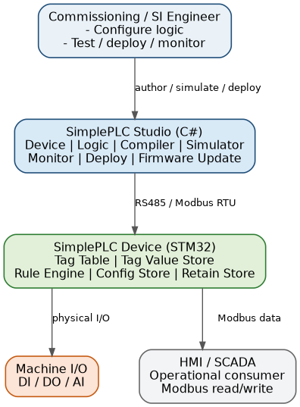
D00: System Context

D01 — C# Solution Components
Purpose | How to read | Development impact
Project/module dependency | App, Core, Infrastructure, Tests and device integration boundary. | Guides Visual Studio solution references.
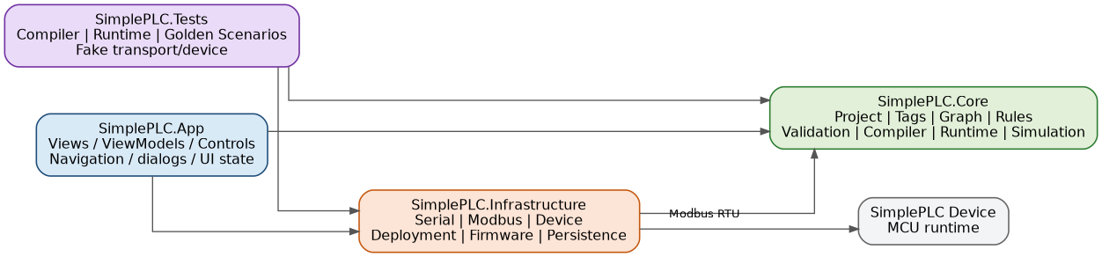
D01: C# Solution Components

D02 — Core Pipeline
Purpose | How to read | Development impact
Core execution pipeline | Project source model flows into validation, compiler, program and runtime. | Guides coding order for Core.
D02: Core Pipeline

D03 — Graph Domain Class Diagram
Purpose | How to read | Development impact
Graph editor domain model | Nodes, ports, edges, connection policy and traversal helper. | Guides LogicGraph implementation.
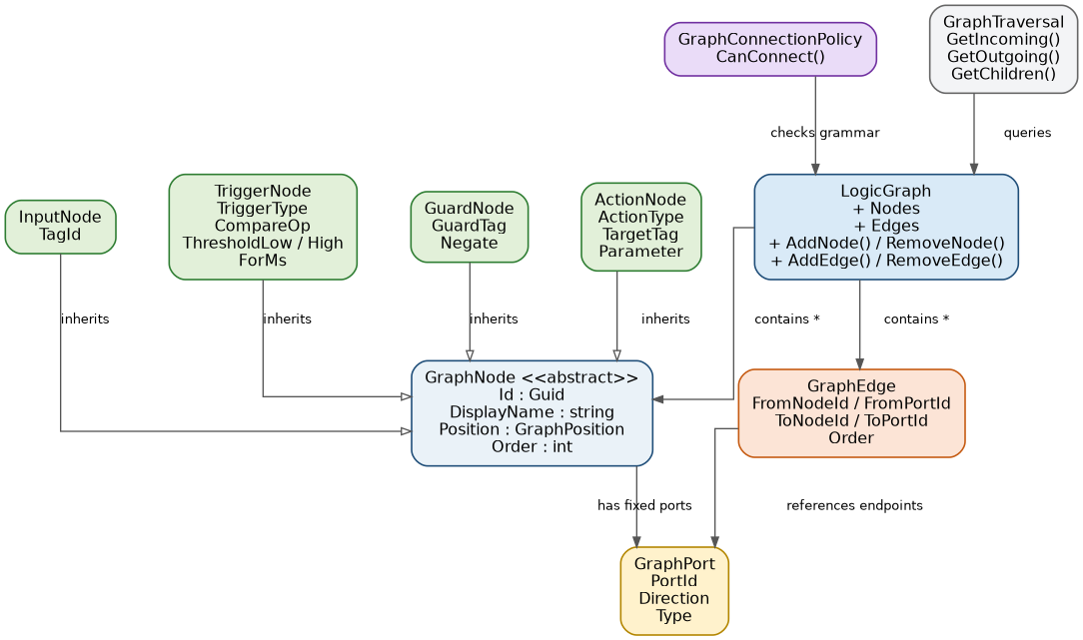
D03: Graph Domain Class Diagram

D04 — Compiler Class Diagram
Purpose | How to read | Development impact
Graph to Rule pipeline | Validators, BranchEnumerator, RuleMapper, RuleValidator and result. | Guides compiler skeleton and unit tests.
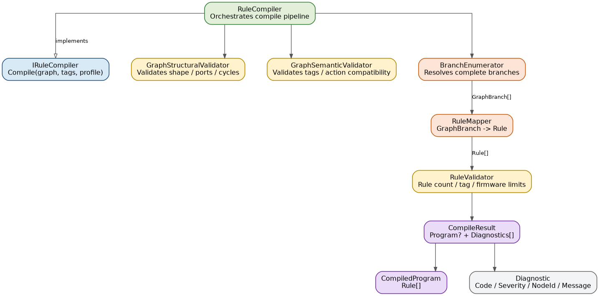
D04: Compiler Class Diagram

D05 — Runtime & Simulator Class Diagram
Purpose | How to read | Development impact
Simulator/runtime ownership | RuntimeEngine executes Rule[] using TagValueStore and RuleRuntimeState. | Guides RuntimeEngine and SimulatorEngine.
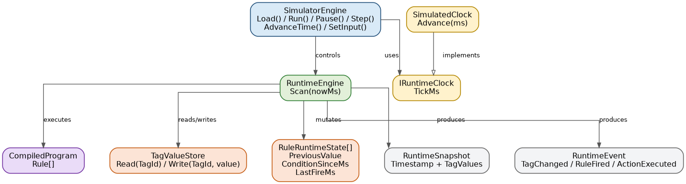
D05: Runtime & Simulator Class Diagram

D06 — Infrastructure & Deploy Components
Purpose | How to read | Development impact
Deployment boundary | RuleBinaryEncoder, CRC, DeviceService, Modbus and Serial. | Keeps deploy separate from compiler.
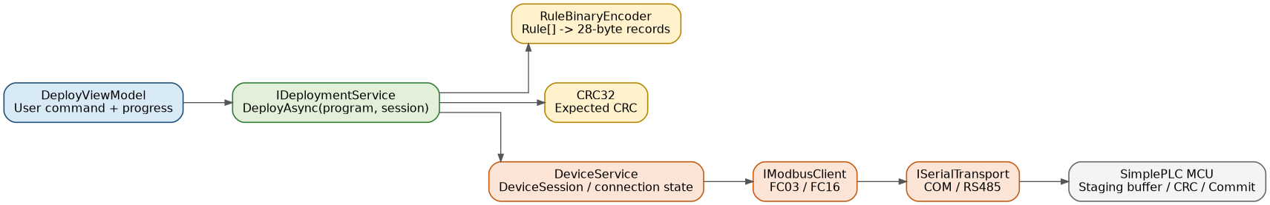
D06: Infrastructure & Deploy Components

D07 — Compile Sequence
Purpose | How to read | Development impact
Compile call flow | Object collaboration when user presses Compile. | Guides CompileCommand implementation.
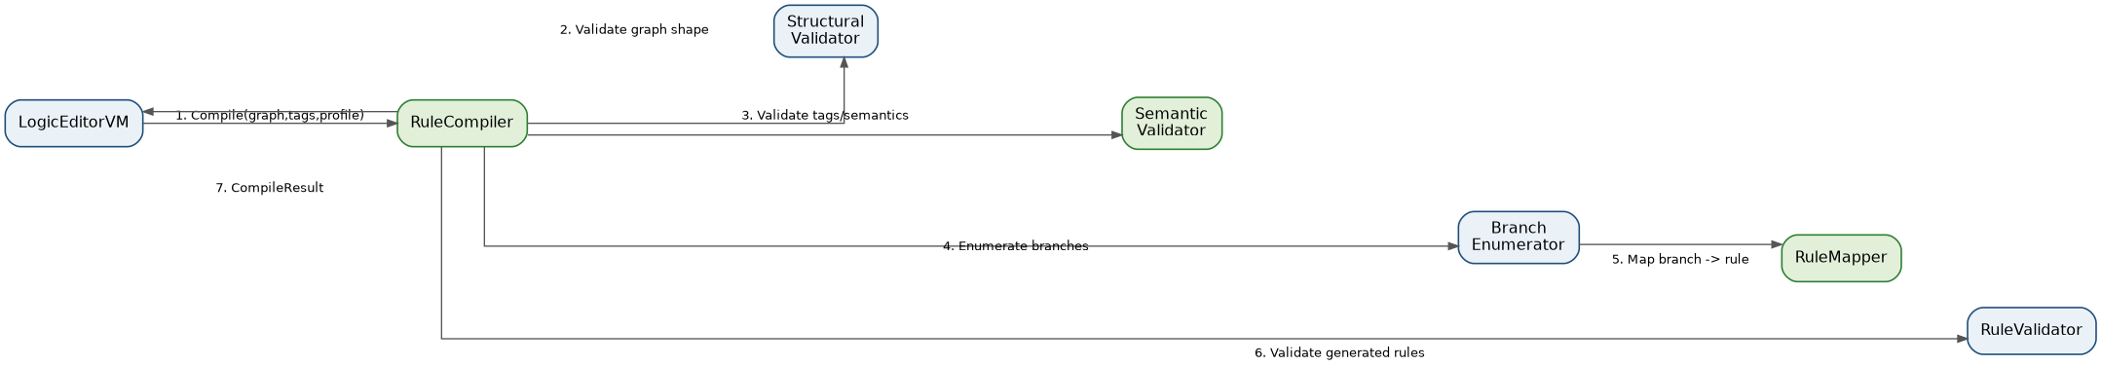
D07: Compile Sequence

D08 — Deploy Sequence
Purpose | How to read | Development impact
Deployment call flow | Encode, stage, verify, commit and confirm active version. | Guides progress stages and failure handling.
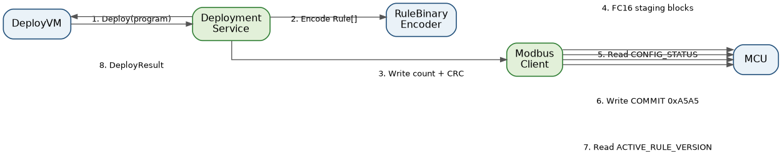
D08: Deploy Sequence

D09 — Monitor Data Flow
Purpose | How to read | Development impact
Runtime source abstraction | Simulator and Live Device feed the same MonitorViewModel contract. | Guides IRuntimeDataSource and Monitor VM.
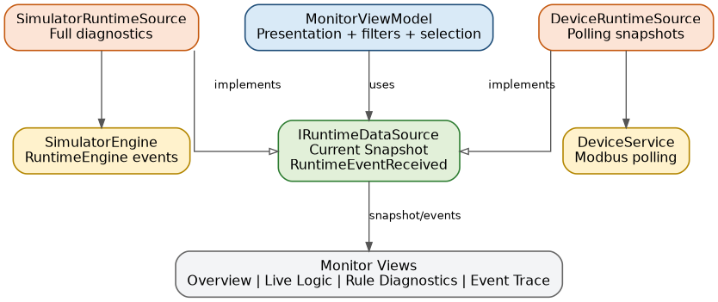
D09: Monitor Data Flow

D10 — State Machines
Purpose | How to read | Development impact
State transitions | Device connection, simulator and deploy finite states. | Guides enums and transition handling.
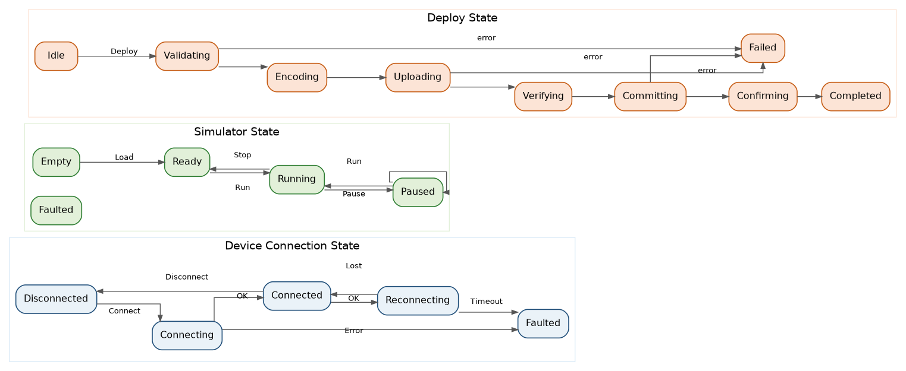
D10: State Machines

Implementation Checklist
Area | Implement first | Can mock/defer | Do not mix with
Core Graph | LogicGraph, GraphNode, GraphEdge, PortId, ConnectionPolicy | Undo/redo, advanced layout | UI control code
Compiler | Structural/Semantic validators, BranchEnumerator, RuleMapper, RuleValidator | Binary encoder | Modbus/deploy
Runtime | RuntimeEngine, TagValueStore, RuleRuntimeState, RuntimeEvent | Live device internal diagnostics | Graph editor
Simulator | SimulatorEngine, SimulatedClock, Step/Advance/Reset | Realtime run loop polish | Device polling
Deploy | DeploymentService, RuleBinaryEncoder, CRC, progress stages | Exact register map until final firmware map | Compiler internals
Monitor | IRuntimeDataSource, MonitorViewModel, Snapshot/Event handling | Full live diagnostics | Runtime mutation

Recommended coding order
- Tag model and TagCatalog
- LogicGraph / GraphNode / GraphEdge / PortId
- GraphConnectionPolicy and validators
- BranchEnumerator and RuleMapper
- RuleCompiler and CompileResult
- RuntimeEngine and TagValueStore
- SimulatorEngine and SimulatedClock
- Monitor abstraction
- Infrastructure / Modbus / Deploy
Firmware-facing boundary: the compiler produces logical Rule[]. RuleBinaryEncoder owns physical packing into 28-byte records, including endianness, padding and guard NEGATE bit. This keeps compiler logic clear and makes simulator testing possible before device integration.

