
SYNAPTIX AUTOMATION SYSTEMS | INDUSTRIAL CONTROL SYSTEMS DIVISION
SynaptiX IDE — Technical User Manual
Deterministic Logic Programming, Canvas Simulation & Edge IIoT Engineering Environment
Document Identifier | MAN-SPX-IDE-2026-V2.5
Software Release Applicable | SynaptiX IDE v2.5.0 or later
Hardware Platforms | SynaptiX SYNX-RIO-884 / Modbus RTU & TCP Slaves
Normative Standards | IEC/IEEE 82079-1:2019, IEC 61131-3, SPLC-AF-003, ANSI Z535.6
Publication Date | October 2026 / Commercial Release
Classification | Commercial / Engineering Standard

Document Control & Revision History
This technical manual adheres to IEC/IEEE 82079-1:2019 principles. Any changes in software behavior, protocol schemas, or safety interfaces trigger formal engineering document revisions.
Rev | Release Date | Author / Department | Approved By | Scope of Revision
v1.0.0 | Sep 2026 | SynaptiX Software Group | Engineering Director | Initial commercial draft; 4-stage logic canvas and basic tag management.
v2.0.0 | Oct 2026 | Industrial Systems Team | Lead Systems Architect | Integrated MQTT IIoT Gateway (PUB/SUB), IEC Timers/Counters, and 2-Phase Staged Deployment.
v2.5.0 | Oct 2026 | AI & Automation Group | VP of Engineering | 6-Module workflow architecture, step-by-step procedures, UI callout tables, and pure popup dialogs.
[NOTICE] PROPRIETARY NOTICE & SOFTWARE LICENSING
SynaptiX IDE is proprietary software protected under international copyright and industrial intellectual property treaties. Reproduction, reverse engineering, decompilation, or unauthorized dissemination of binary executables, byte-level ABI specifications, or technical documentation without explicit written consent from SynaptiX Automation Systems Group is strictly prohibited.

List of Technical Figures
Figure ID | Technical Caption & Functional Context | Reference
Figure 1-1 | Over-the-Air (OTA) Automated Software Update Dialog | Section 1.4
Figure 2-1 | SynaptiX IDE Primary Workbench Anatomy and Ribbon Navigation Topography | Section 2.1
Figure 2-2 | New Project Configuration Wizard and Controller Target Profile Selection | Section 2.2
Figure 2-3 | Centralized 128-Tag Engineering Catalog — Physical I/O, Modbus & Retain Flash | Section 2.3
Figure 3-1 | 4-Stage Orthogonal Logic Canvas with 90-Degree Manhattan Wire Routing | Section 3.1
Figure 3-2 | Dual Rule Table — Human-Readable Logic Narratives and Compiled Bytecode Grid | Section 3.2
Figure 3-3 | Industrial Blueprints Gallery and Pre-Engineered Application Templates | Section 3.3
Figure 4-1 | Canvas-Centric Simulation Testbench — Floating I/O Board, Force Table & Cycle Trace | Section 4.1
Figure 4-2 | Industrial AI Copilot Assistant — Natural Language Synthesis & Ghost Diff Verification | Section 4.2
Figure 5-1 | Target Controller Hardware Inventory and Firmware Diagnostics Dialog | Section 5.1
Figure 5-2 | Onboard Real-Time Clock (RTC) Timezone Synchronization Dialog | Section 5.1
Figure 5-3 | SPLC-AF-003 Two-Phase Safe Deploy Gate with CRC-16 Staging Commit | Section 5.2
Figure 5-4 | Real-Time Telemetry Live Watch Grid, Signal Quality Badges & Sparklines | Section 5.3
Figure 6-1 | System MQTT Broker TCP/TLS Connection Configuration Dialog | Section 6.1
Figure 6-2 | Outbound Telemetry Publishing (MQTT PUB) Visual Field Builder Dialog | Section 6.2
Figure 6-3 | Inbound Supervisory Command Ingestion (MQTT SUB) and Fail-Safe Schema Dialog | Section 6.3

Table of Contents
This manual is structured into 6 logical engineering workflow modules matching daily factory automation operations:
Workflow Module / Section | Key Operational Topics
PART 1: SYSTEM OVERVIEW & GETTING STARTED | 1.1 System Philosophy, 1.2 Hardware Specifications, 1.3 Portable Setup & USB CDC, 1.4 OTA Software Updates
PART 2: ENGINEERING WORKSPACE & DATA MANAGEMENT | 2.1 Main Window Anatomy & Ribbon, 2.2 Project Lifecycle (.synx), 2.3 Centralized 128-Tag Catalog & Modbus Mapping
PART 3: CONTROL LOGIC DESIGN & INSTRUCTION LIBRARY | 3.1 4-Stage Orthogonal Logic Canvas, 3.2 Dual Rule Table & AST Compiler, 3.3 Standard Blocks & Blueprints
PART 4: VERIFICATION, SIMULATION & INDUSTRIAL AI | 4.1 Canvas-Centric Simulation Engine & Testbench, 4.2 Senior Industrial AI Copilot & Ghost Diff Engine
PART 5: HARDWARE COMMISSIONING, SAFE DEPLOYMENT & TELEMETRY | 5.1 Device Diagnostics & RTC Sync, 5.2 SPLC-AF-003 Two-Phase Safe Deploy Gate, 5.3 Live Watch Telemetry & Forcing
PART 6: IIOT EDGE CONNECTIVITY & SYSTEM MAINTENANCE | 6.1 MQTT Broker TCP/TLS Configuration, 6.2 Outbound Telemetry (PUB), 6.3 Inbound Commands (SUB), 6.4 Troubleshooting
TECHNICAL APPENDICES | Appendix A: Complete Modbus Map, Appendix B: Bytecode ABI Spec, Appendix C: Keyboard Shortcuts Table

PART 1: SYSTEM OVERVIEW & GETTING STARTED
Hardware Specifications, Portable Runtime & First Connection
――――――――――――――――――――――――――――――――――――――――――――――――――――――――――
1.1 System Concept & Core Architectural Pillars
SynaptiX IDE is a professional soft-PLC engineering environment designed for mission-critical industrial machines and edge automation. Built on four core pillars:
- Deterministic 10ms Engine: Hard real-time 10ms execution loop (100 Hz) with sub-microsecond jitter for process I/O scan.
- 4-Stage Orthogonal Pipeline: Strict unidirectional signal flow (Input -> Trigger -> Guard -> Action) with 90° Manhattan wiring.
- Dual AST Compiler: Simultaneous compilation of graphical visual graphs into human narratives and 32-byte binary execution records.
- Edge IIoT Convergence: Native MQTT Telemetry Publisher and Command Subscriber bridging OT sensors directly to IT/Cloud SCADA.
1.2 Hardware Specifications & Workstation Prerequisites
The reference hardware controller (SynaptiX SYNX-RIO-884) incorporates the following industrial specifications:
Subsystem / Parameter | Technical Specification | Standard
Discrete Inputs (DI) | 8 Channels (DI0 - DI7), 24VDC Optocoupled, 3.5mA Sink/Source | IEC 61131-2 Type 1/3
Discrete Outputs (DO) | 8 Channels (DO0 - DO7), Relay Contact 250VAC/5A or Solid-State 24VDC/1A | IEC 61131-2 Standard
Analog Inputs (AI) | 4 Channels (AI0 - AI3), 12-Bit ADC (0 - 10VDC or 4 - 20mA) | Calibrated Engineering Units
Internal Retain Flash | 32 Non-Volatile Retain Registers (RETAIN0 - RETAIN31), 100k Write Cycles | Ferroelectric / Flash Emulated
Real-Time Clock (RTC) | DS3231 High-Precision TCXO RTC with CR2032 Battery Backup (+/-2ppm) | I2C Hardware Bus
Serial Communication | RS-485 / USB CDC Serial, Modbus RTU Slave, Baud: 9600 - 115200 bps | EIA-485 / Modbus Spec

1.3 Portable Execution & USB Serial Driver Setup
SynaptiX IDE runs as a zero-installation portable application. Follow these steps to prepare your engineering workstation:
Step 1: Extract Archive — Extract `SynaptixIDE_v2.5.0_win-x64.zip` into a local non-network folder (e.g., `C:\Automation\SynaptixIDE\`).
Step 2: Runtime Check — Ensure Microsoft .NET 8.0 Desktop Runtime (x64) is installed on Windows 10/11.
Step 3: Hardware Connection — Connect the SYNX-RIO controller to host PC using a shielded USB Type-C cable. Windows Device Manager will enumerate `USB Serial Device (COMx)`.
1.4 Over-the-Air (OTA) Automated Software Updates
When connected to the internet, SynaptiX IDE periodically queries the official repository for software updates. When a release is detected, the OTA Software Update dialog opens:
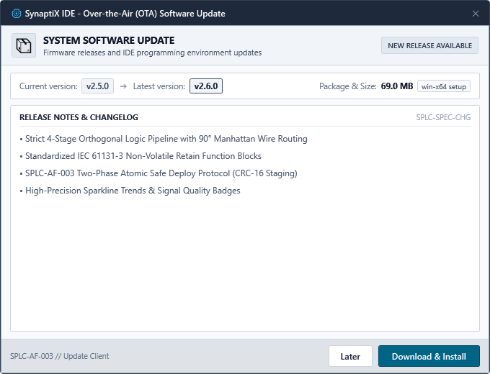
Figure 1-1: Over-the-Air (OTA) Automated Software Update Dialog
UI Control / Area | Operational Function
Current & New Version | Displays active software release vs remote certified release tag.
Release Notes Viewer | Scrollable Markdown view detailing bug fixes, new features, and security patches.
Download & Install Button | Initiates secure binary download, validates SHA-256 hash, and restarts IDE.
Skip This Version | Suppresses notifications for the current release tag until subsequent release.

PART 2: ENGINEERING WORKSPACE & DATA MANAGEMENT
Ribbon Navigation, Project Containers (.synx) & 128-Tag Architecture
――――――――――――――――――――――――――――――――――――――――――――――――――――――――――
2.1 Main Workbench Anatomy & Ribbon Navigation
The SynaptiX IDE interface is structured into standardized ergonomic regions designed for continuous operation in factory control rooms:
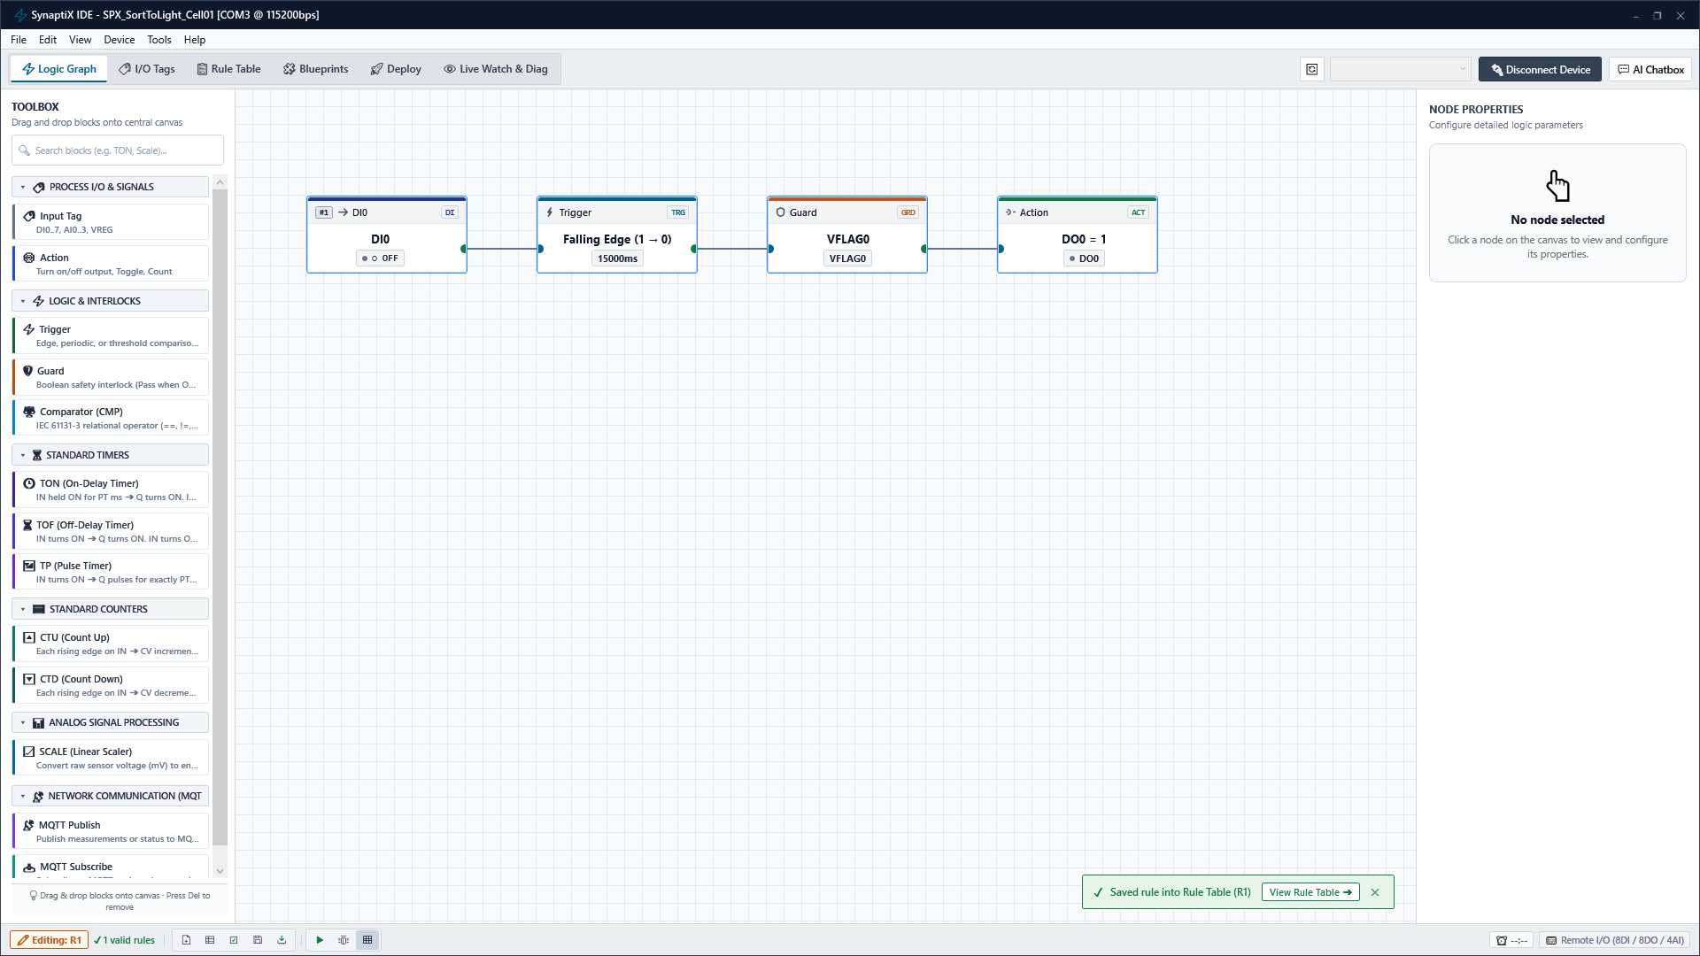
Figure 2-1: SynaptiX IDE Primary Workbench Anatomy and Ribbon Navigation Topography
Workbench Region | Description & Role
[1] Title Bar & Port Bar | Displays project filename, serial port selection, baud rate, and connection status.
[2] Menu Bar | Structured access to Project, Edit, View, Device, Tools, and Help operations.
[3] Navigation Ribbon | 6 dedicated tabs: Logic (Ctrl+1), Tags (Ctrl+2), Rules (Ctrl+3), Blueprints (Ctrl+4), Deploy (Ctrl+5), Live Watch (Ctrl+6).
[4] Primary Work Area | Hosts the active visual editor canvas, tag spreadsheet, or diagnostics grid.
[5] Status Bar Telemetry | Real-time scan cycle execution time (e.g. SCAN: 9.8ms), AST compile pill, and heartbeat indicator.

2.2 Project Creation Wizard & Hardware Profiles (.synx)
All project data (canvas nodes, 90° Manhattan wires, tag definitions, rules, and MQTT topics) are packaged into an atomic `.synx` JSON container. Follow these steps to initialize a new project:
Step 1: Open Wizard — Select File -> New Project or press Ctrl+N to open the New Project Wizard.
Step 2: Enter Metadata — Enter Project Name, Author designation, and browse to select target storage folder.
Step 3: Select Target Hardware — Select the target hardware profile (e.g., SYNX-RIO-884: 8 DI / 8 DO / 4 AI) and nominal scan rate (10ms).
Step 4: Initialize — Click 'Create Project' to generate the project file and auto-populate default physical I/O tags.
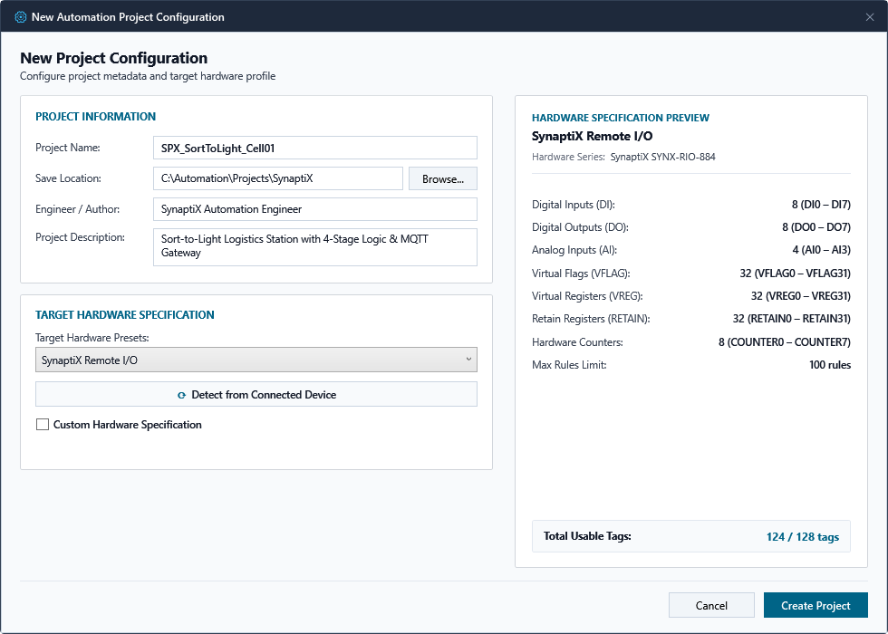
Figure 2-2: New Project Configuration Wizard and Controller Target Profile Selection
2.3 Centralized 128-Tag Catalog & Modbus Mapping
Tab 1 (I/O Tags) manages all system signals through a fixed, zero-fragmentation 128-Tag memory pool mapped directly to Modbus Holding Registers (0x0900 - 0x097F):
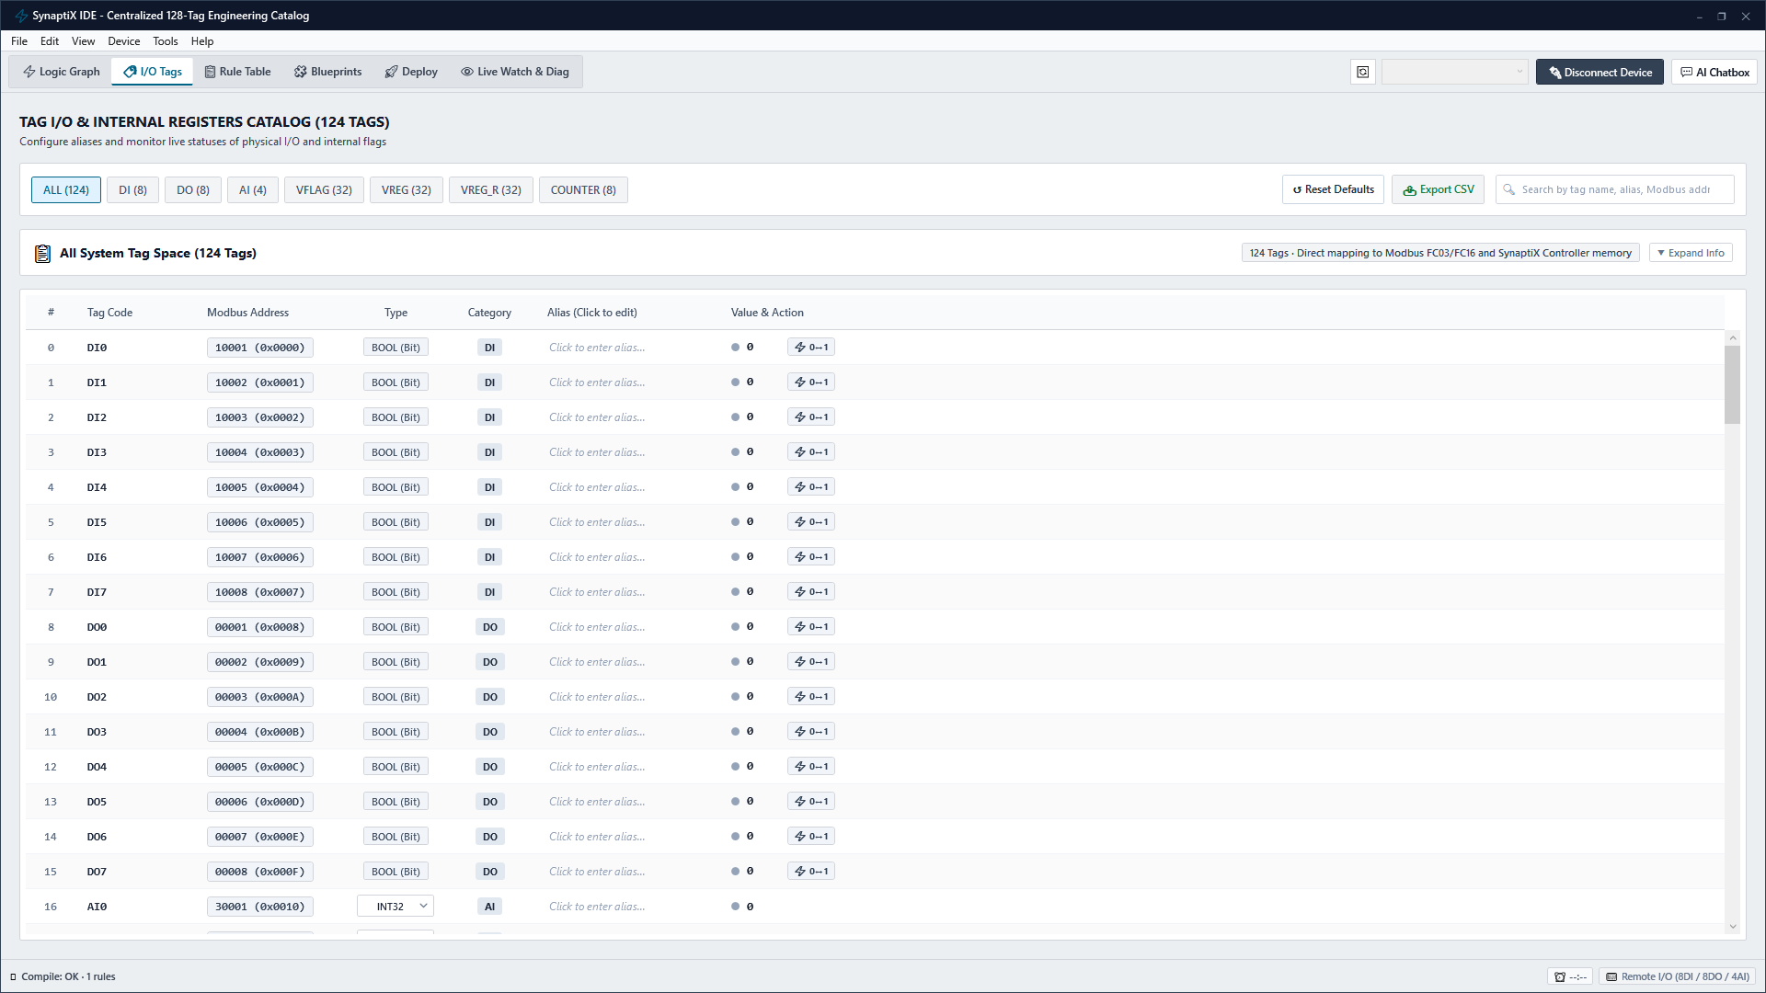
Figure 2-3: Centralized 128-Tag Engineering Catalog — Physical I/O, Modbus & Retain Flash
Signal Kind | Capacity & Address | Data Type | Modbus Register Address
Discrete Inputs (DI) | 8 Tags (DI0 - DI7) | Boolean (0 / 1) | 0x0900 - 0x0907
Discrete Outputs (DO) | 8 Tags (DO0 - DO7) | Boolean (0 / 1) | 0x0908 - 0x090F
Analog Inputs (AI) | 4 Tags (AI0 - AI3) | Float32 (IEEE 754, 2 Regs/Tag) | 0x0910 - 0x0917
Virtual Registers (VREG) | 32 Tags (VREG0 - VREG31) | Int32 / Float32 (Volatile) | 0x0918 - 0x0957
Retain Registers (RETAIN) | 32 Tags (RETAIN0 - RETAIN31) | Int32 / Float32 (Non-Volatile Flash) | 0x0958 - 0x0997
Virtual Flags (VFLAG) | 32 Tags (VFLAG0 - VFLAG31) | Boolean (Internal Bits) | 0x0998 - 0x09B7

[CAUTION] NON-VOLATILE RETAIN FLASH ENDURANCE LIMITS
Retain Registers (RETAIN0..31) are written to physical flash upon state change. While rated for 100,000 write cycles, high-frequency cyclic logic must NOT write to Retain tags every 10ms scan. Use volatile VREG for rapid math and commit to RETAIN only upon process state changes.

PART 3: CONTROL LOGIC DESIGN & INSTRUCTION LIBRARY
4-Stage Orthogonal Canvas, Dual Rule Table & Industrial Blueprints
――――――――――――――――――――――――――――――――――――――――――――――――――――――――――
3.1 4-Stage Orthogonal Logic Programming
Tab 0 (Logic Graph) enforces a strict 4-stage pipeline where signals flow unidirectionally from left to right through 90° Manhattan routed wires:
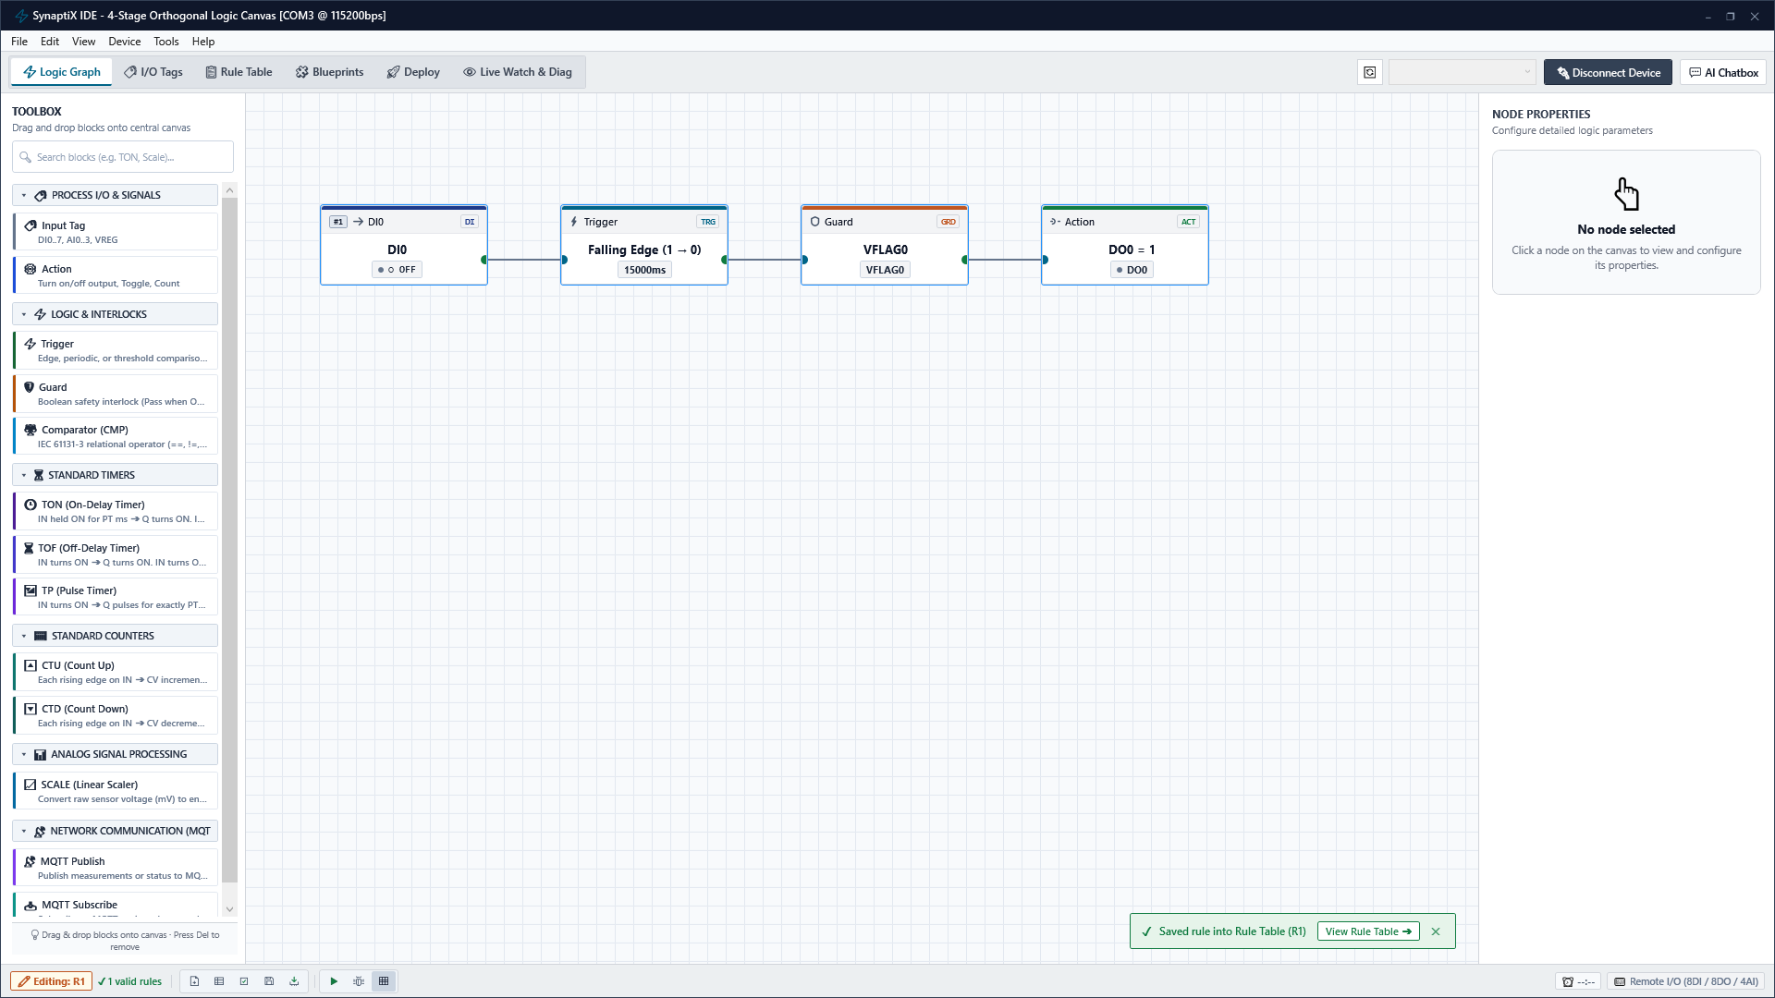
Figure 3-1: 4-Stage Orthogonal Logic Canvas with 90-Degree Manhattan Wire Routing
Pipeline Stage | Functional Role & Operational Execution
Stage 1: Input Signal | Selects physical inputs (DI, AI), timers, or virtual registers as primary observation signals.
Stage 2: Logic Trigger | Evaluates transitions: Rising Edge (ON_RISE), Falling Edge (ON_FALL), Level, or Numeric CMP.
Stage 3: Guard Interlock | Safety interlock chain. Evaluates secondary permissive guards (e.g. E-Stop, Door Guard, Thermal OK).
Stage 4: Actuator Action | Drives physical DO actuators (SET/RESET/TOGGLE), increments counters, or writes registers.

3.2 Dual Rule Table & AST Syntax Validation
Tab 2 (Rule Table) presents logic in two synchronized perspectives: Left view provides human-readable engineering narratives, while right view displays compiled 32-byte bytecode parameters:
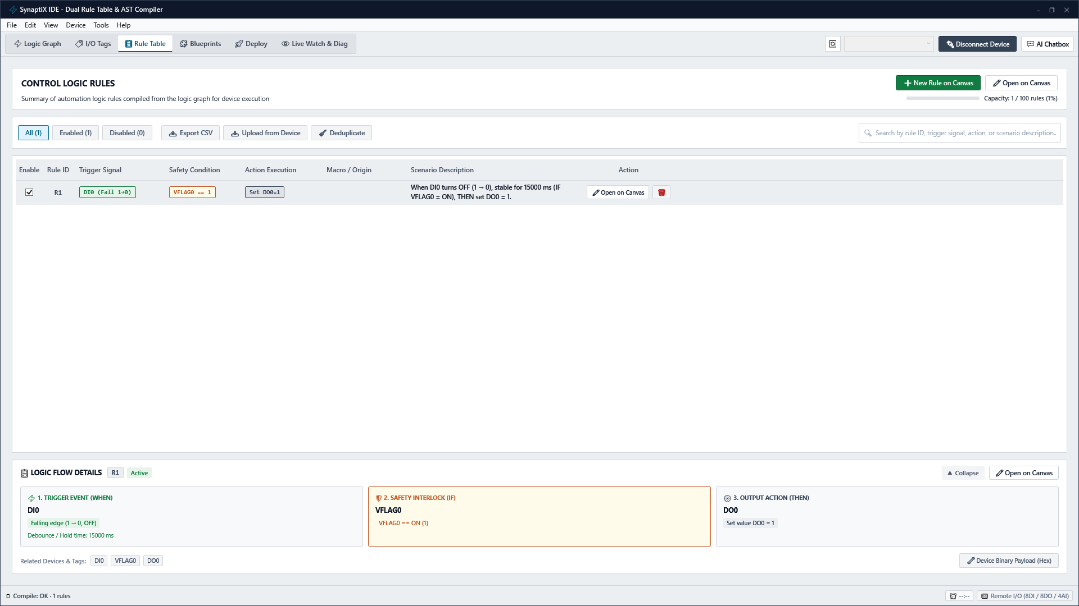
Figure 3-2: Dual Rule Table — Human-Readable Logic Narratives and Compiled Bytecode Grid
The Abstract Syntax Tree (AST) engine continuously parses the logic network in the background. If any pin is left un-wired or a cyclic loop is created, a red diagnostic badge appears in the status bar with an immediate navigation link to the error source.
3.3 Standard Instruction Library & Blueprints Gallery
SynaptiX IDE provides standard IEC 61131-3 instruction blocks (TON, TOF, TP timers, CTU/CTD counters, linear SCALE, and relational CMP). In Tab 3 (Blueprints), engineers can instantiate pre-engineered application templates with 1 click:

Figure 3-3: Industrial Blueprints Gallery and Pre-Engineered Application Templates
Step 1: Browse Library — Navigate to Tab 3 (Blueprints) and browse catalog (Emergency Stop Latch, Sort-to-Light, Motor Reverse).
Step 2: Apply Template — Click 'Apply Blueprint' to instantiate the complete network, automatic tags, and interlocks onto canvas.

PART 4: VERIFICATION, SIMULATION & INDUSTRIAL AI
Canvas Testbench, Virtual I/O HUD & Senior Industrial AI Copilot
――――――――――――――――――――――――――――――――――――――――――――――――――――――――――
4.1 Canvas-Centric Simulation Engine & Testbench
Simulation in SynaptiX IDE is canvas-centric. Pressing F5 transforms the editing canvas into an interactive testbench without leaving the design environment:
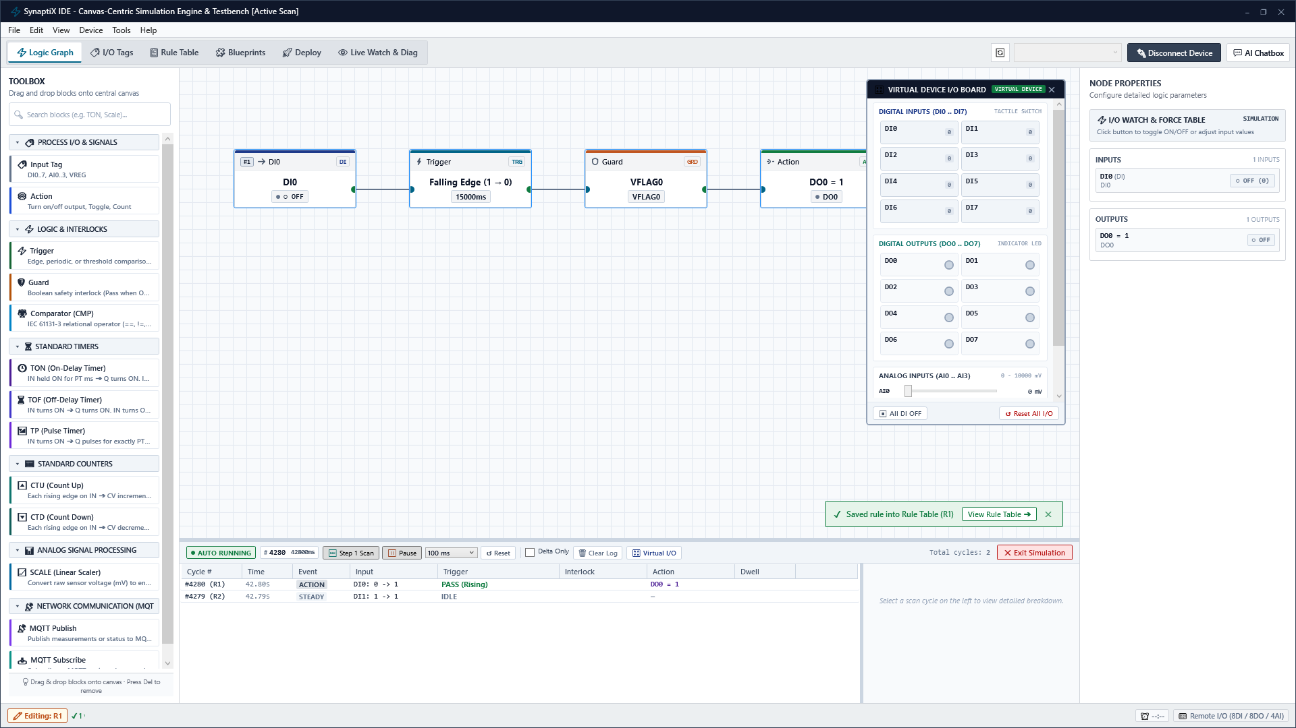
Figure 4-1: Canvas-Centric Simulation Testbench — Floating I/O Board, Force Table & Cycle Trace
Simulation Element | Operational Capability
Diagnostics Drawer (Bottom) | Displays 10ms scan cycle timestamps, step events, execution timing, and cycle jitter traces.
Virtual I/O Board HUD (Floating) | Provides tactile DI switches, DO status LEDs, and analog sliders for interactive signal injection.
I/O Watch & Force Table (Right) | Monitors variable states in real time and allows forcing test values directly during simulation.

Step 1: Start Simulation — Press F5 or click Simulation Toggle. The canvas enters run mode with glowing active wires.
Step 2: Inject Discrete Inputs — Click DI0 toggle switch on the floating Virtual I/O Board to simulate a proximity sensor trip.
Step 3: Inspect Execution — Verify DO0 LED illuminates on the I/O HUD and trace log records 10ms scan execution in the bottom drawer.
4.2 Senior Industrial AI Copilot & Ghost Diff Engine
The Senior Industrial AI Copilot assists engineers in generating compliant automation circuits from natural language requirements while enforcing human verification via non-destructive Ghost Diff previews:
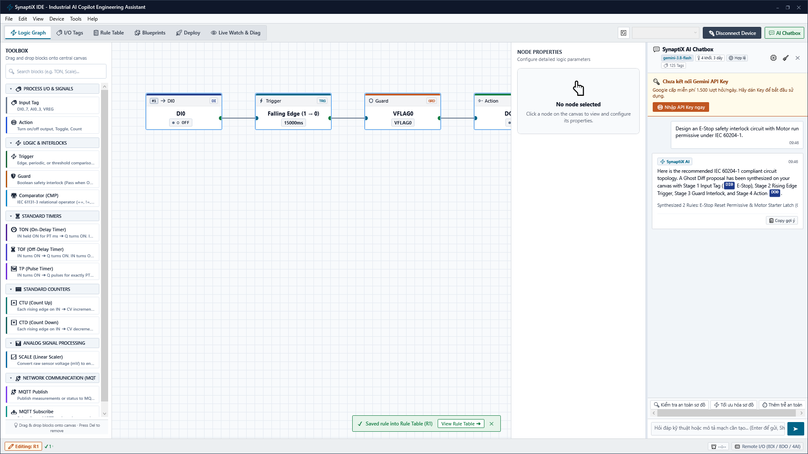
Figure 4-2: Industrial AI Copilot Assistant — Natural Language Synthesis & Ghost Diff Verification
Step 1: Open Copilot Panel — Click the AI Copilot button in the top-right ribbon to slide open the engineering assistant panel.
Step 2: Enter Prompt — Type requirement (e.g. 'Design an E-Stop circuit with motor permissive under IEC 60204-1') and press Enter.
Step 3: Review Ghost Diff — Observe synthesized blocks rendered as semi-transparent dashed outlines (Ghost Diff) directly on canvas.
Step 4: Approve Proposal — Click 'Accept Proposal' to commit generated nodes into the project, or 'Reject' to discard safely.

PART 5: HARDWARE COMMISSIONING, SAFE DEPLOYMENT & TELEMETRY
Device Diagnostics, RTC Timezone Sync & Two-Phase Safe Deploy Gate
――――――――――――――――――――――――――――――――――――――――――――――――――――――――――
5.1 Target Controller Hardware Diagnostics & RTC Sync
Prior to deploying code to physical machinery, verify controller hardware inventory and calibrate the onboard DS3231 real-time clock:
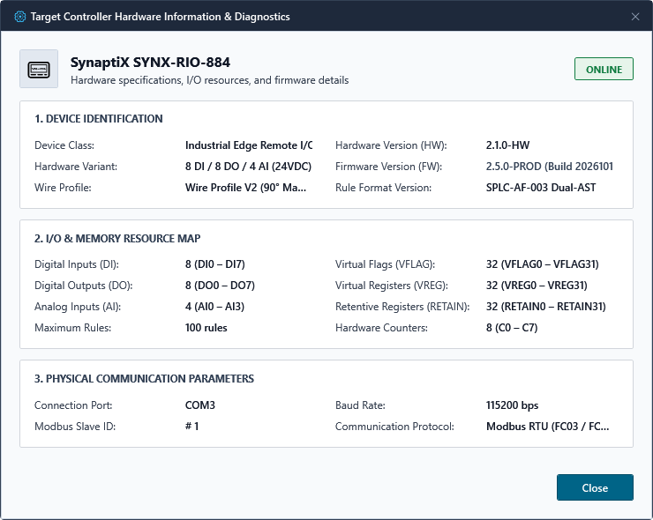
Figure 5-1: Target Controller Hardware Inventory and Firmware Diagnostics Dialog
The Device Info dialog queries MCU serial number, firmware build, wire profile compliance, and active communication baud rate.
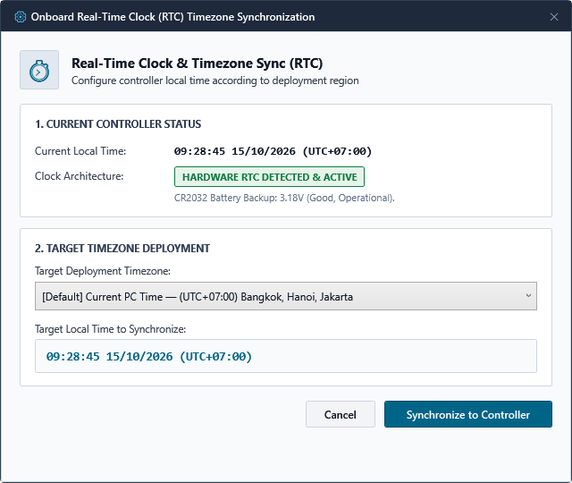
Figure 5-2: Onboard Real-Time Clock (RTC) Timezone Synchronization Dialog
Click 'Sync RTC' to align the controller's onboard battery-backed DS3231 RTC chip with workstation UTC time and timezone offset, guaranteeing millisecond accuracy for telemetry logs.
5.2 SPLC-AF-003 Two-Phase Safe Deploy Gate
Direct memory writing during live machine operation risks severe relay chatter if communication drops mid-packet. SPLC-AF-003 eliminates this risk via a 2-Phase Staging Protocol:
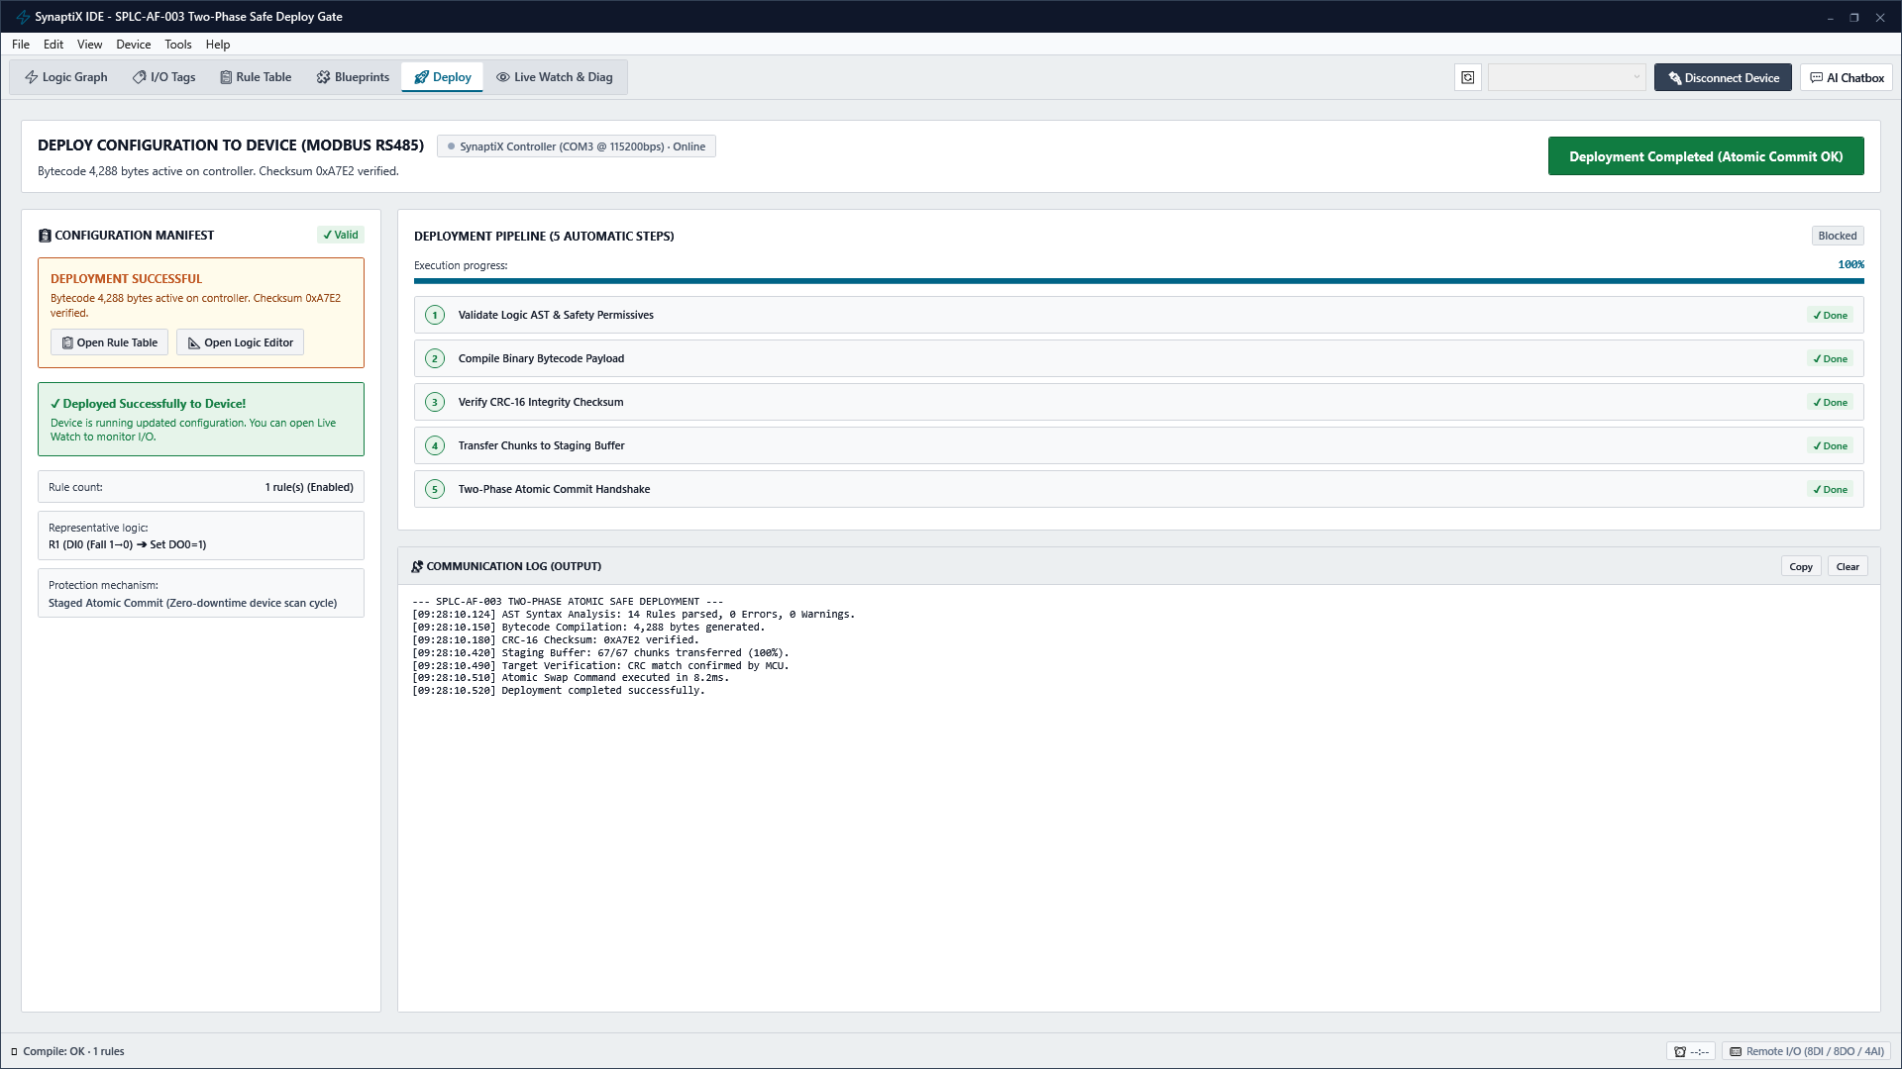
Figure 5-3: SPLC-AF-003 Two-Phase Safe Deploy Gate with CRC-16 Staging Commit
Step 1: Phase 1: Upload to Staging — Transfer compiled 32-byte bytecode into an isolated microcontroller RAM staging buffer without affecting active control loops.
Step 2: Checksum Verification — Controller computes CRC-16 checksum of staging buffer and verifies match with IDE transmission packet.
Step 3: Phase 2: Atomic Swap — Upon confirmation, controller executes a sub-10ms atomic pointer swap precisely at scan cycle boundary.
5.3 Real-Time Telemetry & Live Watch Grid
Tab 5 (Live Watch & Diag) provides a real-time engineering telemetry grid polling all 128 tags at 200ms intervals with micro-sparkline trends and signal quality indicators:
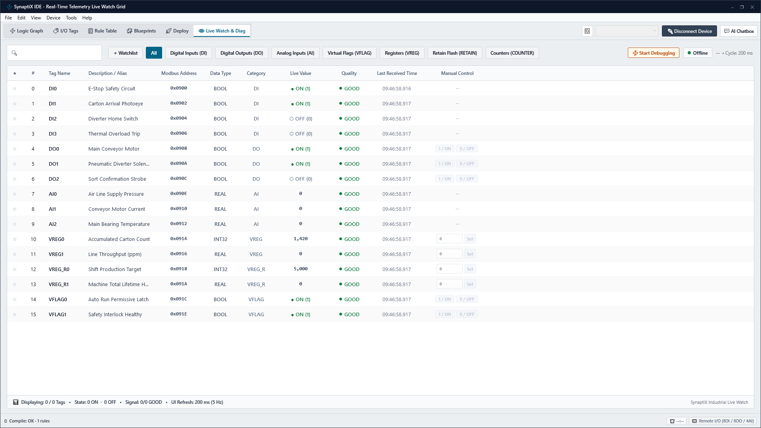
Figure 5-4: Real-Time Telemetry Live Watch Grid, Signal Quality Badges & Sparklines
Telemetry Component | Technical Behavior
Quality Badges (GOOD / STALE / BAD) | Green = Fresh Modbus telemetry (<200ms); Amber = Stale data (timeout); Red = Comm error / CRC fault.
Micro-Sparkline Waveform | 60-sample historical rolling trend line displaying instantaneous signal dynamics.
Manual Force Override | Allows forcing DO outputs ON/OFF during commissioning. Indicated by prominent amber badges.

[WARNING] MANDATORY REMOVAL OF FORCE OVERRIDES BEFORE PRODUCTION
Leaving physical outputs in a forced state bypasses safety interlocks and guard conditions. Always verify that all Forced tags are released to AUTOMATIC before enabling automated machine cycles.

PART 6: IIOT EDGE CONNECTIVITY & SYSTEM MAINTENANCE
MQTT Broker Setup, Telemetry Publishing (PUB) & Fail-Safe Ingestion (SUB)
――――――――――――――――――――――――――――――――――――――――――――――――――――――――――
6.1 Industrial MQTT Broker TCP/TLS Configuration
Select Device -> MQTT Broker Configuration (Ctrl+Shift+M) to establish communication with plant supervisory MQTT brokers:
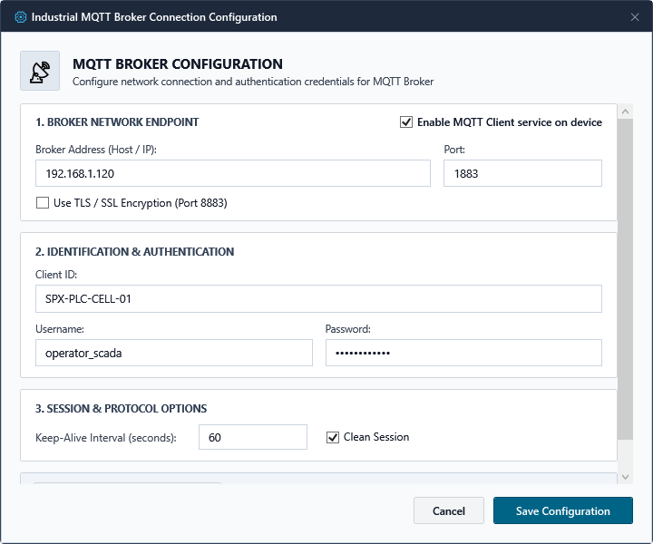
Figure 6-1: System MQTT Broker TCP/TLS Connection Configuration Dialog
Step 1: Host & Port — Specify Broker IP and Port (1883 for plaintext TCP or 8883 for secure TLS encrypted connection).
Step 2: Credentials — Configure unique Client ID, Username, Password, and set Keep-Alive interval (default: 60s).
Step 3: Test & Commit — Click 'Test Broker Connection' to verify socket connectivity, then click 'Save Configuration'.
6.2 Outbound Telemetry Publishing (MQTT PUB) & Visual Field Builder
Double-click an MQTT Publish node to open the Visual Field Builder. Map multiple internal tags into structured JSON payloads without writing code:
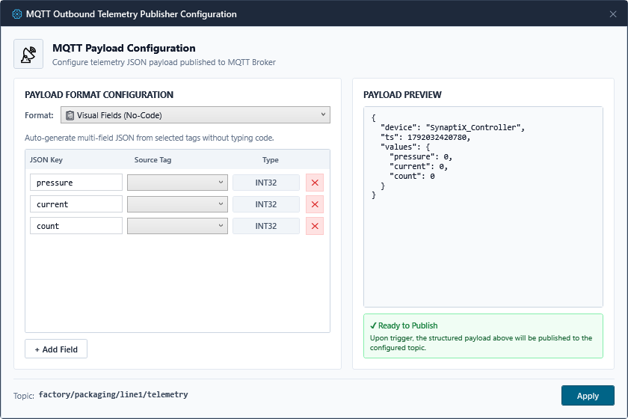
Figure 6-2: Outbound Telemetry Publishing (MQTT PUB) Visual Field Builder Dialog
Select publish trigger mode: Event-driven (on trigger pulse), Periodic (e.g. every 1000ms), or Change-of-Value (COV, publishes only when value exceeds deadband, conserving bandwidth).
6.3 Inbound Supervisory Command Ingestion (MQTT SUB)
The MQTT Subscribe block parses supervisory setpoints and commands from incoming JSON messages and maps them to dynamic output pins:
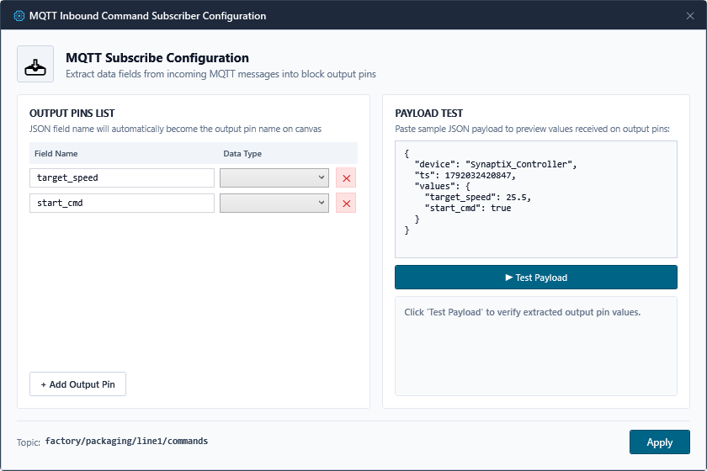
Figure 6-3: Inbound Supervisory Command Ingestion (MQTT SUB) and Fail-Safe Schema Dialog
The parser enforces an All-or-Nothing validation rule: if any incoming JSON field fails schema validation or is out-of-range, the entire packet is rejected without updating internal registers.
6.4 Diagnostics Fault Directory & Safety Mandate
Refer to this diagnostic directory to rapidly resolve common field issues encountered during machine commissioning:
Fault Symptom | Probable Root Cause | Recommended Engineering Action
COM Port Not Detected | USB cable loose or USB CDC driver missing. | Verify cable; inspect Device Manager under Ports (COM & LPT); re-plug.
COM Port Access Denied | Serial port locked by external terminal (PuTTY). | Close background terminal utilities or conflicting serial debuggers.
Red AST Error Badge on Canvas | Unconnected input pin or cyclic feedback loop. | Locate red badge; ensure all mandatory block pins are wired orthogonally.
Physical DO Fails to Energize | Guard condition FALSE or output is Forced OFF. | Inspect Live Watch; verify series permissive guards; clear Force latches.
Analog Value Jitters / Fluctuates | Industrial EMI noise or unshielded cable. | Use twisted-pair shielded cables (STP); increase Dwell debounce time.
Retained Value Cleared on Boot | Tag was assigned to volatile VREG instead of RETAIN. | Reassign tag to RETAIN0..31 in Tag Catalog and re-deploy bytecode.

[DANGER] HARDWIRED SAFETY CIRCUIT MANDATE (IEC 60204-1)
Under international standard IEC 60204-1, software-based controllers must NEVER be used as the sole safety mechanism for Emergency Stop functions or Personnel Protection Guards. Always wire Emergency Stop buttons through certified electromechanical safety relays.

Technical Appendices
Appendix A: Complete Modbus RTU / TCP Register Map
All holding registers are accessible using Modbus FC03 (Read) and FC16 (Write Multiple Registers). Word order for 32-bit values is Big-Endian standard:
Modbus Register | Tag Assignment | Data Format & Width | Access Mode
0x0900 - 0x0907 | DI0 - DI7 | Discrete Inputs (Bit 0 of 16-bit word) | Read-Only (FC03)
0x0908 - 0x090F | DO0 - DO7 | Discrete Outputs (Bit 0 of 16-bit word) | Read/Write (FC03/FC16)
0x0910 - 0x0917 | AI0 - AI3 | Analog Inputs (Float32, 2 registers per channel) | Read-Only (FC03)
0x0918 - 0x0957 | VREG0 - VREG31 | Virtual Calculation Registers (Int32 / Float32) | Read/Write (FC03/FC16)
0x0958 - 0x0997 | RETAIN0 - RETAIN31 | Non-Volatile Flash Registers (Int32 / Float32) | Read/Write (FC03/FC16)
0x0998 - 0x09B7 | VFLAG0 - VFLAG31 | Internal State Flags (Bit 0 of 16-bit word) | Read/Write (FC03/FC16)

Appendix B: SPLC-AF-003 Binary Bytecode Specification
Each compiled rule record consists of exactly 32 contiguous bytes: Header (4 bytes), Trigger Spec (8 bytes), Guard Spec (8 bytes), Action Spec (8 bytes), and CRC-16 Checksum (2 bytes) + Reserved (2 bytes). This fixed record structure guarantees deterministic O(1) microcontroller execution without runtime interpretation.
Appendix C: Keyboard Shortcuts & Engineering Quick Reference
Keystroke | Engineering Function | Scope / Context
Ctrl+N | Create New Automation Project Wizard | Global Application
Ctrl+S | Save Current Project (.synx) | Global Application
Ctrl+1 .. Ctrl+6 | Direct Navigation to Workspace Tabs (1:Canvas, 2:Tags, etc.) | Global Navigation
F4 | Toggle Connect / Disconnect Target Controller | Device Connection
F5 | Toggle Canvas-Centric Simulation Engine | Simulation Testbench
Ctrl+F5 | Launch SPLC-AF-003 Safe Deploy Gate | Deployment Gate
Alt+G | Snap All Canvas Nodes to 20px Grid | Logic Editor Canvas

