ENTERPRISE TECHNICAL SOLUTION & COMMERCIAL PROPOSAL
Turnkey Industrial Sort-to-Light System
High-Velocity Parcel Routing Edge Hardware & SynaptiX Automation Fleet Management Suite for Fulfillment Centers
Target Client: | SPX Logistics Vietnam (Shopee Express Fulfillment Operations)
Deployment Scope: | Pilot Rollout of 26 Sorting Racks across 5 Primary SOCs (Buon Ma Thuot, Vinh, Dien Khanh, Hung Yen, Ha Noi)
Document Reference: | SPX-STL-PROPOSAL-2026-V1.0
Proposal Status: | Official Release Candidate (Approved for Commercial & Technical Tender)
Solution Provider: | Industrial Automation Solutions & Systems Architecture Team
Effective Date: | October 2026

■ COMMERCIAL & TECHNICAL VALUE COMMITMENT
Executive Commitment: This proposal provides a complete, turnkey automation solution engineered to resolve the operational bottlenecks of manual sorting at SPX Logistics. By replacing fragile ad-hoc microcontroller boards with our decoupled industrial GatewayV2 edge controllers and the zero-code SynaptiX Studio platform, we guarantee sub-50ms routing response, zero line downtime, and effortless multi-rack fleet management across all 5 regional fulfillment hubs.

Key Performance Deliverables (SLA Summary)
< 50 ms  Response Latency  From WMS barcode scan to instantaneous bin LED illumination. | 100% Zero-Code  Operational Agility  Warehouse supervisors adapt pick rules without firmware developers. | < 3 Mins  Modular MTTR  Hot-swap DIN-rail replacement during shift accidents. | 99.9% Uptime  Fleet Reliability  Decoupled dual-module hardware with triple-watchdog fail-safe.

1. Project Context, Operational Objectives & Fulfillment KPIs
Fulfillment Operational Landscape: As Southeast Asia's leading e-commerce logistics platform, SPX Logistics handles massive parcel inflows across its Sortation Centers (SOCs). During promotional campaigns (such as 11.11, 12.12, and festive seasons), fulfillment centers process over 300,000 parcels daily per facility. At this velocity, manual sorting reliance leads to sorting fatigue, mis-routed cages, and shipment delays.
Pilot Scope & Geographic Distribution: The Sort-to-Light (STL) system is designated as the primary automation interface between the parcel conveyor sorting line and outbound transport cages. The pilot phase encompasses 26 multi-tier sorting racks deployed across 5 strategic SOCs:
- Northern Regional Hubs: Ha Noi SOC (8 Racks), Hung Yen SOC (6 Racks).
- Central Regional Hubs: Vinh SOC (4 Racks), Dien Khanh SOC (4 Racks).
- Highland Regional Hub: Buon Ma Thuot (BMT) SOC (4 Racks).
Core Success Criteria: To deliver immediate operational return on investment, the proposed solution targets four strict operational benchmarks:
- 1. Sorting Cycle Velocity: Paring down parcel allocation time from 8.5 seconds (manual barcode label reading) to under 2.2 seconds per piece.
- 2. Error Elimination: Reducing bin allocation errors from the industry average of 1.8% to strictly < 0.05% through unambiguous color guidance.
- 3. Rapid Worker Onboarding: Enabling temporary seasonal workers to reach 100% sorting productivity within 15 minutes of zero-training onboarding.
- 4. Fleet Availability: Continuous 24/7 sorting without unexpected line freezes or controller bricking during hot rule updates.
2. End-to-End Warehouse Operational Workflow
Human-Centric Sorting Pipeline: The Sort-to-Light system is engineered around the natural physical movement of the warehouse operator, eliminating wasted cognitive effort and hesitation at every parcel hand-off:
Phase | Operational Touchpoint | System Action & Worker Interaction
Step 1 | Conveyor Parcel Arrival | Operator picks parcel from conveyor and scans the 1D/2D tracking barcode using an omnidirectional fixed scanner or wearable Bluetooth ring scanner.
Step 2 | WMS Routing Lookup | SPX WMS processes tracking number, identifies delivery routing zone, and dispatches JSON MQTT command to target rack topic (e.g. spx/stl/rack_04/cmd).
Step 3 | Instantaneous Light-Up (<50ms) | GatewayV2 ingests command, extracts target bin ID (1 to 18) and color code, triggering the Remote I/O slave. The designated bin illuminates immediately.
Step 4 | Intuitive Parcel Placement | Worker matches parcel with illuminated bin. High-contrast LED diffused glow guides peripheral vision without requiring worker to look up or read text.
Step 5 | Pick Confirmation & Extinguish | Worker drops parcel into bin. Optical through-beam sensor (or tactile slap-button) senses hand entry, instantly extinguishing light and confirming pick.
Step 6 | Real-Time Telemetry & Next Item | Edge Gateway dispatches completion telemetry (cycle duration, pick timestamp) back to WMS. Rack is ready for the next parcel within 10 milliseconds.

2.1 Dynamic Color Indication Scheme (Multi-Route Visual Management)
Visual Ergonomics & Coding: Unlike rigid single-color systems, each IC16703 LED module features full 24-bit RGB addressability. This enables warehouse shift supervisors to color-code parcel handling categories dynamically:
Visual State | Color Representation | Hex / PWM | Operational Meaning & Route Assignment
Solid Green | Standard Local Route | #00FF00 (0,255,0) | Standard intra-province delivery routes; fast packing cage.
Solid Blue | Inter-Province Linehaul | #0088FF (0,136,255) | Inter-provincial transfer containers departing on scheduled linehaul trucks.
Solid Magenta | Shopee VIP / Express | #FF00FF (255,0,255) | Shopee 2-Hour / Next-Day Delivery parcels requiring priority handling.
Solid Amber | Fragile / High-Value | #FFA500 (255,165,0) | Parcels marked fragile, electronic devices, or requiring special cushioning.
Flashing Red | Exception / Mis-Sort | #FF0000 (Blink 2Hz) | Invalid barcode, cancelled order, or destination full. Direct to quarantine bin.

3. Turnkey Physical Hardware Solution (The On-Rack Kit)
Rack Physical Form Factor: The physical solution is engineered specifically for SPX standard warehouse sorting racks measuring 2.5m (Height) × 1.8m (Width) × 0.6m (Depth). Each rack is organized into 3 horizontal tiers, with 6 sorting bins per tier, totaling 18 dedicated sorting apertures.
3.1 Decoupled 1:1 Dual-Module Edge Architecture
Core Electrical Philosophy: To guarantee 100% immune operation against electrical noise and network freezes, our hardware solution deploys two physically decoupled industrial modules in a dedicated base enclosure:
- 1. GatewayV2 Controller (Fleet & Cloud Master): Features high-performance Wi-Fi 2.4GHz with external high-gain antenna, TLS encryption, and executes the deterministic SynaptiX Rule Engine. Communicates outbound to SPX WMS and down to the Remote I/O slave.
- 2. Smart Remote I/O (Physical LED Driver Slave): Dedicated slave board isolated over an industrial RS-485 Modbus RTU bus. Generates precise 800 kHz serial waveforms directly into the IC16703 LED drivers without CPU interrupts or software jitter.
■ ZERO-JITTER HARDWARE ISOLATION
Decoupling Advantage: In traditional single-MCU setups, background Wi-Fi beacon scanning or MQTT TLS handshakes freeze processor interrupts for 50-200ms, causing LED data pulses to collapse into strobe flicker or unresponsiveness. Our 1:1 hardware isolation guarantees rock-solid, jitter-free LED illumination regardless of warehouse wireless traffic.

3.2 Packaged Bill of Materials & Industrial Specifications
Subsystem | Industrial Component | Qty | Technical Function & Standard Compliance
Edge Gateway | Industrial GatewayV2 Master | 1 Unit | Wi-Fi 2.4GHz, MQTT v3.1.1/v5 client, Modbus RTU master, DIN-rail IP40 enclosure.
Actuation Slave | Smart Remote I/O Controller | 1 Unit | STM32/ESP32 slave, 800kHz IC16703 driver, 74AHCT125 5V level shifter, RS-485 port.
Power Supply | Mean Well LRS-75-12 | 1 Unit | 12V DC, 6.0A, 75W, universal AC input (85-264VAC), short-circuit/overload protection.
Indicator Bar | IC16703 12V 3-LED Modules | 18 Pcs | Full-color RGB, 0.72W/module, housed in anodized aluminum channels with frosted PMMA.
Optical Harness | Industrial Pre-Keyed Cabling | 1 Set | Shielded twisted pair for RS-485, AWG18 power distribution, quick-disconnect M8/screw.
Protection | TVS & Signal Damping Kit | 1 Set | Bidirectional SMAJ15A / SMAJ5.0A surge diodes, 33Ω series impedance matching resistors.

3.3 Power Budget & Worker Optical Comfort
Engineering Safeguards: The electrical and optical designs prioritize 24/7 continuous warehouse operation:
- Power Sizing Margin: 18 modules × 0.72W max = 12.96W. Adding 3.5W controller idle = 16.46W total power. With the 75W Mean Well PSU, the load factor is only 21.9%, delivering an extraordinary 5.7× safety margin. The power supply runs cool (ambient +8°C), achieving an estimated MTBF exceeding 300,000 hours.
- Anti-Glare Optical Ergonomics: Direct bare LEDs create intense glare that causes eye fatigue and headaches for operators over an 8-hour shift. Our solution encapsulates modules inside extruded aluminum profiles capped with frosted PMMA diffusion lenses, providing wide 160° gentle peripheral visibility with zero pinpoint glare.
4. The Core Solution Engine: SynaptiX Studio Automation Platform
Centralized Automation Suite: The defining commercial and technical differentiator of our solution is SynaptiX Studio. Rather than delivering a black-box microcontroller requiring embedded C/C++ programmers for every minor modification, SynaptiX Studio empowers SPX automation supervisors to manage, adapt, and supervise sorting logic visually.
4.1 Visual Rule Orchestration (Clean Dual-Network FBD Canvas)
Standardized Logic Networks: In SynaptiX Studio, sorting logic is represented as standardized, orthogonal Function Block Diagrams. All nodes adhere to strict industrial layout standards, creating an intuitive workflow that any electrical engineer or automation technician can audit at a glance:
- Activation Pipeline: Network 1 (Top Row): The WMS Command Receiver [MQTT SUB] ingests routing messages, extracts bin target and color, passes through an edge-detection trigger, and feeds a 5000ms TON Auto-Off Timer to illuminate the bin indicator (DO0 = 1).
- Confirmation & Telemetry Pipeline: Network 2 (Bottom Row): The Optical Pick Sensor (DI0) detects parcel placement, fires an edge pulse, instantly extinguishes the bin light (DO0 = 0), and triggers the [MQTT PUB] telemetry block to report cycle completion to the WMS.
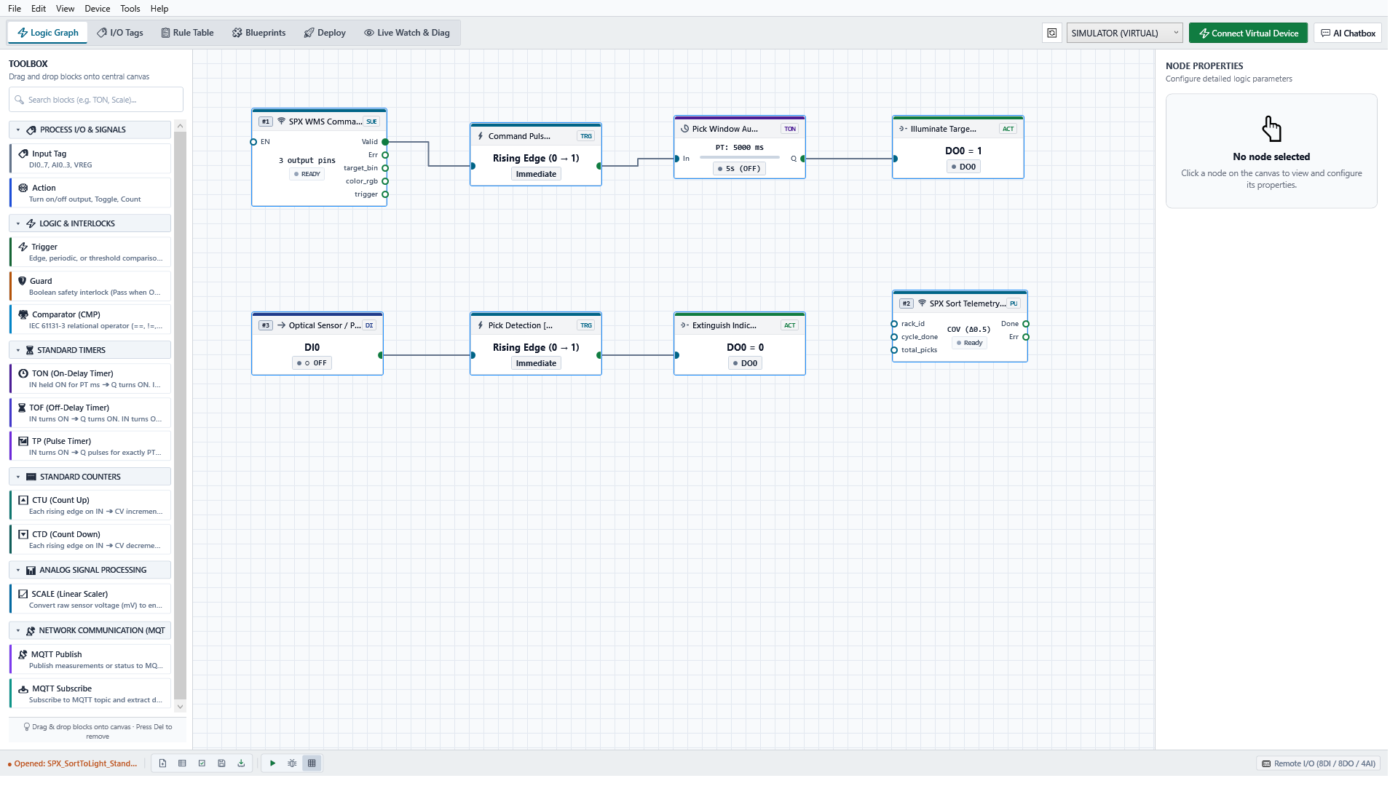
Figure: SynaptiX Studio Standard Logic Editor. Displaying orthogonal dual-network layout: Row 1 (WMS Command Ingestion -> 5s TON Timer -> Bin Illumination) and Row 2 (Optical Sensor -> Extinguish Indicator -> Telemetry Dispatch).
4.2 Centralized Tag Catalog & Real-Time Register Space
Unified Address Space: SynaptiX Studio maintains a single, transparent Tag Catalog organizing physical I/O channels, virtual registers, and communication flags. Shift technicians can view and force values live for fast on-site verification:
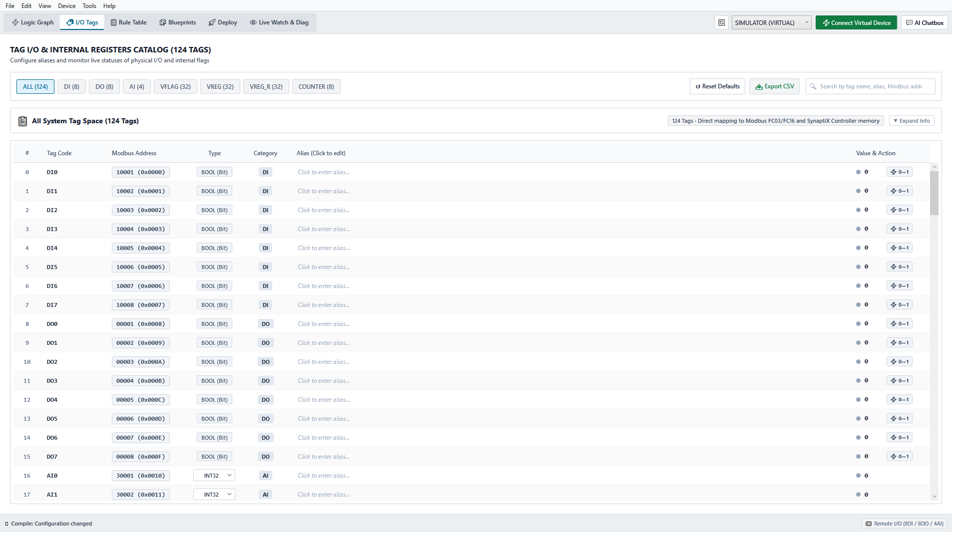
Figure: SynaptiX Studio Unified Tag Catalog (124 Tags). Centralized mapping of physical digital I/Os, virtual flags (VFLAG), and retentive holding registers with live status toggling.
4.3 Instant Multi-Rack Fleet Replication via Blueprint Library
1-Click Multi-Hub Rollout: Deploying 26 racks across 5 cities poses a major configuration risk if done manually. SynaptiX Studio eliminates configuration drift through its industrial Blueprint Library. A validated 'SPX Sort-to-Light Golden Template' is packaged once and deployed across all racks with zero manual rewiring:
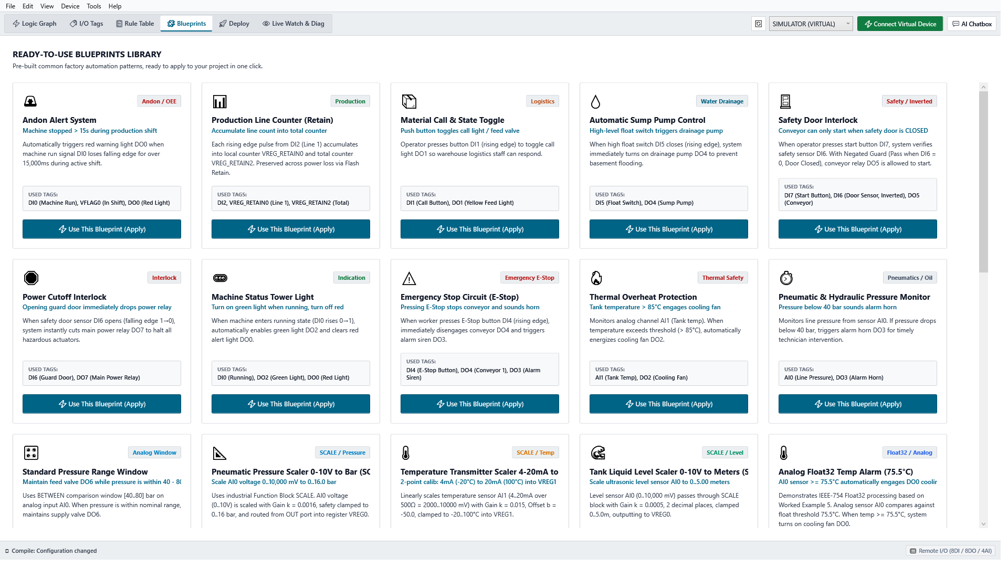
Figure: SynaptiX Studio Pre-Engineered Blueprint Library. Reusable, validated industrial templates ready for instantaneous multi-facility replication.
4.4 Zero-Downtime Hot Staging Deployment (The 5-Step Safety Gate)
Uninterrupted Hot Deployment: Updating sorting rules during live warehouse operations normally risks bricking controllers or interrupting sorting lanes. SynaptiX Studio introduces an enterprise-grade 5-Stage Staged Atomic Commit Pipeline:
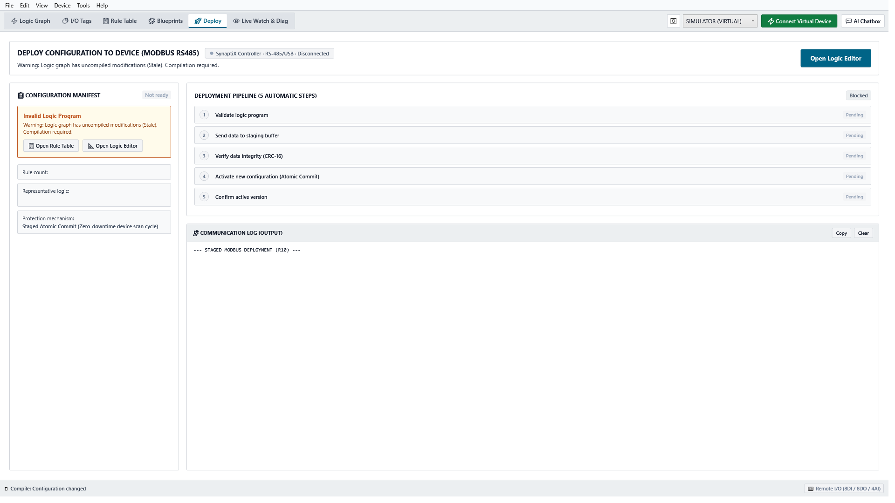
Figure: SynaptiX Studio 5-Step Deployment Pipeline. Featuring Pre-flight Rule Validation, Staged RAM Buffer Upload, CRC-16 Verification, and Sub-Millisecond Atomic Pointer Swap.
Phase | Deployment Stage | Operational Safeguard & Technical Mechanism
Stage 1 | Static Rule & Cycle Validation | Studio compiler verifies rule grammar, circular dependencies, and tag boundaries. Prevents flawed logic from leaving the engineering workstation.
Stage 2 | Staged RAM Buffer Upload | New rule binaries are transmitted over Wi-Fi into an isolated staging buffer in controller RAM. The active sorting engine continues executing the old rules without pause.
Stage 3 | Hardware CRC-16 Checksum | The MCU performs an independent hardware CRC-16 calculation over the staging buffer. Any packet corruption or transmission dropped byte triggers an immediate abort.
Stage 4 | Sub-Millisecond Atomic Commit | Studio issues the atomic commit key (0xA5A5). In a single CPU clock cycle (< 1ms), the MCU swaps memory pointers to activate the new logic seamlessly.
Stage 5 | Active Version Acknowledgement | Controller returns the new active checksum to Studio. Zero parcels are dropped, and zero operator downtime occurs.

5. High Availability, Safety Mechanisms & Service Level Agreement
Industrial Fault Tolerance: Warehouse operations cannot tolerate frozen equipment during high-volume parcel sortation. Our solution integrates multi-tiered safety watchdogs and hot-swappable field modularity:
5.1 Triple Watchdog Safety Architecture
- 1. Broker Disconnect Watchdog: If warehouse Wi-Fi drops or the MQTT broker is unreachable for > 5000ms, GatewayV2 shifts the rack to amber warning beacon mode, notifying workers while preventing mis-directed parcel drops.
- 2. Inter-Module Lease Watchdog: The Remote I/O slave continuously monitors Modbus register 0x0A20. If GatewayV2 fails to refresh the heartbeat within 3000ms, the slave automatically blanks all 18 LED modules to eliminate ghost indications.
- 3. Hardware Task Watchdog: Independent hardware watchdog (IWDG) automatically restarts the microcontroller within 15 milliseconds in the rare event of brownout or voltage sag.
5.2 Sub-3-Minute Mean Time to Repair (MTTR)
Rapid Field Hot-Swap: If a rack controller suffers physical damage from a hand truck or pallet jack collision, our modular DIN-rail architecture guarantees restoration in under 3 minutes:
- 1. Technician snaps damaged module off DIN-rail and unplugs pre-keyed terminal blocks (no screwdrivers or soldering required).
- 2. Snaps new pre-provisioned spare module onto DIN-rail and plugs in terminal blocks (45 seconds).
- 3. SynaptiX Studio automatically recognizes the new module MAC address, transmits the rack's golden profile wirelessly, and resumes live sorting (under 90 seconds total).
6. Multi-Site Pilot Rollout & Commissioning Roadmap (5 SOCs)
Standardized Deployment Methodology: To ensure flawless execution across all 26 racks in 5 fulfillment hubs, our engineering team adheres to a structured, repeatable site commissioning protocol:
Fulfillment Center (SOC) | Rack Qty | Target Regional Coverage | Site Commissioning Window
Ha Noi Mega SOC | 8 Racks | Northern Primary Fulfillment Hub | Phase 1: Week 1 (4 Days)
Hung Yen SOC | 6 Racks | Red River Delta Logistics Hub | Phase 1: Week 2 (3 Days)
Vinh SOC | 4 Racks | North-Central Distribution Hub | Phase 2: Week 3 (2 Days)
Dien Khanh SOC | 4 Racks | South-Central Coastal Hub | Phase 2: Week 3 (2 Days)
Buon Ma Thuot (BMT) SOC | 4 Racks | Central Highlands Regional Hub | Phase 2: Week 4 (2 Days)

■ PLUG-AND-PLAY DEPLOYMENT ASSURANCE
Standardized On-Site Commissioning (15 Mins / Rack): Each kit is fully pre-assembled, burned-in, and pre-addressed at our factory. On-site installation requires only: 1) Mounting DIN-rail enclosure to rack base, 2) Clipping 3 LED aluminum bars along shelf beams, 3) Connecting AC power & verifying Wi-Fi signal. Rack is certified operational in 15 minutes.

7. Value Proposition & Comparative ROI
Strategic Solution Comparison: The matrix below summarizes the decisive operational and financial advantages of our industrial solution compared to traditional ad-hoc prototype builds:
Evaluation Criterion | Traditional DIY Prototype Build | SynaptiX Turnkey Industrial Solution
Control Architecture | Single ESP32 handling Wi-Fi + LED waveforms. High risk of timing freeze. | 1:1 Decoupled Dual-Module (GatewayV2 + Remote I/O over RS-485). 100% decoupled.
Warehouse Rule Changes | Requires firmware developer to modify C/C++ code, re-compile and flash. | SynaptiX Studio zero-code FBD editor. Warehouse staff configure in minutes.
Multi-Rack Rollout | Manual USB flashing rack-by-rack across 26 racks in 5 provinces. | One-click deployment via SynaptiX Blueprint Library across all 5 SOCs.
Deployment Safety | Full flash overwrite. Risk of bricking rack mid-shift during Wi-Fi drops. | 5-Step Staged Atomic Commit with CRC-16 and sub-millisecond pointer swap.
Optical Ergonomics | Bare point-source LEDs. Operator eye strain and glare during long shifts. | Anodized aluminum profiles with frosted PMMA diffusers. 160° glare-free glow.
Signal Integrity | Bare 3.3V GPIO driving 5m wires. Signal degradation and flicker. | Active 74AHCT125 5V TTL level shifter + 33Ω damping + TVS surge protection.
Fleet Observability | Zero remote visibility. Faults only discovered when operator complains. | Real-time MQTT telemetry, live tag watch table, and automatic alert notifications.
Mean Time to Repair (MTTR) | > 2 Hours (unsoldering, rewiring, manual microcontroller programming). | < 3 Minutes (tool-less DIN-rail snap swap with pre-keyed connectors).

■ TENDER SUMMARY & PARTNERSHIP VISION
Summary Conclusion: Our proposed solution provides SPX Logistics with an industrial, future-proof Sort-to-Light infrastructure. By combining ruggedized edge hardware with the intuitive SynaptiX Studio platform, SPX gains the operational agility to adapt sorting rules in minutes, eliminate sorting errors, and effortlessly scale from the 26-rack pilot to hundreds of sorting hubs nationwide.

