TECHNICAL PROPOSAL & SYSTEM SPECIFICATION
Next-Generation Industrial Sort-to-Light System
Enterprise Edge Hardware Architecture & SynaptiX Studio Zero-Code Automation Platform for Fulfillment Centers
Target Client: | SPX Logistics Vietnam (Shopee Express Fulfillment Operations)
Pilot Deployment Scope: | 26 Sorting Racks across 5 Primary SOCs (BMT, Vinh, Dien Khanh, Hung Yen, Ha Noi)
Document Classification: | Engineering Proposal & Architectural Specification (Ref: SPX-STL-PROP-2026-V1)
Solution Platform: | SynaptiX Studio Industrial Automation Platform & GatewayV2 Edge Controller

■ EXECUTIVE PROPOSITION
This proposal delivers an end-to-end industrial automation solution engineered specifically for SPX Logistics Sort-to-Light operations. By integrating our industrial GatewayV2 edge controllers with the SynaptiX Studio visual automation suite, we replace fragile DIY prototype firmware with a robust, zero-code, fail-safe edge architecture capable of sustaining 24/7 high-throughput parcel sorting with zero downtime.

1. Executive Summary & Technical Vision
Operational Context: Modern high-velocity sorting hubs operate under stringent throughput quotas where sorting delays, mis-sorts, or workstation downtime directly inflate cost-per-parcel and degrade end-customer delivery SLAs. During mega-sales campaigns (such as 11.11, 12.12, or Lunar New Year peaks), parcel processing density at regional SOCs surges by over 300%, requiring continuous 24/7 sorting reliability without unexpected line stoppages.
The Maintenance Bottleneck: In conventional Sort-to-Light deployments, edge controllers are frequently built upon ad-hoc microcontroller boards running hard-coded, monolithic firmware. When sorting requirements evolve (such as altering LED timeout windows, switching pick/put logic, adjusting indicator colors for VIP packages, or adding audio beepers), warehouse technicians cannot modify the system on-site. Any minor change necessitates a software developer to rewrite C/C++ firmware, recompile binaries, and physically flash microcontrollers over USB cables across 26 independent sorting racks.
The Solution Paradigm: Our proposed technical solution eliminates this operational liability through an integrated, dual-pillar automation architecture:
- 1. Industrial Edge Hardware Layer (GatewayV2 + Remote I/O): Decouples cloud/broker connectivity (Wi-Fi 2.4GHz + MQTT Client) from field bus actuation (RS-485 Modbus RTU). A physical hardware separation guarantees that transient Wi-Fi packet drops or broker reconnections will never freeze high-speed LED timing signals.
- 2. SynaptiX Studio Automation Platform: Eliminates low-level embedded coding entirely. Warehouse automation engineers design, simulate, verify, and wirelessly deploy sorting rules using intuitive Function Block Diagrams (FBD) with 5-stage CRC-16 atomic verification and zero line downtime.
2. End-to-End System Architecture
System Topology: The proposed architecture establishes a resilient 3-tier topology connecting the enterprise WMS/Sorting Server directly down to each individual parcel bin indicator across the 26 pilot racks.
Tier | System Layer | Technical Function & Communication Role
Tier 1 | SPX WMS & Sorting Server | Dispatches real-time pick/put routing commands via MQTT broker (spx/sort_to_light/rack_xx/cmd). Ingests rack telemetry, pick timestamps, and diagnostics.
Tier 2 | GatewayV2 Edge Controller (Rack Master) | Industrial DIN-rail gateway per rack. Subscribes to broker commands, parses JSON payloads via SynaptiX Rule Engine, and commands local Remote I/O over Modbus RTU (RS-485).
Tier 3 | Smart Remote I/O Slave & IC16703 LED Bus | Dedicated real-time microcontroller driving 18 addressable IC16703 LED modules across 3 rack tiers via 74AHCT125 level-shifter with Mean Well 12V 75W PSU.

2.1 The 1:1 Dual-Module Rack Architecture (Hardware Decoupling)
Architectural Principle: Rather than forcing a single microcontroller to juggle high-level TCP/IP networking, TLS handshakes, JSON deserialization, AND nanosecond-precise LED bit-banging simultaneously, our solution deploys a physically isolated 1:1 master-slave architecture per rack:
- GatewayV2 (Edge Master): Manages enterprise Wi-Fi 2.4GHz communication, TLS encryption, MQTT pub/sub queues, and executes the SynaptiX deterministic Rule Engine.
- Smart Remote I/O (Actuation Slave): Dedicated slave board isolated on an industrial RS-485 bus (Modbus RTU @ 115,200 baud). Handles the 800 kHz precision waveform generation required by IC16703 / WS2811 LED driver chips without CPU interruption.
■ RELIABILITY ASSURANCE
Physical separation of the networking engine from the hardware actuation layer completely eliminates the notorious 'LED flicker and freeze' problem caused by Wi-Fi background interrupts in single-chip designs. Even if the warehouse Wi-Fi fluctuates or reconnects, active LED indicators remain perfectly stable and responsive.

2.2 Standardized Modbus RTU Inter-Module Contract
Data Contract: The GatewayV2 communicates with the Remote I/O slave using an open, deterministic Modbus RTU register mapping over shielded RS-485. This ensures vendor-independence and transparent diagnostic observability:
Address | Register Type | Data Format | Engineering Function
0x0001 - 0x0012 | Holding Register | UINT16 (18 Regs) | Bin 1 to 18 Target State (0=OFF, 1=ON, 2=Blink Fast, 3=Blink Slow)
0x0020 - 0x0032 | Holding Register | UINT16 (RGB565) | Bin 1 to 18 Color Mapping (Packed RGB values per cell)
0x0050 | Holding Register | UINT16 (ms) | Global Auto-Timeout Timer (0 = Latched, 1000..30000ms Auto-Off)
0x0A00 | Holding Register | UINT16 (Bitmask) | Module Diagnostics & Overcurrent / Over-temperature Warning
0x0A20 | Holding Register | UINT16 (Heartbeat) | Safety Watchdog Lease Register (Must refresh every 3000ms)

3. The Signature Platform: SynaptiX Studio
Zero-Code Industrial Engineering: The cornerstone of our technical solution is SynaptiX Studio—our enterprise industrial automation suite. SynaptiX Studio empowers SPX fulfillment engineering teams to commission, configure, simulate, and supervise Sort-to-Light racks without touching a single line of embedded source code.
3.1 Step 1: Visual Logic Wiring & Dynamic MQTT Ingestion
Visual Canvas Workflow: In SynaptiX Studio, sorting automation logic is constructed visually on an industrial Function Block Diagram (FBD) canvas. Instead of writing custom JSON parsing loops in firmware, engineers simply drag the [MQTT SUB] block and connect it directly to standard IEC 61131-3 functional blocks:
- Native MQTT Subscribe Node: Listens to 'spx/sort_to_light/rack_01/cmd' with automatic JSONPath extraction. Extracts target cell ID ($.bin_id), RGB color values ($.color.r, $.color.g, $.color.b), and execution trigger ($.trigger).
- Edge Detect Trigger (ON_RISE): Extracts the rising edge of the sorting command to trigger immediate parcel allocation.
- Pick Window Timer (TON 5s): Enforces a strict 5000ms operational window. If an operator picks the parcel, the light turns off; if no action occurs within 5 seconds, the timer safely resets the indicators.
- Telemetry Publisher (MQTT PUB): Publishes real-time rack heartbeat, active bin ID, and cycle timestamps back to SPX central operations over MQTT telemetry.
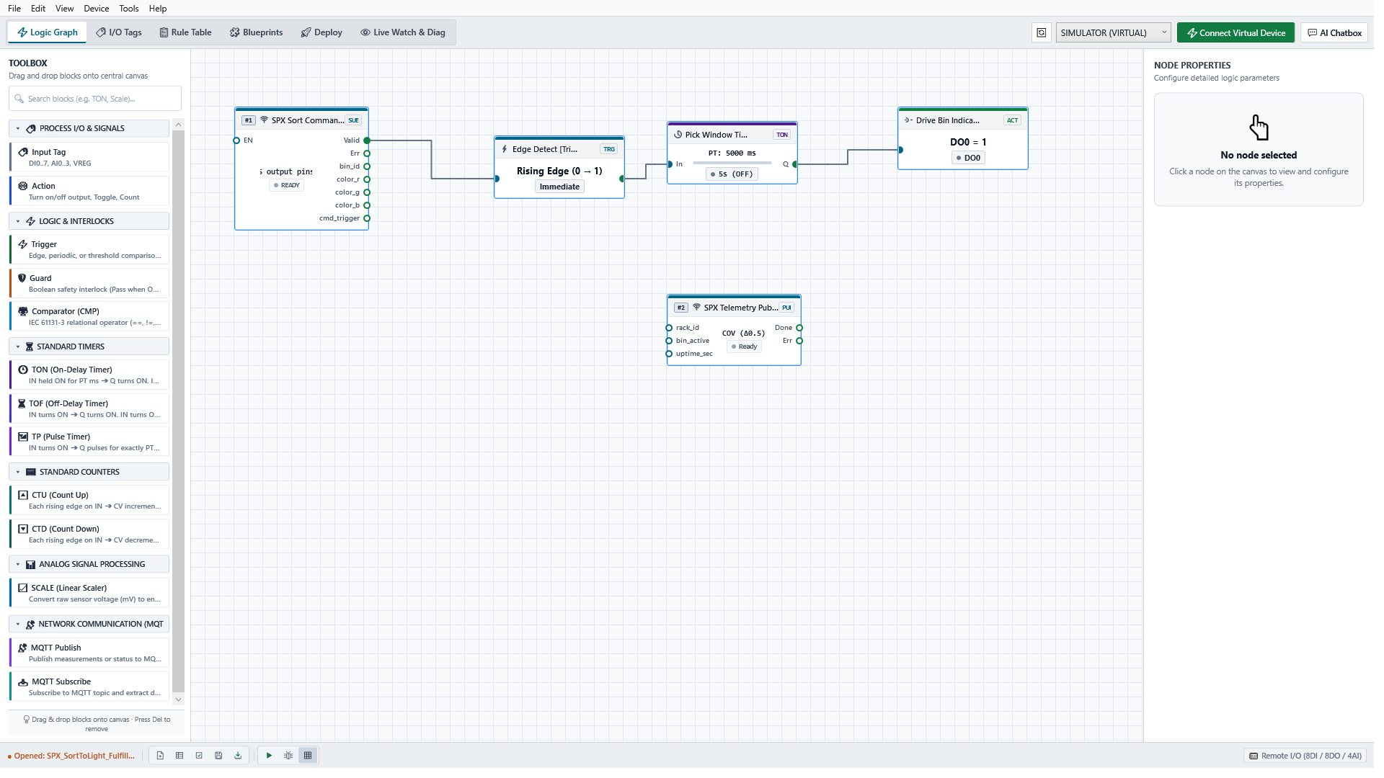
Figure: SynaptiX Studio Logic Graph Editor configured for SPX Sort-to-Light Rack #01. Showing visual pipeline: MQTT Subscriber -> Edge Trigger -> 5s TON Timer -> DO0 Actuation -> Telemetry Publisher.
3.2 Step 2: Unified Tag Catalog & Pre-Engineered Blueprints
Centralized Memory Management: SynaptiX Studio centralizes all physical hardware channels and virtual registers into a structured Tag Space. Every physical output, virtual flag, and communication register is mapped directly to standardized Modbus addresses with human-readable aliases and real-time values:
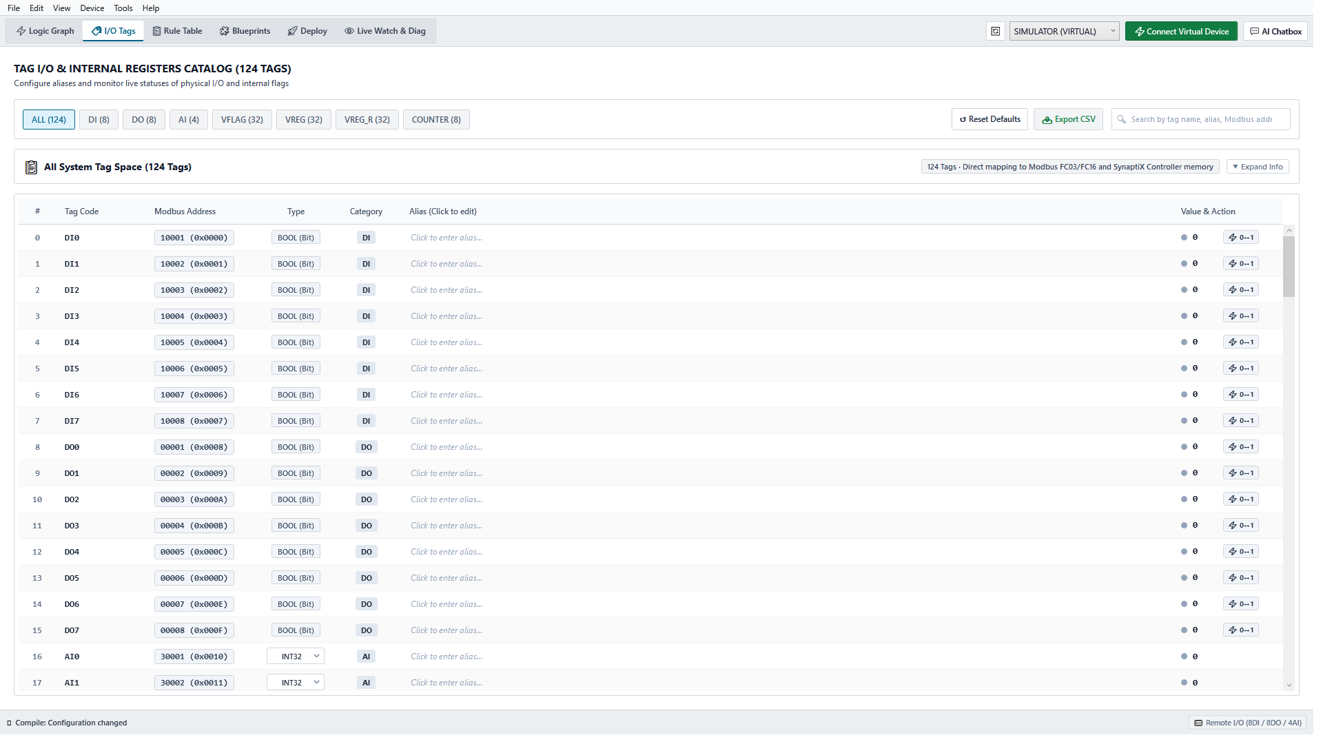
Figure: SynaptiX Studio Unified Tag Catalog (124 Tags). Direct mapping of physical I/Os, virtual flags (VFLAG), and retentive holding registers with live status toggling.
Rapid Template Duplication: To ensure rapid deployment across 26 sorting racks, SynaptiX Studio provides a pre-engineered Blueprint Library. Automation engineers can select the 'SPX Sort-to-Light Standard' blueprint and instantiate a validated, safety-checked configuration onto any rack controller in less than 60 seconds:
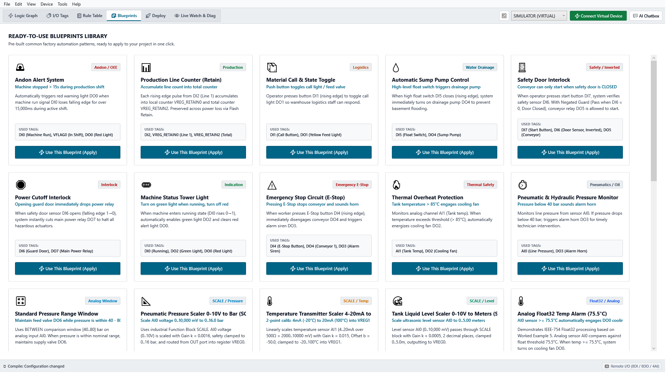
Figure: SynaptiX Studio Industrial Blueprint Library. Standardized logic templates (Andon, Logistics Calling, Production Counters) ready for instantaneous multi-rack deployment.
3.3 Step 3: Zero-Downtime Deployment Gate (The 5-Step Safety Pipeline)
Industrial Safety Gate: A catastrophic failure mode in typical warehouse IoT systems occurs when a firmware flash is interrupted midway by a power flicker or Wi-Fi drop, leaving edge controllers bricked and sorting racks dead in the middle of a shift. SynaptiX Studio eliminates this risk through an automated 5-Step Staged Atomic Commit Pipeline:
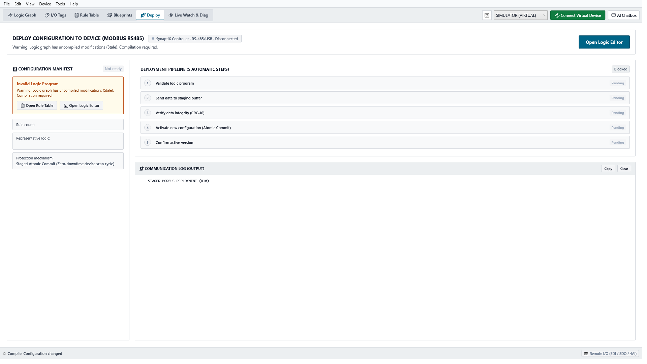
Figure: SynaptiX Studio 5-Step Deployment Pipeline. Featuring Staged Buffer Upload, CRC-16 Integrity Verification, and Atomic Magic Commit for zero-downtime hot updates.
Step | Deployment Stage | Verification & Fail-Safe Protection
Step 1 | Rule & Grammar Validation | SynaptiX compiler inspects topological rule dependencies, cycle detection, and tag range constraints. Rejects invalid logic before transmission.
Step 2 | Staged Buffer Upload (0x9010) | Rules are transmitted into an isolated staging buffer in MCU RAM. The active sorting engine continues running the current rules without interruption.
Step 3 | CRC-16 Integrity Checksum | The MCU calculates a 16-bit CRC over the staging buffer and compares it against the Studio compiler hash. Any corrupted bit aborts the transaction.
Step 4 | Atomic Magic Commit (0xA5A5) | Studio writes the atomic authorization key (0xA5A5) to register 0xA000. In a single scan cycle (sub-1ms), the MCU swaps pointers to activate the new logic.
Step 5 | Active Version Confirmation | MCU confirms the active rule checksum and notifies Studio. The rack transition completes with zero sorting downtime.

4. Edge Hardware Implementation & Field Wiring
Industrial Ruggedization: While SynaptiX Studio provides software intelligence, the physical edge hardware is engineered to withstand demanding warehouse electrical and thermal environments:
4.1 Power Architecture & Safety Margins
Power Budget Analysis: Each rack is powered by an industry-standard Mean Well LRS-75-12 power supply (12V DC, 6.0A, 75W output). The power budget for the 18 LED modules is rigorously calculated:
- Module Current Draw: Each IC16703 LED module draws 0.06A @ 12V (0.72W max at 100% full white illumination).
- Total Rack LED Consumption: 18 modules × 0.72W = 12.96W total full-load power.
- Control Electronics Power: Controller & Gateway idle power: 3.5W.
- PSU Utilization: (12.96W + 3.5W) / 75W = 21.9% load factor. Over 78% headroom remains, providing a 5.7× safety margin that prevents power supply overheating and ensures MTBF > 300,000 hours.
4.2 Signal Integrity & Level Shifting Protection
Noise Immunity Measures: Driving high-speed serial LED data lines (800 kHz) across 3 horizontal rack tiers (total harness length ~4.5 meters) introduces substantial capacitive loading and electromagnetic noise from adjacent conveyor motors. Our design implements three strict signal integrity protections:
- 1. Active 74AHCT125 Level Shifter: Converts 3.3V MCU CMOS outputs to sharp, true 5V TTL logic levels with high drive current (±25mA), ensuring rapid rise times (<10ns) across the harness.
- 2. Impedance Matching: Each LED data line includes a 33Ω series damping resistor at the transmitter to suppress transmission line ringing and signal overshoot.
- 3. TVS Surge & ESD Clamping: Data lines and 12V DC power are protected with bidirectional TVS diodes (SMAJ5.0A / SMAJ15A) against electrostatic discharge (ESD) and inductive spikes from warehouse machinery.
5. Industrial Safety, Fail-Safe Mechanisms & Operational SLA
Graceful Degradation: Industrial automation systems in logistics must handle edge exceptions gracefully without operator confusion. Our solution incorporates multi-level fail-safe engines:
5.1 Triple Watchdog Safety Architecture
- 1. Cloud/Broker Disconnect Watchdog: If Wi-Fi drops or the MQTT broker becomes unreachable for > 5000ms, the GatewayV2 automatically switches rack status to safe mode (pulsing amber tower light), signaling operators that the rack is offline while preventing stale parcel allocations.
- 2. Inter-Module Lease Watchdog: The Remote I/O slave continuously monitors Modbus register 0x0A20. If GatewayV2 fails to renew the heartbeat within 3000ms, the LED driver automatically blanks all 18 LED modules to eliminate ghost indications.
- 3. Hardware Task Watchdog: Internal STM32/ESP32 hardware independent watchdog (IWDG) triggers an instant microsecond reset in the rare event of firmware task lockup.
5.2 Maintenance & MTTR Reduction
Modular Field Serviceability: In the event of physical damage to an edge controller (e.g., impact from a hand truck), our modular DIN-rail design enables sub-3-minute replacement (MTTR < 3 min). A technician snaps a replacement module onto the DIN rail, plugs in the pre-keyed terminal blocks, and SynaptiX Studio automatically recognizes the hardware, flashes the rack's golden profile wirelessly, and resumes operations.
6. Value Proposition & Comparative Matrix
Solution Comparison: The table below contrasts the traditional DIY prototype approach against the proposed SynaptiX Industrial Automation Solution:
Technical Criterion | Traditional DIY Prototype | SynaptiX Industrial Solution
Control Architecture | Single ESP32 juggling Wi-Fi, MQTT & LED waveforms. Prone to timing freeze. | 1:1 Dual-module (GatewayV2 + Smart Remote I/O over RS-485). 100% decoupled.
Logic Customization | Requires embedded C/C++ developers to re-code, re-compile and flash USB. | SynaptiX Studio zero-code FBD editor. Warehouse technicians configure in minutes.
Deployment Safety | Full firmware reflash. Risk of bricking rack mid-shift during Wi-Fi glitch. | 5-Step Staged Atomic Commit with CRC-16 staging and sub-millisecond pointer swap.
Signal Integrity | Bare 3.3V GPIO driving 5m wires. Signal degradation, flicker and ghost LEDs. | 74AHCT125 true 5V TTL level shifting + 33Ω damping + TVS surge protection.
Multi-Rack Scalability | Manual one-by-one USB flashing across 26 racks in 5 SOCs. | One-click deployment via SynaptiX Blueprint Library. Rapid rollout to 100+ racks.
Telemetry & Observability | Basic print logs over serial monitor. No remote health monitoring. | Full MQTT telemetry (uptime, pick cycle times, live watch table & diagnostics).
Mean Time to Repair (MTTR) | > 2 hours (soldering, breadboard rewiring, manual code reloading). | < 3 minutes (modular DIN-rail hot-swap, pre-keyed industrial screw terminals).

■ COMMERCIAL & TECHNICAL CONCLUSION
By adopting SynaptiX Studio and the GatewayV2 edge architecture, SPX Logistics secures an enterprise-grade automation infrastructure capable of scaling effortlessly from the current 26 pilot racks to hundreds of sorting lines nationwide. We deliver 99.9% sorting uptime, zero-code operational agility, and complete peace of mind during fulfillment peak seasons.

