Click on the project name to get into the project.

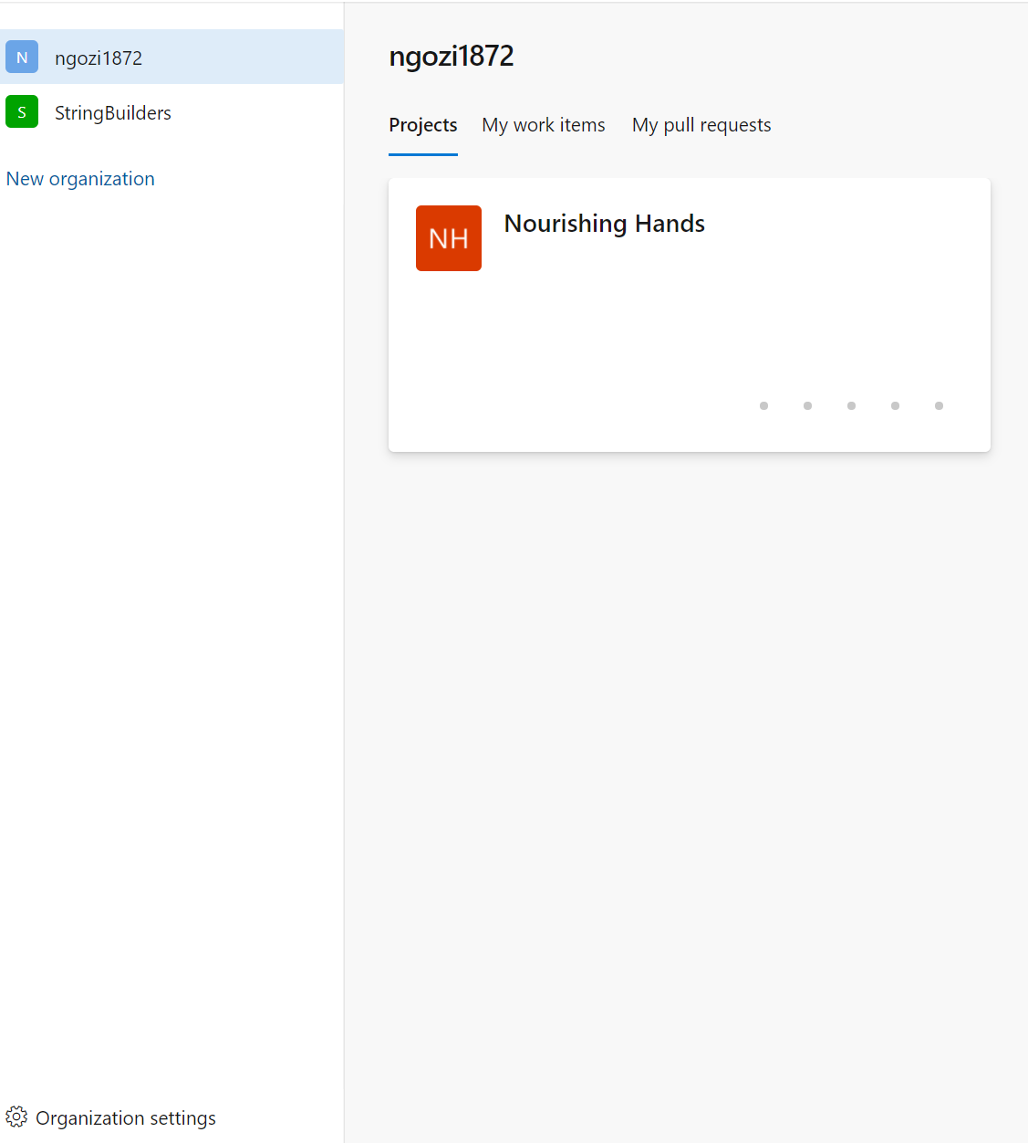

On the side menu bar, click on Boards.

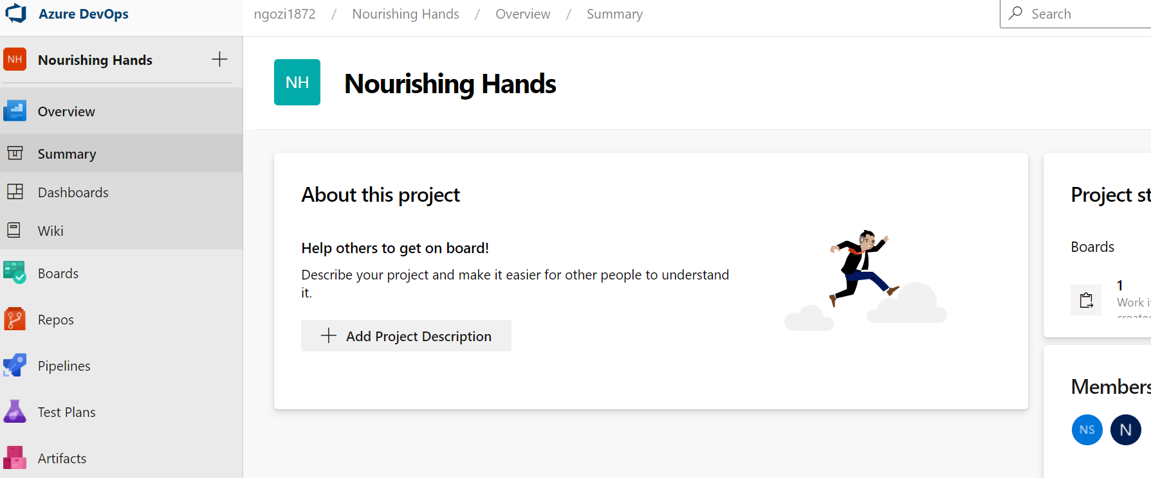

Click on Backlogs

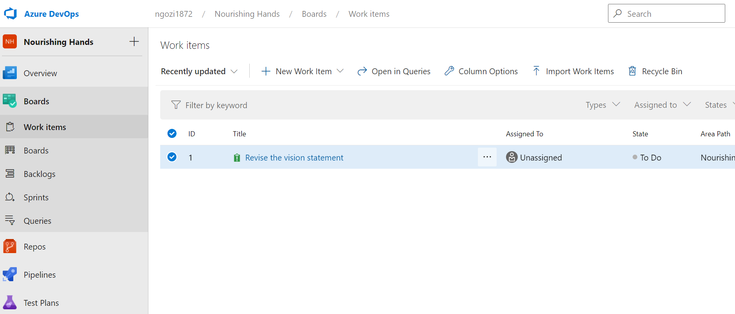

Click on New Work Item



A pop up window opens, here you can enter the task title

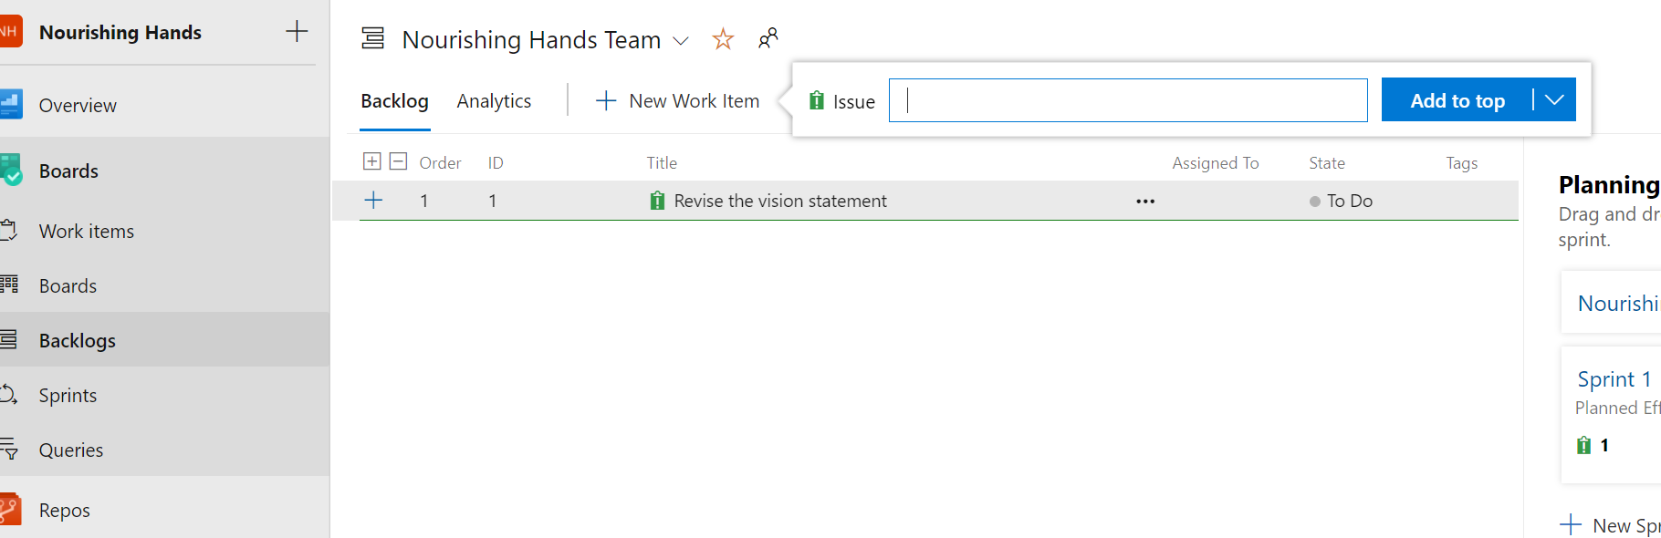

See example, click on title to edit add document, verbiage etc.

