**State of the Art of Adaptive Learning**

Christoph Fröschl

Graz University of Technology, A-8010 Graz, Austria

Email: christoph.froeschl@gmail.com

Loc Nguyen

University of Science, Ho Chi Minh, Vietnam

Email: ng_phloc@yahoo.com

Phung Do

University of Information Technology, Ho Chi Minh, Vietnam

Email: dtminhphung@yahoo.com

### Abstract

The traditional learning with live interactions between teacher and students has achieved many successes but nowadays it raises the demand of personalized learning when computer and internet are booming. Learning is mostly associated with activities involving computers and interactive networks simultaneously and users require that learning material/activities should be provided to them in suitable manner. This is origin of adaptive learning domain. For this reason, the adaptive learning system (ALS) must have ability to change its action to provide learning content and pedagogic environment/method for every student in accordance with her/his individual characteristics. Adaptive systems are researched and developed for a long time; there are many kinds of them. So it is very difficult for researchers to analyze them. In this study report, I collect scientific resources to bring out an overview of adaptive learning systems along with their features. Main reference is the master thesis “User Modeling and User Proﬁling in Adaptive E-learning Systems” of author Christoph Fröschl. I express my deep gratitude to the author Christoph Fröschl for providing her/his great research.

**Keywords**: adaptive learning, user model, learner model, intelligent tutoring system, adaptive educational hypermedia system, AEHS.

### 1. Introduction

The term *adaptive* is defined as “able to change when necessary in order to deal with different situations” (Fröschl, 2005, p. 11). In learning context, the adaptive learning system must have ability to change its action to provide learning content and pedagogic environment/method for every student in accordance with her/his individual characteristics such as knowledge, goal, experience, interest, background... when these characteristics vary from person to person and are structured in user model or learner model (Fröschl, 2005, p. 27). Recall that user model or learner model is constructed from these characteristics. Therefore, adaptive leaning systems tailor learning material to user information available in learner model. The survey of existing adaptive systems is represented in this study report.

Section 2 is to classify existing adaptive systems in their development history. Two modern and popular systems: Intelligent Tutoring System (ITS) and Adaptive Educational Hypermedia System (AEHS) are described in sections 3 and 4; each system is surveyed entirely and enclosed with specific example. Section 5 is the conclusion of existing ITS and AEHS. Note that there is a strong relationship between user model (learner model) and adaptive learning system when adaptive learning system takes advantages of user model (learner model) so as to make adaptation effects and hence, please pay attention that user model (learner model) is the heart of modern adaptive system such as ITS and AEHS.

### 2. Classification of adaptive learning systems

Along with the progress of adaptive learning research, there are five main trends of adaptive systems (Fröschl, 2005, pp. 14-18):

* Macro-adaptive system
* Micro-adaptive system
* Aptitude-treatment interactions system (ATI)
* Intelligent tutoring system (ITS)
* Adaptive Hypermedia System (AHS) or Adaptive Educational Hypermedia System (AEHS)

These systems are introduced in successive as below.

**Macro-adaptive system**

The early researches on adaptive learning intend to adapt the instructional performances to students on the macro level. Such system is called macro-adaptive system (Fröschl, 2005, p. 14). Students are classified into groups by grades from tests. Students in the same group have similar adaptive instruction. To identify each student with her/his group leads to the poor adaptation. Besides, the groups rarely receive different adaptive instruction.

**Aptitude-treatment interactions system (ATI)**

As known, e-learning environment serves many persons but is required to be appropriate to each individual. This system adapts specific instructional strategies to specific student’s characteristics (aptitudes) such as knowledge, learning styles, intellectual abilities, and cognitive styles. ATI also permits user to control partially or totally the learning process (Mödritscher, Garcia-Barrios, & Gütl, 2004) (Fröschl, 2005, p. 14). User can control learning instruction or content presentation in course. Researches prove that successful level of user’s control depends on her/his aptitudes.

**Micro-adaptive system**

This system, so-called micro-adaptive performs adaptivities on micro level since it discovers and analyzes individuals need to provide user the appropriate instructions (Mödritscher, Garcia-Barrios, & Gütl, 2004) (Fröschl, 2005, p. 15). When student is ongoing learning process, system observes and diagnoses continuously his/her activities (Mödritscher, Garcia-Barrios, & Gütl, 2004). System’s efficiency is evaluated on how much the adaptive procedures are tailored to user’s needs.

**Intelligent tutoring system (ITS)**

ITS which is the hybrid approach coordinates aspects of micro-adaptive system and ATI. ITS is implemented by artificial intelligence methods. It aims to resemble the situation in which teacher and student sit down one-on-one and attempt to teach and learn together. ITS considers both user’s aptitudes and user’s needs. This is the first system applying user modeling techniques. Hence, user information is collected and structured more comprehensively. By the possibility of inferring new information from user model, ITS can perform prominently adaptive strategies. ITS is subdivided into four main components (Mayo, 2001, p. 3) (Fröschl, 2005, p. 16): domain expert, user modeler, tutoring module and user interface which have respective functions (see section 3).

**Adaptive Hypermedia System (AHS)**

AHS (Fröschl, 2005, p. 17) has also been researched for a long time until now, which is the next generation of ITS. AHS combines adaptive instructional systems (macro-adaptive, ATI, micro-adaptive, ITS) and hypermedia systems. For openers, we should glance over what is hypermedia. Hypertext is defined as a set of nodes of text which are connected by links; each node contains some amount of information (text) and a number of links to other nodes (Henze, 2005, p. 11). Hypermedia is an extension of hypertext, which makes use of multiple forms of media, such as text, video, audio, and graphics (Henze, 2005, p. 11).

Author (Brusilovsky, 1996, p. 1) stated that “AHS can be useful in any application area where the system is expected to be used by people with different goals and knowledge and where the hyperspace is reasonably big. User with different goals and knowledge may be interested in different pieces of information presented on a hypermedia page and may use different links for navigation”. In short, AHS uses the user model containing personal information about her/his goals, interests, and knowledge to adapt the content and navigation in hypermedia space; so it aims to two kinds of adaptation: adaptive presentation and adaptive navigation (see section 4). For example, if user is a novice, system gives more annotations about the lecture which she/he is studying.

**Adaptive Educational Hypermedia System (AEHS)**

AEHS is specific AHS applied in learning context. Hypermedia space in AEHS is re-organized and tracked strictly. Moreover, it is kept large enough to be appropriate for teaching because user will be involved in trouble when navigating if hypermedia space is too large. There is separate knowledge space including knowledge items; each item is mapped to hypermedia in hypermedia space. Both knowledge space and hypermedia space constitute the document space. An AEHS consists of document space, user model, observations and adaptation component (Karampiperis & Sampson, 2005, p. 130). We will survey AEHS instead of AHS in section 4.

### 3. Intelligent Tutoring System (ITS)

Formerly, intelligent tutoring system (ITS) and artificial intelligence (AI) are areas which have been researched separately. AI developed fast in 1960’s; Alan Turing (<http://en.wikipedia.org/wiki/Alan_Turing>) thought that computer can “think” as human. Education becomes the fertile ground for applying AI methods since computer plays the role of human teacher. More and more people attend distance courses in the universities and they want to become self-taught mans who prefer a lifelong study; so computer is the best choice. Early ITS is the Computer Assisted Instructional (CAI) system that was generative (Urban-Lurain, 2002). CAI system provides instruction aiming to improve students’ skill. It gives students content presentation and records their learning performance but does not care about the knowledge students gained.

User not attached special importance in CAI system becomes the main object in the overall system in the next researches. The system no longer gives only one instructional pattern to all students; it wants to know what types of student are considered and determines which instructions should be presented adaptively to each individual. So, ITS is directed to modeling user. The first modeling approach is stereotype classifying users into groups of characteristics.

The rapid progress in AI supports many powerful mathematical tools for inference. The demand of reasoning new assumptions out of available information in user model is satisfied by using such tools. User’s knowledge, needs and aptitudes are included in user model. Until now, ITS is evolved and distinguish from previous CAI system. The implicit assumption about the learner now focused on *learning-by-doing*. ITS is classified as being computer-based, problem-solving monitors, coaches, laboratory instructors and consultants (Urban-Lurain, 2002). The available information in user model, especially knowledge becomes more and more important.

#### 3.1. Architecture of ITS

As discussed, ITS is the modern system since it inherits all strong points of micro-adaptive system, ATI and CAI. ITS has components expressing content taught, adaptive procedures and techniques for collecting, storing user characteristics and inferring new assumptions from them. General architecture of ITS shown in figure 3.1.1 (Mayo, 2001, p. 3) is constituted of four main parts such as domain expert, user modeler, pedagogical module, and user interface as follows:

* *Domain expert* (Mayo, 2001, p. 2) is responsible for structuring, storing and manipulating knowledge space (domain knowledge). The quality of domain knowledge depends on domain expert; it varies from teaching strategies to a considerable amount of knowledge available in learning course. Knowledge space contents many knowledge items which student must be mastered in course. Domain expert supports directly pedagogical module to perform adaptive functions.
* *User modeler* (Mayo, 2001, p. 3) constructs and manages user information represented by user model. This includes long-term information: goals, demography information, mastered knowledge, etc. and short-term information: whether or not students do exercises, visit a web site, etc. User modeler also interacts with pedagogical module to catch and log user’s tasks. User model can be stored in relation database (Ramakrishnan & Gehrke, 2003, pp. 25-94) or XML files (W3C, Extensible Markup Language (XML) 1.0 (Fifth Edition), 2008). User model has critical role; if it is bad in that it does not express solidly user’s characteristics, the pedagogical module cannot make decisions in proper way.
* *Pedagogical module* also called tutoring module or didactics moduleis the centric component in ITS, which adapts instructional procedures to students. This module makes decisions about the teaching process relating to the next problem selection, next topic selection, adaptive presentation of error messages, and selective highlighting or hiding of text (Mayo, 2001, p. 3). Pedagogical module co-operates with the user modeler and domain expert to draw information about domain knowledge and user when making decisions. Pedagogical module is the heart of ITS, whose characteristics are summarized in sub-section 3.2.
* *User interface* is the component taking full responsibility for user-machine interaction. The user interface is rather necessary when it proposes user-friendly environment and gives motivation for student to learn (Mayo, 2001, p. 4). If other parts raise error or do not work properly, user interface can notice or guide user to overcome troubles when using ITS. The interface can improve learning by reducing the cognitive load. While three other parts focus on learning and adaptive procedures, the user interface aims to users.

**Domain Expert**

**Pedagogical Module**

**Interface**

Domain Knowledge

Pedagogical Knowledge

**Student Modeler**

Student Models

Student

**Figure 3.1.1.** General Architecture of ITS

#### 3.2. Characteristics of pedagogical module

Author (Wenger, 1987) stated that “when learning is viewed as successive transitions between knowledge states, the purpose of teaching is accordingly to facilitate the student’s traversal of the space of knowledge states”, referred from (Urban-Lurain, 2002). According to (Wenger, 1987), the core of ITS – pedagogical module provides two main adaptive tasks (makes decisions): diagnosis and didactics.

* *Diagnosis*: The ITS “diagnoses” students’ states as three levels (Urban-Lurain, 2002):
* *Behavioral level*: Learner’s knowledge is ignored but her/his behavior is observed (Urban-Lurain, 2002).
* *Epistemic level*: Learner’s knowledge state is inferred from her/his observed behavior (Urban-Lurain, 2002).
* *Individual level*: Learner’s personal traits, motivational style, self-concept relevant to the domain, etc. are considered (Urban-Lurain, 2002). At this level, students become active learners.
* *Didactics* is the “delivery” aspect of teaching (Urban-Lurain, 2002), which is also referred as making decisions process. The author (Wenger, 1987) claimed that didactics is implemented according to four principles:
* *Plans of action* are used to guide learner and provide the context for diagnostic operations (Urban-Lurain, 2002).
* *Strategic contexts*: in which the plans of action are implemented (Urban-Lurain, 2002).
* *Decision base* contains rules for dispatching learning and system resources according to pre-defined constraints (Urban-Lurain, 2002).
* *Target level* of the student model: selecting the level at which the teaching takes place (Urban-Lurain, 2002). Depending on user state level, the pedagogical module will make appropriate instructional decisions.

#### 3.3. An example of ITS: ANATOM-TUTOR

As the name suggests, ANATOM-TUTOR developed by author (Beaumont, 1994) is the ITS used for anatomy education (specifically for brain, including the visual system, the pupillary light reflex system and the accommodation reflex system). Three important components in ANATOM-TUTOR are ANATOM knowledge base, the didactic module, and the user modeling component corresponding to three modules in the general architecture of ITS: domain expert, pedagogical module and user modeler.

The knowledge base contains anatomical concepts represented in frame-based formalism (Beaumont, 1994, p. 30). Concepts associated to their relations are located in the concept hierarchy. The reasoning is executed by built-in mechanism.

The user modeling component shown in figure 3.3.1 (Beaumont, 1994, p. 35) applies stereotype method to build up user model. First, system classifies users when they answer the initial questions at the start of course. This task will activate default stereotype for individual. Each user’s stereotype is refined frequently by surveying and reasoning from observations.

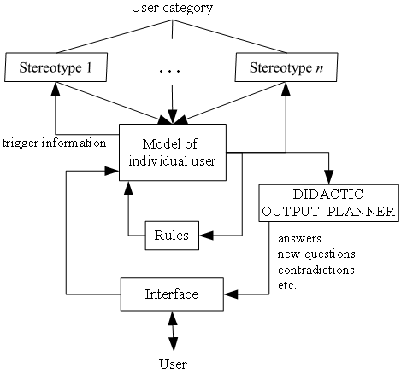

**Figure 3.3.1.** User modeling component in ANATOM-TUTOR

The didactic module “teaches” user by providing the adaptive knowledge in form of lessons, explanation, etc. There are two kinds of teaching knowledge (Beaumont, 1994, p. 30):

* Global teaching knowledge refers to the general structure of a lesson (Beaumont, 1994, p. 30).
* Local teaching knowledge refers here to what to do when a student gets into difficulties (Beaumont, 1994, p. 30).

There are many ITS systems but ANATOM-TUTOR is given as typical example because its knowledge base, user model and pedagogical module have coherent interaction with built-in reasoning mechanism. Moreover, medical teaching is worthy to be attached special importance due to humanity.

### 4. Adaptive Educational Hypermedia System (AEHS)

Adaptive Educational Hypermedia System (AEHS) inherits basic components of ITS in respect of implementation but takes advantage of plentiful supplies of learning material in hypermedia space. It is possible to understand that AEHS is specific AHS (see section 2) that serves educational purpose. Adaptation is ability to change system’s behaviors to tune with learner model. When hypermedia is the combination of hypertext and multimedia, AEHS can be known as the system providing learner with learning material in form of hypertext and multimedia like hyper book and electronic book tailored to learner’s preference. According to (Brusilovsky, 1996, pp. 10-13), there are two forms of adaptation: adaptive presentation and adaptive navigation:

* *Adaptive presentation* refers to the information which is shown, in other word, what is shown to the user. Figure 4.1 depicts adaptive presentation (Brusilovsky, 2001, p. 100).
* *Adaptive navigation* refers to manipulation of the links, thereby; user can navigate through in hypermedia. In other word, it is where user can go. Figure 4.2 depicts adaptive presentation (Brusilovsky, 2001, p. 100).

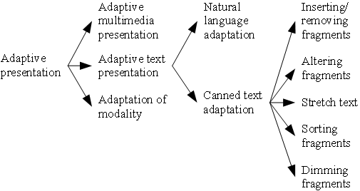

**Figure 4.1.** Adaptive representation

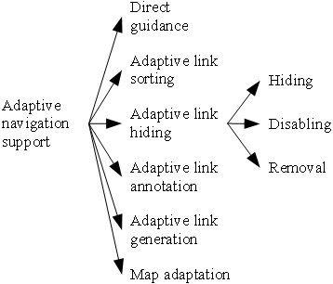

**Figure 4.2.** Adaptive navigation

Canned text adaptation (De Bra, Stash, & Smits, 2005, p. 4) is the most important case of adaptive presentation. It focuses on processing adaptive text parts called as fragments. There are three main kinds of text adaptation:

* *Conditional text*: Fragments are inserted, removed, altered and dimmed when certain conditions relating user characteristics are met.
* *Stretch text*: Some keywords of document are replaced by longer descriptions according to user’s knowledge.
* *Sorting fragments*: Fragments are sorted according to their relevance for the user.

Adaptive navigation (De Bra, Stash, & Smits, 2005, p. 5) supports some following cases of navigations:

* *Direct guidance*: guiding user sequentially through the hypermedia system by two methods:

1. Next best: providing a suitable next link.
2. Page sequencing or trails generate a reading sequence through hypermedia space.

* *Adaptive link sorting*: sorting links of hypermedia due to their relevance for user.
* *Adaptive link hiding*: limiting the navigational possibilities by hiding links not suitable to user. Link hiding is implemented by making it invisible or disabling it or removing it.
* *Link annotation*: showing users hints to the content of the pages which the links point to. The annotation might be text, icon or traffic light metaphor. The metaphor is displayed as a colored ball which is annotated the link pointing to a document in hypermedia space. For example, the red ball indicates that document is not recommended to user. The yellow ball has the same meaning to red ball but it is less strict than red ball. The green ball hints that document should be recommended to user. The grey ball indicates that user has already known this document.
* *Link generation*: generating appropriate links so that system prevents user from getting involved in large hyperspace.
* *Map adaptation*: graphical overviews of adaptive links.

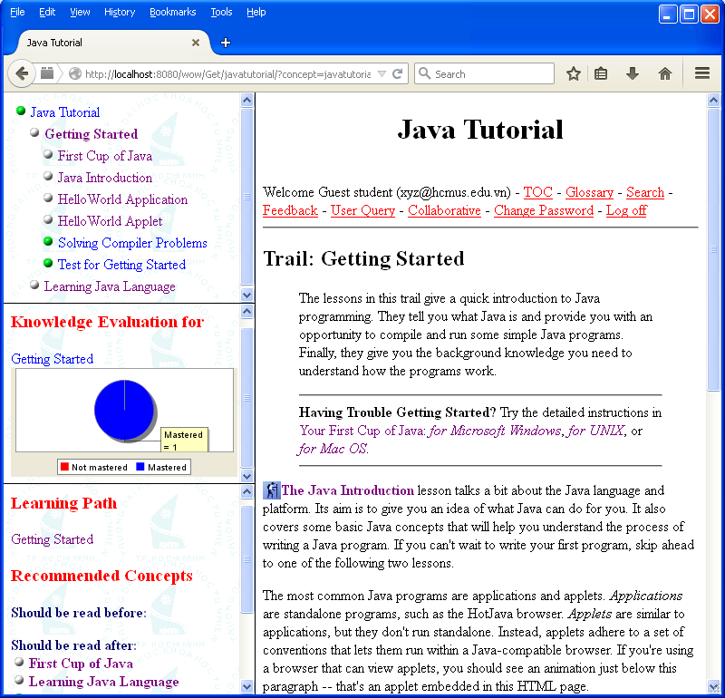

**Figure 4.3.** A typical example of adaptive navigation

The left pane of figure 4.3 shows a typical example of adaptive navigation.

#### 4.1. Architecture of AEHS

In general, the architecture of AEHS shown in figure 4.1.1 (Karampiperis & Sampson, 2005, p. 130) has two layers: *runtime layer* and *storage layer*. Runtime layer has responsibility for presenting adaptive learning material to user and observing user in order to update learner model. Storage layer is the main engine which controls adaptive process with some tasks as follows:

* Initialize and update learner model.
* Choose concepts in domain model, educational resource in Media Space by selection rules.
* Store learning resources, domain ontology, learner model, etc.

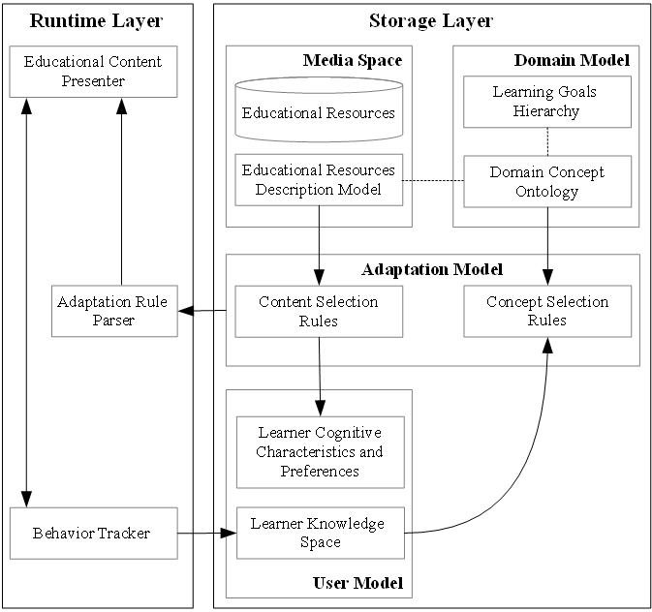

**Figure 4.1.1.** General architecture of AEHS

As seen in general architecture, storage layer has four models:

* *Media space*: contains learning resources and associated descriptive information (metadata). Learning resources such as lectures, tests, examples, and exercises are often stored as hypertext and hypermedia like (x)html files (W3C, XHTML™ 1.1 - Module-based XHTML - Second Edition, 2010).Media space is also called resource model.
* *Domain model*: constitutes the structure of domain knowledge. Domain model was often shown in form of graph. Nowadays, researchers intend to build domain model according to ontology (Wikipedia, Ontology (information science), 2014).
* *Adaptation model*: is the centric component which gives effect to adaptation. It contains concept selection rules and content selection rules. Concept selection rules are used to choose appropriate concepts from domain model. On the other hand, we apply content selection rules into choosing suitable educational resource from medial model. These rules must tune with user model so that the selection gets correct.
* *User model*: contains information and data about user.

The generalized system of AEHS is adaptive education system (AES) in which it is not required to store learning resources in hypermedia space but AEHS is the most popular adaptive learning system. Note that main content of AEHS here is copied partially from the other study report “Learner Model in Adaptive Learner” (Nguyen & Do, 2008).

#### 4.2. Characteristics of AEHS

AEHS has many variants in implementation; each of them conforms to specific requirements conditional upon application. It is very difficult to characterize such domain-dependent variants if it has no common language for describing AEHS. Authors (Henze & Nejdl, 2004) use first-order logic (FOL) to define a language for comparing and analyzing AEHS. Therefore, an AHES is a quadruple (DOCS, UM, OBS, AC).

**DOCS** (Henze & Nejdl, 2004, p. 4) refers both hypermedia space and knowledge structure (domain model). DOCS contains the documents which are organized in accordance with domain model representing all relationships between documents. Each document associated with information / learning material in hypermedia space such as text, hypertext, and audio has the identifier denoted *doc_id*. There are logical predicates that show the relationships of documents in domain model. For example (Henze & Nejdl, 2004):

* Predicate *part_of*(*doc_id*1, *doc_id*2) means that *doc_id*2 is a part of *doc_id*1.
* Predicate *preq*(*doc_id*1, *doc_id*2) means that *doc_id*2 is prerequisite of *doc_id*1.
* Predicate *is_a*(*doc_id*1, *doc_id*2) expresses the taxonomy on documents.
* Predicate *is_dependent*(*doc_id*1, *doc_id*2) expresses the dependencies between documents.

So, every document is considered as knowledge element or topic, which is the basic unit in DOCS.

**UM** (Henze & Nejdl, 2004, p. 4) is responsible for managing information about user such as knowledge, goals, and learning styles. In short, UM has below functions:

* Initialization is the process which gathers information and data about user and constructs user model from this information.
* Updating user model by using observations OBS.
* Reasoning new information about user out from available data in user model.

User models are classified into: stereotype model, overlay model, differential model, perturbation model, and plan model. For example, the domain (in DOCS) is decomposed into a set of elements and the overlay model is simply a set of masteries over those elements.

Each element in UM represents a user, which is denoted logically by identifier *user_id*. Characteristics assigned to user are expressed by predicates: *has_property*(*user id*, *characteristic x*), *has_property*(*user id*, *characteristic x*, *value*). The very important characteristic “knowledge” is expressed by predicates (Henze & Nejdl, 2004, p. 4):

* Predicate *know*(*doc_id*, *user_id*): tells us whether user knows document.
* Predicate *know*(*doc_id*, *user_id*, *value*):tells us amount of knowledge user has on document. The variable *value* refers the user’s knowledge level.

**OBS** (Henze & Nejdl, 2004, p. 5).Both system’s runtime behaviors concerning to user and user’s interaction with system are monitored and recorded as observations OBS. For example, how users did the test, whether users visited course web pages and how long users studied online are considered as observations OBS used to update user model. Hence, the objects of OBS for modeling observations are the users and observations. Suppose systems recognized that user *user_id* visited the document *doc_id*; this observation is expressed by predicates such as *obs*(*doc_id*, *user_id*) and *obs*(*doc_id*, *user_id*, *value*). The following predicate is more complex, in which the *value* can tell us how many times user visited the document.

**AC** (Henze & Nejdl, 2004, p. 5), the most important (adaptive) component, contains rules supporting adaptive procedures. In other words, adaptive functionality is a set of rules describing AEHS’s runtime behaviors. Suppose there is a functionality which is to decide whether or not recommend a document for learning to student. This functionality which belongs to the group determining the learning state of documents is described as the rule: “student should learn a document if she/he has already visited (learned) all prerequisites of this document. This rule is expressed as FOL predicate (Henze & Nejdl, 2004, p. 5):

$$∀user_id,∀{doc_id}_{1}\left(∀{doc_id}_{2},preq\left({doc_id}_{1},{doc_id}_{2}\right)⇒obs\left({doc_id}_{2},user_id,visited\right)\right)⟹learning_state\left({doc_id}_{1},user_id,recommended_for_reading\right)$$

#### 4.3. An example of AEHS: Adaptive Hypermedia for All (AHA!)

**A**daptive **H**ypermedia for **A**ll (AHA!) developed by author Paul De Bra (De Bra & Calvi, 1998) is a Java-based open source software which is based on Dexter Hypertext Reference Model (Halasz & Schwartz, 1990, p. 3) and aims to general-purpose adaptive hypermedia system. The AHA! architecture so-called AHAM complies with the standards of general architecture of AEHS, please the architecture of AEHS in sub-section 4.1. The reference model AHAM (De Bra, Houben, & Wu, 1999, p. 3) has three layers: runtime layer, storage layer, within-component layer.

* Runtime layer has the same function to user interface module of ITS, which interacts with users. This layer must be implemented according to specifications in “Presentation specifications” (De Bra, Houben, & Wu, 1999, p. 3).
* Storage layer which is the heart of AHA! has three models: domain model (DM), user model (UM), adaptation model (AM). These models are managed by AHA! engine discussed later.
* Within-component layer describes the internal data objects, e.g. the resources (x)html (W3C, XHTML™ 1.1 - Module-based XHTML - Second Edition, 2010) linked to concepts. AHA! accesses these objects through “anchoring”.

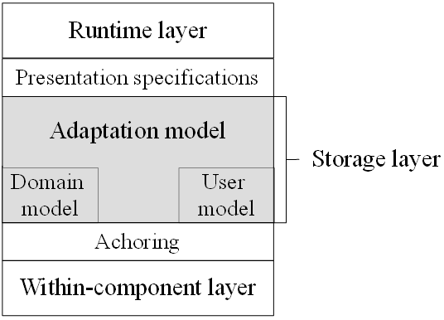

**Figure 4.3.1.** AHAM – The architecture of AHA!

The implemented framework of AHA! (De Bra, Smits, & Stash, 2006) is constituted of Java web server, connection servlets (Java Servlet, 2014) and AHA! engine. When users request a concept / document, the engine will return adaptive learning material consisting of (x)html pages, possibly other media objects. In brief, AHA!, a web-based system, receives user HTTP request (Wikipedia, Hypertext Transfer Protocol, 2014) and sends back HTTP response containing adaptive instructions. Figure 4.3.1 (De Bra, Houben, & Wu, 1999, p. 3) and figure 4.3.2 (De Bra, Smits, & Stash, 2006) depict the architecture AHAM and the implemented framework of AHA!, respectively.

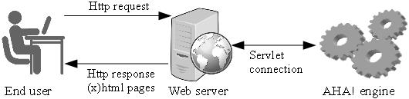

**Figure 4.3.2.** Implemented framework of AHA!

**The AHA! engine** (De Bra, Smits, & Stash, 2006) manipulates three main models as below:

* Domain model (DM) contains domain concepts associated with web learning resources. The relationships between concepts are also specified.
* User model (UM) describes user information. UM is built up by applying overlay modeling approach. Hence, UM is the mastered subset of DM.
* Adaptation model (AM) contains adaptive rules; each rule is associated with a domain concept and used to update UM when executing.

The combination of DM and AM represents a model of the conceptual structure of the application. So AHA! engine has responsibility for executing rules, updating user model and filtering retrieved resources. The AHA! engine is shown in figure 4.3.3 (De Bra, Smits, & Stash, 2006).

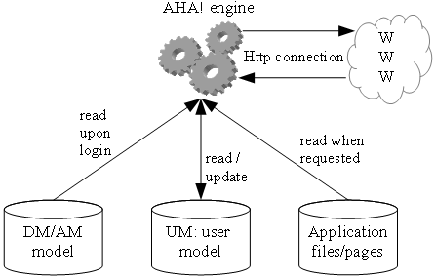

**Figure 4.3.3.** AHA! engine

Moreover, AHA! engine also manages application files, resource files in (x)html. DM, UM and AM are store in relation database (Ramakrishnan & Gehrke, 2003, pp. 25-94) or XML files (W3C, Extensible Markup Language (XML) 1.0 (Fifth Edition), 2008). The engine manipulates them through three abstract tiers (De Bra, Smits, & Stash, 2006) as below:

* Concept tier: to create concepts, find concepts and link concepts to resources.
* Profile tier: to create user profiles, find a profile and destroy profiles. Note that AHA! identifies user profile with user model.
* Log tier: to record user’s interactions with system, e.g. where and when user accessed some concepts.

**Adaptive procedure** is processed by the engine described above. The interaction between user and AHA! happens through HTTP protocol; whenever users send the HTTP request since the click on the link in course pages, adaptive process occurs as following steps (De Bra, Smits, & Stash, 2006):

1. Finding the request *concept* in DM and getting the resource (web pages, exercises, tests, etc.) associated with this concept.
2. Retrieving UM.
3. Executing adaptive rules (in AM) attached to the request concept. These rules will update attributes of UM (users’ characteristics). The executing process spreads over AM since the update can trigger other rules associated with updated attributes. So this process continues until no rule is triggered.
4. The resources associated with request concept are retrieved and filtered by adaptive rules in AM so that they are suitable to users (tuned to UM).

### 5. Conclusion of existing ITS and AEHS

We already described architecture and basic features of adaptive learning systems in which ITS and AEHS are researched and developed continuously nowadays. When AEHS and ITS are compared together, their architectures are very similar. For example, adaptation component in AEHS “plays the role” of pedagogical module in ITS. However, AEHS has some prominent advantages when it makes use of web technology. Hypermedia space in AEHS is more plentiful and convenient with non-linear navigation than knowledge space in ITS. Moreover, the interface in AEHS is more friendly than ITS due to using web page and HTTP protocol (Wikipedia, Hypertext Transfer Protocol, 2014) as means of interaction between user-machine in learning environment. That client-server architecture is implemented perfectly in AEHS through HTTP protocol will provide user the collaborative environment in e-learning; learners can share their experiments over network.

AEHS has some variants such as Adaptive Educational Web-Based System (AEWBS) and Adaptive Educational Intelligent Web-Based System (AEIWBS) focusing on web technology and artificial intelligence techniques but the ideology of such variants does not go beyond AEHS. So, I don’t include them in this study report.

### References

Beaumont, I. H. (1994). User Modeling in the Interactive Anatomy Tutoring System ANATOM-TUTOR. (A. Kobsa, Ed.) *User Modeling and User-Adapted Interaction, 4*(1), 21-45.

Brusilovsky, P. (1996). Methods and Techniques of Adaptive Hypermedia. (A. Kobsa, Ed.) *User Modeling and User-Adapted Interaction, 6*(2-3), 87-129.

Brusilovsky, P. (2001). Adaptive Hypermedia. *User Modeling and User-Adapted Interaction, 11*(1-2), 87-110.

De Bra, P., & Calvi, L. (1998). AHA! An open Adaptive Hypermedia Architecture. (D. Tudhope, & D. Cunliffe, Eds.) *The New Review of Hypermedia and Multimedia, 4*(1), 115-139.

De Bra, P., Houben, G.-J., & Wu, H. (1999). AHAM: A Dexter-based Reference Model for Adaptive Hypermedia. In J. Westbomke, U. K. Wiil, & J. J. Leggett (Ed.), *Proceedings of 10th ACM Conference on Hypertext and hypermedia: eturning to our diverse roots: returning to our diverse roots (Hypertext '99)* (pp. 147-156). Darmstadt, Germany: ACM Press.

De Bra, P., Smits, D., & Stash, N. (2006). The Design of AHA! In U. K. Wiil, P. J. Nürnberg, & J. Rubart (Ed.), *Proceedings of the seventeenth ACM Hypertext Conference on Hypertext and hypermedia (Hypertext '06)* (pp. 171-195). Odense, Denmark: ACM Press.

De Bra, P., Stash, N., & Smits, D. (2005). Creating Adaptive Web-Based Applications. In L. Ardissono, P. Brna, & T. Mitrovic (Ed.), *Tutorial at the 10th International Conference on User Modeling.* Edinburgh, Scotland: Springer-Verlag Berlin, Heidelberg.

Fröschl, C. (2005). *User Modeling and User Profiling in Adaptive E-learning Systems.* Master Thesis, Graz University of Technology, Austria.

Halasz, F. G., & Schwartz, M. (1990). The Dexter Hypertext Reference Model. In J. Moline, D. Benigni, & J. Baronas (Ed.), *Proceedings of the NIST Hypertext Standardization Workshop* (pp. 95-133). National Institute of Standards and Technology, Gaithersburg, Maryland, USA.

Henze, N. (2005). *Personalization for the World Wide Web.* Lecture Notes, Reasoning Web Summer School, University of Hannover, Germany.

Henze, N., & Nejdl, W. (2004). A Logical Characterization of Adaptive Educational Hypermedia. (P. Brusilovsky, & P. De Bra, Eds.) *New Review of Hypermedia and Multimedia (NRHM), 10*(1), 77-113.

Karampiperis, P., & Sampson, D. (2005). Adaptive Learning Resources Sequencing in Educational Hypermedia Systems. (C.-K. Looi, & Kinshuk, Eds.) *Educational Technology & Society, 8*(4), 128-147.

Mayo, M. J. (2001). *Bayesian Student Modelling and Decision-Theoretic Selection of Tutorial Actions in Intelligent Tutoring Systems.* PhD Thesis, University of Canterbury, New Zealand.

Mödritscher, F., Garcia-Barrios, V. M., & Gütl, C. (2004). The Past, the Present and the Future of adaptive E-Learning. *Proceedings of the International Conference Interactive Computer Aided Learning (ICL2004).*

Nguyen, L., & Do, P. (2008). Learner Model in Adaptive Learning. *The 2018 World Congress on Science, Engineering and Technology (WCSET2008).* *35*, pp. 396-400. Paris, France: World Congress on Science, Engineering and Technology (WASET). Retrieved from https://www.researchgate.net/publication/282679719_Learner_Model_in_Adaptive_Learning

Ramakrishnan, R., & Gehrke, J. (2003). *Database Management Systems* (3rd Edition ed.). New York, USA: McGraw-Hill Higher Education.

Urban-Lurain, M. (2002). *Intelligent Tutoring Systems: An Historic Review in the Context of the Development of Artificial Intelligence and Educational Psychology.* Lecture Notes on course CSE 101, Michigan State University, Computer Science and Engineering.

W3C. (2008, November 26). *Extensible Markup Language (XML) 1.0 (Fifth Edition)*, 1.0. (T. Bray, J. Paoli, C. M. Sperberg-McQueen, E. Maler, F. Yergeau, Editors, & World Wide Web Consortium) Retrieved September 17, 2014, from W3C website: http://www.w3.org/TR/2008/REC-xml-20081126/

W3C. (2010, November 23). *XHTML™ 1.1 - Module-based XHTML - Second Edition*, 1.1. (S. McCarron, M. Ishikawa, M. Altheim, S. McCarron, Editors, & World Wide Web Consortium) Retrieved September 28, 2014, from W3C website: http://www.w3.org/TR/2010/REC-xhtml11-20101123

Wenger, E. (1987). *Artificial Intelligence and Tutoring Systems: Computational and Cognitive Approaches to the Communication of Knowledge.* (J. T. Ritschdorff, Ed.) San Francisco, California, USA: Morgan Kaufmann Publishers Inc.

Wikipedia. (2014, September 14). *Hypertext Transfer Protocol*. (Wikimedia Foundation) Retrieved September 15, 2014, from Wikipedia website: http://en.wikipedia.org/wiki/Hypertext_Transfer_Protocol

Wikipedia. (2014, September 12). *Java Servlet*. (Wikimedia Foundation) Retrieved September 15, 2014, from Wikipedia website: http://en.wikipedia.org/wiki/Java_Servlet

Wikipedia. (2014, August 28). *Ontology (information science)*. (Wikimedia Foundation) Retrieved September 17, 2014, from Wikipedia website: http://en.wikipedia.org/wiki/Ontology_(information_science)