**Learner Model in Adaptive Learning**

Christoph Fröschl

Graz University of Technology, A-8010 Graz, Austria

Email: christoph.froeschl@gmail.com

Loc Nguyen

University of Science, Ho Chi Minh, Vietnam

Email: ng_phloc@yahoo.com

Phung Do

University of Information Technology, Ho Chi Minh, Vietnam

Email: dtminhphung@yahoo.com

## Abstract

Every student has individual features such as knowledge, goals, experiences, interests, backgrounds, personal traits, learning styles, learning activities, and study results. User model or learner model is constructed from these features. The process to build up learner model is called user modeling process or learner modeling process. Adaptive learning system uses learner model to make adaptation. In other words, adaptive learning system takes advantages individual information available in learner model in order to tailor learning materials (lessons, exercises, tests, etc.) and teaching methods to each student. Anyway, learner model is very important to adaptive learning system and other adaptive applications. This study report focuses on learner model, which is extracted from the master thesis “User Modeling and User Proﬁling in Adaptive E-learning Systems” of author Christoph Fröschl. I express my deep gratitude to the author Christoph Fröschl for providing her/his great research.

**Keywords**: learner model, user model, user modeling, learner modeling, adaptive learning.

## 1. Introduction

Formerly, learning management systems (Wikipedia, Learning management system, 2014) such as Moodle (About Moodle - the open source learning platform, 2014) and Sakai (About Sakai Project, 2014) support well for interaction between learner and lesson, learner and teacher. However, every student has individual features such as knowledge, goals, experiences, interests, backgrounds, personal traits, learning styles, learning activities, and study results. So, there is emergent demand for tailoring learning materials such as lessons, exercises, tests to each student. This is personalized learning or adaptive learning process and the system which supports such process was called *adaptive learning system*. Thus, adaptive learning system is able to change its action to provide both learning contents and pedagogic environment/methods appropriate to each student. Adaptive system bases on the “description of learner’s properties” called *user model* or *learner model* so as to make adaptation. In other words, adaptive learning system tunes learning materials and teaching methods to learner model. It is easy to recognize that learner model contains aforementioned features such as knowledge, goals, experiences, interests, backgrounds, personal traits, learning styles, learning activities, study results. The process which gathers information to build up learner model and update it was named: *user modeling* or *learner modeling*. The system that performs user modeling process and manages user model is called *user modeling system*. User model and user modeling system are main subjects in this study report.

Hereafter, section 2 is a short introduction of adaptive learning system. Section 3 focuses on learner model which is the main subject of this study report. Section 4 is conclusion.

## 2. Adaptive Learning System

The term *adaptive* is defined as “able to change when necessary in order to deal with different situations” (Fröschl, 2005, p. 11). In learning context, the adaptive learning system must have ability to change its action to provide learning content and pedagogic environment/method for every student in accordance with her/his individual characteristics such as knowledge, goal, experience, interest, background... when these characteristics vary from person to person and are structured in user model or learner model (Fröschl, 2005, p. 27). Recall that user model or learner model is constructed from these characteristics. Therefore, adaptive leaning systems tailor learning material to user information available in learner model.

Along with the progress of adaptive learning research, there are five main trends of adaptive systems (Fröschl, 2005, pp. 14-18):

* Macro-adaptive system
* Micro-adaptive system
* Aptitude-treatment interactions system (ATI)
* Intelligent tutoring system (ITS)
* Adaptive Hypermedia System (AHS) or Adaptive Educational Hypermedia System (AEHS)

These systems are introduced in successive as below.

**Macro-adaptive system**

The early researches on adaptive learning intend to adapt the instructional performances to students on the macro level. Such system is called macro-adaptive system (Fröschl, 2005, p. 14). Students are classified into groups by grades from tests. Students in the same group have similar adaptive instruction. To identify each student with her/his group leads to the poor adaptation. Besides, the groups rarely receive different adaptive instruction.

**Aptitude-treatment interactions system (ATI)**

As known, e-learning environment serves many persons but is required to be appropriate to each individual. This system adapts specific instructional strategies to specific student’s characteristics (aptitudes) such as knowledge, learning styles, intellectual abilities, and cognitive styles. ATI also permits user to control partially or totally the learning process (Mödritscher, Garcia-Barrios, & Gütl, 2004) (Fröschl, 2005, p. 14). User can control learning instruction or content presentation in course. Researches prove that successful level of user’s control depends on her/his aptitudes.

**Micro-adaptive system**

This system, so-called micro-adaptive performs adaptivities on micro level since it discovers and analyzes individuals need to provide user the appropriate instructions (Mödritscher, Garcia-Barrios, & Gütl, 2004) (Fröschl, 2005, p. 15). When student is ongoing learning process, system observes and diagnoses continuously his/her activities (Mödritscher, Garcia-Barrios, & Gütl, 2004). System’s efficiency is evaluated on how much the adaptive procedures are tailored to user’s needs.

**Intelligent tutoring system (ITS)**

ITS which is the hybrid approach coordinates aspects of micro-adaptive system and ATI. ITS is implemented by artificial intelligence methods. It aims to resemble the situation in which teacher and student sit down one-on-one and attempt to teach and learn together. ITS considers both user’s aptitudes and user’s needs. This is the first system applying user modeling techniques. Hence, user information is collected and structured more comprehensively. By the possibility of inferring new information from user model, ITS can perform prominently adaptive strategies. ITS is subdivided into four main components (Mayo, 2001, p. 3) (Fröschl, 2005, p. 16): domain expert, user modeler, tutoring module and user interface which have respective functions.

**Adaptive Hypermedia System (AHS)**

AHS (Fröschl, 2005, p. 17) has also been researched for a long time until now, which is the next generation of ITS. AHS combines adaptive instructional systems (macro-adaptive, ATI, micro-adaptive, ITS) and hypermedia systems. For openers, we should glance over what is hypermedia. Hypertext is defined as a set of nodes of text which are connected by links; each node contains some amount of information (text) and a number of links to other nodes (Henze, 2005, p. 11). Hypermedia is an extension of hypertext, which makes use of multiple forms of media, such as text, video, audio, and graphics (Henze, 2005, p. 11).

Author (Brusilovsky, 1996, p. 1) stated that “AHS can be useful in any application area where the system is expected to be used by people with different goals and knowledge and where the hyperspace is reasonably big. User with different goals and knowledge may be interested in different pieces of information presented on a hypermedia page and may use different links for navigation”. In short, AHS uses the user model containing personal information about her/his goals, interests, and knowledge to adapt the content and navigation in hypermedia space; so it aims to two kinds of adaptation: adaptive presentation and adaptive navigation. For example, if user is a novice, system gives more annotations about the lecture which she/he is studying.

**Adaptive Educational Hypermedia System (AEHS)**

AEHS is specific AHS applied in learning context. Hypermedia space in AEHS is re-organized and tracked strictly. Moreover, it is kept large enough to be appropriate for teaching because user will be involved in trouble when navigating if hypermedia space is too large. There is separate knowledge space including knowledge items; each item is mapped to hypermedia in hypermedia space. Both knowledge space and hypermedia space constitute the document space. AEHS inherits basic components of ITS in respect of implementation but takes advantage of plentiful supplies of learning material in hypermedia space. Because AEHS is an important adaptive learning system, it is necessary to describe it in detail. When hypermedia is the combination of hypertext and multimedia, AEHS can be known as the system providing learner with learning material in form of hypertext and multimedia like hyper book and electronic book tailored to learner’s preference. According to (Brusilovsky, 1996, pp. 10-13), there are two forms of adaptation: adaptive presentation and adaptive navigation:

* *Adaptive presentation* refers to the information which is shown, in other word, what is shown to the user. Figure 2.1 depicts adaptive presentation (Brusilovsky, 2001, p. 100).
* *Adaptive navigation* refers to manipulation of the links, thereby; user can navigate through in hypermedia. In other word, it is where user can go. Figure 2.2 depicts adaptive presentation (Brusilovsky, 2001, p. 100).

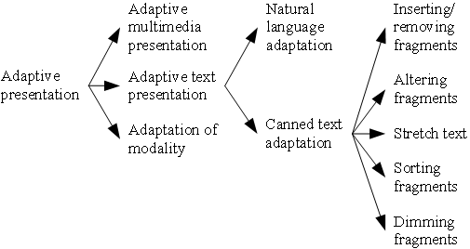

**Figure 2.1.** Adaptive representation

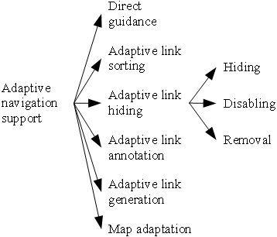

**Figure 2.2.** Adaptive navigation

In general, the architecture of AEHS shown in figure 2.3 (Karampiperis & Sampson, 2005, p. 130) has two layers: *runtime layer* and *storage layer*. Runtime layer has responsibility for presenting adaptive learning material to user and observing user in order to update learner model. Storage layer is the main engine which controls adaptive process with some tasks as follows:

* Initialize and update learner model.
* Choose concepts in domain model, educational resource in Media Space by selection rules.
* Store learning resources, domain ontology, learner model, etc.

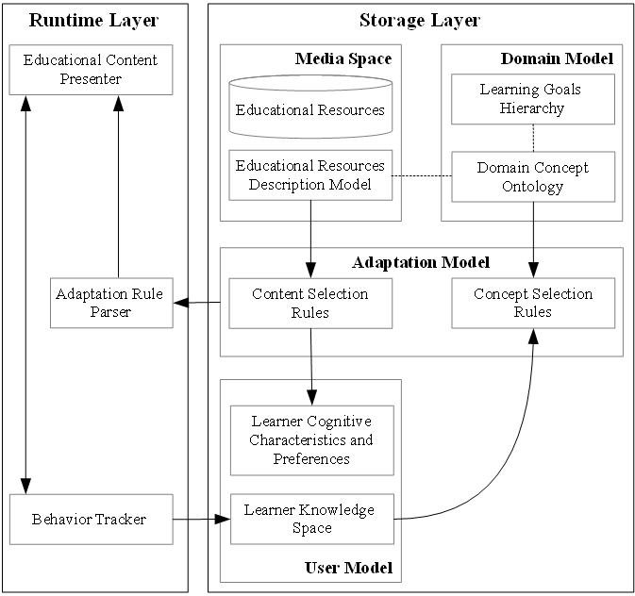

**Figure 2.3.** General architecture of AEHS

As seen in general architecture, storage layer has four models:

* *Media space*: contains learning resources and associated descriptive information (metadata). Learning resources such as lectures, tests, examples, and exercises are often stored as hypertext and hypermedia like (x)html files (W3C, XHTML™ 1.1 - Module-based XHTML - Second Edition, 2010).Media space is also called resource model.
* *Domain model*: constitutes the structure of domain knowledge. Domain model was often shown in form of graph. Nowadays, researchers intend to build domain model according to ontology (Wikipedia, Ontology (information science), 2014).
* *Adaptation model*: is the centric component which gives effect to adaptation. It contains concept selection rules and content selection rules. Concept selection rules are used to choose appropriate concepts from domain model. On the other hand, we apply content selection rules into choosing suitable educational resource from medial model. These rules must tune with user model so that the selection gets correct.
* *User model*: contains information and data about user.

The generalized system of AEHS is adaptive education system (AES) in which it is not required to store learning resources in hypermedia space but AEHS is the most popular adaptive learning system.

## 3. Learner Model

Recall that learner model is defined shortly as a description of learner’s properties and it is the core of adaptive learning system. Note that the term “learning” often refers to electronic learning or *e-learning* in this study report if there is no additional explanation. E-learning is also generic term of web-based learning, distance learning and online learning, which is known as study activities together with support of computer and network (Fröschl, 2005, p. 12). In e-learning environment, interaction between learners and learners, between learners and teachers, between learners and learning materials often occurs on network or internet and learning materials are often electronic documents such as files, web pages and software instead of traditional paper-based books. Essential concepts of internet and web page are introduced in (Wikipedia, Internet, 2014) and (Wikipedia, Web page, 2014).

There is slight difference between user modeling and learner modeling as authors (Paiva & Self, 1995, p. 198) stated that “learner modeling is more concerned with diagnosing learner misconceptions and user modeling is more relevant to natural language understanding”. However, in this study report, users are considered as learners or students who are diagnosed in their learning process. So, *user model*, *student model and learner model are synonymic terms* and I will use terms “user model”, “learner model” and “student model” interchangeably.

The terminologies: user model and user profile are often used interchangeably but they have slight difference. A profile contains personal information without inferring or interpreting. User model has a higher level than profile, expresses abstract overview of learner. Moreover, it is able to deduce more extra information about learner from model. User model is often applied in special domain.

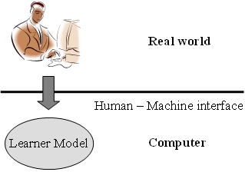

**Figure 3.1.** User modeling

Figure 3.1 (Fröschl, 2005, p. 10) (Kay, 2001, p. 5) sketches out the user modeling process in which a learner in real world is simplified and simulated as a learner model stored in computer via human-machine interface. Because user modeling system provides valuable information in user model for adaptive learning system to make adaptation, it is possible to say that there is a duality of user modeling and adaptive learning. Figure 3.2 (Fröschl, 2005, p. 13) (Brusilovsky, 1996, p. 2) depicts classical relationship between user modeling and adapting.

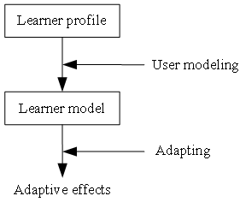

**Figure 3.2.** Learner profile and learner model in adaptation

Because this study report proposes a user modeling system for adaptive learning, it is relevant to both user modeling and adaptive learning. Thus, this study report is survey of user model.

Now basic concepts of user model (learner model), user modeling, user modeling system and adaptive learning system were introduced. Details of learner model along with description of learner’s essential features and classification of learner model are described in sub-sections 3.1 and 3.2. Note that the main content of this section and previous section is extracted from the master thesis “*User Modeling and User Proﬁling in Adaptive E-learning Systems*” of the author (Fröschl, 2005). I express my deep gratitude to the author Fröschl for providing her/his great research.

### 3.1. Information in user model

User model must contain important information about user such as domain knowledge, learning performance, interests, preference, goal, tasks, background, personal traits (learning style, aptitude,…), learning activities, environment (context of work) and other useful features.

Content of learner model can be divided into two categories: domain specific information and domain independent information (Fröschl, 2005, p. 27).

#### 3.1.1. Domain specific information

Domain specific information (Fröschl, 2005, p. 27) reflects the status and degree of knowledge and skills which student achieved in certain subject or major. Domain specific information is organized as knowledge model. Knowledge model has many elements (concept, topic, subject, etc.) which student needs to learn. Knowledge model can be created by some ways which result many forms. Some widespread forms will be introduced below:

* *Vector model*. Learner’s knowledge in domain was modeled in a vector. This vector consists of knowledge items, concepts, topics, or subjects in domain. Each element of vector which is a real number or integer number (ranging within an interval) shows the degree which learner gains knowledge about those knowledge items, concepts, topics or subjects. An typical example of vector model is *U*=(*k*1, *k*2,…, *kn*) where each *ki* is a numeric value expresses how much user masters over a knowledge item. Vector model is simplest but very effective.
* *Overlay model*. Learner’s knowledge is the subset of expertise’s knowledge. Similar to vector model, each element in overlay model is the number which presents learner’s knowledge level (see more in sub-section 3.2.2).
* *Fault model*. The drawback of vector model and overlay model is that it cannot describe the lack of learner’s knowledge. Fault model can contain learner’s errors or bugs and what reasons learners have these errors. Taking out information from fault model, adaptive system can deliver learning material, concepts, subjects or topics that users don’t know. Adaptive systems can also give users explanations, annotation to know accurately them or provide users guidance to correct errors.

Besides essential information about domain, there was extra information stored in learner model, such as prior knowledge of learner, records of learning performance, records of test results (Han B. , 2001, p. 13) (Fröschl, 2005, p. 29).

#### 3.1.2. Domain independent information

Besides information about knowledge, domain independence information (Fröschl, 2005, pp. 29-31) may include goals, interests, background and experience, individual traits, aptitudes and demographic information.

* *Interests*. User interests are known simply as user’s preferences, likes, and dislikes on something. Interest is particularly essential in commercial recommendation system. It is also important in adaptive educational system.
* *Goals*. In most cases, goal expresses learner’s purpose; in other words, it is an answer for the question what learners want to achieve in learning course. There are two kinds of goal: long-term and short-term. Long-term goal is relatively permanent in course. Moreover, learner can propose herself/himself long-term plans for lifelong study. By short-term goal, learner intends to solve certain problem such as passing an examination and doing exercise. Short-term goal is also called as problem-solving goal.
* *Background* and *experience*. Background includes skills or knowledge that learner gained in the past. Such information affects adaptive process. For example, if student experiences hardships in previous courses then adaptive learning system should deliver high level exercises to her/him.
* *Personal traits*. Personal traits are user’s characteristics which together define a learner as an individual. Two basic personal traits are *learning styles* and *aptitudes.*
* Learning styles are defined as “the composite of characteristic cognitive, affective and psychological factors that serve as relatively stable indicators of how a learner perceives, interacts with and responds to the learning environment” (Stash, 2007, p. 93). Table 3.1.2.1 shows some common learning styles.

|  |  |
| --- | --- |
| Group | Description |
| *Activist* | Activists understand information only if they discussed it and applied it. |
| *Reflector* | Reflectors think thoroughly about things before doing any practice. |
| *Pragmatist* | Pragmatists have practical mind, prefer to try and test techniques relevant to problems (Stash, 2007, p. 106). |
| *Theorist* | Theorists think things through in logical steps, understand different facts into coherent theory (Stash, 2007, p. 106). |

###### **Table 3.1.2.1.** Some common learning styles

* There are eight forms of aptitudes (Fröschl, 2005, p. 30) (Lane, 2000): linguistic, logical/mathematical, spatial, kinesthetic, musical, interpersonal, intrapersonal, naturalist. Table 3.1.2.2 shows eight forms of aptitudes.

|  |  |
| --- | --- |
| Aptitude | Description |
| *Linguistic* | Competence to use language |
| *Logical-Mathematical* | Competence to use reason, number and logic |
| *Visual-Spatial* | Competence to perceive the visual |
| *Bodily-Kinesthetic* | Competence to use body effectively and handle objects skillfully |
| *Musical* | Competence to create and compose music |
| *Interpersonal* | Competence to communicate with other person |
| *Intrapersonal* | Competence to self-reflect |
| *Naturalist* | Competence to realize flora and fauna |

###### **Table 3.1.2.2.** Eight forms of aptitudes

However, for me, aptitudes are learner’s features not used usually in adaptive process because they are too complex and unpractical to implement in software engineering. Learning styles are more important than aptitudes.

* *Demographic information*. Demographic data includes name, birth day, sex, ID card, etc. In general, demographic information is used to identify person*.*

### 3.2. Classification of user models

User models are classified into three main kinds such as stereotype model, overlay model and plan model according to their representations. Differential model and perturbation model are variants of overlay model. These models are described in sub-section 3.2.1 (stereotype model), 3.2.2 (overlay model), 3.2.3 (differential model), 3.2.4 (perturbation model), and 3.2.5 (plan model). Note that there are many approaches to construct these models, ranging from probability and statistics to artificial intelligence, machine learning and data mining. There are some recommended books for generic study of statistics, artificial intelligence, machine learning, and data mining such as “Applied Statistics and Probability for Engineers” by authors (Montgomery & Runger, 2003), “Artificial Intelligence: A Modern Approach” by authors (Russell & Norvig, 2003), “Machine Learning” by author (Mitchell, 1997), and “Data Mining: Concepts and Techniques” by authors (Han & Kamber, 2006). You should refer to these books for concepts in probability, statistics, artificial intelligence, machine learning and data mining occurring frequently in this study report.

#### 3.2.1. Stereotype model

Stereotype (Rich, 1979) is a set of user’s frequent characteristics. New learner will be classified according to their initial features, each classifier is stereotype. It is able to infer much more new assumptions about user from small amount of information available in stereotype (Fröschl, 2005, p. 34). If information about user is gained in detailed and concretely, assumptions will be changed to become more precise. The term “assumption” refers the system’s belief about user but this belief is not totally reliable, just temporary.

In general, stereotype represents a category or group of learners. There are two kinds of stereotype: *fix* and *default* (Fröschl, 2005, p. 34).

In fix stereotype, predefined stereotype is assigned to learner at abstract level. For example (see figure 3.2.1.1), in Java tutorial course, students are divided into five groups, corresponding to five levels, each level is more difficult than previous level: novice, begin, known, advanced and expert. Note that Java is popular object-oriented programming language <https://www.oracle.com/java>. After obtaining individual information such as former knowledge and experience, system will assign one of five levels to each learner and never change.

In default stereotype, it is more flexible. Therefore, an initial stereotype is assigned to each learner. It means that learner has default stereotype. System will observe students and gather their performance data, actions, results of tests, etc. in learning process. Finally, system changes the default stereotype to new more appropriate stereotype. Straightforward, the setting of stereotype is gradually replaced by more precisely and is more fit to learner.

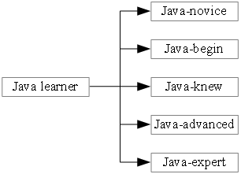

**Figure 3.2.1.1.** An example of stereotypes of Java learner

There are three important components in a stereotype: trigger, inference and retraction (Fröschl, 2005, p. 34):

* *Trigger* is used to activate a stereotype. In other word, it is a condition (e.g. logic expression) to assign a stereotype to learner. For example: if trigger “don’t know Java” is activated, the stereotype “Java-novice” will be assigned to learner.
* *Inference* is inferring engine, responsible for deducing related information about user from stereotype. For example: if learner is glued to “Java-expert” stereotype, inference engine should take out both essential and extra information such as learner’s mastery of object-oriented programming, interface, swing, internationalization problem, and Java pattern.
* *Retraction* conditions are used to deactivate learner’s stereotype. There is a circumstance: student was assigned by stereotype “Java-novice” at the beginning of course but after learning process, student knew thoroughly Java, so her/his stereotype “Java-novice” is no longer suitable. Event “Learner does final Java test very well” is condition to retract her/his stereotype “Java-novice” and she/he will be assigned by a new appropriate stereotype – “Java-expert”.

#### 3.2.2. Overlay model

The essential idea of overlay modeling is that the learner model is the subset of domain model (Mayo, 2001, pp. 56-58). In other words, the user overlay model is a shot of comprehensive domain model. Domain model is constituted of a set of knowledge elements representing expertise’s knowledge, normally; each element represents a knowledge item, concept, subject or topic in the major. So, the structure of user model “imitates” the structure of domain model. However, each element in user model (corresponding to each element in domain model) has a specific value measuring user’s knowledge about that element. This value is considered as the mastery of domain element ranging within certain interval.

Straightforward, the domain is decomposed into a set of elements and the overlay model (namely, user model) is simply a set of masteries over those elements. Suppose that the mastery of each element varies from 0 (*not mastered*) to 1 (*mastered*). Then the expert model is the overlay with 1 for each element and the learner model is the overlay with at most 1 for each element.

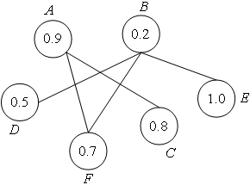

**Figure 3.2.2.1.** An example of overlay model having six concepts

An example of overlay model is shown in figure 3.2.2.1 in which there are six concepts *A*, *B*, *C*, *D*, *E* and *F*; each concept (element) is attached by a number ranging in [0, 1] indicating user’s mastery over such concept. The arc connecting two concepts expresses their relationship. There are many relationships such as prerequisite, dependency, parent-child, cause-effect, aggregation, and diagnostic. Each relationship is specified according to application context. Moreover, arcs can be direct or indirect; figure 3.2.2.1 depicts an indirect overlay model.

Overlay modeling approach was based on domain models which are often constructed as knowledge network or knowledge hierarchical tree. Authors and experts have responsibility for creating domain model. Normally, each concept in domain model is mapped to learning object. Nowadays, there is a trend to build up domain model by ontology (Wikipedia, Ontology (information science), 2014).

Additionally, overlay model is essential graph model whose nodes are knowledge elements, which leads to many approaches to build up overlay model from statistics to machine learning and one of them is Bayesian network method. It is possible to say that Bayesian network is an advanced variant of overlay model.

#### 3.2.3. Differential model

Overlay model is based on expert’s domain knowledge. It is requisite for tutor/teacher to suggest necessary knowledge to learner. That knowledge is called *expected knowledge*. In other words, expected knowledge is domain knowledge that learner should be mastered at the certain time.

Therefore, differential model (Mayo, 2001, p. 58) is basically an overlay on expected knowledge, which in turn is an overlay on expert’s domain knowledge. With the overview of top-down methodology, differential model is a variant of overlay model. In detail, the differential model is instance of the class “fault model” (see sub-section 3.1.1) because expected knowledge can be considered as the knowledge that user lacks.

#### 3.2.4. Perturbation model

Both overlay model and differential model assume that learner’s knowledge is the subset of expertise’s knowledge. They are not interested in learner’s errors caused by misconceptions or lack of knowledge. These errors are considered as *mal-knowledge* or incorrect beliefs.

Perturbation model (Mayo, 2001, p. 59) represents learners as the subset of expert’s knowledge (like overlay model) plus their mal-knowledge. Hence, perturbation model is also instance of the class “fault model”. This model open up new trend of modeling, so it can support better for adaptive system. In figure 3.2.4.1 (Mayo, 2001, p. 60), learner knowledge shown as shading area includes both correct knowledge and incorrect knowledge (mal-knowledge).

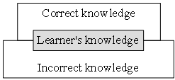

**Figure 3.2.4.1.** Illustration of perturbation model

#### 3.2.5. Plan model

Plan is a sequence of learners’ actions to achieve desires or concrete goals (Fröschl, 2005, p. 35). Plan recognition is based on tracking input user’s performance (Kobsa, 1993, p. 3). There is the library consisting of all possible plans. User’s actions are regarded and matched to these plans. The plan which is most similar to user’s actions is chosen as learner model. This is plan recognition process. In this approach, it is very expensive to create library and requires complex computation and large storage. Furthermore, matching algorithm needs careful implementation and spends much time in executing.

## 4. Conclusion

In general, user model has extremely important role in most user-oriented system, especially, adaptive learning system. It is not easy to classify learner models and methods of modeling but useful learner models are described in sub-section 3.2. However, it is asserted that building up the learner model must follow three below steps:

* *Initialization* is the first step in user modeling. It gathers information and data about user and it constructs user model from this information. Initialization process also determines structure of user model, reasoning method and storage of user model. There are two common ways to gain data about user so that system can initialize user model: explicit questions and initial tests (Fröschl, 2005, p. 36).
* *Updating* intends to keep user model up-to-date. System can observe user’s actions, track user’s performance, and analyze user’s feedback. Those tasks are done implicitly or explicitly (Fröschl, 2005, p. 37).
* *Reasoning* new information about user out from available data in user model.

Reasoning is complicated but most interesting and so, research of learner modeling is ongoing.

## References

Brusilovsky, P. (1996). Methods and Techniques of Adaptive Hypermedia. (A. Kobsa, Ed.) *User Modeling and User-Adapted Interaction, 6*(2-3), 87-129.

Fröschl, C. (2005). *User Modeling and User Profiling in Adaptive E-learning Systems.* Master Thesis, Graz University of Technology, Austria.

Han, B. (2001). *Student Modelling and Adaptivity in web based Learning.* Master Thesis, Massey University, New Zealand.

Han, J., & Kamber, M. (2006). *Data Mining: Concepts and Techniques* (2nd Edition ed.). (J. Gray, Ed.) San Francisco, CA, USA: Morgan Kaufmann Publishers, Elsevier.

Kay, J. (2001). User Modeling for Adaptation. In C. Stephanidis, & G. Salvendy (Ed.), *User Interfaces for All: Concepts, Methods, and Tools* (Vol. IV, pp. 271-294). Mahwah, New Jersey, USA: Lawrence Erlbaum Associates, Inc.

Kobsa, A. (1993). User Modeling: Recent Work, Prospects and Hazards. In M. Schneider-Hufschmidt, T. Kühme, & U. Malinowski, *Adaptive User Interfaces: Principles and Practice* (illustrated ed., Vol. 10, pp. 111-125). Amsterdam: North Holland Elsevier.

Lane, C. (2000). *Implementing Multiple Intelligences and Learning Styles in Distributed Learning/IMS Projects.* Technical Report, The Education Coalition (TEC), California, USA.

Mayo, M. J. (2001). *Bayesian Student Modelling and Decision-Theoretic Selection of Tutorial Actions in Intelligent Tutoring Systems.* PhD Thesis, University of Canterbury, New Zealand.

Mitchell, T. M. (1997). *Machine Learning.* Burr Ridge, Illinois, USA: McGraw-Hill Science/Engineering/Math.

Montgomery, D. C., & Runger, G. C. (2003). *Applied Statistics and Probability for Engineers* (3rd Edition ed.). New York, NY, USA: John Wiley & Sons, Inc.

Moodle, H. (2014, September 8). *About Moodle - the open source learning platform*, 2.7.2. (Moodle Headquarters) Retrieved September 18, 2014, from Moodle website: https://docs.moodle.org/27/en/About_Moodle

Paiva, A., & Self, J. (1995). TAGUS - A User and Learner Modeling Workbench. (A. Kobsa, Ed.) *International Journal of User Modeling and User-Adapted Interaction, 4*(3), 197-226.

Rich, E. (1979). User Modeling via Stereotypes. *Cognitive Science, 3*(4), 329-354.

Russell, S. J., & Norvig, P. (2003). *Artificial Intelligence: A Modern Approach* (2nd Edition ed.). Upper Saddle River, New Jersey, USA: Pearson Education, Inc.

Sakai, P. (2014, July 8). *About Sakai Project*, 10. (Apereo Foundation) Retrieved September 18, 2014, from Sakai Project website: https://sakaiproject.org/about-us

Stash, N. (2007). *Incorporating Cognitive/Learning Styles in a General-Purpose Adaptive Hypermedia System.* Eindhoven University of Technology, Netherlands. ACM SIGWEB Newsletter.

Wikipedia. (2014, October 3). *Internet*. (Wikimedia Foundation) Retrieved October 7, 2014, from Wikipedia website: http://en.wikipedia.org/wiki/Internet

Wikipedia. (2014, September 11). *Learning management system*. (Wikimedia Foundation) Retrieved September 18, 2014, from Wikipedia website: http://en.wikipedia.org/wiki/Learning_management_system

Wikipedia. (2014, August 28). *Ontology (information science)*. (Wikimedia Foundation) Retrieved September 17, 2014, from Wikipedia website: http://en.wikipedia.org/wiki/Ontology_(information_science)

Wikipedia. (2014, October 5). *Web page*. (Wikimedia Foundation) Retrieved October 7, 2014, from Wikipedia website: http://en.wikipedia.org/wiki/Web_page