Overview of Bayesian Network

Loc Nguyen
University of Technology, Ho Chi Minh city, Vietnam
Email: ng_phloc@yahoo.com, Phone: +84-975250362

Abstract
Bayesian network is applied widely in machine learning, data mining, diagnosis, etc; it has a solid evidence-based inference which is familiar to human intuition. However Bayesian network causes a little confusion because there are many complicated concepts, formulas and diagrams relating to it. Such concepts should be organized and presented in clear manner so as to be easy to understand it. This is the goal of this report.
This report includes 4 main parts that cover principles of Bayesian network:
- Part 1: Introduction to Bayesian network giving some basic concepts.
- Part 2: Bayesian network inference discussing inference mechanism inside Bayesian network.
- Part 3: Parameter learning tells us how to update parameters of Bayesian network.
- Part 4: Structure learning surveys some main techniques to build up Bayesian network.

Keywords: Bayesian network, parameter learning, structure learning

1. Introduction to Bayesian network

1.1. Bayesian rule
Bayesian network theory starts with the concept of Bayesian inference, a form of statistical method, which is responsible for collecting evidences to change the current belief in given hypothesis. The more evidences are observed, the higher degree of belief in hypothesis is. First, this belief was assigned an initial probability. When evidences were gathered enough, the hypothesis is considered trustworthy.
Bayesian inference was based on Bayesian rule with some special aspects:
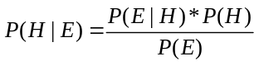 _{(1.1)}
Where H is probability variable denoting a hypothesis existing before evidence and E is also probability variable notating an observed evidence.
P(H) is prior probability of hypothesis and P(H | E) which is the conditional probability of H with given E, is called posterior probability. It tells us the changed belief in hypothesis when occurring evidence.
P(E) is the probability of occurring evidence E together all mutually exclusive cases of hypothesis. If H and E are discrete,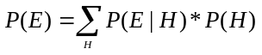 otherwise 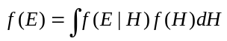with H and E being continuous, f denoting probability density function.
When P(E) is constant value, P(E | H) is the likelihood function of H with fixed E. Likelihood function is often used to estimate parameters of probability distribution.

1.2. Bayesian network
Bayesian network (BN) is the directed acyclic graph (DAG) [1] in which the nodes (vertices) are linked together by directed edges (arcs); each edge expresses the dependence relationships between nodes. If there is the edge from node A to B, we call “A causes B” or “A is parent of B”, in other words, B depends conditionally on A. So the edge A→B denotes parent-child, prerequisite or cause-effect relationship. Otherwise there is no edge between A and B, it asserts the conditional independence. Let V={X₁, X₂, X₃,…, X_{n}} and E be a set of nodes and a set of edges, the BN is denoted as below:
G=(V, E) where G is the DAG, V is a set of nodes and E is a set of edges

X
Y
Z
T
Figure 1.1: Bayesian network.
Note that node X_{i} is also random variable. In this paper the uppercase letter (for example X, Y, Z, etc.) denotes random variables or set of random variables; the lowercase letter (for example x, y, z, etc.) denote its instantiation. We should glance over other popular concepts.
- If there is an edge between X and Y (X→Y or X←Y) then X and Y are called adjacent each other (or incident to the edge).
- Given k nodes {X₁, X₂, X₃,…, X_{k}} in such a way that every pair of node (X_{i}, X_{i+1}) are incident to the edge X_{i}→X_{i+1} where 1 ik-1, all edges that connects such k nodes compose a path from X₁ to X_{k} denoted as [X₁, X₂, X₃,…, X_{k}] or X₁→X₂→…→X_{k}. The nodes X₂, X₃,…, X_{k-1} are called interior nodes of the path. The sub-path X_{m}→…X_{n} is a path from X_{m} to X_{n}: X_{m}→X_{m+1}→…→X_{n} where 1m<nk. The directed cycle is a path from a node to itself. The simple path is a path that has no directed cycle. The DAG is the graph that has no directed cycle.
- If there is a path from X to Y then X is called ancestor of Y and Y is called descendant of X. If Y isn’t a descendant of X, Y is called non-descendent of X.
- If the direction isn’t considered then edge and path are called link and chain, respectively. Link is denoted A – B. Chain is denoted A – B – C, for example.
- Graph G is a tree if every node except root has only one parent. G is called single-connected if there is only one chain (if exists) between two nodes. Almost BN (s) surveyed here are single-connected DAG (s).

The strength of dependence between two nodes is quantified by conditional probability table (CPT). In continuous case, CPT becomes conditional probability density function (CPD). So each node has its own local CPT. In case that a node has no parent, its CPT degenerates into prior probabilities. For example, suppose X_{k} is binary node and it has two parents X_{i} and X_{j}, the CPT (or CPD) of X_{k} which is the conditional probability P(X_{k} | X_{i}, X_{j}) has eight entries:
P(X_{k}=1|X_{i}=1, X_{j}=1) | P(X_{k}=0|X_{i}=1, X_{j}=1)
P(X_{k}=1|X_{i}=1, X_{j}=0) | P(X_{k}=0|X_{i}=1, X_{j}=0)
P(X_{k}=1|X_{i}=0, X_{j}=1) | P(X_{k}=0|X_{i}=0, X_{j}=1)
P(X_{k}=1|X_{i}=0, X_{j}=0) | P(X_{k}=0|X_{i}=0, X_{j}=0)

It is asserted that if X_{i} is binary node and has n parents then its CPT has 2^{n+1} entries. However only 2^{n} entries are specified in practice due to P(X_{i}=0 | …) = 1- P(X_{i}=1|…) when X_{i} is binary. In case that X_{i} has k possible values, each CPT has k^{n} entries.

Example 1.1: Suppose event “cloudy” is cause of event “rain”. Events “rain” and “sprinkler” which in turn is cause of “grass is wet” [5] [7]. So we have three causal-effect relationships of: 1-cloudy to rain, 2- rain to wet grass, 3-sprinkler to wet grass. This model is expressed below by BN with four nodes and three arcs corresponding to four events and three relationships. Every node has two possible values True (1) and False (0) together its CPT.
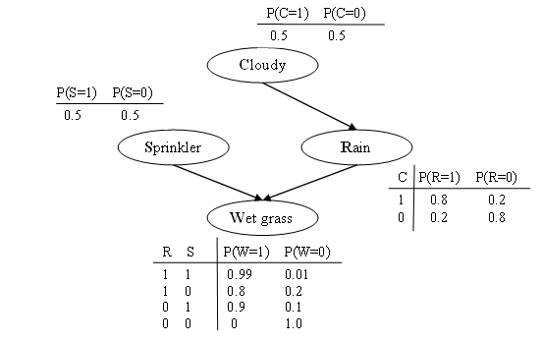
Figure 1.2: Bayesian network with CPT (s) in example 1.1.
Let PA_{i} be the set of parents of node X_{i}, the joint probability distribution of whole BN is defined as product of CPT(s) or CPD(s) in continuous case of all nodes.
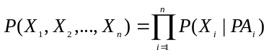 _{(1.2)}
So BN is represented by its joint probability distribution P and its DAG.
(G, P) where G=(V, E) is a DAG and P is joint probability distribution.

Suppose Ω_{i} is the subset of PA_{i} such that X_{i} must depend conditionally and directly on every variable in Ω_{i}. In other words, there is always an edge from each node in Ω_{i} to X_{i} and no intermediate node between them. This criterion is called as Markov condition which will be discussed later. The joint probability P is re-written as below:
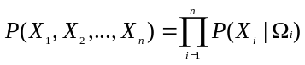 _{(1.3)}
Back the “wet grass” BN in example 1.1, the joint probability is:
P(C, R, S, W)=P(C)*P(R)*P(R|C)*P(S|C)*P(W|C,R,S)
We have P(S | C) = P(S) due to the conditional independence assertion about variables S and C. Furthermore, because S is intermediate node between C and W, we should remove C from P(W | C, R, S), hence, P(W | C, R, S) = P(W | R, S). In short, the joint probability is shown below:
P(C, R, S, W)=P(C)*P(S)*P(R|C)*P(W|R,S)

1.3. Bayesian network reference
Using Bayesian reference, we need to compute the posterior probability of each hypothesis node in network. In general, the computation based on Bayesian rule is known as the inference in Bayesian network.
Reviewing example 1.1, suppose W becomes evidence variable which is observed the fact that the grass is wet, so, W has value 1. There is request for answering the question: how to determine which cause (sprinkler or rain) is more possible for wet grass. Hence, we will calculate two posterior probabilities of S (=1) and R (=1) in condition W (=1). These probabilities are also called explanations for W.
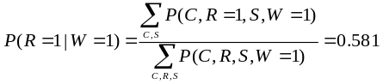
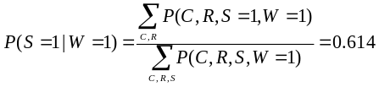
Because of P(R=1|W=1) < P(S=1|W=1), it is concluded that sprinkler is the most likely cause of wet grass. Note that two above formulas which are also variants of Bayesian rule (see formula 1.1) will be surveyed more carefully in the “Bayesian network inference” section.

1.4. Markov condition and Markov equivalence
The inference in BN becomes complex and ineffective when the size of BN is large. Suppose BN has n binary nodes. In the worst case, each node has n-1 parents, thus, the joint probability has n*2^{n} entries. There is a boom of CPT (s). There is a restrictive criterion so-called Markov condition that makes the relationships (also CPT) among nodes simpler.
Given Bayesian network (G, P) and three sets of nodes: A={X_{i},…, X_{j}}, B={X_{k},…, X_{l}} and C={X_{m},…, X_{n}}:
- The denotation I_{P}(A,B) or I_{G}(A,B) indicates that A and B are independent.
- The denotation I_{P}(A,B|C ) or I_{G}(A,B|C ) indicates that A and B conditional independent given C.
Let (G, P) be Bayesian network, Markov condition is stated that every node X is conditional independent from its non-descendants given its parent. In other word node X is only dependent on its previous nodes (directed parents).
, I_{P}(X, N_{X} | PA_{X})
Where E is the set of edges in G, N_{X} and PA_{X} are set of non-descendants of X and parents of X, respectively.
Z
X
X
X
Y
X
Z
X
X
X
Y
X
(a)
(b)
Figure 1.3: Example about Markov condition: (a) satisfy, (b) not satisfy
Because inference and structure learning algorithms are based on Markov condition, please pay attention to it.
Suppose Bayesian (G, P) satisfies Markov condition, it is necessary to find out or check whether a node (or a set of nodes) Z that separates a node (or a set of nodes) X from another node (or a set of nodes) Y. It means that whether there is I_{P}(X, Y | Z). In this case, X and Y are called d-separated by Z.
There are some important concepts that constitute the d-separation concept:
- The chain X→Z→Y or X←Z←Y is called serial path.
- The chain X→Z←Y is called convergent.
- The chain X←Z→Y is called divergent.
- The chain X–Z–Y is called uncoupled chain if X and Y aren’t adjacent.
Of course, serial path, convergent path and divergent path are uncoupled chain.

X
Y
Z
X
Y
Z
X
Y
Z
X
Y
Z
(a)
(b)
(c)
(d)
Figure 1.4: Serial path (a), convergent path (b), divergent path (c), and uncoupled chain (d).
Let X, Y and Z be sets of nodes where X, Y, ZV. Given the chain p between X and Y, p is blocked by Z if and only if one of two conditions is satisfied:
- There is an intermediate node MZ on p so that all edges on p incident to M are serial or divergent at M.
- There is an intermediate node M on p so that:
  - MZ and all descendants of MZ
  - All edges op p incident to M are convergent.

X
Y
Z
W
X
Y
Z
W
T
M
(a)
(b)
Figure 1.5: The chain X–Y–Z–W in (a) is blocked by {Y, Z} because edges incident to Y are divergent at Y. The chain X–Y–Z–W–T in (b) is blocked by {Z, W} because there is such a node Y on chain that Y{Z, W}, its descendant M {Z, W}, and edges incident to Y are convergent at Y .

X and Y are d-separated by Z if all chains between X and Y are blocked by Z. Z is also called a d-separation of G.
X₁
X₂
X₃
X₄
X₅
X₆
Figure 1.6: {X₁, X₂} is d-separated from {X₅, X₆} by {X₃, X₄}.
BN (s) which have the same set of nodes are Markov equivalent if and only if they have same d-separations. In other words, BN (s) that are Markov equivalent have the same independences. Given G₁=(V, E₁) and G₂=(V, E₂), we have:
Where A, B, C are mutually disjoint sub-set of V. Note that G₁ and G₂ must be DAG and satisfy Markov condition.

The goal of giving “Markov equivalent” concept is to represent BN (s) that have the same structure and joint probability. So the representation of such BN (s) is called Markov equivalent class which is also a Bayesian network. In conclusion, Markov equivalence divides all DAG (or BN) into disjoint Markov equivalent classes. In practice, Markov equivalent class is often find out or surveyed instead of considering many BN (s).
2. Bayesian network inference

2.1. Simple inference
The essence of Bayesian reference is to compute the posterior probabilities of nodes given evidences. Note that evidences or conditions are also nodes which are observed and have concrete values. Back example 1.1 “wet grass”. The posterior probability of R = 1 (rain) given W =1 (wet grass) is the ratio of the marginal probability of R, W over C, S to the marginal probability of W over C, R, S.
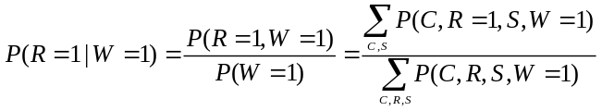
Let V={X₁, X₂,… X_{n}} be a whole set of nodes. Let D={X_{m}, X_{u},…, X_{n}} be a set of evidences, DV. Let d=(x_{m}, x_{u},…, x_{n}} be the instantiation of D. In general case, the marginal probability of X_{k}=x_{k} is:
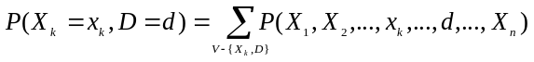
Where P(X₁, X₂,…, X_{n}) is the global joint probability.
The marginal probability of D = d is:
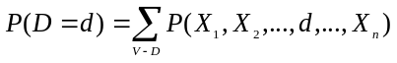
The probability of X_{k} = k given D = d is:
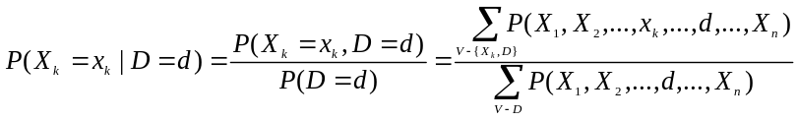 _{(2.1)}
The above formula is the basic idea of simple inference. Note that it is also a variant of Bayesian rule (see formula 1.1). But the cost of computing it based on marginal probabilities is very high because there are a huge number of numeric operations such as additions and multiplications in computation expression. If the joint probability has many terms, brute force method for determining combinations of such operations is impossible. There are three main approaches that improve this computation:
- Taking advantage of Markov condition: Pearl’s message propagation [1] [4] is well-known algorithm.
- OR-gate model inference [1] which simulates OR-gate electronic circuit.
- Reducing the amount of numeric operations computed in marginal probability. Optimal factoring [1] is the well-known technique.

2.2. Pearl’s message propagation algorithm
Suppose Bayesian network is DAG G=(E, V) which is a tree having only one root. Given a set of evidence nodes DV; every node in D has concrete value. Let D_{X} is the sub-set of D including X and descendants of X and let N_{X} be the sub-set of D including X and non-descendant of X. Let C_{X} and PA_{X} be children and parents of X, respectively. Let R be root node. Let O be evidence node, OD.
X
N_{X}
D_{X}
Figure 2.1: X, D_{X} and N_{X}. Note that N_{X} is green and D_{X} is red.
The essence of inference is to compute the posterior probability P(X|D) for every X. We have:
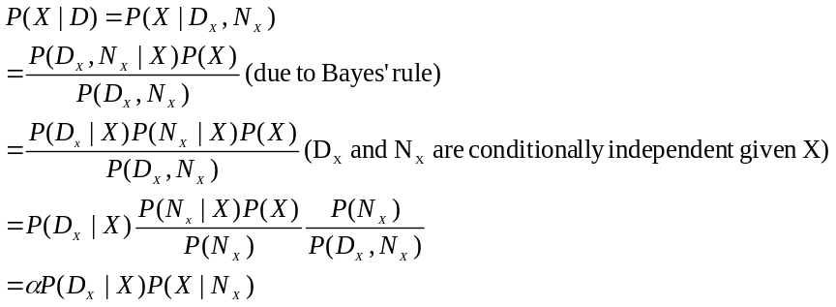
Where 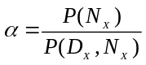is the constant independent from X.
Let λ(X) and π(X) be P(D_{X}|X) and P(X|N_{X}), respectively.
P(X|D) = αλ(X) π(X) _{(2.2)}

The λ(X) and π(X) are called λ value and π value of X, respectively.
For each child Y of X, let λ_{Y}(X) be λ message that connects X and Y. Note that λ_{Y}(X) is conditional probability of D_{Y} given X.
_{(2.3)}
For each parent Z of X, let π_{X}(Z) be π message that connects Z and X. Note that π_{X}(Z) is conditional probability of X given N_{X}.
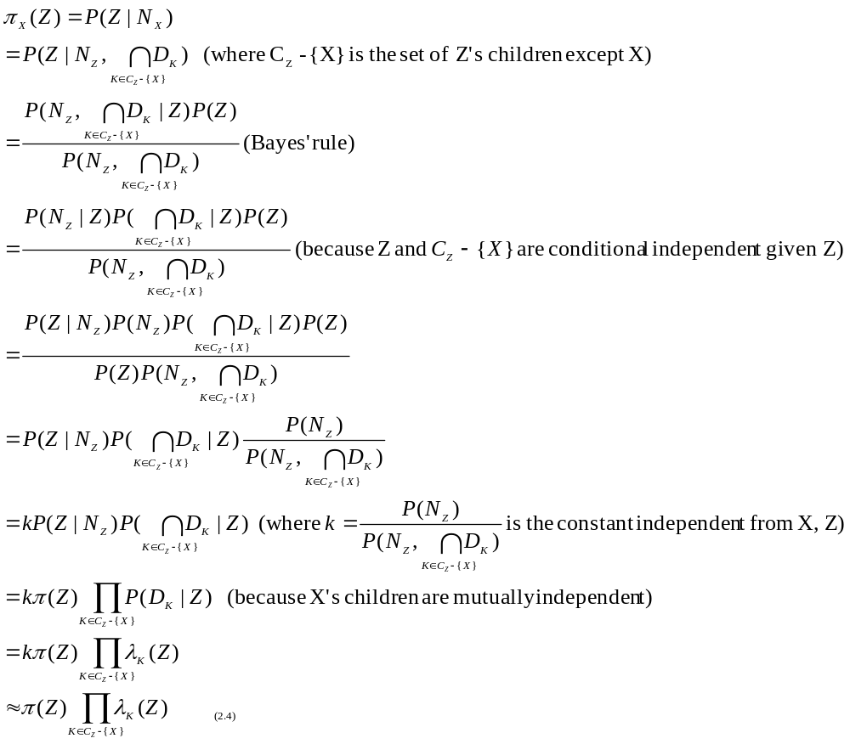

Don’t worry about π_{X}(Z) is proportioned to 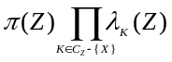 by removing constant k because the posterior probability P(X|D) itself is also proportioned to λ(X) and π(X) via constant α. These constants will be eliminated when P(X|D) is normalized. Now we have:
- Value λ(X) = P(D_{X}|X)
- Message 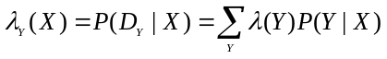for each Y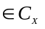
- Value π (X) = P(X|N_{X})
- Message 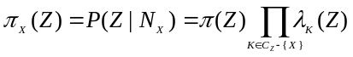 for each ZPA_{X}.
The λ and π values are updated according to λ and π messages. Whenever evidence O D occurs, Pearl’s algorithm propagates downwards π message and propagates upwards λ message in order to update λ value and π value of each variable X so that the posterior probability P(X|D) can be computed. The process of upwards-downwards propagation spreads over all variables of network.
X
Z
Y
T
π_{X}(Z)
λ_{X}(Z)
λ_{T}(X)
π_{T}(X)
λ_{Y}(X)
π_{Y}(X)
Figure 2.2: Pearl propagation algorithm (X is focused node).

Please pay attention to following notices when updating λ value and π value at certain variable X:
- If Xand suppose X’s instantiation (value) is x then:
λ(X=x) = P(x|x)= 1 due to XD_{X} and Markov condition. So λ(Xx) = 0
π (X=x) = P(x|x)= 1 due to XN_{X} and Markov condition. So π (Xx) = 0
P(X=x|D) = 1 and P(Xx|D) = 0.
- If XD and X is leaf then:
λ(X) = P(Ø|X) = 1 due to D_{X}= Ø
π (X) is computed as if X were intermediate variable.
P(X|D)= απ(X)
- If XD and X is root then:
λ (X) is computed as if X were intermediate variable.
π (X)=P(X|Ø)=P(X)
P(X|D)= αλ(X)P(X)
- If XD and X is intermediate variable then:
(Because X’s children are mutually independent)
Where Z is parent of X.
P(X|D)= αλ(X)π(X)

Pseudo-code for Pearl’s algorithm shown below includes three functions:
- Function “void init” initialize π value for every node. At that time the set of evidence nodes D is empty.
- Function “void update” is executed whenever evidence node O occurs. This function adds O to set D, propagates upwards λ message over all parents of O by calling function “void propagate_up”, and propagates down π message over all children of O by calling function “void propagate_down”.
- Function “void propagate_up_λ_message” computes λ value and posterior probability of current node, and continues to propagate upwards and downwards λ, π messages by calling itself and function “void propagate_down_π_message”. Process of propagation stops when there is no node to be propagated.
- Function “void propagate_down_π_message” computes π value and posterior probability of current node, and continues to propagate downwards π message by calling itself. Process of propagation stops when there is no node to be propagated.

void init(G, D)
{
D=Ø;
for each XV
{
λ(X) = 1; //due to D = Ø
for each parent Z of X //propagate up λ message
λ_{X}(Z) = 1; // due to D = Ø
}
P(R|D) = P(R); //posterior probability of root node
π(R) = P(R); // π value

for each child K of R //browse root’s children
propagate_up_π_message(R, K);
}

void update(O, o)
{
D = DO
λ(O=o) = π(O=o) = P(O=o|D) = 1; //due to O
λ(Oo) = π(Oo) = P(Oo|D) = 1; //due to OD

if OR and O’s parent Z D // O isn’t root and parent of O doesn’t belong to D
propagate_up_ λ_message(O, Z);

for each child K of O such that K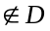 //browse O’s children
propagate_up_π_message(O, K);
}

void propagate_up_λ_message(Y, X)
{
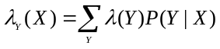; //Y propagate upwards λ message
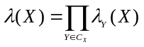; //update λ value
P(X|D)= αλ(X)π(X); //compute posterior probability of X
normalize P(X|D); //eliminate constant α

if XR and X’s parent Z D
propagate_up_ λ_message(X, Z);

for each child K of X such that KY and K //browse O’s children
propagate_up_π_message(X, K);
}

void propagate_down_π_message(Z, X)
{
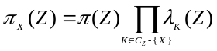; //Y propagate downwards π message
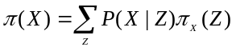; //update π value
P(X|D)= αλ(X)π(X); //compute posterior probability of X
normalize P(X|D); //eliminate constant α

for each child K of X such that K //browse O’s children
propagate_up_π_message(X, K);
}

Example 2.1: Given Bayesian network shown in figure 2.3, suppose evidence X has value 1. Hence, we need to compute posterior probabilities of T, Y, Z in condition X=1. Firstly, function “void init” is called to initialize network.
Z
X
Y
T
P(Z=1) P(Z=0)

0.6 0.4
Z P(Y=1) P(Y=0)

1 0.6 0.4

0 0.3 0.7
Z P(X=1) P(X=0)

1 0.7 0.3

0 0.2 0.8
X P(T=1) P(T=0)

1 0.9 0.1

0 0.4 0.6
Figure 2.3: Bayesian network with CPT (s)

Function init(G,D) is executed:
D = Ø
λ(Z= 1) = λ(Z = 0) = 1
λ(X = 1) = λ(X = 0) = 1
λ(Y = 1) = λ(Y = 0) = 1
λ(T = 1) = λ(T = 0) = 1

λ_{X}(Z=1) = λ_{X}(Z=0) = 1
λ_{Y}(Z=1) = λ_{Y}(Z=0) = 1
λ_{T}(X=1) = λ_{T}(X=0) = 1

P(Z=1|d) = P(Z=1) = 0.6. Note that let d be instantiation of D
P(Z=0|d) = P(Z=0) = 0.4
π(Z=1) = P(Z=1) = 0.6
π(Z=0) = P(Z=0) = 0.4

Calling propagate_down_π_message(Z, X)
Calling propagate_down_π_message(Z, Y)

Then, function propagate_down_π_message(Z, X) is executed:
π_{X}(Z=1)= π(Z=1) λ_{X}(Z=1)=1*0.6=0.6
π_{X}(Z=0)= π(Z=0) λ_{X}(Z=0)=1*0.4=0.4

π(X=1) = P(X=1|Z=1) π_{X}(Z=1) + P(X=1|Z=0) π_{X}(Z=0) = 0.7*0.6 + 0.2*0.4 = 0.5
π(X=0) = P(X=0|Z=1) π_{X}(Z=1) + P(X=0|Z=0) π_{X}(Z=0) = 0.3*0.6 + 0.8*0.4 = 0.5

P(X=1) = α λ(X = 1) π(X=1)=α1*0.5=α0.5
P(X=0) = α λ(X = 0) π(X=0)=α1*0.5= α0.5

P(X=1) = 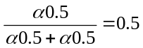
P(X=0) =

Calling propagate_down_π_message(X, T)

Then, function propagate_down_π_message(X, T) is executed:
π_{T}(X=1)= π(X=1) =0.5
π_{T}(X=0)= π(X=0) =0.5

π(T=1) = P(T=1|X=1) π_{T}(X=1) + P(T=1|X=0)π_{T}(X=0) = 0.9*0.5 + 0.4*0.5 = 0.65
π(T=0) = P(T=0|X=1) π_{T}(X=1) + P(T=0|X=0)π_{T}(X=0) = 0.1*0.5 + 0.6*0.5= 0.4

P(T=1) = α λ(T = 1)π(T=1) = α1*0.65= α0.65
P(T=0) = α λ(T = 0)π(T=0) = α1*0.4= α0.4

P(T=1) = 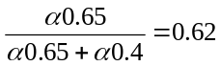
P(T=0) = 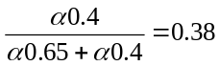

Then function propagate_down_π_message(Z, Y) is executed:
π_{Y}(Z=1)= π(Z=1)λ_{Y}(Z=1) =1*0.6=0.6
π_{Y}(Z=0)= π(Z=0)λ_{Y}(Z=0)=1*0.4=0.4

π(Y=1) = P(Y=1|Z=1)π_{X}(Z=1) + P(Y=1|Z=0)π_{X}(Z=0) = 0.6*0.6 + 0.3*0.3 = 0.45
π(Y=0) = P(Y=0|Z=1)π_{X}(Z=1) + P(Y=0|Z=0)π_{X}(Z=0) = 0.3*0.4 + 0.8*0.7 = 0.68

P(Y=1) = αλ(Y = 1)π(Y=1) = α1*0.45= α0.45
P(Y=0) = αλ(Y = 0)π(Y=0) = α1*0.68= α0.68

P(Y=1) = 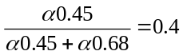
P(Y=0) = 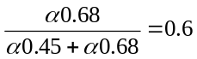

The initialized Bayesian network is shown below:
Z
X
Y
T
P(Z=1) P(Z=0)

0.6 0.4
P(Y=1) P(Y=0)

0.4 0.6

P(X=1) P(X=0)

0.5 0.5
P(T=1) P(T=0)

0.62 0.38

Figure 2.4: Initialized Bayesian network
When X becomes evidence and gains value 1, the function update(X, 1) is called:
D = DX={X}
Because d is instantiation of D, we have d = {X=1}
λ(X=1) = π(X=1)=P(X=1|d)=1
λ(X=0) = π(X=0)=P(X=0|d)=0

Calling propagate_up_λ_message(X, Z)
Calling propagate_down_π_message (X, T)

Then, function propagate_up_λ_message(X, Z) is executed:
λ_{X}(Z=1) = λ(X=1)P(X=1|Z=1) + λ(X=0)P(X=0|Z=1) = 1*0.7 + 0*0.3 = 0.7
λ(Z=1) = λ_{X}(Z=1)λ_{Y}(Z=1) = 0.7*1 = 0.7
P(Z=1|d) = αλ(Z=1)π(Z=1)= α0.7*0.6 = α0.42

λ_{X}(Z=0) = λ(X=1)P(X=1|Z=0) + λ(X=0)P(X=0|Z=0) = 1*0.2 + 0*0.8 = 0.2
λ(Z=0) = λ_{X}(Z=0)λ_{Y}(Z=0) = 0.2*1 = 0.2
P(Z=0|d) = αλ(Z=0) π(Z=0)= α0.2*0.4 = α0.08

P(Z=1|d) = 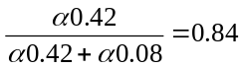
P(Z=0|d) = 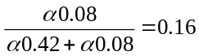
Calling propagate_down_π_message(Z, Y)

Then, function propagate_down_π_message (Z, Y) is executed:
π_{Y}(Z=1)= π(Z=1) λ_{Y}(Z=1) =1*0.6=0.6
π_{Y}(Z=0)= π(Z=0) λ_{Y}(Z=0)=1*0.4=0.4

π(Y=1) = P(Y=1|Z=1) π_{X}(Z=1) + P(Y=1|Z=0) π_{X}(Z=0) = 0.6*0.6 + 0.3*0.4 = 0.48
π(Y=0) = P(Y=0|Z=1) π_{X}(Z=1) + P(Y=0|Z=0) π_{X}(Z=0) = 0.3*0.6 + 0.8*0.4 = 0.5

P(Y=1) = α λ(Y = 1) π(Y=1) = α1*0.48= α0.48
P(Y=0) = α λ(Y = 0) π(Y=0) = α1*0.5= α0.5

P(Y=1) = 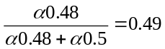
P(Y=0) = 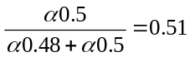

Then function propagate_down_π_message(X, T) is executed
π_{T}(X=1)= π(X=1) =1
π_{T}(X=0)= π(X=0) =0

π(T=1) = P(T=1|X=1) π_{T}(X=1) + P(T=1|X=0) π_{T}(X=0) = 0.9*1 + 0.4*0 = 0.9
π(T=0) = P(T=0|X=1) π_{T}(X=1) + P(T=0|X=0) π_{T}(X=0) = 0.1*1 + 0.6*0= 0.1

P(T=1) = α λ(T = 1) π(T=1) = α1*0.9= α0.9
P(T=0) = α λ(T = 0) π(T=0) = α1*0.1= α0.1

P(T=1) = 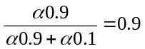
P(T=0) = 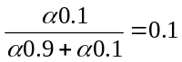

Finally, all posterior probabilities are computed as in following figure
Z
X
Y
T
P(Z=1) P(Z=0)

0.84 0.16
P(Y=1) P(Y=0)

0.49 0.51

P(X=1) P(X=0)

1 0
P(T=1) P(T=0)

0.9 0.1
Figure 2.4: All posterior probabilities are computed after running Pearl algorithm (X is evidence)

2.3. OR-gate inference
In OR-gate electric circuit, the output value becomes TRUE if there is at least one of inputs being TRUE. Suppose every node is binary, OR-gate inference [1] in Bayesian network simulates such circuit based on three assumptions:
- Cause inhibition: Given a cause-effect relationship denoted by edge X→Y, there is a factor I that inhibits X from causing Y. Factor I is called inhibition of X. That the inhibition I is turned off is the prerequisite of X causing Y.
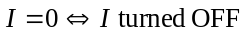
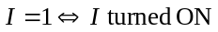

- Inhibition independence: Inhibitions are mutually independent. For example inhibition I₁ of X₁ is independent from inhibition I₂ of X₂.
- OR condition: Suppose we have a set of cause-effect relationships in which Y is the effect of many causes X₁, X₂,…, X_{n} (see following figure). Let I_{i} be the inhibition of X_{i}. The effect Y can not happen (Y=0) if at least one of X_{i} is equal 0 or one of inhibitions is ON:
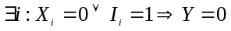

X₁
X₂
X₃
X_{n}
…
Y
Figure 2.4: Cause-effect relationships.
Suppose we have n causes X₁, X₂,…, X_{n} and one result Y. According to “cause inhibition” and “inhibition independence” assumptions, let I_{i} be the inhibition of X_{i}. Let A_{i} be dummy variable so that A_{i} is ON (=1) if X_{i} is equal to 1 and I_{i} is OFF (=0).
P(A_{i} = ON | X_{i}=1, I_{i}=OFF) = 1
P(A_{i} = ON | X_{i}=1, I_{i}=ON) = 0
P(A_{i} = ON | X_{i}=0, I_{i}=OFF) = 0
P(A_{i} = ON | X_{i}=0, I_{i}=ON) = 0

P(A_{i} = OFF | X_{i}=1, I_{i}=OFF) = 0
P(A_{i} = OFF | X_{i}=1, I_{i}=ON) = 1
P(A_{i} = OFF | X_{i}=0, I_{i}=OFF) = 1
P(A_{i} = OFF | X_{i}=0, I_{i}=ON) = 1

Applying “OR condition”, the condition probability of Y is equal 0 (Y never happens) if at least one A_{i} is ON. It means that Y happens (Y=1) if all A_{i} (s) are ON.
P(Y=0|A_{i}=ON) = 0
P(Y=0|A_{i}=OFF) = 1
P(Y=1|A_{i}=ON) = 1
P(Y=1|A_{i}=OFF) = 0

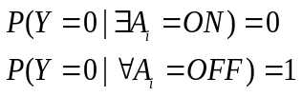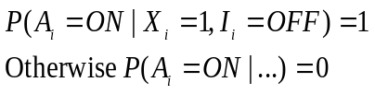
X₁
I₁
X₂
I₂
X_{n}
I_{n}
A₁
A₂
A_{n}
Y
…
P(I_{i}=ON) = 1 – P(X_{i}=1)
Figure 2.5: OR-gate model.

Now the strength of each cause-effect relationship X_{i}→Y is quantified by the CPT P(Y|X_{i}). Suppose causes (X₁, X₂,…,X_{i},…, X_{n}) become evidences having values (x₁, x₂,…, x_{i},…, x_{n}). Let P(X_{i}=1) = p_{i} be the probability of X_{i} = 1. The probability of X_{i} ‘s inhibition is the inverse:
P(I_{i}=ON) = 1 – P(X_{i}=1)
Let O be the set of such i that X_{i} = 1.
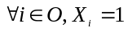

The goal of inference is to determine the posterior probability P(Y| X₁, X₂,…,X_{i},…, X_{n}). We have:
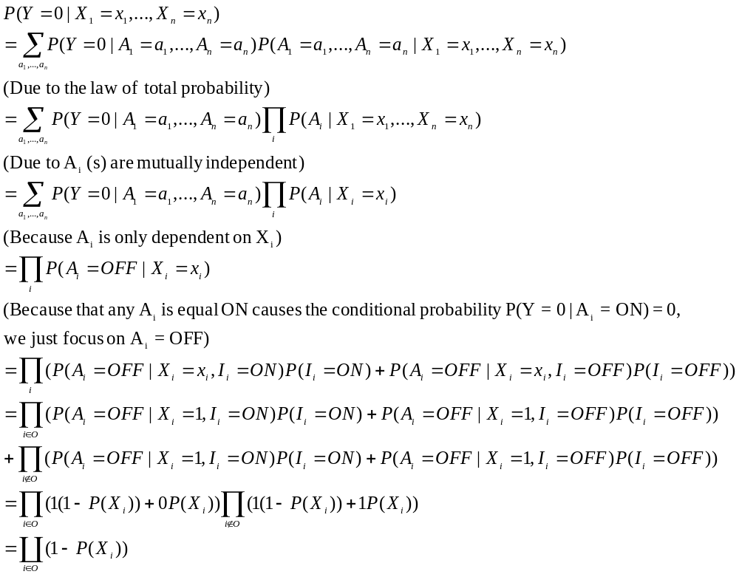
In conclusion, we have
P(Y=0|X₁,X₂,…, X_{n}) = 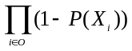 _{(2.5)}
P(Y=1|X₁,X₂,…, X_{n}) = 1 – _{(2.6)}
Where O is the set of such i that X_{i} = 1.

Example 2.2: Given cause-effect relationship shown in following figure. Given prior probabilities of causes X₁, X₂, X₃ are 0.2, 0.5, 0.3, respectively. We need to compute the conditional probability of effect P(Y=1|X₁=1, X₂=0, X₃=1).
X₂
X₁
X₃
Y
P(X₁) = 0.2
P(X₂) = 0.5
P(X₃) = 0.3
Figure 2.6: OR-gate inference example.
Applying formula 2.6, we have:
P(Y=1| X₁=1, X₂=0, X₃=1) = 1 – (1 – P(X₁=1))(1 –P(X₃=1)) = 1 – 0.8*0.7 = 0.44

2.4. Optimal factoring
The basic idea of this technique is to reduce the amount of numeric operations by changing the order of combinations of such operations. Back example 1.1, given joint probability P(C, R, S, W)=P(C)*P(S)*P(R|C)*P(W|R,S), the marginal probability of R = 1 is factorized as below:
Because each binary variable has 2 values, there are 2² combinations of C and S. Each product has 3 multiplications. So the total number of required multiplications is 3*2² = 12. Now the ordering of expression is changed by the factorization as below:
The inner sum of products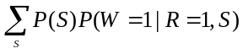 has 1*2¹=2 multiplications. Although the outer sum of products 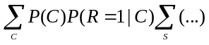 contains 4 variables, it has 2*2¹= 4 multiplications because expressions which don’t relate to variable S such as P(C) and P(R=1|C) are taken out the inner sum of products. So the total number of required multiplications is 4+2=6. Six multiplications are saved.
It is easy to recognize the best ordering of expressions which produces the minimal required multiplications if the number of variables is small. How we can do that in case of many variables. The answer relates to the optimal factoring problem.

Given F = (V, S, Q) is defined as the triple consisting of [1, pp. 163]:
- A set of n nodes (or variables) V= {X₁, X₂,…, X_{n}}
- A set of m sub-sets S = {S_{{1}}, S_{{2}},…, S_{{m}}} where S_{{I}} V
- A target set QV
The factoring α of S is a binary tree satisfying three following condition [1, pp.164]:
- All and only member S_{{I}} of S are leaves.
- The parent of nodes S_{{I}} and S_{{J}} are denoted S_{{IJ}}
- The root of tree is S_{{1,2,..,m}}
Note that S corresponds to operands of marginal probability and α corresponds with the factorization of marginal probability.

Example 2.3: Like example 2.1, let Z, X, Y, T be nodes of Bayesian network shown in following figure.
Z
X
Y
T
The joint probability is P(Z,X,Y,T) = P(Z)P(X|Z)P(Y|Z)P(T|X). Suppose X is evidence, we need to compute the posterior conditional probability P(Z=1|X=1). The marginal probability over Z, X shown below is the sum of products which will be optimized:
The factoring instance F(V, S, Q) is defined as below:
- V = {Z, X, Y, T}
- S = {S_{{1}}={Z}, S_{{2}}={X, Z}, S_{{3}}={Y, Z}, S_{{4}}={T,X}}
- Q = {Z, X}
Suppose factoring α₁, α₂ correspond to two factorizations of marginal probability P(Z=1,X=1).
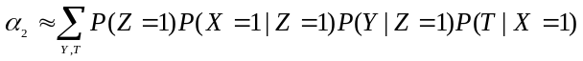

S_{{1,2,3,4}}}
S_{{1}}
S_{{3}}
S_{{2}}
S_{{4}}
S_{{1,2}}
S_{{3,4}}
S_{{1}}
S_{{1,2,3,4}}}
S_{{2,3,4}}
S_{{2}}
S_{{3,4}}
S_{{3}}
S_{{4}}
(b)
(a)

Figure 2.7: (a) Factoring α₁ and (b) Factoring α₂

Given F, the cost of factoring α denoted cost_{α}(F) is two following steps:
- All non-leave nodes are determined according to formula:
S_{{IJ}} = S_{{I}} S_{{J}}–W_{{IJ}} where W_{{IJ}}= {wQ and wS_{{k}} for all kIJ }
- The cost of each node is computed according to formula:
For leaf nodes: cost_{α}(S_{{j}}) = 0, j=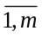
For non-leaf nodes: cost_{α}(S_{{IJ}}) = cost_{α}(S_{I}) + cost_{α}(S_{J}) + 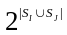
Where |.| denotes the cardinality of the set.

The cost of factoring α: cost_{α}(F)= cost_{α}(S_{{1,…,m}}). The less this cost is, the better binary tree is.
Applying optimal factoring problem into Bayesian inference, the set of nodes V in F corresponds with variables in BN and the tree α corresponds with the ordering of multiplications in marginal probability. The cost of factoring instance cost_{α}(F) is equal to the number of multiplications. The problem becomes easy when we find out the best binary tree α having the least cost_{α}(F) and compute the marginal probability with the same ordering of multiplications to this tree.

Back example 2.3, the cost of factoring α₁ is computed as below:
cost_{α1}(S{1,2,3,4}) = cost_{α1}(S_{{1,2}}) + cost_{α1}(S_{{3,4}}) = (0+0+2⁰) + (0+0+2²) = 5
cost_{α2}(S{1,2,3,4}) = cost_{α1}(S_{{2,3,4}}) + cost_{α1}(S_{{1}}) + 2² = cost_{α1}(S_{{2,3,4}}) + 0 + 2²
= cost_{α1}(S_{{3,4}}) + cost_{α1}(S_{{2}}) + 2² + 2²
= (0+0+2¹) + 0 + 2² + 2² = 10
Because cost_{α1}(S{1,2,3,4}) is lesser than cost_{α2}(S{1,2,3,4}), the following ordering of multiplications is chosen:

3. Parameter learning

3.1. Beta function and augmented Bayesian network
There is a family of PDF which quantifies and updates the strength of conditional dependencies among nodes by natural way is called beta density function, denoted as β(f; a, b) or Beta(f; a, b) with parameters a, b, N=a+b where a, b should be integer number > 0
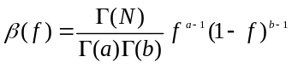
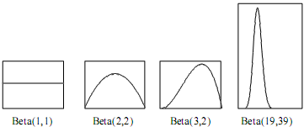
Figure 3.1: Beta functions
It means that, there are “a” successful outcomes (for example, f =1) in “a+b” trials. Higher value of “a” is, higher ratio of success is, so, the graph leans forward right. Higher value of “a+b” is, the more the mass is concentrate around a/(a+b) and the more narrow the graph is. Definition of beta function is based on gamma function described below:
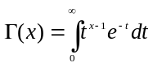 _{(3.1)}
The integral will converges if x>0, at that time, 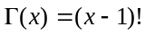. Of course, we have 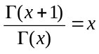 _{(3.2)}
From formula 3.1, 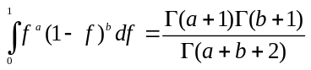 _{(3.3)}
Suppose there is one binary variable X in network and the probability distribution of X is considered as relative frequency having values in [0, 1] which is the range of variable F. We add a dummy variable F (whose space consists of numbers in [0, 1], of course) which acts as the parent of X and has a beta density function β(f; a, b), so as to:
P(X=1|f) = f, where f denotes values of F
X and F constitute a simple network which is referred as augmented BN. So X is referred as real variable (hypothesis) opposite to dummy variable.
F
β(f; a,b) and f have space [0,1]
X
P(X=1 | f) = f
Figure 3.2: The simple augmented BN with only one hypothesis node X

Obviously, P(X=1) = E(F) where E(F) is the expectation of F
Proof, owing to the law of total probability
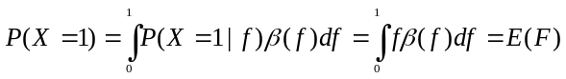
Due to F is beta function, 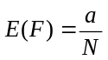, so, 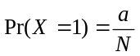 _{(3.4)}
Proof, 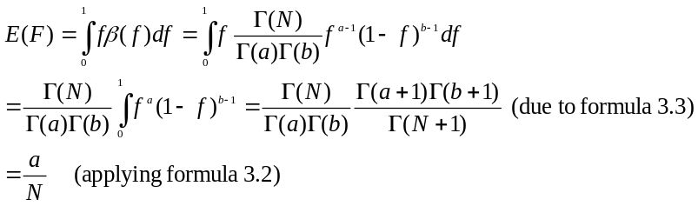
The ultimate purpose of Bayesian inference is to consolidate a hypothesis (namely, variable) by collecting evidences. Suppose we perform M trials of a random process, the outcome of u^{th} trial is denoted X^{(u)} considered as evidence variable whose probability P(X^{(u)} = 1 | f) = f. So, all X^{(u)} are conditionally dependent on F. The probability of variable X, P(X=1) is learned by these evidences
We denote the vector of all evidences as D = (X⁽¹⁾, X⁽²⁾,…, X^{(M)}) which is also called the sample of size M. Given this sample, β(f) is called the prior density function, and P(X^{(u)} = 1) = a/N (due to formula 3.1) is called prior probability of X^{(u)}. It is necessary to determine the posterior density function β(f|D) and the posterior probability of X, namely P(X|D). The nature of this process is the parameter learning. Note that P(X|D) is referred as P(X^{(M+1)} | D).

X⁽¹⁾
P(X¹|f)=f
X⁽²⁾
…
P(X²|f)=f
X^{(M)}
P(X^{M}|f)=f
F
β(f; a,b) and f have space [0,1]
Figure 3.3: The sample D=(X⁽¹⁾, X⁽²⁾,…, X^{(M)}) size of M
We only surveyed in the case of binomial sample, in other words, D having binomial distribution is called binomial sample and the network in figure 3 becomes a binomial augmented BN. Then, suppose s is the number of all evidences X^{(i)} which have value 1 (success), otherwise, t is the number of all evidences X^{(j)} which have value 0 (failed). Of course, s + t = M.
Owing the law of total probability, we have
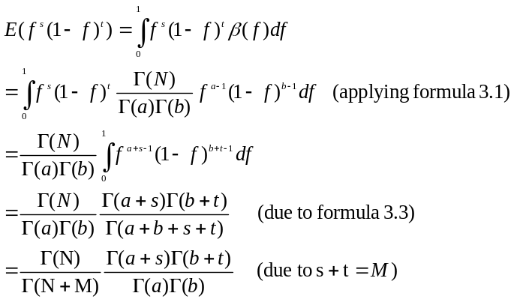
_{(3.5)}
And,
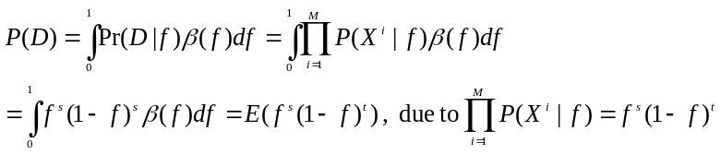
_{(3.6)}

3.2. Parameter learning
The essence of parameter learning is to compute the posterior density function [1]. Now, we need to compute the posterior density function β(f|D) and the posterior probability P(X=1|D). It is essential to determine the probability distribution of X.
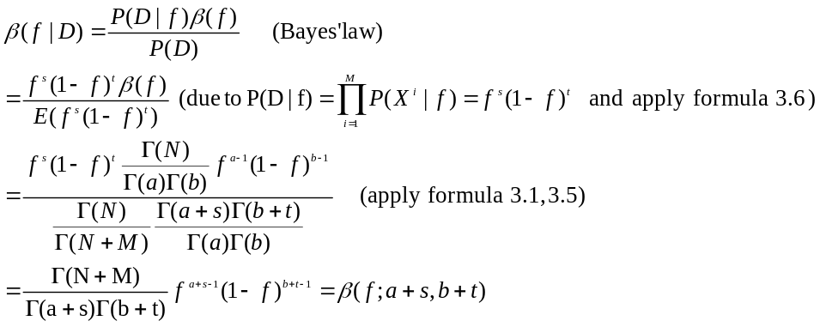
_{(3.7)}

Then the posterior density function is β(f; a+s, b+t) where the prior density function is β(f; a, b). According to formula 3.4, the posterior probability:
P(X=1|D) = E( β(f|D) ) = 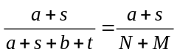 _{(3.8)}
In general, you should merely engrave the formula 3.1, 3.4, 3.7, 3.8 and the way to recognize prior density function, prior probability of X and posterior density function, posterior probability of X, respectively on your memory.
3.3. Expanding augmented BN with more than one hypothesis node
Suppose we have a BN with two binary random variables and there is conditional dependence assertion between these nodes. See the network and CPT (s) in the figure below
X₁
P(X₁=1) P(X₁=0)

1/2 1/2
X₂
X₁ P(X₂=1)

1/2
0 1/2
(a)
X₁
X₂
F₁₁
β(f₁₁; 1, 1)
F₂₂
β(f₂₂; 1, 1)
F₂₁
β(f₂₁; 1, 1)
(b)
Figure 3.4: BN (a) and expended augmented BN (b)
For every node (variable) X_{i}, we add dummy parent nodes to X_{i}, obeying two ways below:
- If X_{i} has no parent (not conditionally dependent on any others), we add only one dummy variable denoted F_{i1} having the probability density function β(f_{i1}; a_{i1}, b_{i1}) so as to: P(X_{i}=1|f_{i1})= f_{i1}
- If X_{i} has a set of k_{i} parents and each parent pa_{il} (l=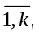) is binary, we add a set of c_{i}=2k_{i} dummy variables F_{i} = {f_{i1}, f_{i2},…,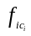}, in turn, instantiations of parents PA_{i}= {pa_{i1}, pa_{i2}, pa_{i3},…, 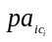}. In other words, c_{i} denotes the number of instantiations of the parents PA_{i}. We have P(X_{i}=1|pa_{ij}, f_{i1},…, f_{ij},…, )=f_{ij}. where 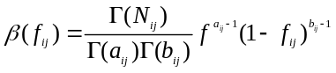
All f_{ij} have no parent and are mutually independent, so, β(f_{i1}, f_{i2},…, ) = β(f_{i1}) β(f_{i2})… β(). Besides this local parameter independence, we have the global parameter independence if reviewing all variables X_{i} s, such below:
β(F₁, F₂,…, F_{n})= β(f₁₁, f₁₂,…, 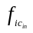)= β(f_{i1}) β(f_{i2})… β()

All variables X_{i} and their dummy variables form the expended augmented BN representing the trust BN in figure 4. In the trust BN, the conditional probability of variable X_{i} with the instantiation of its parent 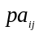, in other words, the ij^{th} conditional distribution is given by P(X_{i}=1|=1) = E(F_{ij})=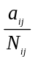 _{(3.8)}, that’s to say the expected value of F_{ij}.
Proof, 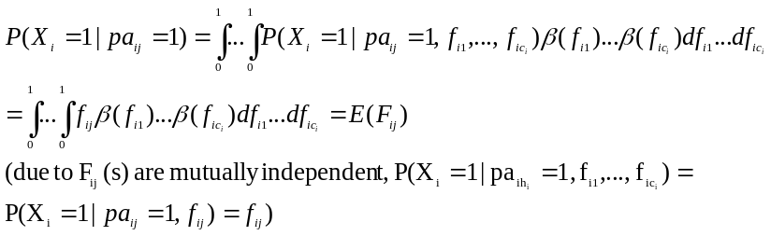
Suppose we perform M trials of random process, the outcome of i^{th} trial which is BN like figure 4 is represented as a random vector 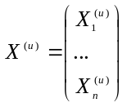 containing all hypothesis variables in network. X^{(u)} is also called evidence vector (or evidence, briefly). M trials constitute the sample of size M which is the set of random vectors denoted as D={X⁽¹⁾, X⁽²⁾,…, X^{(M)}}. D is also called evidence matrix. We review only in case of binomial sample; it means that D is the binomial BN sample of size M. For example, this sample corresponding to the network in figure 4 is showed below:
X⁽¹⁾
…
X^{(M)}
F
X₁⁽¹⁾
X₂⁽¹⁾
X₁⁽²⁾
X₂⁽²⁾
F₁₁
F₂₂
X⁽²⁾
(a)
F₂₁
(b)
Figure 3.5: Expanded binomial BN sample of size M
After occurring M trial, the augmented BN was updated and dummy variables’ density functions and hypothesis variables’ conditional probabilities changed. We need to compute the posterior density function β(f_{ij}|D) of each dummy variable F_{ij} and the posterior condition probability P(X_{i}=1|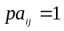, D) of each variable X_{i}. Note that the samples X^{(u)} s are mutually independent with all given F_{ij}. We have,
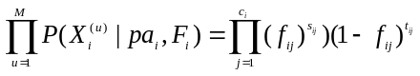
Where
- c_{i} is the number of instances of X_{i}^{(u)} ‘s parents. In binary case, each X_{i}^{(u)} (s) parent has two instances/values, namely, 0 and 1.
- s_{ij}, respective to f_{ij}, is the number of all evidences that variable X_{i} = 1 and = 1
- t_{ij}, respective to f_{ij}, is the number of all evidences that variable X_{i} = 1 and = 0.

We have,
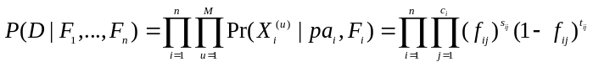 _{(3.9)}
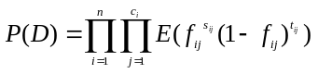 _{(2.10)}
Proof,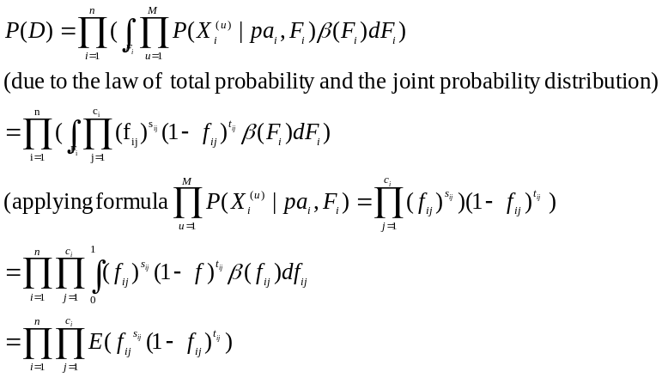
There is the question “how to determine 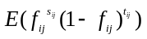”. Applying formula 3.5, we have:
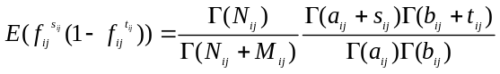 _{(3.11)} Where N_{ij}=a_{ij}+b_{ij} and M_{ij}=s_{ij}+t_{ij}

3.4. Updating posterior density function with multi-node Bayesian network
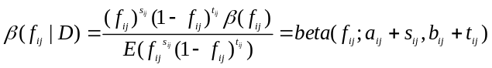 _{(3.12)}
Proof,

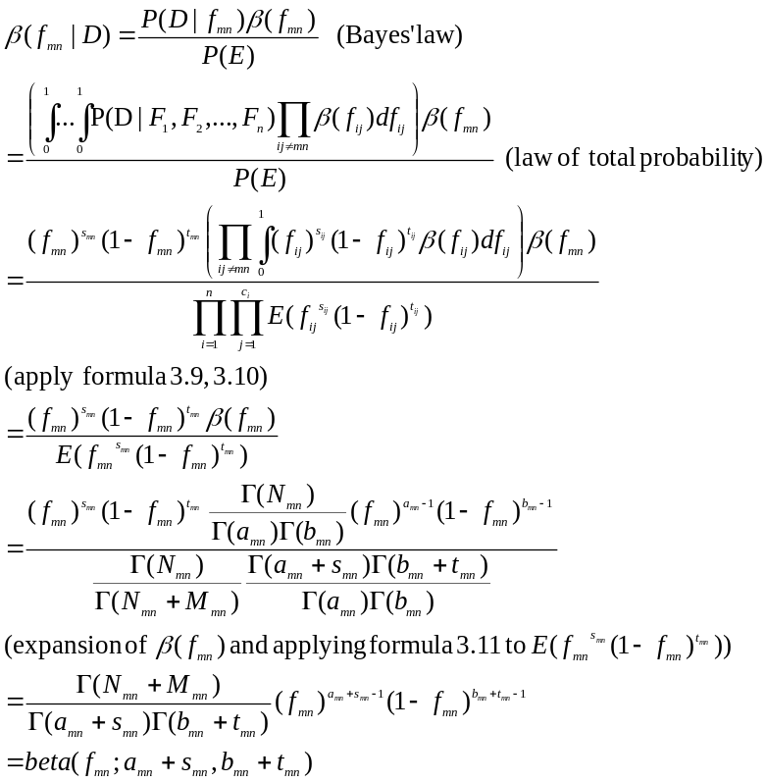

According to formula 3.8 and 3.12,
P(X_{i}=1|=1, D) = E(F_{ij}) = E(β(f_{ij}|D)) = 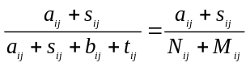 _{(3.13)}
In short, in case of binomial distribution, if we have the real/trust BN embedded in the expanded augmented network such as figure 3.4 and each dummy node F_{ij} has a prior beta distribution β(f_{ij}; a_{ij}, b_{ij}) and each hypothesis node X_{i} has the prior conditional probability P(X_{i}=1|)=E(β(f_{ij}))=, the parameter learning process based on a set of evidences is to update the posterior density function β(f_{ij}|D) and the posterior conditional probability P(X_{i}=1|,D). Indeed, 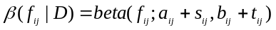 and P(X_{i}=1|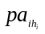=1, E) =E(β(f_{ij}|D))= 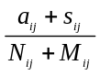
Example 3.1: Suppose we have the set of 5 evidences D={X⁽¹⁾, X⁽²⁾, X⁽³⁾, X⁽⁴⁾, X⁽⁵⁾} owing to network in figure 3.4
 | x₁ | x₂
X⁽¹⁾ | X₁⁽¹⁾ = 1 | X₂⁽¹⁾ = 1
X⁽²⁾ | X₁⁽²⁾ = 1 | X₂⁽²⁾ = 1
X⁽³⁾ | X₁⁽³⁾ = 1 | X₂⁽³⁾ = 1
X⁽⁴⁾ | X₁⁽⁴⁾ = 1 | X₂⁽⁴⁾ = 0
X⁽⁵⁾ | X₁⁽⁵⁾ = 0 | X₂⁽⁵⁾ = 0
Table 3.1: Set of evidences D corresponding to 5 trials (sample of size 5)
Note that the first evidence 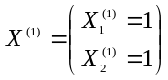implies that variable X₂=1 given X₁=1 occurs in the first trial. We need to compute all posterior density functions β(f₁₁|D), β(f₂₁|D), β(f₂₂|D) and all conditional probabilities P(X₁=1), P(X₂=1|X₁=1), P(X₂=1|X₁=0) from prior density functions β(f₁₁; 1,1), β(f₂₁; 1,1), β(f₂₂; 1,1). In fact,
s₁₁=1+1+1+1+0=4 | t₁₁=0+0+0+0+1=1
s₂₁=1+1+1+0+0=3 | t₂₁=0+0+0+0+1=1
s₂₂=0+0+0+0+0=0 | t₂₁=0+0+0+0+1=1

β(f₁₁|D) = β(f₁₁; a₁₁+s₁₁, b₁₁+t₁₁)= β(f₁₁; 1+4, 1+1)= β(f₁₁; 5, 2)
β(f₂₁|D) = β(f₂₁; a₂₁+s₂₁, b₂₁+t₂₁)= β(f₂₁; 1+3, 1+1)= β(f₁₁; 4, 2)
β(f₂₂|D) = β(f₂₂; a₂₂+s₂₂, b₂₂+t₂₂)= β(f₂₂; 1+0, 1+1)= β(f₁₁; 1, 2)

and P(X₁=1), P(X₂=1|X₁=1), P(X₂=1|X₁=0) are expectations of β(f₁₁|D), β(f₂₁|D), β(f₂₂|D). Then,
P(X₁=1)= 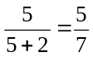 | P(X₂=1|X₁=1)= 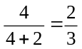 | P(X₂=1|X₁=0)= 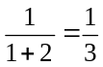
Network in figure 3.4 changed as follows:
X₁
P(X₁=1) P(X₁=0)

5/7 2/7
X₂
X₁ P(X₂=1)

2/3
0 1/3
(a)
X₁
X₂
F₁₁
β(f₁₁; 5, 2)
F₂₂
β(f₂₂; 1, 2)
F₂₁
β(f₂₁; 4, 2)
(b)
Figure 3.6: Updated version of BN (a) and augmented BN (b) in figure 3.4

3.5. Parameter learning in case of data missing
In practice there are some evidences in D such as X^{(u)} (s) which lack information and thus, it stimulates the question “How to update network from data missing”. We must address this problem by artificial intelligence techniques, namely, expectation maximization (EM) algorithm – a famous technique solving estimation of data missing.

Example 3.2: Like above example, we have the set of 5 evidences D={X⁽¹⁾, X⁽²⁾, X⁽³⁾, X⁽⁴⁾, X⁽⁵⁾} along with network in figure 4 but the evidences X⁽²⁾ and X⁽⁵⁾ have not data yet.
 | x₁ | x₂
X⁽¹⁾ | X₁⁽¹⁾ = 1 | X₂⁽¹⁾ = 1
X⁽²⁾ | X₁⁽²⁾ = 1 | X₂⁽²⁾ = v₁?
X⁽³⁾ | X₁⁽³⁾ = 1 | X₂⁽³⁾ = 1
X⁽⁴⁾ | X₁⁽⁴⁾ = 1 | X₂⁽⁴⁾ = 0
X⁽⁵⁾ | X₁⁽⁵⁾ = 0 | X₂⁽⁵⁾ = v₂?
Table 3.2: Set of evidences D (for network in figure 4) with data missing
As known, s₂₁ , t₂₁ and s₂₂ , t₂₂ can’t be computed directly, it means that it is not able to compute directly the posterior density functions β(f₂₁|D) and β(f₂₂|D). In evidence X⁽²⁾, v₁ must be determined. Obviously, v₁ obtains one of two values which is respective to two situations:
- X₁⁽²⁾ = 1 and X₂⁽²⁾=1, it is easy to infer that v₁=P(X₂⁽²⁾=1|X₁⁽²⁾ = 1)=E(β₂₁)=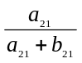= ½
- X₁⁽²⁾ = 1 and X₂⁽²⁾=0, it is easy to infer that v₁=P(X₂⁽²⁾=1|X₁⁽²⁾ = 0)=E(β₂₂)=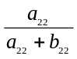= ½
We split X⁽²⁾ into two X’⁽²⁾ (s) corresponding to two above situations in which the probability of occurrence of X₂=1 given X₁=1 is estimated as ½ and the probability of occurrence of X₂=0 given X₁=1 is also considered as ½. We perform similarly this task for X⁽⁵⁾.
 | X₁ | x₂
X⁽¹⁾ | X₁⁽¹⁾ = 1 | X₂⁽¹⁾ = 1
X^{‘(2)} | X₁^{‘(2)} = 1 | X₂^{‘(2)} = 1/2
X^{‘(2)} | X₁^{‘(2)} = 1 | X₂^{‘(2)} = 1/2
X⁽³⁾ | X₁⁽³⁾ = 1 | X₂⁽³⁾ = 1
X⁽⁴⁾ | X₁⁽⁴⁾ = 1 | X₂⁽⁴⁾ = 0
X^{‘(5)} | X₁^{‘(5)} = 0 | X₂^{‘(5)} = 1/2
X^{‘(5)} | X₁^{‘(5)} = 0 | X₂^{‘(5)} = 1/2
Table 3.3: New split evidences D’ for network in figure 3.4
So, we have 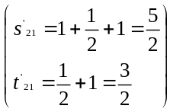and 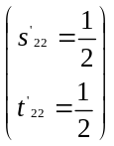 where s’₂₁, t’₂₁, s’₂₂, t’₂₂ are the counts in D’. Then
β(f₂₁|D)= β(f₂₁; a₂₁+s’₂₁, b₂₁+t’₂₁)= β(f₂₁;1+5/2, 1+3/2)= β(f₂₁;7/2, 5/2)
β(f₂₂|D)= β(f₂₂; a₂₂+s’₂₂, b₂₂+t’₂₂)= β(f₂₂;1+1/2, 1+1/2)= β(f₂₂;3/2, 3/2)
P(X₂=1| X₁=1)=E(β(f₂₁|D))=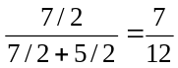 | P(X₂=0| X₁=1)=E(β(f₂₂|D))=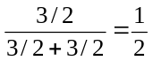
If there are more evidences, this task repeated more and more brings out the EM algorithm [1] [6] having two steps.
- Step1. We compute s’_{ij} and t’_{ij} based on the expected value of given β(f_{ij}), s’_{ij}=E(β(f_{ij})) and t’_{ij}=1- E(β(f_{ij})). Next, replacing missing data by s’_{ij} and t’_{ij} . This step is called Expectation step.
- Step 2. We determine the posterior density function f_{ij} by computing its parameters a_{ij}=a_{ij}+s_{ij} and b_{ij}=b_{ij}+t_{ij}. Note that s_{ij} and t_{ij} are recomputed absolutely together on occurrence of s’_{ij} and t’_{ij}. Terminating algorithm if the stop condition (for example, the number of iterations approaches k times) becomes true, otherwise, reiterating step 1. This step is called the Maximization step.
After k^{th} iteration, we have 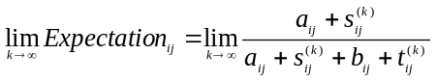which will approach a certain limit. Don’t worry about the case of infinite iterations, we will obtain approximate s’_{ij}, t’_{ij}, posterior f_{ij} if k is large enough due to certain value of 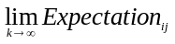
4. Structure learning
As discussed, DAG (s) that contain the same given nodes V are Markov equivalent if they satisfy Markov condition and have the same d-separations. In other words, they entail the same conditional independences and their joint conditional probabilities are identical. Let the pattern gp represent these Markov equivalent DAG (s). Such pattern gp is called Markov equivalent class. Of course given a set of nodes V, there are a lot of equivalent classes. Let GP be random variable whose values are pattern gp. The basic idea of structure learning approaches is to find out the pattern gp that satisfy some condition best. Instead of searching many individual DAG According to given condition, there are two main learning approaches:
- Score-based approach [1]: For each pattern gpGP, the gp which gains the maximal scoring criterion score(D,gp) given training data set D is the best gp. Because the essence of score-based approach is find out the most likely structure, it is also called model selection [1] approach.
- Constraint-based approach [1]: Given a set of conditional independences (a set of d-separations), the best gp is the DAG which satisfy Markov condition over all and only these conditional independences. Such independences play the role of the “door latch” for learning algorithm.
Note that in structure learning context, Bayesian network or pattern gp is mentioned as a DAG.

4.1. Score-based approach
Given a set of random variables (nodes) V = {X₁, X₂,…, X_{n}}, let (G, P) be possible Bayesian network where P is joint conditional probability density and G=(V, E) is the DAG. Let (G, F^{(G)},,^{(G)}) be the augmented BN with equivalent sample size N where F(G) is augmented variables (nodes) attached to every nodes in V and (G) represents beta distributions for augmented (see section about parameter learning). Pattern gp also represents Markov equivalent augmented BN. Scored-based approach has three following steps:
- Suppose all augmented BN (s) has the same equivalent sample size N.
- Let r_{i} be the number of possible values of variable X_{i}. If X_{i} is binary then r_{i} = 2. Let q_{i} be the number of distinct instantiations of parents of X_{i}. For example, if X_{i} and its parents are binary and X_{i} have 1 parents then q_{i} = 2. All augmented variables F_{ij} representing the conditional probability of X_{i} given instantiation j of its parent are assigned to uniform distribution according to equivalent sample size N:
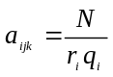
- Given D={X⁽¹⁾, X⁽²⁾,…, X^{(M)}} is the training data set size M, where X^{(h)} is a trial. Note that X^{(h)}=(X^{(h)}₁, X^{(h)}₂,…, X^{(h)}_{n}) is a n-dimension vector which is a outcome (instantiation) of variable X_{i}. X^{(h)}_{i} has the same space to X_{i}. Each DAG gp which is connected by variables in V is assigned a value so-called scoring criterion score(D,gp). This score is the posterior probability of gp given training data set D.
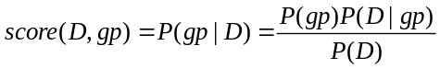
Where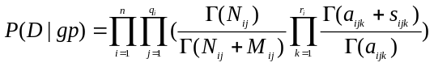
P(gp) is the prior probability of gp. P(D) is constant.
In practice, score(D,gp) is only dependent on P(D|gp) when P(D) is ignored and P(gp) is initialized subjectively.
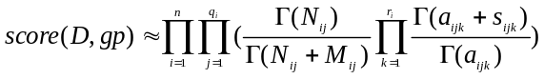 _{(4.1)}
- Which gp gaining maximal score(D,gp) is chosen.
Example 4.1: Suppose there are two variables X₁, X₂, we don’t know exactly their relationship but the training data D is observed as below:
X₁ | X₂
1 | 0
1 | 0
1 | 0
1 | 1
0 | 1
0 | 0
Let gp₁ be the DAG in which X₁ is parent of X₂; otherwise let gp₂ be the DAG in which X₁ and X₂ are mutually independent. Given the sample size is N = 4
X₁
X₂
F⁽¹⁾₁₁
F⁽¹⁾₂₁
F⁽¹⁾₂₂
β⁽¹⁾(f₁₁;2,2)
β⁽¹⁾(f₁₁;1,1)
β⁽¹⁾(f₁₁;1,1)
X₁
X₂
F⁽²⁾₁₁
F⁽²⁾₂₁
β⁽²⁾(f₁₁;2,2)
β⁽²⁾(f₂₁;2,2)
(a)
(b)
Figure 4.1: Augmented Bayesian networks of gp₁ (a) and gp₂ (b)
We have:
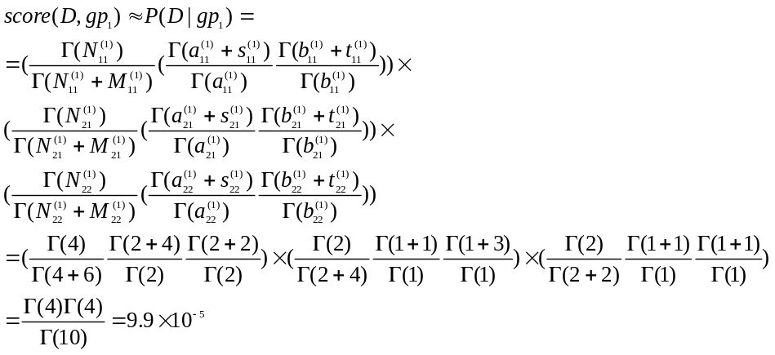

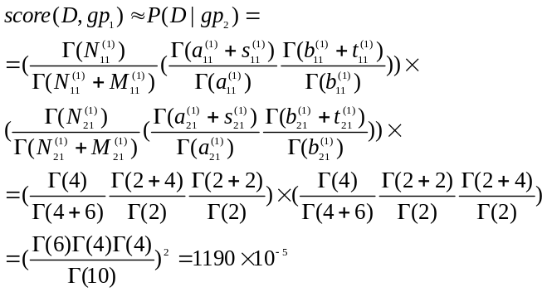
Because score(D,gp₂) is larger than score(D,gp₂), the equivalent pattern gp₁ is chosen as Bayesian network appropriate to training data set.
In above example we recognize that it is difficult to determine all DAG (s). So the score-based approach becomes ineffective in case of many variables. The number of DAG (s) which is surveyed to compute scoring criterion gets huge. It is impossible to do brute-force searching over DAG (s) space. There are some heuristic algorithms to reduce whole DAG (s) space to smaller space so-called candidate set of DAG (s) obeying some restriction, for example, the prior ordering of variables. Such heuristic algorithms are classified into approximate learning. The global score can defined as a product of local scores:
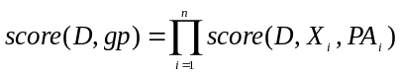
Where score(D,X_{i},PA_{i}) is the local score of X_{i} given its parents PA_{i}.
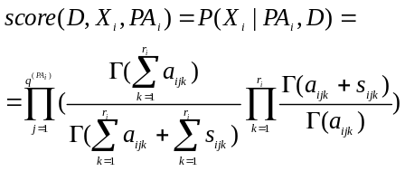 _{(4.2)}
Let 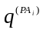be the number of distinct instantiations of parents of X_{i}
The K2 algorithm tries to find out the pattern DAG gp whose each variable X_{i} maximizes local score score(D,X_{i},PA_{i}) instead of discovering all DAG (s). It means that K2 algorithm finds out optimal parents PA_{i} of each X_{i}. Note that it expects that the global score will be approached by maximizing each partial local score. K2 algorithm has following steps:
- Suppose there is an ordering (X₁, X₂,…, X_{n}). There is no backward edge, for example, the edge X_{i}←X_{j} (if exist) where i < j is invalid. Let Pre(X_{i}) be the set of previous nodes of X_{i} in ordering. Let PA_{i} is parents of X_{i}. K2’s mission is to find out PA_{i} for every X_{i}. Firstly, each PA_{i} (s) is set to be empty and each local score(D,X_{i},PA_{i}) is initialized with such empty PA_{i}.
- Each X_{i} is visited according to the ordering. When X_{i} is visited, which node in Pre(X_{i}) that maximizes the local score(D,X_{i},PA_{i}) is added to PA_{i}.
- Algorithm terminates when no node is added to PA_{i}.

4.2. Constraint-based approach
Given (G, P) let IND_{P} be a set of conditional independences. IND_{P} is considered as the set of constraints. Constraint-based approach tries to find out the DAG that satisfies IND_{P} based on theory of d-separation. In other words the set of d-separations of the best DAG pattern are the same as IND_{P}.

Example 4.2: Suppose we have V = {X, Y, Z} and IND_{P} = {I(X,Y)}. Because X and Z isn’t d-separated from any set, there must be a link between X and Z. In similar, there is must be a link between Y and Z. We have:
X
Y
Z
Because X–Z–Y is uncoupled chain and there is a d-separation I(X,Y), the chain X–Z–Y should be converged.
X
Y
Z
If the number of variables is large we need effective algorithms. The simple algorithm includes two steps:
- Firstly, the structure of DAG is drafted as “skeleton”. If there is no conditional independence relating to X_{i} and X_{j} then the link between them is created. So skeleton is the undirected graph which contains variables (nodes) and links.
- The second step is to determine direction of links by applying four following rules in sequence rule 1, rule 2, rule 3, rule 4:
- Rule 1: If the uncoupled chain X–Z–Y exists and Z isn’t in any set that d-separate X from Y then this chain is assumed convergent: X→Z←Y
- Rule 2: If the uncoupled chain X→Z–Y exists (having an edge X→Z) then this chain is assumed serial path: X→Z→Y.
- Rule 3: If the edge X→Y caused a directed cycle at a position in network then it is reversed: X←Y. This rule is applied to remove directed cycles so that the expected BN is a DAG.
- Rule 4: If all rules 1, 2, 3 are consumed the all remaining links have arbitrary direction.

Example 4.3: Suppose we have V = {X, Y, Z, T} and IND_{P} = {I(X,Y), I(X,T), I(Y,T)}. Because there is no conditional independence between X and Y, between Z and T, the “skeleton” is drafted as below:

X
Y
Z
T
Applying rule 1: Because the uncoupled chain X–Z–Y exists and Z isn’t in any set that d-separate X from Y, this chain is assumed convergent: X→Z←Y
X
Y
Z
T

Applying rule 2: Because the uncoupled chain X→Z–T exists, we have the assumed serial path: X→Z→T.
X
Y
Z
T

5. Conclusion
Three significant domains of Bayesian network (BN) are inference mechanism, parameter learning and structure learning. The first domain tells the usability of BN and the others indicates how to build up BN. The ideology of BN is to apply a mathematical inference tool (namely Bayesian rule) into a graph with expectation of extending and enhancing the ability of such tool so as to solve realistic problems, especially diagnosis domain.
However in the process of developing BN, there are many problems involving in real number (continuous case) and nodes dependency. This report focuses on discrete case when the probability of each node is discrete CPT, not continuous PDF. The first-order Markov condition has important role in BN study when there is an assumption “nodes are dependent on only their direct parents”. If the first-order Markov condition isn’t satisfied, many inference and learning algorithms go wrong. I think that BN will get more potential and enjoyable if first-order (Markov) condition is replaced by n-order condition.
Moreover the parameter & structure learning becomes difficult when training data is missing (not complete). Missing data problem is introduced in section 3 but its detail goes beyond this report. I hope that we have a chance to discuss about it.
Finally, BN discussed here is “static” BN because the temporal relationships among nodes aren’t concerned. The “static” BN is represented at only one time point. Otherwise dynamic Bayesian network (DBN) aims to model the temporal relationships among nodes. The process of inference is concerned in time series; in some realistic case this is necessary. However the cost of inference and learning in DBN is much higher than BN because the size of DBN gets huge for long-time process. Because of the limitation of this report, the algorithm that keeps the size of DBN intact (not changed) isn’t introduced here. In general, the essence of such algorithm is to take advantage of both Markov condition and knowledge (inference) accumulation. Due to the complexity of DBN, we should consider to choose which one (BN or DBN) to apply into concrete domain. It depends on what your domain is and what your purpose is.

Reference

- Richard E. Neapolitan (2003). Learning Bayesian Networks. Northeastern Illinois University Chicago, Illinois 2003.

- David Heckerman (1995). A Tutorial on Learning With Bayesian Networks. Technical Report MSR-TR-95-06. Microsoft Research Advanced Technology Division, Microsoft Corporation.

- Man Nguyen (2009). Man Nguyen documents and publications, http://www.cse.hcmut.edu.vn/~mnguyen/research_preprints.html. University of Technology, Ho Chi Minh city, Vietnam.

- Judea Pearl (1986). Fusion, Propagation, and Structuring in Belief Networks. Artificial Intelligence, Vol. 29, 1986.

- Judea Pearl (1988). Probabilistic Reasoning in Intelligent Systems. Morgan Kaufmann Publish, San Mateo, California, 1988. ISBN-13: 978-1558604797

- Sean Borman (2009). The Expectation Maximization Algorithm - A short tutorial, last updated January 09, 2009. Department of Electrical Engineering at the University of Notre Dame, in South Bend, Indiana.

- Kevin P Murphy (1998). A Brief Introduction to Graphical Models and Bayesian Networks at http://www.cs.ubc.ca/~murphyk/Bayes/bnintro.html. Department of Computer Science, University of British Columbia.

