Phoebe Framework and Experimental Results for Estimating Fetal Age and Weight

Phoebe Framework and Experimental Results for Estimating Fetal Age and Weight

Loc Nguyen
Sunflower Soft Company, Ho Chi Minh, Vietnam
Email: ng_phloc@yahoo.com

Thu-Hang T. Ho
Vinh Long General Hospital, Vinh Long, Vietnam
Email: bshangvl2000@yahoo.com

Truong-Duyet Phan
Hanoi Medical University, Hanoi, Vietnam
Email: duyet38hangthiec@gmail.com

Abstract
Fetal age and weight estimation plays an important role in pregnant treatments. There are many estimation formulas created by combination of statistics and obstetrics. However, such formulas give optimal estimation if and only if they are applied into specified community. This research proposes a so-called Phoebe framework that supports physicians and scientists to find out most accurate formulas with regard to the community where scientists do their research. The built-in algorithm of Phoebe framework uses statistical regression technique for fetal age and weight estimation based on fetal ultrasound measures such as bi-parietal diameter, head circumference, abdominal circumference, fetal length, arm volume, and thigh volume. This algorithm is based on heuristic assumptions, which aims to produce good estimation formulas as fast as possible. From experimental results, the framework produces optimal formulas with high adequacy and accuracy. Moreover, the framework gives facilities to physicians and scientists for exploiting useful statistical information under pregnant data. Phoebe framework is a computer software available at http://phoebe.locnguyen.net.
Keywords: fetal age estimation, fetal weight estimation, ultrasound measures, regression model, estimation formula.
1. Introduction
Fetal age and weight estimation is to predict the birth weight or birth age before delivery. It is very important for doctors to diagnose abnormal or diseased cases so that she/he can decide treatments on such cases. Because this research mentions both age estimation and weight estimation, for convenience, the term “birth estimation” implicates both of them. There are two methods for birth estimation:
- Determining volume of fetal inside mother womb and then, calculating fetal weight based on such volume and mass density of flesh and bone. By the other way, fetal age and weight can be estimated according to size of mother womb.
- Applying statistical regression model: Fetal ultrasound measures such as bi-parietal diameter (bpd), head circumference (hc), abdominal circumference (ac), fetal length (fl), arm volume (arm_vol), and thigh volume (thigh_vol) are recorded and considered as input sample for regression analysis which results in a regression function. This function is formula for estimating fetal age and weight according to ultrasound measures such as bpd, hc, ac, fl, arm_vol, and thigh_vol. Data that is composed of these ultrasound measures is called gestational sample or pregnant sample. Terms: “sample” and “data” have the same meaning in this research. Sample is representation of population where research takes place.
Because the second method reflects features of population from statistical data, the regression model is chosen for birth estimation in this research. Note, some terminologies such as function, regression function, estimation function, regression model, estimation model, formula, regression formula, and estimation formula have the same meaning.
There are many estimation formulas resulted from gestational researches such as [1 – 9]. Some of them gain high accuracy but they are only appropriate to population, community or ethnic group where such researches are done. If we apply these formulas into other community such as Vietnam, they are no longer accurate. Moreover, it is difficult to find out a new and effective estimation formula or the cost of time and (computer) resources of formula discovery is expensive. Therefore, the first goal of this research is to propose an effective built-in algorithm which produces highly accurate formulas that are easy to tune with specified population. The process of producing formulas by such algorithm is as fast as possible. In addition, physicians and researchers always want to discover useful statistical information from measure sample and regression model. Thus, the second goal of this research is to give facilities to physicians and researchers by introducing them a framework that is called Phoebe framework or Phoebe system. Phoebe framework implements such built-in algorithm in the first goal and provides a tool allowing physicians and researchers to exploit and take advantage of useful information under gestational sample. This tool is programmed as computer software. Moreover, Phoebe framework allows software developers to modify its modules. For example, developers can improve the built-in algorithm by adding heuristic constraints.
This chapter is the improved collection of our two articles “A framework of fetal age and weight estimation” [10] and “Experimental Results of Phoebe Framework: Optimal Formulas for Estimating Fetus Weight and Age” [11]. Section 2 gives an overview of the architecture of Phoebe framework. Section 3 is description of the built-in algorithm to produce optimal formulas which are appropriated to a concrete population like Vietnam. Such algorithm is the core of Phoebe framework. Section 4 discusses main use cases of the framework with respect to gestational sample. As experimental results, some interesting estimation formulas produced by the framework are described in section 5. A proposal of early weight estimation is proposed in section 6. Section 7 is conclusion. Note that Phoebe framework used statistic software package “Java Scientific Library” of Michael Thomas Flanagan [12] and parsing package “A Java expression parser” of Jos de Jong [13]. The package “Java Scientific Library” is the most important in the framework. The framework is implemented by Java language [14].
2. General architecture of Phoebe framework
Based on clinical data input which includes fetal ultrasound measures such as bpd, hc, ac, and fl, the framework produces optimal formulas for estimating fetal weight and fetal age with highest precision. Moreover, statistical information about fetus and gestation is also described in detailed with two forms: numerical format and graph format. So the framework consists of four components as follows:
- Dataset component is responsible for managing information about fetal ultrasound measures such as bpd, hc, ac, fl and extra gestational information in reasonable and intelligent manner. This component allows other components to retrieve such information. Gestational information is organized into some abstract structure, e.g., a matrix whose each row represents a sample of bpd, hc, ac, fl measures. Table 1 is an example of this abstract structure.
- Regression component represents estimation formula or regression function. This component reads ultrasound information from Dataset component and builds up optimal estimation formula from such information. The built-in algorithm, which is used to discover and construct estimation formula, is discussed in section 3. This component is the most important one because it implements such discovery algorithm.
- Statistical Manifest component describes statistical information of both ultrasound measures and regression function, for example: mean and standard deviation of bpd samples, sum of residuals, correlation coefficient of regression function, and percentile graph of fetal weight. Statistical manifest is organized into two forms such as numerical format and graph format.
- User Interface (UI) component is responsible for providing interaction between system and users such as physicians and researchers. A popular use case is that users enter ultrasound measures and require system to print out both optimal estimation formula and statistical information about such ultrasound measures; moreover users can retrieve other information in Dataset component. UI component links to all of other components so as to give users as many facilities as possible.
bpd | hc | fl | ac | fetal age  (week) | fetal weight  (gram)
74 | 262 | 51 | 255 | 28 | 900
72 | 260 | 51 | 232 | 28 | 900
68 | 260 | 50 | 229 | 28 | 900
72 | 275 | 52 | 240 | 28 | 900
72 | 274 | 52 | 240 | 28 | 950
74 | 253 | 50 | 235 | 28 | 950
71 | 257 | 52 | 239 | 28 | 950
71 | 255 | 53 | 236 | 28 | 950
70 | 264 | 52 | 246 | 28 | 950
Table 1. An example of gestational sample matrix
Three components: Dataset, Regression and Statistical Manifest are basic components. The fourth component User Interface is the bridge among them. Figure 1 shows general architecture of Phoebe framework.
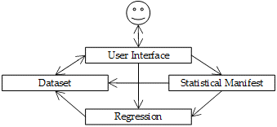
Figure 1. General architecture of Phoebe framework
3. Built-in algorithm of Phoebe framework
Phoebe framework uses regression model for estimating fetal weight and age. Suppose a linear regression function Y = α₀ + α₁X₁ + α₂X₂ + … + α_{n}X_{n} where Y is fetal weight or age whereas X_{i} (s) are gestational ultrasound measures such as bpd, hc, ac, and fl. Variable Y is called response variable or dependent variable. Each X_{i} is called regression variable, regressor, regression variable, or independent variable. Each α_{i} is called regression coefficient. Given a set of measure values of X_{i} (s), the value of Y called Y-estimated calculated from this regression function is estimated fetal weight (or age) which is compared with real value of Y measured from ultrasonic machine. The real value of Y called Y-real is fetal weight (or age) available in sample. In this research, the notation Y refers implicitly to Y-estimated if there is no explanation. The deviation between Y-estimated and Y-real is criterion used to assess the quality or the precision of regression function. This deviation is also called estimation error. The less the deviation is, the better the regression function is. The goal of this research is to find out the optimal regression function or estimation formula whose precision is highest.
A regression function will be good if it meets two conditions as follows:
- The correlation between Y-estimated and Y-real is large.
- The sum of residuals is small. Note that residual is defined as the square of deviation between Y-estimated and Y-real. We have:
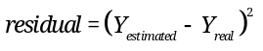
These two conditions are called the pair of optimal conditions. A regression function is optimal or best if it satisfies the pair of optimal conditions at most, where correlation between Y-estimated and Y-real is largest and the sum of residuals is smallest. Given a set of regression variables X_{i} (where i = 1, 2,…, n), we recognize that a regression function is a combination of k variables X_{i} (s) where k ≤ n so that such combination achieves the pair of optimal conditions. Given a set of possible regression variables VAR = {X₁, X₂,…, X_{n}} being ultrasound measures, brute-force algorithm can be used to find out optimal function, which includes three following steps:
- Let indicator number k be initialized 1, which responds to k-combination having k regression variables.
- All combinations of n variables taken k are created. For each k-combination, the function built up by k variables in this k-combination is evaluated on the pair of optimal conditions; if such function satisfies these conditions at most then, it is optimal function.
- Indicator k is increased by 1. If k = n then algorithm stops, otherwise go back step 2.
The number of combinations which brute-force algorithm browses is:
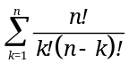
Where n is the number of regression variables and notation “k!” denotes factorial of k. If n is large enough, there are a huge number of combinations, which causes that the brute-force algorithm never terminates and it is impossible to find out the best function. Moreover there are many kinds of regression function such as linear, quadric, cube, logarithm, exponent, and product. So we propose an algorithm which overcomes this drawback and always finds out the optimal function. In other words, the termination of the proposed algorithm is determined and the time cost is decreased significantly because the searching space is reduced as small as possible. The proposed algorithm is called seed germination (SG) algorithm. SG is built-in algorithm of Phoebe framework, which is the core of Phoebe framework. It is heuristic algorithm, which is based on the pair of heuristic assumptions as follows:
- First assumption: regression variables X_{i} (s) trends to be mutually independent. It means that any pair of X_{i} and X_{j} with ij in an optimal function are mutually independent. The independence is reduced into the looser condition “the correlation coefficient of any pair of X_{i} and X_{j} is less than a threshold δ”. This is minimum assumption.
- Second assumption: each variable X_{i} contributes to quality of optimal function. The contribution rate of a variable X_{i} is defined as the correlation coefficient between such variable and Y-real. The higher the contribution rate is, the more important the respective variable is. Variables with high contribution rate are called contributive variables. So optimal function includes only contributive regression variables. The second assumption is stated that “the correlation coefficient of any regression variable X_{i} and real response value Y-real is greater than a threshold ε”. This is maximum assumption.
SG algorithm tries to find out a combination of regression variables X_{i} (s) so that such combination satisfies such pair of heuristic assumptions. In other words, it is expected that this combination can constitute an optimal regression function that satisfies the pair of heuristic conditions, as follows [10, p. 22]:
- The correlation coefficient of any pair of X_{i} and X_{j} is less than the minimum threshold δ > 0. This condition is corresponding to the minimum assumption, which is called minimum condition or independence condition.
- The correlation coefficient of any X_{i} and Y-real is greater than the maximum threshold ε > 0. This condition is corresponding to the maximum assumption, which is called maximum condition or contribution condition.
Given a set of possible regression variables VAR = {X₁, X₂,…, X_{n}} being ultrasound measures, let f = α₀ + α₁X₁ + α₂X₂ + … + α_{k}X_{k} (k ≤ n) be the estimation function and let Re(f) = {X₁, X₂,…, X_{k}} be its regression variables. Note that the value of f is fetal age or fetal weight. Re(f) is considered as the representation of f. Let OPTIMAL be the output of SG algorithm, which is a set of optimal functions returned. OPTIMAL is initialized as empty set. Let Re(OPTIMAL) be a set of regression variables contained in all optimal functions f OPTIMAL. SG algorithm has four following steps [10, p. 22]:
- Let C be the complement set of VAR with regard to OPTIMAL, we have C = VAR \ Re(OPTIMAL) where the backslash “\” denotes complement operator in set theory. It means that C is in VAR but not in Re(OPTIMAL).
- Let G C be a list of regression variables satisfying the pair of heuristic conditions. Note, G is subset of C. If G is empty, the algorithm terminates; otherwise going to step 3.
- We iterate over G in order to find out candidate list of good functions. For each regression variable X G, let L be the union set of optimal regression variables and X. We have L = Re(f){X} where f OPTIMAL. Suppose CANDIDATE is candidate list of good functions, which is initialized as empty set. Let g be the new function created from L; in other words, regression variables of g belong to L, Re(g) = L. If function g meets the pair of heuristic conditions, it is added into CANDIDATE, CANDIDATE = CANDIDATE{g}.
- Let BEST be a set of best functions taken from CANDIDATE. In other words, these functions belong to CANDIDATE and satisfy the pair of heuristic conditions at most, where correlation is largest and the sum of residuals is smallest. If BEST equals OPTIMAL then the algorithm stops; otherwise assigning BEST to OPTIMAL and going back step 1. Note that two sets are equal if their elements are the same.
Figure 2 shows the flow chart of SG algorithm.
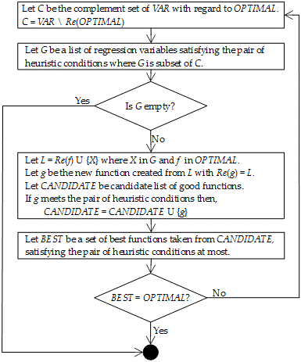
Figure 2. Flow chart of SG algorithm
SG algorithm was described in article “A framework of fetal age and weight estimation” [10, pp. 21-23]. It is easy to recognize that the essence of SG algorithm is to reduce search space by choosing regression variables satisfying heuristic assumption as “seeds”. Optimal functions are composed of these seeds. The algorithm always delivers best functions but can lose other good functions. The length of function is defined as the number of its regression variables. Terminated condition is that no more optimal functions can be found out or possible variables are browsed exhaustedly. So the result function is the longest and best one but some other shorter functions may be significantly good.
The current implementation of SG algorithm establishes that the minimum threshold δ is arbitrary. It also supports non-linear regression models shown in Table 2 as follows:
Polynomial | 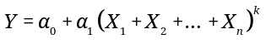
Logarithm
Logarithm | 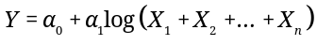
Exponent | 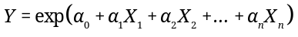
Exponent | 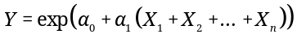
Product | 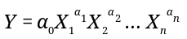
Table 2. Non-linear regression models
The notations “exp” and “log” denote exponent function and natural logarithm function, respectively. Most of non-linear regression models can be transformed into linear regression models. For example, given the product model, the following is an example of linear transformation.
Let,
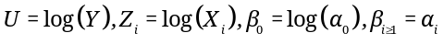
The product model becomes linear model with regard to variables U, Z_{i} and coefficients β_{i} as follows:
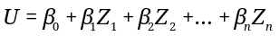
Table 3 shows how to transform non-linear models into linear models.
Polynomial
transformation
Polynomial  transformation | 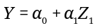  Where,
Logarithm
transformation
Logarithm  transformation | 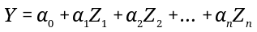  Where Z_{i} = log(X_{i})
Logarithm  transformation | 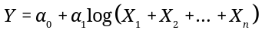
Logarithm  transformation | Where Z₁ = log(X₁ + X₂ + … + X_{n})
Exponent
transformation
Exponent  transformation | 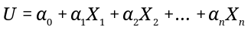  Where U = log(Y)
Exponent
transformation
Exponent  transformation | 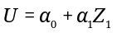  Where U = log(Y) and Z₁ = X₁ + X₂ + … + X_{n}
Product
transformation
Product  transformation | Where,
Table 3. Transformation of non-linear models into linear models
With the built-in SG algorithm, Phoebe framework can be totally used for any regression application beyond birth estimation.
4. Use cases of Phoebe framework
Phoebe framework has three basic use cases realized by three components dataset, regression model and statistical manifest discussed in section 2. Three basic use cases includes:
- Discovering optimal formulas with high accuracy. Optimal formulas are results of SG algorithm described in section 3.
- Providing statistical information under gestational sample. Statistical information is in numeric format and graph format.
- Comparison among different formulas.
Use case 1: Discovering optimal formulas
Given gestational data [15] is composed of two-dimension ultrasound measures of pregnant women. These measures are taken at Vinh Long General Hospital – Vietnam, which include bi-parietal diameter (bpd), head circumference (hc), abdominal circumference (ac) and fetal length (fl). Fetal age is from 28 weeks to 42 weeks. Fetal weight is measured by gram. Gestational sample is shown in Figure 3.
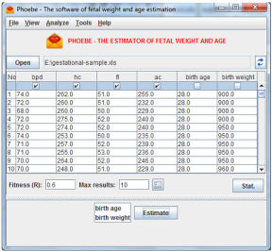
Figure 3. Gestational sample
After specifying maximum threshold ε (fitness value) and which measures are regression variables and response variable, user presses button “Estimate” to retrieve optimal formulas as results of SG algorithm. Such optimal formulas are shown in Figure 4. Note, in Figure 4, regression variables are bpd, hc, ac, and fl whereas response variable is fetal weight. The threshold ε is 0.6.
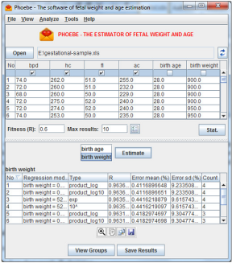
Figure 4. Optimal weight estimation formulas
An estimation formula with one or two regressors (ultrasound measures) can be represented as a graph. In the illustrative Figure 5, the horizontal axis indicates the measure bpd in millimeter and the right vertical axis indicates the measure ac in millimeter. The left vertical axis shows the estimated weight.
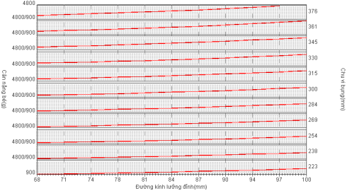
Figure 5. Estimation graph for estimating fetal weight
The graph in Figure 5 has 11 estimation lines represented as internal (red) lines. Each estimation line corresponds to a small interval of ac. Fetal weight on each estimation line ranges from 900 grams to 4800 grams. This is a way to shows a three-dimension function as a two-dimension graph. For example, given bpd = 90 and ac = 300, we need to estimate fetal weight. Because ac is 300 millimeter, we look at the sixth estimation line from bottom to up. The intersection point between bpd = 90 and the sixth estimation line is projected on the left vertical axis, which results out a fetal weight that approximates to (4800 – 900) / 2 + 900 ≈ 2850 grams because such intersection point is near to midpoint of the weight range on the sixth estimation line.
Use case 2: Providing statistical information
Statistical information is classified into two groups: gestational information and estimation information.
- Gestational information contains statistical attributes about fetal ultrasound measures, for example: mean, median and standard deviation of bpd.
- Estimation information contains attributes about estimation model, for example: correlation coefficient, sum of residuals and estimation error of estimation formula.
In representation, statistical information is described in two forms: numeric format and graph format. Figure 6 shows statistical attributes (mean, median, standard deviation, histogram, etc.) of fetal age and ultrasound measures bpd, hc, ac, fl.
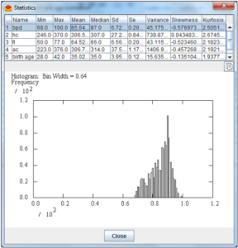
Figure 6. Gestational statistical information
Figure 7 shows full description of a weight estimation formula: weight = 0.000043 * (bpd^1.948640) * (hc^0.263745) * (fl^0.601972) * (ac^0.905524). For instance, sum of residuals (SS) is 46412446.0047 and estimation error is -7.4655 ± 212.5571. Note, the sign “^” denotes exponent function, for example 2^3 = 8.
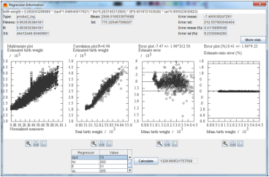
Figure 7. Statistical estimation information
Use case 3: Comparison among different formulas
There are many criteria to evaluate efficiency and accuracy of estimation formulas. These criteria are called evaluation criteria, for example: correlation coefficient, sum of residuals, estimation error. Each formula has individual strong points and drawbacks. A formula is better than another one in terms of some criteria but may be worse than this other one in terms of different criteria. An optimal formula is the one that has more strong points than drawbacks in most criteria. Hence, Phoebe framework supports the comparison among different formulas via evaluation matrix represented in Figure 8. Each row in evaluation matrix represents a formula whereas each column indicates a criterion. For example, first row, second row and third row represent three formulas in form of logarithm function, exponent function, and linear function, respectively. Four criteria: multivariate correlation, estimation correlation, error range and ratio error range are arranged in three respective columns.
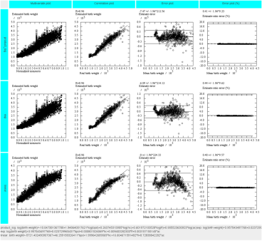
Figure 8. Comparison among different formulas
Tables 4, 5, 6, 7, and 8 in the section of experimental results are numeric interpretations of evaluation matrix in Figure 8.
5. Experimental Results
We make experiments based on Phoebe framework in order to find out optimal formulas for estimating fetus weight and ages with note that such formulas are most appropriate to our gestational samples. We use two samples in which the first sample includes two-dimension (2D) ultrasound measures of 1027 cases and the second sample includes three-dimension (3D) ultrasound measures of 506 cases. Ho and Phan [15 – 16] collected these samples of pregnant women at Vinh Long General Hospital – Vietnam with obeying strictly all medical ethical criteria. These women and their husbands are Vietnamese. Their periods are regular and their last periods are determined. Each of them has only one alive fetus. Fetal age is from 28 weeks to 42 weeks. Delivery time is not over 48 hours since ultrasound scan. Measures in 2D sample are bpd, hc, ac, and fl. Measures in 3D sample are bpd, hc, ac, fl, thigh_vol, arm_vol. The unit of bpd, hc, ac, fl is millimeter. The unit of thigh_vol and arm_vol is cm³. The units of fetal age and fetal weight are week and gram, respectively. Experimental results mentioned in this section were also published in our article “Experimental Results of Phoebe Framework: Optimal Formulas for Estimating Fetus Weight and Age” [11].
The proposed framework can produce amazing formulas. We compare our optimal formulas with the others according to metrics such as estimation correlation and estimation error range, given such two gestational samples. Let Y = {y₁, y₂,…, y_{n}} and Z = {z₁, z₂,…, z_{n}} be fetal sample age/weight and fetal estimated age/weight, respectively. The estimation correlation denoted R is correlation coefficient of sample response value and estimated response value, according to Eq. (1). The correlation R reflects adequacy of a given formula. The larger the R is, the better the formula is.
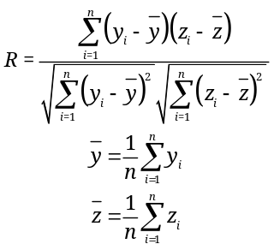 | (1)
An estimation error denoted d_{i} is deviation between z_{i} and y_{i}. The estimation error mean denoted µ is mean of errors. The error mean µ reflects accuracy of a given formula. The smaller the absolute value of µ is, the more accurate the formula is. If µ is positive, the respective formula leans to overestimation. If µ is negative, the respective formula leans to low estimation. The standard deviation σ of estimation errors reflects stability of a given formula. The smaller the standard deviation σ is, the more stable the formula is. The combination of error mean µ and standard deviation σ results out a so-called error range. Eq. (2) explains how to calculate µ, σ, and error range.
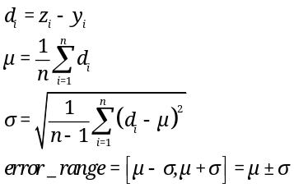 | (2)
For example, if µ = -0.0292 and σ = 1.45 then, the error range is -0.0292±1.45, which means that the total average error ranges from -1.4792 = -0.0292-1.45 to 1.4208 = -0.0292+1.45. The error range reflects both adequacy and accuracy of a given formula.
Table 4 shows comparison between our best age formula and the others with 2D sample. As a convention, the name of each formula is the name of respective author listed in references section. For example, formula “Ho 1” is the first formula of the author Ho [4]. As seen in Table 4 our formula is the best with R=0.9303 and error range -0.0292±1.4500 week (s). As a convention, our formulas have names with prefix “NH”.
Formula | Expression | R | Error Range
NH 1 | log(age) = 2.419638 + 0.002012 * bpd + 0.000934 * hc + 0.00547 * fl + 0.001042 * ac | 0.9303 | -0.0292±1.4500
NH 2 | age = -3.364759 + 0.056285 * bpd + 0.034697 * hc + 0.188156 * fl + 0.035304 * ac | 0.9285 | 0±1.4682
Ho 1 | age = 331.022308 - 1.611774 * (hc + ac) + 0.00278 * ((hc + ac)^2) - 0.000002 * ((hc + ac)^3) | 0.9212 | 0±1.5384
Varol 6 | age = 11.769 + 1.275 * fl/10 + 0.449 * ((fl/10)^2) - 0.02 * ((fl/10)^3) | 0.8949 | -1.6807±1.8525
Varol 1 | age = 5.596 + 0.941 * ac/10 | 0.8941 | -0.5683±1.7711
Varol 5 | age = 1.863 + 6.280 * fl/10 - 0.211 * ((fl/10)^2) | 0.8934 | -1.5182±2.1150
Table 4. Comparison of age estimation with 2D sample.
The sign “^” denotes exponent operator. The template of formulas aims to flexibility, which can be input of any computational tool. Table 5 shows comparison between our best weight formula and the others with 2D sample. As seen in Table 5, our formula is the best with R=0.9636 and error range -7.4656±212.5573 grams.
Formula | Expression | R | Error Range
NH 3 | log(weight) = -10.047381 + 1.94864 * log(bpd) + 0.263745 * log(hc) + 0.601972 * log(fl) + 0.905524 * log(ac) | 0.9636 | -7.4656±212.5573
NH 4 | log(weight) = 3.957543 + 0.02373 * bpd + 0.000802 * hc + 0.009403 * fl + 0.003157 * ac | 0.9635 | -6.0901±214.1153
Sherpard | weight = 10^(1.2508 + 0.166 * bpd/10 + 0.046 * ac/10 - 0.002646 * ac * bpd/100) | 0.9619 | -65.8121±219.0392
Ho 2 | weight = 10^(1.746 + 0.0124 * bpd + 0.001906 * ac) | 0.9602 | -11.5576±223.5124
Hadlock | weight = 10^(1.304 + 0.05281 * ac/10 + 0.1938 * fl/10 - 0.004 * ac * fl/100) | 0.9395 | -76.4960±272.9474
Campbell & Wilkin | weight = 1000 * exp(-4.564 + 0.282 * ac/10 - 0.00331 * ac * ac/100) | 0.9215 | 68.1261±308.5728
Table 5. Comparison of weight estimation with 2D sample.
Table 6 shows comparison between our best age formula and the others with 3D sample. As seen in Table 6, our formula is the best with R=0.9970 and error range ±0.2696 week.
Formula | Expression | R | Error Range
NH 5 | age = 20.759763 + 0.170859 * (thigh_vol + arm_vol) - 0.000545 * ((thigh_vol + arm_vol)^2) + 0.000001 * ((thigh_vol + arm_vol)^3) | 0.9970 | 0±0.2696
NH 6 | age = 21.816252 + 0.137531 * (thigh_vol + arm_vol) - 0.000228 * ((thigh_vol + arm_vol)^2) | 0.9969 | 0±0.2752
Ho 3 | age = 21.1148 + 0.2381 * thigh_vol - 0.001 * (thigh_vol^2) + 0.000002 * (thigh_vol^3) | 0.9960 | -0.0150±0.3173
Ho 4 | age = 167.079079 - 1.553705 * ac + 0.005559 * (ac^2) - 0.000006 * (ac^3) | 0.8482 | 0.3723±1.8985
Table 6. Comparison of age estimation with 3D sample.
Table 7 shows comparison between our best weight formula and the others with 3D sample. As seen in Table 7, our formula is the best with R=0.9708 and error range -0.0001 ± 180.9803 grams.
Formula | Expression | R | Error Range
NH 7 | weight = -3617.936175 + 0.513171 * hc + 1.960176 * ac + 39.804645 * bpd + 17.016936 * fl + 8.366404 * thigh_vol + 5.828808 * arm_vol | 0.9708 | -0.0001±180.9803
NH 8 | weight = -3626.314419 + 43.426744 * bpd + 23.645338 * fl + 11.414273 * thigh_vol | 0.9698 | 0±184.0439
Ho 5 | weight = -3306 + 55.477 * bpd + 13.483 * thigh_vol | 0.9663 | -0.0072±194.0956
Lee 3 | weight = exp(0.5046 + 1.9665 * log(bpd/10) - 0.3040 * (log(bpd/10)^2) + 0.9675 * log(ac/10) + 0.3557 * log(arm_vol)) | 0.9620 | 247.8761±206.1607
Lee 5 | weight = exp(2.1264 + 1.1461 * log(ac/10) + 0.4314 * log(thigh_vol)) | 0.9514 | 289.2660±234.0763
Lee 2 | weight = exp(-3.6138 + 4.6761 * log(ac/10) - 0.4959 * (log(ac/10)^2) + 0.3795 * log(arm_vol)) | 0.9472 | 316.4974±242.7964
Ho 6 | weight = -882.7049 + 73.9955 * thigh_vol - 0.497 * (thigh_vol^2) + 0.0014 * (thigh_vol^3) | 0.9385 | -7.5001±260.4596
Lee 4 | weight = exp(4.7806 + 0.7596 * log(thigh_vol)) | 0.9298 | 737.4932±344.1904
Lee 1 | weight = exp(4.9588 + 1.0721 * log(arm_vol) - 0.0526 * (log(arm_vol)^2)) | 0.9281 | 867.0836±309.5779
Chang | weight = 1080.8735 + 22.44701 * thigh_vol | 0.9229 | 456.5168±298.2517
Table 7. Comparison of weight estimation with 3D sample.
Within the context of this research, from section of 3D ultrasound in PhD dissertation of Ho [4], I recognize that fetus weight and fetus age are mutually dependent. For instance, when fetus age increases, fetus weight increase too. As a result, weight estimation is improved significantly if fetus age was known before. If fetus age is added into the regression model of fetus weight as a regression variable (regressor), the resulted weight estimation formula, called dual formula, is even better than the most optimal ones shown in Tables 5 and 6. Such dual formula is not only precise but also practical because many pregnant women knew their gestational age before taking an ultrasound examination. Given 2D sample and 3D sample, Table 8 shows dual formulas in comparison with the most optimal ones shown in Tables 5 and 7 with regard to R and error range. As a convention, our dual formulas have names with prefix “NHD”. Notation “log10” denotes logarithm function with base 10.
Formula | Expression | R | Error Range
NHD 1  (2D sample) | log10(weight) = -3.715073 + 1.873457 * log10(bpd) + 0.363783 * log10(fl) + 0.691683 * log10(ac) + 0.722245 * log10(age) | 0.9674 | -5.6422 ± 202.0395
NHD 2  (2D sample) | log10(weight) = -3.761798 + 2.001731 * log10(bpd) + 0.811078 * log10(ac) + 0.826279 * log10(age) | 0.9667 | -5.6111 ± 204.1477
NHD 3  (3D sample) | weight = -4988.000528 + 66.374156 * age + 0.370084 * hc + 1.943247 * ac + 39.464816 * bpd + 13.215505 * fl + 3.658463 * thigh_vol | 0.9715 | 0 ± 178.8091
NHD 4  (3D sample) | weight = -4982.099978 + 68.089354 * age + 2.001675 * ac + 39.85375 * bpd + 13.229377 * fl + 3.619405 * thigh_vol | 0.9714 | 0 ± 178.9114
NH 3  (2D sample) | log(weight) = -10.047381 + 1.94864 * log(bpd) + 0.263745 * log(hc) + 0.601972 * log(fl) + 0.905524 * log(ac) | 0.9636 | -7.4656±212.5573
NH 4  (2D sample) | log(weight) = 3.957543 + 0.02373 * bpd + 0.000802 * hc + 0.009403 * fl + 0.003157 * ac | 0.9635 | -6.0901±214.1153
NH 7  (3D sample) | weight = -3617.936175 + 0.513171 * hc + 1.960176 * ac + 39.804645 * bpd + 17.016936 * fl + 8.366404 * thigh_vol + 5.828808 * arm_vol | 0.9708 | -0.0001±180.9803
NH 8  (3D sample) | weight = -3626.314419 + 43.426744 * bpd + 23.645338 * fl + 11.414273 * thigh_vol | 0.9698 | 0±184.0439
Table 8. Weight estimation dual formulas.
In Table 8, all dual formulas NHD * are better than normal formulas NH * with regard to R and error range. Moreover, NHD * do not need too much regressors. Given 2D sample, NHD 1 and NHD 2 use 4 and 3 regressors including age regressor, respectively whereas both NH 3 and NH 4 uses 4 regressors. Given 3D sample, NHD 3 and NHD 4 use 6 and 5 regressors including age regressor, respectively whereas NH 7 and NH 8 use 5 and 3 regressors, respectively.
Although our formulas are better than all remaining ones with high adequacy (large R) and high accuracy (small error range), other researches are always significant because their formulas are very simple and practical. Moreover, our formulas are not global. If they are applied into other samples collected in other communities, their accuracy may be decreased and they may not be still better than traditional formulas such as Sherpard and Hadlock. However, it is easy to draw from our experimental results that if Phoebe framework is used for the same samples with other researches, it will always produces preeminent formulas. In order to achieve global optimality with Phoebe framework, the following are two essential suggestions:
- Experimenting on Phoebe framework with many samples.
- Adding more knowledge of pregnancy study, ultrasound technique, and obstetrics into Phoebe framework. In other words, the additional knowledge will be modeled as constraints of SG algorithm.
These suggestions go beyond this research. For my opinion, we cannot reach absolutely the global optimality because Phoebe framework focuses on local optimality with specific communities. Essentially, the suggestions only alleviate the weak point of the built-in SG algorithm in global optimality.
6. A proposal of early weight estimation
The used ultrasound samples are collected in fetal age from 28 weeks to 42 weeks because delivery time is not over 48 hours since last ultrasound scan. Hence, accuracy of weight estimation is only ensured when ultrasound examinations are performed after 28-week old fetal age. This section propose an early weight estimation, in which ultrasound measures can be taken before 28-week old fetal age. We do not ensure improvement of estimation accuracy yet because we do not make experiments on the proposal yet but the gestational sample can be totally collected at any appropriate time points in gestational period. In other words, the sample can lack fetal weights. This is a convenience for practitioners because they do not need to concern fetal weights when taking ultrasound examinations. Consequently, early weight estimation is achieved. As a convention, vectors are column vectors if there is no additional information.
Without loss of generality, regression models are linear such as Y = α₀ + α₁X₁ + α₂X₂ + … + α_{n}X_{n} and Z = β₀ + β₁X₁ + β₂X₂ + … + β_{n}X_{n} where Y is fetal age and Z is fetal weight whereas X_{i} (s) are gestational ultrasound measures such as bpd, hc, ac, and fl. Suppose both Y and Z conform normal distribution, according to equation 3 [17, pp. 8-9].
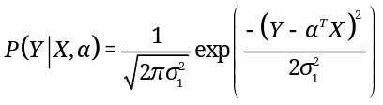  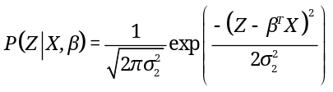 | (3)
Where, α = (α₁, α₂,…, α_{n})^{T} and β = (β₁, β₂,…, β_{n})^{T} are parameter vectors where X = (1, X₁, X₂,…, X_{n})^{T} is data vector. The means of Y and Z are α^{T}X and β^{T}X, respectively whereas the variances of Y and Z are 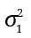and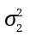, respectively. Note that the superscript “^{T}” denotes transposition operator in vector and matrix. Let D = (X, y, z) be collected sample in which X is a set of sample measures, y is a set of sample fetal ages, and z is a set of fetal weights with note that z is missed (empty) or incomplete. If z is empty, there is no z_{i} in z. If z is incomplete, z has some values but there are also some missing values in z. However, the constraint is that y must be complete, which means that all pregnant women within the research knew their gestational age. Now we focus on estimate α and β based on D. As a convention let α* and β* be estimates of α and β, respectively [17, p. 8].
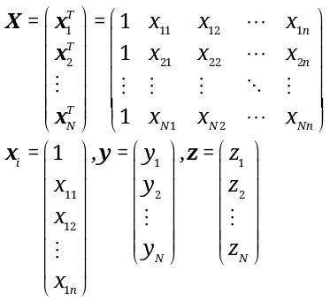
Given X, joint probability of Y and Z is product of the probability of Y given X and the probability of Z given X because Y and Z are conditionally independent given X, according to equation 4.
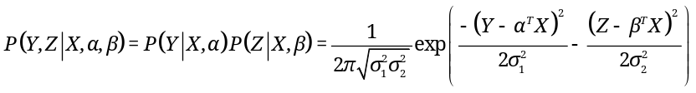 | (4)
Conditional expectation of sufficient statistic Z given X with regard to P(Z | X, β) is specified by equation 5.
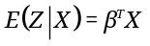 | (5)
When Z is hidden variable, there is a latent dependent relationship between Y and Z, which is specified by joint probability of Y and Z.
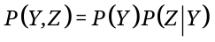
Variables Y and Z have different measures. For instance, the unit of Y is week whereas the unit of Z is gram. Suppose Y is considered as discrete variable whose values from 1 to K where K can be up to 42, for example. The P(Y) becomes parameter θ_{Y}, which is the probability of Y where Y is from 1 to K.
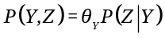
For each Z, suppose the condition probability P(Z | Y) is distributed normally with mean μ_{Y} and variance σ_{Y}². Equation 6 specifies the joint probability P(Y, Z).
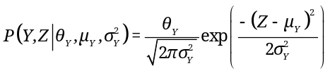 | (6)
Conditional expectation of sufficient statistic Z given Y with regard to P(Z | Y, μ_{Y}, σ_{Y}²) is specified by equation 7.
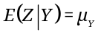 | (7)
Please pay attention to equation 7 because Z will be estimated by such expectation later. Equation 8 specifies expectation of sufficient statistic Z with regard to P(Y, Z | θ_{Y}, μ_{Y}, σ_{Y}²).
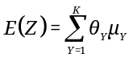 | (8)
Due to:
The full joint probability of Y and Z given X and parameters α, β, θ_{Y}, μ_{Y}, and σ_{Y}² is the product specified by equation 9.
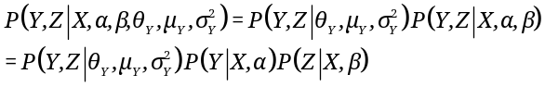 | (9)
Where P(Y, Z | X, α, β) and P(Y, Z | θ_{Y}, μ_{Y}, σ_{Y}²) are specified by equations 4 and 6, respectively. Equation 9 indicates that both explicit dependence via P(Y, Z | X, α, β) and implicit dependence via P(Y, Z | θ_{Y}, μ_{Y}, σ_{Y}²) between Y and Z. Explicit dependence and implicit dependence share equal influence on Z if E(Z | X) specified by equation 5 is equal to E(Z) specified by equation 8, according to equation 10.
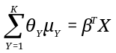 | (10)
Given sample D, all θ_{Y} become constants and determined by equation 11.
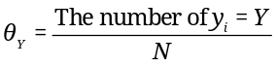 | (11)
For convenience, let Θ = (α, β, μ_{Y})^{T} be the compound parameter. The full joint probability specified by equation 9 is re-written as follows:
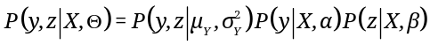
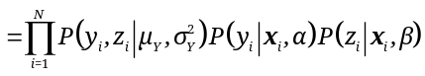
(Due to all observations are independently and identically distributed)
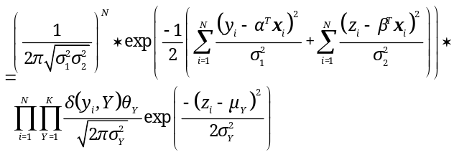
Where,
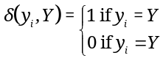
It is conventional that if δ(y_{i}, Y) = 0 then, the respective probability P(y_{i}, z_{i} | μ_{Y}, σ_{Y}²) is removed from the product. The log-likelihood function is logarithm of the full joint probability as follows:
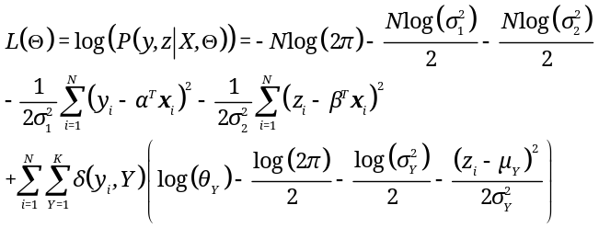
When log(2π) and θ_{Y} are constants, the reduced log-likelihood function is derived from the log-likelihood as seen in equation 12.
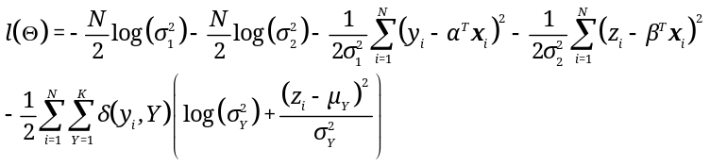 | (12)
The optimal estimate Θ* is a maximizer of l(Θ), according to equation 13 [17, p. 9).
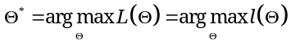 | (13)
By taking first-order partial derivatives of l(Θ) with regard to Θ [18, p. 34], we obtain:
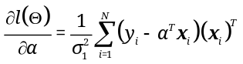
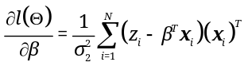
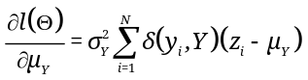
When first-order partial derivatives of l(Θ) are equal to zero, it gets locally maximal. In other words, Θ* is solution of the equation system 14 resulted from setting such derivatives to be zero and setting E(Z | X) = E(Z).
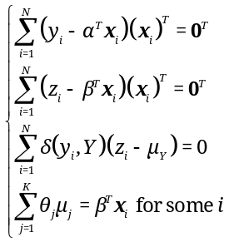 | (14)
Where,
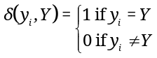
The notation 0 = (0, 0,…, 0)^{T} denotes zero vector. All equations in the system 14 are linear, whose unknowns are Θ = (α, β, μ_{Y})^{T}. The last equation in the system 14 is equation 10 with the heuristic assumption that explicit dependence and implicit dependence share equal influence on Z. Such last equation is only used to adjust μ_{Y} (s) if the heuristic assumption is concerned; otherwise it is ignored.
We apply expectation maximization (EM) algorithm into estimating Θ = (α, β, μ_{Y})^{T} with lack of fetal weights. Note that the full joint probability P(Y, Z | X, α, β, μ_{Y}) specified by equation 9 is product of regular exponential distributions. EM algorithm has many iterations and each iteration has expectation step (E-step) and maximization step (M-step) for estimating parameters. Given current parameter Θ_{t} = (α^{t}, β^{t}, μ_{Y}^{t})^{T} at the t^{th} iteration, the two steps are shown in Table 9 [19, p. 4].
- E-step: Estimating only missing values z_{i} (s) as the expectation of themselves based on the current mean , according to equation 7. Note, each missing value z_{i} is always associated with an observation y_{i}.
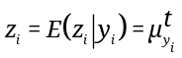
- M-step: The next parameter Θ^{t+1} is a maximizer of l(Θ), which is the solution of equation system 14. Note, Θ^{t+1} becomes current parameter for the next iteration.
Table 9. E-step and M-step of EM algorithm
The equation system 14 is solvable because missing values z_{i} (s) were estimated in E-step. The EM algorithm stops if at some t^{th} iteration, we have Θ^{t} = Θ^{t+1} = Θ*. At that time, Θ* = (α*, β*, μ_{Y}*)^{T} is the optimal estimate of EM algorithm and hence linear regression functions of Y and Z is determined with α*, β*.
As usual, all parameters are changed after every iteration of EM algorithm but fortunately, α* is determined as a partial solution of the equation system 14 at the first iteration of EM process because both X and y are complete. In other words, α* is fixed whereas β and μ_{Y} are changed in EM process. Equation 15 [20, p. 417] specifies α*.
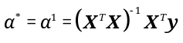 | (15)
Where the superscript “^{–1}” denotes the inversion of matrix.
At the first iteration, as usual Θ¹ is initialized arbitrarily but we can improved convergence of EM algorithm by initializing 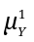 as sample mean. Without loss of generality, suppose practitioners obtained n < N fetal weights z₁, z₂,…, z_{n} from n ultrasound scans. Moreover, the fetal age of all pregnant women over such n scans is the same, which is Y. Thus, is initialized by equation 16.
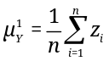 | (16)
The parameter β¹ at the first iteration is initialized according to previous studies in the literature.
7. Conclusions
According to experimental results, there is no doubt that Phoebe framework produces optimal formulas with high adequacy and accuracy; please see Tables 4, 5, 6, 7, and 8 for more details. However we also recognize the weak point of our research is that the built-in SG algorithm can lose some good formulas due to the heuristic conditions. The suggestive solution is to add more constraints into such conditions; please read the article “A framework of fetal age and weight estimation” [10, pp. 24-25] for more details. The proposal of early weight estimation uses actually an additional constraint which is the latent relationship between fetal age and fetal weight. Such latent relationship represented by the joint probability of fetal age and fetal weight is a knowledge aspect of pregnancy study. For further research, we will make experiment on the proposal and try our best to discover other knowledge aspects.
Another weak point of our research is difficult to apply our complex formulas for fast mental calculation because we must pay the price for their high accuracy. In the future, we will embed these formulas into software or hardware of medical ultrasound machine so that users are easy to read estimated values resulted from machine.
Acknowledgements
We express our deep gratitude to the author Michael Thomas Flanagan – University College London and the author Jos de Jong for giving us helpful software packages that help us to implement the framework.
References
[1] | F. P. Hadlock, R. B. Harrist, R. S. Sharman, R. L. Deter and S. K. Park, "Estimation of fetal weight with use of head, body and femur measurements: A prospective study," American Journal of Obstetrics and Gynecology, vol. 151, no. 3, pp. 333-337, 1 February 1985.
[2] | D. T. Phan, "Ứng dụng siêu âm để chẩn đoán tuổi thai và cân nặng thai trong tử cung," Hanoi University of Medicine, Hanoi, 1985.
[3] | T. N. T. Phạm, "Ước lượng cân nặng thai nhi qua các số đo của thai trên siêu âm," Ho Chi Minh University of Medicine and Pharmacy, Ho Chi Minh, 2000.
[4] | T. H. T. Ho, "Nghiên Cứu Phương Pháp Ước Lượng Trọng Lượng Thai, Tuổi Thai Bằng Siêu Âm Hai và Ba Chiều," Hanoi Univerisy of Medicine, Hanoi, 2011.
[5] | J. M. Shepard, A. V. Richards, L. R. Berkowitz, L. S. Warsof and C. J. Hobbins, "An evaluation of two equations for predicting fetal weight by ultrasound," American Journal of Obstetrics and Gynecology, vol. 142, no. 1, pp. 47-54, 1 January 1982.
[6] | S. Campbell and D. Wilkin, "Ultrasonic measurement of fetal abdomen circumference in the estimation of fetal weight," BJOG: An International Journal of Obstetrics & Gynaecology, vol. 82, no. 9, pp. 689-697, September 1975.
[7] | W. Lee, M. Balasubramaniam, R. L. Deter, L. Yeo, S. S. Hassan, F. Gotsch, J. P. Kusanovic, L. F. Gonçalves and R. Romero, "New fetal weight estimation models using fractional limb volume," Ultrasound in Obstetrics & Gynecology, vol. 34, no. 5, pp. 556-565, 1 November 2009.
[8] | F.-M. Chang, R.-I. Liang, H.-C. Ko, B.-L. Yao, C.-H. Chang and C.-H. Yu, "Three-dimensional ultrasound-assessed fetal thigh volumetry in predicting birth weight," Obstetrics & Gynecology, vol. 90, no. 3, pp. 331-339, September 1997.
[9] | F. Varol, A. Saltik, P. B. Kaplan, T. Kilic and T. Yardim, "Evaluation of Gestational Age Based on Ultrasound Fetal Growth Measurements," Yonsei Medical Journal, vol. 42, no. 3, pp. 299-303, June 2001.
[10] | M. T. Flanagan, Java Scientific Library, M. T. Flanagan, Ed., London, Enland: University College London, 2004.
[11] | J. d. Jong, A Java expression parser, Rotterdam: SpeQ Mathematics, 2010.
[12] | Oracle, "Java language," Oracle Corporation, [Online]. Available: https://www.oracle.com/java. [Accessed 25 December 2014].
[13] | L. Nguyen and H. Ho, "A framework of fetal age and weight estimation," Journal of Gynecology and Obstetrics (JGO), vol. 2, no. 2, pp. 20-25, 30 March 2014.
[14] | T. H. T. Ho and D. T. Phan, "Ước lượng cân nặng của thai từ 37 – 42 tuần bằng siêu âm 2 chiều," Journal of Practical Medicine, vol. 12, no. 797, pp. 8-9, December 2011.
[15] | T.-H. T. Ho and D. T. Phan, "Ước lượng tuổi thai qua các số đo thể tích cánh tay bằng siêu âm 3 chiều và các số đo bằng siêu âm 2 chiều," Journal of Practical Medicine, vol. 12, no. 798, pp. 12-15, December 2011.
[16] | L. Nguyen and T.-H. T. Ho, "Experimental Results of Phoebe Framework: Optimal Formulas for Estimating Fetus Weight and Age," Journal of Community & Public Health Nursing, vol. 3, no. 2, pp. 1-5, 13 March 2017.
[17] | F. Lindsten, T. B. Schön, A. Svensson and N. Wahlström, "Probabilistic modeling – linear regression & Gaussian processes," Uppsala University, Uppsala, 2017.
[18] | L. Nguyen, Matrix Analysis and Calculus, 1st ed., C. Evans, Ed., Hanoi: Lambert Academic Publishing, 2015, p. 72.
[19] | A. P. Dempster, N. M. Laird and D. B. Rubin, "Maximum Likelihood from Incomplete Data via the EM Algorithm," Journal of the Royal Statistical Society, Series B (Methodological), vol. 39, no. 1, pp. 1-38, 1977.
[20] | D. C. Montgomery and G. C. Runger, Applied Statistics and Probability for Engineers, 3rd Edition ed., New York, NY: John Wiley & Sons, Inc, 2003, p. 706.

