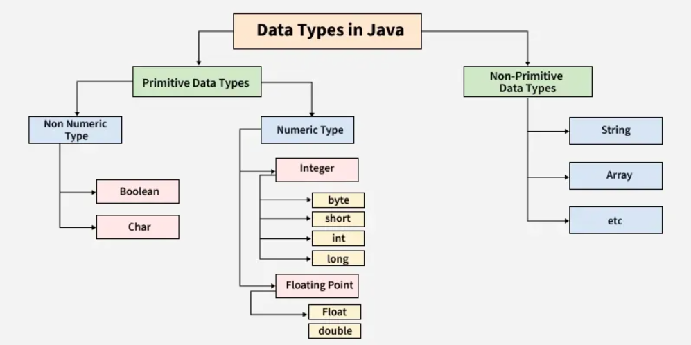
Figure 1: https://www.geeksforgeeks.org/java/java-data-types/

Operation là trong UML
Method là trong code

Java - OOPs (Object-Oriented Programming) Concepts (tutorials point)
Java OOP(Object Oriented Programming) Concepts - GeeksforGeeks (full)
What is a Method in Object-Oriented Programming (OOP)? | Cincom (method)

Heap & Stack memory:
Stack Memory and Heap Space in Java | Baeldung
Java Stack vs Heap Memory Allocation - GeeksforGeeks

Getter & Setter:
Getter and Setter in Java - GeeksforGeeks
Getter and Setter in Java

Overloading & Overriding:
Overloading vs Overriding in Java - GeeksforGeeks

UML Notion:
UML Class Diagram Tutorial

constructor trong abstract class và constructor trong interface (Java 8+) ?

