VIETNAM NATIONAL UNIVERSITY – HO CHI MINH CITY
INTERNATIONAL UNIVERSITY
SCHOOL OF COMPUTER SCIENCE AND ENGINEERING


Website Application Development Lab 01
Student name: Nguyen Quynh Anh - ITCSIU24005

Table of Contents
A. Exercise 01 – Basic: University Department Website: 3
Task description: 3
Results: 3
Home Page (index.html): 3
Faculty Page (faculty.html): 4
Contact page (contact.html): 6
Explanation: 7
B. Exercise 02: Course registration system 9
Task Description 9
Results: 9
Home page 9
Course catalog page 10
CS101 Page 14
CS201 Page 16
Registration form page 18
Confirmation page 20
Contact Page 22
Explanation: 24
C. Exercise 03: Multi-section website with edge cases 25
Task description: 25
Results: 25
Home Page: 25
Research Page: 27
Publication Page: 30
People Page: 36
Join Us Page: 39
Contact Page: 43
Technical Challenges: 45
3. Complex Tables 45
4. Form Edge Cases 46
5. Broken Link Detection 48
6. URL Parameter Handling 49
7. Alternative Text for Images 50
Performance and Logic Challenges 51
1. Large Table Performance 51
2. Form Submission Logic with File Uploads 51
3. Navigation Efficiency 51
Explanation: 52
1. Architecture Decisions (200-300 words) 52
2. Semantic HTML Choices (150-200 words) 53
3. Form Analysis (200-250 words) 53
D. Lab completion checklist 54
Functional correctness 54
Semantic HTML 54
Forms 55
Understanding 55
Debugging Skills 55
Code Quality 56
Documentation (for exercises requiring explanation) 56
E. Thinking & Discussion Questions 56
Question 1: Request-Response Analysis 56
Question 2: GET vs POST (Preview) 57
Question 3: Semantic HTML Trade-offs 58
Question 4: Debugging Scenario 59
Question 5: Stateless HTTP 60
Question 6: Form Design 61
Question 7: Performance and Scalability 62
Question 8: Real-World Architecture 63

Exercise 01 – Basic: University Department Website:

Task description:
Create a small website for a university department (Computer Science, Mathematics, or any department of your choice) consisting of at least 3 pages.

Results:

Home Page (index.html):
<!DOCTYPE html>
<html lang="en">
<head>
<meta charset="UTF-8">
<meta name="viewport" content="width=device-width, initial-scale=1.0">
<title>Computer Science Department</title>
</head>
<body>
<header>
<h1>Department of Computer Science</h1>
<nav>
<ul>
<li><a href="index.html">Home</a></li>
<li><a href="faculty.html">Faculty</a></li>
<li><a href="contact.html">Contact</a></li>
</ul>
</nav>
</header>
<main>
<h2>Welcome to the Computer Science Department</h2>
<p>Welcome to the Department of Computer Science. We are dedicated to delivering world-class education and fostering cutting-edge research in software engineering, artificial intelligence, computer vision, and systems infrastructure. Our curriculum is designed to empower students with both theoretical foundations and practical skills.</p>
<p>Our department offers undergraduate and graduate programs tailored to modern industry demands. Through hands-on laboratory work, collaborative projects, and industry partnerships, our students build strong problem-solving skill sets that prepare them for top tech careers and academia.</p>
<p>Explore our site to meet our distinguished faculty members or contact us directly to learn more about our academic offerings and upcoming admissions cycles.</p>
</main>
<footer>
<p>&copy; 2026 Department of Computer Science. All rights reserved.</p>
</footer>
</body>
</html>
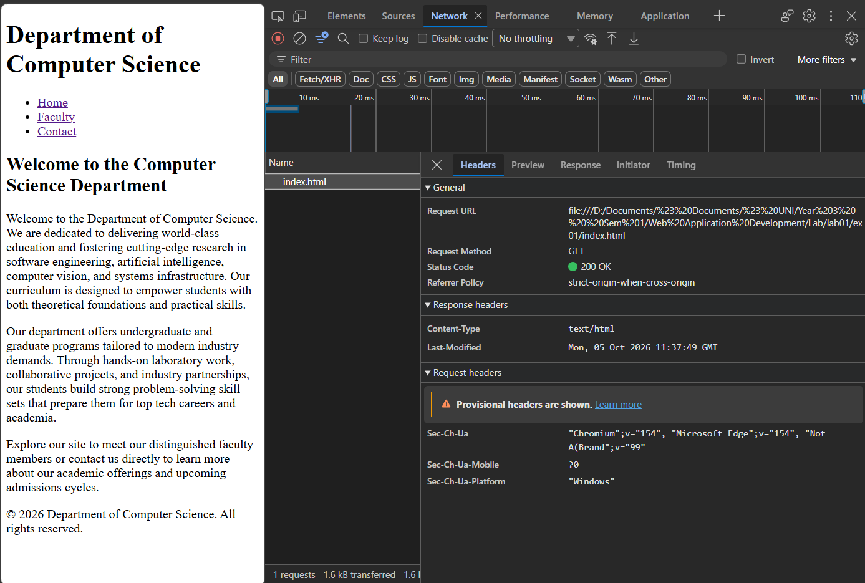

Faculty Page (faculty.html):
<!DOCTYPE html>
<html lang="en">
<head>
<meta charset="UTF-8">
<meta name="viewport" content="width=device-width, initial-scale=1.0">
<title>Department of Computer Science - Faculty</title>
</head>
<body>
<header>
<h1>Department of Computer Science</h1>
<nav>
<ul>
<li><a href="index.html">Home</a></li>
<li><a href="faculty.html">Faculty</a></li>
<li><a href="contact.html">Contact</a></li>
</ul>
</nav>
</header>
<main>
<section>
<h2>Faculty Members</h2>
<article>
<h3>Dr. Nguyen Van A</h3>
<p><strong>Title:</strong> Professor</p>
<p><strong>Research Interests:</strong> Theory of Computation, Artificial Intelligence, Cryptography</p>
<p><strong>Email:</strong> <a href="mailto:nguyenvana@hcmiu.edu">nguyenvana@hcmiu.edu</a></p>
</article>
<article>
<h3>Dr. Nguyen Thi B</h3>
<p><strong>Title:</strong> Professor</p>
<p><strong>Research Interests:</strong> {Theory of Computation, Artificial Intelligence, Cryptography}</p>
<p><strong>Email:</strong> <a href="mailto:nguyenvana@hcmiu.edu">nguyenvana@hcmiu.edu</a></p>
</article>
</section>
</main>
</body>
</html>
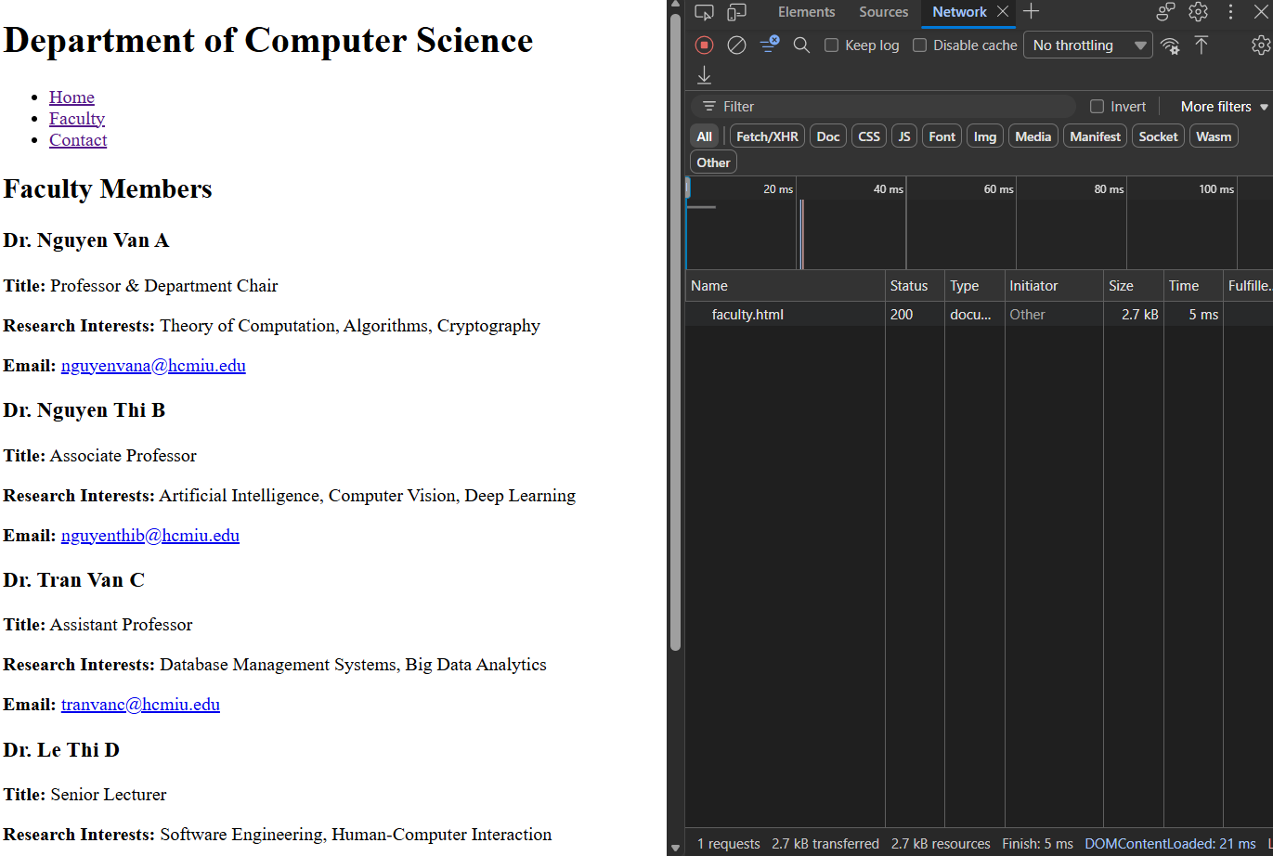

Contact page (contact.html):
<!DOCTYPE html>
<html lang="en">
<head>
<meta charset="UTF-8">
<meta name="viewport" content="width=device-width, initial-scale=1.0">
<title>Department of Computer Science - Faculty</title>
</head>
<body>
<header>
<h1>Department of Computer Science</h1>
<nav>
<ul>
<li><a href="index.html">Home</a></li>
<li><a href="faculty.html">Faculty</a></li>
<li><a href="contact.html">Contact</a></li>
</ul>
</nav>
</header>
<main>
<section>
<h2>Contact Us:</h2>
<address>
<ul>
<li><strong>Email: </strong> <a href="mailto:cs-department@hcmiu.edu">cs-department@hcmiu.edu</a></li>
<li><strong>Address: </strong>ABC, Dong Hoa, Ho Chi Minh city</li>
</ul>
</address>
<h3>Phone number: </h3>
<p><strong>Phone:</strong> (555) 019-2834</p>
<h3>Office Hours</h3>
<ul>
<li><strong>Monday - Friday:</strong> 8:00 AM - 5:30 PM</li>
<li><strong>Saturday - Sunday:</strong> Closed</li>
</ul>
</section>
</main>
<footer>
<p>&copy; 2026 Department of Computer Science. All rights reserved.</p>
</footer>
</body>
</html>

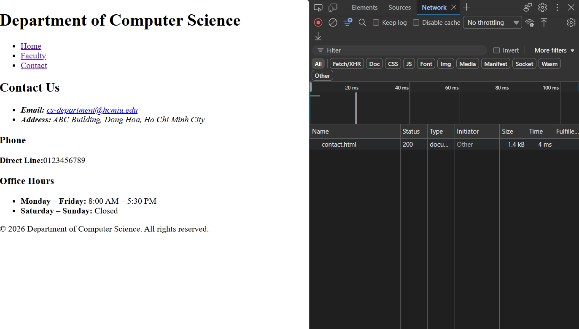

Explanation:
Structure:
The reason that I choose <header>, <main>, <footer>, <nav>, <section>, <article> is as follows:
The main reason for all semantic elements is their readability, accessibility, and cleaner styling. This lets programmers easily distinguish and access sections.
<header>: used for representing introductory text or navigation links. It is usually placed at the top of the file and holds elements like a logo, search bar, and navigation bar.
<main>: represents the dominant or primary content of the <body> of a document. It contains content directly related to or expanding upon the central topic of the page.
<footer>: defines a footer for a document or section, typically containing author information, copyright data, contact details, or sitemap links.
<nav>: represents a section of a page whose purpose is to provide navigation links, either within the current document or to other documents.
<section>: represents a standalone, generic section of a document that groups related content together, typically with a heading. It works like a chapter in a book.
<article>: represents a self-contained composition in a document, page, or site that is intended to be independently reusable or redistributable (e.g., a blog post or news item). This element can stand alone even if it is not placed in the file or stands with other content.
<address>: Reserved on contact.html to supply author/contact details for the department or site administrator following standard HTML5 specifications.
Navigation:
The logic under navigation bar is an <a> link (e.g., <a href="[https://example.com/about.html] (https://example.com/about.html)">About</a>). Therefore, when the user clicks a navigation link, the web browser will respond as follows:
URL Resolution & DNS Lookup: The browser resolves the relative target into an absolute URI. If pointing to an external domain, it queries a DNS server to translate the hostname into an IP address.
TCP / TLS Handshake: The browser opens a TCP connection (3-way handshake) to the target server's port (typically port 80 for HTTP or 443 for HTTPS).
HTTP Request Sent: The browser sends an HTTP GET request (e.g., GET /faculty.html HTTP/1.1) along with request headers like Host, User-Agent, and Accept.
Server Processing: The web server receives the request, locates /faculty.html on the server’s file system, reads the file content, and builds the response.
HTTP Response Returned: The server responds with a status line (e.g., HTTP/1.1 200 OK), response headers (Content-Type: text/html), and the actual HTML document payload.
Parsing & Rendering: The browser parses the HTML DOM tree, identifies linked sub-resources (like images), issues secondary requests, and renders the layout on screen.
File Paths: If your index.html is in a folder called department/, and you have an image in department/images/logo.png, what is the correct relative path to use in index.html?
The correct path to use in the index.html file is <img src="images/logo.png" alt="Logo">. We need to have the folder name before using the image path (index.html is inside the department/ folder) in the src attribute of the <img>.
Testing:
To verify the functionality and correctness of the website, the following local testing procedures were conducted:
Local HTTP Server Execution: Served the website locally using standard tools (such as Python's http.server module or Live Server) to verify request handling and path routing.
Link Navigation & Integrity Verification: Tested navigation links across all three pages to ensure smooth routing without encountering 404 errors or broken relative paths.

Exercise 02: Course registration system

Task Description
Create a multi-page course registration system that demonstrates understanding of forms, tables, and navigation.

Results:

Home page
<!DOCTYPE html>
<html lang="en">
<head>
<meta charset="UTF-8">
<meta name="viewport" content="width=device-width, initial-scale=1.0">
<title>Computer Science Department</title>
</head>
<body>
<header>
<h1>Department of Computer Science</h1>
<nav>
<ul>
<li><a href="index.html">Home</a></li>
<li><a href="courses.html">Courses</a></li>
<li><a href="registration.html">Registration</a></li>
<li><a href="contact.html">Contact</a></li>
</ul>
</nav>
</header>
<main>
<section>
<h2>Welcome to the Computer Science Department</h2>
<p>Welcome to the Department of Computer Science. We are dedicated to delivering world-class education and fostering cutting-edge research in software engineering, artificial intelligence, computer vision, and systems infrastructure. Our curriculum is designed to empower students with both theoretical foundations and practical skills.</p>
<p>Our department offers undergraduate and graduate programs tailored to modern industry demands. Through hands-on laboratory work, collaborative projects, and industry partnerships, our students build strong problem-solving skill sets that prepare them for top tech careers and academia.</p>
<p>Explore our site to meet our distinguished faculty members or contact us directly to learn more about our academic offerings and upcoming admissions cycles.</p>
</section>
</main>
<footer>
<p>&copy; 2026 Department of Computer Science. All rights reserved.</p>
</footer>
</body>
</html>

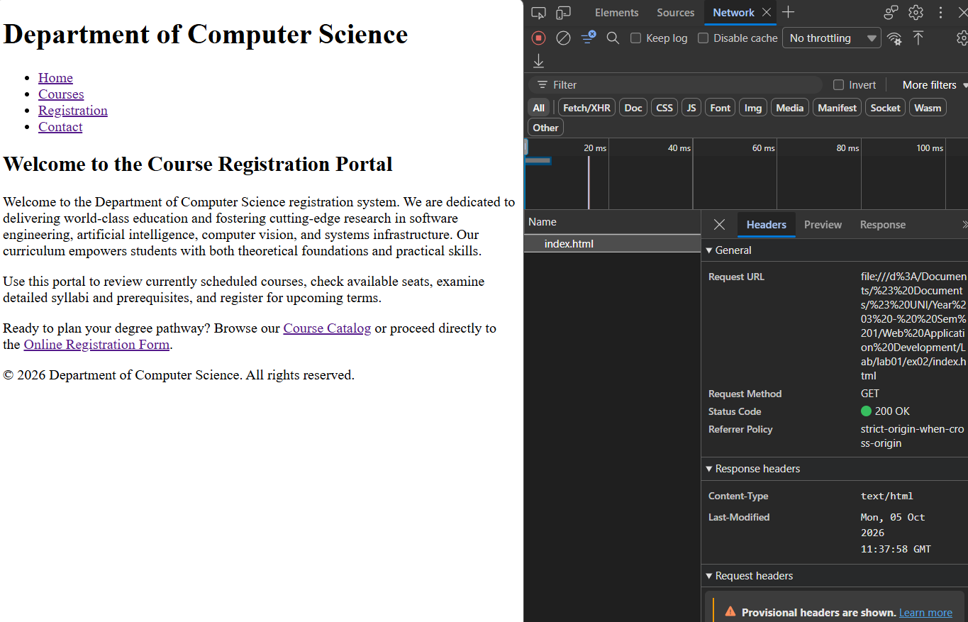

Course catalog page

<!DOCTYPE html>
<html lang="en">
<head>
<meta charset="UTF-8">
<meta name="viewport" content="width=device-width, initial-scale=1.0">
<title>Computer Science Department</title>
</head>
<body>
<header>
<h1>Department of Computer Science</h1>
<nav>
<ul>
<li><a href="index.html">Home</a></li>
<li><a href="courses.html">Courses</a></li>
<li><a href="registration.html">Registration</a></li>
<li><a href="contact.html">Contact</a></li>
</ul>
</nav>
</header>
<main>
<section>
<h2>Welcome to the Computer Science Department</h2>
<p>Welcome to the Department of Computer Science. We are dedicated to delivering world-class education and fostering cutting-edge research in software engineering, artificial intelligence, computer vision, and systems infrastructure. Our curriculum is designed to empower students with both theoretical foundations and practical skills.</p>
<p>Our department offers undergraduate and graduate programs tailored to modern industry demands. Through hands-on laboratory work, collaborative projects, and industry partnerships, our students build strong problem-solving skill sets that prepare them for top tech careers and academia.</p>
<p>Explore our site to meet our distinguished faculty members or contact us directly to learn more about our academic offerings and upcoming admissions cycles.</p>
</section>
</main>
<footer>
<p>&copy; 2026 Department of Computer Science. All rights reserved.</p>
</footer>
</body>
</html>
<li><a href="index.html">Home</a></li>
<li><a href="courses.html">Courses</a></li>
<li><a href="registration.html">Registration</a></li>
<li><a href="contact.html">Contact</a></li>
</ul>
</nav>
</header>
<main>
<section>
<h2>Available Courses</h2>
<table border="1">
<caption>Available Computer Science Courses - Academic Year 2025/2026</caption>
<thead>
<tr>
<th scope="col">Course Code</th>
<th scope="col">Title</th>
<th scope="col">Credits</th>
<th scope="col">Schedule</th>
<th scope="col">Instructor</th>
<th scope="col">Available Seats</th>
</tr>
</thead>
<tbody>
<tr>
<td><a href=".\courses\cs101.html">CS101</a></td>
<td>Introduction to Computer Science</td>
<td>3</td>
<td>Mon/Wed 09:00 - 10:30</td>
<td>Dr. Nguyen Van A</td>
<td>12</td>
</tr>
<tr>
<td><a href=".\courses\cs201.html">CS201</a></td>
<td>Data Structures & Algorithms</td>
<td>4</td>
<td>Mon/Wed 09:00 - 10:30</td>
<td>Dr. Nguyen Van A</td>
<td>5</td>
</tr>
<tr>
<td>CS301</td>
<td>Web Development Fundamentals</td>
<td>3</td>
<td>Mon/Wed 09:00 - 10:30</td>
<td>Dr. Nguyen Van A</td>
<td>8</td>
</tr>
<tr>
<td>CS305</td>
<td>Database Management Systems</td>
<td>3</td>
<td>Mon/Wed 09:00 - 10:30</td>
<td>Dr. Nguyen Van A</td>
<td>2</td>
</tr>
<tr>
<td>CS401</td>
<td>Operating Systems</td>
<td>4</td>
<td>Fri 09:00 - 12:00</td>
<td>Dr. Nguyen Van A</td>
<td>15</td>
</tr>
<tr>
<td>CS420</td>
<td>Computer Graphics & Vision</td>
<td>3</td>
<td>Fri 09:00 - 12:00</td>
<td>Dr. Nguyen Van A</td>
<td>7</td>
</tr>
<tr>
<td>CS450</td>
<td>Artificial Intelligence</td>
<td>3</td>
<td>Tue/Thu 09:30 - 11:00</td>
<td>Dr. Nguyen Van A</td>
<td>0</td>
</tr>
<tr>
<td>CS480</td>
<td>Software Engineering Principles</td>
<td>4</td>
<td>Fri 13:00 - 16:00</td>
<td>Dr. Nguyen Van A</td>
<td>10</td>
</tr>
</tbody>
</table>
</section>
</main>
<footer>
<p>&copy; 2026 Department of Computer Science. All rights reserved.</p>
</footer>
</body>
</html>

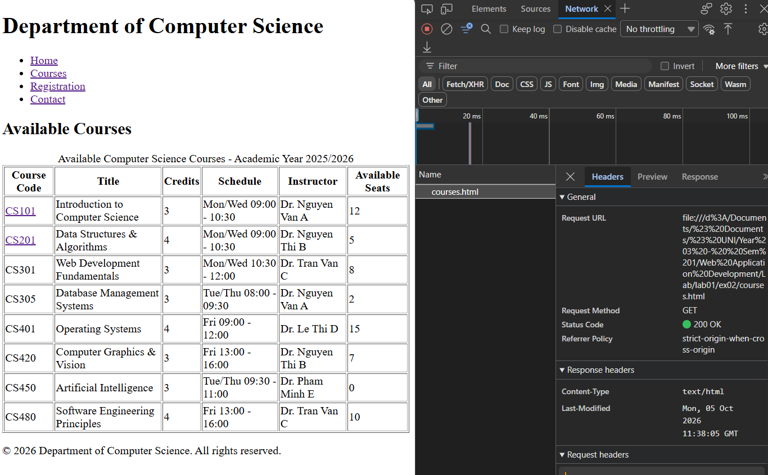

CS101 Page
<!DOCTYPE html>
<html lang="en">
<head>
<meta charset="UTF-8">
<meta name="viewport" content="width=device-width, initial-scale=1.0">
<title>Computer Science Department</title>
</head>
<body>
<header>
<h1>Department of Computer Science</h1>
<nav>
<ul>
<li><a href="../index.html">Home</a></li>
<li><a href="../courses.html">Courses</a></li>
<li><a href="../registration.html">Registration</a></li>
<li><a href="../contact.html">Contact</a></li>
</ul>
</nav>
</header>
<main>
<article>
<h2>CS101: Introduction to Computer Science</h2>
<p><strong>Credits:</strong> 3</p>
<p><strong>Instructor:</strong> Dr. Nguyen Van A (nguyenvana@hcmiu.edu)</p>
<p><strong>Schedule:</strong> Mondays & Wednesdays, 09:00 AM - 10:30 AM</p>
<p><strong>Location:</strong> A2, Room 101</p>
<h3>Course Description</h3>
<p>An entry-level introduction to core computer science principles. Topics include basic problem-solving, algorithmic thinking, data representation, pseudocode design, and an overview of computing history.</p>
<h3>Prerequisites</h3>
<p>None. Open to all majors.</p>
<p><a href="../courses.html">&larr; Back to Course Catalog</a> | <a href="../registration.html">Register for this course</a></p>
</article>
</main>
<footer>
<p>&copy; 2026 Department of Computer Science. All rights reserved.</p>
</footer>
</body>
</html>

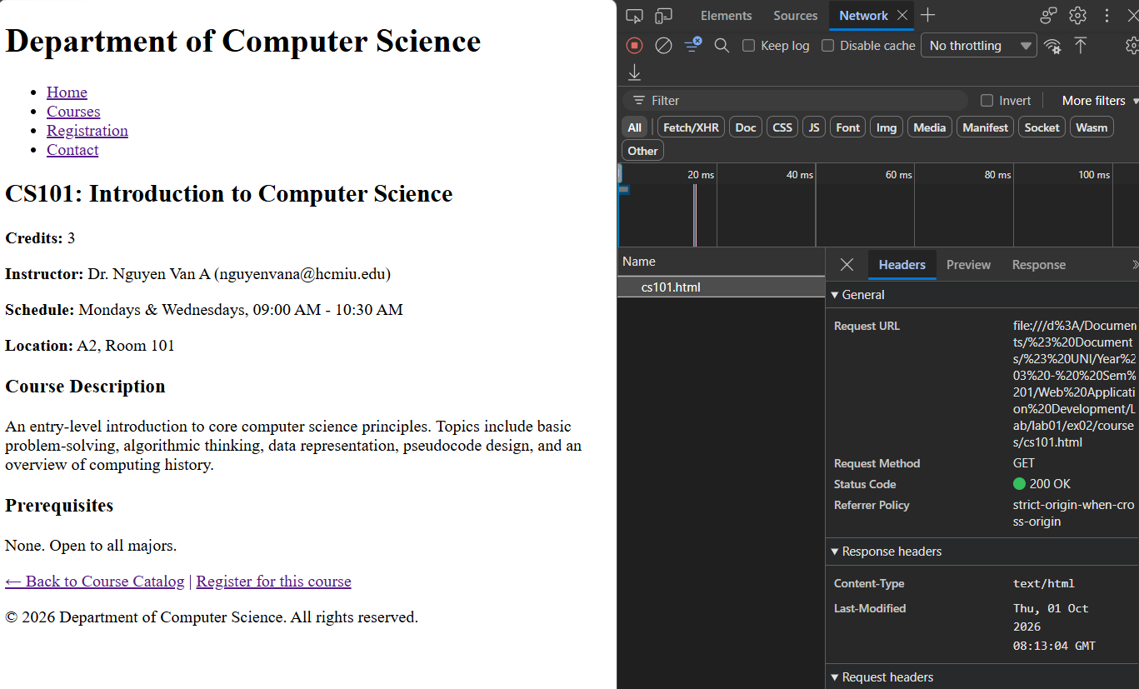

CS201 Page
<!DOCTYPE html>
<html lang="en">
<head>
<meta charset="UTF-8">
<meta name="viewport" content="width=device-width, initial-scale=1.0">
<title>Computer Science Department</title>
</head>
<body>
<header>
<h1>Department of Computer Science</h1>
<nav>
<ul>
<li><a href="../index.html">Home</a></li>
<li><a href="../courses.html">Courses</a></li>
<li><a href="../registration.html">Registration</a></li>
<li><a href="../contact.html">Contact</a></li>
</ul>
</nav>
</header>
<main>
<article>
<h2>CS201: Data Structures &amp; Algorithms</h2>
<p><strong>Credits:</strong> 4</p>
<p><strong>Instructor:</strong> Dr. Nguyen Van A (nguyenvana@hcmiu.edu)</p>
<p><strong>Schedule:</strong> Tuesdays & Thursdays, 11:00 AM - 12:30 PM</p>
<p><strong>Location:</strong> A1, Room 204</p>
<h3>Course Description</h3>
<p>In-depth study of fundamental abstract data types and algorithmic structures. Topics include arrays, linked lists, stacks, queues, binary trees, hash tables, sorting algorithms, and basic asymptotic Big-O time complexity analysis.</p>
<h3>Prerequisites</h3>
<p>CS101 or equivalent programming background.</p>
<p><a href="../courses.html">&larr; Back to Course Catalog</a> | <a href="../registration.html">Register for this course</a></p>
</article>
</main>
<footer>
<p>&copy; 2026 Department of Computer Science. All rights reserved.</p>
</footer>
</body>
</html>
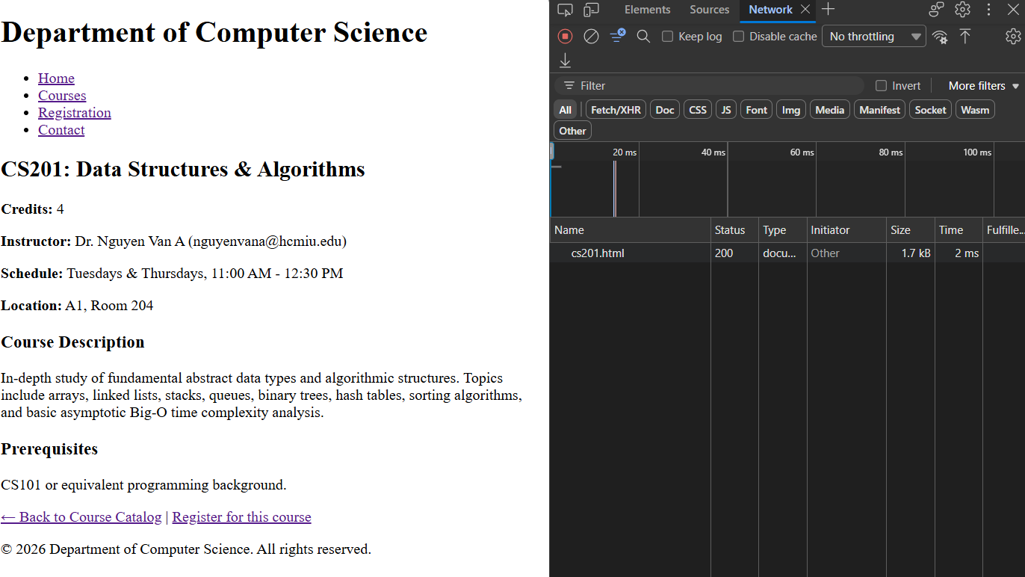

Registration form page
<!DOCTYPE html>
<html lang="en">
<head>
<meta charset="UTF-8">
<meta name="viewport" content="width=device-width, initial-scale=1.0">
<title>Document</title>
</head>
<body>
<header>
<h1>Department of Computer Science</h1>
<nav>
<ul>
<li><a href="index.html">Home</a></li>
<li><a href="courses.html">Courses</a></li>
<li><a href="registration.html">Registration</a></li>
<li><a href="contact.html">Contact</a></li>
</ul>
</nav>
</header>
<main>
<section>
<h2>Registration Form</h2>
<form action="./confirmation.html" method="get">
<fieldset>
<legend>Student Information</legend>
<!-- The legend tag is used in html to provide a caption or title for the associated fieldset element, improving accessibility and usability for all users, inclusing those using screen readers -->
<p>
<label for="fullname">Full name:</label>
<input type="text" id="fullname" name="fullname" required><br><br>
</p>
<p>
<label for="id">Student ID:</label>
<input type="text" id="id" name="id" required><br><br>
</p>
<p>
<label for="email">Email:</label>
<input type="text" id="email" name="email" required><br><br>
</p>
</fieldset>
<fieldset>
<legend>Course selection</legend>
<p>Select one or more courses:</p>
<p>
<input type="checkbox" id="course-cs101" name="course" value="CS101">
<label for="course-cs101">CS101 - Introduction to Computer Science</label><br>
<input type="checkbox" id="course-cs201" name="course" value="CS201">
<label for="course-cs201">CS201 - Data Structures &amp; Algorithms</label><br>
<input type="checkbox" id="course-cs301" name="course" value="CS301">
<label for="course-cs301">CS301 - Web Development Fundamentals</label><br>
<input type="checkbox" id="course-cs305" name="course" value="CS305">
<label for="course-cs305">CS305 - Database Management Systems</label><br>
<input type="checkbox" id="course-cs401" name="course" value="CS401">
<label for="course-cs401">CS401 - Operating Systems</label><br>
<input type="checkbox" id="course-cs420" name="course" value="CS420">
<label for="course-cs420">CS420 - Computer Graphics &amp; Vision</label><br>
<input type="checkbox" id="course-cs450" name="course" value="CS450">
<label for="course-cs450">CS450 - Artificial Intelligence</label><br>
<input type="checkbox" id="course-cs480" name="course" value="CS480">
<label for="course-cs480">CS480 - Software Engineering Principles</label>
</p>
<p><strong>Semester:</strong></p>
<p>
<input type="radio" id="fall2025" name="semester" value="Fall 2025" checked>
<label for="fall2025">Fall 2025</label><br>
<input type="radio" id="spring2026" name="semester" value="Spring 2026">
<label for="spring2026">Spring 2026</label><br>
<input type="radio" id="summer2026" name="semester" value="Summer 2026">
<label for="summer2026">Summer 2026</label>
</p>
</fieldset>
<fieldset>
<legend>Additional Information</legend>
<label for="info">Comments & Special requests:</label>
<textarea id="info" name="info" rows="4" cols="40" placeholder="Any comments, requests or support needs"></textarea>
</fieldset>
<p>
<button type="submit">Submit Registration</button>
<button type="reset">Reset Form</button>
</p>
</form>
</section>
</main>
<footer>
<p>&copy; 2026 Department of Computer Science. All rights reserved.</p>
</footer>
</body>
</html>

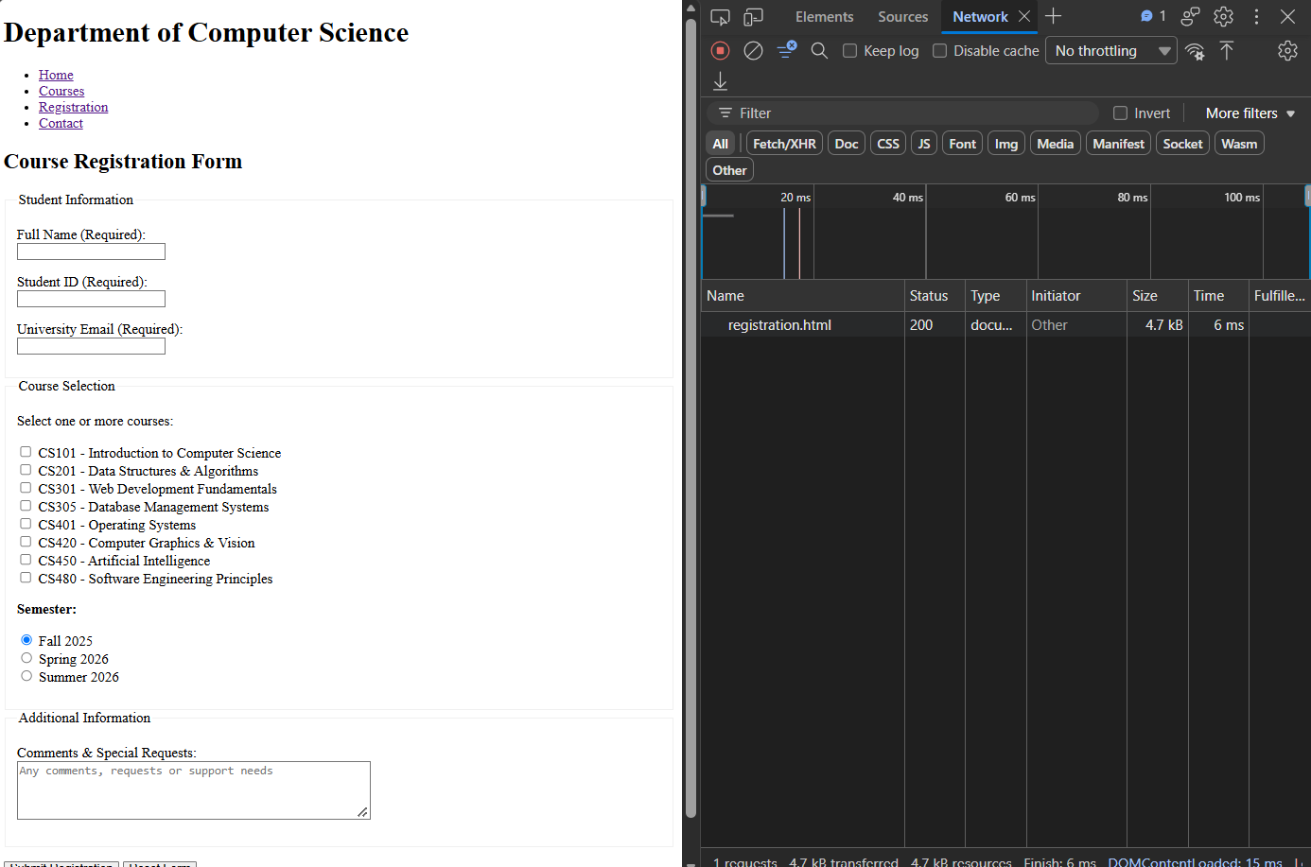

Confirmation page
<!DOCTYPE html>
<html lang="en">
<head>
<meta charset="UTF-8">
<meta name="viewport" content="width=device-width, initial-scale=1.0">
<title>Computer Science Department</title>
</head>
<body>
<header>
<h1>Department of Computer Science</h1>
<nav>
<ul>
<li><a href="index.html">Home</a></li>
<li><a href="courses.html">Courses</a></li>
<li><a href="registration.html">Registration</a></li>
<li><a href="contact.html">Contact</a></li>
</ul>
</nav>
</header>
<main>
<section>
<h2>Registration Completed!</h2>
<p>We have received your courses registration. If you have any questions or problems, please check our contacts at <a href="contact.html">Contact Page</a></p>
<p><em>In a real application, results would be displayed here based on your search criteria.</em></p>
<p>Your search parameters appear in the URL above.</p>
<p><a href="index.html">&larr; Return to Home Page</a></p>
</section>
</main>
<footer>
<p>&copy; 2026 Department of Computer Science. All rights reserved.</p>
</footer>
</body>
</html>
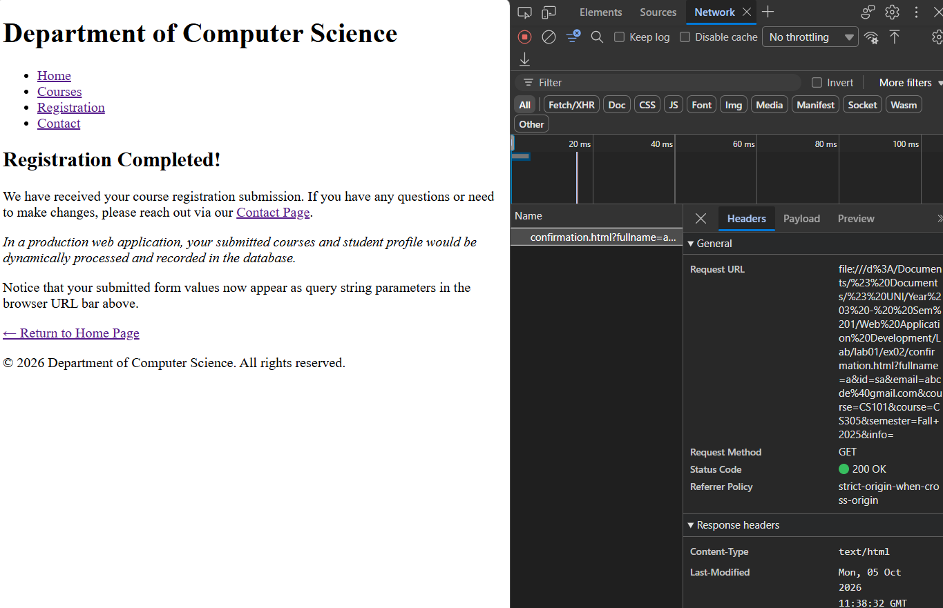

Contact Page
<!DOCTYPE html>
<html lang="en">
<head>
<meta charset="UTF-8">
<meta name="viewport" content="width=device-width, initial-scale=1.0">
<title>Department of Computer Science - Faculty</title>
</head>
<body>
<header>
<h1>Department of Computer Science</h1>
<nav>
<ul>
<li><a href="index.html">Home</a></li>
<li><a href="courses.html">Courses</a></li>
<li><a href="registration.html">Registration</a></li>
<li><a href="contact.html">Contact</a></li>
</ul>
</nav>
</header>
<main>
<section>
<h2>Contact Us:</h2>
<address>
<ul>
<li><strong>Email: </strong> <a href="mailto:cs-department@hcmiu.edu">cs-department@hcmiu.edu</a></li>
<li><strong>Address: </strong>Department of Computer Science <br>ABC, Dong Hoa, Ho Chi Minh city</li>
</ul>
</address>
<h3>Phone number: </h3>
<p><strong>Phone:</strong> (555) 019-2834</p>
<h3>Office Hours</h3>
<ul>
<li><strong>Monday - Friday:</strong> 8:00 AM - 5:30 PM</li>
<li><strong>Saturday - Sunday:</strong> Closed</li>
</ul>
</section>
</main>
<footer>
<p>&copy; 2026 Department of Computer Science. All rights reserved.</p>
</footer>
</body>
</html>
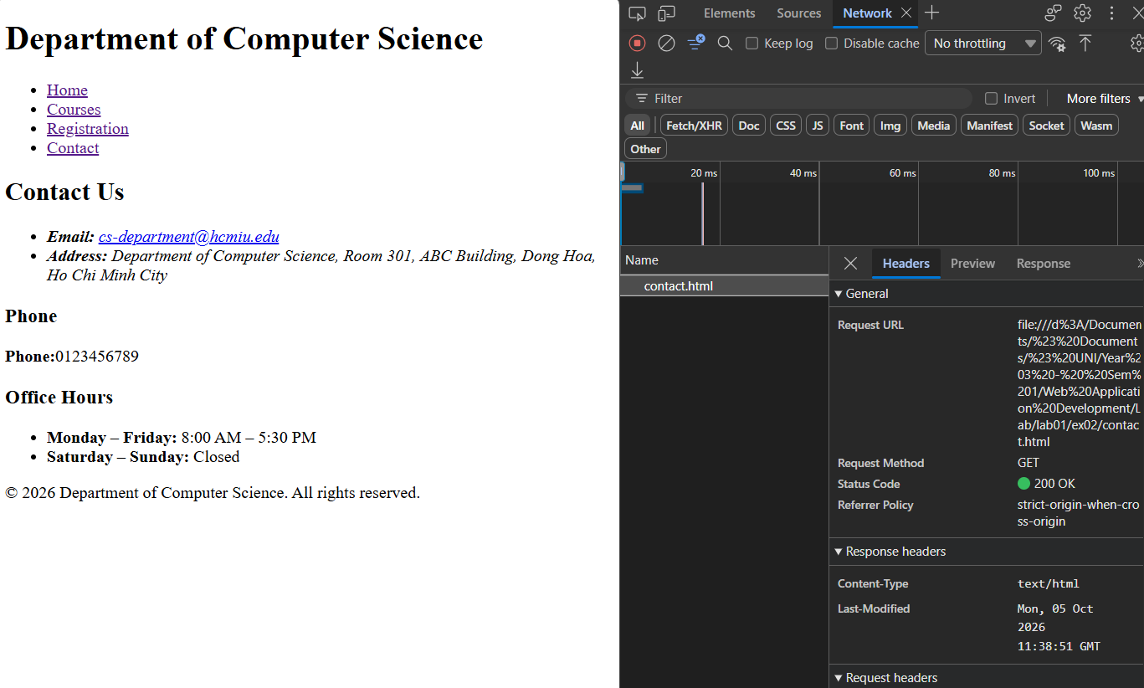

Explanation:
- Design Decisions: Why did you choose <select multiple> vs checkboxes for course selection? What are the advantages and disadvantages of your choice?
Decision: Checkboxes were chosen.
Trade-offs: <select multiple> occupies less vertical space, but requires desktop users to know non-obvious keyboard shortcuts (holding Ctrl or Cmd), which often confuses non-technical users and performs poorly on mobile browsers. Checkboxes provide clear visibility of all options simultaneously and allow one-click toggling, offering superior usability in plain HTML.
- Data Flow: When a student submits the registration form, trace exactly what happens:
- What HTTP method is used?
- Where does the data go?
- What appears in the URL?
- Is this data persistent (saved anywhere)?

- HTTP method used is GET, <form action="./confirmation.html" method="get">.
- The browser extracts the values of the submitted form, encodes them as key-value paris, and adds them as a query string to the URL in “action=”confirmation.html””.
- The URL is as follows: confirmation.html?fullname=Jane+Doe&student_id=CS102&email=jane%40univ.edu&course=CS301&course=CS302&semester=Fall2025&comments=None
- Data is not saved anywhere. Because the application uses static HTML files without any backend server or database, and the submitted data stays in the URL and will be deleted when we move to another page. To store the value, we need to integrate backend/database into the website.
- Validation: Which form fields did you mark as required? Why? What happens if a user tries to submit without filling required fields?
- The values that are marked as required are full name, student ID, and email.
- That information is required because it identifies the applicant’s name, ID number, and communication channel. Otherwise, we cannot specify who that person is.
- If the person does not fill in the form, the website will block the submission, focus on the first invalid field, and display a notification (e.g., please fill out this field), preventing page reload or query string dispatch.
- Real-world issues: This system uses GET to submit registration data. In a real system, would this be acceptable? Why or why not? What are the security and practical implications?
- It is not acceptable in real-world issues. It will publish all the filled-in data, making the data exposed. URLs also have character limits, meaning long comments or multiple course selections could be extracted.
- Table accessibility: How did you ensure your course table is accessible? (Consider: headers, caption, semantic markup)
- Added a <caption> element to clearly summarize the table contents.
- Used proper structural divisions (<thead>, <tbody>) and wrapped all column headers in <th> tags so others can read column labels alongside data values.

Exercise 03: Multi-section website with edge cases

Task description:
Create a comprehensive university research lab website that demonstrates mastery of HTML structure, navigation patterns, and edge case handling.

Results:

Home Page:
<!DOCTYPE html>
<html lang="en">
<head>
<meta charset="UTF-8">
<meta name="viewport" content="width=device-width, initial-scale=1.0">
<title>Research Lab</title>
</head>
<body>
<header>
<img src="images/logo.png" alt="Research Lab Logo">
<h1>Research Laboratory</h1>
<nav>
<ul>
<li><strong>Home (Current Page)</strong></li>
<li><a href="research.html">Research</a></li>
<li><a href="publications.html">Publications</a></li>
<li><a href="people.html">People</a></li>
<li><a href="join.html">Join Us</a></li>
<li><a href="contact.html">Contact</a></li>
</ul>
</nav>
</header>
<main>
<section>
<h2>Lab Mission</h2>
<p>Our research lab is dedicated to advancing the field of computer science through innovative research and collaboration. We focus on areas such as artificial intelligence, machine learning, and data science.</p>
</section>
<section id="quick-links">
<h2>Quick Links &amp; Direct Access</h2>
<ul>
<li><a href="people.html#dr-smith">Deep Link 1: View Lab Director Dr. Alice Smith's Profile</a></li>
<li><a href="research.html#proj-gaussian">Deep Link 2: Explore 3D Gaussian Splatting Research Project</a></li>
<li><a href="publications.html#pub-2023">Deep Link 3: Browse 2023 Peer-Reviewed Publications</a></li>
<li><a href="people.html#phd-students">Deep Link 4: See Current PhD Students &amp; Research Interests</a></li>
<li><a href="contact.html#lab-location">Deep Link 5: View Lab Location &amp; Campus Map</a></li>
</ul>
</section>
<section id="news">
<h2>Recent News</h2>
<article>
<h3>October 2023: New Paper Accepted</h3>
<p>3D Gaussian Splatting for Real-Time Radiance Field Rendering has been accepted for publication. Read more on the <a href="publications.html#pub-2023">Publications page</a>.</p>
</article>
<article>
<h3>September 2023: Lab Receives Research Equipment Grant</h3>
<p>We are excited to announce new GPU server infrastructure for scalable deep learning training.</p>
</article>
<article>
<h3>August 2023: Research Positions Open for Fall Semester</h3>
<p>Interested candidates in Computer Vision and Graphics are encouraged to apply via our <a href="join.html">Join Us portal</a>.</p>
</article>
</section>
</main>
<footer>
<p>&copy; 2026 Department of Computer Science. All rights reserved.</p>
</footer>
</body>
</html>
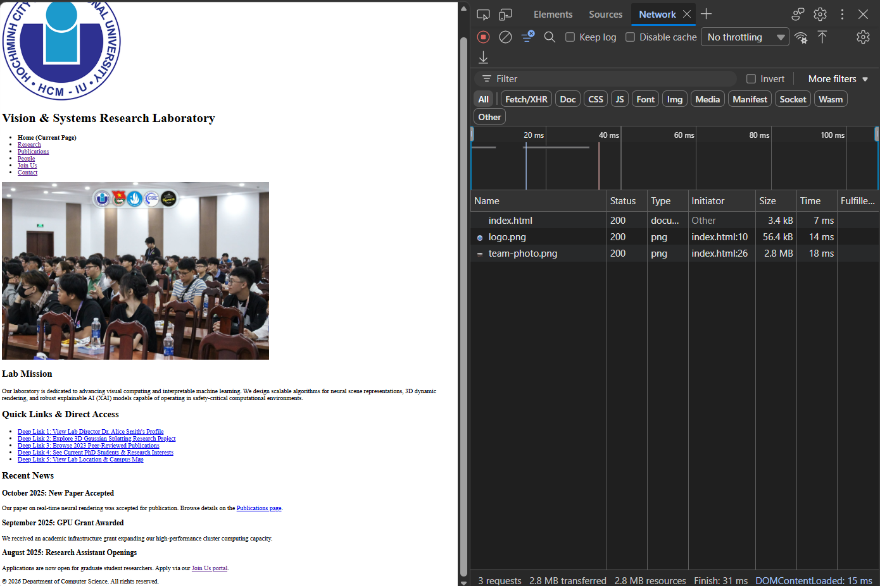

Research Page:
<!DOCTYPE html>
<html lang="en">
<head>
<meta charset="UTF-8">
<meta name="viewport" content="width=device-width, initial-scale=1.0">
<title>Research Lab</title>
</head>
<body>
<header>
<img src="images/logo.png" alt="Research Lab Logo">
<h1>Research Laboratory</h1>
<nav>
<ul>
<li><a href="index.html">Home</a></li>
<li><strong>Research (Current Page)</strong></li>
<li><a href="publications.html">Publications</a></li>
<li><a href="people.html">People</a></li>
<li><a href="join.html">Join Us</a></li>
<li><a href="contact.html">Contact</a></li>
</ul>
</nav>
</header>
<main>
<h2>Active Research Projects</h2>
<!-- Project 1 with Deep Link target -->
<section id="proj-gaussian">
<h3>Project 1: Real-Time Radiance Fields &amp; 3D Gaussian Splatting</h3>
<p>
Investigating novel primitive representation and GPU-accelerated rasterization techniques to render
complex 3D dynamic scenes in real-time under severe computational constraints.
</p>
<h4>Team Members &amp; Roles:</h4>
<ul>
<li><strong>Dr. Alice Smith</strong>
<ul>
<li>Principal Investigator</li>
<li>Algorithm Architecture &amp; Funding Lead</li>
</ul>
</li>
<li><strong>Guanjun Wu</strong>
<ul>
<li>Lead PhD Researcher</li>
<li>Dynamic Scene Optimization &amp; C# Unity Shader Developer</li>
</ul>
</li>
</ul>
<h4>Key Publications:</h4>
<ul>
<li>3D Gaussian Splatting for Real-Time Radiance Field Rendering (SIGGRAPH 2023)</li>
<li>4D Gaussian Splatting for Real-Time Dynamic Scene Rendering (CVPR 2024)</li>
</ul>
</section>
<hr>
<!-- Project 2 -->
<section id="proj-xai">
<h3>Project 2: Explainable AI &amp; Saliency Map Evaluation</h3>
<p>
Developing rigorous theoretical frameworks and sanity checks to assess whether post-hoc attribution methods
faithfully reflect the underlying decision logic of deep vision and language models.
</p>
<h4>Team Members &amp; Roles:</h4>
<ul>
<li><strong>Dr. Robert Vance</strong>
<ul>
<li>Co-Investigator</li>
<li>Statistical Validation Supervisor</li>
</ul>
</li>
<li><strong>Alon Jacovi</strong>
<ul>
<li>PhD Candidate</li>
<li>Faithfulness Evaluation Metrics Specialist</li>
</ul>
</li>
</ul>
<h4>Key Publications:</h4>
<ul>
<li>Sanity Checks for Saliency Maps (NeurIPS 2018)</li>
<li>Towards Faithfully Interpretable NLP Systems (ACL 2020)</li>
</ul>
</section>
<hr>
<!-- Project 3 -->
<section id="proj-robustness">
<h3>Project 3: Robust Losses in Adverse Neural Environments</h3>
<p>
Designing loss functions resilient to spatial distractors, transient occlusions, and adversarial perturbation
in multi-view reconstruction pipelines.
</p>
<h4>Team Members &amp; Roles:</h4>
<ul>
<li><strong>Sara Sabour</strong>
<ul>
<li>Postdoctoral Fellow</li>
<li>Robust Loss Formulation Lead</li>
</ul>
</li>
</ul>
<h4>Key Publications:</h4>
<ul>
<li>RobustNeRF: Ignoring Distractors with Robust Losses (CVPR 2023)</li>
</ul>
</section>
</main>
<footer>
<p>&copy; 2026 Department of Computer Science. All rights reserved.</p>
</footer>
</body>
</html>
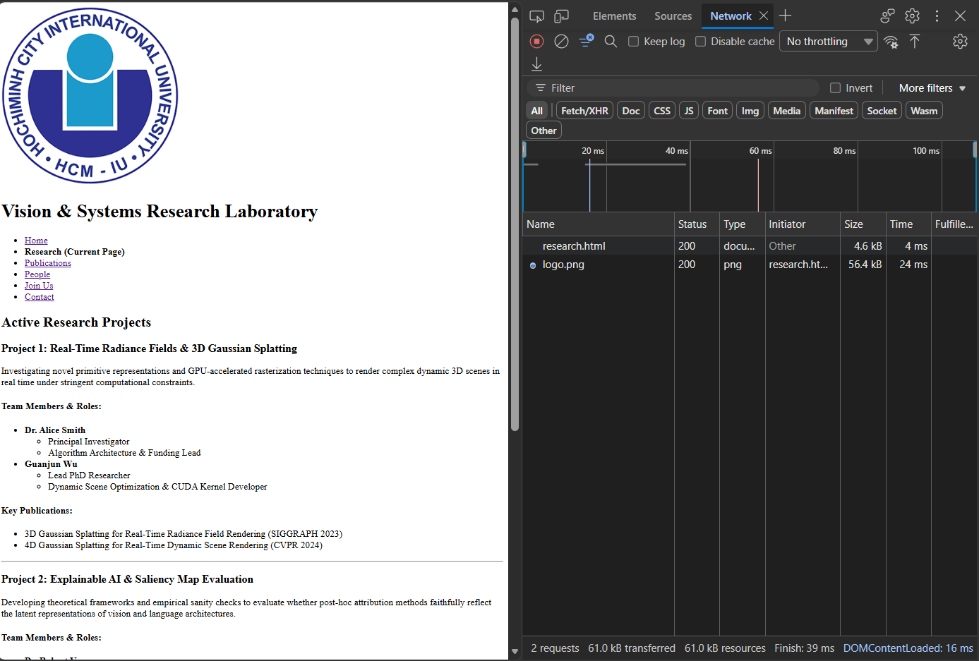

Publication Page:
<!DOCTYPE html>
<html lang="en">
<head>
<meta charset="UTF-8">
<meta name="viewport" content="width=device-width, initial-scale=1.0">
<title>Publications - Vision &amp; Systems Research Lab</title>
</head>
<body>
<header>
<img src="images/logo.png" alt="Vision and Systems Research Lab Seal depicting neural network and optical lens vectors">
<h1>Vision &amp; Systems Research Laboratory</h1>
<nav>
<ul>
<li><a href="index.html">Home</a></li>
<li><a href="research.html">Research</a></li>
<li><strong>Publications (Current Page)</strong></li>
<li><a href="people.html">People</a></li>
<li><a href="join.html">Join Us</a></li>
<li><a href="contact.html">Contact</a></li>
</ul>
</nav>
</header>
<main>
<h2>Peer-Reviewed Lab Publications</h2>
<!-- Edge Case #6: Filter Publications Form via GET -->
<section id="filter-section">
<fieldset>
<legend>Filter Publications</legend>
<form action="publications.html" method="GET">
<label for="year-select">Select Year:</label>
<select id="year-select" name="year">
<option value="all">All Years</option>
<option value="2023">2023</option>
<option value="2020">2020</option>
<option value="2019">2019</option>
<option value="2018">2018</option>
<option value="2017">2017</option>
</select>
<button type="submit">Filter Publications</button>
</form>
</fieldset>
</section>
<!-- Requirement #3 & Edge Case #3: Complex Tables with Rowspan, Multiple Authors, Long Titles & Missing Data -->
<section id="publications-list">
<!-- Group 2023 -->
<h3 id="pub-2023">2023</h3>
<table border="1">
<caption>Publications list for Year 2023</caption>
<thead>
<tr>
<th scope="col">Year</th>
<th scope="col">#</th>
<th scope="col">Title</th>
<th scope="col">Authors</th>
<th scope="col">Venue</th>
<th scope="col">Link</th>
</tr>
</thead>
<tbody>
<tr>
<!-- Rowspan demonstrating grouped year cells across multiple rows -->
<th scope="row" rowspan="4">2023</th>
<td>1</td>
<td>3D Gaussian Splatting for Real-Time Radiance Field Rendering</td>
<td>Bernhard Kerbl, Georgios Kopanas, Thomas Leimkühler, George Drettakis</td>
<td>SIGGRAPH / TOG 2023</td>
<td><a href="https://arxiv.org/abs/2308.04079" target="_blank">PDF Paper</a></td>
</tr>
<tr>
<td>2</td>
<td>RobustNeRF: Ignoring Distractors with Robust Losses</td>
<td>Sara Sabour, Matt Tancik, Peter Shirley, Aleksander Hołynski, Sara Fridovich-Keil</td>
<td>CVPR 2023</td>
<td><a href="https://arxiv.org/abs/2302.00833" target="_blank">PDF Paper</a></td>
</tr>
<tr>
<td>3</td>
<td>SynBody: Synthetic Dataset with Layered Human Models for 3D Human Perception and Modeling</td>
<td>Zhitao Yang, Zerui Chen, Yushun Seng, Zhao Wang</td>
<td>ICCV 2023</td>
<td><a href="https://arxiv.org/abs/2303.17368" target="_blank">PDF Paper</a></td>
</tr>
<tr>
<td>4</td>
<td>4D Gaussian Splatting for Real-Time Dynamic Scene Rendering</td>
<td>Guanjun Wu, Taoran Yi, Jiemin Fang, Lingxi Xie, Xiaopeng Zhang, Wei Wei, Qi Tian, Xinggang Wang</td>
<td>CVPR 2024</td>
<!-- Edge Case #3: Explicit handling of missing links -->
<td><em>Preprint Pending (No direct link available)</em></td>
</tr>
</tbody>
</table>
<!-- Group 2020 -->
<h3 id="pub-2020">2020</h3>
<table border="1">
<caption>Publications list for Year 2020</caption>
<thead>
<tr>
<th scope="col">Year</th>
<th scope="col">#</th>
<th scope="col">Title</th>
<th scope="col">Authors</th>
<th scope="col">Venue</th>
<th scope="col">Link</th>
</tr>
</thead>
<tbody>
<tr>
<th scope="row">2020</th>
<td>5</td>
<td>Towards Faithfully Interpretable NLP Systems: How Should We Define and Evaluate Faithfulness?</td>
<td>Alon Jacovi, Yoav Goldberg</td>
<td>ACL 2020</td>
<td><a href="https://aclanthology.org/2020.acl-main.386/" target="_blank">PDF Paper</a></td>
</tr>
</tbody>
</table>
<!-- Group 2019 -->
<h3 id="pub-2019">2019</h3>
<table border="1">
<caption>Publications list for Year 2019</caption>
<thead>
<tr>
<th scope="col">Year</th>
<th scope="col">#</th>
<th scope="col">Title</th>
<th scope="col">Authors</th>
<th scope="col">Venue</th>
<th scope="col">Link</th>
</tr>
</thead>
<tbody>
<tr>
<th scope="row">2019</th>
<td>6</td>
<td>A Benchmark for Interpretability Methods in Deep Neural Networks</td>
<td>Sara Hooker, Dumitru Erhan, Pieter-Jan Kindermans, Been Kim</td>
<td>NeurIPS 2019</td>
<td><a href="https://arxiv.org/abs/1806.10758" target="_blank">PDF Paper</a></td>
</tr>
</tbody>
</table>
<!-- Group 2018 -->
<h3 id="pub-2018">2018</h3>
<table border="1">
<caption>Publications list for Year 2018</caption>
<thead>
<tr>
<th scope="col">Year</th>
<th scope="col">#</th>
<th scope="col">Title</th>
<th scope="col">Authors</th>
<th scope="col">Venue</th>
<th scope="col">Link</th>
</tr>
</thead>
<tbody>
<tr>
<th scope="row" rowspan="2">2018</th>
<td>7</td>
<td>RISE: Randomized Input Sampling for Explanation of Black-box Models</td>
<td>Vitali Petsiuk, Abir Das, Kate Saenko</td>
<td>BMVC 2018</td>
<td><a href="https://papers.nips.cc/paper_files/paper/2018/hash/294a8ed24b1ad22ec2e7efea049b8737-Abstract.html" target="_blank">PDF Paper</a></td>
</tr>
<tr>
<td>8</td>
<td>Sanity Checks for Saliency Maps</td>
<td>Julius Adebayo, Justin Gilmer, Michael Muelly, Ian Goodfellow, Moritz Hardt, Been Kim</td>
<td>NeurIPS 2018</td>
<td><a href="https://papers.nips.cc/paper_files/paper/2017/hash/2650d6089a6d640c5e85b2b88265dc2b-Abstract.html" target="_blank">PDF Paper</a></td>
</tr>
</tbody>
</table>
<!-- Group 2017 -->
<h3 id="pub-2017">2017</h3>
<table border="1">
<caption>Publications list for Year 2017</caption>
<thead>
<tr>
<th scope="col">Year</th>
<th scope="col">#</th>
<th scope="col">Title</th>
<th scope="col">Authors</th>
<th scope="col">Venue</th>
<th scope="col">Link</th>
</tr>
</thead>
<tbody>
<tr>
<th scope="row" rowspan="2">2017</th>
<td>9</td>
<td>What Uncertainties Do We Need in Bayesian Deep Learning for Computer Vision?</td>
<td>Alex Kendall, Yarin Gal</td>
<td>NeurIPS 2017</td>
<td><a href="https://papers.nips.cc/paper_files/paper/2017/hash/2650d6089a6d640c5e85b2b88265dc2b-Abstract.html" target="_blank">PDF Paper</a></td>
</tr>
<tr>
<td>10</td>
<td>Understanding Black-box Predictions via Influence Functions</td>
<td>Pang Wei Koh, Percy Liang</td>
<td>ICML 2017</td>
<td><a href="https://arxiv.org/abs/1806.07421" target="_blank">PDF Paper</a></td>
</tr>
</tbody>
</table>
</section>
</main>
<footer>
<p>&copy; 2026 Department of Computer Science. All rights reserved.</p>
</footer>
</body>
</html>

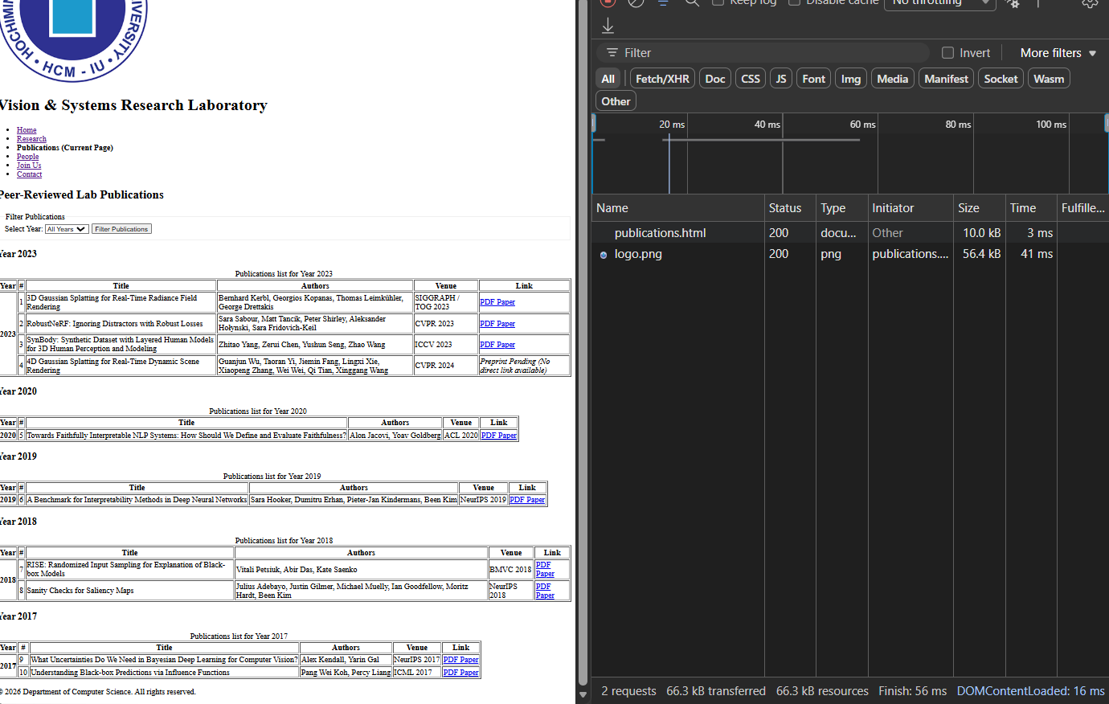

People Page:
<!DOCTYPE html>
<html lang="en">
<head>
<meta charset="UTF-8">
<meta name="viewport" content="width=device-width, initial-scale=1.0">
<title>Research Lab</title>
</head>
<body>
<header>
<img src="images/logo.png" alt="Research Lab Logo">
<h1>Research Laboratory</h1>
<nav>
<ul>
<li><a href="index.html">Home</a></li>
<li><a href="research.html">Research</a></li>
<li><a href="publications.html">Publications</a></li>
<li><strong>People (Current Page)</strong></li>
<li><a href="join.html">Join Us</a></li>
<li><a href="contact.html">Contact</a></li>
</ul>
</nav>
</header>
<main>
<!-- Faculty Section -->
<section id="faculty">
<h2>Faculty Members</h2>
<article id="dr-smith">
<h3>Dr. Alice Smith - Associate Professor &amp; Lab Director</h3>
<p><strong>Research Focus:</strong> 3D Computer Graphics, Gaussian Splatting, Real-Time Rendering.</p>
<p><strong>Bio:</strong> Dr. Smith leads the lab's visual rendering projects. She completed her postdoc at MIT and received her PhD from Stanford.</p>
<p><strong>Contact:</strong> asmith@univ-lab.edu</p>
</article>
<article id="dr-vance">
<h3>Dr. Robert Vance - Assistant Professor</h3>
<p><strong>Research Focus:</strong> Explainable AI, Saliency Map Sanity Checks, Model Interpretability.</p>
<p><strong>Bio:</strong> Dr. Vance works on verifying deep neural network reliability and trustworthiness in safety-critical systems.</p>
</article>
</section>
<hr>
<!-- PhD Students Section -->
<section id="phd-students">
<h2>PhD Students</h2>
<ul>
<li>
<strong>Guanjun Wu</strong> (4th Year)
<br><em>Research Interest:</em> 4D Dynamic Scene Gaussian Splatting and CUDA acceleration.
</li>
<li>
<strong>Alon Jacovi</strong> (3rd Year)
<br><em>Research Interest:</em> Quantitative evaluation of NLP model faithfulness.
</li>
<li>
<strong>Zhitao Yang</strong> (2nd Year)
<br><em>Research Interest:</em> Synthetic human dataset generation and parametric body models.
</li>
</ul>
</section>
<hr>
<!-- Alumni Section -->
<section id="alumni">
<h2>Lab Alumni</h2>
<table border="1">
<caption>Former Lab Members and Current Positions</caption>
<thead>
<tr>
<th scope="col">Name</th>
<th scope="col">Degree / Role</th>
<th scope="col">Graduation Year</th>
<th scope="col">Current Position</th>
</tr>
</thead>
<tbody>
<tr>
<td>Dr. Alex Kendall</td>
<td>PhD Student</td>
<td>2020</td>
<td>CEO at Wayve Robotics</td>
</tr>
<tr>
<td>Dr. Sara Sabour</td>
<td>Postdoctoral Researcher</td>
<td>2023</td>
<td>Senior Staff Research Scientist at Google DeepMind</td>
</tr>
</tbody>
</table>
</section>
</main>
<footer>
<p>&copy; 2026 Department of Computer Science. All rights reserved.</p>
</footer>
</body>
</html>

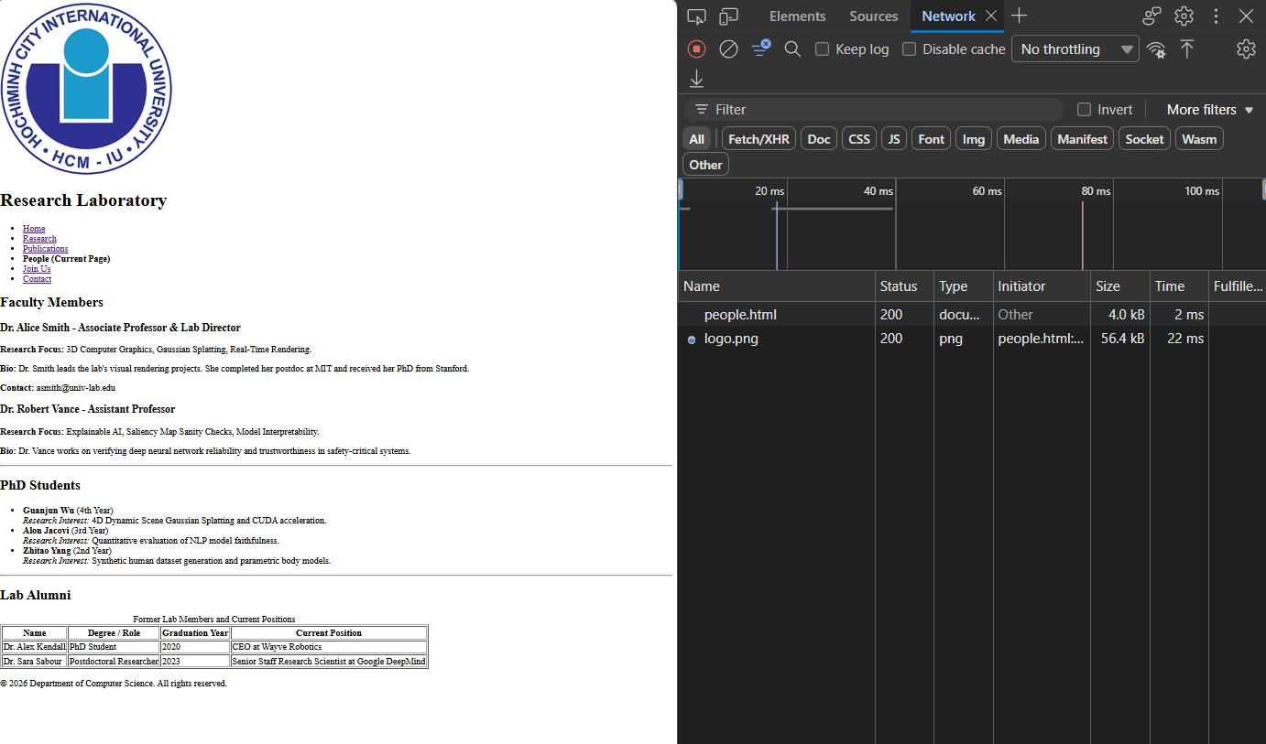

Join Us Page:
<!DOCTYPE html>
<html lang="en">
<head>
<meta charset="UTF-8">
<meta name="viewport" content="width=device-width, initial-scale=1.0">
<title>Research Lab</title>
</head>
<body>
<header>
<img src="images/logo.png" alt="Research Lab Logo">
<h1>Research Laboratory</h1>
<nav>
<ul>
<li><a href="index.html">Home</a></li>
<li><a href="research.html">Research</a></li>
<li><a href="publications.html">Publications</a></li>
<li><a href="people.html">People</a></li>
<li><strong>Join Us (Current Page)</strong></li>
<li><a href="contact.html">Contact</a></li>
</ul>
</nav>
</header>
<main>
<section id="join-info">
<h2>Prospective Researchers</h2>
<p>
We are actively recruiting passionate prospective PhD students, postdocs, and undergraduate research assistants.
Please complete the application form below.
</p>
</section>
<section id="application-form">
<h2>Lab Application Form</h2>
<!-- Technical Challenge #4 Notice on GET upload limitation -->
<p><strong>Note on File Submission:</strong> This form operates using HTTP GET for demonstration requirements. File binary payloads cannot be transmitted via GET query strings; only the filename reference will be appended to the submission string.</p>
<!-- All forms MUST use GET method per constraint -->
<form action="join.html" method="GET">
<fieldset>
<legend>Applicant Information</legend>
<!-- Validation: required and pattern attribute to handle whitespace/trimming -->
<p>
<label for="applicant-name">Full Name (Required):</label><br>
<input type="text" id="applicant-name" name="fullname" required pattern=".*\S+.*" title="Name must contain letters and cannot be blank or only spaces.">
</p>
<!-- Validation: Type email and regular expression -->
<p>
<label for="applicant-email">Email Address (Required):</label><br>
<input type="email" id="applicant-email" name="email" required pattern="[a-z0-9._%+\-]+@[a-z0-9.\-]+\.[a-z]{2,}$" title="Enter a valid email address (e.g. name@domain.com)">
</p>
<!-- Validation: Phone regex requirement -->
<p>
<label for="applicant-phone">Phone Number (Required):</label><br>
<input type="tel" id="applicant-phone" name="phone" required pattern="^\+?[0-9\s\-]{8,15}$" title="Enter a valid phone number (8-15 digits, optional + prefix).">
</p>
<p>
<label for="position">Target Position:</label><br>
<select id="position" name="position">
<option value="phd">PhD Student</option>
<option value="postdoc">Postdoc</option>
<option value="ra">Research Assistant</option>
<option value="intern">Intern</option>
</select>
</p>
<p>
<label for="interests">Statement of Research Interests:</label><br>
<textarea id="interests" name="interests" rows="5" cols="50" placeholder="Describe your background in 3D graphics, PyTorch, CUDA, or XAI..."></textarea>
</p>
<!-- Form Edge Case #4: File Upload field in GET Form -->
<p>
<label for="resume-file">Upload CV / Resume (PDF):</label><br>
<input type="file" id="resume-file" name="resume">
</p>
<p>
<label>Availability (Select all that apply):</label><br>
<input type="checkbox" id="avail-now" name="availability" value="immediately">
<label for="avail-now">Immediately</label><br>
<input type="checkbox" id="avail-sum26" name="availability" value="summer2026">
<label for="avail-sum26">Summer 2026</label><br>
<input type="checkbox" id="avail-fall26" name="availability" value="fall2026">
<label for="avail-fall26">Fall 2026</label><br>
<input type="checkbox" id="avail-spr27" name="availability" value="spring2027">
<label for="avail-spr27">Spring 2027</label>
</p>
<p>
<button type="submit">Submit Application (GET)</button>
</p>
</fieldset>
</form>
</section>
</main>
<footer>
<p>&copy; 2026 Department of Computer Science. All rights reserved.</p>
</footer>
</body>
</html>

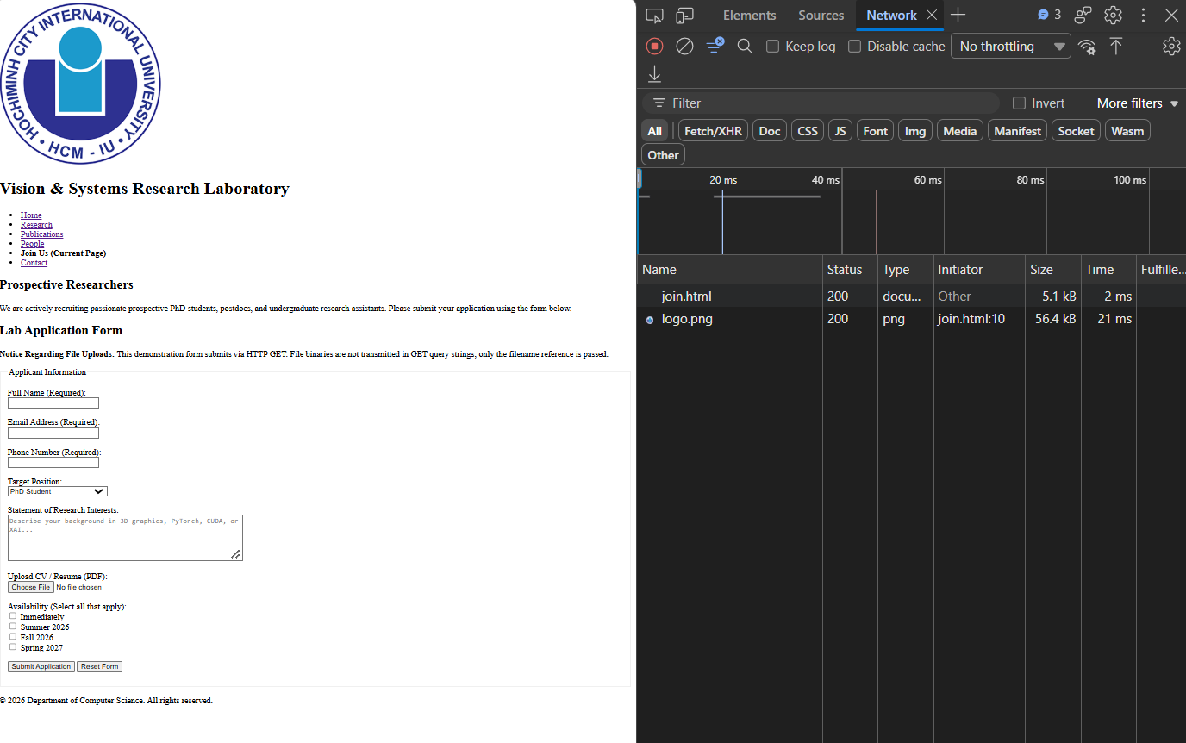

Contact Page:
<!DOCTYPE html>
<html lang="en">
<head>
<meta charset="UTF-8">
<meta name="viewport" content="width=device-width, initial-scale=1.0">
<title>Research Lab</title>
</head>
<body>
<header>
<img src="images/logo.png" alt="Research Lab Logo">
<h1>Research Laboratory</h1>
<nav>
<ul>
<li><a href="index.html">Home</a></li>
<li><a href="research.html">Research</a></li>
<li><a href="publications.html">Publications</a></li>
<li><a href="people.html">People</a></li>
<li><a href="join.html">Join Us</a></li>
<li><strong>Contact (Current Page)</strong></li>
</ul>
</nav>
</header>
<main>
<section id="lab-location">
<h2>Lab Address &amp; Location</h2>
<address>
Research Laboratory<br>
Department of Computer Science, Room 402<br>
International Unversity, ABC, Dong Hoa, Ho Chi Minh city<br>
</address>
<br>
<!-- Image #3: Informative Campus Map -->
<img src="images/map.png" alt="University Campus Map" width="600" height="400">
</section>
<section>
<h2>Contact Us:</h2>
<address>
<ul>
<li><strong>Email: </strong> <a href="mailto:cs-department@hcmiu.edu">cs-department@hcmiu.edu</a></li>
<li><strong>Address: </strong>Department of Computer Science <br>ABC, Dong Hoa, Ho Chi Minh city</li>
</ul>
</address>
<h3>Phone number: </h3>
<p><strong>Phone:</strong> (555) 019-2834</p>
<h3>Office Hours</h3>
<ul>
<li><strong>Monday - Friday:</strong> 8:00 AM - 5:30 PM</li>
<li><strong>Saturday - Sunday:</strong> Closed</li>
</ul>
</section>
<section>
<h2>Contact Form</h2>
<form action="../contact.html" method="GET">
<label for="name">Name:</label>
<input type="text" id="name" name="name" required><br><br>
<label for="email">Email:</label>
<input type="email" id="email" name="email" required><br><br>
<label for="message">Message:</label><br>
<textarea id="message" name="message" rows="5" cols="40" required></textarea><br><br>
<input type="submit" value="Submit">
</form>
</main>
<footer>
<p>&copy; 2026 Department of Computer Science. All rights reserved.</p>
</footer>
</body>
</html>
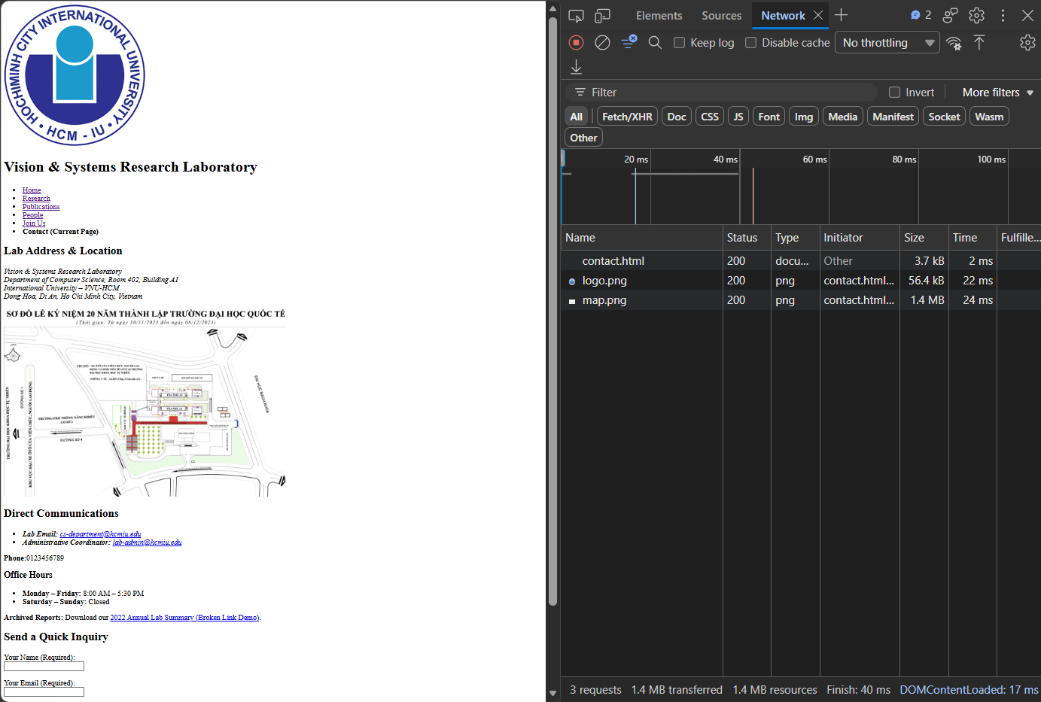

Technical Challenges:

3. Complex Tables
- Publications table must handle:
- Multiple authors (how do you display this in a table cell?)
- Long titles (what happens to table layout?)
- Missing data (what if no link available?)
- Use rowspan or colspan where appropriate
Answers:
- For multiple authors, I listed all the names of the authors. But another way is to create a list where one line is one of the authors’ names.
- With a long title, a browser table will expand horizontally to fit the content automatically and wrap the title text onto multiple vertical lines depending on available viewport width. This will push the following columns to the right and significantly increase the row height. If we want to break the title, we can insert <br> if we want to manually format.
- For the missing data, we can display text like “N/A” or “Link is not available” to intentionally display that there is no link.
- Use rowspan to group papers of the same year or category, as follows:
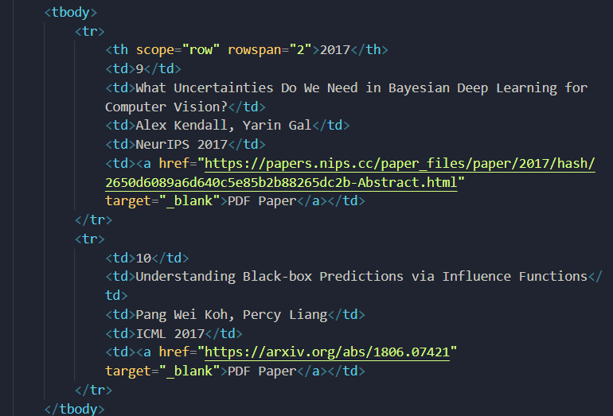

4. Form Edge Cases
- What happens if someone types a space in a required field?
- What validation do you add for email and phone?
- How do you handle the file upload field? (GET doesn’t support uploads - how do you communicate this?)
Answers:
- HTML5 sees backspace as a character so if a person type a space in required fiel, they can bypass the system’s emptiness checks.
- For email validation: I enforce submission to follow the structure
  - [a-z0-9._%+\-]+: Requires one or more lowercase alphanumeric characters or allowed symbols before the @.
  - @: Matches the literal @ symbol.
  - [a-z0-9.\-]+: Matches the domain name segment.
  - \.[a-z]{2,}$: Requires a dot followed by a top-level domain (TLD) of at least 2 lowercase letters (e.g., .com, .org, .edu).
- For telephone validation, it should follow this pattern:
  - ^: Asserts the start of the string.
  - \+?: Allows an optional leading plus sign (+) for international country codes.
  - [0-9\s\-]{8,15}: Permits digits, spaces, and hyphens with a total length between 8 and 15 characters.
  - $: Asserts the end of the string.
- HTTP method GET does not support upload files but when we use <input type=”file”>, the file can be uploaded but the binary file payload will drop that binary content instead of transmitting.
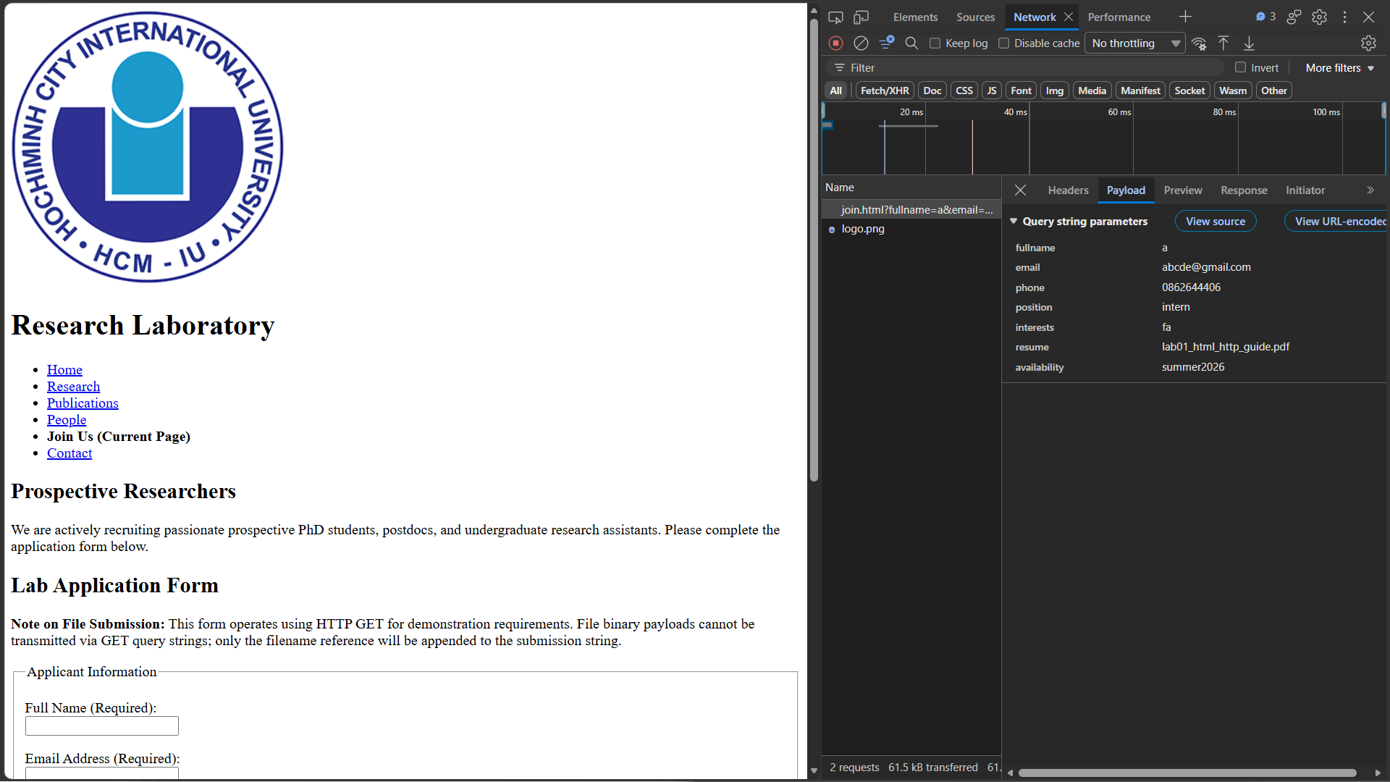
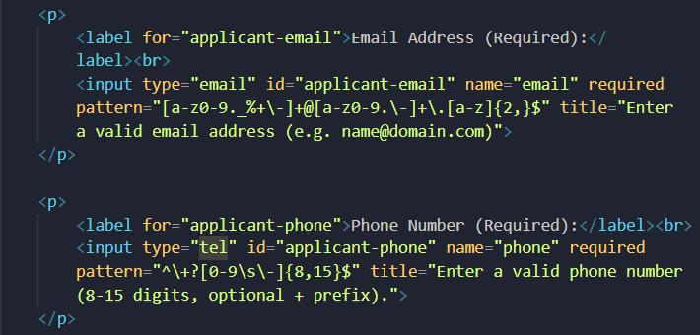
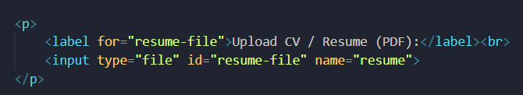

5. Broken Link Detection
- Intentionally create ONE broken link
- Document where it is and how someone would discover it using DevTools
Answers:
- I intentionally created one broken link in the contact form, after filling the form and submit. This is how a person would discover it using DevTools:
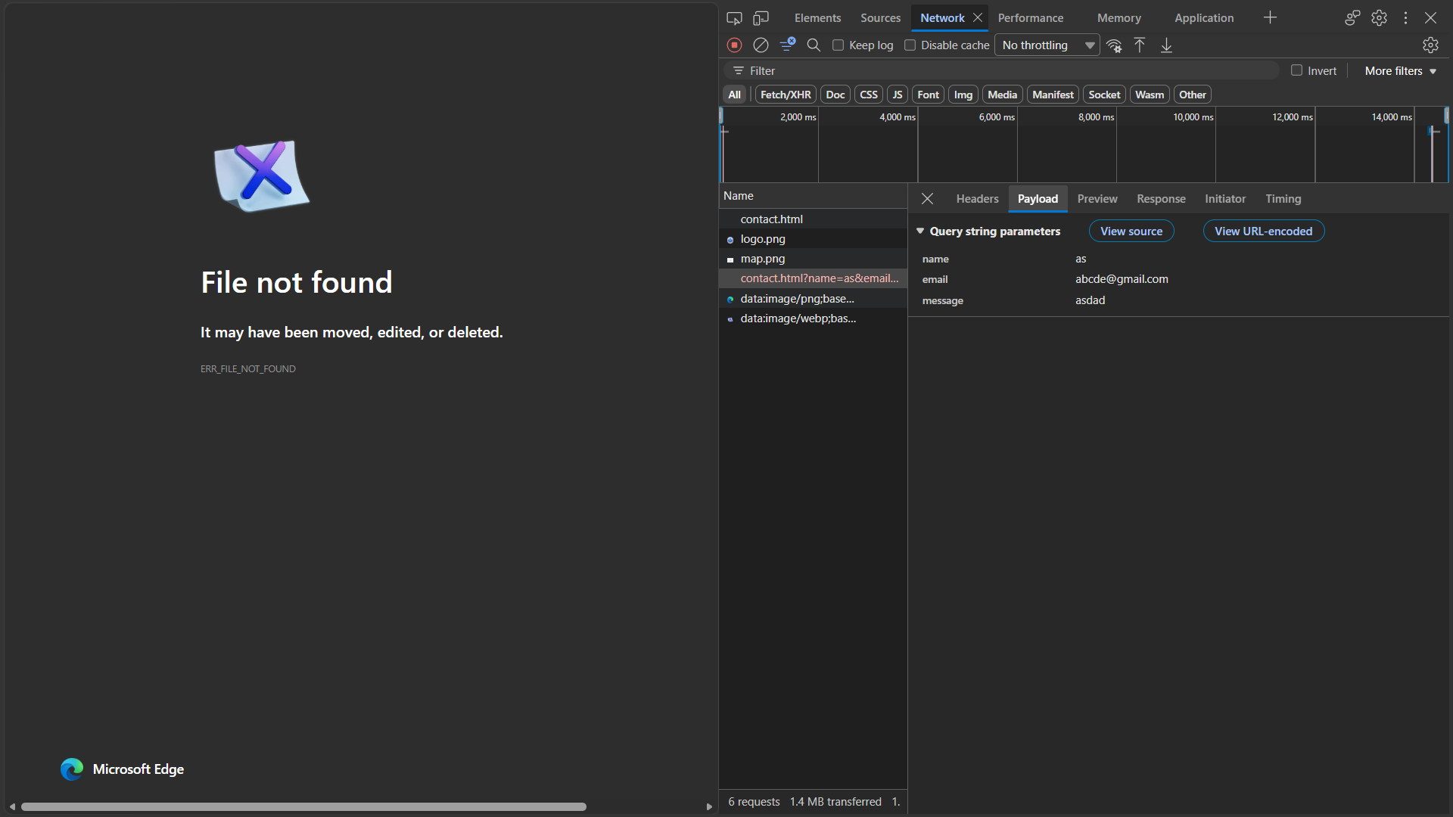

6. URL Parameter Handling
- Create a “Filter Publications” form that uses GET to filter by year
- Target page: publications.html
- After submission, URL should be: publications.html?year=2024
- Document what you would need to actually implement filtering (server-side processing)
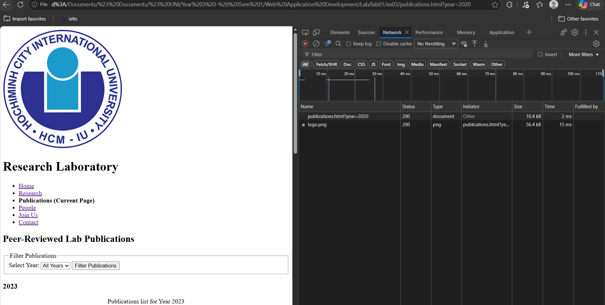
After applying the filer, the URL show all the value of the filter: publications.html?year=2020 but now filtering at all. Because this is a static HTML website without a backend runtime, submitting this form simply reloads the page with parameters appended to the URL and the table rows do not change dynamically.
To fully implement this feature, the server-side should be done as follows:
- Backend web server: an environment that is capable of catching incoming HTTP requests.
- Extract the request parameter: server-side logic to parse the query string and read the variable (e.g., extract the year from the url: publications.html?year=2020 → year = 2020)
- Database querying: based on the year we extracted from the url, there needs to be a query to connect with the database to extract all the papers/publications from the database (e.g., SELECT * FROM publications WHERE year = 2020;)
- Response rendering: with the results we get from the database, there should be a script to update the table into the page without a full page reload.

7. Alternative Text for Images
- Include at least 3 images
- One must be decorative (empty alt: alt="")
- Two must be informative (descriptive alt text)
- Explain your decisions
images/banner-divider.png (Decorative):
- Code: <img src="images/team-photo.png" alt="Team photo of the Vision & Systems Research Laboratory" width="800" height="120">
- Reasoning: It serves strictly as a visual divider above the mission statement. Setting alt="" instructs screen readers to skip it, preventing auditory clutter for visually impaired users.
images/logo.png (Informative):
- Code: <img src="images/logo.png" alt="Vision and Systems Research Lab Seal depicting neural network and optical lens vectors">
- Reasoning: Represents the official identity of the research unit. The alt text describes the graphical emblem so assistive software announces the institutional branding.
images/map.png (Informative):
- Code: <img src="images/map.png" alt="Schematic campus map pointing out Building A1 and Computer Science Lab 402" width="600" height="400">
- Reasoning: Conveys functional spatial data. The text description informs visitors precisely which building and room number correspond to the facility even if the image fails to download or render.

Performance and Logic Challenges

1. Large Table Performance
- HTTP Requests: Loading publications.html with an HTML table of 10+ rows initiates only 1 HTTP GET request for the document itself (plus individual requests for embedded images). Text inside HTML table cells is transferred inside the primary HTML payload, requiring zero additional network calls.
- Impact of 1,000 Rows: If expanded to 1,000 rows, the HTML document payload size increases by several megabytes. The browser must construct a much larger DOM tree, resulting in noticeable parse latency, high memory consumption, and sluggish scrolling performance on low-powered client devices.
- DevTools Investigation: To profile this, open DevTools (F12), switch to the Performance tab, record a page reload, and analyze the duration of the Parse HTML and Layout / Reflow phases. In the Network tab, inspect the document's Size column and the DOMContentLoaded milestone.

2. Form Submission Logic with File Uploads
- GET Behavior: When an <input type="file"> is submitted inside a method="GET" form, HTTP specification dictates that binary file streams cannot be appended to a URI query string. The browser strips the binary content and passes only the filename as an unencoded text parameter (e.g., resume=curriculum-vitae.pdf).
- Real-World Solution: Production file submissions must use method="POST" coupled with the encoding header enctype="multipart/form-data". This directs the browser to transport the binary file in segmented payload blocks inside the HTTP request body.

3. Navigation Efficiency
- Static Navigation Redundancy: Replicating identical <header> and <nav> blocks manually across all 6 pages introduces high architectural maintenance debt. If a menu link label changes or a new page is added, the developer must manually edit all 6 HTML files.
- Maintenance Problem: In static multi-page sites, manual synchronization quickly leads to human error, including broken relative paths, missing links, and inconsistent active page labels. In later labs, this is resolved via server-side templating engines (e.g., JSP, Jinja2, Thymeleaf) or modular component includes where navigation is authored in one partial file and included dynamically across all templates.

Explanation:
Write a technical report (plain text or Markdown) answering these questions:

1. Architecture Decisions (200-300 words)
- Explain your folder structure
- Why did you organize content into these 6 pages?
- How did you decide what content goes on which page?

ex03
├── index.html
├── research.html
├── publications.html
├── people.html
├── join.html
├── contact.html
└── images/
├── logo.png
├── map.png
└── team-photo.png

In my folder, I have another folder is images where I put all the images into the folder (for clearer structure). Meanwhile HTML files stay in the root folder, making linking pages together very easily without typing complicated paths like ../.
The home page (index.html) gives a quick introduction to, what we do, and brief new items. The research page is only for research topics, projects, and member roles. The publications page shows scientific papers in a neat table sorted by year. For people page, it introduces the professors, PhD students, and past alumni. About the join us page, it is for recruitment information and the job application form. I decided the content based on what a student or visitor usually wants to find. If someone just wants to read papers, they go right into the publications paper. Every page has its own clear purpose, which keeps the website easy to use and maintain.

2. Semantic HTML Choices (150-200 words)
- Pick 3 sections from your site
- For each, explain which semantic element you used and why
- Example: “I used for research projects because…”

I picked semantic HTML tags to make my website meaningful instead of just using generic <div> tags:
- <article> for research projects (on research.html): I used <article> because each project has its own title, description, team, and publications. It is a complete, standalone story. If you copy one project out of the page, it still makes total sense by itself.
- <nav> for the menu (inside <header> on all pages): I wrapped all page links inside <nav>. This tells web browsers and screen reader tools: "Hey, this is the main navigation menu". It helps blind users jump between pages much faster.
- <address> for lab contact information (on contact.html): I used <address> to wrap the room number, lab email, and telephone number. HTML rules say <address> should be used specifically for author or organization contact details, not regular text.

3. Form Analysis (200-250 words)
- Explain the data flow when someone submits the application form
- What HTTP method is used?
- Where does the data appear?
- Why is file upload problematic with GET?
- How would POST solve this?

When a person fills out the application form on join.html and clicks the Submit button, the browser starts sending the data. The form uses the GET method because of method="GET" in the code. The browser takes the names and values from every input box, connects them with & signs, and puts them directly into the URL query string. When submitted, you see everything right in your browser address bar like this: join.html?name=abc&email=abc%40email.com&position=intern&resume=cv.pdf. Because we only have static HTML files and no backend server or database, this data is not saved anywhere and disappears if you leave the page. The GET method only sends short text through the URL. A real PDF or image resume is big binary data. You cannot pack a whole file into a URL address. So, the browser only grabs the file name string (like cv.pdf) and drops the actual file content completely.

The POST method does not display data on the URL. Instead, it puts the information inside the hidden HTTP request body. When using POST with enctype="multipart/form-data", the browser can break big files into chunks and send the whole real file safely to the server.

D. Lab completion checklist

Functional correctness
- All HTML files have valid HTML5 structure ((<!DOCTYPE html>, <html>, <head>, <body> )
- All pages have a <title> that describes the page
- All internal links work (no 404 errors)
- All images display correctly or have appropriate alt text
- Forms submit successfully and data appears in URL (for GET forms)
- Navigation is consistent across all pages
- File and folder structure is logical and organized

Semantic HTML
- I used <header>, <nav>, <main>, <footer> where appropriate
- I used heading hierarchy correctly (h1 → h2 → h3, no skipping)
- I used semantic elements (<article>, <section>, <aside>) correctly
- I used lists (<ul>, <ol>, <dl>) for list-like content
- I used <table> only for tabular data, not layout
- I avoided presentational elements (<font>, <center>, etc.)

Forms
- All form inputs have associated elements
- I used appropriate input types (email, number, tel, etc.)
- Required fields are marked with required attribute
- Form method and action attributes are correct
- I understand what happens to form data when submitted \

Understanding
- I can explain what happens when I click a link (HTTP request-response cycle)
- I understand the difference between absolute and relative URLs
- I know how to use DevTools Network tab to inspect HTTP requests
- I understand HTTP status codes (200, 404, etc.)
- I can explain why GET method displays data in the URL
- I know the difference between semantic and presentational HTML

Debugging Skills
- I tested all links by clicking them
- I used DevTools to verify no broken resources (images, pages)
- I checked HTTP status codes for all requests
- I inspected form submission in DevTools Network tab
- I validated my HTML structure (proper nesting)

Code Quality
- My HTML is properly indented and readable
- I used meaningful file names (lowercase, no spaces)
- I used comments to mark major sections
- I avoided duplicate code where possible
- My code follows consistent style

Documentation (for exercises requiring explanation)
- I answered all required questions
- I explained design decisions with reasoning
- I identified trade-offs in my approach
- I discussed real-world implications
- I documented edge cases and how I handled them

E. Thinking & Discussion Questions

Question 1: Request-Response Analysis
Scenario: You have a page courses.html that contains:
- 1 HTML file
- 2 images (logo.png, banner.jpg)
- 5 links to other pages within your site
Questions:
a) When a user first visits courses.html, how many HTTP requests does the browser make?
Explain each request.
The browser makes 3 HTTP requests in total.
- Request 1: a GET request for the HTML document itself
- Request 2: after parsing the HTML document, the brower disovers the first image tag and sends a separate GET request to fetch logo.png.
- Request 3: The browser discovers the second image tag and sends an additional GET request to fetch banner.jpg (the 5 links do not trigger any requests upon loading because hyperlinks are only fetched when clicked.)
b) The user clicks a link to about.html. How many new HTTP requests occur?
At least 1 http request occurs immediately for the about.html document. If about.html references additional external resources (such as its own images or stylesheets), the browser will issue extra requests for each discovered resource.
c) The user clicks the browser’s “Back” button to return to courses.html. Does the browser make new HTTP requests? Why or why not?
In the local file environment, the browser typically re-reads the files locally or retrieves the cached representation directly without network overhead. In a web environment with a server, browsers use an in-memory or disk cache (such as the back-forward cache) to render the previous page instantly without making full new http requests.
d) In a real-world scenario with a server, how would caching affect these requests?

Question 2: GET vs POST (Preview)
Scenario: You’re building a course registration form.
Questions:
a) What are the problems with using GET for course registration?
- Security and privacy: because the GET method does not store any information and expose all on the screen, specifically the URL.
- Violates HTTP Protocol Design: The GET method is designed to be "safe" and idempotent, meant purely for retrieving information without changing server state. Course registration alters system state (allocating a seat, decreasing availability count, generating student records).
- URL Length Limitations: URLs are practically constrained to roughly 2,048 characters. Selecting many courses or submitting lengthy comments can cause data to be truncated or rejected.
b) Even though you haven’t learned POST, predict: how might POST solve these problems?
- Hides Data from the URL: POST transports form values inside the HTTP Request Body rather than in the visible URL query string, preventing data from appearing in browser history or server access logs.
- No Length Limits: Unlike URLs, the request body in POST can handle significantly larger payloads, easily accommodating long comments or file attachments.
- Represents State Modification: POST is explicitly designed for operations that modify server data, helping servers distinguish read operations from create/update actions.
c) Are there any situations where GET would be appropriate for a registration system? (Hint: Think about search/filter functionality)
- Search and Filtering: Using GET is ideal for searching available courses, filtering courses by department, level, or semester, and sorting class schedules.
- Search queries do not modify server data. Storing search criteria inside the query string (e.g., courses.html?level=300&semester=Fall2026) allows students to bookmark their search results, use the browser back/forward buttons seamlessly, and share direct links to specific filtered course lists with other students.

Question 3: Semantic HTML Trade-offs
Scenario: You’re building a page showing faculty profiles. Each profile includes: name, title, photo,
research interests, publications, contact info.
Questions:
a) Would you use <article>, <section>, or <div> for each profile? Justify your choice.
I would use <article> for each profile. An <article> element represents a complete, self-contained piece of content that makes sense on its own and can be independently distributed or reused. Thereby, a faculty profile (name, title, photo, research interests, publications, and contact info) forms a complete standalone biography, it fits the definition of <article>. Meanwhile <section> is intended for generic thematic groupings of related content (e.g., grouping the entire department directory), and <div> has no semantic meaning at all, offering no structural information to browsers or assistive technologies.
b) What are the concrete benefits of using semantic elements here? Give 3 specific examples.
- Accessibility (Screen Readers): Assistive devices can recognize <article> as an independent landmark, allowing visually impaired users to jump directly from one faculty member to the next using keyboard navigation.
- Search Engine Optimization (SEO): Search crawlers understand the structure of the document (e.g., matching the researcher's name in a heading inside an <article> with their publication list), resulting in rich search snippets and higher search relevance.
- Maintainability and Separation of Concerns: Developers reading the code immediately know what the block represents without inspecting CSS class names, keeping the content structure strictly separated from visual presentation.
c) Your teammate argues: “Semantic HTML doesn’t matter because we’ll style everything with CSS anyway.” How do you respond?
CSS only controls the visual appearance of the website and has nothing to do with the context or the meaning to machine parsers. Search engines (like Google) crawl the semantic HTML outline to index and rank information accurately, which CSS cannot assist with. And HTML has a lot of semantic features that ensures future-proof code, allowing further improvement and maintenance.

Question 4: Debugging Scenario
Scenario: A student creates a website with this structure:
my-site/
pages/
index.html
about.html
images/
logo.png
In pages/index.html, they write:
<img src="images/logo.png" alt="Logo">
The image doesn’t display.
Questions:
a) Why doesn’t the image display?
The file path images/logo.png written inside pages/index.html causes the browser to look for my-site/pages/images/logo.png.
b) What is the correct path?
The correct relative path is:
<img src="../images/logo.png" alt="Logo">
The phrase ../ steps up one directory out of pages/ into my-site/, and then enters images/logo.png.
c) How would you use DevTools to diagnose this problem?
Open DevTools (F12 or Ctrl + Shift + I) and check two tabs:
- Console tab: Look for a red error message indicating a failed resource: GET .../pages/images/logo.png 404 (Not Found).
- Network tab: Reload the page; inspect the failed red row for logo.png, verify its Status shows 404 (or failed under file://), and inspect the Request URL in the Headers panel to see the exact wrong path the browser attempted to resolve.
d) If this happened on a live website, what would users see, and how would it affect their
experience?
Users would see a broken image placeholder icon along with the fallback text "Logo" specified in the alt attribute. It gives an unprofessional, unfinished impression, degrades user trust, and deprives users of key visual branding.

Question 5: Stateless HTTP
Scenario: You build a multi-page course catalog. On page 1, a user searches for “web development.” On page 2, they expect to see filtered results.
Questions:
a) With only HTML and HTTP GET, how can page 2 “remember” what the user searched for?
Page 2 "remembers" by reading the query string parameters appended to the URL by the GET request. When the user submits the search form, the browser constructs a URL such as page2.html?query=web+development, passing the search parameters directly to the next page via the address bar.
b) What are the limitations of this approach?
- No automatic rendering: Static HTML alone cannot read its own URL parameters to filter or hide content without a backend script or client-side JavaScript.
- Parameter Loss: If the user clicks any standard hyperlink on page 2 that doesn't explicitly forward ?query=web+development, the search state is immediately lost.
- Length Limits & Clutter: Complex search filters clutter the address bar and can hit the practical ~2048 character URL length limit.
c) You haven’t learned server-side programming yet, but predict: how would a server-side solution improve this?
A server-side program can read the incoming query parameter from the HTTP request, query a database for courses matching that keyword, dynamically build an HTML page containing only those matching records, and return that tailored HTML to the client. The server can also store state in a user Session (via cookies), remembering filters across multiple page clicks without needing to manually pass URL parameters on every link.
d) In a real application (like Amazon search), how do search results persist as you navigate between pages?
Search parameters are preserved in the URL query string across pagination links (e.g., [amazon.com/s?k=laptop&page=2](https://amazon.com/s?k=laptop&page=2)), allowing URLs to be bookmarked and shared. In addition, modern web applications synchronize this URL state with server-side sessions, cookies, or client-side storage (localStorage / sessionStorage) so that browsing preferences and user filters remain active.

Question 6: Form Design
Scenario: You’re designing a course evaluation form with 20 questions (mix of text, ratings, multiple
choice).
Questions:
a) Should you use one long form or split it across multiple pages? What are the trade-offs?
One Long Form:
- Pros: Simple to implement in static HTML; submits all 20 questions in a single HTTP request without state management.
- Cons: Overwhelming cognitive load for the user; high risk of losing all 20 answers if the page accidentally refreshes or crashes.
Multi-Page Form:
- Pros: Better user experience; less fatigue per screen; clear progress tracking.
- Cons: Requires a mechanism to pass state from step to step (e.g., hidden inputs, sessions), which is difficult and impractical with pure static HTML.
b) If using GET method, what happens to the URL after submission?
The browser appends all 20 field names and values to the action URL as a massive query string: submit.html?q1=answer1&q2=answer2&q3=answer3...&q20=answer20 The resulting URL becomes extremely long, visually cluttered, and exposes every answer directly in the browser address bar and history.
c) Is there a practical limit to how much data you can send via GET? What would happen if you exceeded it?
Yes, the practical limit across most browsers and web servers is around 2,048 characters (approx. 2 KB). If exceeded, the web server rejects the request with an HTTP error status code, typically 414 URI Too Long (or fails to process the truncated data), causing form submission to fail.
d) How would you handle a situation where the user accidentally closes the browser before
submitting?
With plain, static HTML and HTTP, all entered data is held in browser memory and is permanently lost once closed. In production applications, this is handled by using JavaScript to listen for the beforeunload event to warn the user, or by auto-saving responses periodically to the browser's localStorage or sending drafts to the server.

Question 7: Performance and Scalability
Scenario: Your course catalog website has:
- 1 home page
- 1 catalog page with a table of 500 courses
- 500 individual course detail pages
Questions:
a) What performance issues might users experience?
There are some issues that can occur:
- High memory usage
- Slow rendering
- Laggy scrolling
- High file size & latency: the single catalog HTML file will be heavy to download if the network is slow
- Difficult further maintenance
b) How many HTTP requests are needed to load the catalog page if each course row includes a thumbnail image?
501 HTTP requests in total:
- 1 request for the catalog.html document.
- 500 separate requests for each of the 500 individual thumbnail images.
c) Without databases or server-side programming, how could you reduce the number of pages needed?
- Consolidate course details directly into the catalog using accordion-style native HTML elements like <details> and <summary>.
- Group courses by semester or subject area into separate sub-catalog pages (e.g., cs-courses.html, math-courses.html) rather than generating 500 separate HTML files.
- Combine related course descriptions into larger summary documents and use in-page anchor links (<a href="courses.html#cs301">) to jump to specific entries.
d) When would static HTML become unmanageable? At what scale would you need a database?
- Static HTML becomes unmanageable as soon as content updates frequently (weekly or daily), when the number of pages exceeds a few dozen, or when multiple authors need to edit content without writing raw HTML code.
- We need a database when the dataset exceeds dozens of structured items (e.g., 50+ courses), when real-time updates are needed (e.g., live available seats), or when search, filtering, and authentication are required.

Question 8: Real-World Architecture
Scenario: Compare these two approaches for a university course catalog:
Approach A: Static HTML (what you built in this lab) - 100 separate HTML files - Manual updates required - No search functionality
Approach B: Server-side generated (preview of later labs) - 1 template file - Data stored in database - Dynamic search and filtering
Questions:
a) In what scenarios is Approach A (static HTML) actually the better choice?
- Archival sites, documentation, legal policies, or simple landing pages where content rarely changes.
- When absolute maximum speed, reliability, and security are required; static files can be served directly from CDNs without server crashes, database down-times, or SQL injection vulnerabilities.
- Sites with strict budget constraints, as static hosting is often free or very inexpensive compared to dedicated backend infrastructure.
b) What specific problems does Approach B solve that Approach A cannot?
- Dynamic Search & Filtering: Allows users to query, sort, and filter hundreds of records on the fly without loading all data simultaneously.
- Centralized Data Management: Updating a course in the database instantly updates every relevant view across the application without editing static files.
- Consistency & Templating: Layout modifications to the header, footer, or navigation are made in one template file and automatically reflect across all pages.
c) What new problems does Approach B introduce (complexity, hosting, maintenance)?
- Infrastructure Complexity: Requires managing an application server (e.g., Node.js, Spring Boot) and a database server (e.g., MySQL, PostgreSQL).
- Maintenance & Security Risks: Introduces potential server crashes (HTTP 500), database connection errors, and security vulnerabilities (SQL injection, CSRF).
- Higher Hosting Costs & Latency: Requires persistent compute resources, and generating HTML dynamically on each request can be slower than serving pre-built static files if not properly cached.
d) For a site that updates once per semester, which approach would you recommend and why?
Approach B should be considered. Even though updates happen only once a semester, a university catalog contains hundreds of courses with interconnected prerequisites, instructors, and schedules. Manually editing 100+ static HTML files each semester is highly prone to human error, broken relative paths, and inconsistent formatting. Storing the course data in a structured spreadsheet or database and rendering the pages via templates guarantees 100% layout consistency with minimal update effort.

