Lab 02 Exercise 3 Research Laboratory Website
Nguyen Quynh Anh | ITCSIU24005 | Web Application Development
The Lab 01 research laboratory website now uses one external stylesheet, three themes, responsive layouts and reusable components. The six original pages retain the supplied research content and deep links. A component showcase and a labeled 60-row performance fixture provide evidence for the advanced CSS requirements.

1 Architecture documentation
The stylesheet is organized as reset, theme tokens, base typography, layouts, components, utilities and responsive preferences. BEM classes describe blocks, elements and variations: site-nav__link--active, card--project, card--person and card--publication. IDs remain stable targets for original deep links and form labels. A developer can first locate the layout section, then the component rule, then the media query that changes it.
Grid separates publication filters from results and arranges project cards. Flexbox handles navigation, faculty cards, student lists and actions. A max-width of 1200px limits long lines, while min-width: 0 prevents grid content from forcing page overflow. Each table owns its horizontal and vertical scrolling region.

2 Theme system analysis
Professional Blue is the default. Academic Green and Dark Mode override semantic custom properties on body[data-theme]. Every component consumes the same variables, including surface, text, border, state and focus colors. Changing the body attribute themes any page without changing its structure. The three showcase links open explicit theme previews; a site-wide persistent switch would require JavaScript or server state.
Theme | Body on surface | Primary button text | Muted text
Blue | 12.46:1 | 7.05:1 | 6.05:1
Green | 12.23:1 | 7.10:1 | 6.20:1
Dark | 12.66:1 | 8.86:1 | 8.23:1

A fourth theme would add a data-theme selector with the same tokens. Existing photographs and SVG colors retain their original appearance; the logo keeps a white backing so it stays legible in Dark Mode. CSS variables do not recolor pixels automatically.

3 Responsive design strategy
Base rules start at 320px: one-column content, wrapping navigation, filters above results, and a vertically stacked student list. At 768px, cards can use two columns and the authors column becomes visible. At 1024px, the publication sidebar uses 250px and projects use three columns. Navigation remains sticky, and scroll padding keeps deep-link headings clear of it.
Publication tables retain horizontal scrolling rather than hiding their titles or venues. Only the authors column is hidden below 768px; authors remain available in expanded title details. Tables also have a bounded height so sticky headers remain useful. This preserves comparison at the cost of scrolling in narrow containers.
Chromium 153 tested ten pages at 320, 375, 768, 1024 and 1440px: all 50 combinations passed page-overflow, image-load, label-target and stylesheet checks. All three themes were checked on the six source pages. A 200 percent root-font-size check passed on Home, Research, People and Join Us at 1024px; it supplements rather than replaces browser zoom testing.
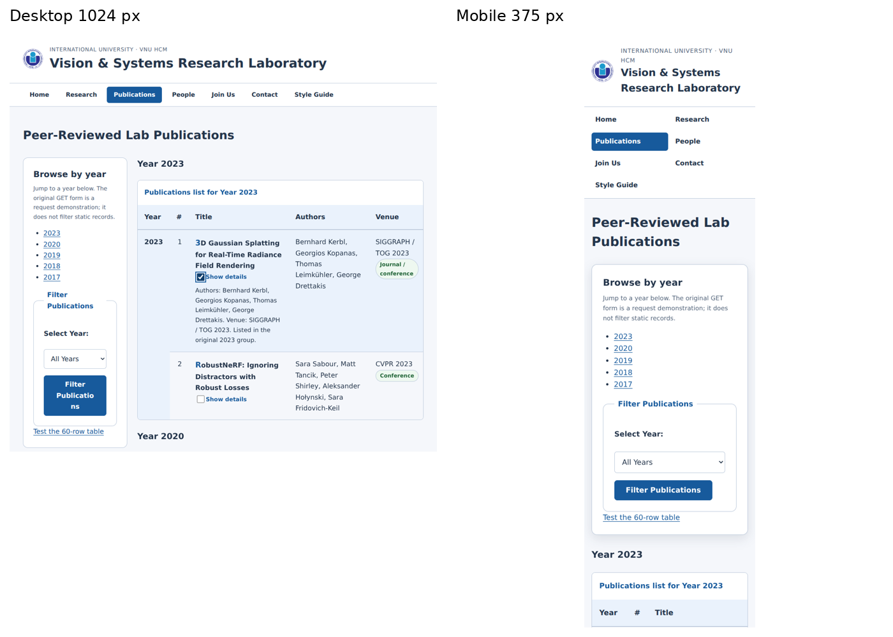
Figure 1 Publications at desktop and mobile widths with the first row expanded

4 Advanced CSS features
:nth-child(3n) gives every third project card a tinted surface; :nth-child(even) stripes table rows. The publication-title ::first-letter treatment creates subtle hierarchy. The native ::file-selector-button styles upload controls while the browser displays the selected filename. CSS cannot reliably read a file name through :placeholder-shown, so that guide example is replaced with the native control.
A visible checkbox followed by its label and sibling details implements row expansion through :checked. The same selector reveals optional funding fields. Radio buttons style a three-stage progress bar; all sections remain visible because the requirement is a visual indicator. The static counter is explicitly labeled as a preview and maxlength limits the statement to 1000 characters.
calc with --spacing-unit gives cards and large buttons consistent proportions. Transforms and short transitions provide card/button feedback, while prefers-reduced-motion removes movement. Scroll-driven navigation shadows are a progressive enhancement behind @supports; browsers without that feature still receive sticky navigation. Grid, Flexbox and ordinary selectors provide the functional baseline.

5 Performance audit
Measured item | Result
External CSS size | 17,592 bytes, below 50 KB
CSSOM entries | 185 including nested rules and keyframes
Rules matched to one table cell | 5
Recorded used rule ranges | 65
60-row frame interval median | 16.7 ms
60-row frame interval 95th percentile | 16.8 ms

The DevTools protocol inspected CSS matching and rule usage. All recorded ranges were used; this does not establish zero unused CSS across the file. Shared components can remain unused on an individual page. The frame test scrolled 60 labeled duplicate rows over 60 requestAnimationFrame callbacks in headless Chromium. Its timing is environment-specific and is not a hardware-independent performance guarantee.
Table hover changes only background color: it does not scale rows or add costly per-row shadows. Small SVG project illustrations, local assets, lazy project images, efficient classes and one stylesheet reduce work. Coverage across every page and a desktop DevTools Performance trace remain useful follow-up audits.

6 Accessibility testing
Calculated sRGB contrast ratios in Section 2 exceed 4.5:1 for body, button and muted text. Success and error styles use both text and color. Labels reference unique inputs; fieldsets have legends; tables have captions and column headers; active navigation uses aria-current; images have alternative text; and the file chooser remains native.
Browser tests verified that Tab reaches the skip link first and Enter transfers focus to main-content. Adding tabindex=-1 to main fixed the original focus behavior. The CSS controls, row expansion and reduced-motion behavior passed functional checks. Visible focus rings remain on links, inputs, buttons and scrollable table wrappers.
The optional authors column remains accessible through expanded details on mobile. Print styles reveal those details and remove navigation, actions and sidebars. Increased-contrast and forced-colors preferences strengthen borders and focus visibility. A disabled field is shown in the component showcase, alongside an explicit aria-invalid error example.
No Firefox or screen-reader validation was performed. A final manual pass should test browser zoom, keyboard order throughout each form, native validation messages, file controls and announcement of expanded checkbox details. A production system would add explicit error summaries and server validation.

7 Edge cases handling
Long headings and card text wrap; the showcase demonstrates ellipsis with full text restored on hover or focus. Missing publication links remain visible as unavailable metadata. The intentionally broken annual-report link is replaced with an unavailable message. Every local asset, HTML destination and fragment target resolves.
Empty and loading states are explicit reusable components in the showcase. A loading spinner stops under reduced motion. Print rules use monochrome tokens, reveal details, repeat table headers, remove scroll clipping and show external URLs. Print preview was inspected in Chromium.
The supplied publication grouping remains unchanged, including a CVPR 2024 venue under the 2023 group. This styling exercise does not assert bibliographic corrections. The performance fixture repeats the ten records six times and labels every copy; it never presents those copies as new research output.

8 Real world critique
The design makes the original academic content easier to navigate and compare without introducing a framework or JavaScript. Shared theme tokens and BEM components reduce duplication. Sticky headers and expandable details support long tables, while responsive cards preserve the relationships between projects and people.
Static GET forms demonstrate request parameters but do not save applications, upload files, send inquiries or filter publications. Year links provide functioning catalog navigation. A real application would require a POST endpoint, secure file storage, server validation and dynamic results. It would also replace the counter preview with a live value and make theme selection persistent.
CSS-only expansion exposes checkbox state rather than a dedicated disclosure announcement. A future implementation could use native details/summary or an accessible button with aria-expanded. Scroll timelines require newer browser support, so the fallback remains sticky navigation with the standard border.

9 Component library and visual evidence
components.html shows the three card variants, primary/secondary/outline/large/disabled buttons, badges, information/success/error alerts, form states, file controls, counters, conditional fields, long text, missing data, and empty/loading states. Theme copies use the same markup and stylesheet. Application and publication links demonstrate the larger compound controls.
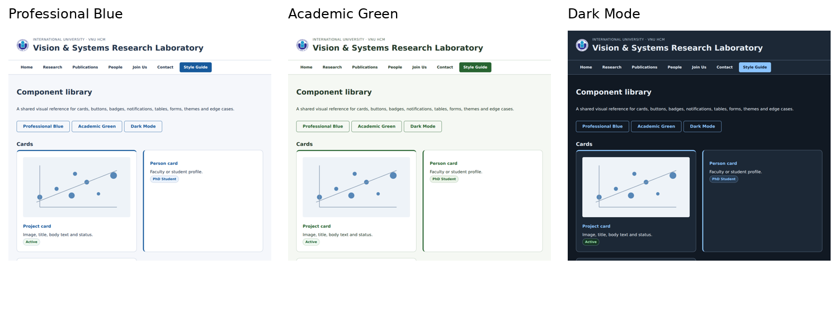
Figure 2 The same component showcase in Blue Green and Dark themes
The ZIP includes full browser screenshots so details can be inspected beyond the cropped report figures. For the interactive DevTools evidence requested in class, inspect a project card in Elements > Computed and capture the box model. The active navigation class also demonstrates a same-specificity source-order override. Protocol measurements in this report are not screenshots of the DevTools panel.

Application and project screenshots
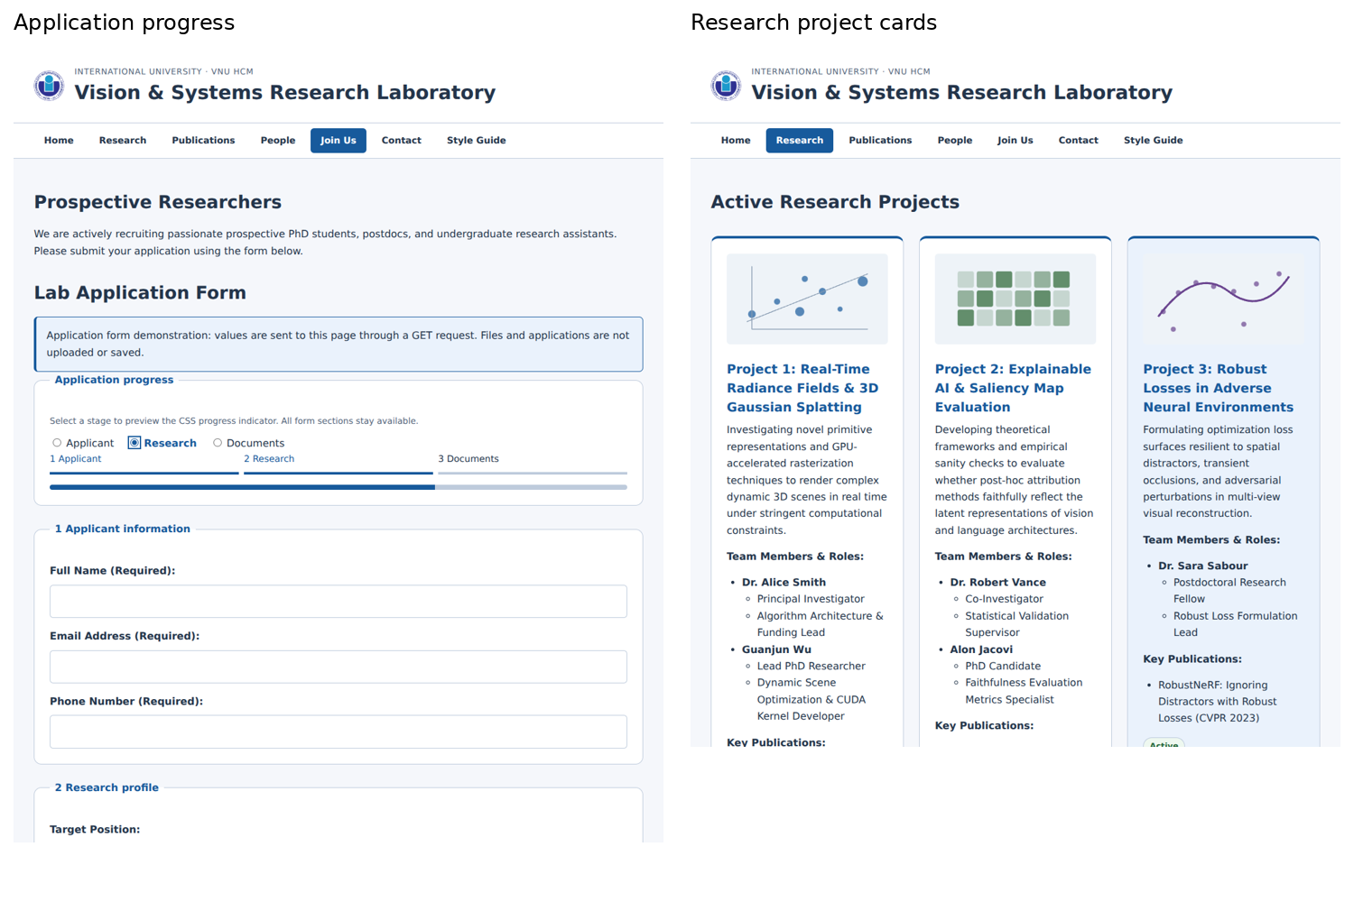
Figure 3 CSS progress preview and three research cards with local SVG illustrations
The progress bar reflects the selected radio stage and does not hide or validate steps. Conditional funding details use :checked. Native file controls show the selected filename. The counter is a static visual preview; no JavaScript is included.

Sources and reproduction
Requirements: lab02_css_layout_guide.pdf, Exercise 3 and the required technical report; WAD Lab 02 CSS and Layout theory, especially slides 16 to 19. Source website: Lab1-ITCSIU24005-NguyenQuynhAnh.zip, ex03. External publication links and record descriptions are retained from that source.
Extract the package and open ex03/index.html. To test themes on any page, change the body data-theme attribute to default, green or dark. Open performance.html to inspect the 60-row fixture. verification.json records browser checks and the observed metrics.

