Boss Katana Head mk2 Tones
(firmware 1.0 and 2.0 !)

Studio rats → Le compresseur ajoute de la réactiviter dans le son comme un ampli à lampes !

Studio rats → on peut partir du versatile tone pour trouver d’autres sons !

IMPORTANT : Pour passer sur une les paul avec Humbucker !! à partir de réglage d’un SINGLE.
EQ → position: ampout, type: parametric, Low Gain: 0, Low-cut Flat: 0, Low-mid gain: -1db, Low-mid Freq: 250 Hz, Low-mid Q: 4, High-mid Gain: +4db, High-mid Freq: 4.00 kHz, High-mid Q: 1, High Gain: 0db, High cut Flat: max, Level: 0db.
Boost → augmenter the drive
D’une façon générale → Augmenter le Treble
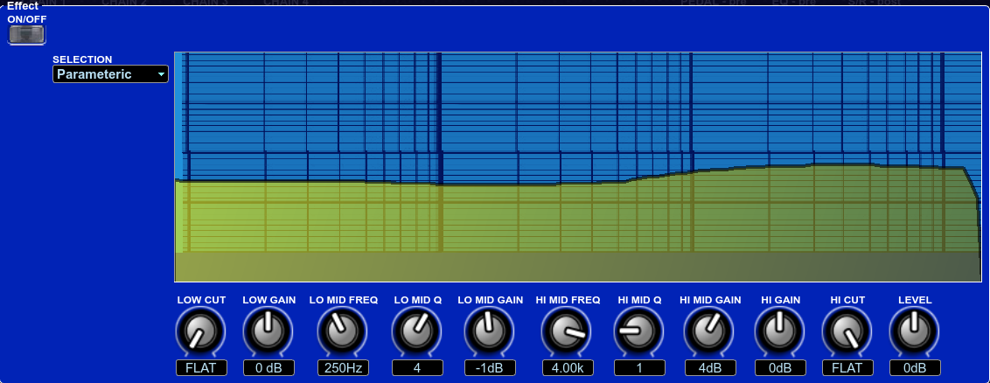

Studio rats Awesome High Gain : (exemple sur Les Paul micro bridge !) Cab vintage
Lead → variation: off, Gain: 74, Volume: 32, Bass: 72, Middle: 72, Treble: 30
Boost → off, Blues Drive, drive: 44, tone: 0, bottom: +10, effect level: 53, soloSw: off, solo level: 50, direct mix: 0
Mod → 38, Compressor, type: boss comp, sustain: 50, attack: 50, tone: +31, level: 45
Fx → off, Guitar sim, type: single → humbucker, body: x, low: 0, high: +23, level: 84
Reverb → 30, Hall, reverb time: 3.9s, low cut: 25.0 Hz, high cut: 6.30 kHz, pre delay: 10ms, density: 10, effect level: 68, direct mix: 100
Delay → 30, Pan, delay time: 710 ms, feedback: 35, high cut: 3.15 kHz, tap time: 50%, effect level: 39, direct mix: 100
Presence → 26

Studio Rats Awesome CLEAN: (WARNING → exemple sur telecaster) cab vintage
Clean → variation: on, Gain: 53, Volume: 17, Bass: 51, Middle: 64, Treble:42
Boost → 20, Treble Boost, drive: 43, tone: +1, bottom: -10, effect level: 75, soloSw: off, solo level: 50, direct mix: 0
Mod → 12, Compressor, type: light, sustain: 50, attack: 50, tone: 0, level: 59
Reverb → 43, Plate, reverb time: 3.0s, low cut: 400Hz, high cut: 1.60 kHz, pre delay: 10ms, effect level: 62, direct mix: 100, density: 5
Delay → 24, Pan, delay time: 567 ms, feedback: 15, high cut: 2.5 kHz, tap time: 50%, effect level: 45, direct mix: 100
Presence → 54

Studio rats Awesome CRUNCH - ROCK: (WARNING → exemple sur P90) ACDC - Cab vintage
Crunch → variation: off, Gain: 42, Volume: 48, Bass: 58, Middle: 72, Treble:30
Boost → off, Blues Drive, drive: 61, tone: 0, bottom: +11, effect level: 40, soloSw: off, solo level: 50, direct mix: 0
Mod → 38, Compressor, type: boss comp, sustain: 50, attack: 50, tone: +31, level: 45
Fx → off, Guitar sim, type: single → humbucker, body: x, low: 0, high: +23, level: 84
Reverb → 30, Plate, reverb time: 2.5s, low cut: 500Hz, high cut: 3.15 kHz, pre delay: 10ms, density: 7, effect level: 53, direct mix: 100
Delay → 30, Pan, delay time: 325 ms, feedback: 32, high cut: 4 kHz, tap time: 50%, effect level: 50, direct mix: 100
Presence → 23

BLUES ROCK: (exemple sur Humbucker proche Les Paul!) cab vintage
Clean → variation: on, Gain: 80, Volume: 50, Bass: 30, Middle: 47, Treble:70
Boost → on, Treble Boost, drive: 16, tone: +7, bottom: -2, effect level: 74, soloSw: off, solo level: 50, direct mix: 0
Mod → 12, Compressor, type: light, sustain: 30, attack: 73, tone: +1, level: 50
Reverb → 49, Room, reverb time: 2.0s, low cut: 400Hz, high cut: 3.15 kHz, pre delay: 10ms, density: 5, effect level: 66, direct mix: 100
Delay → 44, Tape Echo, delay time: 127 ms, feedback: 32, high cut: 2 kHz, effect level: 56, direct mix: 100
Presence → 78

VERSATILE CLEAN to LEAD: (exemple sur telecaster voir au dessus pour passer sur humbucker) cab vintage
Clean → variation: on, Gain: 66, Volume: 59, Bass: 37, Middle: 63, Treble:43
Boost → off, Warm Overdrive, drive: 39, tone: 0, bottom: +10, effect level: 38, soloSw: off, solo level: 74, direct mix: 0 (can change the type off boost, distorsion, etc)
Mod → Compressor, type: light, sustain: 61, attack: 83, tone: 0, level: 43
Reverb → Plate, reverb time: 3.1s, low cut: 400Hz, high cut: 4.0 kHz, pre delay: 10ms, density: 5, effect level: 54, direct mix: 100
Delay → Pan, delay time: 400 ms, feedback: 33, high cut: 4.00 kHz, effect level: 41, direct mix: 100
Noise suppressor → do want you need :-)
Presence → 61

Modded MARSHALL TONE: JMP AMP (exemple sur humbucker micro bridge !) Cab modern
Clean → variation: on, Gain: 68, Volume: 50, Bass: 46, Middle: 55, Treble: 65
Boost → on, Guv’nor DS, drive: 44, tone: +3, bottom: -2, effect level: 53, soloSw: off, solo level: 50, direct mix: 0
Mod → off, 38, Compressor, type: boss comp, sustain: 50, attack: 50, tone: +31, level: 45
Reverb → 30, Hall, reverb time: 3.9s, low cut: 25.0 Hz, high cut: 6.30 kHz, pre delay: 10ms, density: 10, effect level: 68, direct mix: 100
Delay → 30, Pan, delay time: 710 ms, feedback: 35, high cut: 3.15 kHz, tap time: 50%, effect level: 39, direct mix: 100
Presence → 50

HENDRIX Tone: (exemple sur stratocaster voir au dessus pour passer sur humbucker) cab vintage
Clean → variation: on, Gain: 66, Volume: 59, Bass: 37, Middle: 63, Treble:43
Boost → on, Rat, drive: 71, tone: 0, bottom: +10, effect level: 38, soloSw: off, solo level: 74, direct mix: 0 (can change the type off boost, distorsion, etc)
Fx → off, uni-vibe, rate: 70, depth: 58, level: 100
Pedal FX → position: input, fx type: wah 95E, pedal pos:100, pedal min: 0, pedal max: 100, effect level: 100, direct mix: 0
Mod → Compressor, type: light, sustain: 61, attack: 83, tone: 0, level: 43
Reverb → Plate, reverb time: 3.1s, low cut: 400Hz, high cut: 4.0 kHz, pre delay: 10ms, density: 5, effect level: 54, direct mix: 100
Delay → Pan, delay time: 400 ms, feedback: 33, high cut: 4.00 kHz, effect level: 41, direct mix: 100
Noise suppressor → do want you need :-)
Presence → 61

GARY Moore: (exemple sur Les Paul neck pickup) cab modern
Brown → variation: on, Gain: 78, Volume: 72, Bass: 19, Middle: 90, Treble:57
Boost →
Mod → Compressor, type: light, sustain: 40, attack: 77, tone: +8, level: 57
Reverb → Hall, reverb time: 2.8s, low cut: 400Hz, high cut: 4.0 kHz, pre delay: 99ms, density: 5, effect level: 66, direct mix: 100
Delay → Analog, delay time: 350 ms, feedback: 32, high cut: 2.50 kHz, effect level: 41, direct mix: 100
Noise suppressor → do want you need :-)
Presence → 60

