Correlation_Exercise

Negar Yazdi

2024-03-31

## Correlation Exercise

# Results:

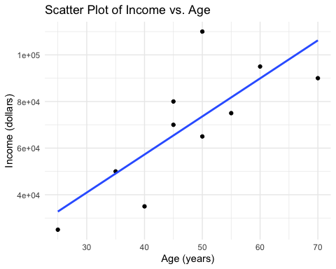

“Pearson’s correlation coefficient (r): 0.779”, indicating a strong positive linear relationship between Income and Age.

“p-value: 0.008”, suggesting that the correlation observed is statistically significant and not due to random chance.