

**STID3133 Research Method in IT**

Quiz 1

Name : NG SHEN MENG____________________

Matric # : 271059_______

Group : A _________________

The following charts are generated from some of data collected by a group of researcher with the objectives to identify the need of a virtual counsellor among UUM students during Covid-19’s Movement Control Order (MCO).

Design an instrument by using at least TWO (2) different scales to collect data that can generate these charts. Add suitable questions to achive the research objective.

**[20 marks]**

|  |
| --- |
|  |
|  |

**Answer:**

The instrument that i use is questionnaire which is design with google form. There are 2 sections in this questionaire.

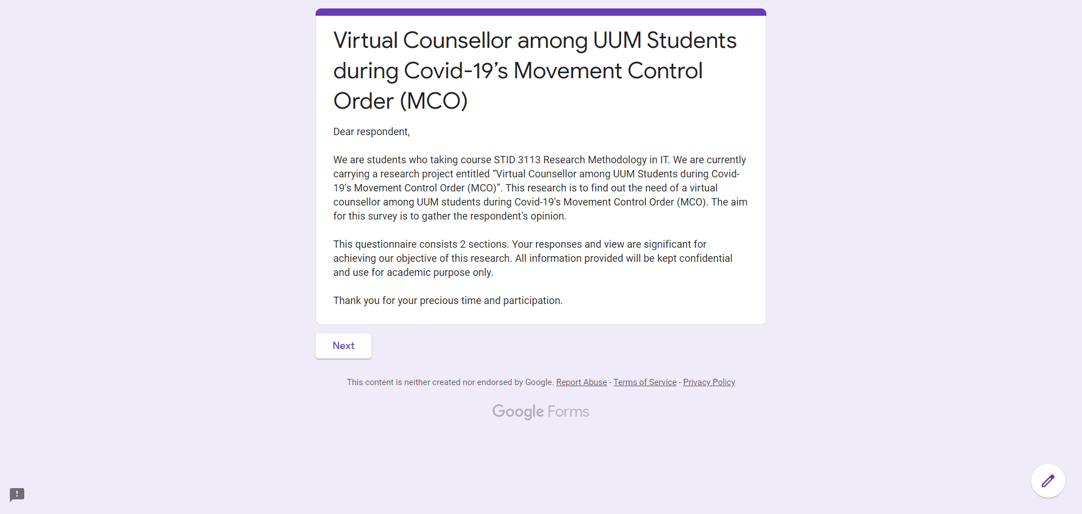

Section A: Demographic

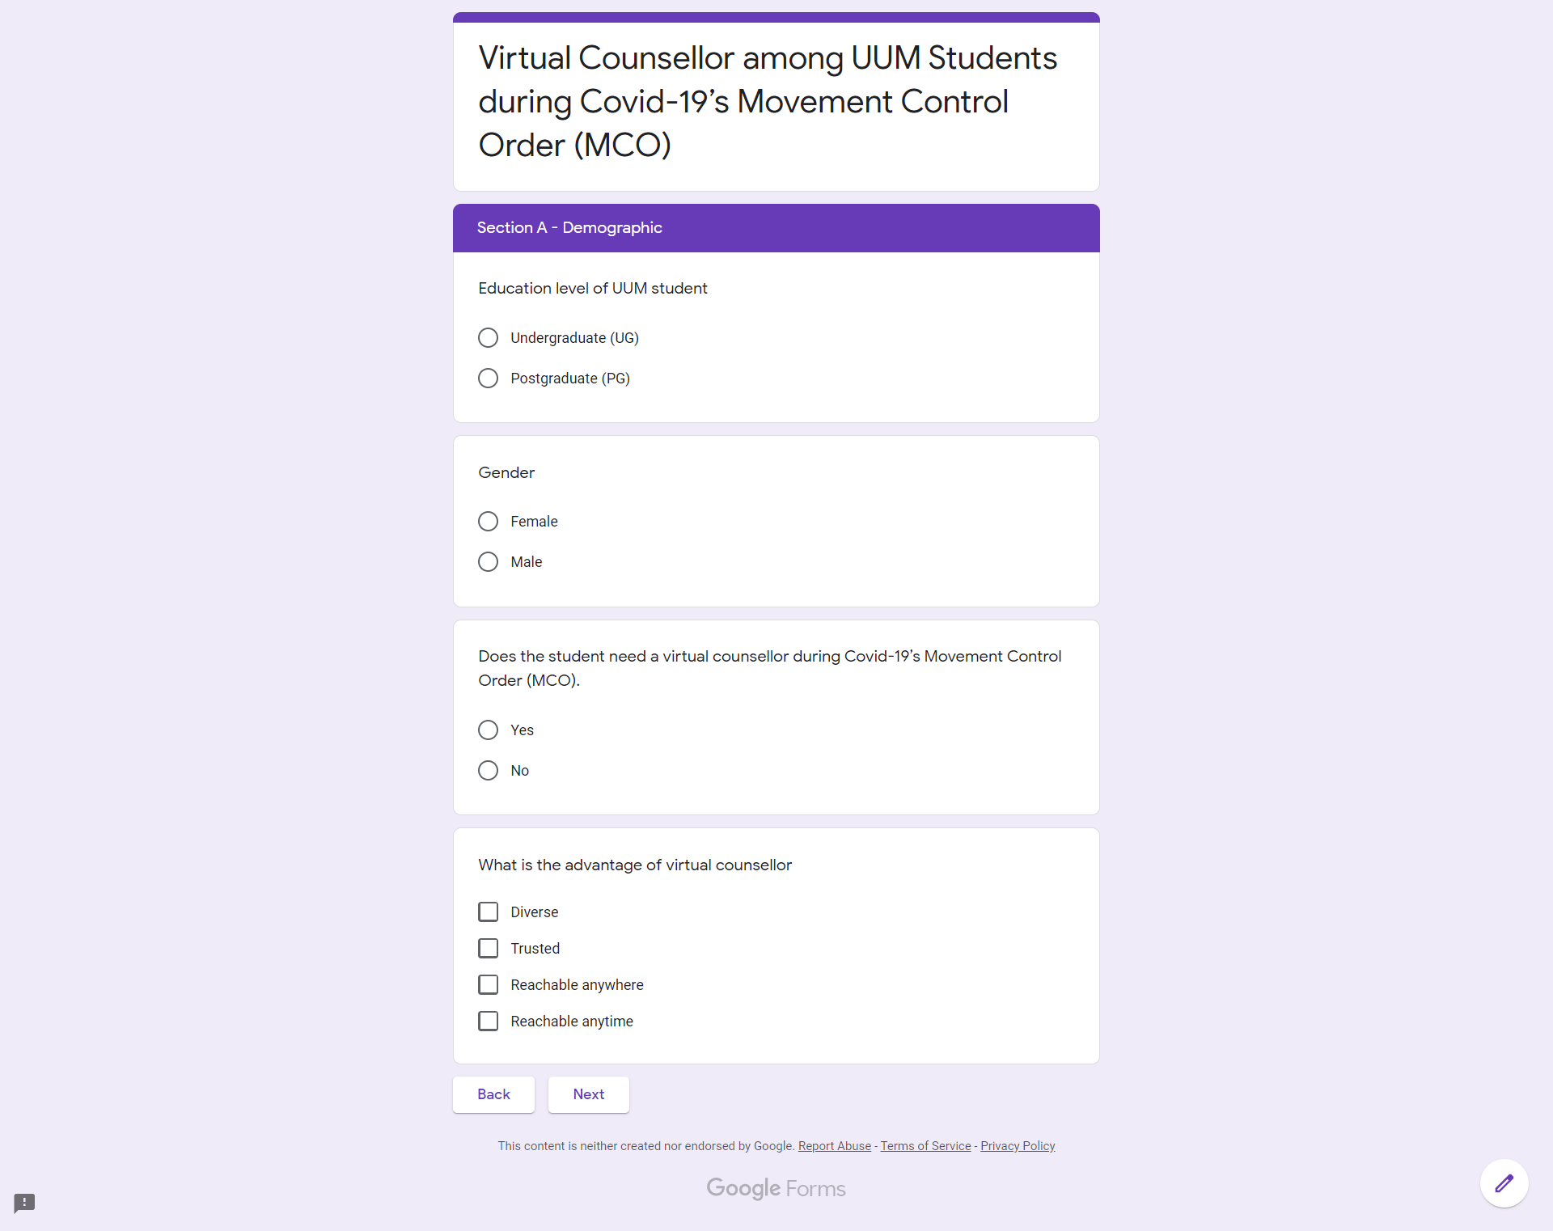

Section B: Features of Virtual Counsellor

