Design, Fabrication & Testing of a Formula Hybrid Race Car
Dhwani Racing - SAE Formula Hybrid Competition 2014
Nitte Meenakshi Institute of Technology, Bangalore, India
Faculty Advisor: Dr. Kiran Aithal S. Team: 11 members across 3 engineering sub-teams

PROJECT OVERVIEW
Dhwani Racing was a student-led team of 11 engineers that designed, fabricated, and raced a formula-style hybrid vehicle for the SAE Formula Hybrid Competition, a joint SAE-IEEE international event held at the New Hampshire Motor Speedway, USA. The car was India’s first-ever entry in the competition. The project spanned 12 months of design, analysis, and fabrication across three integrated sub-teams: Control Systems (suspension, steering, brakes, wheels), Powertrain (hybrid engine-motor system, batteries, drivetrain), and Structure & Body (chassis, impact attenuator, bodywork, aerodynamics). We built the vehicle platform from scratch (no legacy chassis or carryover assemblies).The team placed 9th internationally among 12 teams and won the “Fan’s Favorite Car” award.
 | 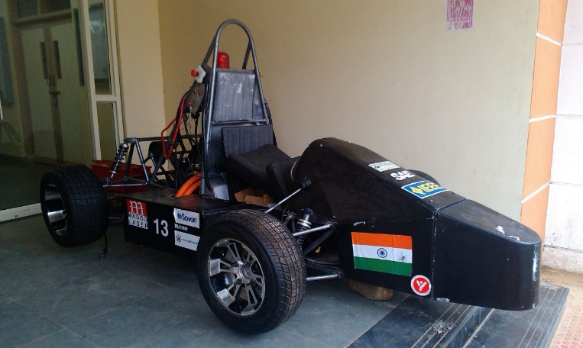
CAD assembly | Fabricated vehicle

VEHICLE SPECIFICATIONS
Parameter | Specification
Dimensions (L × W × H) | 2850 × 1550 × 1350 mm
Wheelbase / Track | 1600 mm / 1300 mm (front & rear)
Weight | 280 kg empty; ~350 kg with driver
Frame | AISI 1018 mild steel tubular space frame (67.5 kg), MIG welded
Impact Attenuator | Al 3003 honeycomb, 250 mm length, 8976 J energy capacity
IC Engine | Bajaj Pulsar 220cc DTSi 21 HP @ 8500 RPM, 19.1 Nm @ 7000 RPM
Electric Motor | Kostov DC motor, 48V, 400A max
Batteries | Enersys Genesis 13EP lead-acid, 4S3P, 48V, 1613 Wh total
Drivetrain | Rear-wheel drive, parallel hybrid, 6 sprockets/chains, LSD
Suspension | Double unequal A-arm (F & R), spring-damper, 7075-Al uprights
Steering | Custom rack & pinion, quick-release hub, 200° driver visibility
Brakes | Diagonal-split hydraulic, 200 mm vented discs, floating calipers
Tires / Wheels | ATV: 200/50 R12 (F), 250/40 R12 (R) on magnesium wheels
Body | Epoxy-reinforced fiberglass shell with integrated firewall

STRUCTURE & CHASSIS
The chassis is a tubular space frame fabricated from AISI 1018 cold-drawn seamless mild steel (1″ OD), joined by MIG welding. This configuration was selected over monocoque and ladder-frame alternatives for its high torsional rigidity, ease of fabrication, and compliance with SAE Formula Hybrid structural rules, including front/main roll hoop requirements, side-impact structures, and bracing geometry. The bare frame weighed 67.5 kg including brackets and paint. A front-mounted impact attenuator made from Al 3003 alloy honeycomb (250 mm deep) passed quasi-static crush testing at 8976 J, exceeding the competition’s energy absorption mandate. A steel firewall separates the driver compartment from the powertrain bay per competition safety rules. The body shell was hand-laid fiberglass over an epoxy matrix, prioritizing low weight and aerodynamic form.

HYBRID POWERTRAIN
The car uses a parallel hybrid architecture: a Bajaj Pulsar 220cc single-cylinder petrol engine and a Kostov separately-excited DC motor drive the rear wheels at different operating points. The engine produces 21 HP at 8500 RPM and 19.1 Nm at 7000 RPM; the electric motor draws from a 48V lead-acid battery pack (Enersys Genesis 13EP, configured 4S3P for 1613 Wh total capacity) and delivers up to 400A peak current. Power is transmitted through a six-sprocket chain drive system with a limited-slip differential (LSD) to maintain traction during high-speed cornering. The electric-only acceleration target, 75 meters in 10 seconds, was achieved in approximately 8.5 seconds, closely matching theoretical predictions. A Curtis Sepex 1274 motor controller manages the DC motor, and the battery management system includes 3 fuses and 6 relays for overcurrent protection.

VEHICLE CONTROL SYSTEMS

Suspension
Double unequal-length, non-parallel A-arm suspension on both axles provides independent control of camber, caster, and toe for consistent tire contact under cornering loads. Static camber is set to −1° with adjustable toe (±2° via threaded rod ends). Roll center height is 160 mm; travel is 1″ jounce/1″ rebound. CNC-machined 7075-T6 aluminum uprights integrate all wheel-corner subsystems.

Steering
A custom-designed rack-and-pinion system with near-Ackermann geometry minimizes tire scrub during low-speed autocross maneuvers. The rack housing, pinion gear, and tie rods were CNC-machined in-house. A quick-disconnect steering hub enables rapid driver egress per competition safety requirements.
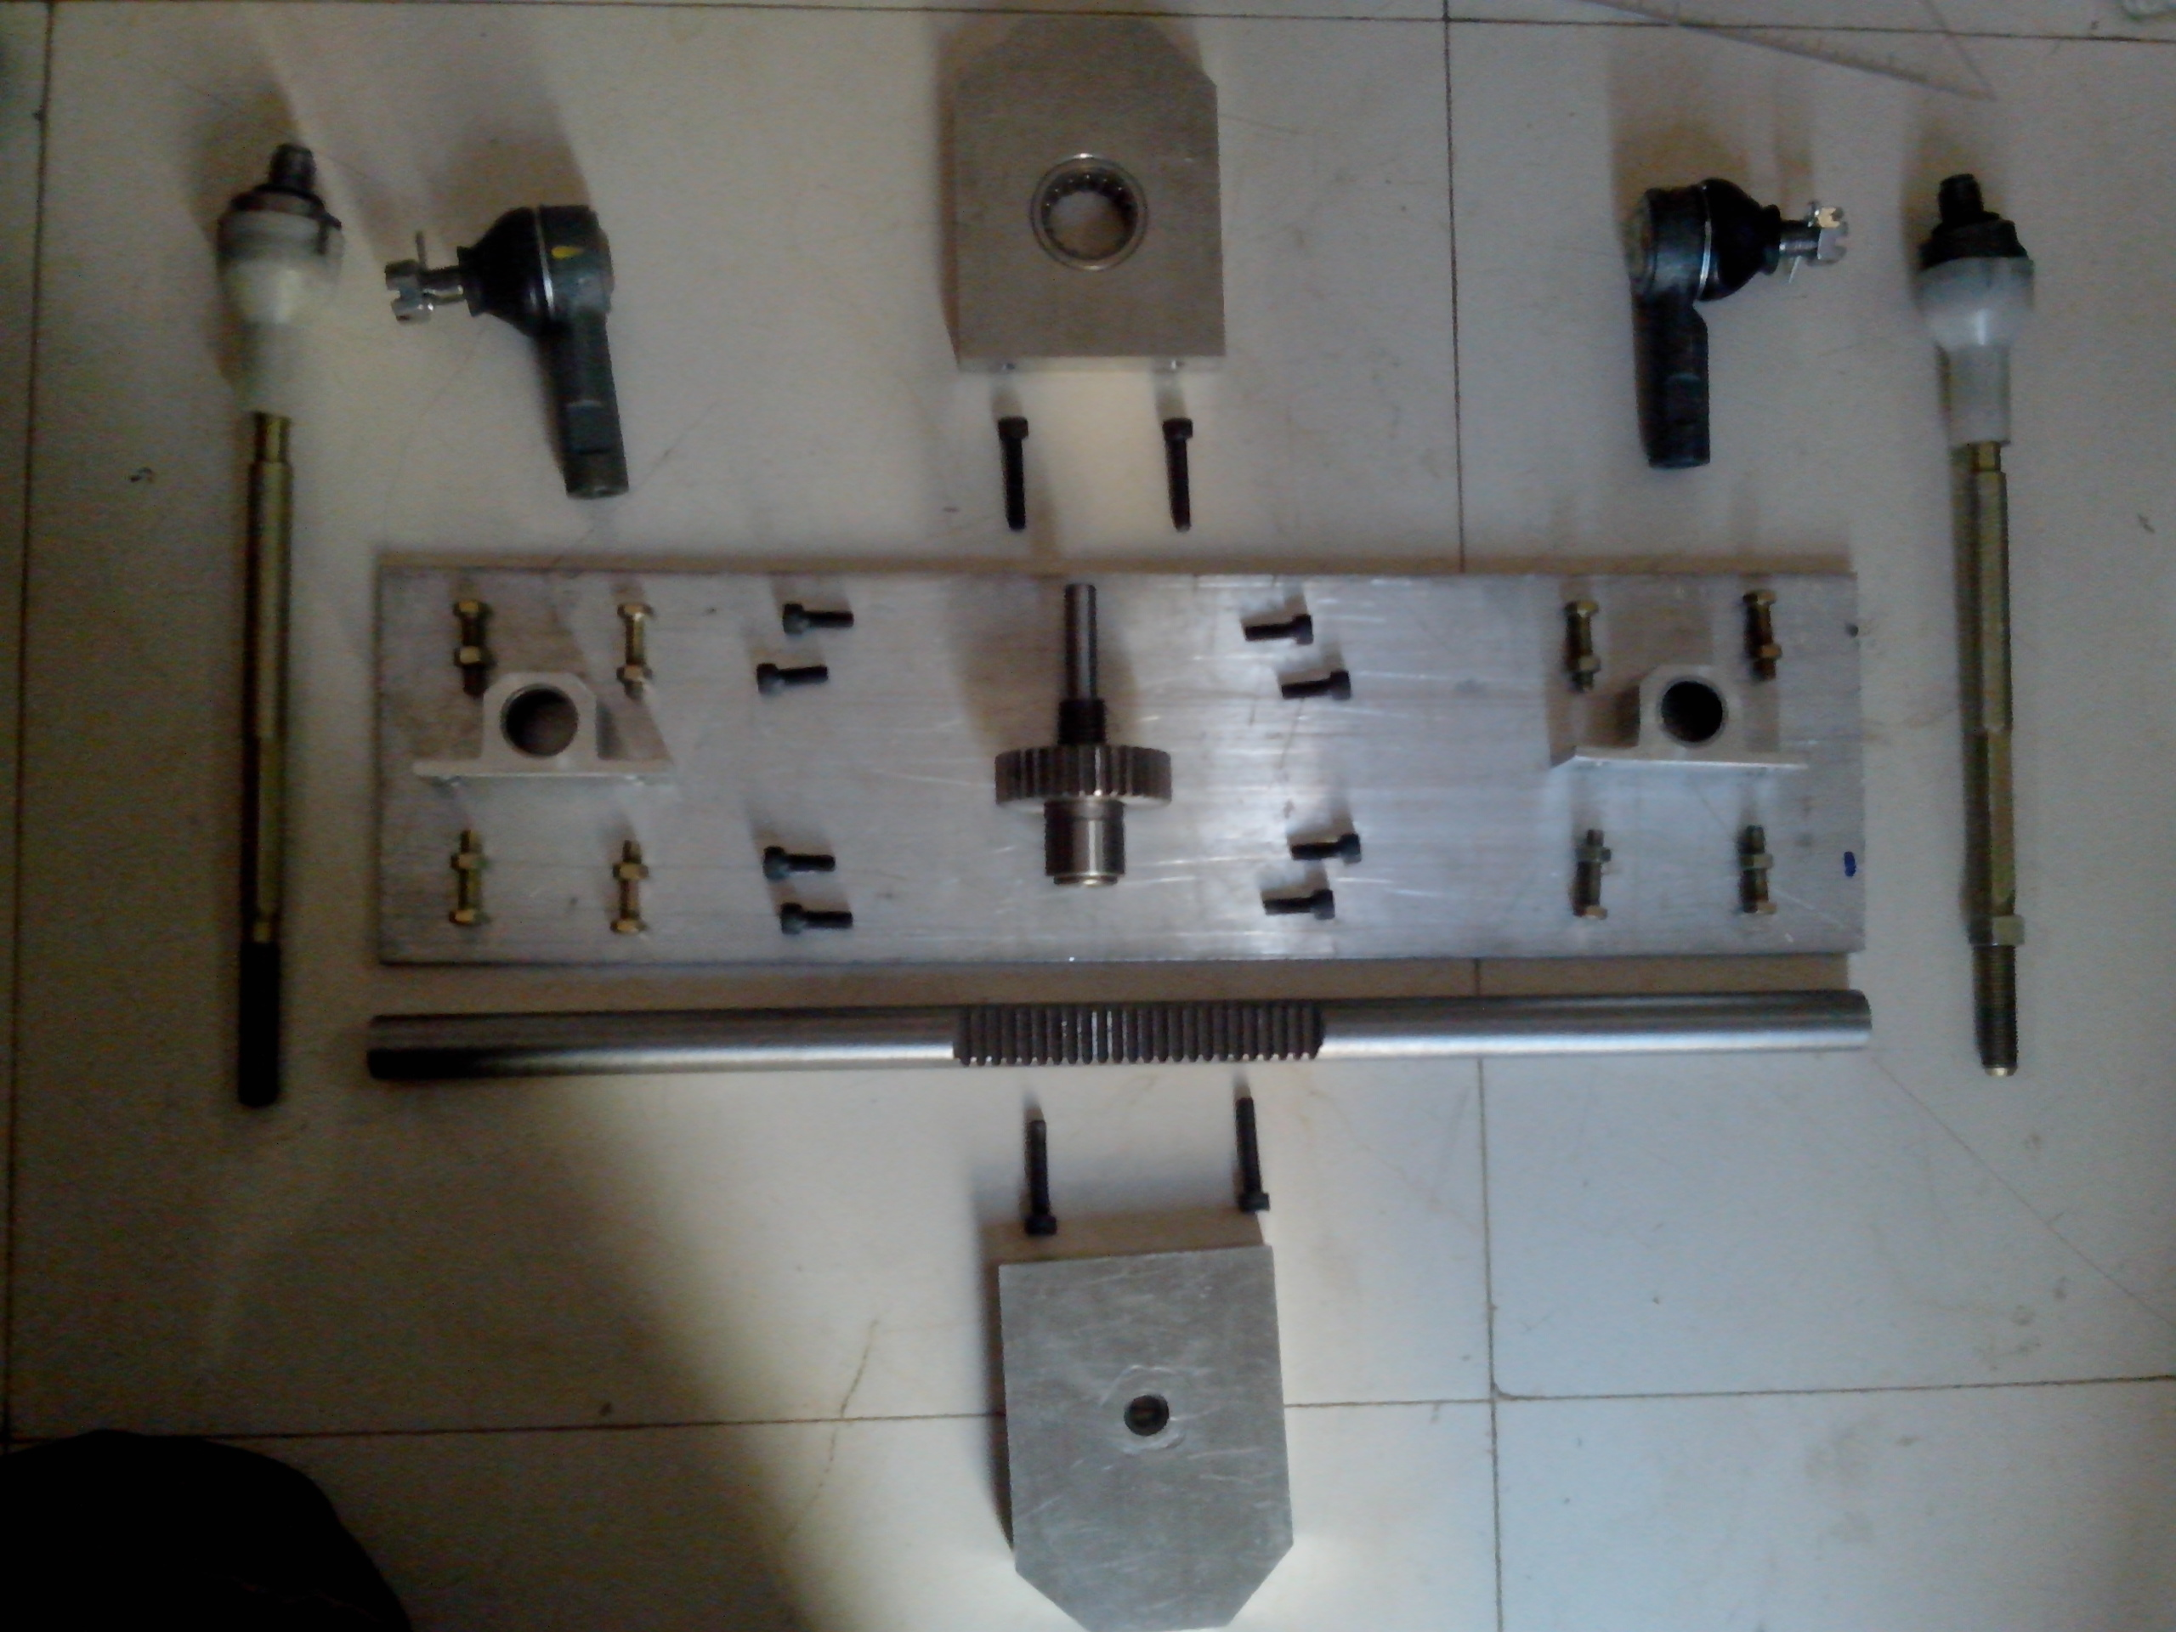
Custom-fabricated steering rack-and-pinion assembly: housing, gears, tie rods, rod ends, and upright brackets.

Brakes
A diagonal-split hydraulic disc brake system provides fail-safe braking: if one circuit fails, the other still brakes one front and one opposite rear wheel, maintaining directional stability. Each corner uses a 200 mm vented steel disc with floating calipers, actuated by a single 19 mm master cylinder.

Wheels & Tires
ATV-grade tires (200/50 R12 front, 250/40 R12 rear) on lightweight magnesium 12″ wheels balance grip, weight, and cost. The wider rears improve traction under acceleration; the narrower fronts reduce steering effort and sharpen turn-in.

FABRICATION & COMPETITION
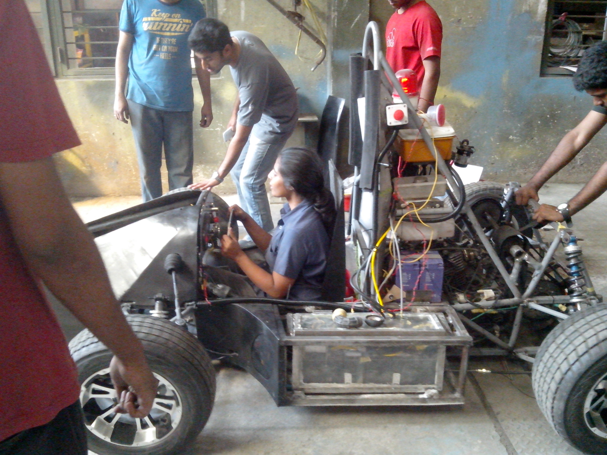 | 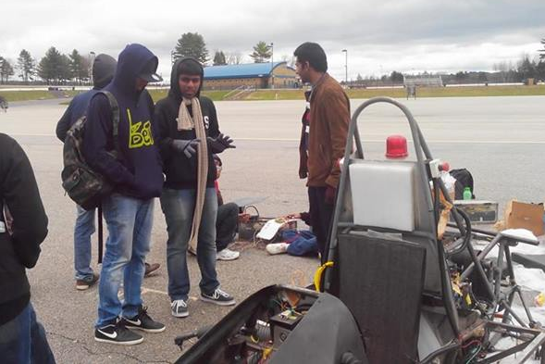
Hands-on fabrication: wiring, powertrain integration, and final assembly. | Team and vehicle at the competition venue.
Fabrication spanned approximately 8 months and involved CNC machining, MIG welding, chain/sprocket assembly, electrical wiring, fiberglass body layup, and iterative integration testing. The team competed at the SAE Formula Hybrid Competition at New Hampshire Motor Speedway, USA. Events included technical inspection, electric-only acceleration, autocross (evaluating combined acceleration, braking, and cornering), and endurance runs. The car placed 9th internationally among 12 teams and won the “Fan’s Favorite Car” award, as India’s first-ever entry in the competition.

ENGINEERING SKILLS & INDUSTRY RELEVANCE
This project developed competencies directly transferable to automotive, aerospace, and manufacturing engineering:
Domain | Skills Applied
Vehicle Dynamics | Suspension geometry, tire modeling, ride/handling trade-offs, braking analysis
Powertrain Engineering | Hybrid architecture design, motor/battery sizing, sprocket ratio calculations
Structural Design | Space frame design, FEA, impact attenuator testing, material selection
Manufacturing | CNC machining, MIG welding, fiberglass layup, sheet metal fabrication
Electrical Systems | Battery management, motor control, instrumentation, safety circuits
Systems Integration | Multi-subsystem packaging, interface design, weight/cost trade-offs
Project Management | 11-person cross-functional team, timeline/budget, sponsor relations
Competition Standards | SAE/IEEE rulebook compliance, design reviews, technical inspection
This project exemplifies competition-based capstone learning: students confronted real manufacturing constraints, iterated under deadlines, integrated across disciplinary boundaries, and presented their work in a professional international engineering forum, all skills that translate directly to industry roles in product development, R&D, and manufacturing engineering.

