UML-Diagrams

# Store system Use cases

## Use case actors

* A ‘manager’ is the person to open, close and manage the store.
* A ‘customer’ is someone to buy items in a Post.
* Secondary actor: The ‘payment authorization service’ is the service provided to verify any customer’s payment method.

## Overview

## Use case description

|  |  |
| --- | --- |
| **Use case #** | 1 |
| **Use case name** | Opens store |
| **Summary** | A manager opens the store |
| **Dependency** |  |
| **Actor** | Manager |
| **Precondition** | Needs to be a manager and store is closed |
| **Description** | A manager opens the store so that customers can access it  User needs to be authorized as a manager |
| **Alternative** |  |
| **Post condition** | Store is open |

|  |  |
| --- | --- |
| **Use case #** | 2 |
| **Use case name** | Sets up posts |
| **Summary** | A manager sets up the POSTs |
| **Dependency** |  |
| **Actor** | Manager |
| **Precondition** | Needs to be a manager |
| **Description** | A manager sets up POSTs so they are ready for use  User needs to be authorized as a manager |
| **Alternative** |  |
| **Post condition** | POSTs ready for use |

|  |  |
| --- | --- |
| **Use case #** | 3 |
| **Use case name** | Manages product catalog |
| **Summary** | A manager maintains the product catalog |
| **Dependency** |  |
| **Actor** | Manager |
| **Precondition** | Needs to be a manager |
| **Description** | A manager sets the product catalog  A manager adds items to the product catalog  A manager removes items from the product catalog  User needs to be authorized as a manager |
| **Alternative** |  |
| **Post condition** | There is a product catalog |

|  |  |
| --- | --- |
| **Use case #** | 4 |
| **Use case name** | Closes store |
| **Summary** | A manager closes the store |
| **Dependency** |  |
| **Actor** | Manager |
| **Precondition** | Needs to be a manager and store is open |
| **Description** | A manager closes the store  User needs to be authorized as a manager |
| **Alternative** |  |
| **Post condition** | Store is closed |

|  |  |
| --- | --- |
| **Use case #** | 5 |
| **Use case name** | Enter UPC codes and quantity |
| **Summary** | A customer enters the desired UPC codes |
| **Dependency** |  |
| **Actor** | Customer |
| **Precondition** |  |
| **Description** | A customer enters the UPC codes and quantity of the desired products |
| **Alternative** |  |
| **Post condition** | One or more items are added |

|  |  |
| --- | --- |
| **Use case #** | 6 |
| **Use case name** | Chooses desired payment method |
| **Summary** | A customer chooses the desired payment method |
| **Dependency** |  |
| **Actor** | Customer |
| **Precondition** |  |
| **Description** | A customer chooses to pay with cash, credit card or check |
| **Alternative** |  |
| **Post condition** | Payment method has been chosen |

|  |  |
| --- | --- |
| **Use case #** | 7 |
| **Use case name** | Provides payment |
| **Summary** | A customer provides the required payment |
| **Dependency** | A payment method is selected |
| **Actor** | Customer |
| **Precondition** | Payment is required |
| **Description** | A customer provides payment in the form of cash, credit card or check, specified in use case 6 |
| **Alternative** |  |
| **Post condition** | Sufficient payment is provided |

|  |  |
| --- | --- |
| **Use case #** | 8 |
| **Use case name** | Verify payment |
| **Summary** | Verifies the payment method provided |
| **Dependency** |  |
| **Actor** | Authorization service |
| **Precondition** | Customer chooses credit or check |
| **Description** | The authorization service verifies the payment method  Payment method gets verified |
| **Alternative** | Verification not given due to insufficient funds |
| **Post condition** | Payment is verified |

## Class diagrams

*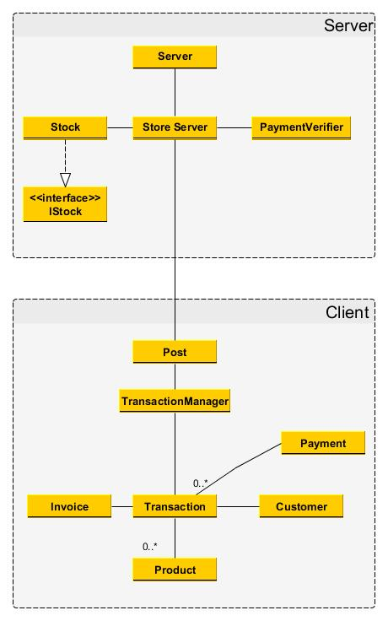 Collapsed class diagram*

# 