**ABSS version 12 Maybank Payment Extractor**

Date: 23 Nov 2018

Prepared by : Ng Teng Yong

**Objective**

1. To extract Bank Register records in ABSS into a csv file that can be easily uploaded to Maybank web app for fund transfer to various suppliers.

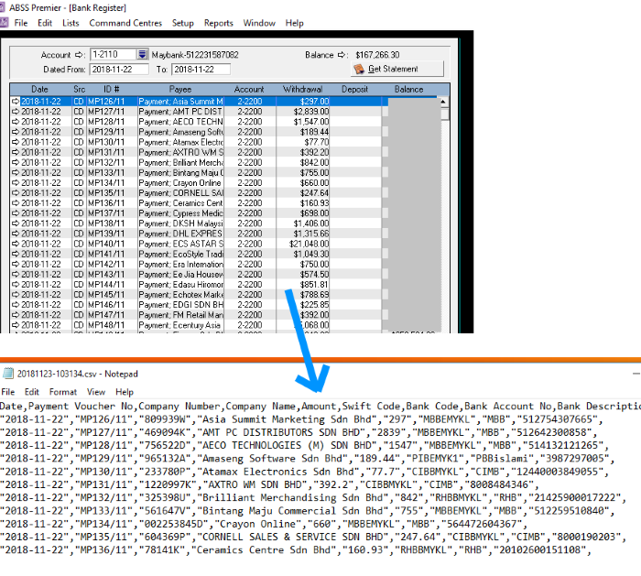

**Installation**

1. Install Abss software on user’s PC
2. Ensure .net framework 4.5 is present on user’s PC
3. Create System DSN entry and name it as “InterbaseSvr”, ensure the driver name is ABSSMY1611 for ABSS version 22

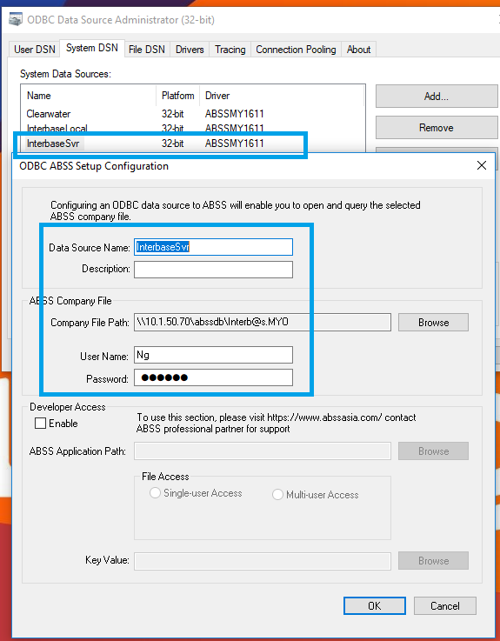

1. Create a folder in C:\AbssMBBPayExtractor (Can be any folder) and copy the program files into it.
2. The program only consists of 2 files thus far,
   1. AbssMaybankPayment.exe
   2. AbssMaybankPayment.exe.config

(open up the .config fie and ensure the value of “AbssDSN” is same as the name of DSN entry)

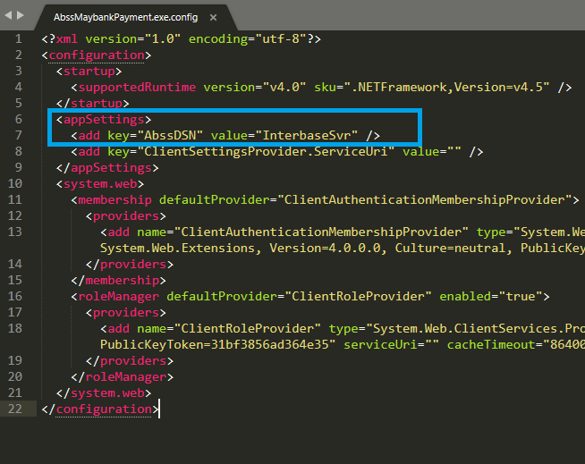

1. Create a shortcut to AbssMaybankPayment.exe in Desktop for ease of access

**Run the application**

1. Double click AbssMaybankPayment.exe
2. Enter username and password
3. Enter Bank Account Code
4. Enter Date of Bank Transfer

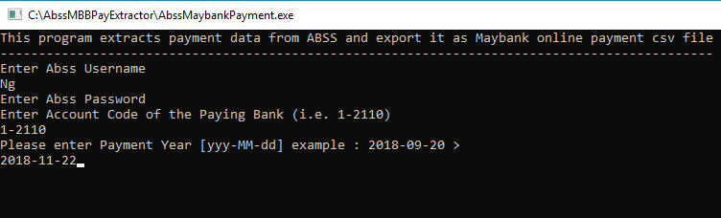

1. Press Enter and the program takes about a minute to complete the extraction cycle.
2. Once the program is done extracting, it shows number of records being exported.
3. The exported files are located in the output folder of the C:\AbssMBBPayExtractor

