UNIVERSITY OF TRANSPORT HO CHI MINH CITY



Project Requirement Specification and Design Document
Course Registration System

Instructor: Trần Thị Mỹ Tiên

HCMC, 2026 8th
GROUP 3
ID | FULL NAME | TASK COMPLETION RATE
075206002543 | Trần Bảo Anh | 100%
070206001860 | Nguyễn Thanh Tuấn | 100%
079307031553 | Vũ Hoàng Uyên Thy | 100%

TABLE OF CONTENT

- Function Requirement 12
- Login (User Authentication) 12
- Manage Account 12
- Manage Users 12
- Manage Major 12
- Manage Curriculum 12
- Manage Course 12
- Manage Semester 13
- Manage Registration Period 13
- Manage Registration Demand 13
- Assign Lecturer 13
- Manage Teaching Course 13
- Manage Student Grades 13
- View Courses 14
- Course Registration 14
- View Registration Status 14
- Drop Course 14
- View Grades 14
- Non-Functional Requirements 15
- Product Requirements 15
- 1 Usability Requirements 15
- 2 Efficiency Requirements 15
- 3 Dependability Requirements 15
- 4 Security Requirements 16
- Organizational Requirements 17
- 1 Operational Requirements 17
- 2 Development Requirements 17
- Data Flow Diagram 17
- Level 0 17
- Level 1 18
- Level 2 18
- Use case Diagram 19
- Overview Diagram 19
- 1 List of Actor 20
- 2 List of Use-cases 21
2. Use Case: Login 25
2.1 Summary 25
2.2 Flow of Events 25
2.2.1 Main Flow 25
2.2.2 Alternative Flows 25
2.3 Special Requirements 25
2.4 Preconditions 25
2.5 Postconditions 25
2.6 Extension Points 26
3. Use Case: Manage Account 26
3.1 Summary 26
3.2 Flow of Events 26
3.2.1 Main Flow 26
3.2.2 Alternative Flows 26
3.3 Special Requirements 26
3.4 Preconditions 26
3.5 Postconditions 26
3.6 Extension Points 27
ADMIN USE CASES 27
4. Use Case: Manage User 27
4.1 Summary 27
4.2 Flow of Events 27
4.2.1 Main Flow 27
4.2.2 Alternative Flows 27
4.3 Special Requirements 27
4.4 Preconditions 27
4.5 Postconditions 28
4.6 Extension Points 28
5. Use Case: Manage Major 28
5.1 Summary 28
5.2 Flow of Events 28
5.2.1 Main Flow 28
5.2.2 Alternative Flows 28
5.3 Special Requirements 28
5.4 Preconditions 28
5.5 Postconditions 28
5.6 Extension Points 28
6. Use Case: Manage Curriculum 29
6.1 Summary 29
6.2 Flow of Events 29
6.2.1 Main Flow 29
6.2.2 Alternative Flows 29
6.3 Special Requirements 29
6.4 Preconditions 29
6.5 Postconditions 29
6.6 Extension Points 30
7. Use Case: Manage Course 30
7.1 Summary 30
7.2 Flow of Events 30
7.2.1 Main Flow 30
7.2.2 Alternative Flows 30
7.3 Special Requirements 30
7.4 Preconditions 31
7.5 Postconditions 31
7.6 Extension Points 31
1. Use Case: Course Registration 31
1.1 Summary 31
1.2 Flow of Events 31
1.2.1 Main Flow 31
1.2.2 Alternative Flows 31
1.3 Special Requirements 32
1.4 Preconditions 32
1.5 Postconditions 32
1.6 Extension Points 32
2. Use Case: Create Course 32
2.1 Summary 32
2.2 Flow of Events 32
2.2.1 Main Flow 32
2.2.2 Alternative Flows 33
2.3 Special Requirements 33
2.4 Preconditions 33
2.5 Postconditions 33
2.6 Extension Points 33
8. Use Case: Manage Semester 33
8.1 Summary 33
8.2 Flow of Events 33
8.2.1 Main Flow 33
8.2.2 Alternative Flows 33
8.3 Special Requirements 34
8.4 Preconditions 34
8.5 Postconditions 34
8.6 Extension Points 34
9. Use Case: Manage Registration Period 34
9.1 Summary 34
9.2 Flow of Events 34
9.2.1 Main Flow 34
9.2.2 Alternative Flows 35
9.3 Special Requirements 35
9.4 Preconditions 35
9.5 Postconditions 35
9.6 Extension Points 35
10. Use Case: Manage Registration Demand 35
10.1 Summary 35
10.2 Flow of Events 35
10.2.1 Main Flow 35
10.2.2 Alternative Flows 36
10.3 Special Requirements 36
10.4 Preconditions 36
10.5 Postconditions 36
10.6 Extension Points 36
11. Use Case: Assign Lecturer 36
11.1 Summary 36
11.2 Flow of Events 36
11.2.1 Main Flow 36
11.2.2 Alternative Flows 37
11.3 Special Requirements 37
11.4 Preconditions 37
11.5 Postconditions 37
11.6 Extension Points 37
Lecturer Use Cases 37
12. Use Case: Manage Teaching Course 37
12.1 Summary 37
12.2 Flow of Events 37
12.2.1 Main Flow 37
12.2.2 Alternative Flows 38
12.3 Special Requirements 38
12.4 Preconditions 38
12.5 Postconditions 38
12.6 Extension Points 38
13. Use Case: Manage Student Grades 38
13.1 Summary 38
13.2 Flow of Events 38
13.2.1 Main Flow 38
13.2.2 Alternative Flows 39
13.3 Special Requirements 39
13.4 Preconditions 39
13.5 Postconditions 39
13.6 Extension Points 39
Student Use Cases 40
14. Use Case: View Courses 40
14.1 Summary 40
14.2 Flow of Events 40
14.2.1 Main Flow 40
14.2.2 Alternative Flows 40
14.3 Special Requirements 40
14.4 Preconditions 40
14.5 Postconditions 40
14.6 Extension Points 40
15. Use Case: Course Registration 40
15.1 Summary 40
15.2 Flow of Events 41
15.2.1 Main Flow 41
15.2.2 Alternative Flows 41
15.3 Special Requirements 41
15.4 Preconditions 42
15.5 Postconditions 42
15.6 Extension Points 42
2. Included Use Case: Check Prerequisite 42
2.1 Summary 42
2.2 Flow of Events 42
2.2.1 Main Flow 42
2.2.2 Alternative Flows 42
2.3 Special Requirements 42
2.4 Preconditions 42
2.5 Postconditions 43
2.6 Extension Points 43
3. Included Use Case: Check Duplicate Registration 43
3.1 Summary 43
3.2 Flow of Events 43
3.2.1 Main Flow 43
3.2.2 Alternative Flows 43
3.3 Special Requirements 43
3.4 Preconditions 43
3.5 Postconditions 43
3.6 Extension Points 43
4. Included Use Case: Check Course Capacity 43
4.1 Summary 43
4.2 Flow of Events 44
4.2.1 Main Flow 44
4.2.2 Alternative Flows 44
4.3 Special Requirements 44
4.4 Preconditions 44
4.5 Postconditions 44
4.6 Extension Points 44
16. Use Case: View Registration Status 44
16.1 Summary 44
16.2 Flow of Events 44
16.2.1 Main Flow 44
16.2.2 Alternative Flows 45
16.3 Special Requirements 45
16.4 Preconditions 45
16.5 Postconditions 45
16.6 Extension Points 45
17. Use Case: Drop Course 45
17.1 Summary 45
17.2 Flow of Events 45
17.2.1 Main Flow 45
17.2.2 Alternative Flows 45
17.3 Special Requirements 46
17.4 Preconditions 46
17.5 Postconditions 46
17.6 Extension Points 46
18. Use Case: View Grades 46
18.1 Summary 46
18.2 Flow of Events 46
18.2.1 Main Flow 46
18.2.2 Alternative Flows 46
18.3 Special Requirements 46
18.4 Preconditions 47
18.5 Postconditions 47
18.6 Extension Points 47
V. Class Diagram 47
VI. Data Model 48
VII. Interface Design Description 48
1. Admin 48
2. Student 54
3. Lecturer 58

COURSE REGISTRATION SYSTEM SPECIFICATION

Function Requirement

Login (User Authentication)
- The system shall allow Admin, Lecturer, and Student to log in using a valid username and password.
- The system shall verify the username, password, and account status.
- If the credentials are valid, the system shall grant access according to the user's role; otherwise, it shall display an appropriate error message.
- After 5 consecutive failed login attempts for the same account, the system shall temporarily block further login attempts for 15 minutes.

Manage Account
- The system shall allow Admin, Lecturer, and Student to view their account information, change their password, and log out.
- The system shall validate the current password before saving a new password.

Manage Users
- The system shall allow the Admin to view, search, create, edit, and deactivate Student and Lecturer accounts.
- Student ID and Lecturer ID shall be unique, and email addresses shall be valid.
- The Admin shall be able to set Lecturer teaching qualifications.
- The system shall ensure that only one Admin account exists.

Manage Major
- The system shall allow the Admin to view, create, edit, and delete Majors.
- Major Code shall be unique.
- The system shall prevent deletion of a Major that is still referenced by existing data.

Manage Curriculum
- The system shall allow the Admin to select a Major and view the Courses in its Curriculum.
- The Admin shall be able to add or remove Courses and set the Recommended Semester.
- The system shall prevent the same Course from being added to the same Curriculum more than once.

Manage Course
- The system shall allow the Admin to view, search, create, edit, and delete Courses.
- Course information shall include Course Code, Course Name, Credit, Prerequisite, and Capacity.
- The system shall validate that Course Code is unique, Credit is valid, Capacity is a positive number, and a Course cannot be its own Prerequisite.

Manage Semester
- The system shall allow the Admin to create, view, edit, and delete Semesters.
- Semester information shall include Semester Name, Start Date, End Date, and Status.
- The system shall validate that Start Date is earlier than End Date and that Semesters do not overlap.

Manage Registration Period
- The system shall allow the Admin to select a Semester and configure a Registration Period with a name, Start Date, and End Date.
- The system shall validate the dates and automatically update the Registration Status as Upcoming, Open, or Closed.
- The system shall allow the Admin to configure a Drop Period, with a Start Date and End Date, for dropping registered Courses.

Manage Registration Demand
- The system shall allow the Admin to select a Registration Period and Major to view registration demand by Course.
- The system shall display Course Code, Course Name, Number of Registered Students, and the registered Student list.
- The system shall allow the Admin to generate a Registration Demand Report.

Assign Lecturer
- The system shall allow the Admin to select a Major and Course and view Lecturers qualified to teach that Course.
- The Admin shall be able to assign a qualified Lecturer to the Course.
- The system shall reject assignments when the Lecturer is not qualified.

Manage Teaching Course
- The system shall allow the Lecturer to select a Semester and view Courses assigned by the Admin.
- The Lecturer shall not be allowed to self-select, request, or modify Course assignments.
- The Lecturer's teaching Course list shall be updated when the Admin changes an assignment.

Manage Student Grades
- The system shall allow the Lecturer to view Students registered in Courses assigned to them.
- The system shall allow the Lecturer to view a Student's Prerequisite status for the Course, without allowing the Lecturer to modify it.
- The Lecturer shall be able to enter or update a Student's Grade.
- The system shall validate the Grade and ensure that the Student is registered in the selected Course and the Course is assigned to that Lecturer.

View Courses
- The system shall allow the Student to view and search Courses belonging to their Major.
- The system shall exclude Courses the Student has already completed or is currently registered in from the displayed list.
- The system shall display Course Code, Course Name, Credit, Prerequisite, Recommended Semester, Capacity, and Available Seats.

Course Registration
- The system shall allow the Student to select a Course to register.
- The system shall validate that the Registration Period is Open, the Course belongs to the Student's Major/Curriculum, the Prerequisite is satisfied, the Student has not already completed the Course, and the Student is not already registered for the Course.
- The system shall check Course Capacity before registration. Registration shall be rejected when no seat is available.
- If all validations pass, the system shall save the registration, decrease Available Seats by one, and display a success message.

View Registration Status
- The system shall allow the Student to select a Semester and view registered Courses and Registration Period information.
- The system shall display Course Code, Course Name, Credit, Registration Status, Registration Start Date, Registration End Date, and Current Registration Status.
- Course registration status shall be shown as Registered or Dropped.

Drop Course
- The system shall allow the Student to select and drop a previously registered Course while the Drop Period is open.
- The system shall require confirmation and validate that the Course was registered by the Student.
- After a successful drop, the system shall update the Registration Status to Dropped, increase Available Seats by one, and display a success message.

View Grades
- The system shall allow the Student to select a Semester and view only their own Grades.
- The system shall display Course Code, Course Name, Credit, Grade, Semester, and Result Status.
- The system shall determine the Result Status as Passed or Not Passed and display an appropriate message when a Grade has not yet been entered.

Non-Functional Requirements

Product Requirements

1 Usability Requirements
Usability
The system shall provide a clear, consistent, and user-friendly interface for Students, Lecturers, and Administrators.
Course, prerequisite, recommended-semester, registration-status, and lecturer information shall be presented clearly.
Course registration status shall be displayed clearly, including Registered, Dropped, and Failed where applicable.
Lecturer-assignment status shall clearly indicate whether a course is Assigned or Unassigned.
Error messages and notifications shall clearly explain the reason for failed operations.

2 Efficiency Requirements
Performance
The system shall respond to common user requests such as login, course viewing, course registration, course dropping, teaching-course viewing, grade entry, grade updating, and grade viewing within 3 seconds under normal operating conditions.
The system shall remain responsive during peak course-registration periods.
Scalability
The system shall support an increasing number of students, lecturers, majors, courses, semesters, registration records, teaching assignments, and grade records.
The system architecture shall support future functional expansion without requiring a complete redesign of the core system.

3 Dependability Requirements
Availability
The system shall be available during normal academic operations and throughout active registration periods, except during scheduled maintenance.
Scheduled maintenance should be performed outside active registration periods whenever possible.
Reliability
The system shall ensure correct and reliable processing of course registration, course dropping, lecturer assignment, grade entry, and grade updates.
If a transaction fails, incomplete changes shall be rolled back so that no partial or invalid data remains.
The system shall prevent duplicate registration of the same course by the same student.
Data Integrity
The system shall maintain valid relationships among Major, Student, Course, Lecturer, Teaching Qualification, Registration, Teaching Assignment, and Grade data.
A student shall only register for courses belonging to the student's assigned major.
A registered course shall reference an existing course.
A lecturer assignment shall reference an existing lecturer and a valid course.
A teaching assignment shall reference a valid Course and Lecturer.
A Grade shall reference an existing Student and Course.
A Lecturer shall only enter or update Grades for Students registered in Courses assigned to that Lecturer.
A Student shall only view their own Grades.
Grade data shall remain associated with the correct Student, Course, Lecturer, and Semester.
Deleting or updating records shall not create orphaned or inconsistent data.
Concurrency
The system shall correctly handle simultaneous registration requests from multiple students.
The system shall prevent duplicate registration records when multiple registration requests are processed concurrently.
The system shall keep course registration data consistent after concurrent operations.
Course registration transactions shall be processed atomically to prevent partial or duplicate registration records.
The system shall correctly process concurrent registration requests without lost transactions or data inconsistency.
Backup and Recovery
The system shall support scheduled backup of important user, course, registration, teaching-assignment, and grade data.
The system shall provide a recovery mechanism for restoring valid data after a critical failure.
The system shall support restoration of normal operation after an unexpected failure.
Recovered data shall not contain duplicate, partial, or inconsistent registration records.

4 Security Requirements
Authentication
The system shall require users to authenticate using a valid username and password before accessing protected functions.
User passwords shall not be stored as plain text and shall be protected using a secure password-storage mechanism.
After 5 consecutive failed login attempts for the same account, the system shall temporarily block further login attempts for 15 minutes.
The system shall allow authenticated users to change their password after verifying the current password.
Authorization
The system shall enforce role-based access control for Student, Lecturer, and Administrator accounts.
Students shall only access student functions such as viewing courses, registering courses, dropping registered courses, viewing registration status, and viewing their own grades.
Lecturers shall only access Courses assigned to them by an Administrator.
Lecturers shall only view Students and enter or update Grades for Courses assigned to them.
Students shall only view their own Grades.
Administrators shall have authority to manage users, majors, courses, semesters, registration periods, registration information, teaching qualifications, and lecturer assignments.
Unauthorized access attempts shall be rejected by the system.

Organizational Requirements

1 Operational Requirements
Maintenance
The system shall be designed to support easy maintenance and updates.
Major functions such as user management, course management, semester management, registration, teaching assignment, and grade management should be separated into manageable modules.
Maintenance and software updates shall preserve existing user, academic, registration, teaching-assignment, and grade data.

2 Development Requirements
Design Constraints
The Course Registration System shall be implemented using Python and a relational database management system.
The system shall use PostgreSQL as the relational database management system.
The system shall use DBeaver to connect to and manage the PostgreSQL database.

Data Flow Diagram

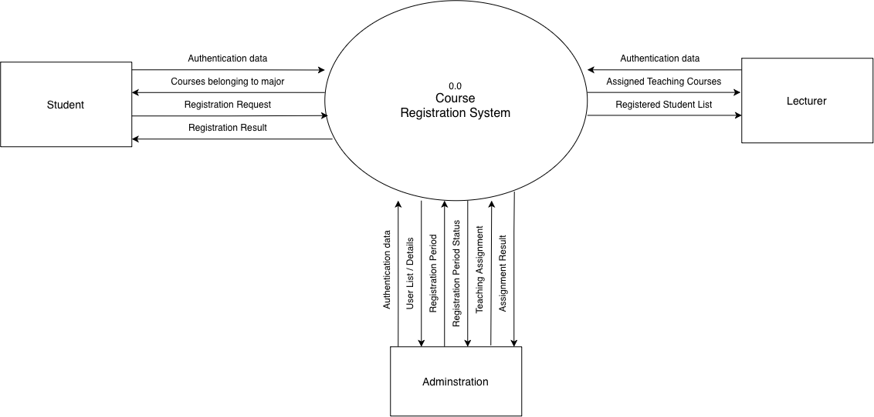
Level 0

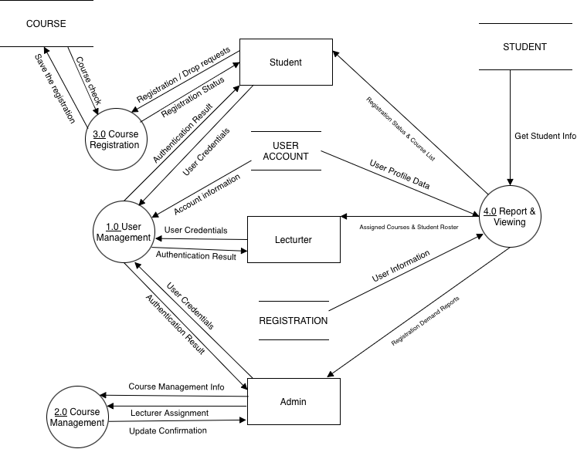
Level 1

Level 2

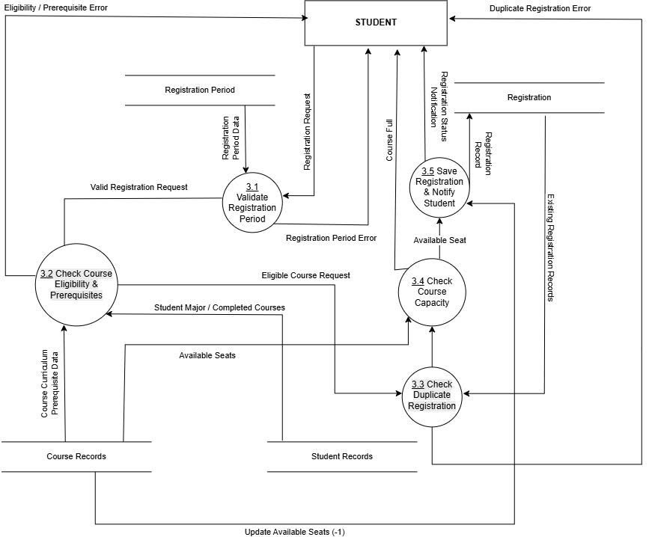
Use case Diagram

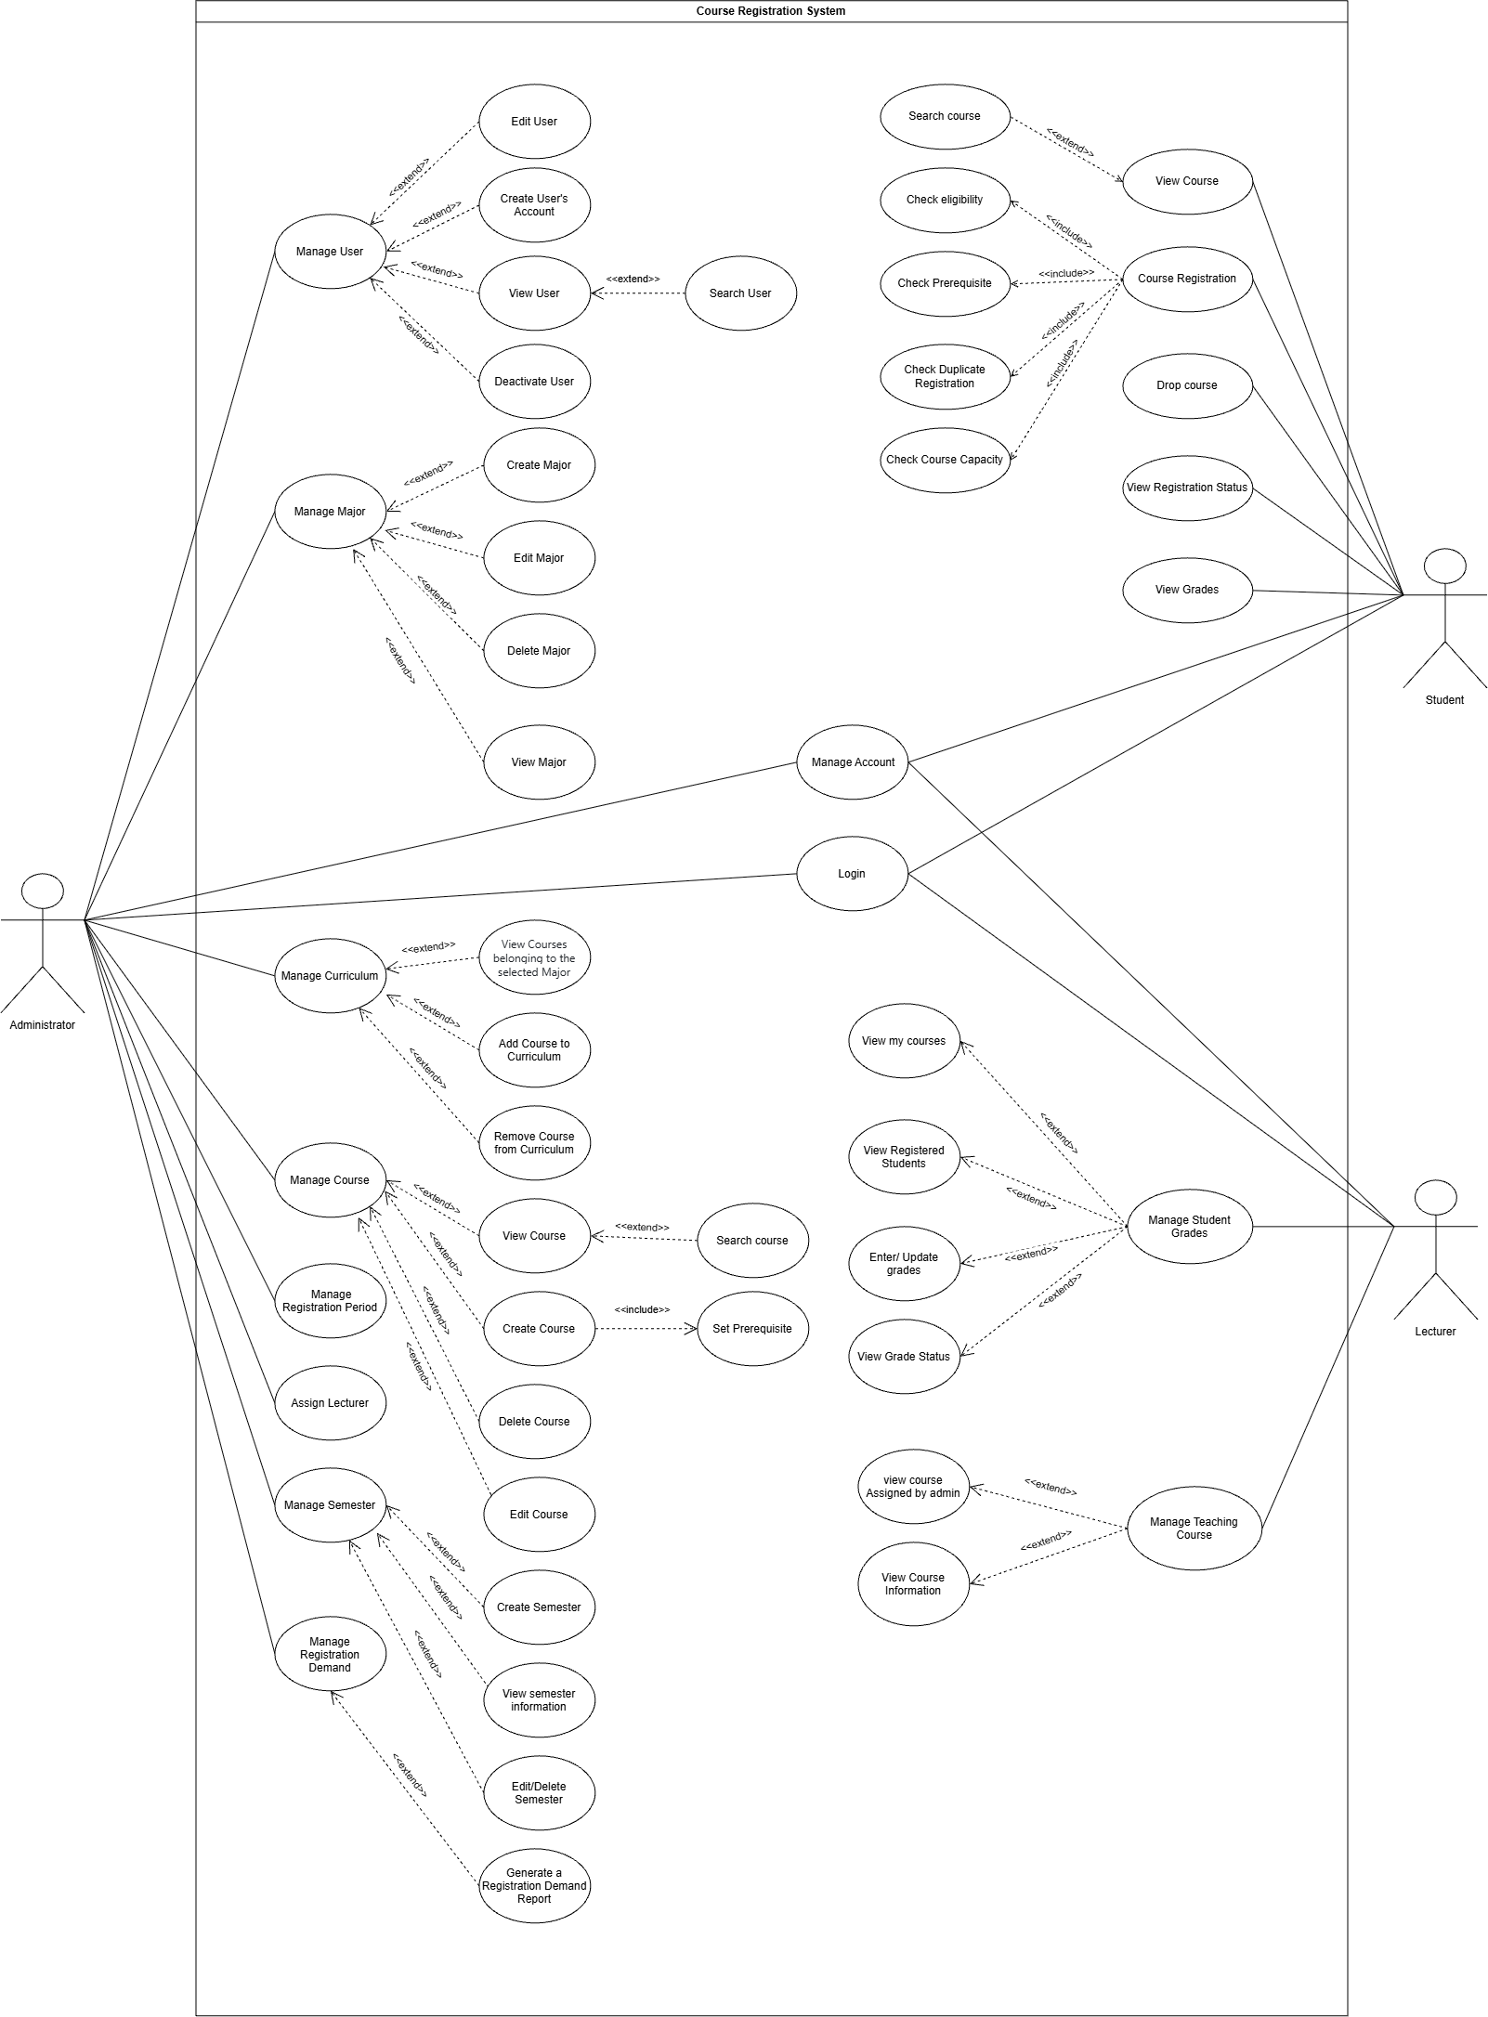
Overview Diagram

1 List of Actor
NO | ACTOR | MEANING
1 | Adminstration | System administrators who manage courses, lecturers, and registration policies.
2 | Student | Users who register, search and manage their courses in the system.
3 | Lecturer | Users who teach courses and view teaching-related information.

2 List of Use-cases
NO | USE CASE | MEANING
1 | Login | Allows the Student, Lecturer, Admin to log in to the system using valid account credentials and access functions according to their role.
2 | Manage Account | Allows the Student, Lecturer, Admin to log in, view personal account information, change password, and log out.
3 | View Course | Allows the Student to view and search for courses belonging to their major.
4 | Register Course | Allows the Student to select and register for courses during an open registration period.
5 | Check eligibility | Automatically included during registration to verify student standing and active status.
6 | Check Prerequisite | Automatically included during registration to ensure student has completed prerequisite courses.
7 | Check Duplicate Registration | Automatically included during registration to prevent duplicate course enrollment or time conflicts.
8 | Check Course Capacity | Automatically included during registration to check remaining seat availability before enrollment.
9 | Drop Course | Allows the Student to drop a successfully registered course while the drop period is open.
10 | View Registration Status | Allows the Student to view registered/dropped courses and registration period details for a semester.
11 | View Grades | Allows the Student to view their own grades and pass/fail status for each semester.
12 | Manage Teaching Course | Allows the Lecturer to view courses assigned by the Admin for a selected semester.
13 | Manage Student Grades | Allows the Lecturer to view registered students and enter or update grades for courses assigned to them.
14 | Manage User | Allows the Admin to create, view, search, edit, and deactivate Student/Lecturer accounts.
15 | Manage Major | Allows the Admin to create, view, edit, and delete majors.
16 | Manage Curriculum | Allows the Admin to add or remove courses from a selected major's curriculum.
17 | Manage Course | Allows the Admin to create, view, search, edit, Set prerequisite , Capacity and delete courses.
18 | Manage Semester | Allows the Admin to create, view, edit, and delete academic semesters.
19 | Manage Registration Period | Allows the Admin to set, open, and close the course registration period for a semester.
20 | Manage Registration Demand | Allows the Admin to view registration demand, student lists, and generate reports.
21 | Assign Lecturer | Allows the Admin to assign qualified lecturers to courses.

2. Use Case: Login

2.1 Summary
This use case allows Admin, Lecturer, and Student to log in to the Course Registration System using valid account credentials and access functions according to their role.

2.2 Flow of Events

2.2.1 Main Flow
The user selects the Login function.
The system requests the username and password.
The user enters the username and password.
The system verifies whether the username exists.
The system verifies whether the password is correct.
The system verifies whether the account is active.
If all credentials are valid, the system authenticates the user and determines access permissions based on the role.
The system grants access to the functions available for that role.

2.2.2 Alternative Flows
- A1. Invalid Username: If the username does not exist, the system displays an appropriate error message and requests reentry.
- A2. Incorrect Password: If the password is incorrect, the system displays an appropriate error message and requests reentry.
- A3. Inactive Account: If the account is not active, the system does not grant access.
- A4. Missing Credentials: If the username or password is missing, the system rejects the login request and indicates that both fields are required.

2.3 Special Requirements
The system shall respond to login requests within 3 seconds under normal operating conditions.
Passwords shall not be stored as plain text and shall use a secure password-storage mechanism.
The system shall enforce role-based access control.

2.4 Preconditions
The user has a valid account in the system.
The account is active.
The user is not currently logged in.

2.5 Postconditions
Success: The user is authenticated and granted access according to the assigned role.
Failure: Access is not granted and an appropriate error message is displayed.

2.6 Extension Points
None specified in the FR.

3. Use Case: Manage Account

3.1 Summary
This use case allows an authenticated Admin, Lecturer, or Student to view and update their profile information, change their password, and log out. The displayed information varies by role.

3.2 Flow of Events

3.2.1 Main Flow
The user selects Manage Account.
The system displays the user's account information according to their role.
The user views their account information and may update editable profile information.
The user may choose Update Profile, Change Password, or Log out.
The system processes the selected action. Account information displayed by role: Admin: username, full name, email, and role. Lecturer: lecturer ID, username, full name, email, and role. Student: student ID, username, full name, email, major, and role.

3.2.2 Alternative Flows
- A1. Incorrect Current Password: If the current password is incorrect, the system rejects the password change and displays an appropriate error message.
- A2. Invalid New Password: If the new password contains fewer than 8 characters, the system rejects the password change and displays an appropriate error message.
- A3. Missing Password Information: If the current password or new password is missing, the system rejects the request and displays an appropriate error message.
- A4. Duplicate Email: If the user updates the profile to an Email already used by another account, the system rejects the update and keeps the existing profile information.

3.3 Special Requirements
The current password must be verified before changing the password.
Passwords shall be protected using a secure password-storage mechanism.

3.4 Preconditions
The user has successfully logged in.

3.5 Postconditions
If the password is changed successfully, the new password is stored securely.
Otherwise, account information remains unchanged.

3.6 Extension Points
Change Password.

ADMIN USE CASES

4. Use Case: Manage User

4.1 Summary
This use case allows the Admin to manage Student and Lecturer accounts by viewing, searching, creating, editing, and deactivating users, and to set teaching qualifications for Lecturers.

4.2 Flow of Events

4.2.1 Main Flow
The Admin selects Manage User.
The system displays a list of Students and Lecturers.
The Admin chooses an action: View User, Search User, Create User Account, Edit User, Deactivate User, or Set Lecturer Teaching Qualifications.
The system validates and processes the selected action. For teaching qualifications, the Admin selects an existing Lecturer and an existing Course, and the system stores the Lecturer-Course qualification.

4.2.2 Alternative Flows
- A1. Duplicate User: If the entered User ID, generated Username, or Email already exists, the system rejects the creation and displays an appropriate error message.
- A2. Missing or Invalid User Information: If required user information is missing or invalid, the system does not save the information and displays an appropriate error message.
- A3. Invalid or Duplicate Teaching Qualification: If the Lecturer or Course does not exist, or the same Lecturer-Course qualification already exists, the system rejects the operation and displays an appropriate error message.
- A4. Deactivation Cancelled: If the Admin does not confirm the deactivation, the system cancels the operation and the account remains active.

4.3 Special Requirements
Student ID and Lecturer ID must be unique.
Email addresses must follow a valid format.
A Lecturer Teaching Qualification must reference an existing Lecturer and an existing Course, and the same Lecturer-Course qualification must not be duplicated.
Confirmation is required before deactivating an account. The system shall ensure that only one Admin account exists in the system.

4.4 Preconditions
The Admin has successfully logged in.

4.5 Postconditions
Success: Student or Lecturer accounts are created, updated, or deactivated according to the Admin’s action, or a valid Lecturer Teaching Qualification is stored.
Failure: No user data is changed.

4.6 Extension Points
Set Lecturer Teaching Qualifications.

5. Use Case: Manage Major

5.1 Summary
This use case allows the Admin to create, view, edit, and delete Majors.

5.2 Flow of Events

5.2.1 Main Flow
The Admin selects Manage Major.
The system displays a list of Majors, including Major Code and Major Name.
The Admin chooses Create, View, Edit, or Delete Major.
The system processes the selected action.

5.2.2 Alternative Flows
- A1. Duplicate Major Code: If the entered Major Code already exists, the system rejects the creation and displays an appropriate error message.
- A2. Invalid Major Information: If required Major information is missing or invalid, the system does not save it and displays an appropriate error message.
- A3. Major Cannot Be Deleted: If the selected Major is still referenced by existing Student or Curriculum data, the system rejects the deletion and leaves the Major unchanged.

5.3 Special Requirements
Major Code must be unique.
A Major may only be deleted if it is not referenced by any Student or Curriculum.
Confirmation is required before deletion.

5.4 Preconditions
The Admin has successfully logged in.

5.5 Postconditions
Success: The Major is created, updated, or deleted accordingly.
Failure: No Major data is changed.

5.6 Extension Points
None specified in the FR.

6. Use Case: Manage Curriculum

6.1 Summary
This use case allows the Admin to select a Major and manage the Courses belonging to that Major's Curriculum, including setting the Recommended Semester for each Course.

6.2 Flow of Events

6.2.1 Main Flow
The Admin selects Manage Curriculum.
The Admin selects a Major.
The system displays Courses belonging to the selected Major's Curriculum, including Course Code, Course Name, Credit, and Recommended Semester.
The Admin chooses Add Course to Curriculum or Remove Course from Curriculum, depending on whether the Course is already included in the selected Major's Curriculum.
The system processes the selected action.

6.2.2 Alternative Flows
- A1. Course Already in Curriculum: If the selected Course already exists in the selected Major's Curriculum, the system does not add it again and displays an appropriate message.
- A2. Course Not Found: If the selected Course does not exist in the Course Catalog, the system rejects the operation and displays an appropriate message.
- A3. Invalid Recommended Semester: If the Recommended Semester value is invalid, the system does not save the change and displays an appropriate error message.
- A4. Removal Not Confirmed: If the Admin does not confirm the removal, the system cancels the operation and the Curriculum remains unchanged.

6.3 Special Requirements
A Course cannot be added to the same Major's Curriculum more than once.
The Course must exist in the Course Catalog before it can be added to a Curriculum.
Recommended Semester must be a valid value.
Confirmation is required before removing a Course.

6.4 Preconditions
The Admin has successfully logged in.
At least one Major exists in the system.

6.5 Postconditions
Success: The Curriculum is updated with the added or removed Course.
Failure: The Curriculum remains unchanged.

6.6 Extension Points
None specified in the FR.

7. Use Case: Manage Course

7.1 Summary
This use case allows the Admin to create, view, search, edit, and delete Courses, and to set a Prerequisite and Capacity for a Course.

7.2 Flow of Events

7.2.1 Main Flow
The Admin selects Manage Course.
The system displays a list of Courses.
The Admin selects the appropriate action based on the intended task: View Course, Search Course, Create Course, Edit Course, Delete Course, Set Prerequisite, or Set Capacity.
If the Admin selects Create Course, the Admin enters the required Course information.
The system validates the entered Course information.
The Admin can set the Prerequisite and Capacity for the Course.
The system processes the selected action.
The system displays the result of the action.

7.2.2 Alternative Flows
- A1. Duplicate Course Code: If the entered Course Code already exists, the system rejects the creation and displays an appropriate error message.
- A2. Missing or Invalid Course Information: If required Course information is missing or invalid, the system rejects the input and displays an appropriate error message.
- A3. Invalid Prerequisite: If the selected Prerequisite does not exist or the Course is selected as its own Prerequisite, the system rejects the selection and displays an appropriate error message.
- A4. Invalid Course Capacity: If the entered Course Capacity is invalid, the system rejects the input and displays an appropriate error message.
- A5. Deletion Not Confirmed: If the Admin does not confirm the deletion, the system does not delete the Course, and the Course remains unchanged.

7.3 Special Requirements
Course Code must be unique.
A Course cannot be its own Prerequisite.
Credit must be a positive valid number.
Course Capacity must be a valid positive number.
Confirmation is required before deleting a Course.
Course deletion must preserve data integrity.

7.4 Preconditions
The Admin has successfully logged in.

7.5 Postconditions
Success: The Course is created, updated, deleted, viewed, or searched successfully, or its Prerequisite or Capacity is set accordingly.
Failure: No Course data is changed when the selected action cannot be completed.

7.6 Extension Points
Set Prerequisite
Set Capacity

1. Use Case: Course Registration

1.1 Summary
Allows Students to select and register for a Course during an open Registration Period. The system verifies the Student's Major/Curriculum eligibility, prerequisite completion, duplicate active Registration, completion status, and Course Capacity before saving the Registration.

1.2 Flow of Events

1.2.1 Main Flow
The Student navigates to the "Course Registration" function on the system.
The system loads the active Registration Period and displays available Courses for the Student.
The Student searches for and selects a desired Course to register.
The Student reviews the selected Course and confirms the Registration.
The system executes automated validation checks (Include): Check Eligibility; Check Prerequisite; Check Duplicate Registration; Check Course Capacity.
The system saves the Registration in the database. Available Seats is derived dynamically as max_capacity minus the number of active Registered registrations.
The system displays a "Registration Successful" notification and updates the enrolled course list on the UI.

1.2.2 Alternative Flows
- A1: Registration Period Closed or Inactive: At Step 2, if the registration period is not open or has expired, the system displays the message "Course registration is currently closed" and disables the registration controls.
- A2: Student Ineligible (Check Eligibility Fails): At Step 5, if the Student profile is invalid or the selected Course does not belong to the Student's Major/Curriculum, the system rejects the Registration and displays an appropriate error message.
- A3: Prerequisite Course Unmet (Check Prerequisite Fails): At Step 5, if the student has not passed the required prerequisite course, the system displays an error "Prerequisite course [Course Code] not completed" and cancels enrollment for that specific course.
- A4: Duplicate Registration (Check Duplicate Registration Fails): At Step 5, if the Student already has an active Registration for the same Course in the selected Registration Period, the system displays an error and rejects the Registration.
- A5: Course Full (Check Course Capacity Fails): At Step 5, if the number of active Registered registrations is greater than or equal to max_capacity, the system reports that the Course is full and rejects the Registration.

1.3 Special Requirements
Database Row-Level Locking: The system locks the selected Course row using FOR UPDATE before checking the active registration count, preventing concurrent requests from exceeding max_capacity.
Response Time: The system shall process registration requests within 3 seconds under normal operating conditions.

1.4 Preconditions
The Student is authenticated and logged into the system.
The registration period for the current semester is set to "Open".

1.5 Postconditions
A new record is inserted into the registrations database table with the status Registered.
Available Seats is not stored as a separate database field; it is derived from max_capacity minus the number of active Registered registrations.

1.6 Extension Points
View Courses: The Student can view Course details before registering.
Drop Course: The Student can drop an active Registration while the associated Registration Period is open.

2. Use Case: Create Course

2.1 Summary
Allows the Administrator to create a new Course and configure its Course Code, Course Name, Credit, optional direct Prerequisite Course, and maximum Capacity.

2.2 Flow of Events

2.2.1 Main Flow
The Admin accesses the "Manage Course" module and selects "Create Course".
The system displays the course creation form.
The Admin fills in the Course details: Course Code, Course Name, Credits, optional Prerequisite, and Capacity.
The Admin configures additional parameters (Include): Set Prerequisite and Set Capacity.
The Admin reviews the input data and clicks "Save Course".
The system validates the input data formatting and constraints.
The system saves the new course entry to the database and displays a "Course Created Successfully" notification.

2.2.2 Alternative Flows
- A1: Duplicate Course Code: At Step 6, if the entered course code already exists in the database, the system displays an error "Course code already exists in the system" and prompts for re-entry.
- A2: Missing Mandatory Fields or Invalid Capacity: At Step 6, if mandatory fields are missing or the maximum capacity is <= 0, the system displays an error "Invalid input data, please verify required fields" and retains the form inputs for correction.

2.3 Special Requirements
Course Code must be unique; Credit and Capacity must be positive; and a Course cannot be its own Prerequisite.

2.4 Preconditions
The user must be authenticated with an active Administrator role.

2.5 Postconditions
A new Course record is saved in the courses table with max_capacity. available_seats is not stored; it is calculated dynamically from active Registered registrations.

2.6 Extension Points
Search Course: The Admin can search for and locate the newly created course within the system directory.
Assign Lecturer: The Admin can assign a qualified Lecturer to the created Course after the Lecturer Teaching Qualification has been configured.

8. Use Case: Manage Semester

8.1 Summary
This use case allows the Admin to create, view, edit, and delete academic Semesters.

8.2 Flow of Events

8.2.1 Main Flow
The Admin selects Manage Semester.
The system displays a list of Semesters.
The Admin chooses Create Semester, View Semester, Edit Semester, or Delete Semester.
The system processes the selected action.

8.2.2 Alternative Flows
- A1. Invalid Semester Dates: If the Start Date is not earlier than the End Date, the system rejects the operation and displays an appropriate error message.
- A2. Semester Date Overlap: If the Semester dates overlap with an existing Semester, the system rejects the operation and displays an appropriate error message.
- A3. Semester In Use: If the selected Semester is referenced by existing Registration or academic data, the system does not allow the Semester to be deleted and displays an appropriate message.
- A4. Deletion Not Confirmed: If the Admin does not confirm the deletion, the system cancels the operation and the Semester remains unchanged.

8.3 Special Requirements
Start Date must be earlier than End Date.
Semesters must not overlap.
Confirmation is required before deletion.
A Semester referenced by Registration or academic data shall not be deleted.

8.4 Preconditions
The Admin has successfully logged in.

8.5 Postconditions
Success: The Semester is created, updated, or deleted accordingly.
Failure: No Semester data is changed.

8.6 Extension Points
None specified in the FR.

9. Use Case: Manage Registration Period

9.1 Summary
This use case allows the Admin to select a Semester and configure its Course Registration Period. The Registration Period status is determined automatically by the system from the current date and the configured Start/End dates.

9.2 Flow of Events

9.2.1 Main Flow
The Admin selects Manage Registration Period.
The Admin selects a Semester.
The Admin enters the Registration Start Date and Registration End Date.
The Admin confirms the schedule.
The system validates the Registration Start and End dates.
The system saves the Registration Period.
The system automatically determines the Registration Status (Scheduled, Open, or Closed) based on the current date.
The system displays the Registration Start Date/Time, Registration End Date/Time, and the current Registration Status.

9.2.2 Alternative Flows
- A1. Invalid Registration Period: If the Registration Start Date/Time is not earlier than the Registration End Date/Time, the system rejects the input and displays an appropriate error message..

9.3 Special Requirements
Registration Start Date/Time must be earlier than Registration End Date/Time.
The Registration Period must fall within the selected Semester.
The Registration Status shall be determined automatically from the configured Start/End dates. In the current system, these configured period dates are also used to validate whether a registered Course may be dropped.
Each Semester may have zero or more Registration Periods.
The system shall remain responsive during peak course-registration periods.

9.4 Preconditions
The Admin has successfully logged in and selected a Semester.
At least one Semester exists.

9.5 Postconditions
Success: The Registration Period is configured for the selected Semester, and its status is automatically reflected as Scheduled, Open, or Closed.
Failure: The Registration Period remains unchanged.

9.6 Extension Points
None specified in the FR.

10. Use Case: Manage Registration Demand

10.1 Summary
This use case allows the Admin to select a Semester and a Major, view registration demand per Course within that Major, view the Student registration list, search Courses, and generate a Registration Demand Report.

10.2 Flow of Events

10.2.1 Main Flow
The Admin selects Manage Registration Demand.
The Admin selects a Registration Period.
The Admin selects a Major.
The system displays the Courses belonging to the selected Major.
For each Course, the system displays the Number of Registered Students.
The Admin selects a Course.
The system displays the list of Students registered for the selected Course.

10.2.2 Alternative Flows
- A1. No Courses Found: If no Courses are found for the selected Major, the system displays an appropriate message.
- A2. No Students Registered: If no Students have registered for the selected Course during the selected Registration Period, the system displays an appropriate message.

10.3 Special Requirements
Registration Demand data must remain consistent with the current registration records.
Generated reports must accurately reflect the registration data.
Requests shall be processed within 3 seconds under normal operating conditions.

10.4 Preconditions
The Admin has successfully logged in.
At least one Semester exists.

10.5 Postconditions
Registration demand information is displayed and, when requested, a report is generated.
No Registration data is modified.

10.6 Extension Points
Generate Registration Demand Report.

11. Use Case: Assign Lecturer

11.1 Summary
This use case allows the Admin to select a Major and a Course, view Lecturers who are qualified to teach that Course, and assign a qualified Lecturer to the Course.

11.2 Flow of Events

11.2.1 Main Flow
The Admin selects Assign Lecturer.
The Admin selects a Major.
The Admin selects a Course.
The system identifies Lecturers who are qualified to teach the selected Course.
The system displays the list of qualified Lecturers.
The Admin selects a qualified Lecturer.
The system validates the Lecturer's qualification.
The system assigns the Lecturer to the Course.
The system displays a success message.

11.2.2 Alternative Flows
- A1. No Qualified Lecturers: If no Lecturer has a Teaching Qualification for the selected Course, the system displays an appropriate message and no Teaching Assignment is created.

11.3 Special Requirements
Only Lecturers with a Teaching Qualification configured by the Admin for the selected Course can be assigned.
A Teaching Assignment shall reference an existing Lecturer and a valid Course.
The system shall prevent invalid Lecturer-Course assignments.
Requests shall be processed within 3 seconds under normal operating conditions.

11.4 Preconditions
The Admin has successfully logged in.
At least one Course exists.

11.5 Postconditions
Success: The Teaching Assignment is saved and a success message is displayed.
Failure: No Teaching Assignment is created.

11.6 Extension Points
None specified in the FR.

Lecturer Use Cases

12. Use Case: Manage Teaching Course

12.1 Summary
This use case allows the Lecturer to select a Semester and view the Courses directly assigned to them by the Admin. The Lecturer cannot self-select, request, or modify their teaching assignment.

12.2 Flow of Events

12.2.1 Main Flow
The Lecturer selects Manage Teaching Course.
The Lecturer selects a Semester.
The system retrieves Courses assigned to the Lecturer by the Admin for the selected Semester.
The system displays Course Code, Course Name, Credit, and Prerequisite.
The Lecturer selects an assigned Course.
The system displays the details of the selected Course.

12.2.2 Alternative Flows
- A1. No Courses Assigned: If no Courses have been assigned to the Lecturer for the selected Semester, the system displays an appropriate message.
- A2. Assignment Changed by Admin: When the Admin creates, changes, or removes a Teaching Assignment, the system updates the Lecturer's teaching Course list accordingly.

12.3 Special Requirements
Teaching-course viewing shall respond within 3 seconds under normal operating conditions.
Lecturers shall only access Courses assigned to them by the Admin.
The Lecturer shall not independently select, register for, request, self-assign, or modify a Course assignment.

12.4 Preconditions
The Lecturer has successfully logged in.
A Semester is selected.

12.5 Postconditions
The Lecturer can view the current list of Courses assigned by the Admin.
No Teaching Assignment is modified by the Lecturer.
The displayed Course list reflects the current Teaching Assignments configured by the Admin.

12.6 Extension Points
None specified in the FR.

13. Use Case: Manage Student Grades

13.1 Summary
This use case allows the Lecturer to select a Semester and a Course assigned to them, view Students registered in that Course, view a Student's Prerequisite status, and enter or update the Student's Grade.

13.2 Flow of Events

13.2.1 Main Flow
The Lecturer selects Manage Student Grades.
The Lecturer selects a Semester.
The system checks that the Registration Period for the selected Semester has ended.
The system displays the Courses assigned to the Lecturer by the Admin for the selected Semester.
The Lecturer selects an assigned Course.
The system displays the Students registered in the selected Course, including Student ID, Student Name, and Email.
The Lecturer selects a Student to view the Student's information.
The Lecturer enters or updates the Student's Grade.
The system validates the Grade, the Student's Registration, and the Lecturer's Course assignment.
If the validation succeeds, the system saves the Grade.
The system displays a success message.

13.2.2 Alternative Flows
- A1. Invalid Grade: If the entered Grade is invalid, the system does not save the Grade and displays an appropriate error message.
- A2. Student Not Registered: If the Student is not registered in the selected Course, the system does not allow the Lecturer to enter or update the Grade and displays an appropriate message.
- A3. Course Not Assigned: If the selected Course is not assigned to the Lecturer, the system does not allow the Lecturer to manage Grades for that Course and displays an appropriate message.
- A4. Grade Save Failed: If the Grade cannot be saved, the system displays an appropriate error message and the existing Grade data remains unchanged.

13.3 Special Requirements
Grade entry and updating shall respond within 3 seconds under normal operating conditions.
A Grade shall reference an existing Student and Course.
Grade data shall remain associated with the correct Student, Course, Lecturer, and Semester.
Lecturers shall only view Students and enter or update Grades for Courses assigned to them.
The Lecturer may view the Student's Prerequisite status for the selected Course but shall not modify it. Failed transactions shall not leave partial or invalid data.

13.4 Preconditions
The Lecturer has successfully logged in.
The selected Semester exists.
The selected Course is assigned to the Lecturer.
The Student is registered in the selected Course.

13.5 Postconditions
Success: The valid Grade is stored or updated for the correct Student and Course.
Failure: Existing Grade data remains valid and no invalid Grade is stored.

13.6 Extension Points
None specified in the FR.

Student Use Cases

14. Use Case: View Courses

14.1 Summary
This use case allows the Student to view Courses belonging to their Major, search Courses by Course Code or Course Name, and view detailed Course information.

14.2 Flow of Events

14.2.1 Main Flow
The Student selects View Courses.
The system identifies the Student's Major.
The system displays Courses belonging to the Student's Major.
The Student may search for a Course using Course Code or Course Name.
The Student selects a Course.
The system displays Course Code, Course Name, Credit, Prerequisite, Recommended Semester, Capacity, and Available Seats.
The Student views the Course information.

14.2.2 Alternative Flows
- A1. Course Not Found: If no Course matches the entered Course Code or Course Name, the system displays an appropriate message.

14.3 Special Requirements
Course, prerequisite, recommended-semester, Capacity, and Available Seats information shall be presented clearly.
Course viewing requests shall be processed within 3 seconds under normal operating conditions.

14.4 Preconditions
The Student has successfully logged in.
The student's major is already in the system.

14.5 Postconditions
The requested Course information is displayed.
No Course or Student data is modified.

14.6 Extension Points
None specified in the FR.

15. Use Case: Course Registration

15.1 Summary
This use case allows the Student to select and register for an available Course belonging to the Student's Major/Curriculum. Before confirmation, the system validates the Registration Period, Student eligibility, Prerequisite requirements, duplicate registration, and Course Capacity.

15.2 Flow of Events

15.2.1 Main Flow
The Student selects a Course to register from the available Courses.
The system checks whether the Registration Period is open.
The system checks whether the Student is eligible to register for the selected Course.
The system checks whether the Student has satisfied the required Prerequisite.
The system verifies that the Student does not already have an active Registration for the same Course.
The system checks whether the Course Capacity has been reached.
If all checks pass, the system allows the Student to confirm the registration.
The Student confirms the registration.
The system saves the Registration.
The system displays a success message.

15.2.2 Alternative Flows
- A1. Registration Period Not Open: If the Registration Period is not open, the system rejects the registration and displays an appropriate error message.
- A2. Student Not Eligible: If the Student is not eligible to register for the selected Course, the system rejects the registration and displays an appropriate error message.
- A3. Prerequisite Not Satisfied: If the Student has not satisfied the required Prerequisite, the system rejects the registration and displays an appropriate error message.
- A4. Duplicate Registration: If the Student already has an active Registration for the selected Course, the system rejects the registration and displays an appropriate error message.
- A5. Course Capacity Reached: If the Course Capacity has been reached, the system rejects the registration and displays an appropriate error message.
- A6. Student Does Not Confirm: If the Student does not confirm the registration, no Registration record is created.

15.3 Special Requirements
Registration shall be processed within 3 seconds under normal operating conditions.
The system shall prevent duplicate active Registrations.
Registration transactions shall be processed atomically.
Simultaneous registration requests shall not result in lost transactions or inconsistent data.
A Student shall only register for Courses belonging to the Student's assigned Major/Curriculum.
The system shall prevent registration when the Course Capacity has been reached.

15.4 Preconditions
The Student has successfully logged in.
The Student has selected an available Course to register.

15.5 Postconditions
Success: A valid Registration record is saved, and the Course's registration information is updated accordingly. A success message is displayed.
Failure: No invalid or partial Registration record is stored, and the Course's registration information remains unchanged.

15.6 Extension Points
Check Eligibility
Check Prerequisite
Check Duplicate Registration
Check Course Capacity

2. Included Use Case: Check Prerequisite

2.1 Summary
Automatically checks the selected Course's single direct prerequisite, if configured, and verifies that the Student has previously passed that prerequisite Course.

2.2 Flow of Events

2.2.1 Main Flow
The system retrieves the prerequisite_course_code configured for the selected Course.
If a prerequisite is configured, the system queries the Student's Registration history for that prerequisite Course and its result_status.
The system verifies that the prerequisite Course has result_status = Passed.
The system confirms prerequisite compliance and returns a Pass validation status to the parent process.

2.2.2 Alternative Flows
- A1: Prerequisite Course Missing or Failed: At Step 3, if the configured prerequisite Course has not been passed, the system rejects the Registration and displays an appropriate prerequisite error.

2.3 Special Requirements
The selected Course may reference at most one direct prerequisite Course.

2.4 Preconditions
Triggered automatically as an <<include>> sub-process during Course Registration.

2.5 Postconditions
Returns a prerequisite validation result (Passed / Failed) to the caller process.

2.6 Extension Points
None.

3. Included Use Case: Check Duplicate Registration

3.1 Summary
Automatically verifies that the Student does not already have an active Registration for the same Course in the selected Registration Period.

3.2 Flow of Events

3.2.1 Main Flow
The system retrieves the Student's active Registered registrations for the selected Registration Period.
The system checks whether the selected course_code already has an active Registration for that Student and Registration Period.
No timetable, day, start-time, end-time, or Course Section conflict check is performed because these fields are not part of the current system data model.
The system confirms that no active duplicate Registration exists and returns a Pass validation status to the parent process.

3.2.2 Alternative Flows
- A1: Duplicate Course Detected: If the student is already registered for the same course, the system flags an error "Course already enrolled" and aborts registration.

3.3 Special Requirements
None.

3.4 Preconditions
Triggered automatically as an <<include>> sub-process during Course Registration.

3.5 Postconditions
Returns a duplicate-registration validation result (Passed / Failed) to the caller process.

3.6 Extension Points
None.

4. Included Use Case: Check Course Capacity

4.1 Summary
Automatically checks whether the selected Course has remaining capacity for the selected Registration Period.

4.2 Flow of Events

4.2.1 Main Flow
The system locks the selected Course row using FOR UPDATE, reads max_capacity, and counts active Registered registrations for that Course and Registration Period.
The system calculates Available Seats = max_capacity - active Registered registrations and checks whether Available Seats > 0.
The system confirms seat availability and returns a Pass validation status to the parent process.

4.2.2 Alternative Flows
- A1: Course Full: At Step 2, if the active Registered registration count is greater than or equal to max_capacity, the system reports that the Course has reached maximum capacity and rejects the Registration.

4.3 Special Requirements
Must execute within an atomic database transaction using row locks (FOR UPDATE) to prevent race conditions during high concurrent traffic.

4.4 Preconditions
Triggered automatically as an <<include>> sub-process during Course Registration.

4.5 Postconditions
Returns a capacity validation result (Passed / Failed) to the caller process.

4.6 Extension Points
None.

16. Use Case: View Registration Status

16.1 Summary
This use case allows the Student to select a Semester and view registered Courses, Course registration status, and Registration Period information.

16.2 Flow of Events

16.2.1 Main Flow
The Student selects View Registration Status.
The Student selects a Semester.
The system retrieves the Student's Course registration information.
The system displays Course Code, Course Name, Credit, and Registration Status.
The system displays Semester, Registration Start Date, Registration End Date, and Current Registration Status.
The system displays the Course registration status as Registered or Dropped.

16.2.2 Alternative Flows
- A1. No Registration Record: If the Student has no registration information for the selected Semester, the system displays an appropriate message.

16.3 Special Requirements
Registration status shall be displayed clearly, including Registered and Dropped.
Registration information must remain associated with the correct Student and Course.

16.4 Preconditions
The Student has successfully logged in.
A Semester has been selected.

16.5 Postconditions
The Student's Registration Status and Registration Period information are displayed.
No Registration data is modified.

16.6 Extension Points
None specified in the FR.

17. Use Case: Drop Course

17.1 Summary
This use case allows the Student to select and drop a previously registered Course while the associated Registration Period is still open.

17.2 Flow of Events

17.2.1 Main Flow
The Student selects Drop Course.
The system displays the Student's actively registered Courses.
The Student selects a Course to drop.
The system verifies that the associated Registration Period is still open based on its configured Start Date and End Date.
If the Registration Period is open, the system asks the Student to confirm the drop.
The Student confirms dropping the Course.
The system updates the Registration Status to Dropped.
The system displays a success message.

17.2.2 Alternative Flows
- A1. Registration Period Closed: If the associated Registration Period is no longer open, the system rejects the drop request and displays an appropriate error message.
- A2. Student Does Not Confirm: If the Student does not confirm the drop, the system cancels the operation and the Registration remains unchanged.

17.3 Special Requirements
Course dropping shall be processed within 3 seconds under normal operating conditions.
The system shall reliably process the operation and roll back incomplete changes if the transaction fails.
Registration data shall remain consistent after the Course is dropped.

17.4 Preconditions
The Student has successfully logged in.
The Student has previously registered for the selected Course.

17.5 Postconditions
Success: The Registration Status is updated to Dropped. Available Seats increases automatically because the active Registered count decreases.
Failure: The existing Registration information remains unchanged.

17.6 Extension Points
None specified in the FR.

18. Use Case: View Grades

18.1 Summary
This use case allows the Student to select a Semester and view their own Grades and Result Status for Courses.

18.2 Flow of Events

18.2.1 Main Flow
The Student selects View Grades.
The Student selects a Semester.
The system retrieves the Student's Grade information.
The system displays Course Code, Course Name, Credit, Grade, and Semester.
The system automatically uses the Grade to determine the Result Status.
The system displays the Result Status as Passed or Not Passed.
The Student views their Grade information.

18.2.2 Alternative Flows
- A1. Grade Not Yet Entered: If a Grade has not yet been entered, the system displays an appropriate message instead of presenting a completed Grade result.

18.3 Special Requirements
The Student shall only be able to view their own Grades.
Grade data shall remain associated with the correct Student, Course, Lecturer, and Semester.
Grade viewing requests shall be processed within 3 seconds under normal operating conditions.
Unauthorized access to another Student's Grades shall be rejected.

18.4 Preconditions
The Student has successfully logged in.

18.5 Postconditions
The Student's Grade and Result Status information is displayed.
No Grade data is modified.

18.6 Extension Points
None specified in the FR.

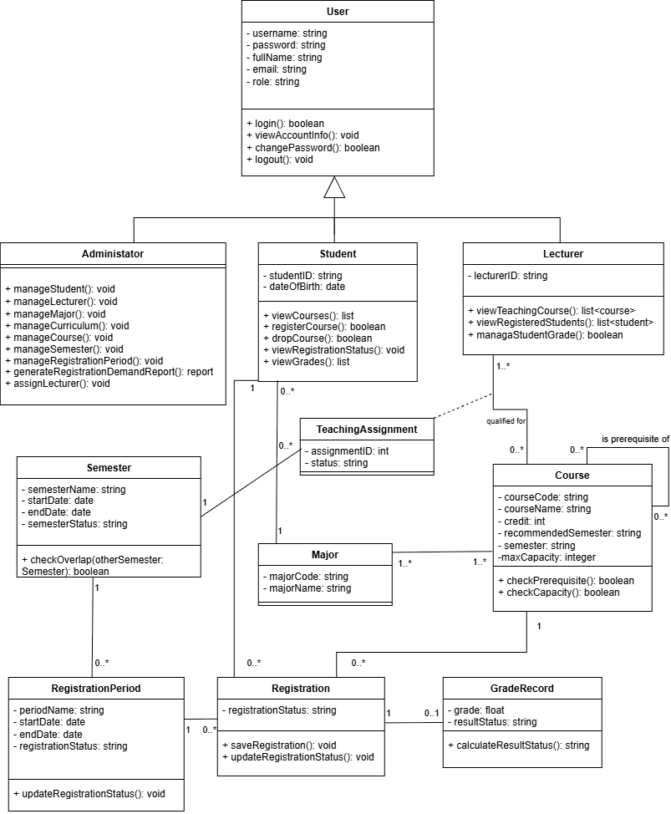
V. Class Diagram

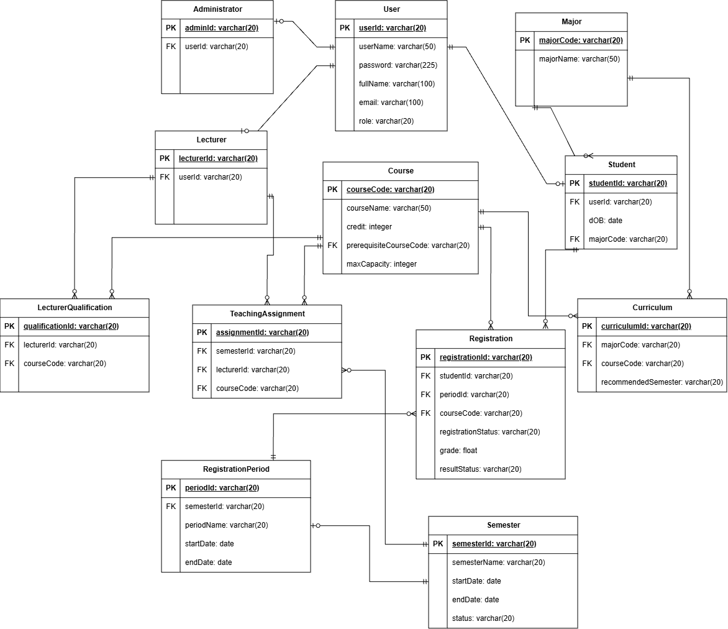
VI. Data Model

VII. Interface Design Description

1. Admin
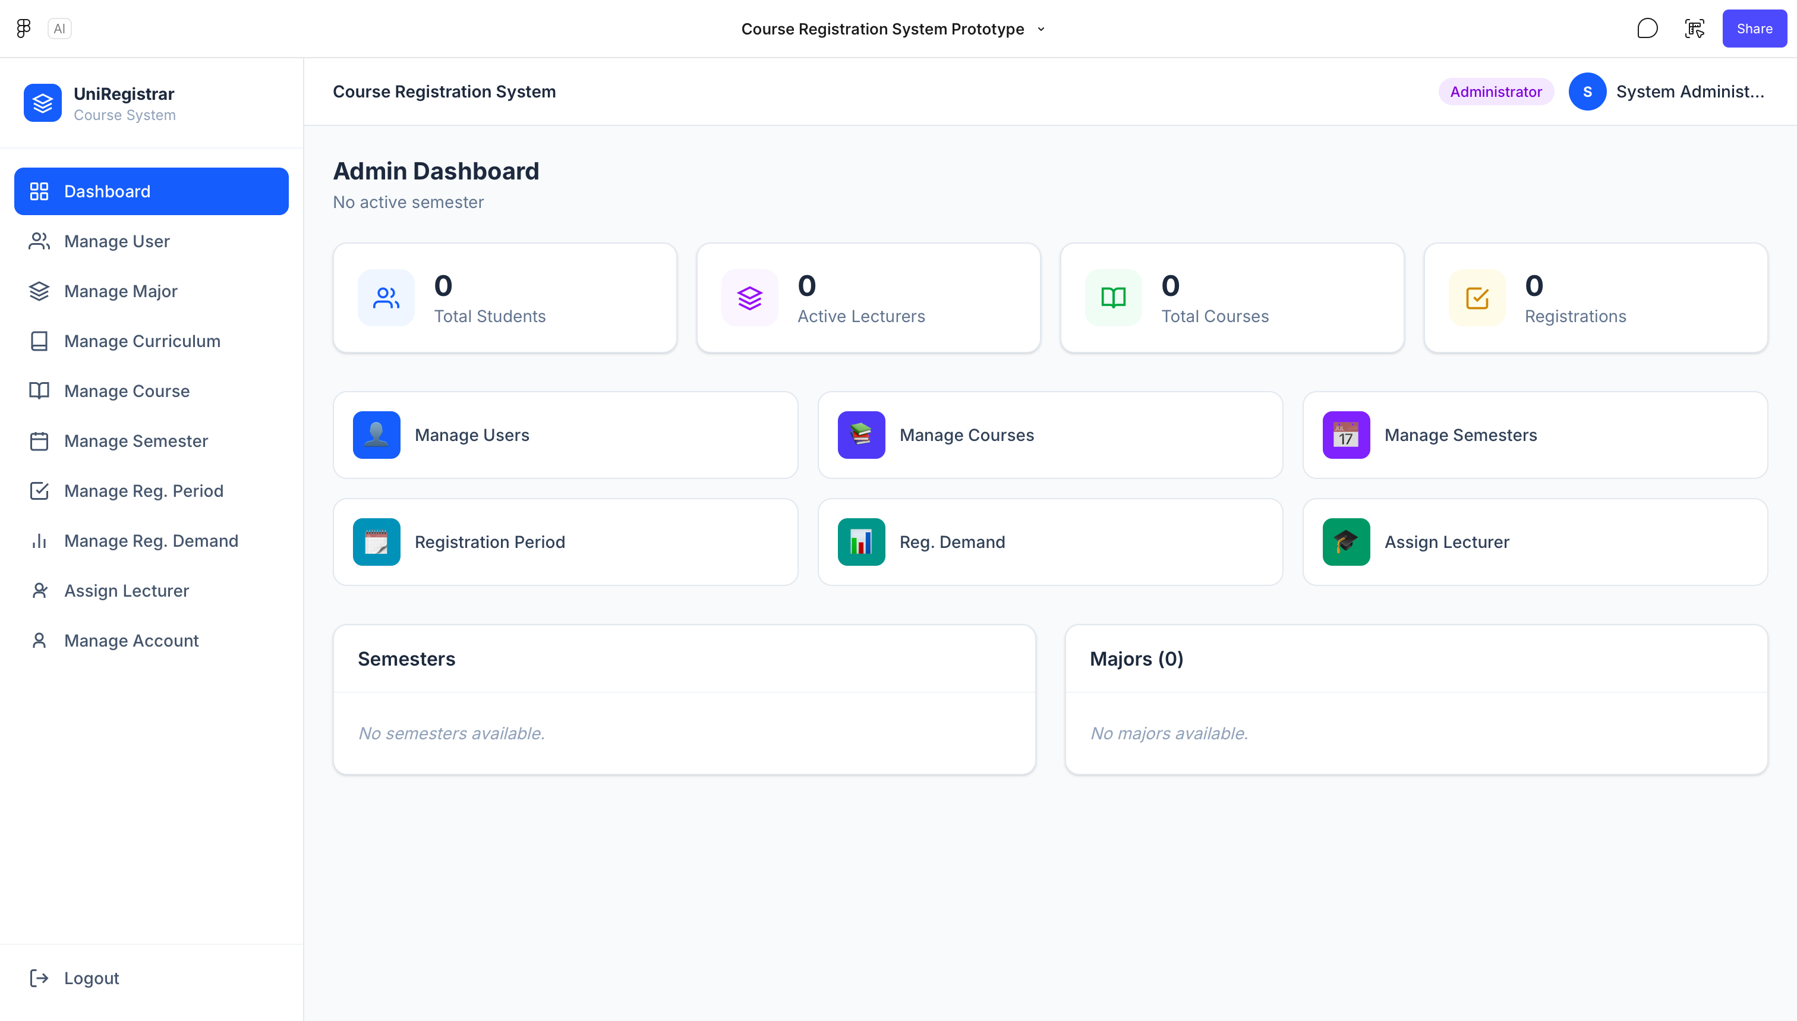
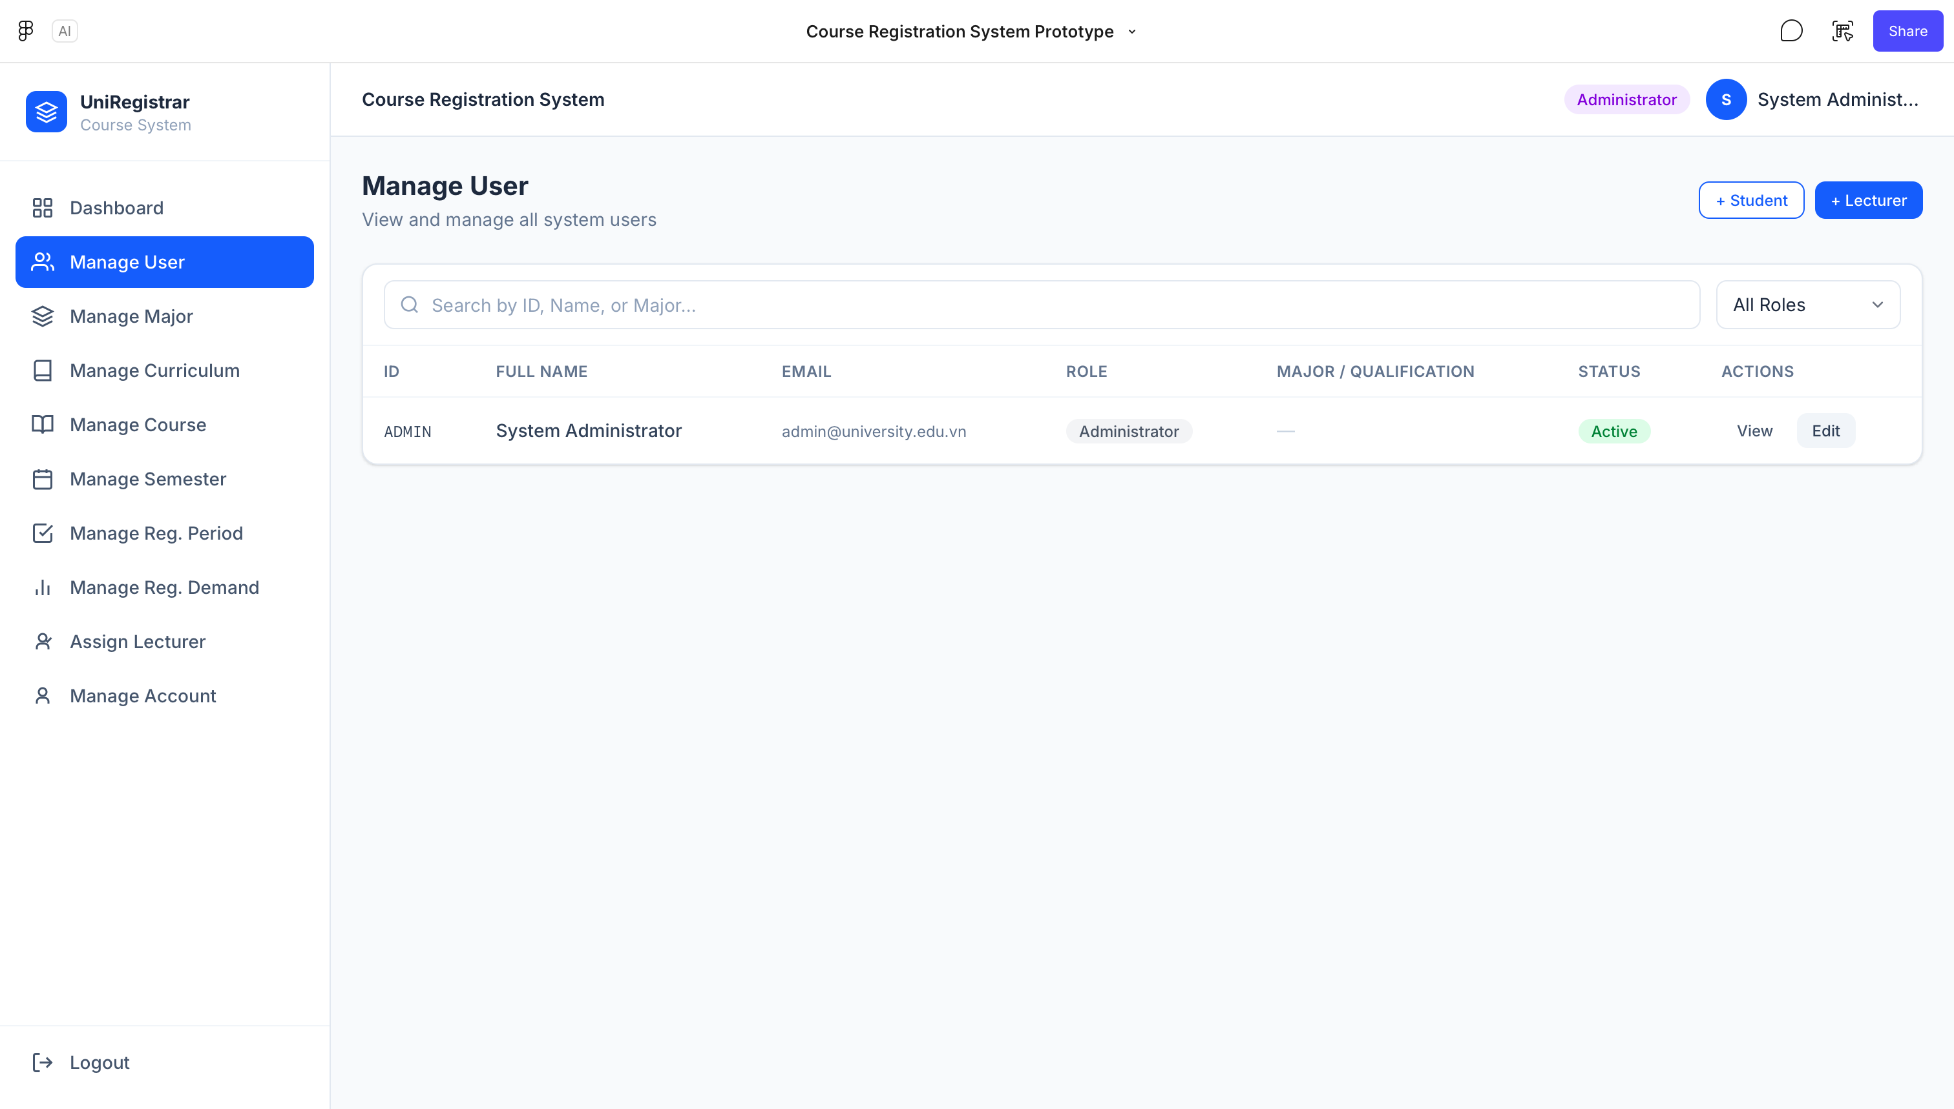
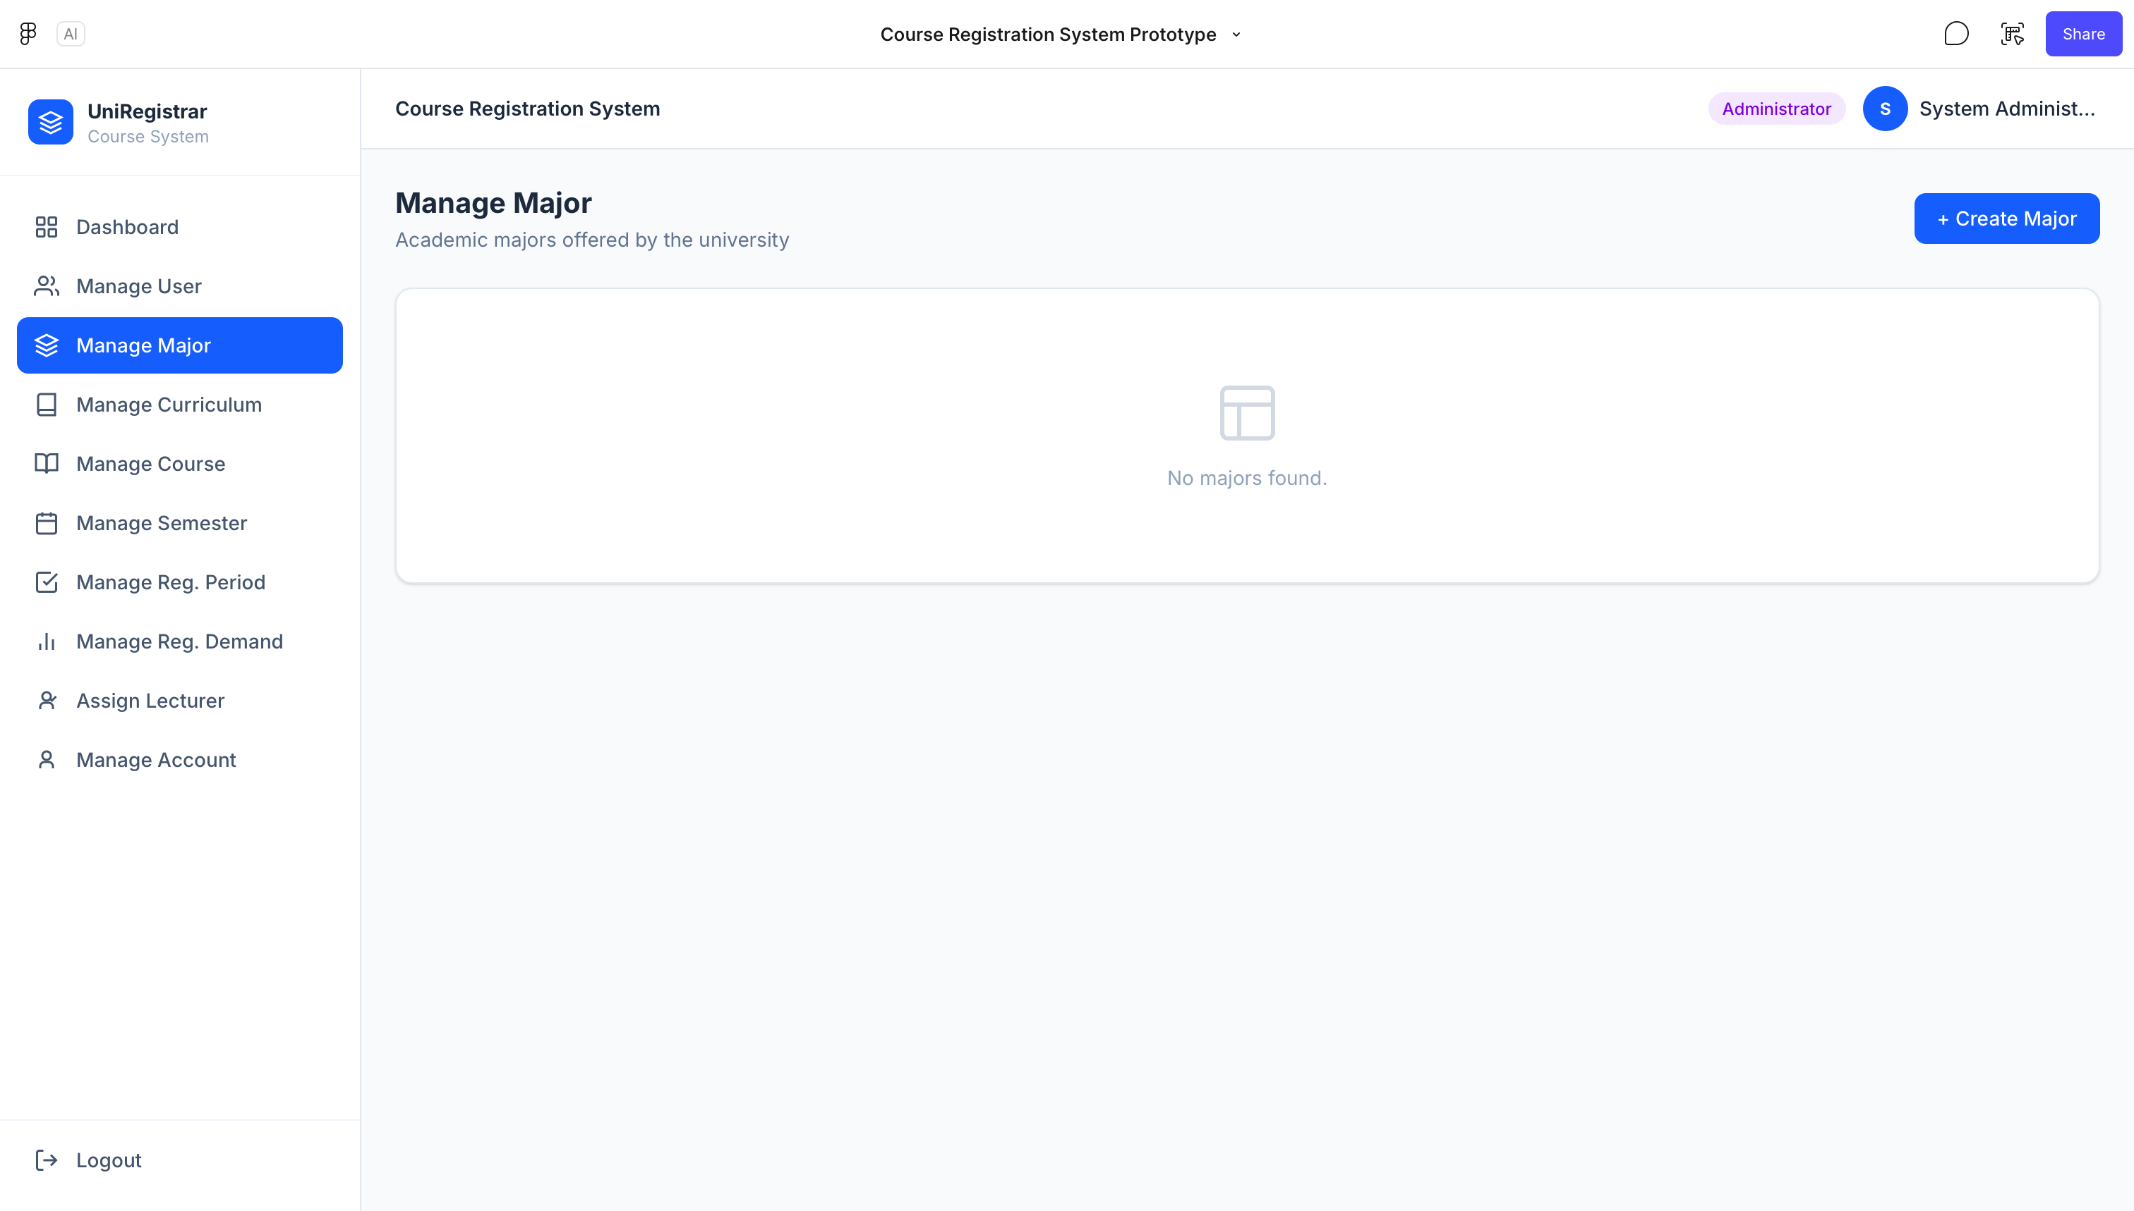
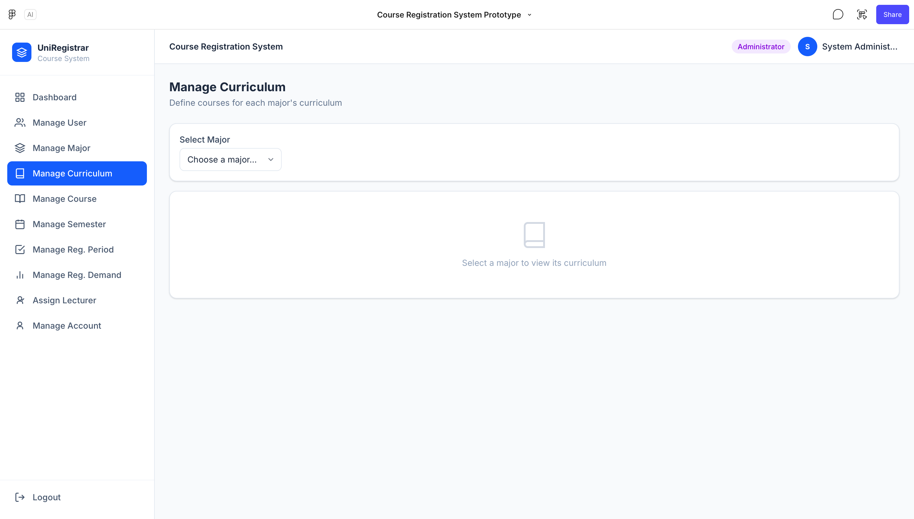
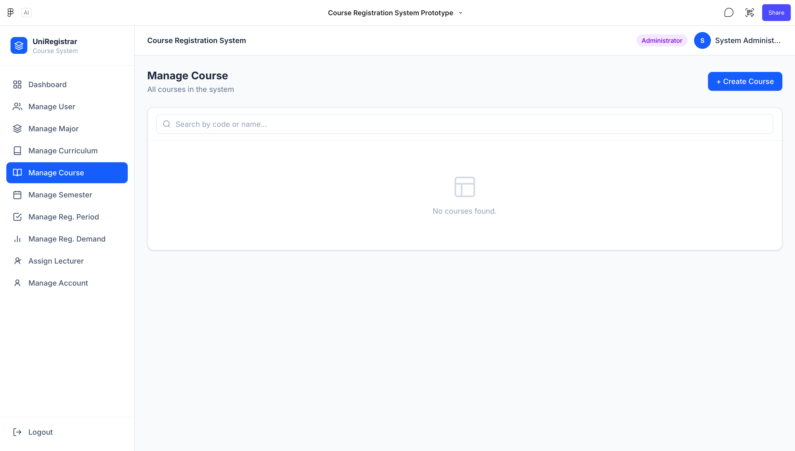
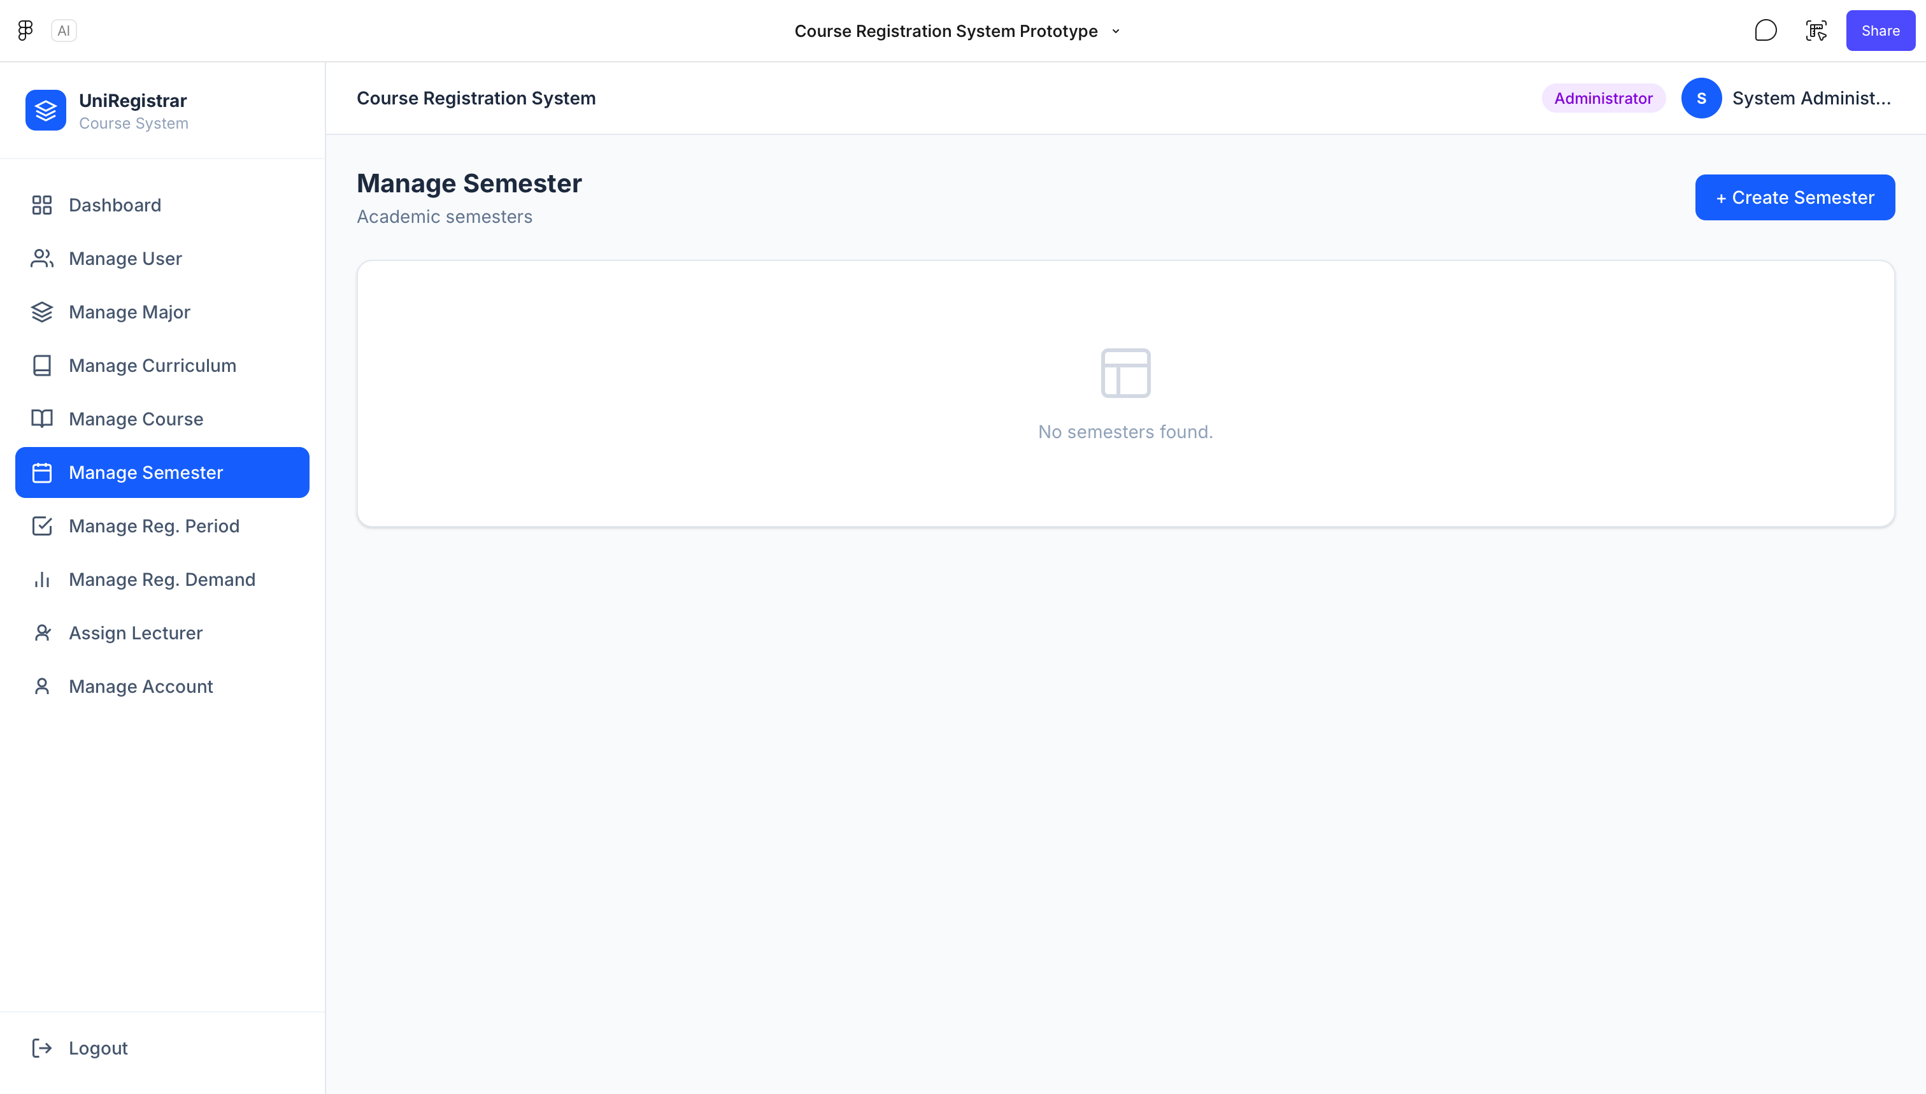
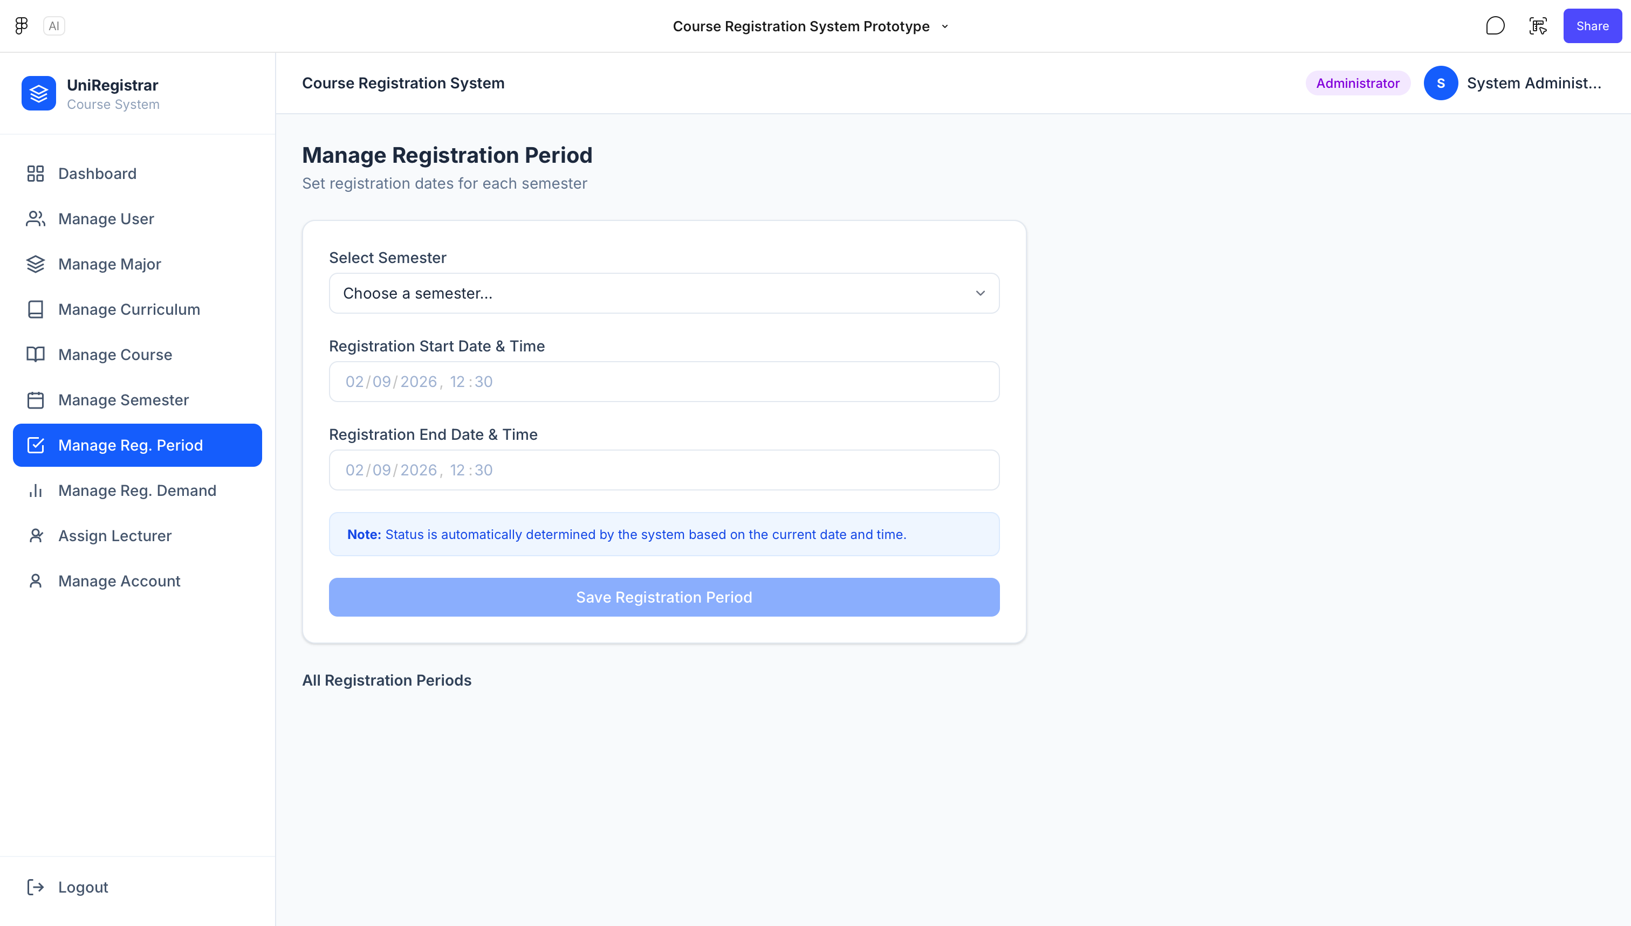
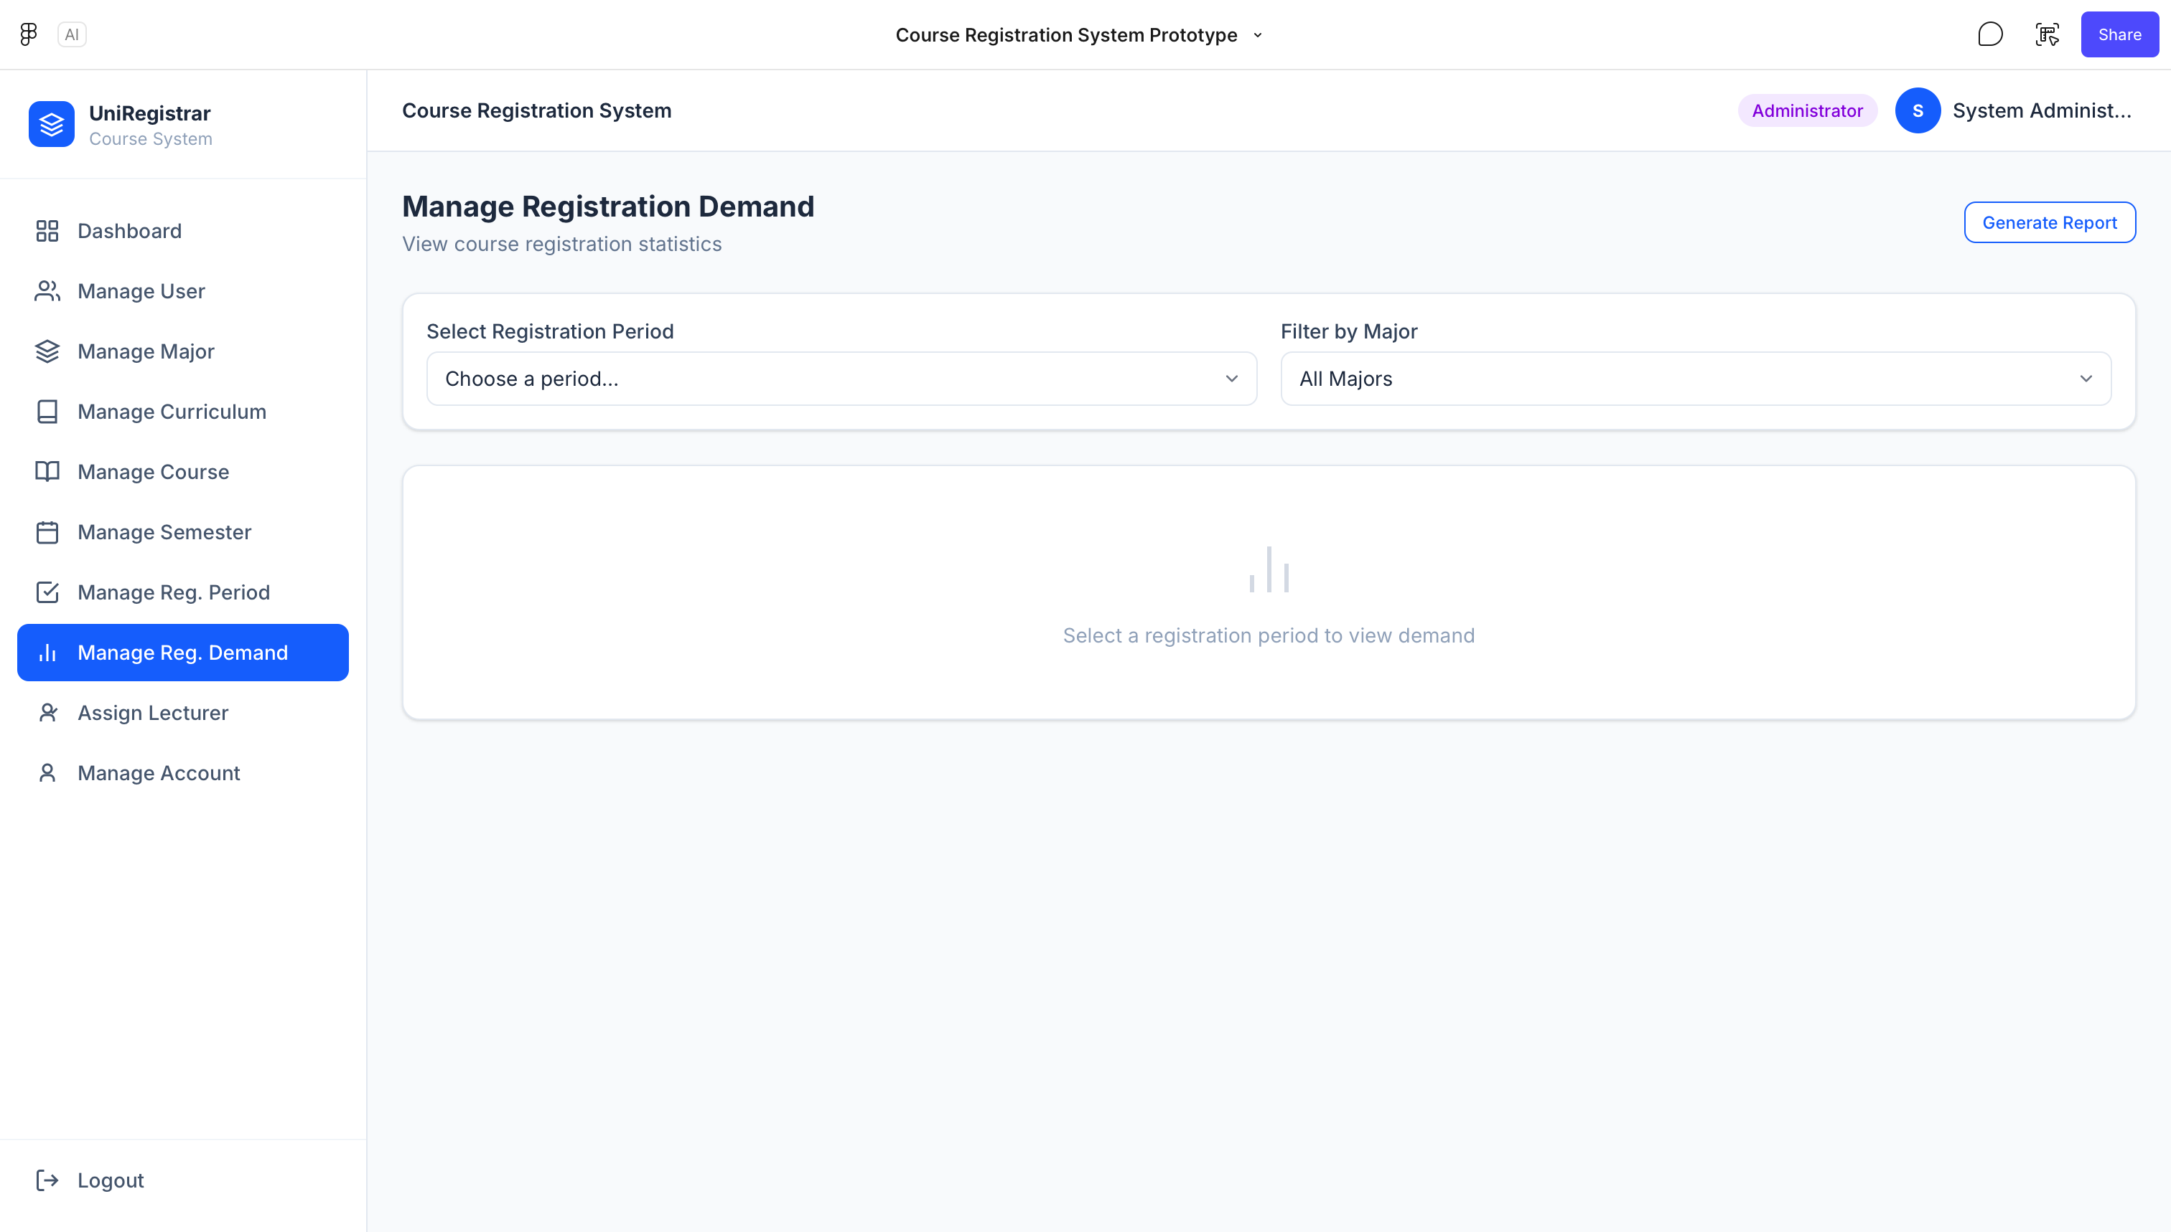
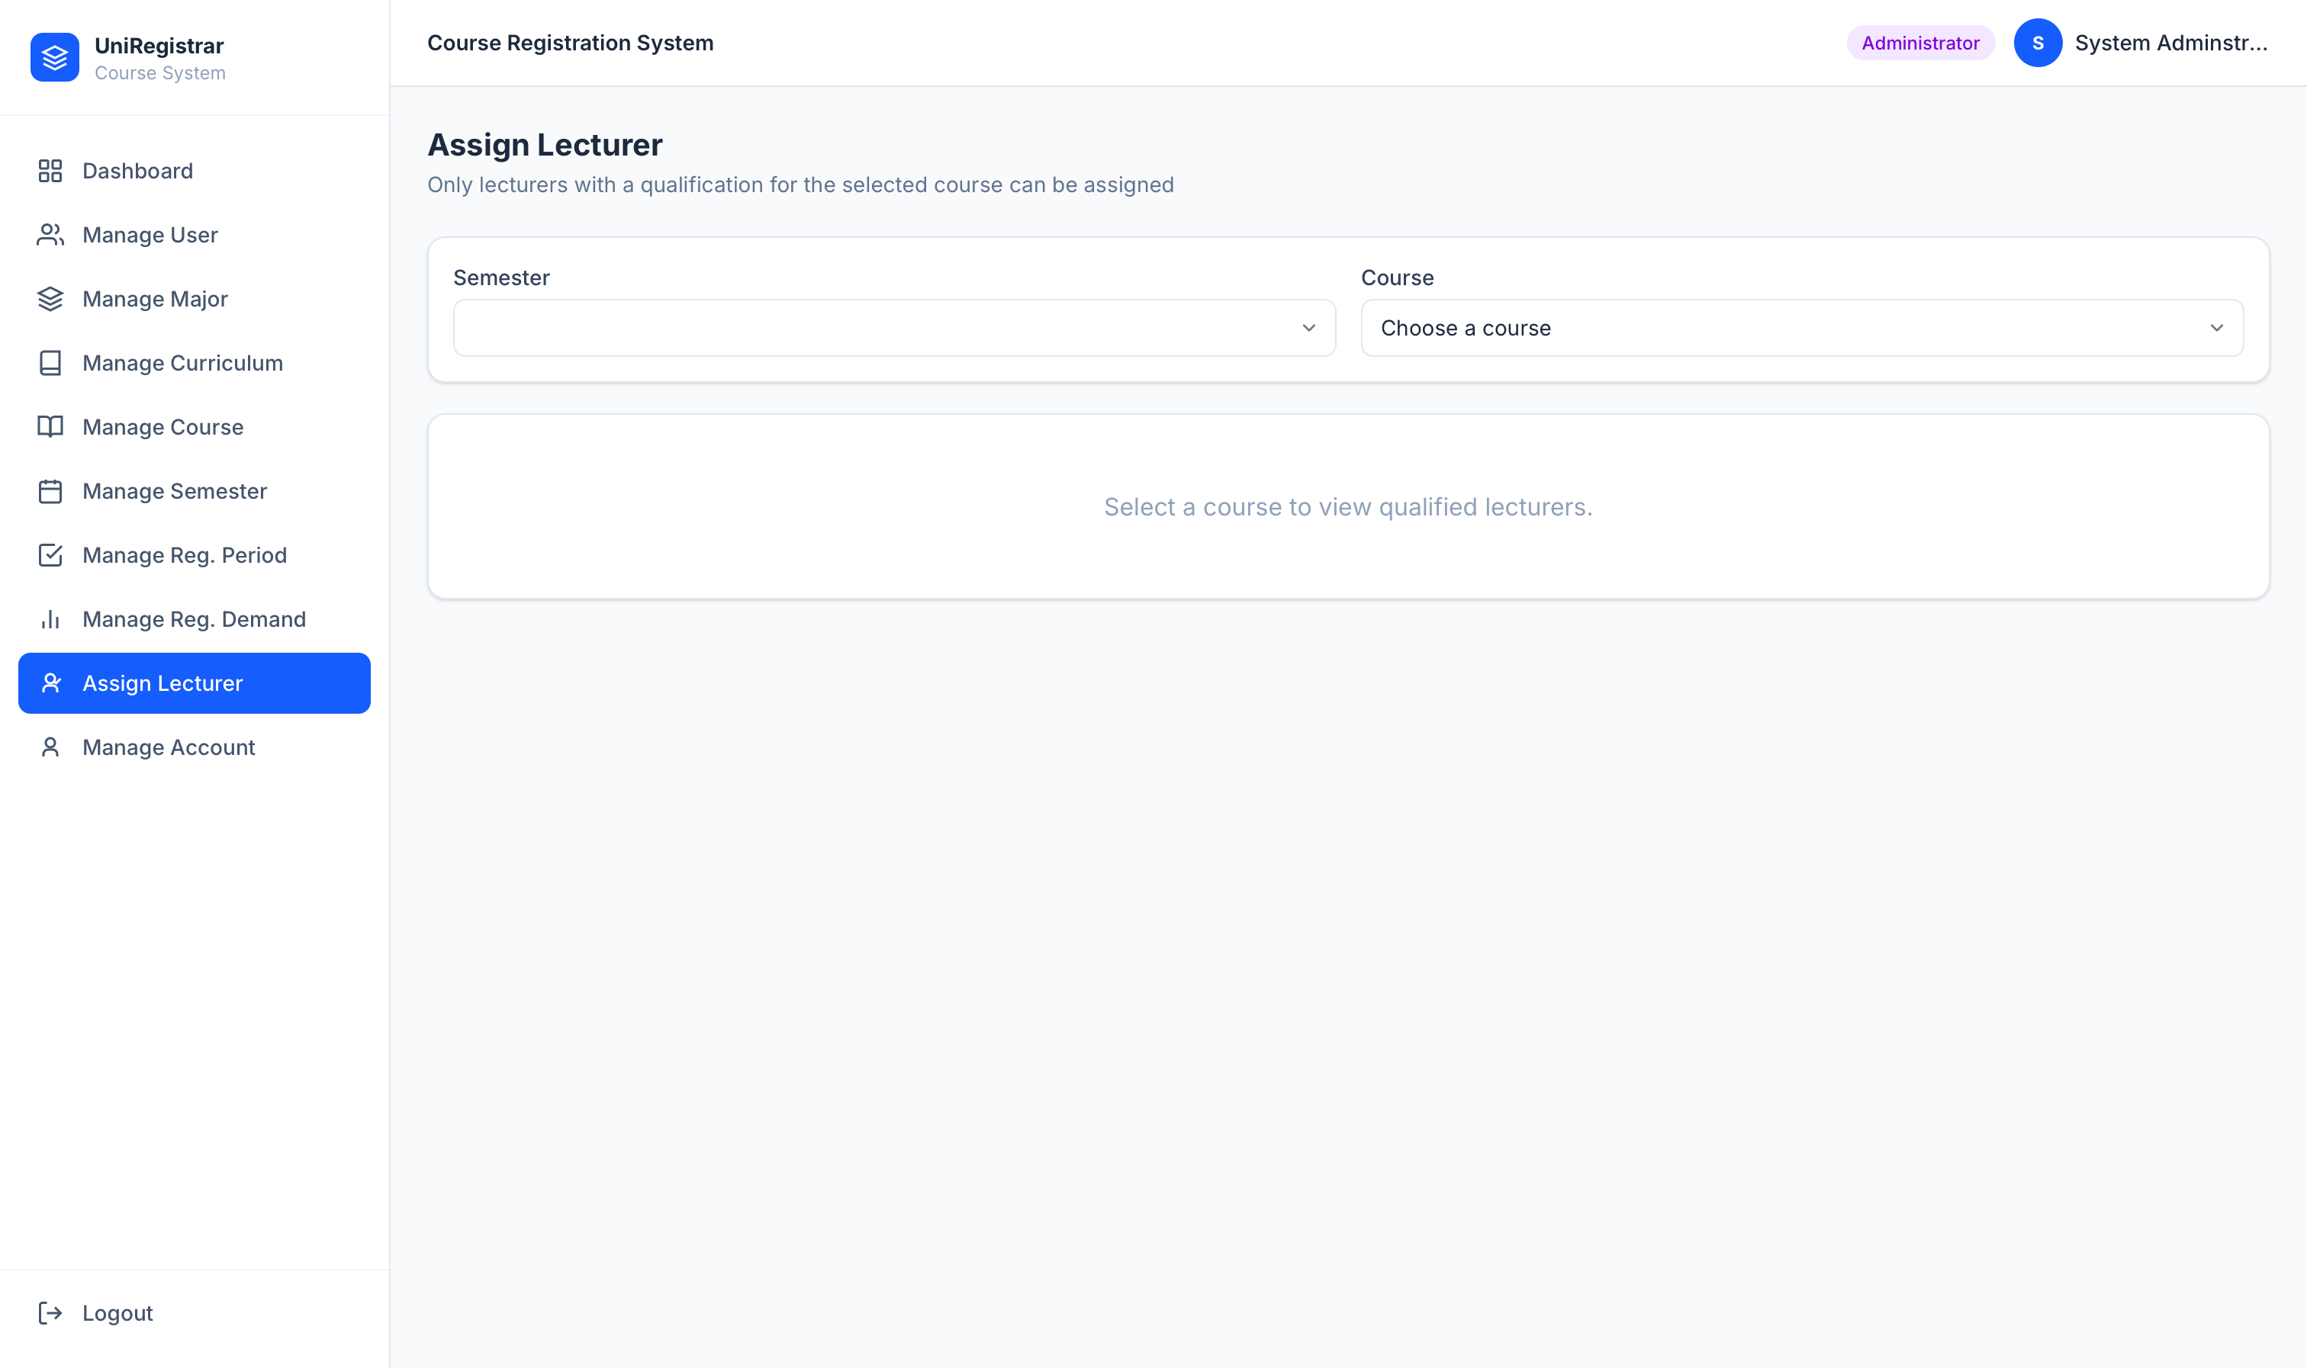
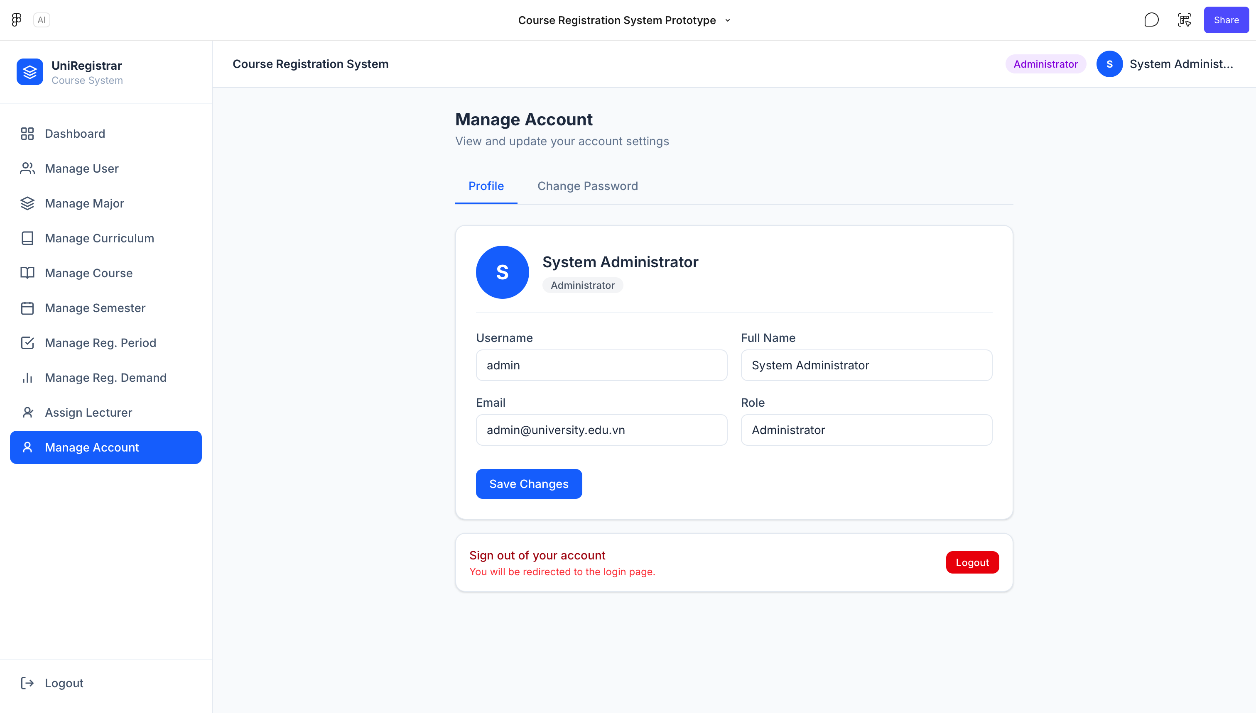
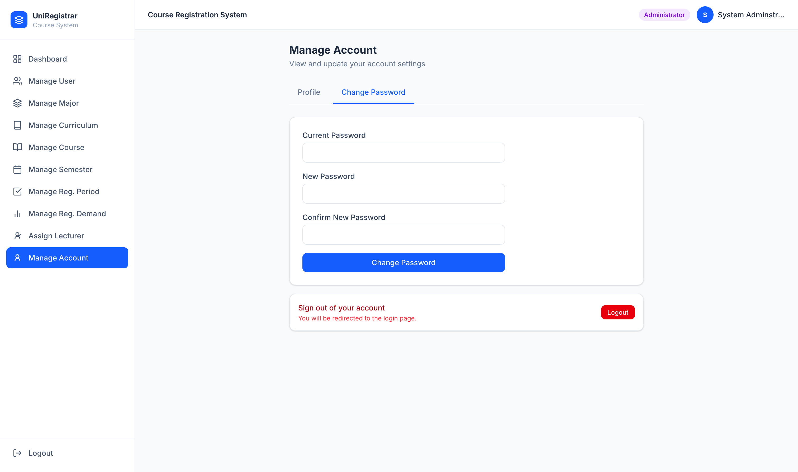

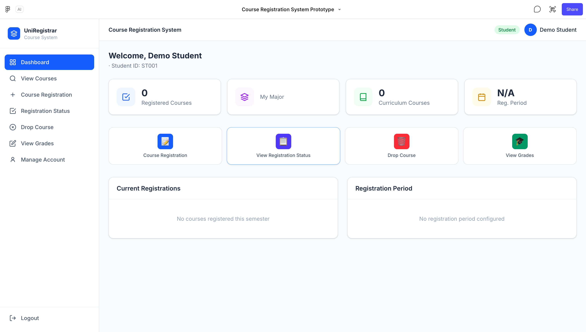
2. Student

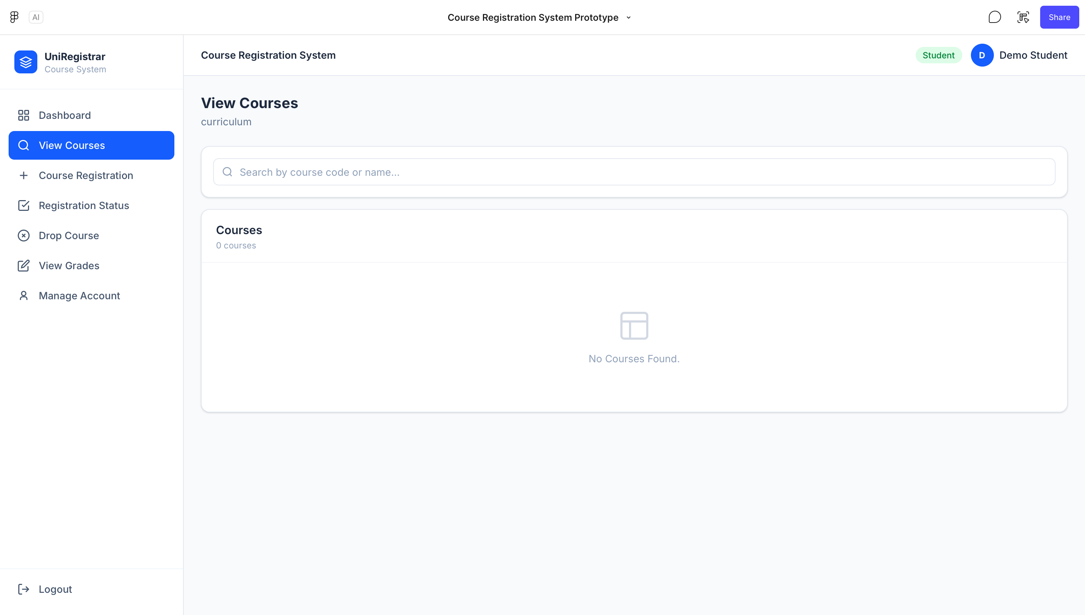
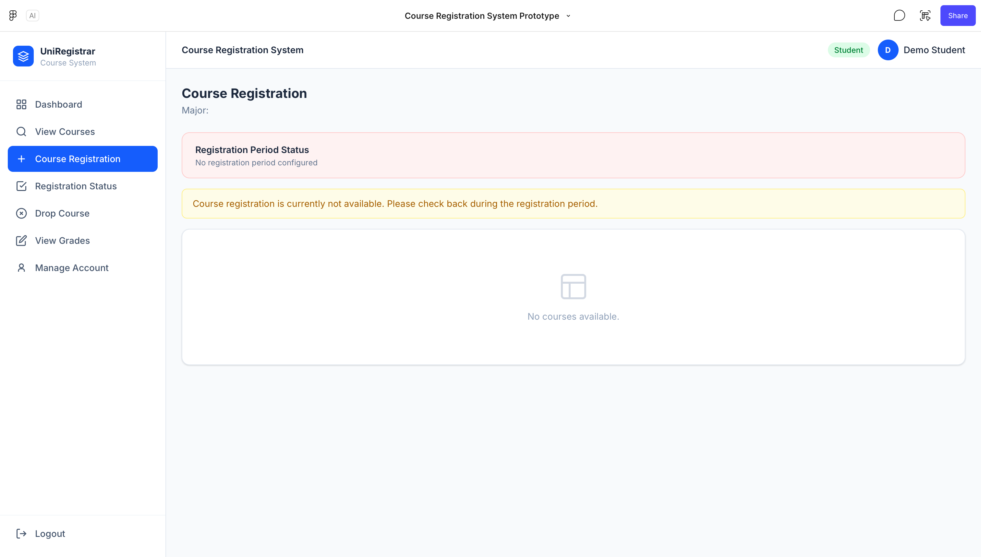
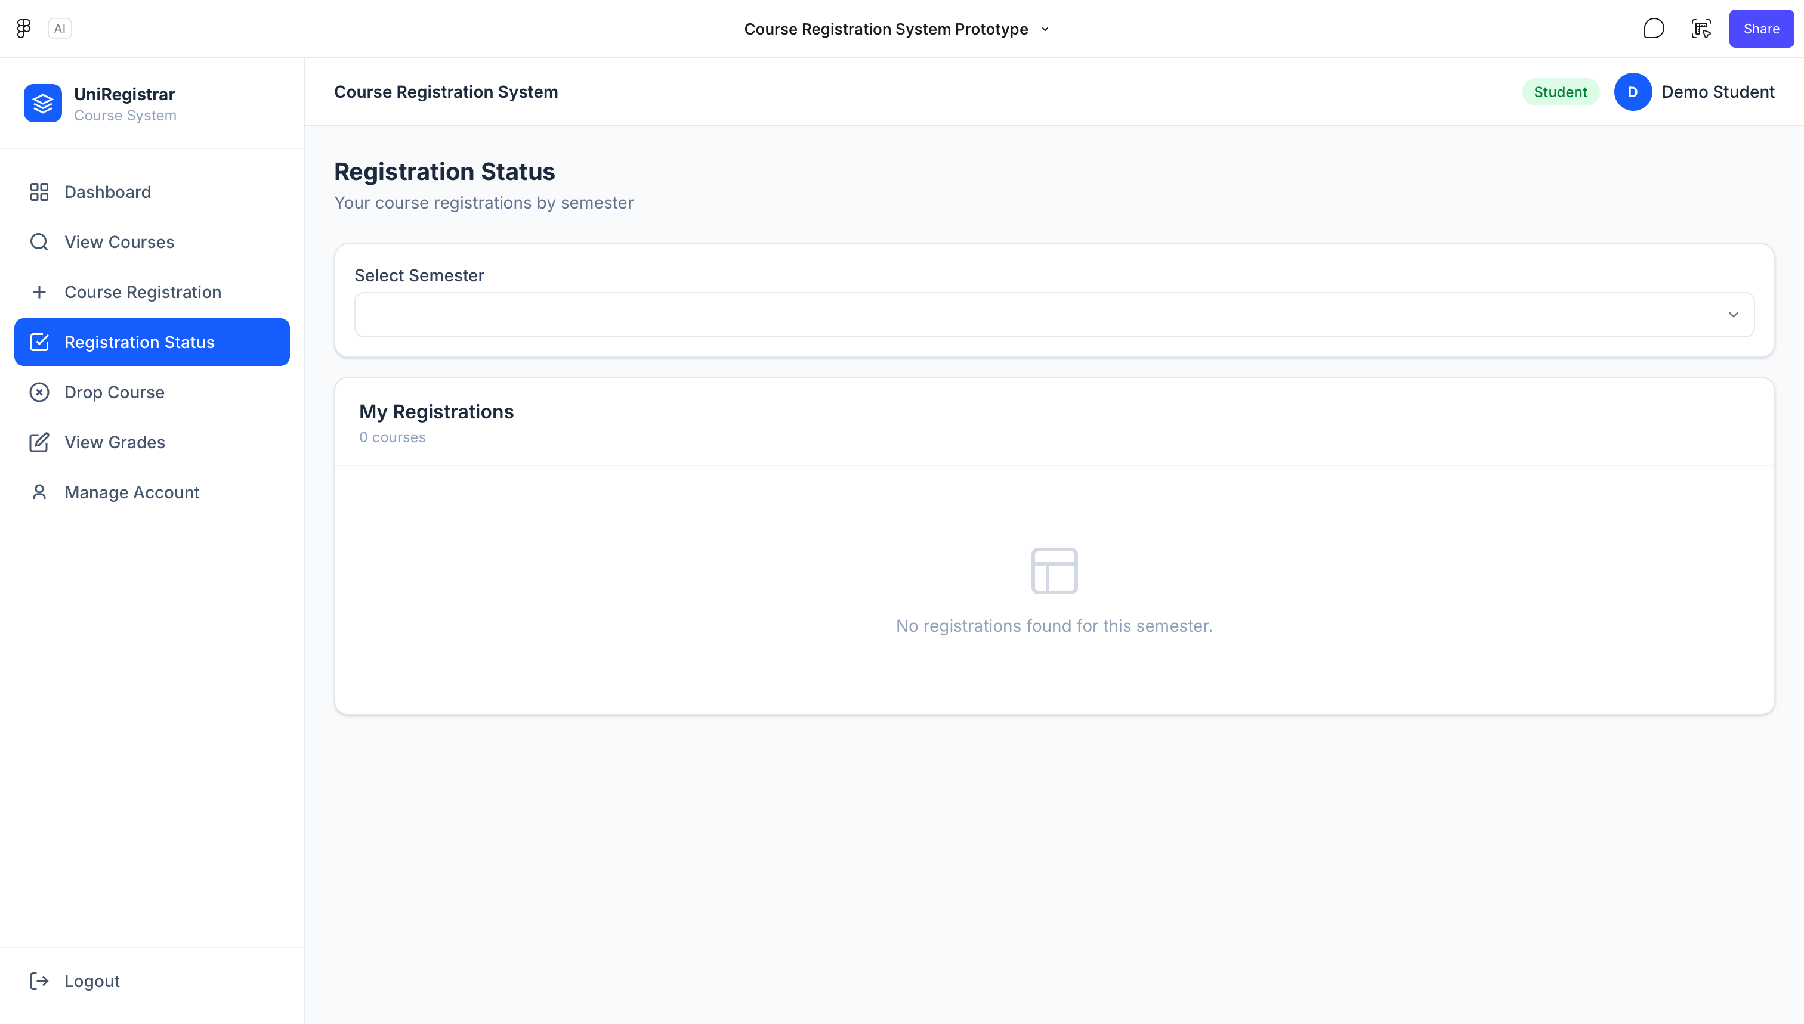
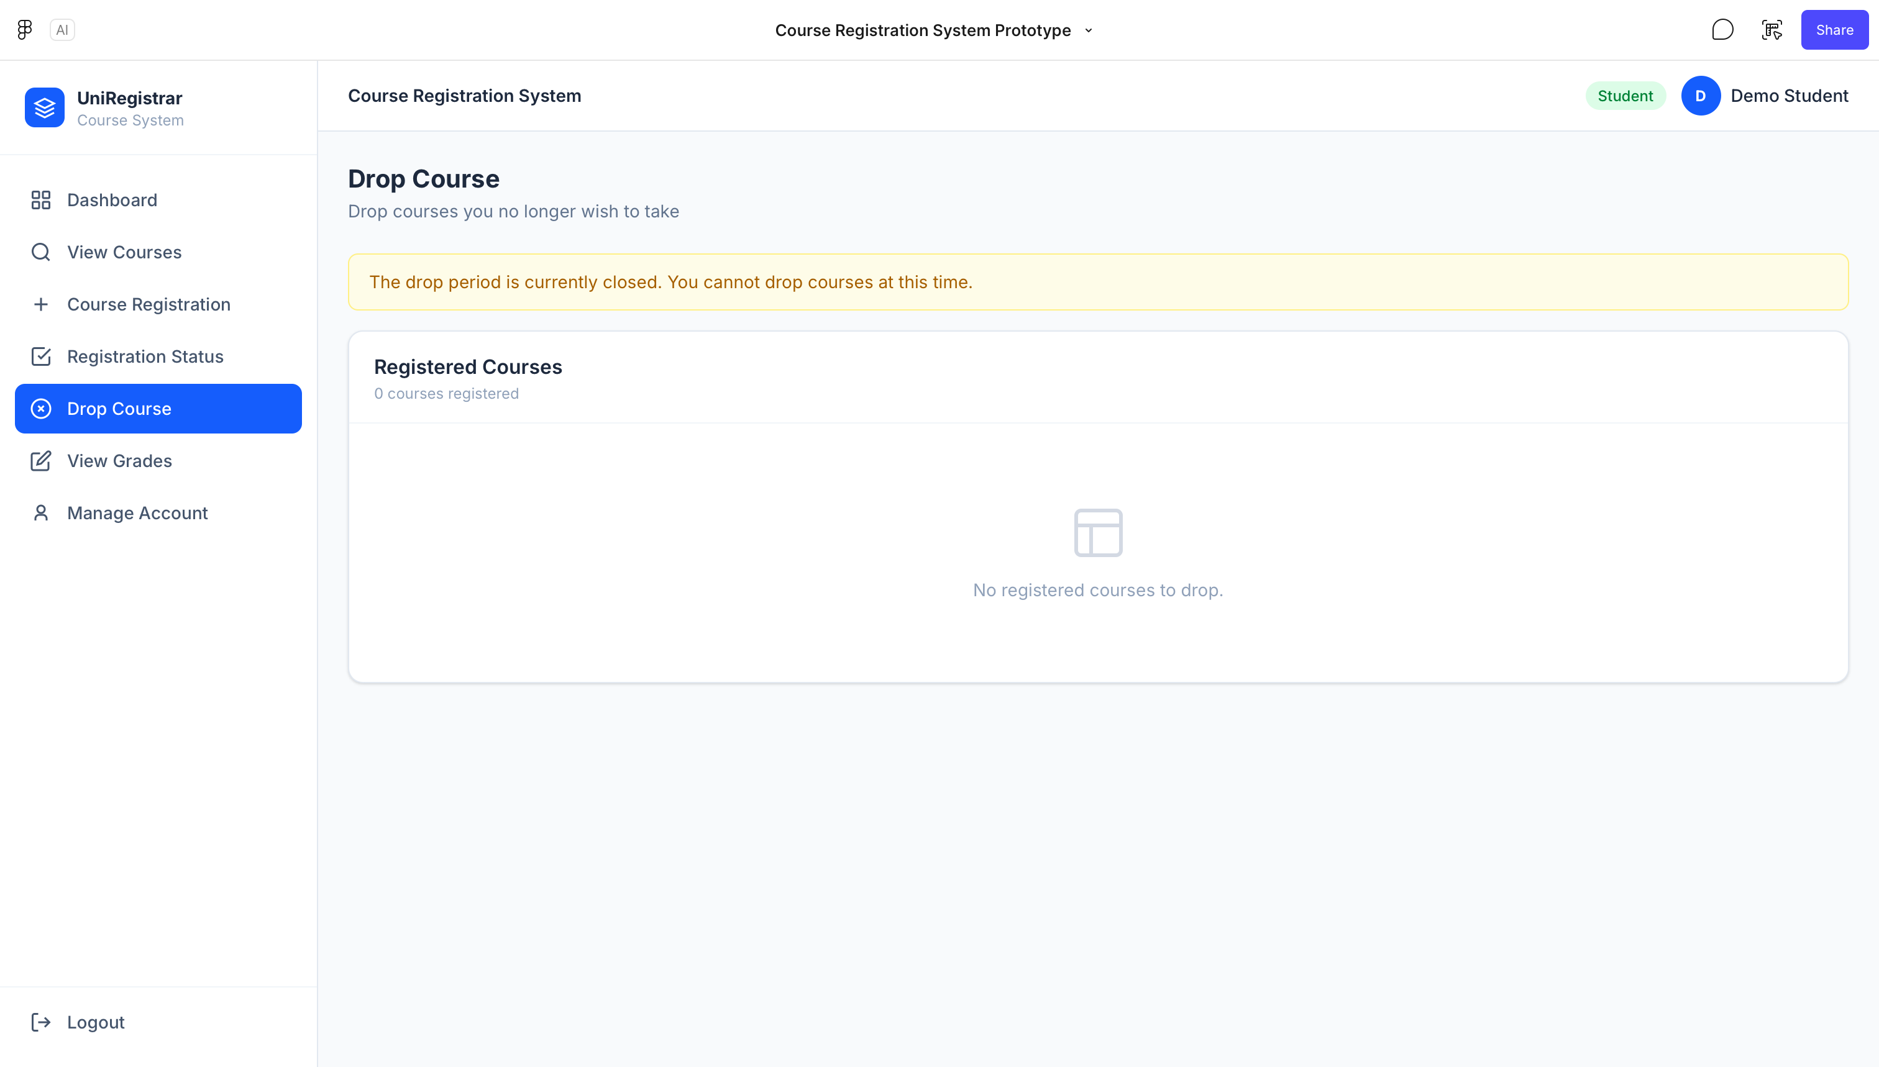
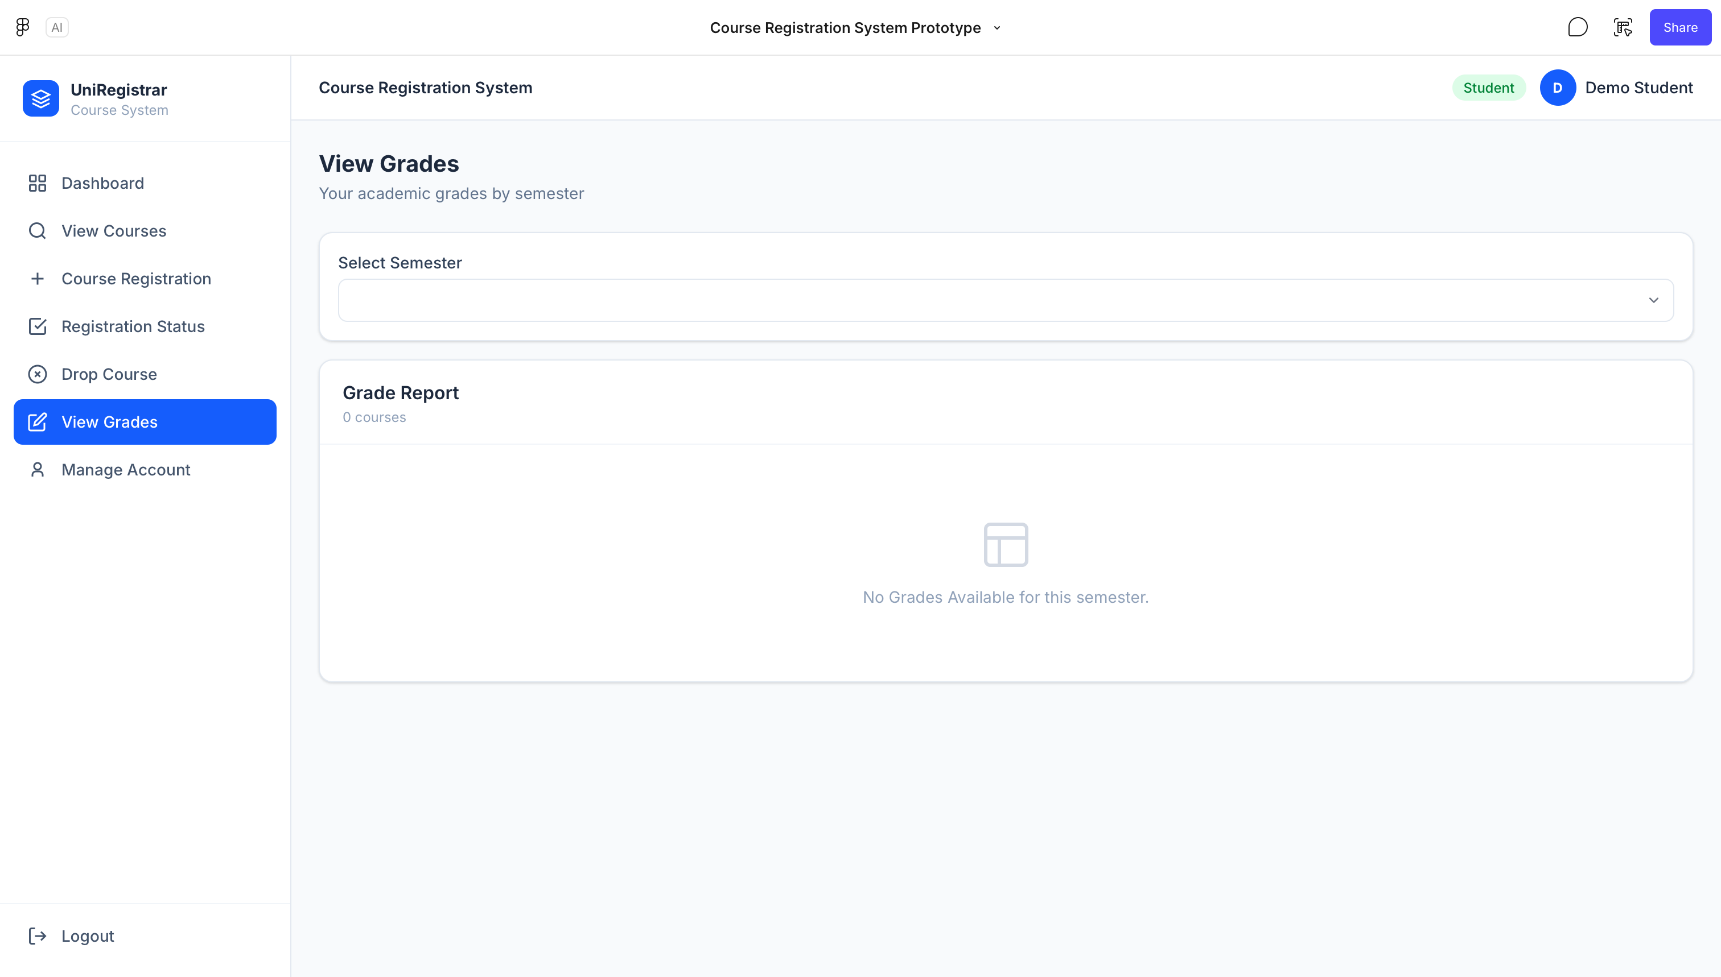
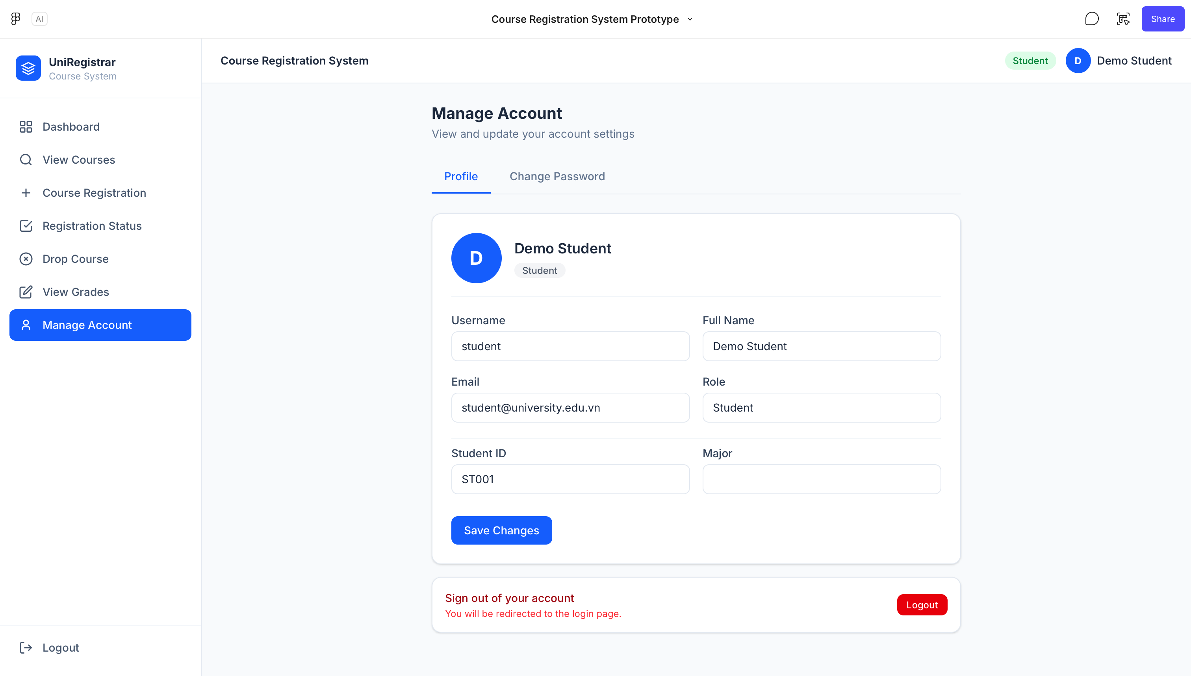
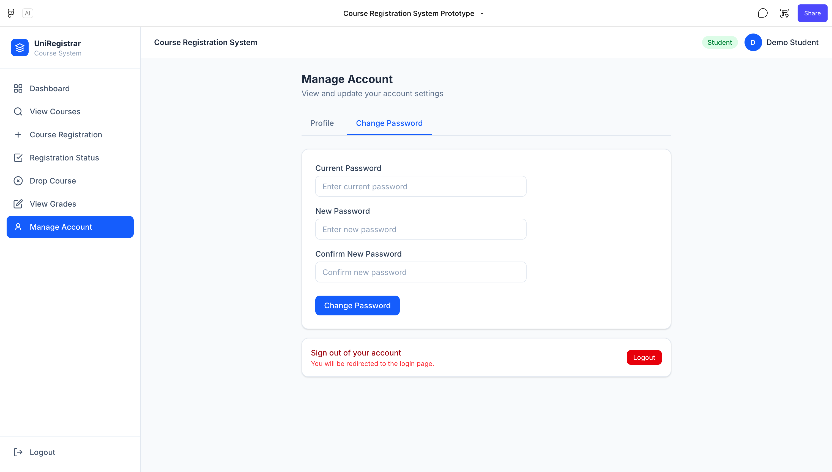

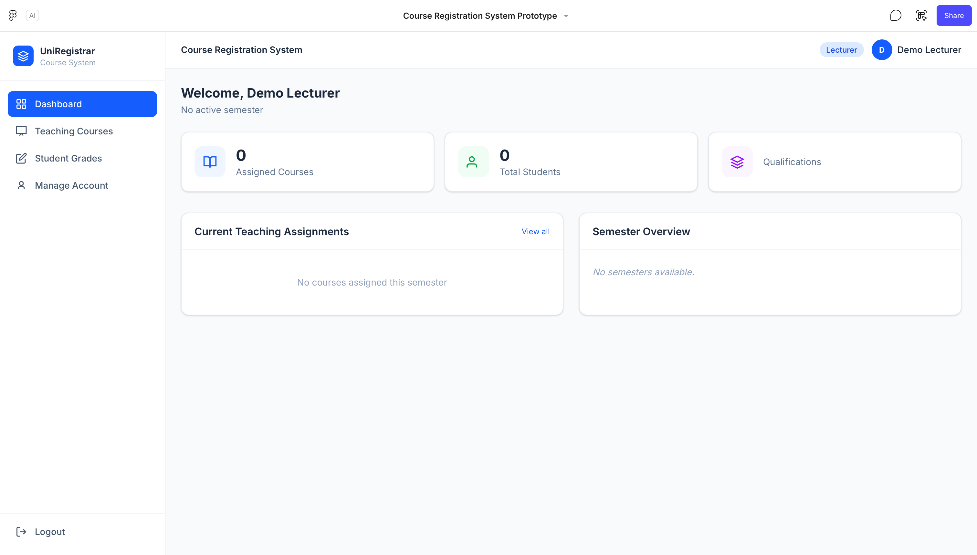
3. Lecturer
