USER GUIDE
BARTENDER LITE v1.0
Design & print free labels
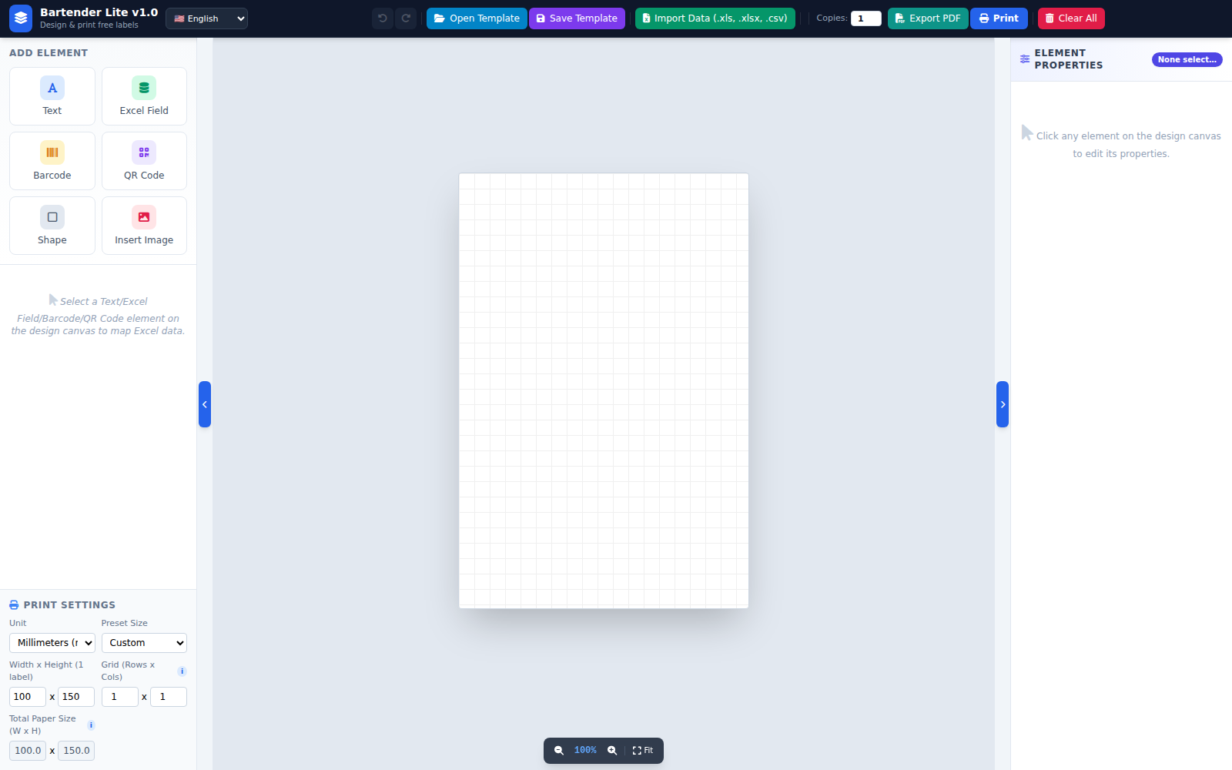

Table of Contents
- 1. Overview
- 2. Interface Overview
- 3. Changing the Interface Language
- 4. Adding and Editing Design Elements
- 5. Importing Excel Data and Column Mapping
- 6. Setting the Label Size and Paper Size
- 7. Preview and Print Range
- 8. Saving and Opening a Template
- 9. Printing and Exporting to PDF
- 10. Quick-Open a Template (Open with)
- 11. Troubleshooting

1. Overview
Bartender Lite is a free application that lets you design and print your own labels (barcodes, QR codes, product information...) directly on your computer, with support for bulk data import from Excel and direct printing to a dedicated label printer or any other printer.
Key features:
- Freely design labels with text, Excel data fields, barcodes, QR codes, shapes and images.
- Automatically calculates the total paper size from the label size and number of rows/columns.
- Bulk mail-merge printing from Excel data, with row-by-row preview.
- Print directly or export a lightweight PDF at the exact paper size.
- Multi-language interface: Vietnamese, English, Simplified Chinese, Korean, Japanese.
- Save/Open templates, with automatic reloading of linked Excel data.

2. Interface Overview
The app has 4 main areas: the top toolbar, the left panel, the design canvas, and the right panel.
Bartender Lite overview

2.1. Top Toolbar
Toolbar with all function buttons
Each button has its own color for easy recognition:
- Undo / Redo — go back or redo the last action.
- Open Template / Save Template (sky blue / violet) — reload or save the current design as a .json file.
- Import Data (.xls, .xlsx, .csv) (emerald) — import an Excel file with your bulk print list.
- Print Range / Copies — only shown once Excel data is imported and mapped.
- Printer selector — lists printers installed on your computer (only in the installed app).
- Export PDF (teal) — export a PDF at the exact designed paper size.
- Print (primary blue) — print directly to the selected printer.
- Clear All (red) — clear the entire current design.

2.2. Left Panel
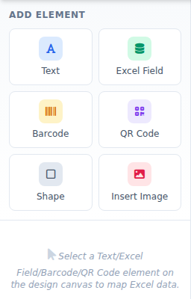
Left panel: Add Element
Contains 3 sections: "Add Element" (Text/Excel Field/Barcode/QR Code/Shape/Insert Image), the "Excel Column Mapping" box (appears when a compatible element is selected), and "Print Settings" at the bottom.

2.3. Design Canvas and Right Panel
The design canvas in the middle is where you drag, drop and arrange elements on the label. The right panel shows the detailed properties of the currently selected element. Above the canvas is the "Preview" bar (only shown with Excel data + mapping), and below it is the Zoom bar — both stay fixed in place and are never covered by the canvas, no matter how far you zoom in.
💡 Note: The two small blue pill-shaped buttons on either side of the canvas show/hide the left and right panels, giving you extra working space when needed.

3. Changing the Interface Language
Right next to the logo and app name in the top-left corner is a language selector. Click it and choose:
- 🇻🇳 Tiếng Việt (default)
- 🇺🇸 English
- 🇨🇳 简体中文
- 🇰🇷 한국어
- 🇯🇵 日本語
The entire interface (buttons, labels, messages) switches instantly. Your language choice is automatically remembered the next time you open the app.

4. Adding and Editing Design Elements
In the "Add Element" section (top of the left panel), click the type of element you want to add: Text, Excel Field, Barcode, QR Code, Shape, or Insert Image.
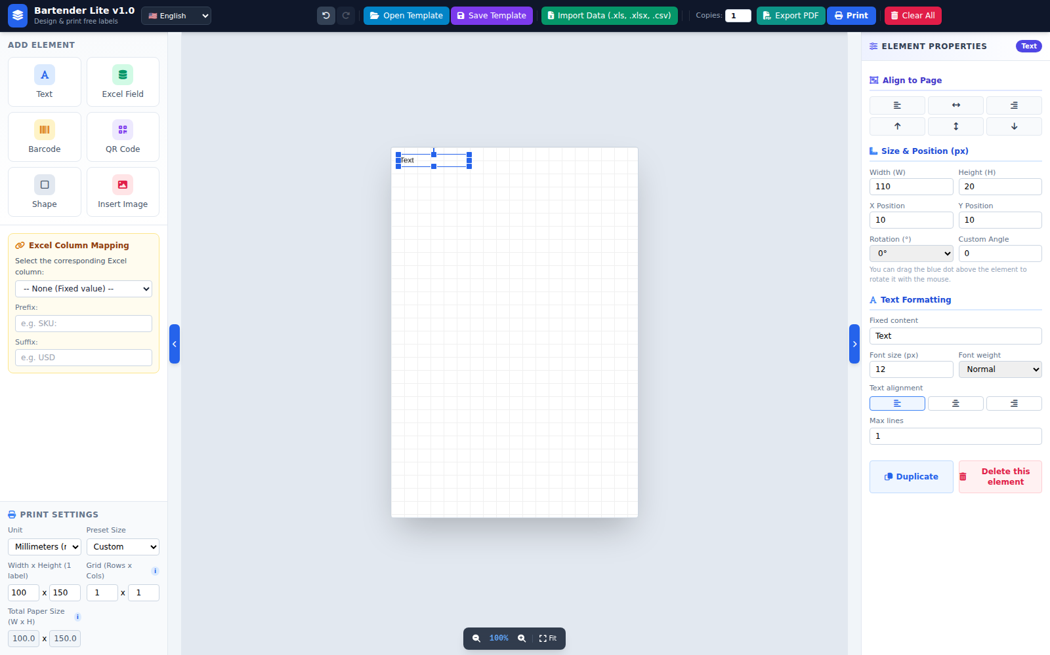
Adding a Text element to the canvas

4.1. Working with elements on the canvas
- Move: Drag with the mouse, or use the arrow keys while the element is selected. Hold Shift + arrow key to move faster.
- Resize: Drag the small blue squares at the corners/edges — you cannot drag beyond the design area.
- Rotate: Drag the blue dot above the element, or type directly into "Rotation (°)" / "Custom Angle".
- Duplicate: Select the element then press Ctrl+C then Ctrl+V, or click "Duplicate" in the right panel.
- Delete one element: Select it then click "Delete this element", or press Delete.
- Clear everything: Click the red "Clear All" button on the toolbar.

4.2. Common Properties
When an element is selected, the right panel shows "Align to Page" (left/center/right, top/center/bottom relative to the label) and "Size & Position": Width, Height, X Position, Y Position, Rotation.
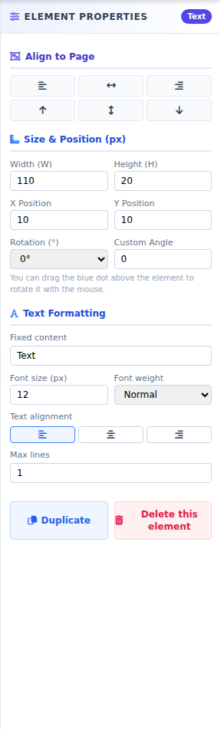
Properties panel for a Text element

4.3. Text / Excel Field formatting
Includes: Fixed content, Font size, Font weight (Normal/Bold), Text alignment (left/center/right), and the "Max lines" field.
💡 Note: The "Max lines" field: if the content is longer than the box, it wraps automatically (up to the number of lines you set). If the box isn't tall enough, it grows taller automatically. If content still overflows, the remainder is cut off with "..." — the font size is never auto-shrunk. Set to 1 for no wrapping.

4.4. QR Code
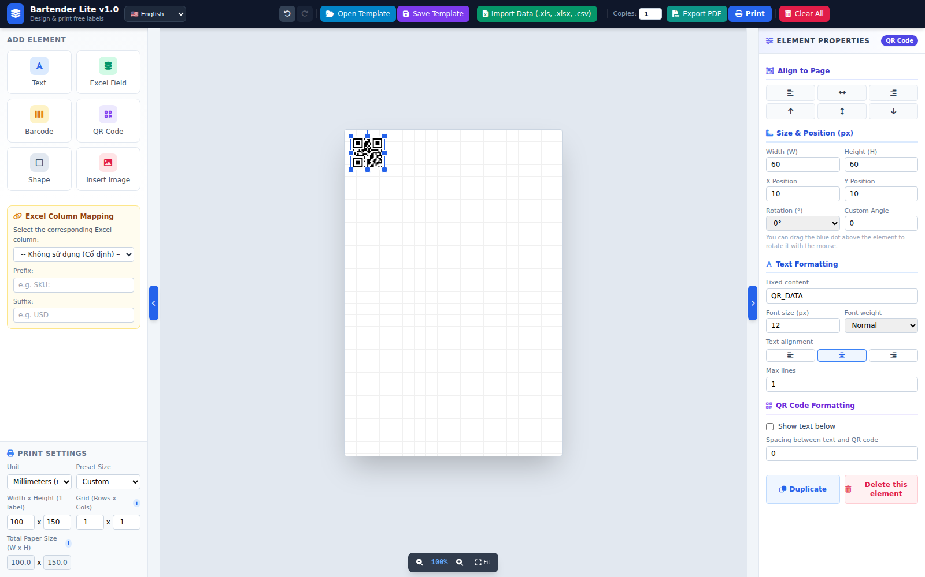
A QR Code element on the design canvas
Under "QR Code Format": toggle "Show text below", adjust "Spacing between text and QR code". The caption text shares the "Max lines" field from the "Text Format" section above.

4.5. Barcode
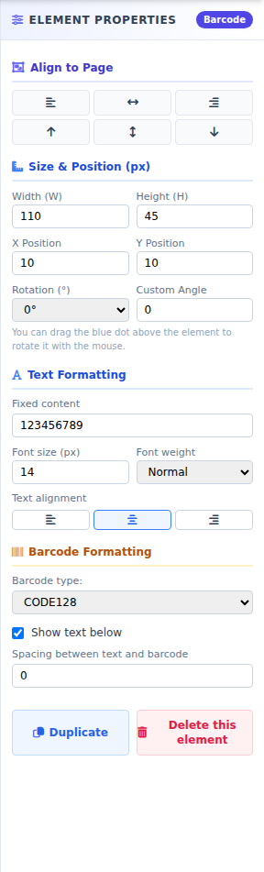
Properties panel for a Barcode
Choose the barcode type (CODE128, EAN13...), toggle the number display below it, and adjust "Spacing between text and barcode". Can be mapped to an Excel column so each label prints a different barcode.

4.6. Shape and Insert Image
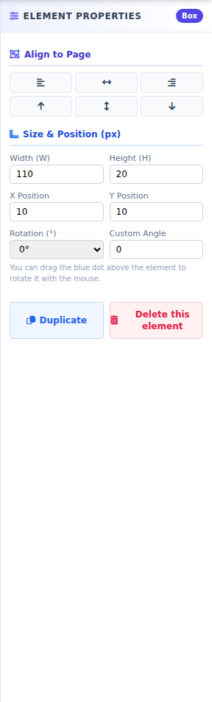
Properties panel for a Shape
"Shape" creates a decorative rectangle/border. "Insert Image" lets you add a logo or a PNG/JPG/SVG image — the image automatically keeps its original aspect ratio when resized, without distortion.

5. Importing Excel Data and Column Mapping

5.1. Importing a Data File
Click the green "Import Data (.xls, .xlsx, .csv)" button on the toolbar and select an Excel/CSV file with your data list (each row is one label, each column is one type of information).

5.2. Mapping a Column to an Element
Select an element (Text/Excel Field/Barcode/QR Code) on the canvas → the "Excel Column Mapping" box appears in the left panel (yellow background) → choose the corresponding Excel column from the dropdown, and optionally add a Prefix/Suffix.
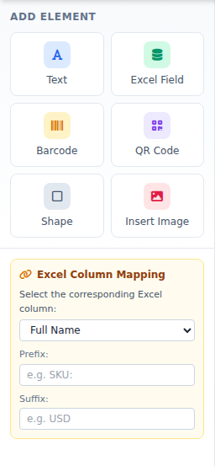
Excel Column Mapping box in the left panel
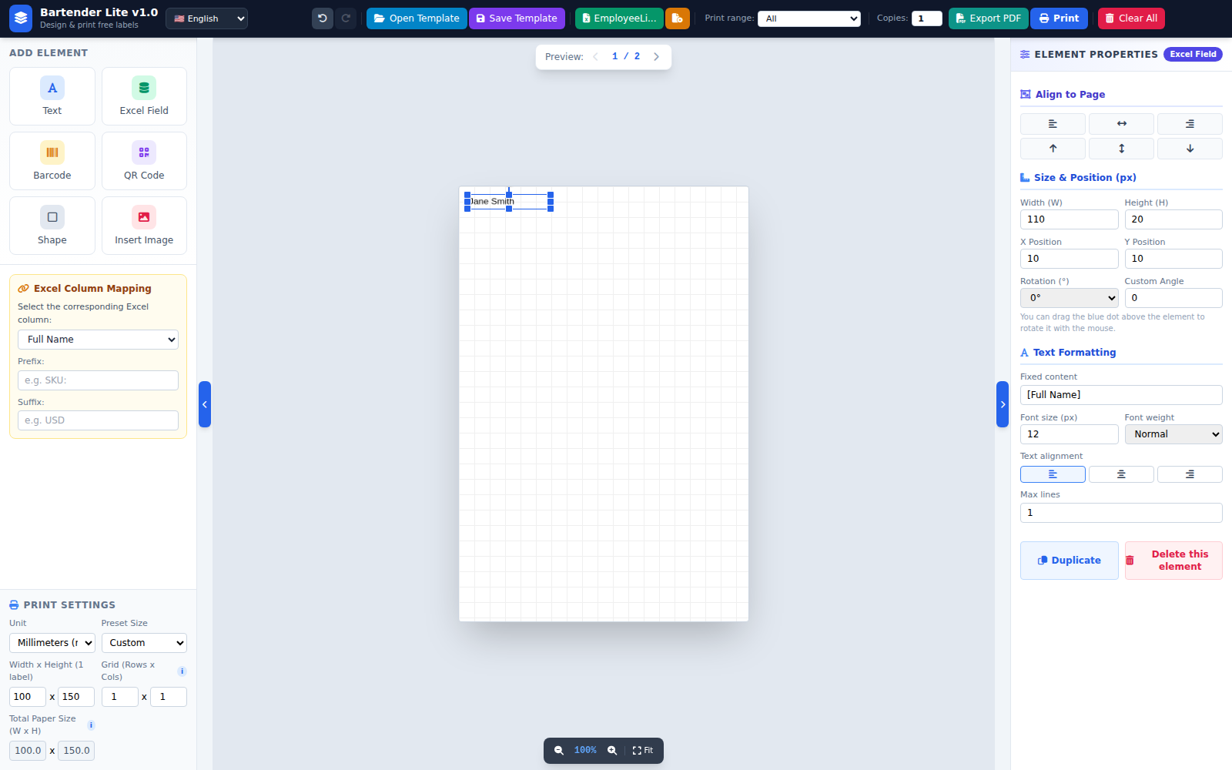
Excel data shown live on the label after mapping
💡 Note: If no element is mapped to an Excel column, even with data imported, the app will only print the number entered in "Copies" (it won't multiply by the number of data rows), since every label's content would be identical.

6. Setting the Label Size and Paper Size
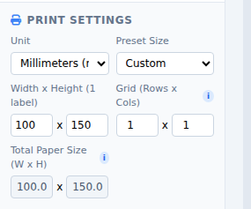
Print Settings section in the left panel
- Unit: Millimeters (mm), Inches (in), or Pixels (px).
- Preset Size: quickly pick a common label size, or "Custom" to enter your own.
- Width x Height (1 label): the actual size of the design canvas.
- Grid (Rows x Cols): Rows = labels stacked vertically, Columns = labels arranged horizontally on one page.
- Total Paper Size: automatically calculated = (label width × columns) × (label height × rows) — no manual entry.
💡 Note: If your label roll has 3 labels per row, enter Columns = 3. Entering the wrong number of columns will cause labels to print in the wrong position on the paper.

7. Preview and Print Range
These two sections only appear once you have imported Excel data AND have at least one element mapped to that data.
The Preview bar, fixed above the design canvas
- Preview: use the left/right arrow buttons to browse through each data row.
- Print range: "All" / "First page (Row 1)" / "Custom" (enter a From row...To row... range).

8. Saving and Opening a Template
Save Template: saves your entire current design as a .json file on your computer.
Open Template: select a previously saved .json file to load the exact same design back.
💡 Note: If the design uses Excel data mapping, the template file automatically saves the PATH to the original Excel file (not the full data, keeping the template file small). When you reopen the template, the app automatically re-reads that exact Excel file — if it has been deleted/moved, the app shows a clear error so you can re-select it.

9. Printing and Exporting to PDF

9.1. Printing Directly
Carefully check that "Print Settings" matches your actual roll/sheet, enter "Copies", select the correct printer, then click the blue "Print" button.

9.2. Exporting a PDF
If direct printing results in the wrong paper size or misaligned position, use the "Export PDF" button — the app generates a PDF at the exact designed paper size, with a lightweight compressed file size. Open it with Adobe/Foxit Reader and print at "Actual size / 100%", not "Fit to page".

10. Quick-Open a Template (Open with)
After installing the app, you can open a .json template file directly: right-click the file → Open with → choose Bartender Lite. The app will launch and automatically load that exact template (including any linked Excel data), without needing to open the app first and use "Open Template".

11. Troubleshooting
Issue | Cause & Fix
Printed labels are misaligned, or the number per row is wrong | Check that the Columns value in "Grid (Rows x Cols)" exactly matches the actual number of labels per row on your paper.
Only 1 label prints even though Copies is set higher | Check the correct printer is selected; try Export PDF and print manually (Actual size 100%).
Imported Excel data but "Preview"/"Print range" don't appear | You need at least one element mapped to an Excel column for these to appear.
QR code / barcode looks blurry when printed | Increase the Width/Height of the QR/barcode element in the right panel.
Opening a template doesn't reload the Excel data | The original Excel file was deleted/moved from its saved path — re-import it manually via "Import Data".
Windows shows a warning / won't run the installer | The app isn't code-signed yet. Click "More info" → "Run anyway"; if it still fails, try "Run as administrator".
Thank you for using Bartender Lite!

