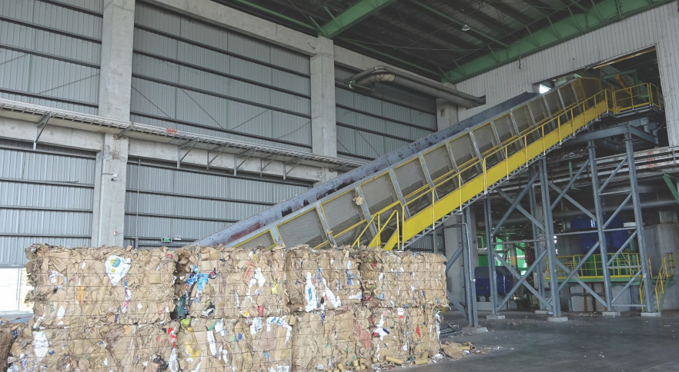
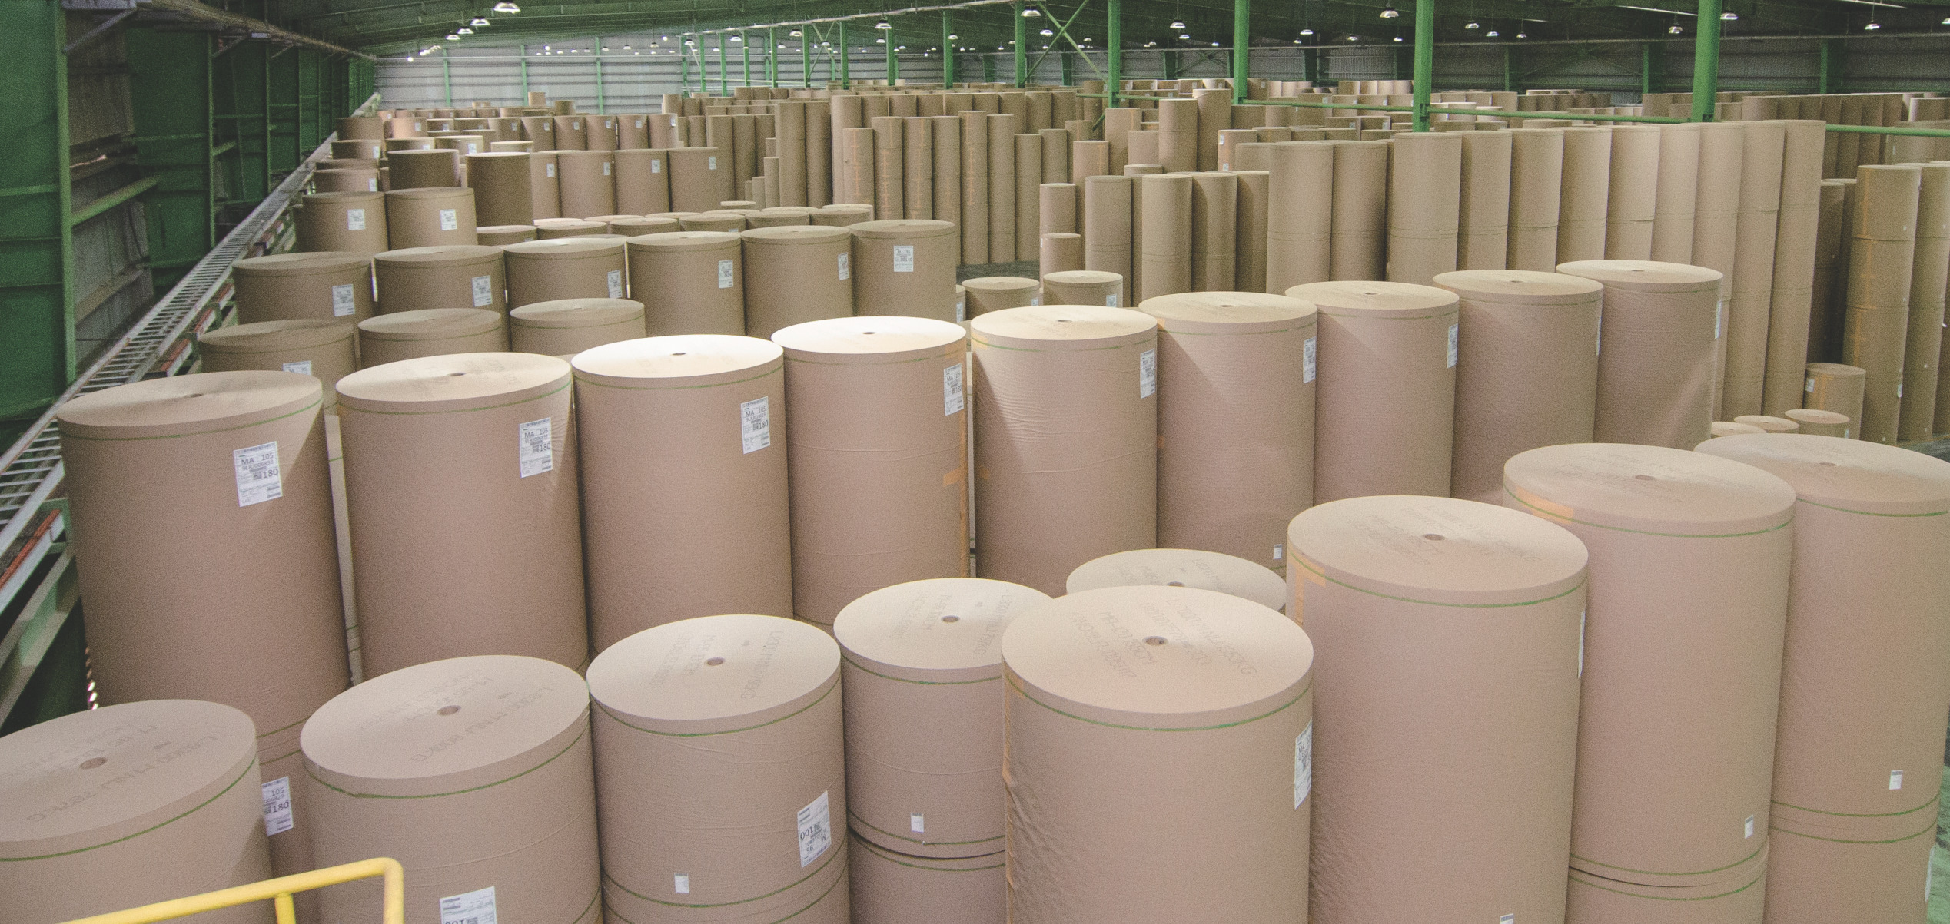
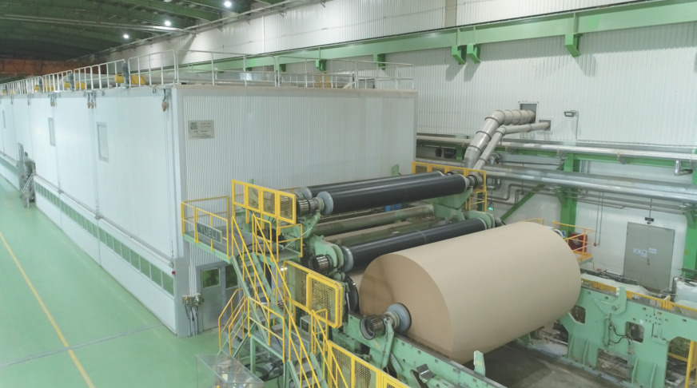
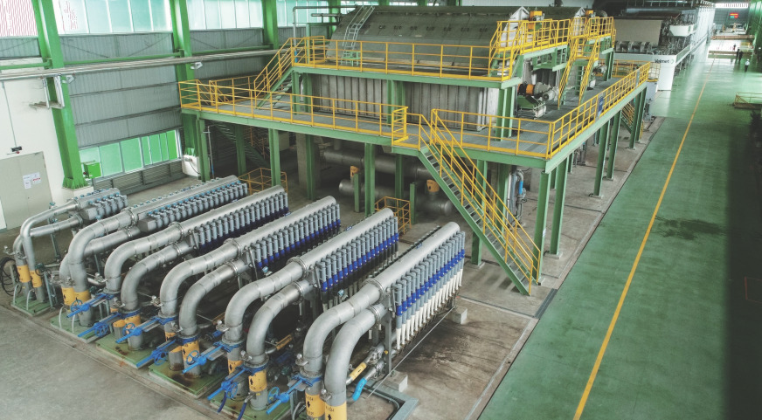
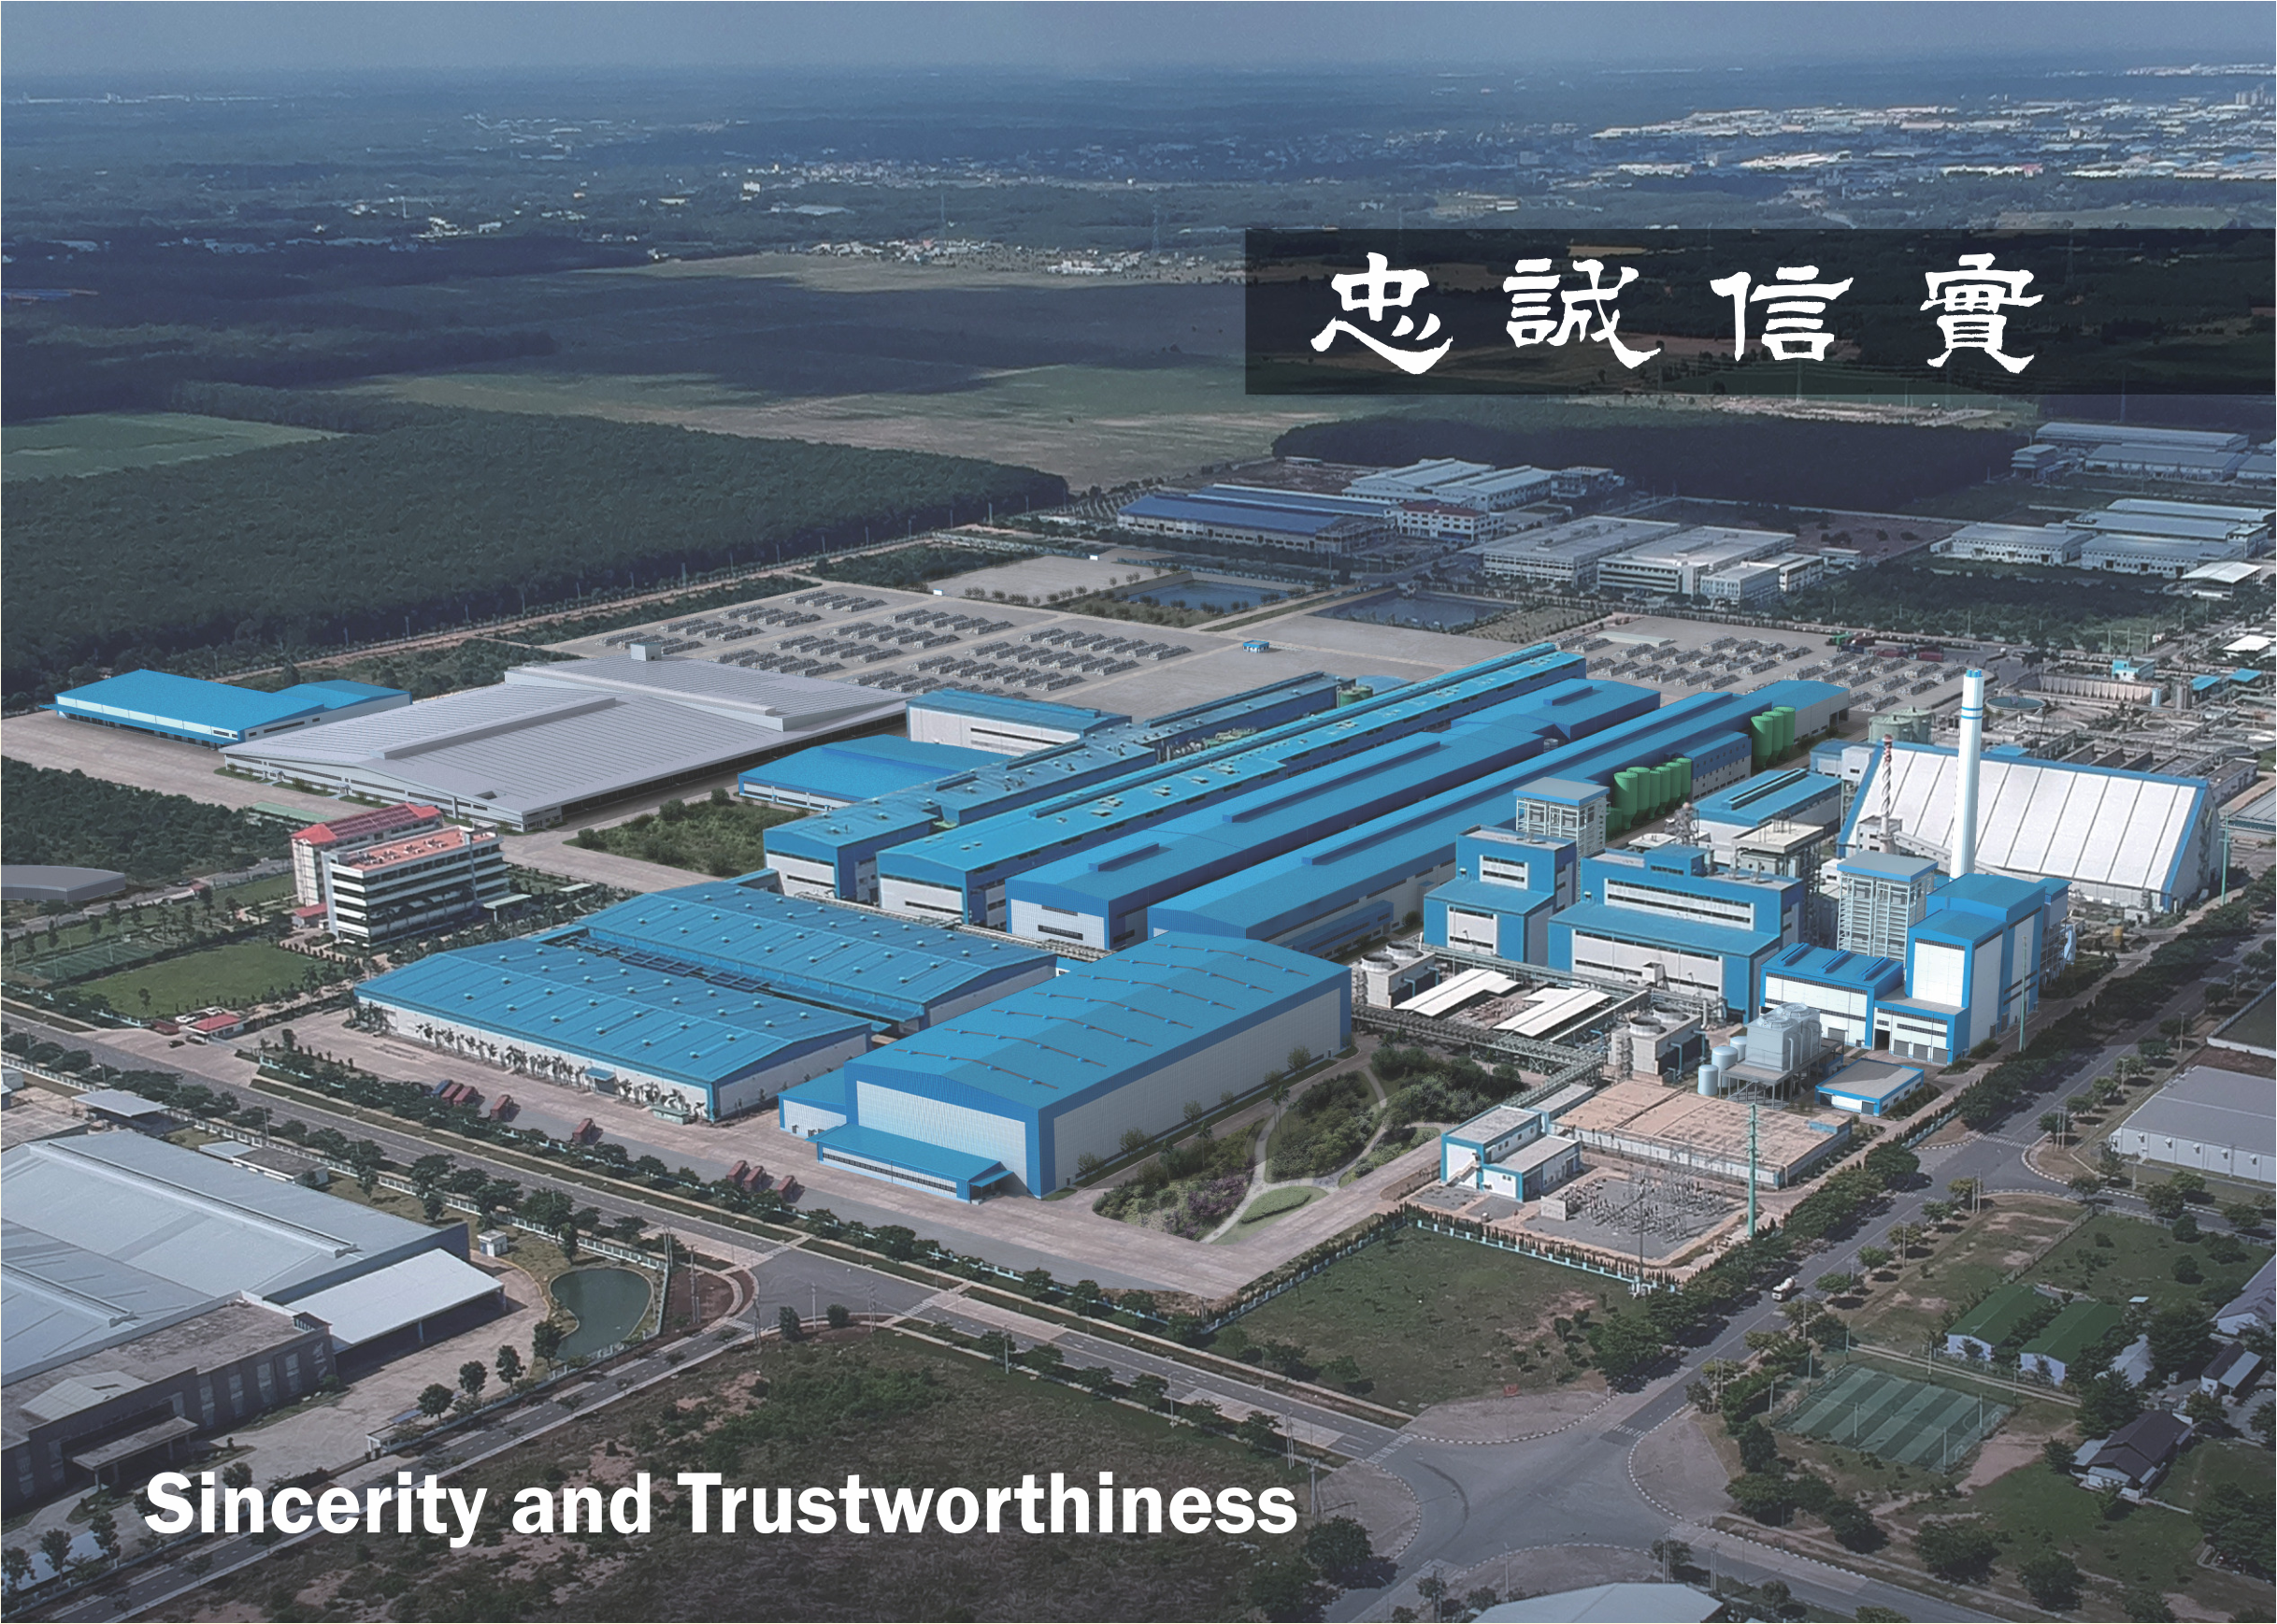

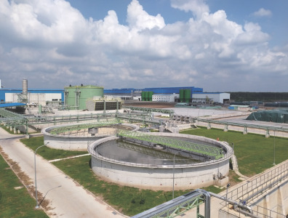
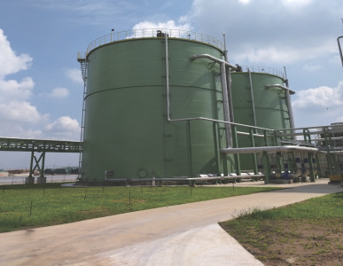
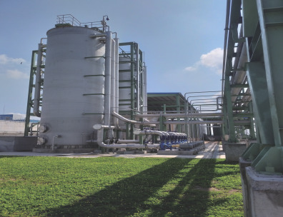
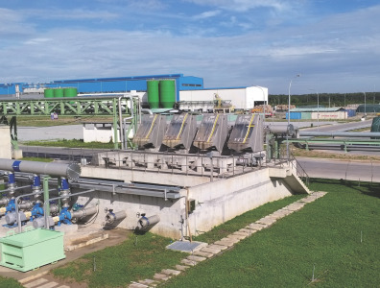
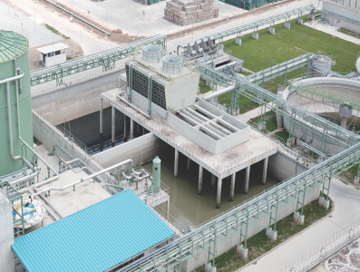
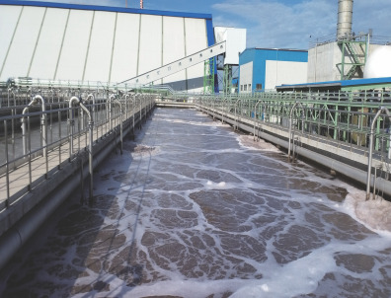
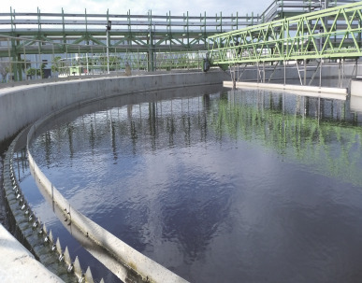
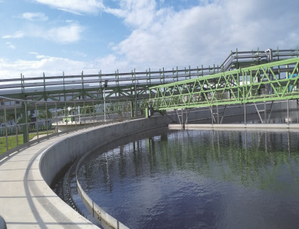

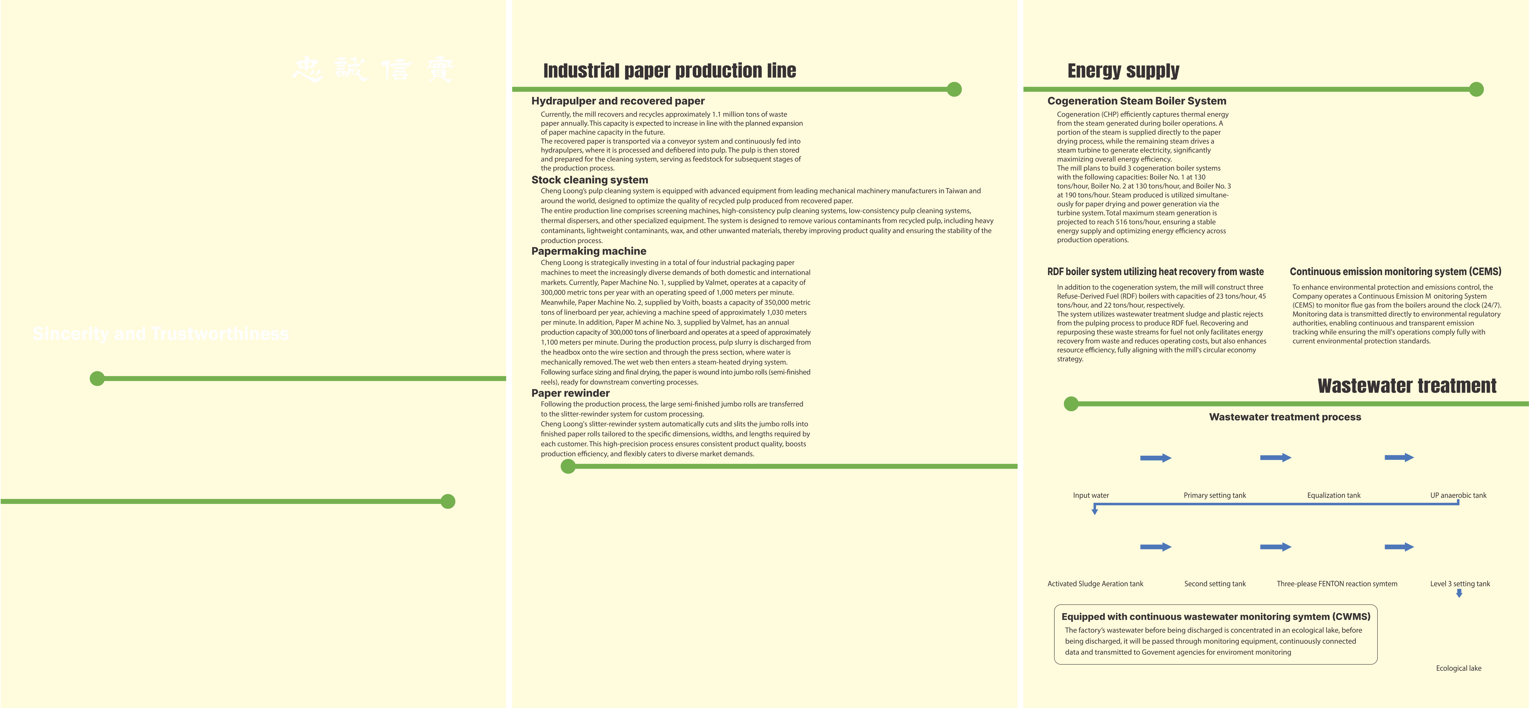
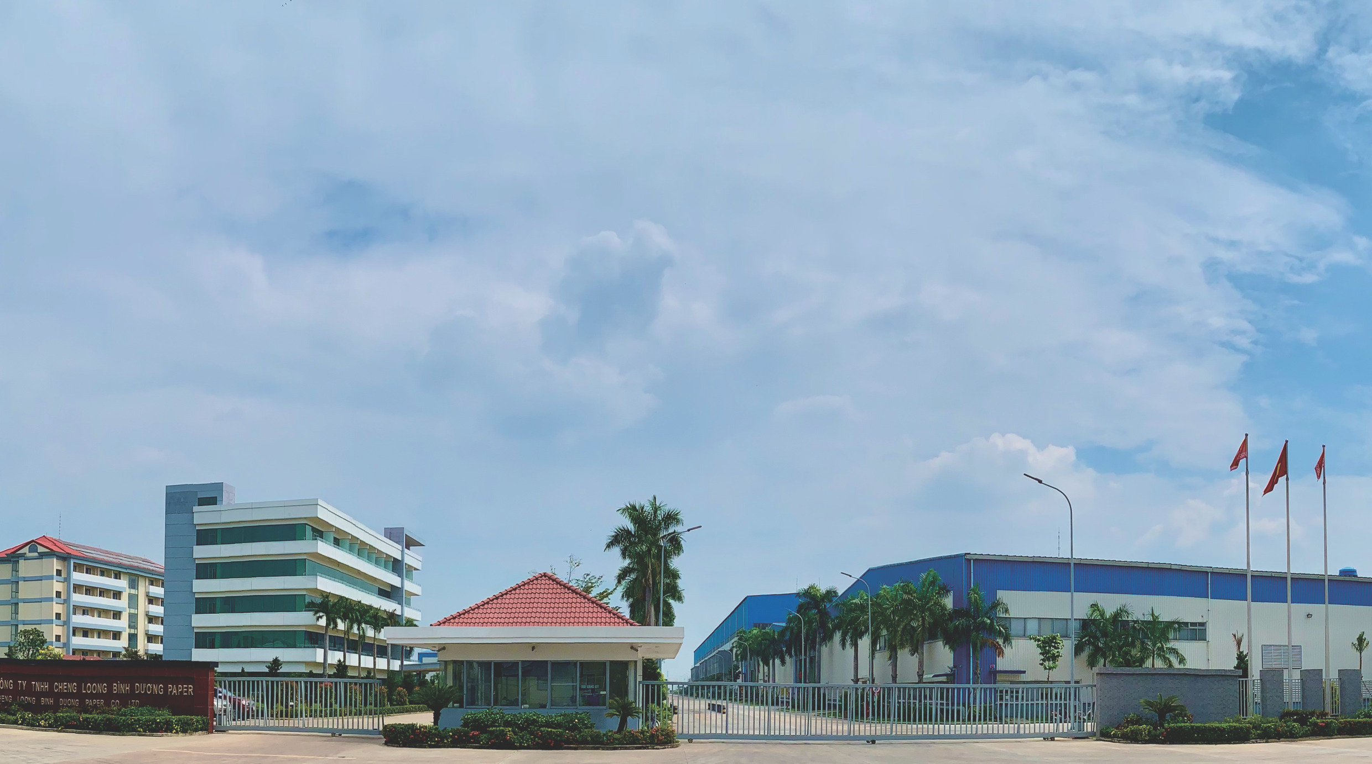

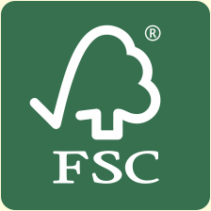
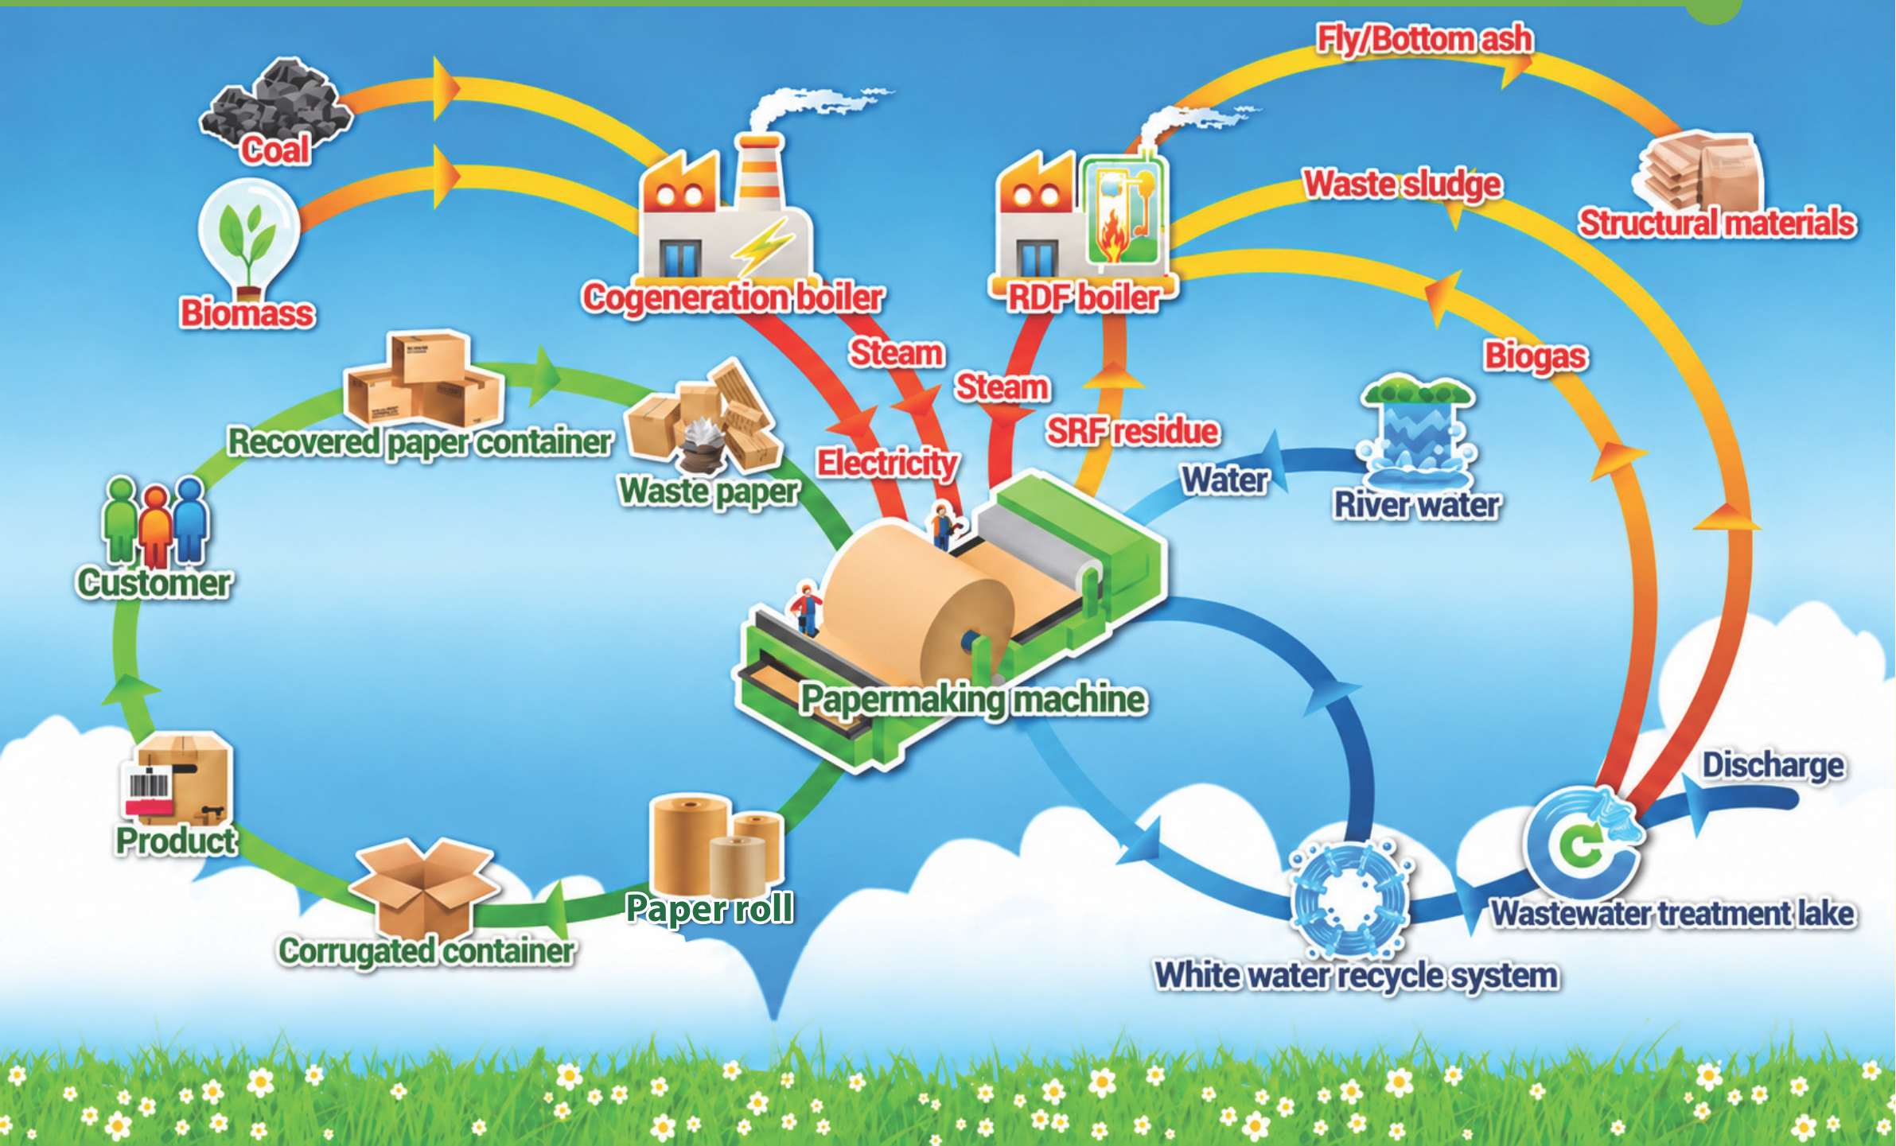
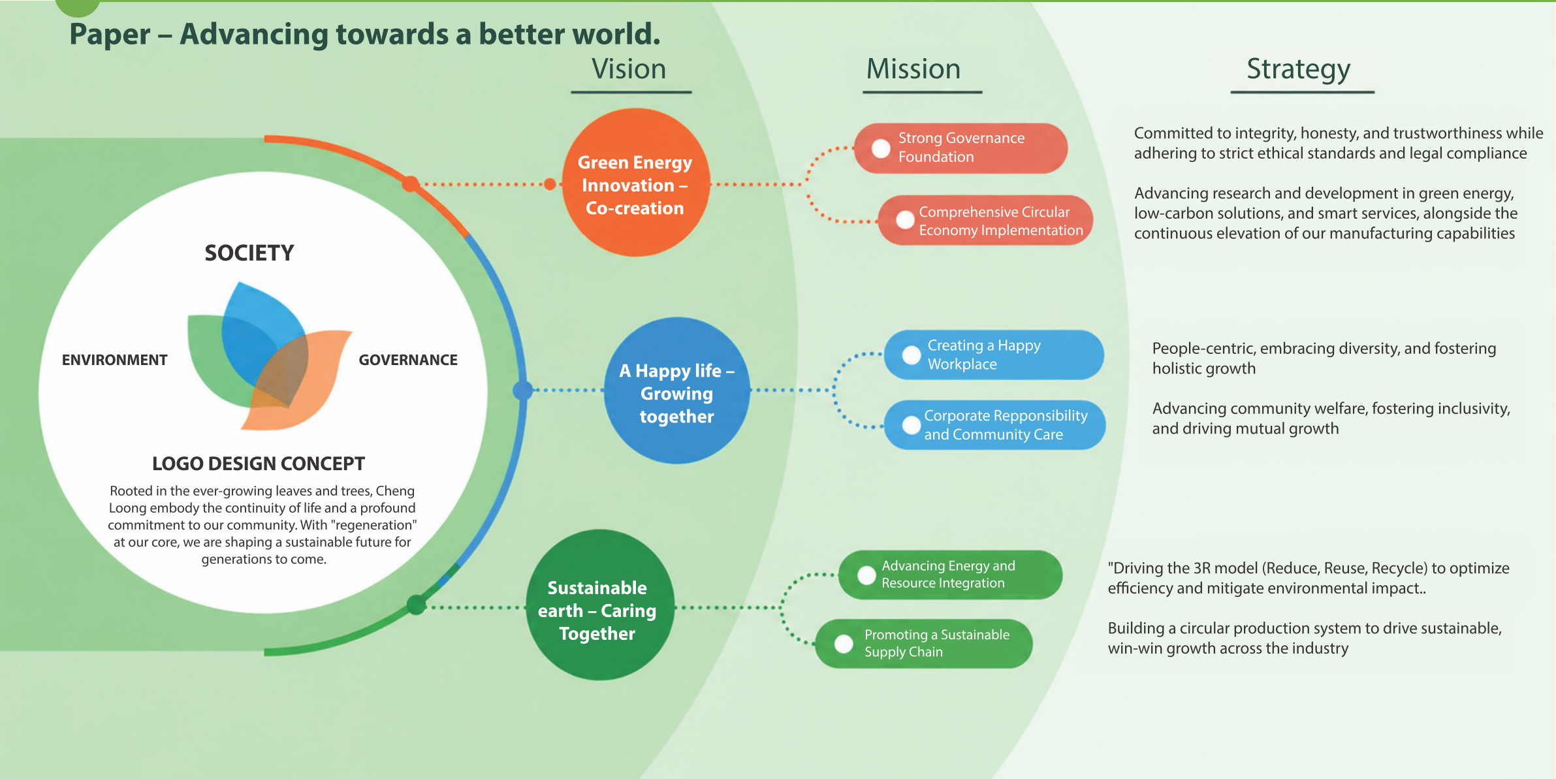
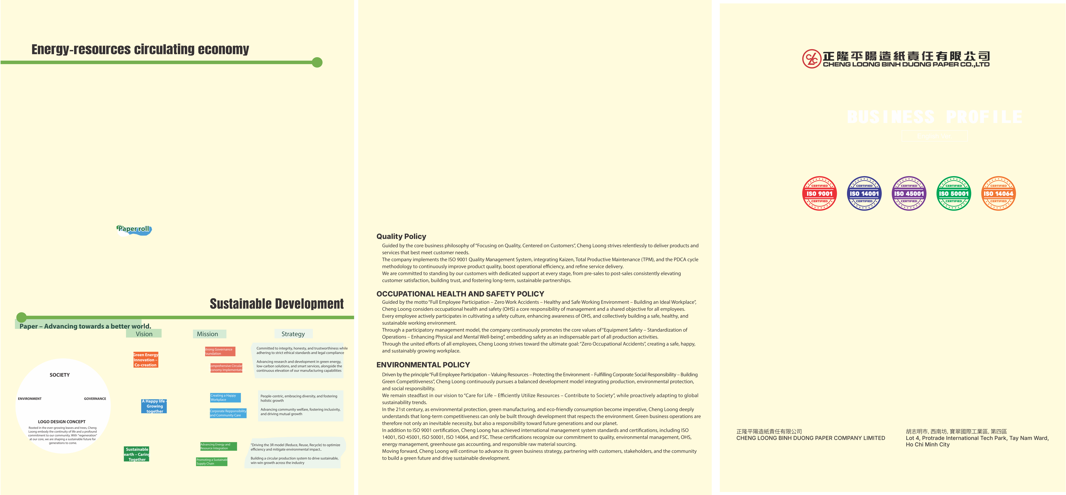
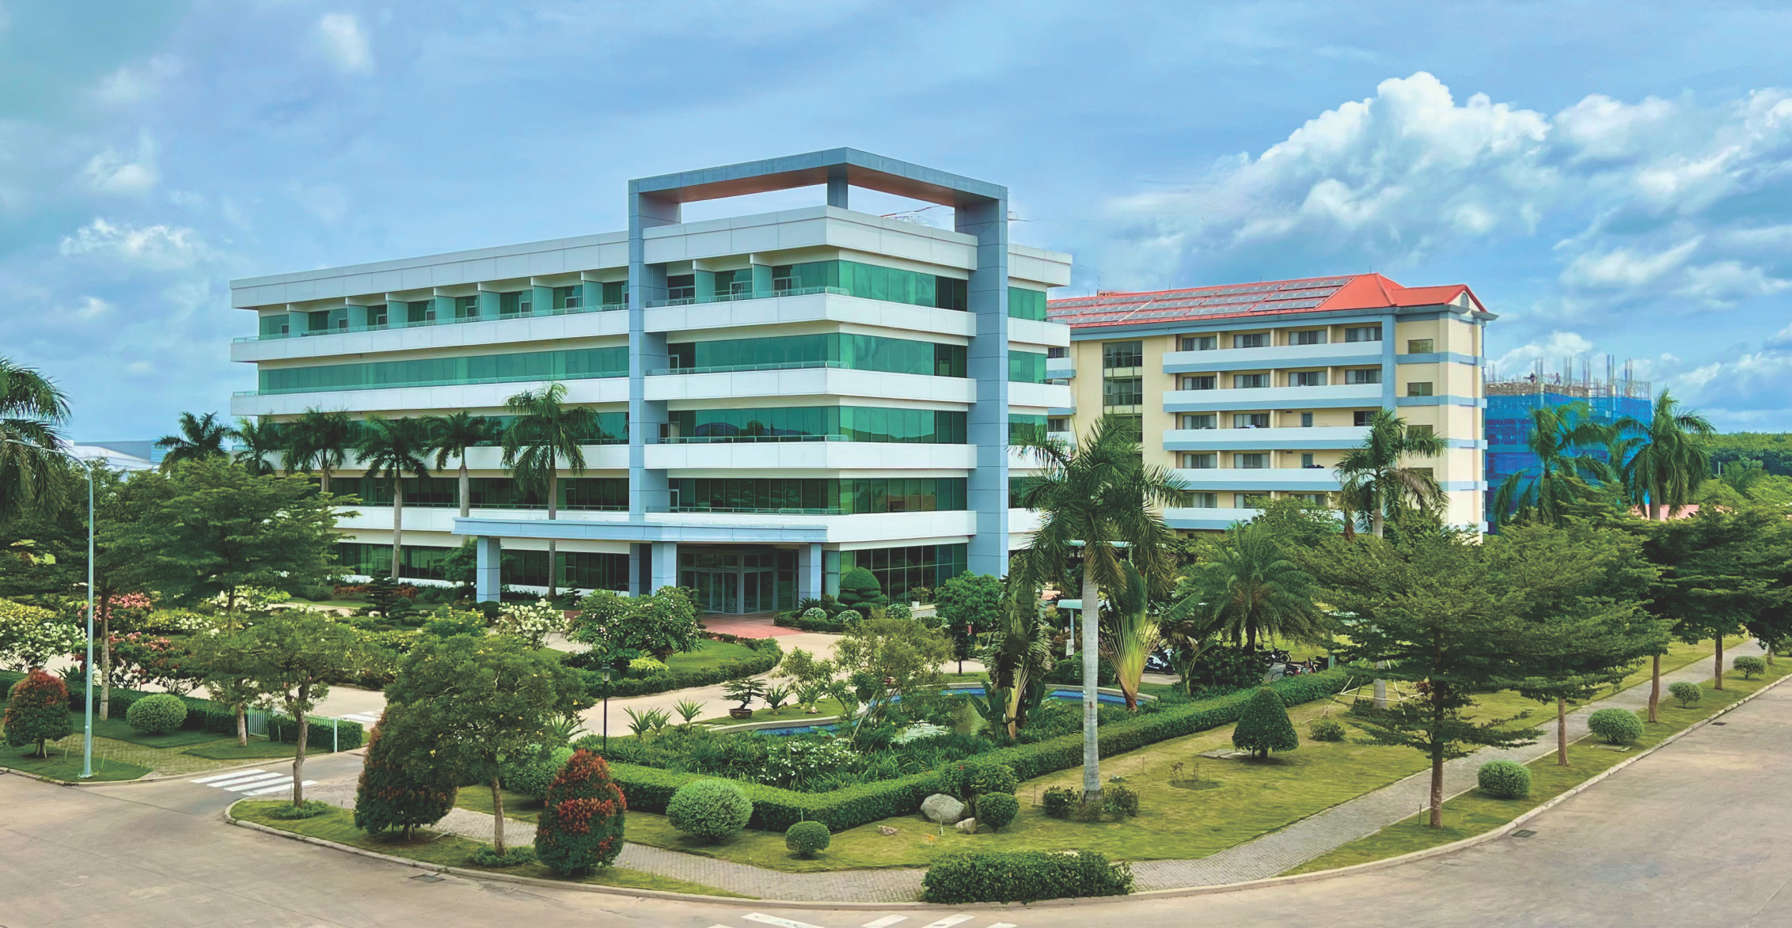
Founded in 1959, Cheng Loong has focused on industrial papermaking and packaging processing as its core
business, gradually developing a comprehensive supply chain. Upholding the business philosophy of “Loyalty
andTrustworthiness”ChengLoongdeliversinternationallycompetitiveproductsthroughhighefficiency,
modern equipment, advanced technology, stable quality, reasonable pricing, and dedicated customer service.
Inaddition,thecompanyembracesthecorporatespiritof“CommitmenttoShareholders,Commitmentto
Customers,andCommitmenttoWork”,withstrongemphasisonproductquality,customerservice,and
advancecorporatesocialresponsibility.ChengLoongconsistentlyadherestoitscommitmentof“High
Quality, Reasonable Prices, On‑Time Delivery, and Best Service”.
HeadquarteredinBanchiaoDistrict,NewTaipeiCity,Taiwan.ChengLoongcurrentlyoperates5papermills
andmorethan18corrugatedcontainerplantsacrossTaiwan,China,andVietnam,distributingproducts
worldwide.TheGroup’sannualpaperproductionexceeds2.8milliontons,whileitsannualpackaging
production surpasses 2 billion m². Cheng Loong is recognized as one of the world’s top 100 paper companies,
the Top 200 global green enterprises, and the Top 50 sustainable enterprises in the Asia‑Pacific region. It is also
Taiwan’s largest manufacturer of packaging and industrial paper.
In 2016, Cheng Loong implemented the investment plan to establish Cheng Loong Binh Duong Paper Co., Ltd.
at Lot 4, Protrade International Tech Park, Tay Nam Ward, Ho Chi Minh City, Vietnam. The investment project is
divided into 5 phases within 15 years with total site area of approximately 800,000m² and investment capital of
USD 1.15 billion. The project’s major facilities include 4 industrial paper machines, 3 cogeneration boilers, 3
RDFboilers,1wastewatertreatmentplantand1corrugatedpackagingplant.Theestimatedannual
production capacity is 1,000,000 tons of industrial packaging paper and 50,000 tons of tissue paper. Aiming to
becomethelargestpapermanufacturingplantinVietnam,wearecommittedtooptimizingoperationsand
driving a circular economy model‑contributing to a modern, sustainable, and socially responsible Vietnamese
paper industry.

