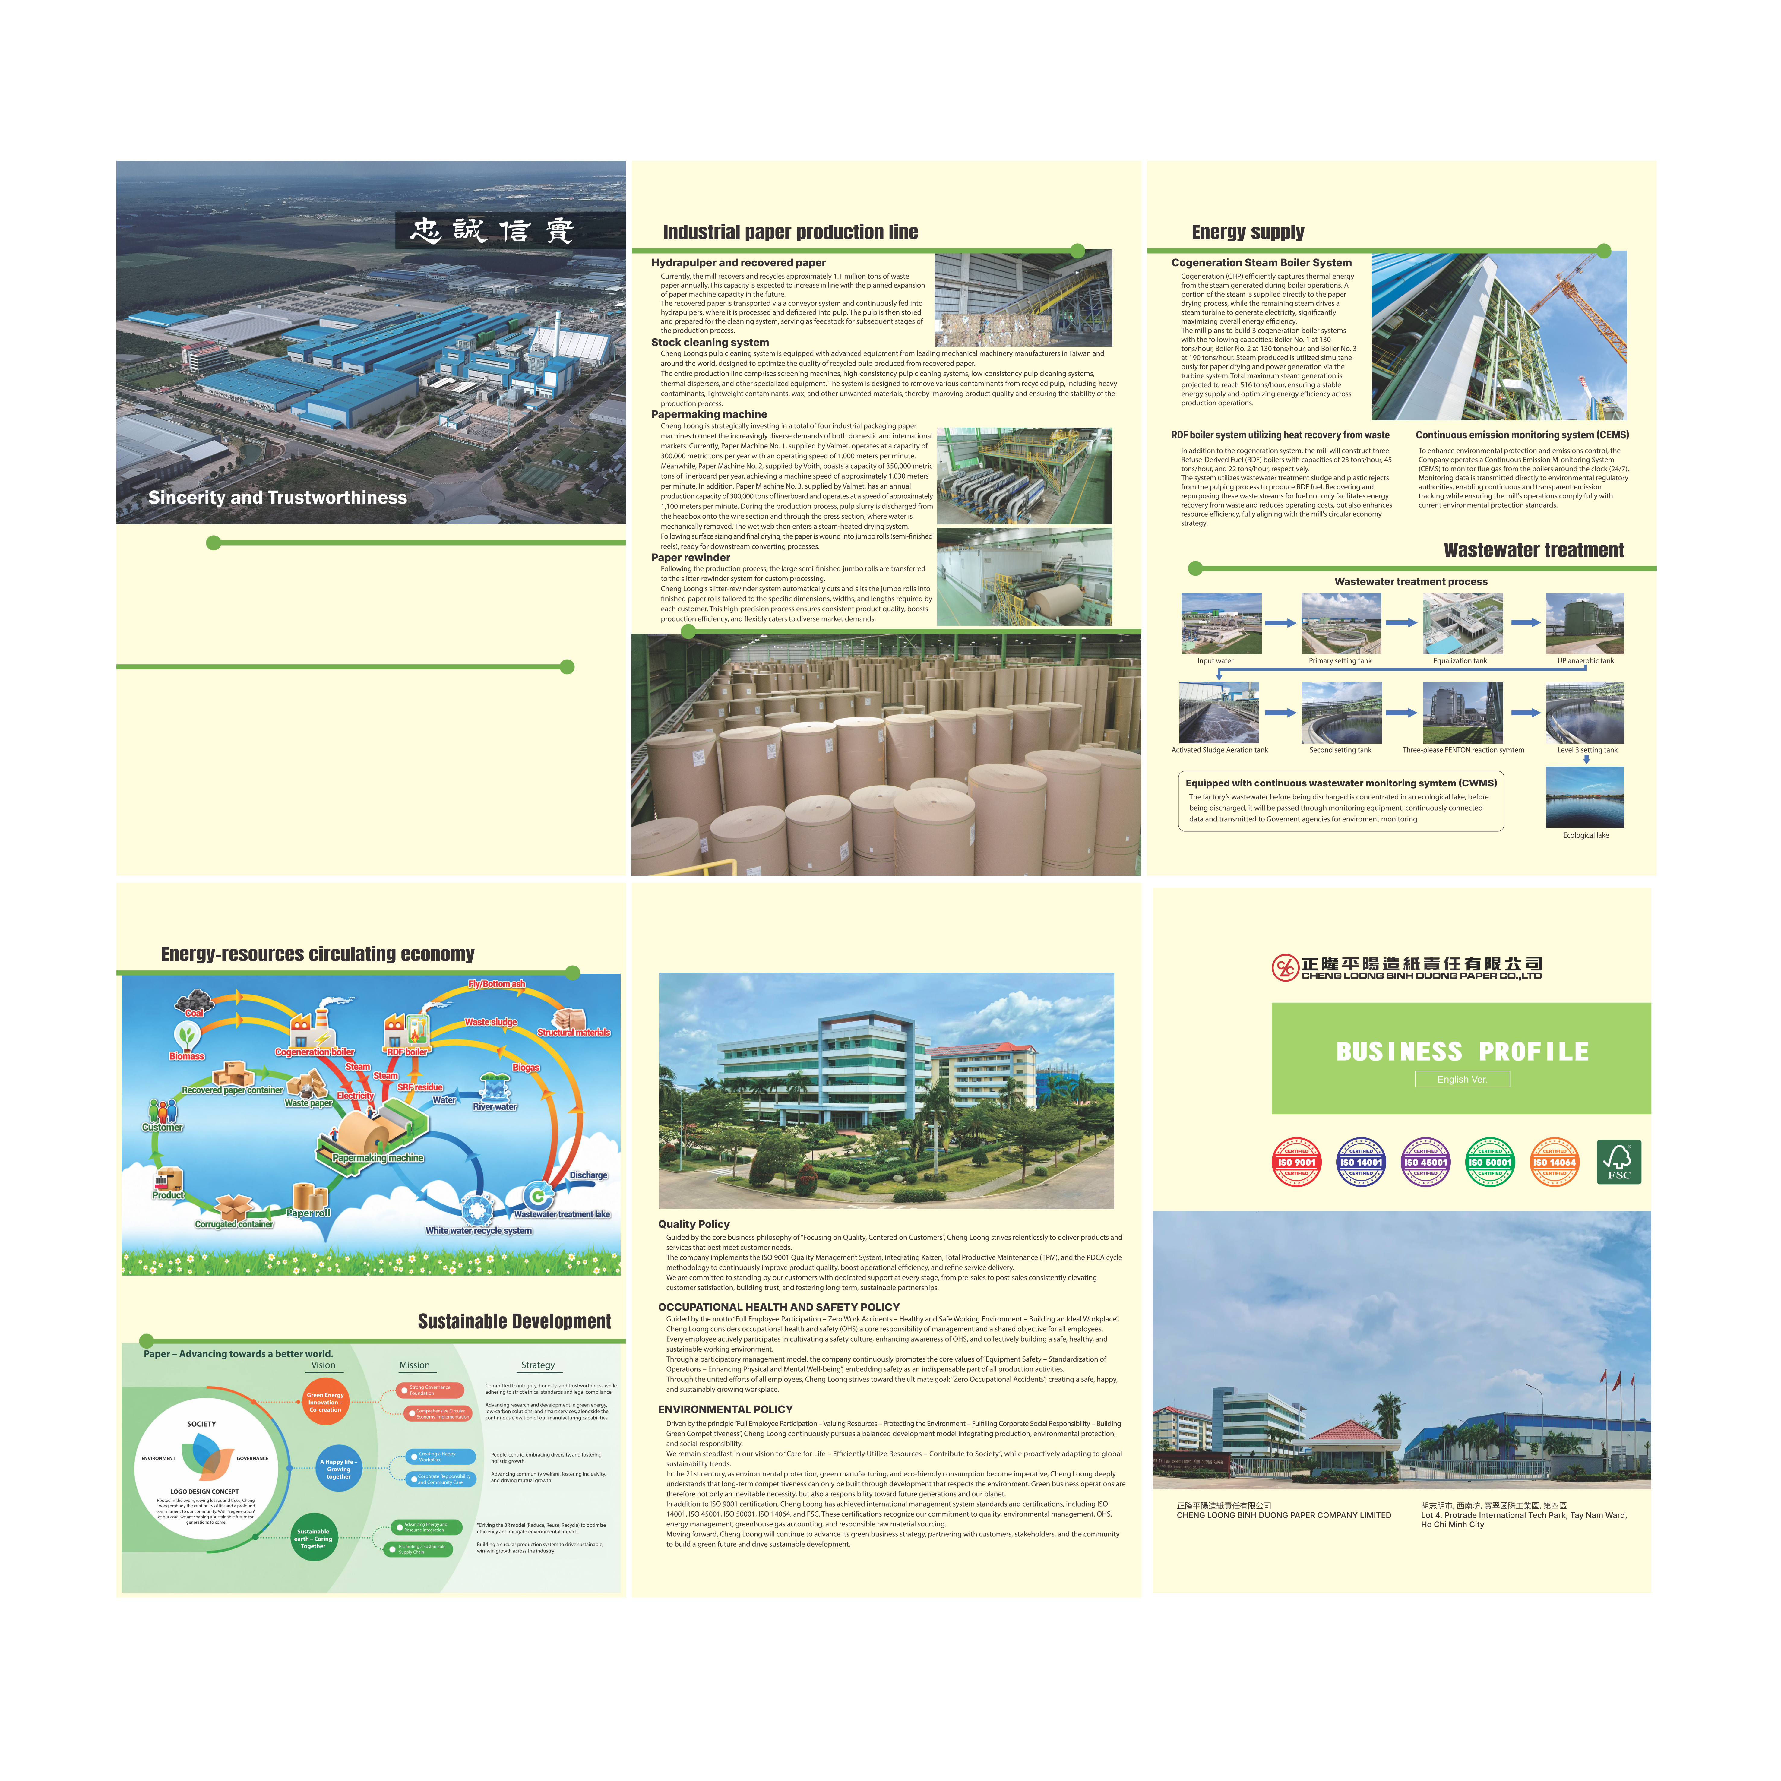
Founded in 1959, Cheng Loong has focused on industrial papermaking and packaging processing as its core
business, gradually developing a comprehensive supply chain. Upholding the business philosophy of “Loyalty
and Trustworthiness” Cheng Loong delivers internationally competitive products through high efficiency,
modern equipment, advanced technology, stable quality, reasonable pricing, and dedicated customer service.
In addition, the company embraces the corporate spirit of “Commitment to Shareholders, Commitment to
Customers, and Commitment to Work”, with strong emphasis on product quality, customer service, and
advance corporate social responsibility. Cheng Loong consistently adheres to its commitment of “High
Quality, Reasonable Prices, On‑Time Delivery, and Best Service”.
Headquartered in Banchiao District, New Taipei City, Taiwan. Cheng Loong currently operates 5 paper mills
and more than 18 corrugated container plants across Taiwan, China, and Vietnam, distributing products
worldwide. The Group’s annual paper production exceeds 2.8 million tons, while its annual packaging
production surpasses 2 billion m². Cheng Loong is recognized as one of the world’s top 100 paper companies,
the Top 200 global green enterprises, and the Top 50 sustainable enterprises in the Asia‑Pacific region. It is also
Taiwan’s largest manufacturer of packaging and industrial paper.
In 2016, Cheng Loong implemented the investment plan to establish Cheng Loong Binh Duong Paper Co., Ltd.
at Lot 4, Protrade International Tech Park, Tay Nam Ward, Ho Chi Minh City, Vietnam. The investment project is
divided into 5 phases within 15 years with total site area of approximately 800,000m² and investment capital of
USD 1.15 billion. The project’s major facilities include 4 industrial paper machines, 3 cogeneration boilers, 3
RDF boilers, 1 wastewater treatment plant and 1 corrugated packaging plant. The estimated annual
production capacity is 1,000,000 tons of industrial packaging paper and 50,000 tons of tissue paper. Aiming to
become the largest paper manufacturing plant in Vietnam, we are committed to optimizing operations and
driving a circular economy model‑contributing to a modern, sustainable, and socially responsible Vietnamese
paper industry.

