REPORT
EEGs from EP (Emotiv Epoc) Signal Preprocessing and Visualizing
Topic: Analyzing EEG brain signals and extending them to real model training applications
- Goal
Apply Python (Pandas, NumPy, Matplotlib) to analyze real datasets.
Prepare clean, standardized data for neural classification.
Design a robust data pipeline that generates statistically uniform features.
Visualize environmental trends and discuss implications for dynamic threshold classification.
- Objectives
Structure raw data using resampling to achieve mathematical stability and fixed dimensions.
Isolate the pure neural signal by filtering massive systemic bias (DC Offset) and physiological noise
Generate statistically uniform features (Z-Score normalization)
Visualize filtering success and interpret patterns to drive dynamic classification strategies.
- Methodology
The project addresses structural data integrity. This requires using Python to robustly ingest the raw EEG signal strings and resolve dimensional inconsistencies via resampling, enforcing a unified feature matrix. Subsequently, the signal's purity will be maximized through a targeted filter chain. Bandpass and Notch will be executed to attenuate physiological noise.
- Dataset Description
Source: MindBigData2022_MNIST_EP
Description from the owner: The "MNIST" of Brain Digits
There is no headers in the files, every line is a signal, and the fields are separated by a tab
[id]: a numeric, only for reference purposes.
[event] id, a integer, used to distinguish the same event captured at different brain locations, used only by multichannel devices
[device]: a 2 character string, "EP" for Emotive Epoc
[channel]: a string, to identify the 10/20 brain location of the signal, with possible values:
EPOC: "AF3, "F7", "F3", "FC5", "T7", "P7", "O1", "O2", "P8", "T8", "FC6", "F4", "F8", "AF4"
[code]: a integer, to identify the digit been thought/seen, with possible values 0,1,2,3,4,5,6,7,8,9 or -1 for random captured signals not related to any of the digits.
[size]: a integer, to identify the size in number of values captured in the 2 seconds of this signal, since the Hz of each device varies, in "theory" the value is close 128Hz for EP, for each of the 2 seconds.
[data]: a coma separated set of numbers, with the time-series amplitude of the signal, each device uses a different precision to identify the electrical potential captured from the brain: real numbers in the case of EP.
- Code
- Import Libraries
import pandas as pd
import matplotlib.pyplot as plt
import numpy as np
from scipy.signal import butter, filtfilt, iirnotch
- Load Data
filename = "/Users/linhnguyen/Documents/VSCode Workspace/mini project lab/EP1.O1.csv"
df = pd.read_csv(filename, sep = "\t", header = None, nrows = 5000) #Load first 5000 rows
print(df.head())
print(df.info())
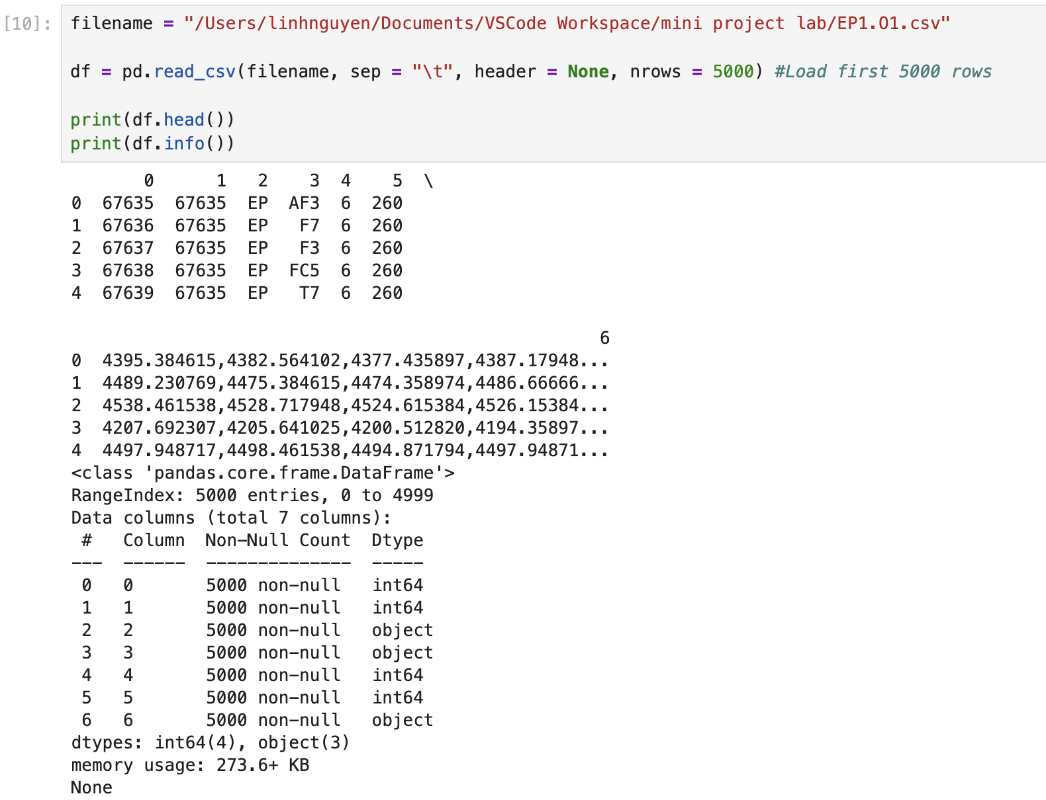
#Label each column
df.columns = ["id", "event", "device", "channel", "code", "size", "data"]
#Drop column because the dataset is default EP (Emotiv Epoc)
df = df.drop("device", axis=1)

print(df.head())
print(df.info())
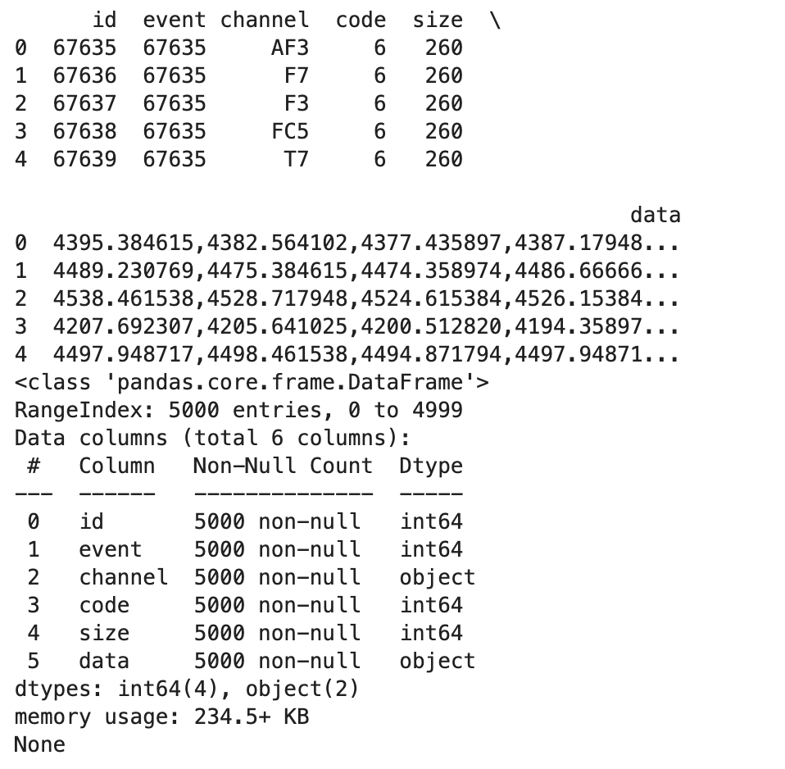
- Descriptive Statistics
- Resample data into same length
from scipy.interpolate import interp1d

#The fixed length for all signals. As established, 256 samples at 128 Hz gives exactly 2.0 seconds of data.
target_length = 256
fs = 128 # Emotiv EPOC (Sampling Frequency in Hz)
channels_of_interest = ["AF3", "F7", "F3", "FC5", "T7", "P7", "O1", "O2", "P8", "T8", "FC6", "F4", "F8", "AF4"]

#Resamples an array to the target length using linear interpolation
def resample_array(array, target_length):
current_length = len(array)
#Efficient check
if current_length == target_length:
return array
#Defining the original grid
input_indices = np.linspace(0, current_length - 1, current_length)
#Defining the new grid
resampled_indices = np.linspace(0, current_length - 1, target_length)
#Takes X-axis (input_indices) and original Y-axis (array, the signal amplitudes) and defines the line connecting all those points.
interpolator = interp1d(input_indices, array, kind='linear')
return np.round(interpolator(resampled_indices), 6)

def parse_and_resample(data_string, target_length):
try:
#Convert string to NumPy array
signal = np.array([float(x) for x in data_string.split(',')])
#Standardize length to 256
return resample_array(signal, target_length)
except ValueError:
return None
#Applies the parse_and_resample function to every single row in the existing 'data' column, creating new column named 'processed_signal'.
df['processed_signal'] = df['data'].apply(
lambda x: parse_and_resample(x, target_length)
)
#Removes any row from the DataFrame where the 'processed_signal' column contains the value None
df.dropna(subset=['processed_signal'], inplace=True)
print(f"Total valid rows remaining: {len(df)}")

- Stacking matrix
#Stacking the master matrix for data alignment and rectangularity
all_signals_matrix = np.vstack(df['processed_signal'].tolist())
print(f"Master Signal Matrix Shape: {all_signals_matrix.shape}")
print(all_signals_matrix)
- Global descriptive statistics
#Calculate global descriptive statistics (across all channels and timepoints)
print("GLOBAL DESCRIPTIVE STATISTICS (All Channels, All Timepoints)")

global_mean = np.mean(all_signals_matrix)
global_std = np.std(all_signals_matrix)
global_min = np.min(all_signals_matrix)
global_max = np.max(all_signals_matrix)
global_median = np.median(all_signals_matrix)
global_range = global_max - global_min

print(f"Overall Mean Amplitude (µV): {global_mean:.4f}")
print(f"Overall Median Amplitude (µV): {global_median:.4f}")
print(f"Overall Standard Deviation (σ): {global_std:.4f}")
print(f"Amplitude Range: {global_range:.4f} µV ({global_min:.4f} to {global_max:.4f})")
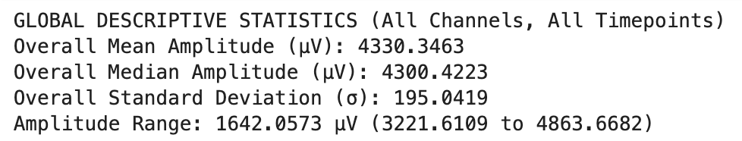
Analyze the result:
The mean amplitude is extremely high for typical EEG, which usually operates in the range of -100 to 100. This suggests the data contains a very large, constant DC offset, likely introduced by the specific EEG hardware setup which measures the raw electrode potential relative to ground.
Also, the variability is high. In comparison, the actual brain signal is only around 5 - 20. This shows the data is extremely noisy.
These are almost certainly transient artifacts like eye blinks or sudden cable movements (which cause spikes much larger than the constant DC offset).
- Descriptive statistics by Channel
#Calculate channel specific statistics
print("CHANNEL-SPECIFIC STATISTICS (Regional Differences)")

#Group the data by channel and calculate descriptive statistics on the signal array
channel_descriptive_stats = df.groupby('channel')['processed_signal'].apply(
lambda x: pd.Series({
#Each trial represents 2.0 seconds of brain activity. The analysis uses 256 time points per trial
'Trial_Count': len(x),
# Calculate standard deviation across all trials for this channel
'Mean_Std_Across_Trials': np.std(np.vstack(x.tolist())),
# Calculate the median value across all trials for this channel
'Median_Amplitude': np.median(np.vstack(x.tolist())),
# Calculate the amplitude range for this channel
'Amplitude_Range': np.ptp(np.vstack(x.tolist())),
})
#Convert the Series of Series into a DataFrame
).unstack()

# Sort by Mean_Std_Across_Trials
channel_descriptive_stats = channel_descriptive_stats.sort_values(
by='Mean_Std_Across_Trials', ascending=False
)

print(channel_descriptive_stats)
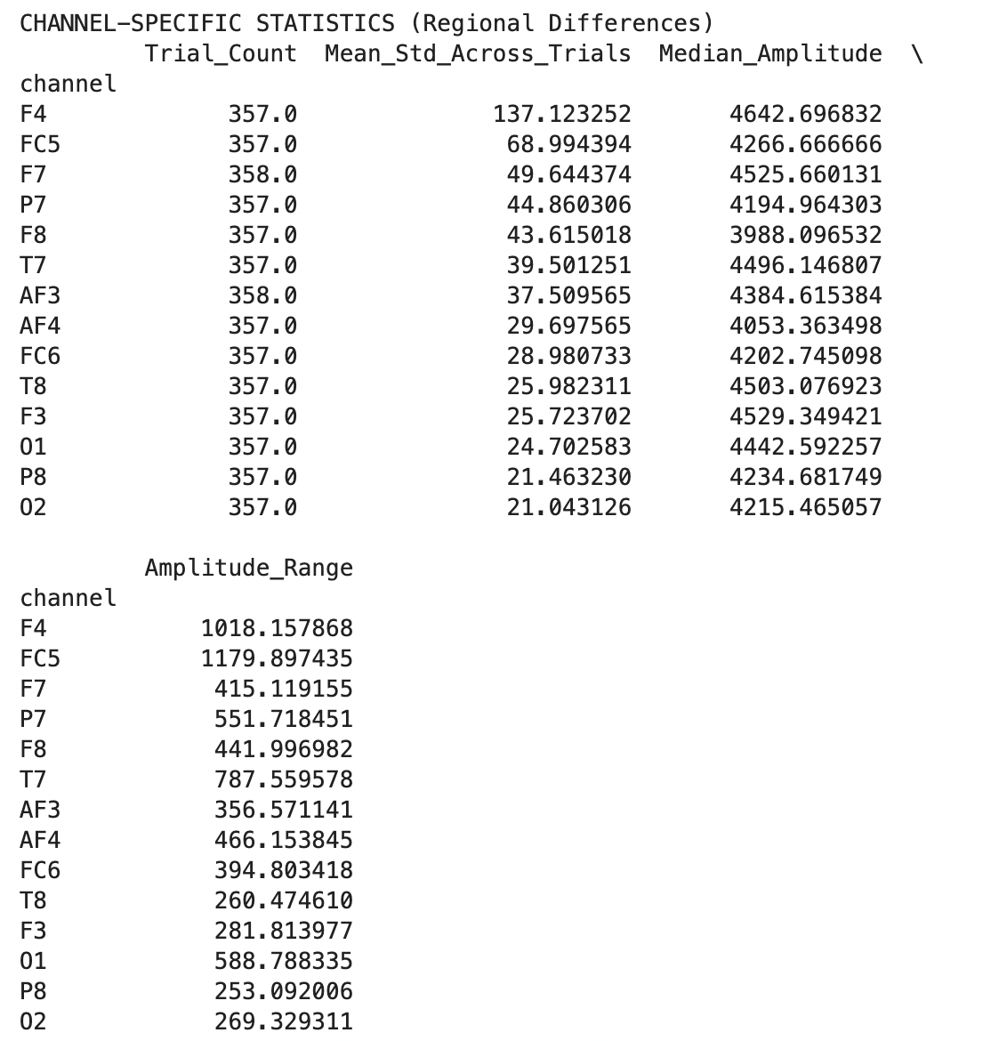
In 14-channel dataset, the channels are surrogates for the following brain lobes:
Functional Group | Channels | Location Detail | Primary Cognitive Function
1. Executive & Attentional Control | AF3, AF4, F3, F4 | Pre-Frontal & Mid-Frontal Lobe | Attention, working memory, planning, task switching
2. Motor & Action Planning | FC5, FC6 | Fronto-Central Region | Motor planning, error processing, somatosensory integration.
3. Temporal & Auditory Processing | T7, T8 | Mid-Temporal Lobe | Auditory processing, language comprehension (wernicke's area proximity).
4. Visual-Spatial Awareness | P7, P8 | Lower-Parietal Region | Visual-spatial attention, orientation, feature binding.
5. Primary Visual Processing | O1, O2 | Occipital Lobe | Primary visual processing, feature recognition.
Analyze the result:
The Standard Deviation (STD) measures the average magnitude of signal fluctuation around the mean. The Amplitude Range (Max - Min) measures the absolute total spread. High values here point strongly to noise/artifacts.
F4:
- STD: 137. 123252 μV (highest)
- Range: 1018.157868 μV
FC5:
- STD: 68.994394 μV
- Range: 1179.897435 μV (highest)
Location & Function | Interpretation
Frontal/Frontal-Central regions, near the eye and jaw muscles. | The F4 and FC5 channels captured the most extreme fluctuations. This is expected, as frontal channels are notoriously susceptible to noise generated by facial expressions, blinking, and chewing, etc. These artifacts are massive electrical signals compared to the tiny brain waves, causing high variance, which must be aggressively cleaned before classification.

O2:
- STD: 21.043126 μV (lowest)
Location & Function | Interpretation
Occipital region (back of the head), processing visual input. | Cleanest channel for Visual Evoked Potential. O2 is located far from major facial muscles, making it one of the "quietest" electrodes. Its low STD suggests two things:  1) Low noise (minimal eye movement), and  2) No strong constant activity

P8:
- Range: 253.092006 μV
Location & Function | Interpretation
Parietal/Temporal area. | Low regional activity or low noise profile. Low range suggests that, across all trials, this region did not exhibit extremely high positive or negative peaks. This could mean either:  1) The subject's task didn't engage this area much, or  2) It simply avoided the gross artifacts that plagued F4 and FC5.
Since the trial count (events) is not the same for every channel (F7 & AF3 is 358), we need to only keep events that are perfectly complete.
- Process unmatched length in Events (Trial Counts)
def filter_incomplete_events(df, num_expected_channels):
print(f"Ensuring Event Completeness for All Channels ({num_expected_channels})")

#Count the number of channels present for every unique event ID
event_counts = df.groupby('event').size()

#Identify the event IDs that have the full complement of channels
#These are the IDs where the count exactly matches the expected number (14).
complete_event_ids = event_counts[event_counts == num_expected_channels].index.tolist()

#Filter the original DataFrame to keep only the complete events
df_complete = df[df['event'].isin(complete_event_ids)].copy()

#Verification and Summary
new_trial_count = len(complete_event_ids)

print(f"Total rows originally processed: {len(df)}")
print(f"Total COMPLETE events (trials) found: {new_trial_count}")

if new_trial_count > 0:
print(f"Final data shape: {new_trial_count * num_expected_channels} rows.")

# Verify the final count for F7 and AF3 (must be the same)
final_channel_counts = df_complete.groupby('channel').size()

print("\nVerified Final Channel Counts")
print(f"AF3 Final Count: {final_channel_counts['AF3']}")
print(f"F7 Final Count: {final_channel_counts['F7']}")
print(f"Status: Trial counts are now perfectly balanced.")

filter_incomplete_events(df, len(channels_of_interest))
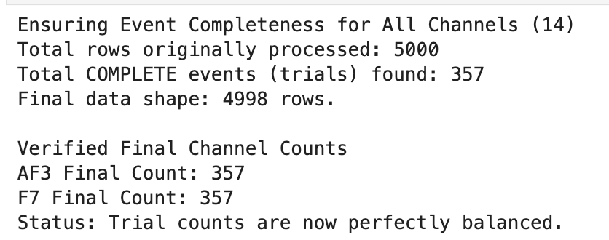
#Calculate trial by trial variablity
print("TRIAL-BY-TRIAL VARIABILITY (Noise Assessment)")

# Calculate the standard deviation (variability) for each individual trial
df['trial_std'] = df['processed_signal'].apply(np.std)

# Find the trials with the highest variability (potential artifacts)
most_variable_trials = df.sort_values(by='trial_std', ascending=False).head(5)

print("Top 5 Most Variable Trials (Highest STD - Potential Artifacts):")
print(most_variable_trials[['channel', 'code', 'trial_std', 'event']])
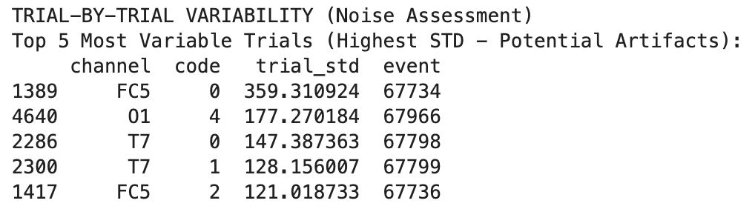
Analyze the result:
Row | Channel | STD (μV) | Digit Code | Interpretation
1389, 1417 | FC5 | 359.310924/  121.018733 | 0, 2 | Frontal Artifact: FC5 is near the fronto-central motor planning region, also close to the eye. This is a classic eye blink or muscle artifact.
4640 | O1 | 177.270184 | 4 | Occipital Anomaly: O1 (Visual cortex) is usually a quiet channel. An STD this high suggests a large, full-head artifact (like a head shift, cable movement, or sneeze) rather than localized muscle noise.
2286, 2300 | T7 | 147.387363/ 128.16007 | 0, 1 | Temporal Artifacts: T7 is the left temporal lobe, close to the jaw. This variability is often caused by chewing, swallowing, or slight jaw tension.

Event 1389 (FC5) has STD 359.31 μV, since global STD was around 195 (and the actual brain signal is only 5 μV - 20 μV), this trial is utterly dominated by noise.
Notice the code column (the digit the subject was viewing) shows 0, 4, 0, 1, 2.
- Correlation: The corruption of the signal is random and not related to the cognitive task itself. Event 1389 (Code 0) is corrupted not because the brain works differently for '0', but because the subject blinked or coughed at that moment.
- Preprocessing
- Bandpass window
#Define the bandpass window (0.5 Hz to 40 Hz)
low, high = 0.5, 40

#Bandpass filter design: Creates the filter coefficients (b, a)
#Order 4 provides a good balance between steepness and minimal distortion.
#Frequencies are normalized by the Nyquist frequency (fs/2).
b, a = butter(4, [low/(fs/2), high/(fs/2)], btype='band')

def bandpass(sig):
#Apply the bandpass filter forward and backward (filtfilt)
#to ensure zero-phase distortion.
return filtfilt(b, a, sig)
- Notch filter design
#Notch filter design (50 Hz power line noise)
#Q = 30 provides a sharp, narrow band rejection to minimize impact on neighboring brain rhythms.
notch_b, notch_a = iirnotch(50, Q=30, fs=fs)

def notch(sig):
#Apply the Notch filter for power line hum removal.
return filtfilt(notch_b, notch_a, sig)
- Clean signals
#Signal cleaning pipeline
def clean_signal(sig):
sig = sig - np.mean(sig) #Remove DC Offset: Subtracts the mean to center the signal at 0 µV.
#This addresses the large, non-neural bias observed in the global statistics (e.g., 4300 µV).
#Bandpass Filter: Removes slow drift (below 0.5 Hz) and muscle/EMG noise (above 40 Hz).
sig = bandpass(sig)
#Notch Filter: Removes the specific electrical hum frequency (50 Hz).
sig = notch(sig)
return sig
- Normalize Z-Score
def normalize(sig):
#Z-Score Normalization: Centers the signal at 0 (mean) and scales variance to 1.
#This is essential for deep learning models to treat features equally.
#1e-8 is added to the standard deviation to prevent division by zero for flat signals.
return (sig - np.mean(sig)) / (np.std(sig) + 1e-8)
#Data processing execution
# List to store the final cleaned, normalized signal arrays
processed = []
# List to store the corresponding digit code labels
labels = []

#Iterate over a sample of the DataFrame
for _, row in df.head(5000).iterrows(): #Try on 5000 samples (since 5000 is loaded)
#Parse data
sig = np.array([float(x) for x in row["data"].split(",")])
#Fulling cleaning chain
sig = clean_signal(sig)
#Z-Score normalization
sig = normalize(sig)
#Store final processed signals and its label
processed.append(sig)
labels.append(row["code"])
- Confirmation the preprocessing
#Confirm the preprocessing execution
#Choose trial sample index
sample_index = 0
try:
#Access raw data string
raw_data_string = df.iloc[sample_index]["data"]

#Parse and resample
signal_raw = np.array([float(x) for x in raw_data_string.split(",")])
signal_raw = resample_array(signal_raw, target_length)

#Apply the full cleaning chain to the raw signal
#Use .copy() to ensure the original signal_raw remains unchanged for comparison
cleaned_signal = clean_signal(signal_raw.copy())

except NameError:
print("ERROR: Necessary functions (clean_signal/resample_array) or DataFrame (df) are not defined.")
exit()
except Exception as e:
print(f"An error occurred during data extraction/cleaning: {e}")
exit()

print("NUMERICAL CONFIRMATION OF PREPROCESSING (BEFORE PLOTTING)")
print(f"Analysis performed on Sample Trial Index: {sample_index}\n")

#DC Offset Removal (Mean Amplitude)
raw_mean = np.mean(signal_raw)
cleaned_mean = np.mean(cleaned_signal)

print(f"1. DC OFFSET REMOVAL (Mean Amplitude):")
print(f" Raw Signal Mean: {raw_mean:.4f} µV")
print(f" Cleaned Signal Mean: {cleaned_mean:.4f} µV (Goal is near 0)")

#Noise Reduction (Standard Deviation)
raw_std = np.std(signal_raw)
cleaned_std = np.std(signal_cleaned)

print(f"2. NOISE REDUCTION (Standard Deviation):")
print(f" Raw Signal STD (Noise): {raw_std:.4f} µV")
print(f" Cleaned Signal STD (Noise):{cleaned_std:.4f} µV")
print(f" Reduction Percentage: {100 * (raw_std - cleaned_std) / raw_std:.2f}%")

#Total Signal Magnitude Check (Peak-to-Peak Range)
raw_range = np.ptp(signal_raw)
cleaned_range = np.ptp(signal_cleaned)

print(f"3. AMPLITUDE RANGE CHECK:")
print(f" Raw Signal Peak-to-Peak: {raw_range:.4f} µV")
print(f" Cleaned Signal Peak-to-Peak:{cleaned_range:.4f} µV")
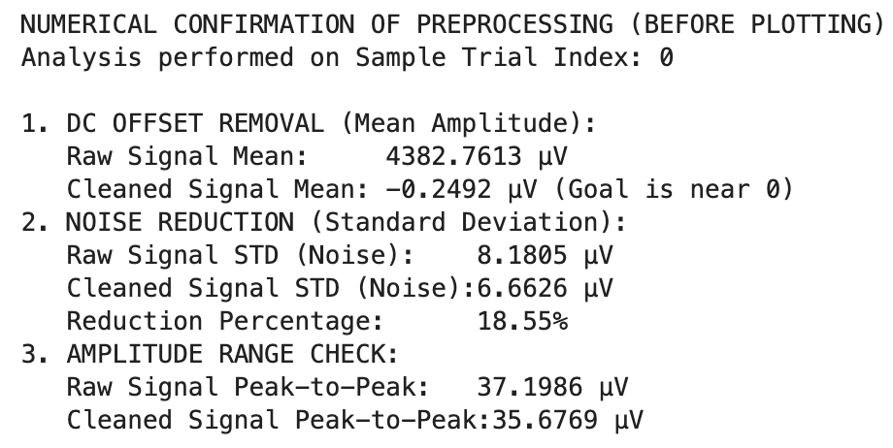
Analyze the result:
Statistic | Raw Signal Value (µV) | Cleaned Signal Value (µV) | Interpretation
Mean Amplitude | 4382.7613 | - 0.2492 | Success. The non-neural baseline of over 4300 µV has been effectively removed, and the signal is now centered at 0 µV, which is the correct baseline for true neural activity. This confirms the success of the sig = sig - np.mean(sig) step.
Standard Deviation | 8.1805 | 6.6626 | 18.55% Reduction. The overall electrical variance of the signal has been reduced by almost one-fifth. This confirms that the Bandpass and Notch filters successfully removed some systemic low- and high-frequency noise.
Peak-to-Peak Range | 37.1986 | 35.6769 | Low Reduction. The total range was reduced by only about 1.5 µV. This is because the signal did not contain any major, transient artifacts (like an eye blink or cable spike) that needed to be clipped.

- Visualization
- Single channel view
#Get the row corresponding to the sample index
selected_row = df.iloc[sample_index]
channel_name = selected_row["channel"]
event_id = selected_row["event"]
digit_code = selected_row["code"]

#Load and process signal for plotting
raw_data_string = selected_row["data"]
signal = np.array([float(x) for x in raw_data_string.split(",")])
signal = resample_array(signal, target_length)
cleaned_signal = clean_signal(signal.copy())

#Plotting code
fig, axes = plt.subplots(2, 1, figsize=(12, 6), sharex=True)
fig.suptitle(f"Raw vs. Cleaned EEG Signal | Index {sample_index}, Event ID {event_id}, Digit: {digit_code}, Channel: {channel_name}", fontsize=14)

#Raw Signal (Highlighting DC Offset and Noise Scale)
axes[0].plot(signal, label="Raw Signal", color="#D62728", linewidth=1)

#Calculate the DC offset line (the mean) to emphasize the bias
raw_mean = np.mean(signal)
axes[0].axhline(raw_mean, color='#FF9896', linestyle='--', label=f'Mean/DC Offset ({raw_mean:.1f} µV)',linewidth=0.8, alpha=0.7)

axes[0].set_title(f"1. Raw Signal ({channel_name}) | High DC Offset and Artifacts")
axes[0].set_ylabel("Amplitude (µV) - Large Scale")
axes[0].legend(loc='lower left')
axes[0].grid(True, linestyle=':', alpha=0.6)

#Cleaned Signal (Highlighting Centered and Reduced Noise)
axes[1].plot(cleaned_signal, label="Cleaned Signal", color="#2CA02C", linewidth=1)

#Add the final mean line to confirm centering at 0
axes[1].axhline(0, color='black', linestyle='--', linewidth=0.8, alpha=0.7)

axes[1].set_title(f"2. Cleaned Signal ({channel_name}) | DC Offset Removed, Noise Filtered")
axes[1].set_ylabel("Amplitude (µV) - Neural Scale")
plt.xlabel(f"Time Samples")

#Adjust Y-axis limits to focus only on the neural activity scale
current_std = np.std(clean_signal(signal))
axes[1].set_ylim(-3 * current_std, 3 * current_std) #Set limits relative to the clean signal's STD
axes[1].legend(loc='lower left')
axes[1].grid(True, linestyle=':', alpha=0.6)

plt.tight_layout(rect=[0, 0, 1, 0.96])
plt.show()
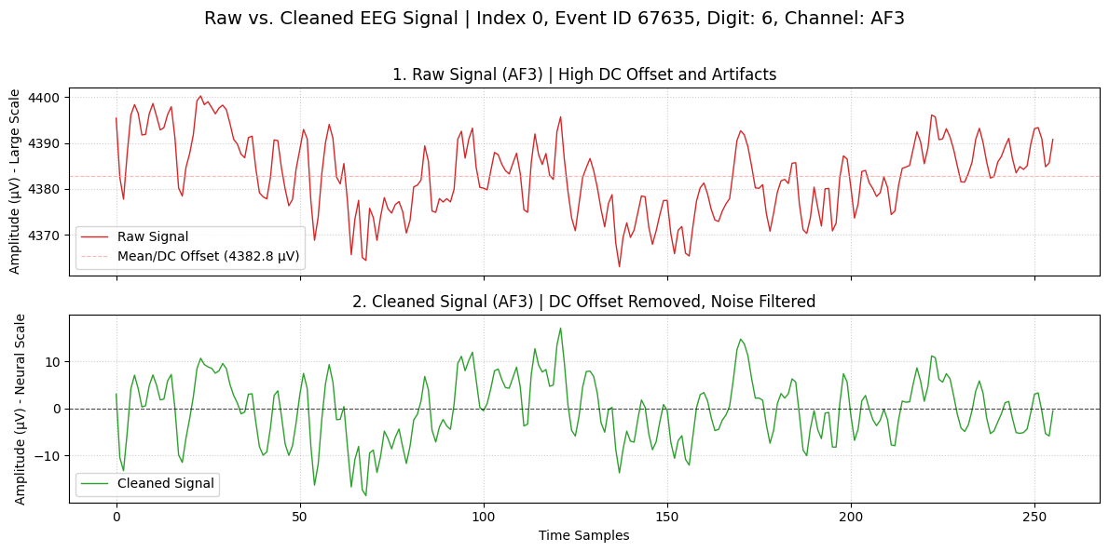
Analyze the chart:
Category | Top Panel  (Raw Signal) | Bottom Panel  (Cleaned Signal)
Type of Chart | Time-Series Line Plot | Time-Series Line Plot (Diagnostic View)
Vertical Scale | Large scale (~4370–4430 µV) dominated by DC offset | Neural scale (–20 to +15 µV), centered around zero
Baseline / Offset | Strong DC offset around ~4382 µV | Baseline corrected to near 0 µV
Noise Level | High; includes drift, low-frequency noise, and artifacts | Reduced noise; clearer rhythmic activity
Trend Visibility | Hidden by large baseline and drift | Clear oscillatory EEG patterns visible
Peaks | Small fluctuations (~10–20 µV) obscured by offset | Distinct peaks: ~+15 µV and –20 µV
Interpretability | Low; raw voltages obscure neural information | High; cleaned waveform reveals neural dynamics

- Raw view of 14 channels on same event
import matplotlib.pyplot as plt

subset = df[df["event"] == event_id]

plt.figure(figsize=(12,6))
for _, row in subset.iterrows():
signal = np.array([float(x) for x in row["data"].split(",")])
plt.plot(signal, label=row["channel"])

plt.title(f"Raw EEG Signals Across 14 Channels | Event ID {event_id} | Digit: {digit_code}")
plt.xlabel("Time Samples")
plt.ylabel("Amplitude (µV)")
plt.legend()
plt.show()
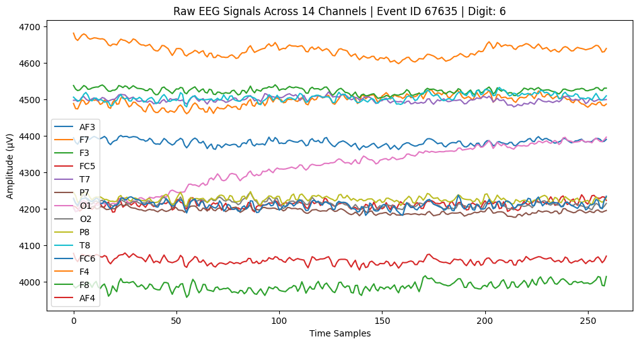Figure 1. Raw EEG Signals Across 14 Channels
- Cleaned spatial view of 14 channels on same event
#Isolate the full event subset (all 14 channels)
event_subset = df[df["event"] == event_id].copy()
channels = event_subset['channel'].unique()
num_channels = len(channels)

#Get the color palette (assuming it's defined elsewhere)
COLOR_CYCLE = plt.cm.tab10.colors
COLOR_LIST = [COLOR_CYCLE[i % len(COLOR_CYCLE)] for i in range(16)]

#Set up the 4x4 plotting grid
fig_spatial, axes_spatial = plt.subplots(4, 4, figsize=(18, 12), sharex=True)
axes_spatial = axes_spatial.flatten()
time_axis = np.arange(target_length)

#Determine Global Y-Limits for Cleaned Signals
all_clean_stds = []
processed_signals = {}
for _, row in event_subset.iterrows():
# Process signal once to determine its clean STD
raw_sig = np.array([float(x) for x in row["data"].split(",")])
raw_sig_resampled = resample_array(raw_sig, target_length)
cleaned_sig = clean_signal(raw_sig_resampled.copy())

#Store processed signal for plotting
processed_signals[row['channel']] = cleaned_sig
all_clean_stds.append(np.std(cleaned_sig))

#Set consistent clean Y-limit (4 times the mean STD of all channels)
global_clean_std = np.mean(all_clean_stds)
y_limit_clean = 4 * global_clean_std

fig_spatial.suptitle(
f"Cleaned EEG Signals Comparison Across {num_channels} Channels | Event ID {event_id} | Digit: {digit_code}",
fontsize=16
)

#Iterate and Plot (Two lines per subplot)
for i, current_channel in enumerate(channels):
ax = axes_spatial[i]
current_color = COLOR_LIST[i]
row = event_subset[event_subset['channel'] == current_channel].iloc[0]

#Reprocess the raw and clean signal for plotting
raw_sig = np.array([float(x) for x in row["data"].split(",")])
raw_sig_resampled = resample_array(raw_sig, target_length)

#Plotting cleaned signal
ax.plot(time_axis, processed_signals[current_channel], label="Cleaned", color=current_color, linewidth=1.5)

#Annotate and Style
ax.set_title(f"{current_channel}", fontsize=12, color=current_color)
ax.axhline(raw_mean, color='r', linestyle=':', linewidth=0.5, alpha=0.5) #DC offset line
ax.axhline(0, color='k', linestyle='-', linewidth=0.8, alpha=0.7) #Zero line

ax.set_ylim(-y_limit_clean, y_limit_clean) #Set clean Y-limit
ax.grid(True, linestyle=':', alpha=0.5)

#Final Axis Labels
if i == 0:
ax.legend(loc='upper right', fontsize=8) #Only show legend once

#Final Layout Adjustments
for i in range(16):
ax = axes_spatial[i]
if i < num_channels:
if i >= 12:
ax.set_xlabel("Time Samples")

if i % 4 == 0:
ax.set_ylabel("Amplitude (µV)")

else:
fig_spatial.delaxes(ax)

plt.tight_layout(rect=[0, 0, 1, 0.96])
plt.show()
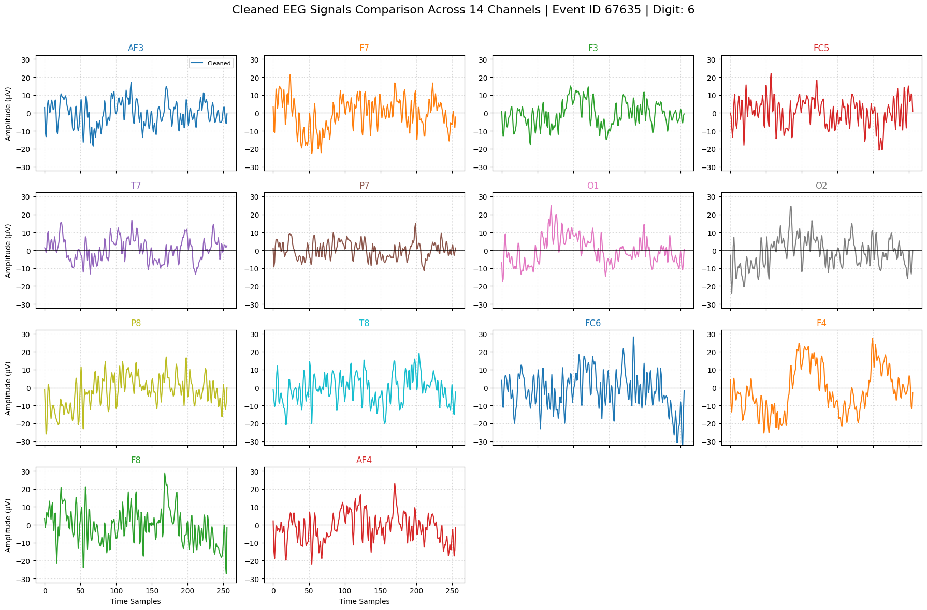Figure 2. Cleaned EEG Signals Across 14 Channels
Compare two figures:
Aspect | Figure 1: Raw EEG Signals Across 14 Channels | Figure 2: Cleaned EEG  (Per-Channel Subplots)
Chart Type | Single multi-line plot with all 14 channels overlaid | Grid of 14 individual subplots, one channel per panel
Horizontal Axis | Time (samples), ~0–260 | Time (samples), ~0–260
Vertical Axis | Amplitude (µV), large range (4000–4700 µV) due to DC offset | Amplitude (µV), centered around –30 to +30 µV
Signal Characteristics | Strong DC offset, channel drift, mixed noise | Baseline-corrected, noise-reduced, clearer oscillations
Trend Visibility | Trends hidden by large offsets and slow drift | Clear neural activity patterns across all channels
Peak Behavior | Peaks small relative to offset, difficult to interpret | Peaks distinct (±10–25 µV), easier to analyze
Interpretability | Low—raw voltage overwhelms signal | High—clean signal suitable for analysis and ML
Purpose | Visualizing unprocessed sensor output | Comparing cleaned neural activity before feature extraction
Usefulness for BCI | Poor—requires preprocessing | Excellent—preprocessed features ready for modeling

Correlation:
The plots show clear differences in signal variance and pattern (morphology), which suggests low correlation between signals from different functional regions.
- High Positive Correlation (Likely): Between neighboring channels in the same functional group, such as O1 and O2 (Occipital). Their waveforms track each other closely, indicating synchronized activity.
- Low/Zero Correlation (Ideal for Classification): Between signals from functionally distinct regions, such as AF3 (attention/frontal) and O1 (vision/occipital). The signals are temporally distinct, allowing the classifier to use them as independent features.
- Anti-Correlation (Strong Feature): The F4 channel shows a clear pattern that seems to swing positive and negative differently from the other frontal channels, confirming its high STD found in the descriptive statistics.
Functional Region | Observation in Plot | Feature Significance for Classification
Frontal/Artifact Zones (F4, FC5) | Signals are chaotic but show large, slow swings (potentially residual low-frequency Electrooculography by eye movements (EOG)). | Can be used to decode Attentional Effort or a specific high-amplitude component that is required for digit processing.
Occipital Zones (O1, O2) | Show distinct, clear peaks (the early components of the Visually Evoked Potential (VEP)). | Pinpoints the timing of Visual Sensory Registration—essential for decoding the moment the digit was seen.
Temporal Zones (T7, T8) | Show generally lower amplitude and more sporadic activity. | Helps eliminate noise and serves as a control channel or a reliable benchmark for lower activity.

- Average Waveform on Same Digit
def plot_digit_erp(df, digit, sample_size):
#Isolates all rows (signals) that correspond to the target digit code (e.g., code 6).
subset = df[df["code"] == digit].head(sample_size).copy()

if subset.empty:
print(f"Error: No trials found for digit {digit}. Load more data to find the digit.")
return

signals = []
signal_lengths = []

#Extract, parse, clean, and normalize signals
for i, row in subset.iterrows():
try:
sig = np.array([float(x) for x in row["data"].split(",")])
sig = resample_array(sig, target_length)
sig = clean_signal(sig)
signals.append(sig)
signal_lengths.append(len(sig))
except ValueError as e:
print(f"Skipping row {i} due to non-numeric data in 'data' column: {e}")
continue

#Plotting
if signals:
avg_signal = np.mean(signals, axis=0)
plt.figure(figsize=(10,4))
plt.plot(avg_signal)
plt.title(f"Average EEG Waveform Across 14 Channels | Digit = {digit} | Size: {sample_size}")
plt.xlabel("Time Samples")
plt.ylabel("Amplitude (µV) ")
plt.show()
else:
print("Cannot plot: 'signals' list is empty or filtering removed all elements.")

plot_digit_erp(df, 6, 50)
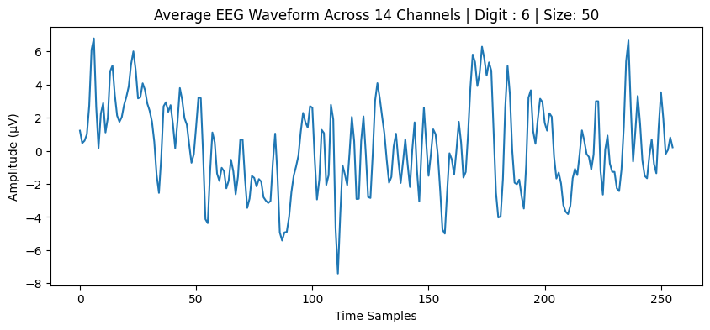
Analyze the chart:
Trend Observations
The waveform appears noisier and more irregular, which is expected when averaging fewer trials.
- Early segment (0–60 samples):
  - Strong positive bursts up to +6–7 µV.
  - Followed by rapid oscillations shifting toward negative amplitudes.
- Middle segment (60–150 samples):
  - Increased jitter and inconsistent direction changes.
  - No clear sustained pattern emerges.
- Late segment (150–260 samples):
  - Alternates between positive and negative swings without a stable trend.
  - Peaks and troughs appear sharper due to less noise cancellation.
Peak Observations
- Highest positive peak: ~+7.0 µV near ~10 samples and again around ~220.
- Deepest negative excursion: approximately –8 µV near ~115 samples.
- These peaks are more extreme, reflecting:
  - Higher noise
  - Less cancellation of random fluctuations
  - Greater variability in neural response timing
- Overall, the waveform lacks the smooth structure typically observed in high-trial averages due to small sample
- Increase the sample size to 100
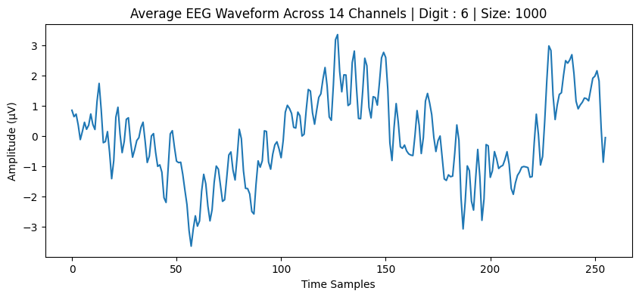
Trend Observations
The waveform exhibits a mixture of rising and falling patterns consistent with normal EEG variability.
- Early segment (0–60 samples):
  - Mostly negative swings, dipping to ~–2.5 µV.
- Middle segment (60–150 samples):
  - Clear upward trend reaching strong positive peaks around 3–3.5 µV.
  - This may reflect a task-related positive deflection (similar to P200/P300 style activity depending on timing).
- Late segment (150–260 samples):
  - More oscillatory, alternating between moderate positive and negative amplitudes.
  - Suggests settling neural activity after the main event-related response.
Peak Observations
- Highest positive peak: ~+3.4 µV near sample ~135.
- Deepest negative excursion: ~–3.3 µV near sample ~190.
- The smoothness of the peaks indicates successful averaging across many trials, reducing noise and highlighting consistent neural components.
- Discussion and Scholarly Context (Further Application)
VEP ( Visually Evoked Potential) Template Creation: The resulting Grand Average ERP plot serves as the statistically reliable template for the cognitive response to the digit stimulus.
BCI Foundation: The resulting clean, standardized feature matrix can be the direct input for a Brain-Computer Interface (BCI) decoder. This methodology is used to train classifiers (like the 1D CNN) to perform tasks such as multi-class prediction (identifying the cognitive intent) which is the basis for communication and control systems.
Neural Discrimination: The successful isolation of the VEP components suggests the presence of distinct patterns between digit codes, which is the necessary prerequisite for successful classification.

