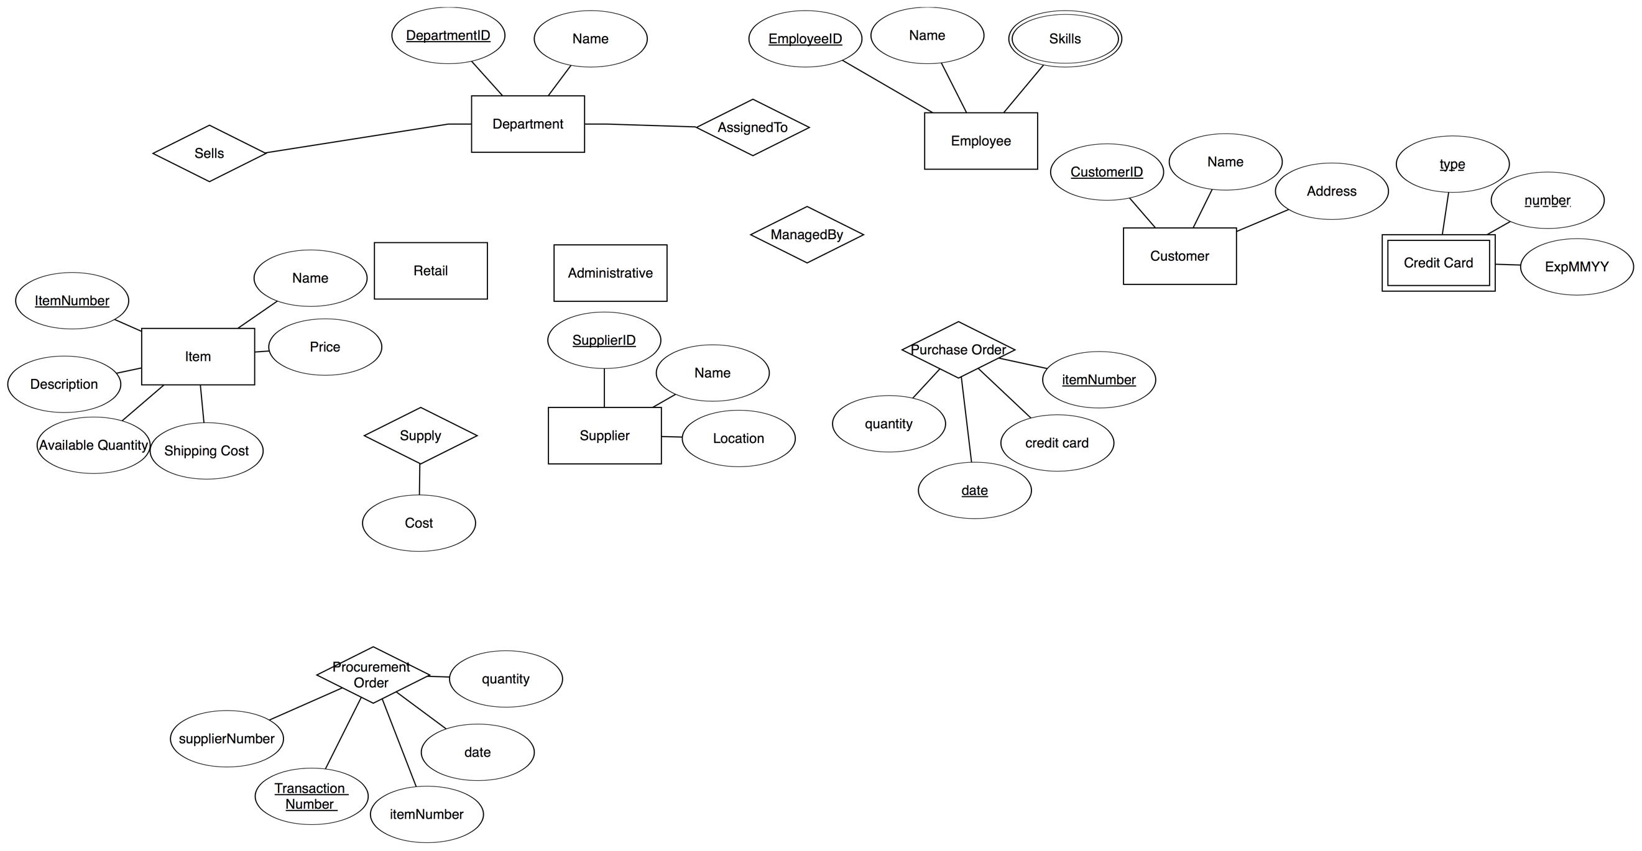

Key: Customer, Item, Date

Disjoint

Owns

Cover

IsA

IsA

0..40

1. Part of the description I haven’t been able to represent in my diagram is: A customer is allowed at most 10 purchases in each month.

* Binary relationship type ManagedBy between Employee and Administrative Department is many-to-one: Administrative Departments have one manager who is an employee who works for the department, e.i. each Administrative Department has at most one manager. However, each Employee can manage any number of Administrative Department.
* Binary relationship type ProcurementOrder between Department and Supplier is many-to-many: A Department can place the ProcurementOrder with any number of Supplier and vice versa.
* Binary relationship type PurchaseOrder between Item and Customer is many-to-one: Each customer is only allowed to buy the same item no more than once in a given date, but the item can be bought by many different customers.
* Binary relationship type AssignedTo, Sells, Supply, between are neither many-to-many, many-to-one, nor one-to-one.