1. Question-1

# Question: Why 25 observations??

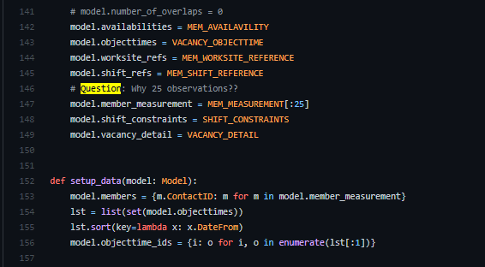

At line 146, I just limited the number of members who might be assigned.

Also, at line 156 I limited the number of days of the vacancy.

**Why**: I limited them because I want to reduce the running time.

1. Question-2

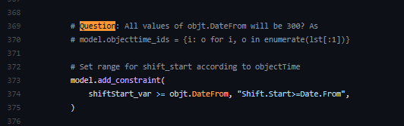

Because I limited the number of days of vacancy to 1, so there is only 1 day (object-time) to be considered. The value 300 is the start-time of that day. 300 is 5:00 am counted from 00:00 of the first day of the vacancy.

For example, the vacancy is from 3/1/2022 to 10/1/2022. Then we consider the first day 3/1. That working day is start from 05:00 to 22:00pm then objt.DateFrom = 5:00 = 60*5 = 300 (mins), objt.DateTo = 22:00 = 22*60 = 1320 (mins). The second day may be the same or different depends on the input excel data. If the second day is from 6am to 20pm then they will be converted to (6+24)*60 and (20+24)*60

1. Question-3

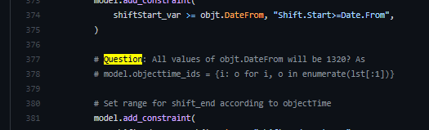

I answered this on the question 2 above. 1320 is the DateTo of the first considered day, every day will be differrent

1. Question-4

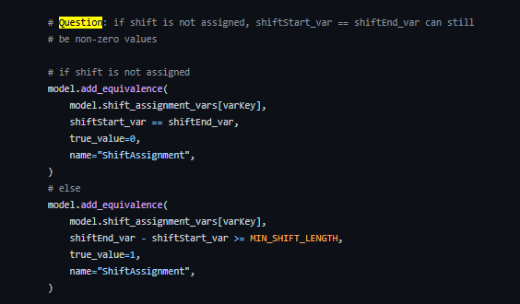

There is a flag binary variable to say a shift is assigned or not. If the flag is True then this shift is assigned as well as Shift_end – Shift_start >= MIN_SHIFT_LENGTH. Otherwise, the flag is False.