Software Requirements Specification

for

Embedded Devices Management

Version v4.28 approved

Prepared by:

Group 5

09/01/2017

**Contents**

Information Document and Author iv

Tracking of Document Version iv

1. Introduction 6

**1.1 Purpose 6**

**1.2 Document Conventions 6**

**1.3 Intended Audience and Reading Suggestions 7**

**1.4 Product Scope 7**

**1.5 Terms and Abbreviate 8**

**1.6 References 8**

2. Overall Description 8

**2.1 Product Perspective 8**

**2.2 Product Functions 9**

**2.3 User Classes and Characteristics 10**

**2.4 Operating Environment 11**

**2.5 Design and Implementation Constraints 11**

**2.6 User Document 12**

**2.7 Assumptions & Dependences 12**

3. External Interface Requirements 12

**3.1 User Interfaces 12**

**3.2 Hardware Interfaces 13**

**3.5 Software Interfaces 13**

**3.4 Communications Interfaces 14**

4. System Features 1

**4.1 UC_001 – Borrow Device 1**

**4.2 UC_002 – Change Password 3**

**4.3 UC_003 - Decentralization Member 4**

**4.4 UC_004 – Display Information 6**

**4.5 UC_005 – Find 8**

**4.6 UC_006 - Logout 9**

**4.7 UC_007 – Manage Member 11**

**4.8 UC_008 – Manage Project 12**

**4.9 UC_009 – Manage LabRoom 14**

**4.10 UC_010 – Manage Producer 15**

**4.11 UC_011 – Manage Device 17**

**4.12 UC_012 – Change Personal Information 18**

**4.13 UC_013 – Setting 19**

5. Other Nonfunctional Requirements 21

**5.1 Performance Requirements 21**

**5.2 Exporting Requirements 21**

**5.3 Security Requirements 21**

**5.4 Software Quality Attributes 22**

**5.5 Software Quality Attributes 24**

6. Other Requirements 24

Appendix A: Glossary table 24

Appendix B: Analysis Models 24

**1. UC_Login 24**

**2. Use Case Diagram: Full size: drive.google.com/drive/folders/0BwvTggymLfLOampveGZPOVUyU2M?usp=sharing 26**

**3. Class Diagram: full size: drive.google.com/drive/folders/0BwvTggymLfLOampveGZPOVUyU2M?usp=sharing 26**

**4. Entity-Relationship Model: full size: drive.google.com/drive/folders/0BwvTggymLfLOampveGZPOVUyU2M?usp=sharing 27**

**5. Sequence diagram 27**

**6. Goal tree: full size: drive.google.com/drive/folders/0BwvTggymLfLOampveGZPOVUyU2M?usp=sharing 28**

**7. Goal analysis diagram: Full size: drive.google.com/drive/folders/0BwvTggymLfLOampveGZPOVUyU2M?usp=sharing 29**

**8. Analyzing costs - Penefits : This file in: drive.google.com/drive/folders/0BwvTggymLfLOampveGZPOVUyU2M?usp=sharing 29**

**9. Q & A: 32**

**10. Matrix requirements: This file in: drive.google.com/drive/folders/0BwvTggymLfLOampveGZPOVUyU2M?usp=sharing 36**

Appendix C: To Be Determined List (Null) 38

# 

# Information Document and Author

Group 5:

Project's Name on RRC Package: quanlynhung_nhom5

Github soure code link: <https://github.com/ngthuc/ptycpm_htql_thietbinhung>

Website link: <https://demo.ngthuc.com/project/ptycpm/login>

Default Account: 2709 Pass : 123123

Additional documentation: <https://drive.google.com/drive/folders/0BwvTggymLfLOampveGZPOVUyU2M>

List of Members:

|  |  |  |
| --- | --- | --- |
| Serial | Full name | Student code |
| 1 | Nguyen Quoc Khanh | B1400696 |
| 2 | Duong Van Lang | B1400700 |
| 3 | Le Minh Luan | B1400704 |
| 4 | Nguyen Thien Minh | B1400706 |
| 5 | Doan Minh Nhut | B1400713 |
| 6 | Huynh Hoang Tho | B1400729 |
| 7 | Le Nguyen Thuc | B1400731 |
| 8 | Huynh Bao Toan | B1400734 |
| 9 | Trac Man Tiep | B1400797 |
|  |  |  |

# Tracking of Document Version

|  |  |  |  |
| --- | --- | --- | --- |
| **Name** | **Date** | **Change Reason** | **Version** |
| Software Requirements 1501 | 15/01/2017 | First Document | 1.15 |
| Software Requirements 2002 | 20/02/2017 | Update Function & Description First | 2.20 |
| Software Requirements 1604 | 16/04/2017 | Update Function & Description Second | 4.16 |
| Software Requirements 2804 | 28/04/2017 | Update Function & Description the Last Time, Project Accomplish | 4.28 |

# Introduction

## Purpose

Successfully built the payment system for embedded devices worked on Web-based. The new system responsed demand:

* Manage for the payment for embedded devices, members, projects, labs, information partners provice used devices work on resreach, study have used embedded devices. Make sure to provide functionality same as the previous crafting management process.
* Contribute to increased convenience, cost savings with the help of technology, overcoming disadvantages of the old process, ensure strict management through decentralization of membership.
* Ensure information consistency, storage work and query by storing it on a database

## Document Conventions

Document Structure: Titles are marked according to numbered list(example, 1, 2, d3, v.v ...), smaller titles are marked according to numbered subsections(example: 1.1, 1.2, 1.3, v.v ...).)

Document Convention:

* Font: Time New Roman.
* Font size: 13 .(except content and data table in Appendix B).
* Font color text: Black.
* Font color title: Blue.
* Margin-left: 3.5 cm.
* Margin-right: 2 cm.
* Margin-top: 3 cm.
* Margin-bottom: 3 cm.
* Line spacing: 1.2 pt.
* The title is bold and larger than the content 2pt. Each title will increase 2pt if the title is larger than the previous title.
* Color Text: Black (Topic and someone Table on Appendix B: Blue or Orgrane).

## Intended Audience and Reading Suggestions

Read Object included: Members, group belong to Software Developer manage embedded devices

**Document included**

* Introduce included: Purpose, The intended audience and suggested reading, Product range, referance documents.
* Overall description included: viewpoint product; product function; user layer & feature, Operating environment;product function; User Guide; assumption & dependent
* Requires an external interface included: user interface;hardware interface software interface,communication interface

**System punction.**

* Other non-functional requirements include: performance,safety; security requirements; Software Quality Attributes; Business rules
* Other requirements.
* Appendix A: Glossary.
* Appendix B: Analytical Models.
* To Be Determined List.

## Product Scope

* Product area:

- Application of information technology in management.

- Strict application of products in the field of information technology.

* Time work : 4 moth (After begin day project: 09/01).
* The scope: Deployed on company, organi in the whole territory of Vietnam is want Embedded Devices Management a online with network Internet.
* Object serving of this software:Manager embedded device, all member want to borrow device .
* Object using document: Group building and pronounciation software K40, Analysis document for Embedded Devices Management CT241, person is manager and testing this software ( Teacher ).
* Basic Content: Analysis apply for archivers - Analysis apply for management.

## Terms and Abbreviate

|  |  |  |
| --- | --- | --- |
| Serial | Terms/abbreviate | Define/ Explain |
| 1 | IDE | Integrated Development Environment |
| 2 | JS | JavaScript |
| 3 | Manager | Orther speaking of Embedded Devices System Manager. |
| 4 | System manager |
| 5 | Embedded Devices Manager |
| 6 | Basic User | Accounts decentralization default |
| 7 | IT | Information Technology |
| 8 | Basic | All account isn’t manager account. |

## References

[1] Requirement analysis in software engineering – Can Tho University.

[2] Software requirements specification by

<https://hienngong.files.wordpress.com/2012/09/mau-bm-qtpm-cnpm-dac-ta-yeu-cau-phan-memsrs-v2-0.doc>

[3] IEEE Recommended Practice for Software Requirements Specifications – Michigan State University

[4] Software Requirements Specification Amazing Lunch Indicator - <http://www.cse.chalmers.se/~feldt/courses/reqeng/examples/srs_example_2010_group2.pdf>.

[5] Software Requirements Specification for nTravel

<https://cs.gmu.edu/~dfleck/classes/cs421/spring08/SampleProject/FINAL%20SRS.pdf>

[6] Software requirements specification guide:

https://www.wattpad.com/4972601-3-1-phân-tích-and-đặc-tả-yêu-cầu-phần-mềm-đặc-tả

# Overall Description

## Product Perspective

In the period of industrialization and modernization of the country, the application of science and technology to work and life is very necessary, and information technology has become an effective tool for the work for us, The management of general equipment and embedded devices in particular in the school, it is a waste of time when managed on the papers. With problem of embedded device management, borrowers find it hard to have information about equipment that can be borrowed, repayment period, How to borrow, How to make relevant documents, Managers often have difficulty in updating information, having problems with large amounts of documents, documents can damage the loss during storage.

Therefore, embedded device management system, to ensure data security, automatic and saving more time. In this section we propose to build a "Embedded Device Management System"on web-base, that supports users and managers, who can access to it anytime, anywhere. Base on web technology is storge database, that helps to solve process and borrows by algorithms, ensure storge using the database structure. This solution helps quick statistics, high accuracy. The comfortable geographical of access,cost saving, time, easy to manage in the future.

## Product Functions

This system has functions:

* Manage members:
* Add member.
* Change personal information.
* Delete member.
* Manage device:
* Update device information.
* Add device.
* Change device information.
* Delete device.
* Allow borrow device.
* Confirmed extension of borrow.
* Display information
* Display device information.
* Display project information.
* Display lab room information..
* Display member information.
* Display personal information.
* Display device borrow information.
* Login.
* Logout.
* Change password.
* Decentralization member.
* Manage Project:
* Add Project.
* Change project information.
* Delete project.
* Manager producer (Partner supplies equipment).
* Add producert.
* Update producer information.
* Delete producer.
* Manage lab room.
* Add lab.
* Update lab.
* Delete lab.
* Find
* Find device.
* Find member.
* Find device.
* Find project.
* Borrow device.
* Adjourn borrow return time.
* Register borrow device:
* Register borrow of project.
* Register borrow of personal.

## User Classes and Characteristics

|  |  |  |  |  |  |
| --- | --- | --- | --- | --- | --- |
| Serial | User | Feature | Functions | Role & level of importance | Requirement |
| 1 | Embedded Device Manager | Manage information & data of the whole system & authorized to set permission for other user | Authorized functions mentioned in section 2.2.Except 2 function in registered item to borrow device:   * Adjourn borrow return time. * Borrow register device : * Register borrow of Project. * Register borrow of personal | Role:  the Highest administrator  Level: very important | Understanding knowledge about IT field  The knowledge of data control and information  Knowledge and experience in managing embedded devices |
| 2 | Member | Allowed to use the system functions. However, limited functionality to changes the database (only for administrators) | * Display information * Login. * Logout. * Change password * Find * Register borrow device | Role: basic user  Level:very improtant | Understanding knowledge about IT field  Knowledge about rule for borrow embedded device |
| ***NOTE: this is basic permission usage, accounts can have function depend on the administrator's authority*** | | | | | |
|  |  |  |  |  |  |

## Operating Environment

Hardware:

|  |  |  |
| --- | --- | --- |
| **System requirement** | **Minimum** | **Recommended** |
| CPU | - Intel(R) Core(TM) 2 CPU E4600 @ 2.40GHz or higher .  - Pentium(R) Dual-Core CPU E2210 @ 2.20 GHz or higher. | - Intel(R) Core(TM) i3-2100 CPU @ 3.10 GHz or higher. | |
| RAM | 1 GB. | 2 GB or higher. | |
| Graphics | Not required | 512 Mb or higher. | |
| Storge | 0.5GB available space | 1GB available space | |
|  |  |  |

Software:

|  |  |  |
| --- | --- | --- |
| **Requirement** | **Minimum** | **Recommended** |
| Adobe Flash Player | Version for 2010 to now | New version now. | |
| Browser | All version browser to 2010 for now | Opera, Mozilla Firefox, Chrome, CocCoc, Yandex, Microsoft Edge, Safari  (All version now) | |
| System Operating | WindowsVista/Windows7/Windows XP/ Windows 8 /Windows 2003 Server/All version Linux for 2000 to now/ all version Mac OS for 2000 to now. | Windows 7 (64/32 bit)/ Windows 8 (64/32 bit)/ Windows 10/Ubuntu 14.04/Ubuntu 16.04, Mac OSX. | |
|  |  |  |

## Design and Implementation Constraints

* Constraints Implement:
* The interface is easy to use with the user, all functions easy to see, easy to implement .
* Devices that want to use the software must connect to the Internet to the application's web site with a web browser .
* Users who want to use the product must have an account and password to login
* Design contraint
* Program language: Web Programing with:
  + Front-end: HTML/CSS + Bootstrap, JS (Ajax, jQuery, JSON)
  + Back-end: PHP, Java Script
* Database design language: MySQL.
* Interface Langguage: Vietnamese.
* IDE: Atom, USBWebServer.
* Graph Drawing Tools: Start UML, Edraw Max
* Documentation and Presentation: Microsoft Ofice 2013, Libre Office.

## User Document

## Assumptions & Dependences

- Website hacked.

- Hardware device malfunction abruptly.

- Unstable power supply or lack of solution for backup power supply.

- Wifi malfunction disconnects

- Handing over the product is not timely

- Sudden changes in the project document.

# 3. External Interface Requirements

## 3.1 User Interfaces

- Font: sans-serif.

- Button: Background color and text color depending on the context, monochrome.

- Menu: Placed at the top of the site.

- The message display as the target (header above) or as text in the layout

- The confirmation dialog box used Dialog.

- Program interface: Type of website interface, included pages:

* Index
* Admin
* Contact
* Device
* Footer
* General
* Header
* Labs
* Login
* Members
* Menu
* Profile
* Project
* Search

Pages can be organized horizontally in the top left of the screen. At the top right of the screen is the login interface, that allows users to use the account to log in, located in the top of same frame as the search box ... The bottom is the contact information, product introduction.

## 3.2 Hardware Interfaces

Hardware support requirements used in the project include:

* Computer: A Computer for Manager Used to manage devices and related to Member with website Manage Embedded Device.
* Database: Capable of holding large data, Allows quick connection, Supports multiple retrieval at the same time. Availability on The expansion of the databse was developed earlier.
* Interactive software with user by mouse, display and keyboard.
* Connection: Need support for connection Internet for device by network wired or wireless network.
* Server HTTPs, server Databasse specific application so as not to affect the existing system.
* User send requirement from system and system will return results to requirement, if have.



## Software Interfaces

In the system, the communication components are as follows:

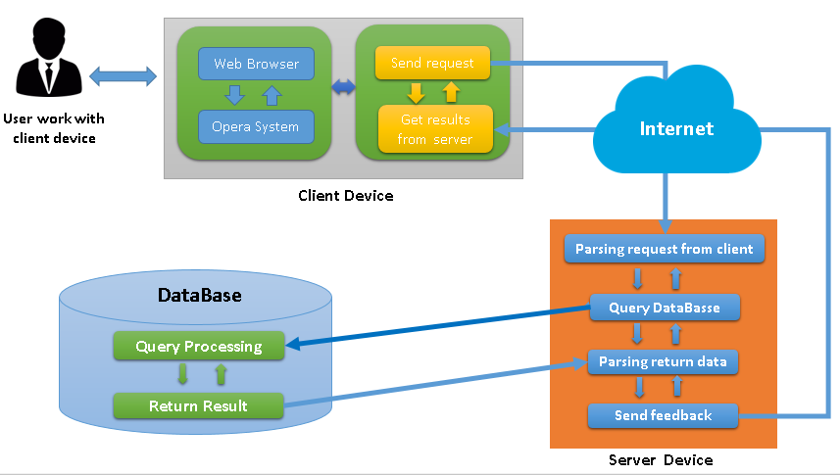

Communication database MySQL: A application program to server will send requirement to system operating and import manager (I/O) to query to the database of MySQL. After processing the request MySQL will asked this requirement. If false, this will return error, if true then the result will be buffered MySQL, then put into the program buffer, Eventually the data is processed and sent back to the client. The client receives the data as a web page and displayed in the browser.

## 3.4 Communications Interfaces

Websites allow users to contact management via mail and site feedback. The system can run on most browsers today commonly used web programs like firefox, opera, googlechorme, ... To ensure a secure communication network, can’t using HTTPS (Hypertext Transfer Protocol Secure - This is a combination of protocols HTTP and security protocol SSL (Secure Socket Layer) or TLS (Transport layer security) Allow secure information exchange over the Internet). Incident can occur in asynchronous systems with different devices on multiple operating systems.

# System Features

|  |  |  |
| --- | --- | --- |
| **ID** | **Use Case Name** | **Note** |
| UC_001 | Borrow Device |  |
| UC_002 | Change Password |  |
| UC_003 | Decentralization Member |  |
| UC_004 | Display Information |  |
| UC_005 | Find |  |
| UC_006 | Logout |  |
| UC_007 | Manage Member |  |
| UC_008 | Manage Project |  |
| UC_009 | Manage LabRoom |  |
| UC_010 | Manage Producer |  |
| UC_011 | Manage Device |  |
| UC_012 | Change Personal Information |  |
| UC_013 | Setting |  |

## UC_001 – Borrow Device

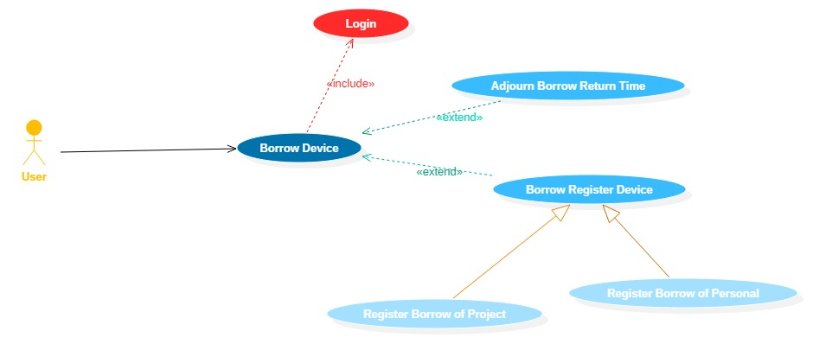

|  |  |  |
| --- | --- | --- |
| **Use case: UC_001_** Borrow Device | | |
| Purpose | Borrow Device | |
| Describe: | User want to borrow device | Extent necessary: High |
| Classify: High |
| Target users | User | |
| Ingredients and concerns | User want to borrow device. | |
| Relationships | +Association :User  +Include: Login  +Extend: Borrow Register Device, Adjour Borrow Return Time  +Generalization: Register Borrow of Project, Register Borrow of Personal | |
| Previous condition | User must login the system before borrow device. | |
| Basic flows | 1. User Login  2. Users select 1 of 3 functions:  Sub 1: If choose Borrow Register Device:  Sub 1.1: Optional Register Borrow of Project  Sub 1.2: Optional Register Borrow of Personal  Stop Event.  Sub 2: If choose Adjour Borrow Return Time  3. Stop Event | |
| Alternative Flows | Users perform interchange Sub, Sub 2 before returning software interface | |
| Result After | Successfully borrowed device. | |

## 4.2 UC_002 – Change Password

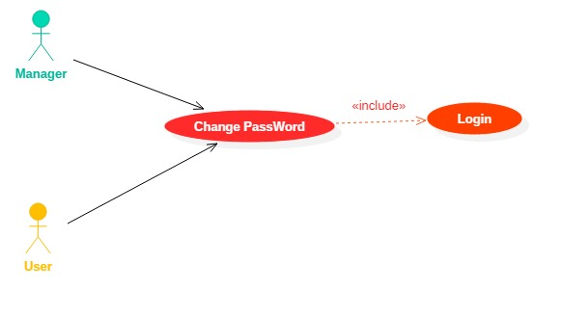

|  |  |  |
| --- | --- | --- |
| **Use case: UC_002_ Change Password** | | |
| Purpose | Allow change password for Account | |
| Describe: | Users or managers want to change password | Extent necessary: High |
| Classify: High |
| Target users | Users,managers | |
| Ingredients and concerns | User or managers want to change password | |
| Relationships | +Association: User, Admin  +Include: Login  +Extend:  +Generalization: | |
| Previous condition | User must login the system before change password. | |
| Basic flows | 1. User/manager select the button Logout  2. Users fill in information to change:  Fill in the old password  Fill in the new password  Retype the new pasword  3. System check registration information  Sub 1: If information is correct → a message will appear to inform the new more successful, go to 4.  Sub 2: If information is incorrect → show error register  a message will appear requesting to enter the correct information, go to 5  4. Display form login,next to step 6  5. Show registration form, request to re-enter registration information  6. Stop Event. | |
| Alternative Flows | User must login the system before change pasword | |
| Result After | Password was successfully changed. | |

## 4.3 UC_003 - Decentralization Member

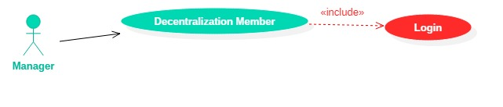

|  |  |  |
| --- | --- | --- |
| **Use case: UC_003_ Decentralization Member** | | |
| Purpose | Allow Decentralization Member for the system | |
| Describe: | Manager can authorized for users | Extent necessary: Medium |
| Classify: Medium |
| Target users | Manager | |
| Ingredients and concerns | Manager can authorized access to users in the system | |
| Relationships | +Association: Manager  +Include: Login  +Extend:  +Generalization: | |
| Previous condition | In status login | |
| Basic flows | 1. Manager choose authority user access  2. Page authority appear  Sub 1: Manager select member(user) want to authorized.  Sub 2: Manager confirm authorized for users  3. Stop Event | |
| Alternative Flows | Manager must login the system before Decentralization Member | |
| Result After | Successfully Decentralization Member. | |

## 4.4 UC_004 – Display Information

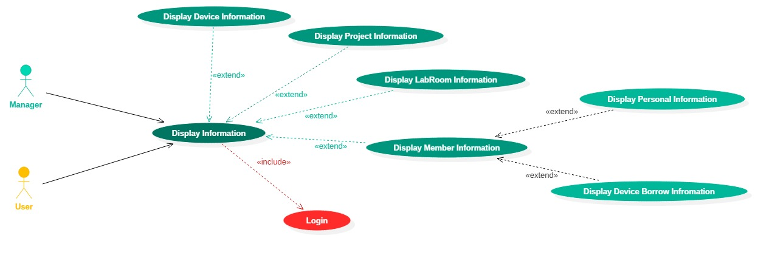

|  |  |  |
| --- | --- | --- |
| **Use case: UC_004_ Display Information** | | |
| Purpose | Display Information | |
| Describe: | Manager &user want to display information | Extent necessary: High |
| Classify: High |
| Target users | Manager, user | |
| Ingredients and concerns | Manager &user want to display information | |
| Relationships | +Association: Manager, User  +Include: Login  +Extend:Display Device Information, Display Project Information, Display Labroom Information, Display Member Information  +Generalization: | |
| Previous condition | User, Manager must login the system before display information. | |
| Basic flows | 1. User login  2. Users select 1 of 3 functions)  Sub 1: choose Display Device Information  Sub 2: choose Display Project Information  Sub 3: choose Display Labroom Information  Sub 4: choose Display Member Information   * Select 1 of 3 functions   + choose Display Personal Information  + choose Display Device Borrow Information | |
| Alternative Flows | Manager perform interchange Sub1,sub 2 before returning software interface | |
| Result After | Successfully Display Information to choose (1,2,3 or 4). | |

## 4.5 UC_005 – Find

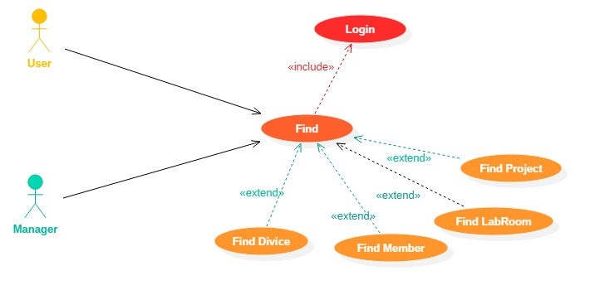

|  |  |  |
| --- | --- | --- |
| **Use case: UC_005_Find** | | |
| Purpose | Allow Find | |
| Describe: | User or manager can find all of information in the system | Extent necessary: Medium |
| Classify: Medium |
| Target users | Basic User, Manager | |
| Ingredients and concerns | User, manager want to search all of information through: Search Device, Member, Project, Labs | |
| Relationships | +Association: User, Admin  +Include: Login  +Extend: Find Device, Find Member, Find Project, Find LabRoom  +Generalization: | |
| Previous condition | Manager must login the system before find information. | |
| Basic flows | 1. User/manager select Find function  2. User/manager enter information to find  Sub 1: If enter device name→ press the button search → next to step 3  Sub 2: If enter member name→ press the button search → next to step 3  Sub 3: If enter project name → press the button search→next to step 3  Sub 4: If enter labRoom name→press the button search→next to step 3  3. Display search result (If exist)  4. Stop Event | |
| Alternative Flows | The system access database to find informations necessary. | |
| Result After | Successfully Find Sub is select (1,2,3 or 4). | |

## 4.6 UC_006 - Logout

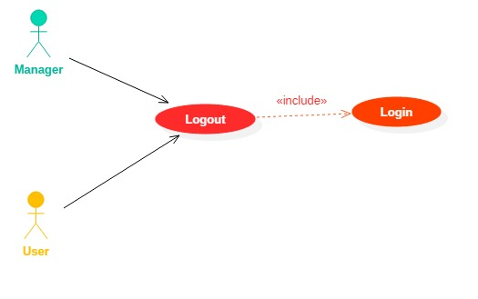

|  |  |  |
| --- | --- | --- |
| **Use case: UC_006_Logout** | | |
| Purpose | Allow logout from the system | |
| Describe: | User or manager want to log out from the system | Extent necessary: Low |
| Classify: Low |
| Target users | Basic User, Manager | |
| Ingredients and concerns | User, Manager want to log out from the system after shutdown using. | |
| Relationships | +Association: User, Admin  +Include: Login  +Extend:  +Generalization: | |
| Previous condition | User muts login | |
| Basic flows | 1. User/manager select the button Logout  2. Form Homepage appear.  3. Stop Event | |
| Alternative Flows | Manager must login the system before logout | |
| Result After | Successfully log out | |

## 4.7 UC_007 – Manage Member

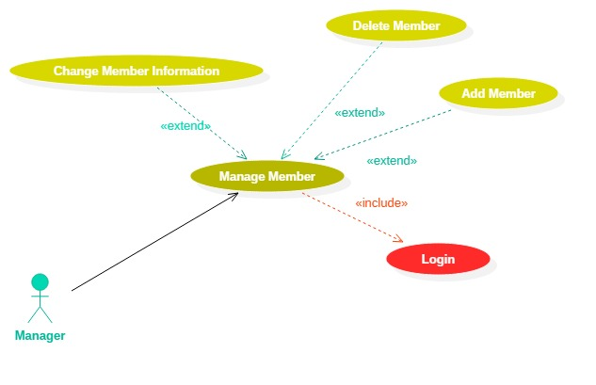

|  |  |  |
| --- | --- | --- |
| **Use case: UC_007_Manage Member** | | |
| Purpose | Manage Member | |
| Describe: | Manager perform Activities related to manage member | Extent necessary: High |
| Classify: High |
| Target users | Manager | |
| Ingredients and concerns | Manager want to add new member,remove & change information member. | |
| Relationships | +Association: Admin  +Include: Login  +Extend: Add Members, Delete Member, Change Information Member.  +Generalization: | |
| Previous condition | Manager must login the system before managing information project. | |
| Basic flows | 1. Manager must login the system before managing information member.  2. Manger select 1 of 3 functions  Sub 1: If select Add Member  Sub 2: If select Delete Member  Sub 3: If select Change Information Member  4. Perform correspondence function Sub 1, Sub 2 or Sub 3  5. Return to software interface  6. Stop Event | |
| Alternative Flows | Manager perform interchange Sub1,sub 2 before returning software interface. | |
| Result After | Successfully Sub to choose (1,2 or 3). | |

## 4.8 UC_008 – Manage Project

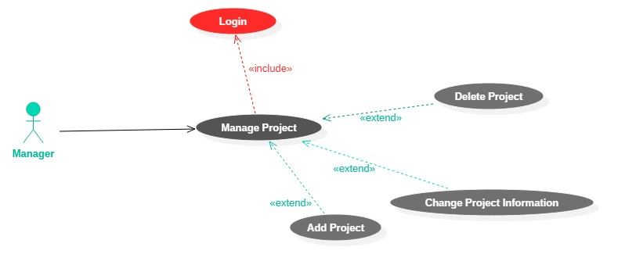

|  |  |  |
| --- | --- | --- |
| **Use case: UC_008_Manage Project** | | |
| Purpose | Project Manager | |
| Describe: | Manager perform Activities related to manage project | Extent necessary: High |
| Classify: High |
| Target users | Manager | |
| Ingredients and concerns | Manager want to add new project,remove &change information project | |
| Relationships | +Association: Admin  +Include: Login  +Extend: Add Project, Delete Project, Change Information Project.  +Generalization: | |
| Previous condition | Manager must login the system before managing information member | |
| Basic flows | 1. Manager login the system before perform manage project  2. Manager select 1 of 3 functions  Sub 1: If select Add Project  Sub 2: If select Delete Project  Sub 3: If select Change Information Project  4. Perform correspondence functions Sub 1, Sub 2 or Sub 3  5. Return to software interface  6. Stop Event | |
| Alternative Flows | Manager perform interchange Sub1,sub 2 before returning software interface. | |
| Result After | Successfully Sub to choose (1,2 or 3). | |

## 4.9 UC_009 – Manage LabRoom

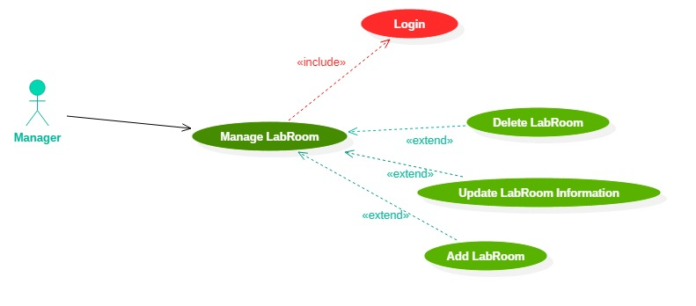

|  |  |  |
| --- | --- | --- |
| **Use case: UC_009_Manage LabRoom** | | |
| Purpose | Manage Lab | |
| Describe: | Manager perform Activities related to manage labroom | Extent necessary: High |
| Classify: High |
| Target users | Manager | |
| Ingredients and concerns | Manager want to add new lab,remove &change information lab. | |
| Relationships | +Association: Admin  +Include: Login  +Extend: Add LabRoom, Delete LabRoom, Update LabRoom Information.  +Generalization: | |
| Previous condition | Manager must login the system before managing information lab | |
| Basic flows | 1. Manager must login the system before managing information lab  2. Manager select 1 of 3 functions  Sub 1: If select Add LabRoom  Sub 2: If select Delete LabRoom  Sub 3: If select Change Information LabRoom  4. Perform correspondence function Sub 1, Sub 2 or Sub 3  5. Return to software interface  6. Stop Event | |
| Alternative Flows | Manager perform interchange Sub1,sub 2 before returning software interface. | |
| Result After | Successfully Sub to choose (1,2 or 3). | |

## 4.10 UC_010 – Manage Producer

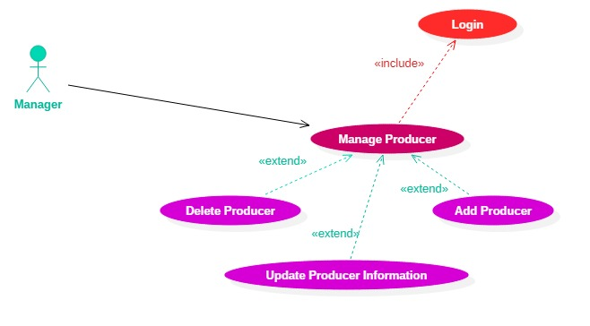

|  |  |  |
| --- | --- | --- |
| **Use case: UC_010_Manage Producer** | | |
| Purpose | Manage Producer | |
| Describe: | Manager perform Activities related to manage producer | Extent necessary: High |
| Classify: High |
| Target users | Manager | |
| Ingredients and concerns | Manager want to add new lab,remove &change information producer | |
| Relationships | +Association: Admin  +Include: Login  +Extend: Add Producer, Delete Producer, Update Producer Information.  +Generalization: | |
| Previous condition | Manager must login the system before managing information producer. | |
| Basic flows | 1. Manager login the system before perform manage producer  2. Manager select 1 of 3 functions  Sub 1: If select Add Producer  Sub 2: If select Delete Producer  Sub 3: If select Update Producer Information.  4. Perform correspondence function Sub 1, Sub 2 or Sub 3  5. Return to software interface  6. Stop Event | |
| Alternative Flows | Manager perform interchange Sub, Sub 2, Sub 3 before returning software interface | |
| Result After | Successfully Sub to choose (1,2 or 3). | |

## 4.11 UC_011 – Manage Device

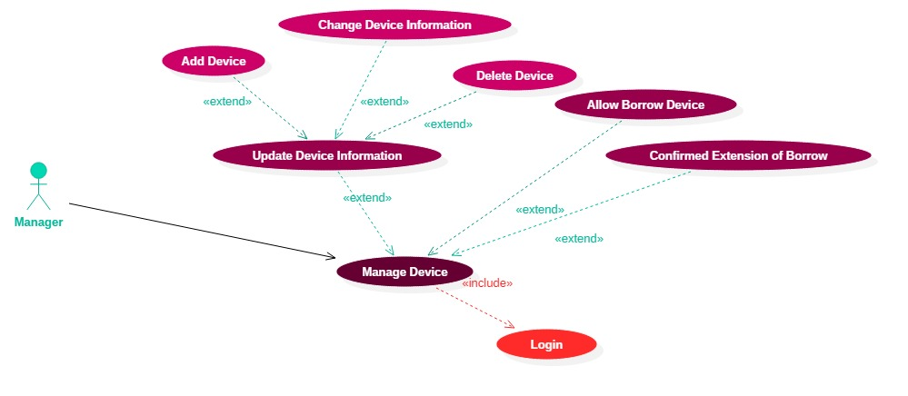

|  |  |  |
| --- | --- | --- |
| **Use case: UC_011_ Manage Device** | | |
| Purpose | Manage Device | |
| Describe: | Manager perform Activities related to manage device | Extent necessary: High |
| Classify: High |
| Target users | Manager | |
| Ingredients and concerns | Manager want to add: Update Device Information, Allow Borrow Device, Confirm Extension of Borrow | |
| Relationships | +Association: Admin  +Include: Login  +Extend: Update Device Information, Allow borrow device, Confirm Extension of Borrow.  +Generalization: | |
| Previous condition | Manager must login the system before managing information Device. | |
| Basic flows | 1. Manager login the system before perform manage Devvice  2. Manager select 1 of 3 functions  Sub 1: If select Update Device Information:  Sub 1.1: Optional Add Device  Sub 1.2: Optional Delete Device  Sub 1.3: Optional Change Device Information  Stop Optional Event.  Sub 2: If select Allow Borrow Device  Sub 3: If select Confirm Extension of Borrow  3. Stop Event | |
| Alternative Flows | Manager perform interchange Sub1,sub 2 before returning software interface. | |
| Result After | Successfully Sub to choose (1,2 or 3). | |

## 4.12 UC_012 – Change Personal Information

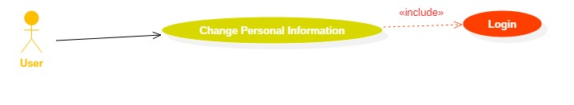

|  |  |  |
| --- | --- | --- |
| **Use case: UC_012_ Change Personal Information** | | |
| Purpose | Change Personal Information | |
| Describe: | User want to change Personal Information. | Extent necessary: Medium |
| Classify: Medium |
| Target users | User | |
| Ingredients and concerns | User want to change personal information. | |
| Relationships | +Association: User  +Include: Login  +Extend:  +Generalization: | |
| Previous condition | User must login the system before change personal information. | |
| Basic flows | 1. User select the button allow perform change personal information  2. User full in information to change:  Update -First and last name  Update - date of birth  Update - Gender  Update - Address  3. Information check system has updated  Sub 1: If information is correct → successfully update information,next to step 4  Sub 2: If information is incorrec → a message will appear requesting to enter the correct information,next to step 5.  4. Display form homepage,next to step 6.  5. Display form change information, Require to re-enter personal information to update.  6. Stop Event | |
| Alternative Flows | The system check personal information has just been updated from the form. Change information to avoid entering letters or symbols, the number is not allowed when updating user information. | |
| Result After | Successfully change personal information . | |

## 4.13 UC_013 – Setting

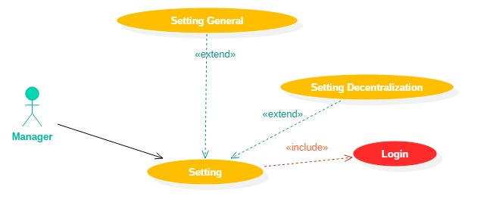

|  |  |  |
| --- | --- | --- |
| **Use case: UC_013_Setting** | | |
| Purpose | System setting | |
| Describe: | Manager perform Activities related to Setting | Extent necessary: High |
| Classify: High |
| Target users | Manager | |
| Ingredients and concerns | Manager want to perform setting,or setting up authorized user | |
| Relationships | +Association: Admin  +Include: Login  +Extend: Setting General, Setting Decentralization  +Generalization: | |
| Previous condition | Manager must login the system before managing information producer. | |
| Basic flows | 1. Manager login the system before perform manage setting  2. Manager select 1 in 2 fuction  Sub 1: If select Setting General  Sub 2: If select Setting Decentralization  4. Perform correspondence function Sub 1 or Sub 2.  5. Return to software interface  6. Stop Event | |
| Alternative Flows | Manager must login the system before system setting | |
| Result After | Successfully change setting system to choose (Sub 1 or Sub 2) | |

# Other Nonfunctional Requirements

## Performance Requirements

|  |  |
| --- | --- |
| **Serial** | **Minimum Requirement** |
| NR_001 | Allows multi-threaded access. |
| NR_002 | The computer acting as the server must operate continuously during the operation of the system.. |
| NR_003 | Always online while using this system |
|  |  |

## Exporting Requirements

|  |  |
| --- | --- |
| **Serial** | **Minimum Requirement** |
| NR_003 | Minimum network connection download / upload speed 4 Mbps / 512 Kbps.. |
| NR_004 | Quick response system is less than 1 second per operatio |
| NR_005 | Ability to adapt to many different devices and operating systems |
| NR_006 | Works well with multiple devices |
| NR_007 | Ensure storage capacity if required to store large amounts of data. |
|  |  |

## Security Requirements

|  |  |
| --- | --- |
| **Serial** | **Minimum Requirement** |
| NR_008 | The system needs to be protected by an advanced and regularly updated data encryption system. |
| NR_009 | Build a password security mechanism to manage access numbers |
| NR_010 | Lets prevent and deny some invalid access |
|  |  |

## Software Quality Attributes

* **Product activity:**
  + **Accuracy**:

|  |  |
| --- | --- |
| **Standard** | **Description** |
| Output tasks | This list includes information such as the borrower, date of the loan, date of return, borrowed equipment, condition of the equipment. Information can be statistic by time, device ID, member and project |
| Accuracy can be achieved | The possibility of false information to the storage limit of less than 1%, the information must be the exact output according to the information stored in the system. |
| Full information output information | The probability of losing data when archiving or reporting is less than 1%. |
| Get the earliest information | Members can view the latest information about the device as soon as the manager updates it |
| Availability of information | Average response time when query execution is less than 1 second, access time to generate report required less than 10 seconds |
| Standards and guidelines needed | Software and documentation must comply as a document provided to the customer. |
|  |  |

* + **Reliability:** The frequency by which equipment status as damage has been borrowed, ... has not been updated promptly resulting in errors in equipment returning less than 1 case per month. The probability of wrong information stored on the return device does not occur..
  + **Effectiveness:** The actual parameters are calculated as follows: Number of current devices, number of members and frequency of use of equipment are borrowed. It then determines the optimal storage, memory, and processing flow for the servers..
  + **Integrity:** Only authorized users of the system can register for a facility loan within the framework allowed for use in the projects in which they participate. Members who are not involved or who are not members of the system will not be able to view information as well as borrow equipment..
  + **Usability:** The system is mainly used for engineers, programmers are those who specialize in information systems. Therefore, when designing the system does not need too much detail, just full of necessary functions so that users can use immediately to start participating in the system.
* **Product update:**
  + **Maintenance:** Programming, system design must comply with the set quality standards. Code, filename, class name, ... to write the correct syntax, agreed standards. Need to arrange the package model to facilitate later upgrades, it is best to use the MVC model..
  + **Flexibility:** Managers can easily add content to the report as well as select the time and duration of the request statistics. Allows the administrator to delegate permissions to other users for management support..
  + **Checking ability:** The lend - return device, change the information of the device, the member must be exported into the system log file to easily check the error in the operation , storage. Do not accept duplication of data in new creation..
* **Product conversion:** 
  + **Ability to move**: Can be used in different browsers or on different operating systems. Not only that, the system needs to be compatible with different devices.
  + **Reusability:** The components of the system are individually designed and have specific specific functions. Ready to change or use for another system.
  + **Interoperability:** Information stored in the system can be displayed as storage files such as SQL, Microsoft Excel, Microsoft Word, ...

## Software Quality Attributes

* Members only use functions within the decentralization framework that the manager rules for each account.
* The administrator has full control of the features mentioned in section 2.2. Except for the two functions in the loan register:
* Adjourn of the borow period:
* Register borrowing equipment
* Borrow equipment for the project.
* Borrow equipment for individuals
* The system always has from one account: Do not allow to delete all accounts in the system..

# Other Requirements

On next design document for this:

Must describe clearly principle of decentralization which is manager using to decentralization for orther user. There are decentralization:

* Owner
* Admin
* Manager
* Member
* Basic User

One decentralization level can change functions on decentralization setting.

# Appendix A: Glossary table

This document does not use many terminology, which are presented in Section 1.5

# Appendix B: Analysis Models

## UC_Login

|  |  |  |
| --- | --- | --- |
| **Use case: UC_Login** | | |
| Purpose | Allow log on system | |
| Describe: | User or Manager want to login on system | Extent necessary: High |
| Classify: High |
| Target users | Basic User, Manager | |
| Ingredients and concerns | User or Manager login on system when want to using all function. | |
| Relationships | +Association: User, Admin  +Include: Login  +Extend:  +Generalization: | |
| Previous condition | None | |
| Basic flows | 1. User /Manager click Login  2. Form Login show  Sub 1: User /Manager inter username and password  Sub 2: System testing login information . Return login true or false, if true, go to Homepage, else re-login.  3. Stop Event | |
| Purpose | None | |
| Describe: | Return login true or false | |

## Use Case Diagram: Full size: drive.google.com/drive/folders/0BwvTggymLfLOampveGZPOVUyU2M?usp=sharing

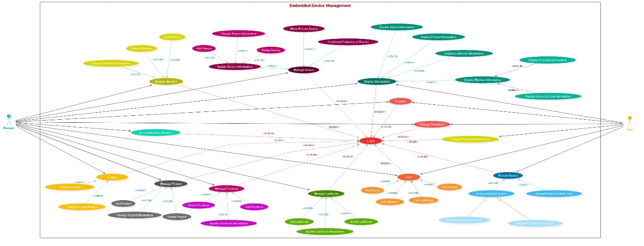

## Class Diagram: full size: drive.google.com/drive/folders/0BwvTggymLfLOampveGZPOVUyU2M?usp=sharing

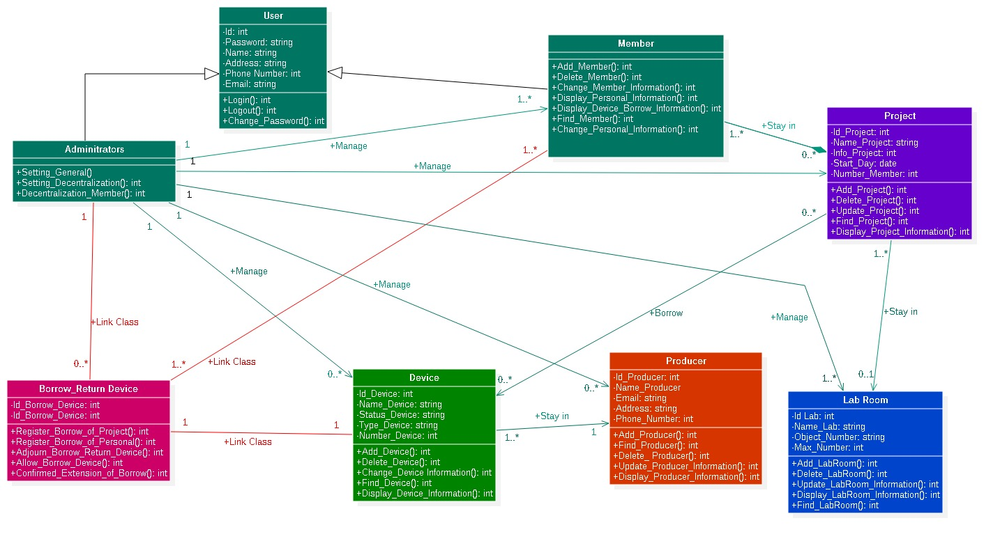

## Entity-Relationship Model: full size: drive.google.com/drive/folders/0BwvTggymLfLOampveGZPOVUyU2M?usp=sharing

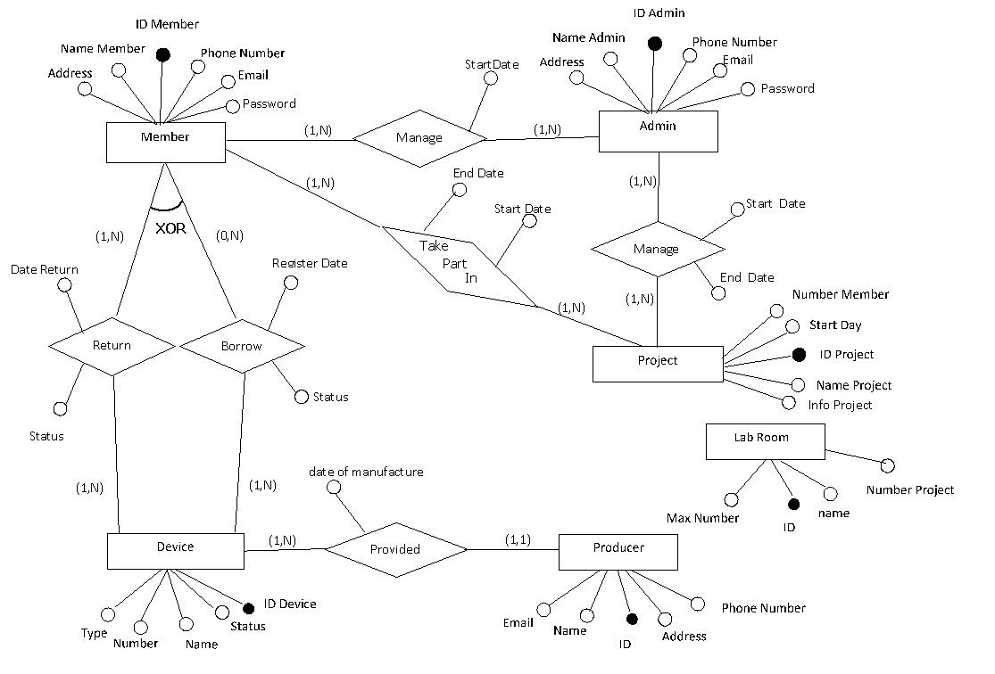

## Sequence diagram

There are too many sequence diagrams so we can not include this document:

Please you can see all sequence diagrams in this link: <https://drive.google.com/drive/folders/0BwvTggymLfLOYWhlQmZCQ2thSUk?usp=sharing>

## Goal tree: full size: drive.google.com/drive/folders/0BwvTggymLfLOampveGZPOVUyU2M?usp=sharing

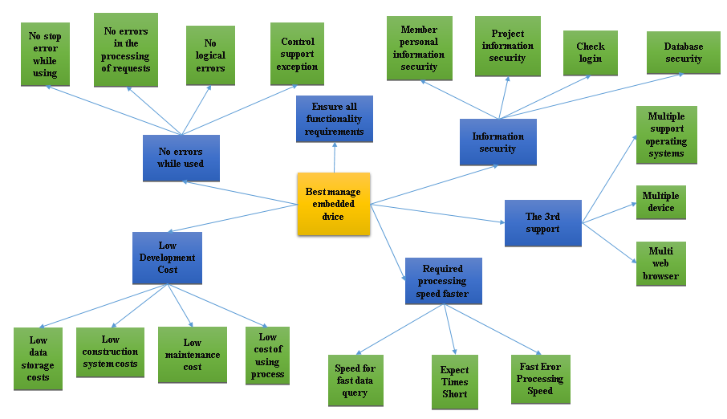

## Goal analysis diagram: Full size: drive.google.com/drive/folders/0BwvTggymLfLOampveGZPOVUyU2M?usp=sharing

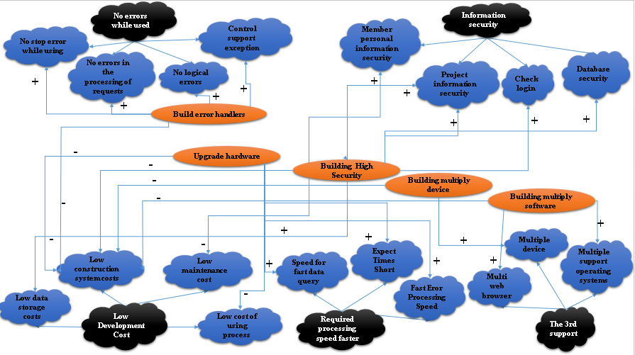

## Analyzing costs - Penefits : This file in: drive.google.com/drive/folders/0BwvTggymLfLOampveGZPOVUyU2M?usp=sharing

|  |  |  |  |  |  |  |  |  |  |  |  |  |  |  |  |  |  |
| --- | --- | --- | --- | --- | --- | --- | --- | --- | --- | --- | --- | --- | --- | --- | --- | --- | --- |
| **Table salary for engineer** | | | | | | | | | | | | | | | | | |
|  |  | | |  |  |  | |  | **Basic salary** | | | | | | **3320000** | | |
| **Ware** | **Coefficient** | | | **Salary** | **Allowance 1  (12% salary)** | **Allowance 2 (4% salary)** | | **Insurrance (34.8% salary)** | **Total salary Reality** | | | **Salary/date** | | | **Salary/hour (H)** | | |
| **1** | 2.34 | | | 7768800 | 932256 | 310752 | | 2703542.4 | 11715350 | | | 585767.52 | | | 73220.94 | | |
| **2** | 2.67 | | | 8864400 | 1063728 | 354576 | | 3084811.2 | 13367515 | | | 668375.76 | | | 83546.97 | | |
| **3** | 3 | | | 9960000 | 1195200 | 398400 | | 3466080 | 15019680 | | | 750984 | | | 93873 | | |
| **4** | 3.33 | | | 11055600 | 1326672 | 442224 | | 3847348.8 | 16671845 | | | 833592.24 | | | 104199.03 | | |
| **5** | 3.66 | | | 12151200 | 1458144 | 486048 | | 4228617.6 | 18324010 | | | 916200.48 | | | 114525.06 | | |
| **6** | 3.99 | | | 13246800 | 1589616 | 529872 | | 4609886.4 | 19976174 | | | 998808.72 | | | 124851.09 | | |
| **7** | 4.32 | | | 14342400 | 1721088 | 573696 | | 4991155.2 | 21628339 | | | 1081416.96 | | | 135177.12 | | |
| **8** | 4.65 | | | 15438000 | 1852560 | 617520 | | 5372424 | 23280504 | | | 1164025.2 | | | 145503.15 | | |
| **9** | 4.98 | | | 16533600 | 1984032 | 661344 | | 5753692.8 | 24932669 | | | 1246633.44 | | | 155829.18 | | |
| **Table calculation software value Software Name: Embedded Device Management Website** | | | | | | | | | | | | | | | | |
|
|  | |  | | | |  | | | |  | | | |  | | |
| **TT** | | **Categories** | | | | **Electrolyte** | | | | **Value** | | | | **Note** | | |
| **I** | | **Calculate the use case score (Use Case)** | | | |  | | | |  | | | |  | | |
| 1 | | Actor Points (TAW) | | | |  | | | | 2 | | | |  | | |
| 2 | | Use-case Points (TBF) | | | |  | | | | 25 | | | |  | | |
| 3 | | Calculate Points UUCP | | | | UUCP = TAW +TBF | | | | 27 | | | |  | | |
| 4 | | Coefficient of complexity about Technical-Technological TCF) | | | | TCF = 0,6 + (0,01 x TFW) | | | | 1.01 | | | |  | | |
| 5 | | Coefficient of complexity about environment (EF) | | | | EF = 1,4 + (-0,03 x EFW) | | | | 0.755 | | | |  | | |
| 6 | | Calculate Points AUCP | | | | AUCP = UUCP x TCF x EF | | | | 20.58885 | | | |  | | |
| **II** | | **Interpolation labor time (P)** | | | | P : people/hour/AUCP | | | | 20 | | | |  | | |
| **III** | | **Actual effort value (E)** | | | | E = 10/6 x AUCP | | | | 34.31475 | | | |  | | |
| **IV** | | **Average wage (H)** | | | | H: people/hour | | | | 73,220.94 | | | | vnd | | |
| **V** | | **Internal Software Value (G)** | | | | G = 1,4 x E x P x H | | | | 70,351,631.02 | | | | vnd | | |
| **Table software cost synthesis** | | | | | | | | | | | | | | | |
|  | | |  | | | |  | | | |  | |  | | |
| **Number** | | | **Expense item** | | | | **Calculation** | | | | **Value** | | **Symbol** | | |
| 1 | | | Software Value | | | | 1,4 x E x P x H | | | | 70,351,631.02 | | G | | |
| 2 | | | General expenses | | | | G x tỷ lệ | | | | 45,728,560.17 | | C | | |
| 3 | | | Income taxable Pre-calculated | | | | (G+C) x tỷ lệ | | | | 6,964,811.47 | | TL | | |
| 4 | | | Software costs | | | | G + C + TL | | | | 123,045,002.66 | | GPM | | |
|  | | | **Total** | | | | GPM | | | | 123,045,003 | |  | | |

|  |  |  |  |  |  |  |
| --- | --- | --- | --- | --- | --- | --- |
| **Cash Flow description** | **Year 0** | **Year 1** | **Year 2** | **Year 3** | **Year 4** | **Year 5** |
| **Development cost:** | ($123,045,003) |  |  |  |  |  |
| **Operation & maintenance Cost:** |  | ($)400000 | ($)450000 | ($)500000 | ($)550000 | ($)600000 |
| **Discount factors for 12%:** | 1 | 0.893 | 0.797 | 0.712 | 0.636 | 0.567 |
| **Time-adjusted Costs (adjusted to present):** | ($123,045,003) | ($357,200) | ($358,650) | ($356,000) | ($349,800) | ($340,200) |
| **Cumulative time- Adjusted cost over** | ($123,045,003) | ($123,402,203) | ($123,760,853) | ($124,116,853) | ($124,466,653) | ($124,806,853) |
| **Benefils derived from Operation of new** | $0 | $25,000,000 | $30,000,000 | $35,000,000 | $40,000,000 | $45,000,000 |
| **Discount factors for 12%:** | $1 | $0.89 | $0.80 | $0.71 | $0.64 | $0.57 |
| **Time-adjusted Benefils (current of present)** | $0 | $22,325,000 | $23,910,000 | $24,920,000 | $25,440,000 | $25,515,000 |
| **Cumulative time- Adjusted bennefits over** | $0 | $22,325,000 | $46,235,000 | $71,155,000 | $96,595,000 | $122,110,000 |
|  | 0 | 1 | 2 | 3 | 4 | 5 |
| **Cumulative lifetime time- adjusted costs+** | ($123,045,003) | ($101,077,203) | ($77,525,853) | ($52,961,853) | ($27,871,653) | ($2,696,853) |

|  |  |  |  |  |  |
| --- | --- | --- | --- | --- | --- |
| **Cash Flow description** | **Year 6** | **Year 7** | **Year 8** | **Year 9** | **Year 10** |
| **Development cost:** |  |  |  |  |  |
| **Operation & maintenance Cost:** | ($)650000 | ($)700000 | ($)750000 | ($)800000 | ($)850000 |
| **Discount factors for 12%:** | 0.507 | 0.452 | 0.404 | 0.361 | 0.322 |
| **Time-adjusted Costs (adjusted to present):** | ($329,550) | ($316,400) | ($303,000) | ($288,800) | ($273,700) |
| **Cumulative time- Adjusted cost over** | ($125,136,403) | ($125,452,803) | ($125,755,803) | ($126,044,603) | ($126,318,303) |
| **Benefils derived from Operation of new** | $50,000,000 | $55,000,000 | $60,000,000 | $65,000,000 | $70,000,000 |
| **Discount factors for 12%:** | $0.51 | $0.45 | $0.40 | $0.36 | $0.32 |
| **Time-adjusted Benefils (current of present)** | $25,350,000 | $24,860,000 | $24,240,000 | $23,465,000 | $22,540,000 |
| **Cumulative time- Adjusted bennefits over** | $147,460,000 | $172,320,000 | $196,560,000 | $220,025,000 | $242,565,000 |
|  | 6 | 7 | 8 | 9 | 10 |
| **Cumulative lifetime time- adjusted costs+** | $22,323,597 | $46,867,197 | $70,804,197 | $93,980,397 | $116,246,697 |

## Q & A:

|  |  |  |  |  |
| --- | --- | --- | --- | --- |
| STT | Question | How to reply | Fields | Who are asked |
| 1 | What happens when a device has been borrowed and has more subscribers borrowing it ? | Fill in the text answer | Manage Device | Manager |
| 2 | Should you search for the device by which attribute ? | Select 1 of 3 answer: - Find device code - Device name  - Producer | Manage Device | Manager and Member |
| 3 | How is show a list of devices ? | Select 1 of 3 answer: - By the line - By the column - By the table | Manage Device | Manager and Member |
| 4 | How is arrange device ? | Select 1 of 4 answer: - Order by device code  - By the alphabetical device name - By the order of the new device - By the Number of borrowings | Manage Device | Manager and Member |
| 5 | How many max device can you borrow ? | Enter the number | Manage Device | Manager |
| 6 | What kind of information device can you manage ? | Fill in the list of information to manage | Manage Device | Manager |
| 7 | How long can you borrow device? | Fill in dates | Manage Device | Manager |
| 8 | How long and how much can you borrow at a time ? | Fill in the text answer | Manage Device | Manager |
| 10 | When Member forgot password, how will solve ? | Fill in the text answer | Manage User | Manager |
| 11 | Should search the Member under  Any of their attributes ? | Select 1 of 3 answer: - By the member code - By the member name - By the project manager name | Manage User | Manager and Member |
| 12 | How is show a list of member ? | Select 1 of 3 answer: - By the line - By the column - By the table | Manage User | Manager and Member |
| 13 | How is sort a list of member ? | Select 1 of 3 answers: - By the member code - By the letter of member name - By the order of the new member | Manage User | Manager and Member |
| 14 | How many max project can a member take part in ? | Fill in the number | Manage Member | Manager |
| 15 | Need to manage the information of Member ? | Fill in the list of information to manage | Manager Member | Manager |
| 16 | Should look for projects under any attribute of it | Select 1 of 3 answers: - By the project name - By the project - By the project manager name | Manage Project | Manager and Member |
| 17 | How is show a list of member ? | Select 1 of 3 answers: - By the line - By the column  - By the table | Manage Project | Manager and Member |
| 18 | How is sort a list of project ? | Select 1 of 3 answers: - By the order of project code - By the letter of project name - By the order of the new member | Manage Project | Manager and Member |
| 19 | How many max member are there in the project ? | Fill in the number | Manage Project | Manager |
| 20 | What information does the project need to manage ? | Fill in the list of information to manage | Manage Project | Manager |
| 21 | What attribute should manufacturers search for ? | Select 1 of 3 answers: - By the producer code - By the producer - By the product | Manage Producer | Manager |
| 22 | How is show a list of producer ? | Select 1 of 3 answers: - By the line - By the column - By the table | Manage Producer | Manager and Member |
| 23 | How is sort a list of producer ? | Select 1 of 3 answers: - By the order of the producer - By the letter of producer name | Manage Producer | Manager and Member |
| 24 | What information does the manufacturer need to manage ? | Fill in the list of information to manage | Manage Producer | Manager |
| 25 | Decentralized to do several types of accounts ? | Fill in the number and list the items | Manage Decentralization | Manager |
| 26 | In the general settings for the system, what items to install ? | Fill in the list of items to install in general | Manage Decentralization | Manager |
| 27 | How many functions need to permitted are there in the install permission ? | Fill in the function to authorized | Manage Decentralization | Manager |
| 28 | Resolve the case of registered members to borrow but not to receive equipment ? | Fill in the solution in the form of a text answer | Manage Borrow and Return | Manager |
| 29 | Resolve a case where members register to borrow but do not return the device upon expiration ? | Fill in the text answer | Manage Borrow and Return | Manager |
| 30 | Has the system limited login ? | Yes or No | Manager Login | Manager |
| 31 | How many items are there in the homepage interface design ? | Select items (You can select more than 1 item): Member Device  Project General notification LabRoom Find button | Design interface | Manager |
| 32 | How many items are there in the user interface design? | Select items (You can select more than 1 item): Member Device  Project General notification LabRoom Find button  Homepage button Logout button Swicth account button Display Infromation button | Design interface |  |
| 33 | How many items are there in the manager interface design ? | Select items (You can select more than 1 item):  Manger Member Manager Device  Manager Project General notification Manager LabRoom Information Find button Homepage button  Logout button Swtich account button Personal Information button General Setting button  Install Decentralization button Borrow and Return Device button | Design interface |  |
| 34 | Which the title bar and the user menu are designed, horizontal or vertical ? | Optional: Design by horizontal, above  Design by horizontal, below Design by the right vertical Design by the left vertical | Design interface | Manager |
| 35 | Which the title bar and the manager menu are designed, horizontal or vertical ? | Optional: Design by horizontal, above  Design by horizontal, below Design by the right vertical Design by the left vertical | Design interface | Manager |

## Matrix requirements: This file in: drive.google.com/drive/folders/0BwvTggymLfLOampveGZPOVUyU2M?usp=sharing

|  |  |  |  |  |  |  |  |  |  |  |  |  |  |
| --- | --- | --- | --- | --- | --- | --- | --- | --- | --- | --- | --- | --- | --- |
|  | UC_001 | UC_002 | UC_003 | UC_004 | UC_005 | UC_006 | UC_007 | UC_008 | UC_009 | UC_010 | UC_011 | UC_012 | UC_013 |
| UC_001 | 1 | 9 | 3 | 5 | 7 | 9 | 1 | 1 | 3 | 5 | 3 | 9 | 7 |
| UC_002 | 1/9 | 1 | 1/5 | 1/7 | 1/5 | 1 | 1/9 | 1/9 | 1/7 | 1/7 | 1/9 | 1 | 1/5 |
| UC_003 | 1/3 | 5 | 1 | 3 | 5 | 7 | 1/3 | 1/3 | 1 | 1 | 1/7 | 1 | 1 |
| UC_004 | 1/5 | 7 | 1/3 | 1 | 3 | 1 | 1/7 | 1/7 | 1/3 | 1/3 | 1/7 | 1 | 1 |
| UC_005 | 1/7 | 5 | 1/5 | 1/3 | 1 | 3 | 1/7 | 1/7 | 1/5 | 1/5 | 1/7 | 3 | 1 |
| UC_006 | 1/9 | 1 | 1/7 | 1 | 1/3 | 1 | 1/9 | 1/9 | 1/7 | 1/7 | 1/9 | 1/5 | 1/7 |
| UC_007 | 1 | 9 | 3 | 7 | 7 | 9 | 1 | 1 | 3 | 3 | 1 | 5 | 5 |
| UC_008 | 1 | 9 | 3 | 7 | 7 | 9 | 1 | 1 | 3 | 3 | 1 | 5 | 5 |
| UC_009 | 1/3 | 7 | 1 | 3 | 5 | 7 | 1/3 | 1/3 | 1 | 1 | 1/3 | 3 | 3 |
| UC_010 | 1/5 | 7 | 1 | 3 | 5 | 7 | 1/3 | 1/3 | 1 | 1 | 1/3 | 3 | 3 |
| UC_011 | 1/3 | 9 | 7 | 7 | 7 | 9 | 1 | 1 | 3 | 3 | 1 | 7 | 7 |
| UC_012 | 1/9 | 1 | 1 | 1 | 1/3 | 5 | 1/5 | 1/5 | 1/3 | 1/3 | 1/7 | 1 | 1 |
| UC_013 | 1/7 | 5 | 1 | 1 | 1 | 7 | 1/5 | 1/5 | 1/3 | 1/3 | 1/7 | 1 | 1 |
| SUM | 5.02 | 75 | 21.88 | 39.48 | 48.87 | 75 | 5.91 | 5.91 | 16.49 | 18.49 | 7.60 | 40.20 | 35.34 |

|  |  |  |  |  |  |  |  |  |  |  |  |  |  |  |  |
| --- | --- | --- | --- | --- | --- | --- | --- | --- | --- | --- | --- | --- | --- | --- | --- |
|  | UC_001 | UC_002 | UC_003 | UC_004 | UC_005 | UC_006 | UC_007 | UC_008 | UC_009 | UC_010 | UC_011 | UC_012 | UC_013 | Sum | Sum/13 |
| UC_001 | 0.199 | 0.120 | 0.137 | 0.127 | 0.143 | 0.120 | 0.169 | 0.169 | 0.182 | 0.270 | 0.395 | 0.224 | 0.198 | 2.454 | 0.189 |
| UC_002 | 0.022 | 0.013 | 0.009 | 0.004 | 0.004 | 0.013 | 0.019 | 0.019 | 0.009 | 0.008 | 0.015 | 0.025 | 0.006 | 0.165 | 0.013 |
| UC_003 | 0.066 | 0.067 | 0.046 | 0.076 | 0.102 | 0.093 | 0.056 | 0.056 | 0.061 | 0.054 | 0.019 | 0.025 | 0.028 | 0.750 | 0.058 |
| UC_004 | 0.040 | 0.093 | 0.015 | 0.025 | 0.061 | 0.013 | 0.024 | 0.024 | 0.020 | 0.018 | 0.019 | 0.025 | 0.028 | 0.407 | 0.031 |
| UC_005 | 0.028 | 0.067 | 0.009 | 0.008 | 0.020 | 0.040 | 0.024 | 0.024 | 0.012 | 0.011 | 0.019 | 0.075 | 0.028 | 0.366 | 0.028 |
| UC_006 | 0.022 | 0.013 | 0.007 | 0.025 | 0.007 | 0.013 | 0.019 | 0.019 | 0.009 | 0.008 | 0.015 | 0.005 | 0.004 | 0.165 | 0.013 |
| UC_007 | 0.199 | 0.120 | 0.137 | 0.177 | 0.143 | 0.120 | 0.169 | 0.169 | 0.182 | 0.162 | 0.132 | 0.124 | 0.141 | 1.977 | 0.152 |
| UC_008 | 0.199 | 0.120 | 0.137 | 0.177 | 0.143 | 0.120 | 0.169 | 0.169 | 0.182 | 0.162 | 0.132 | 0.124 | 0.141 | 1.977 | 0.152 |
| UC_009 | 0.066 | 0.093 | 0.046 | 0.076 | 0.102 | 0.093 | 0.056 | 0.056 | 0.061 | 0.054 | 0.044 | 0.075 | 0.085 | 0.908 | 0.070 |
| UC_010 | 0.040 | 0.093 | 0.046 | 0.076 | 0.102 | 0.093 | 0.056 | 0.056 | 0.061 | 0.054 | 0.044 | 0.075 | 0.085 | 0.881 | 0.068 |
| UC_011 | 0.066 | 0.120 | 0.320 | 0.177 | 0.143 | 0.120 | 0.169 | 0.169 | 0.182 | 0.162 | 0.132 | 0.174 | 0.198 | 2.133 | 0.164 |
| UC_012 | 0.022 | 0.013 | 0.046 | 0.025 | 0.007 | 0.067 | 0.034 | 0.034 | 0.020 | 0.018 | 0.019 | 0.025 | 0.028 | 0.358 | 0.028 |
| UC_013 | 0.028 | 0.067 | 0.046 | 0.025 | 0.020 | 0.093 | 0.034 | 0.034 | 0.020 | 0.018 | 0.019 | 0.025 | 0.028 | 0.458 | 0.035 |

|  |  |  |
| --- | --- | --- |
| ID | Name | Ratio |
| UC_001 | Borrow Device | 18.875% |
| UC_002 | Change Password | 1.268% |
| UC_003 | Decentralization Member | 5.769% |
| UC_004 | Display Information | 3.131% |
| UC_005 | Find | 2.817% |
| UC_006 | Logout | 1.270% |
| UC_007 | Manage Member | 15.209% |
| UC_008 | Manage Project | 15.209% |
| UC_009 | Manage LabRoom | 6.985% |
| UC_010 | Manage Producer | 6.781% |
| UC_011 | Manage Device | 16.411% |
| UC_012 | Change Personal Information | 2.753% |
| UC_013 | Setting | 3.522% |

# Appendix C: To Be Determined List (Null)

The end