We have been granted access to PACE-ICE (Instructional Cluster Environment) to offer students compute for projects.
PACE-ICE documentation
Important Ground rules
- Read PACE documentation and follow any guidelines or rules outlined there.
- DO NOT contact PACE support. PACE does not provide direct support for students.
- We have a large class size and can only provide limited support. Please post PACE related questions in this thread and we will try to answer them as much as we can.
Basic Info
- To Login: First connect to GaTech VPN (via GlobalProtect) then ssh into the head node [login-ice.pace.gatech.edu](http://login-ice.pace.gatech.edu/) using gatech ID and PW. (reference PACE documentation link for up-to-date info and more details).
- PACE uses SLURM scheduler for either interactive sessions or batched jobs. reference PACE documentation for useful SLURM commands.
- Interactive graphical jobs can also be submitted via Open OnDemand. Files can also be moved via this method.
- Do NOT run compute heavy jobs on login node.
- Each job can request a maximum of 512 CPU hours and 16 GPU hours. The maximum walltime is 8 hours, unless further restricted by the CPU hour or GPU hour maximum.
- Known issues: high latency to the cluster can cause dropped connections. Unfortunately this is not something neither we or PACE can solve.
- When requiring GPUs: V100 is not a bad choice; they are typically easier to get a spot on than an A -series. That said the A100s are noticeably faster.
Guide
PACE's is a remote cluster of machine, using the slurm system (link) to allocate resources (CPUs, GPUs, etc) and schedule users requests. This means that most of the workflow requires a secure (ssh) connection and is done via the terminal.
Therefore, the two first sections below contains details to:
- Connect to PACE via ssh, using the terminal and VSCode ssh extension
- How to run programs in slurm, with a step-by-step example of a typical workflow considering an interactive job.
  - Important: read on how to use the scratch folder to avoid running into storage problems that can completely disrupt your workflow.
  - TLDR: always download models, big files and install python packages (including virtual environments) in the ~/scratch folder.
Additionally:
- Section (3) contains more details on how to troubleshoot in case you face storage quota problems; (4) contains specifics for installing Torch with CUDA compatible versions; (5) a list of most used slurm commands; (6) how to submit batch (non-interactive) jobs; (7) some additional links
1) Connecting to PACE
For any of the following, first connect to GT VPN via GlobalProtect. This link has instructions and links to download specific software to connect to VPN
https://gatech.service-now.com/home?id=kb_article_view&sysparm_article=KB0042133
Connecting to PACE via terminal
- Use the following command to connect to PACE via ssh
ssh <gtid>@login-<cluster>.pace.gatech.edu

# Example:
ssh mandrade9@login-ice.pace.gatech.edu
This will ask for a password. Use same you used to login into canvas, BuzzPort, etc.
If you are not familiar with ssh and want to learn more, there are plenty of good tutorials on the web.
You can proceed to (2) to understand the PACE workflow. The following two sections are optional (though highly recommended)
Passwordless SSH Connection (Optional)
To avoid inputting a password every time you run the ssh command, follow the steps below. They will allow to login to a remote machine, including via VSCode, without entering passwords.
Linux & MAC
- Generate an ssh key
- This will ask for location, passphrase, etc. You can just press enter; no need to input anything
- This will create an ~/.ssh directory if you don't have one, with public-private keys in it.
ssh-keygen -t rsa
- make a directory in the remote machine to hold the ssh keys:
ssh mandrade9@login-ice.pace.gatech.edu mkdir -p .ssh
- Will ask for your usual GaTech password
- Append ssh key from local machine to the remote machine authorized keys
cat .ssh/id_rsa.pub | ssh mandrade9@login-ice.pace.gatech.edu 'cat >> .ssh/authorized_keys'
- Will ask for your usual GaTech password
Windows:
ON CMD or Powershell:
- Generate an ssh key
- Will ask for location, passphrase, etc. You can just press enter; no need to input anything
ssh-keygen -t rsa
- make a directory in the remote machine to hold ssh keys
ssh mandrade9@login-ice.pace.gatech.edu mkdir -p .ssh
- Will ask for your usual GaTech password
- Append ssh key from local machine to the remote machine authorized keys
cat ~/.ssh/id_rsa.pub | ssh mandrade9@login-ice.pace.gatech.edu 'cat >> .ssh/authorized_keys'
- Will ask for your usual GaTech password
Connecting to PACE via VSCode (Optional)
Connecting to PACE via VSCode is recommended if you use the IDE. It allows to use all the convenient features provided by VSCode and gives an experience similar as if you were simply opening a new window in your local machine. (See useful features below)
NOTE: before connecting via VSCode, ensure you are connected to GT VPN.
To connect with VSCode:
- Search for ssh in the extensions window and download the "Remote - SSH" extension
- Open the command pallete (windows: ctrl+shift+p, MAC command+shif+p) and type ssh. Select the option "Remote-SSH:Connect to Host..."
- Select Add New SSH Host... then type the same command you would use in the terminal: ssh mandrade9@login-ice.pace.gatech.edu
- Open the command palette again and select `Remote-SSH: Connect to host` Enter your password (the same you use for canvas, buzzport, etc)
- A new VSCode window sh
ould open. Like below:
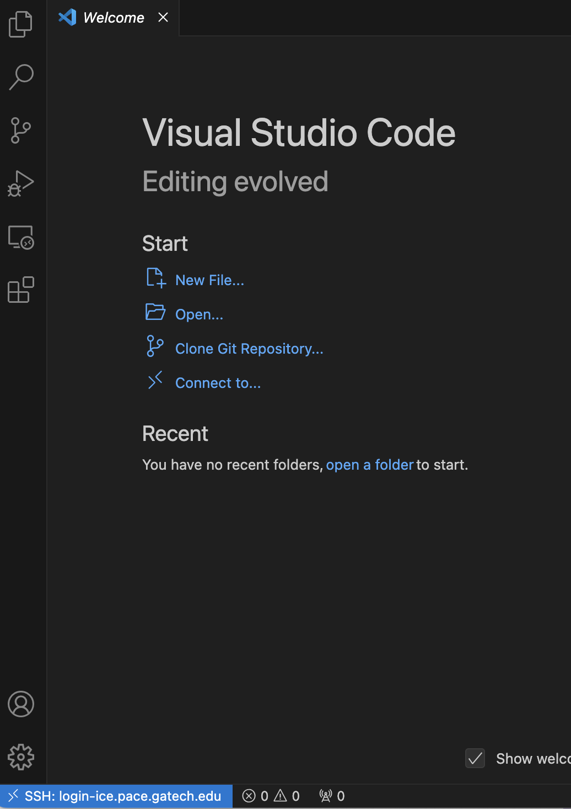
The ssh: login-ice.pace.gatech.edu in the left corner indicates you are connected to a PACE login node.
VSCode saves ssh configurations a local file and all you have to do is select this and enter your password.
Useful features:
Two simple examples of convenient features of connecting via VSCode
One SSH, Multiple terminals Using VSCode's integrated terminal, you can have multiple terminals pointing to different PACE nodes, with no need to ssh again.
GUI-based file navigation. Clicking Open Folder to set the folder VSCode points gives a visual explorer of the folder selected, similar as in your local computer. For instance, the below will update the file explorer to show only the folders at the DL directory and make it my working directory.
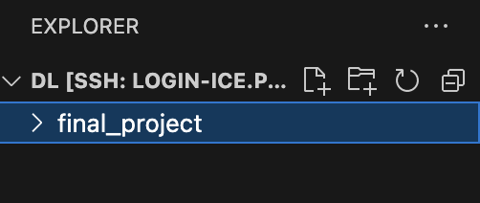
Troubleshooting
When first connecting, you might run in the error "VSCode Server could not be installed...". This can be caused by insufficient storage space for VSCode Server to install the necessary archives in your PACE home folder.
To resolve this, see Cleaning space if you run out of storage and What is the scratch folder and why use it
2) SLURM and Workflow in PACE
PACE's use the SLURM system to allocate resources (CPUs, GPUs, etc) and schedule user tasks.
The typically slurm workflow goes as follows:
- ssh into PACE (as in (1)) -> request an interactive computing node -> load necessary software ('modules') -> run your code
- ssh into PACE, submit batched jobs to computing nodes.
Translation:
- Interactive node: this gives you access to a machine (via terminal) to run commands on the fly.
  - Example, you can run python gen_images.py, see the results in your terminal / folders, change code, run again
- Submit batched jobs: put a script on a queue to be executed by slurm when resources are available.
  - Example: put python train_model.py in the queue. You don't interact with the terminal of this computing node; results will be available in logs/folders you specify.
  - This is useful when more time/resources are needed. See (6) for more.
Below section describes case (1), specifically how to install packages and run python using anaconda and the scratch folder to avoid problems with storage.
- Even if you are planning to use batch jobs, it is useful to read the below for the initial setup and get used to the worflow.
Requesting an interactive node
When you log into PACE, you will receive a terminal pointing to a "login node", like below:
~ ssh mandrade9@login-ice.pace.gatech.edu

(base) [mandrade9@login-ice-3 ~]$
The login node does not have much computing power and is accessed by many people at once. You should not execute heavy programs on it, or else performance for all users may be affected!
To run heavy programs, you should request a computing node, like below:
salloc -N1 -t0:15:00 --cpus-per-task 8 --ntasks-per-node=1 --gres=gpu:V100:2 --mem-per-gpu=32G
In this example, I requested:
- one computing node (-N1 )
- for 15 minutes (-t0:15:00)
- With 8 CPU cores (--cpus-per-task)
- With two V100 GPUs (--gres=gpu:V100:2), each of which with 32GB of memory (--mem-per-gpu=32G)
  - Check this link for information on hardware available to request
After the command, you will get something like this in the same terminal window:
---------------------------------------
Begin Slurm Prolog: Oct-06-2024 18:10:28
Job ID: 708556
User ID: <user>
Account: oms-csp
Job name: interactive
Partition: coc-gpu,ice-gpu
---------------------------------------
[<user>@atl1-1-01-002-5-0 DL]$
Notice now the terminal points to a different location now.
Running nvidia-smi, I can confirm a GPU was allocated and see the specs of the GPUs provided to me:
Sun Oct 6 18:11:13 2024
+-----------------------------------------------------------------------------------------+
| NVIDIA-SMI 555.42.02 Driver Version: 555.42.02 CUDA Version: 12.5 |
|-----------------------------------------+------------------------+----------------------+
| GPU Name Persistence-M | Bus-Id Disp.A | Volatile Uncorr. ECC |
| Fan Temp Perf Pwr:Usage/Cap | Memory-Usage | GPU-Util Compute M. |
| | | MIG M. |
|=========================================+========================+======================|
| 0 Tesla V100-PCIE-32GB On | 00000000:3B:00.0 Off | 0 |
| N/A 40C P0 26W / 250W | 1MiB / 32768MiB | 0% Default |
| | | N/A |
+-----------------------------------------+------------------------+----------------------+
| 1 Tesla V100-PCIE-32GB On | 00000000:5E:00.0 Off | 0 |
| N/A 31C P0 26W / 250W | 1MiB / 32768MiB | 0% Default |
| | | N/A |
+-----------------------------------------+------------------------+----------------------+

+-----------------------------------------------------------------------------------------+
| Processes: |
| GPU GI CI PID Type Process name GPU Memory |
| ID ID Usage |
|=========================================================================================|
| No running processes found |
+-----------------------------------------------------------------------------------------+
Loading softwares = modules
Computing nodes initialize with the bare minimum of software. For instance, nodes don't usually start with anaconda or gcc.
PACE has commonly used programs pre-installed. You can "load" these modules via the command:
module load <module_name>
To find which software is available and their identifiers, use the spider command:
module spider <partial_module_name>
For example, to see which versions of anaconda are available:
[<user>@atl1-1-01-002-5-0 DL]$ module spider anaconda

----------------------------------------------------------------------------------------------
anaconda3:
----------------------------------------------------------------------------------------------
Description:
Python environment

Versions:
anaconda3/2022.05.0.1
anaconda3/2023.03
This tells that I can load anaconda via:
module load anaconda3/2022.05.0.1
NOTE: software versions are not the same among PACE nodes.
- For instance, if you request a A100 GPU you may receive a node with only conda versions 2023+
- This gives a little headache when using different nodes - common, as not always the same nodes are available. For anaconda in particular, I tend to create one environment for each node to avoid problems.
Using the scratch directory (IMPORTANT)
TLDR: make sure to always download models, big files and install python packages (including virtual environments) in the ~/scratch folder.
Before installing packages and running Python programs, it's important to understand some details about PACE's file system and storage. Otherwise, you may face storage quota issues, be unable to create new files, and have your workflow completely disrupted.
When you log into PACE, you'll get a typical file system. This is how my home directory looks like.
[<user>@atl1-1-01-002-5-0 ~]$ ls
DL scratch
These directories are accessible through any node. You can see there are folders for some classes, and a folder called scratch.
- If you do not see a scratch folder, follow the steps in the 'Finding the scratch folder' below.
In PACE, you have only 15GB of storage in the home directory and all of its subdirectories, except for scratch. In the scratch folder you have 300GB. See here for more details.
- Note: scratch is not backed up, and at the end of each semester, all files in scratch directories not touched in 120 days are deleted.
This means I can surpass my storage quota and be unable to install or create any other file (and to work) if I, for example:
- Download a big model to the DL folder
- Run pip3 install pytorch or conda install pytorch a couple times. This is because without further instruction, conda will install the files for the virtual environments in your home directory. And they occupy a lot of space.
Find/Create scratch folder
If you don't see a scratch folder in the home directory:
- create it on the home directory with mkdir ~/scratch. This should link to the real location of scratch storage automatically.
- If it does not (or you just want to make sure), find the real location of scratch storage with pace-quota:
[mandrade9@login-ice-3 ~]$ pace-quota

# Output:
# Filesystem Usage (GB) Limit
# Home:/home/hice1/mandrade9 21.3 30.0 70.9%
# Scratch:/storage/ice1/9/2/mandrade9 50.7 300.0 16.9%
- And then manually create a link:
mkdir ~/scratch
ln -s /storage/ice1/9/2/mandrade9 scratch
- Obs: you can work directly with /storage/ice1/9/2/mandrade9. I just find more convenient using it from my home directory :)
Creating a virtual environment in the scratch folder and installing python packages
Steps:
- Load the anaconda module
module load anaconda3/2022.05.0.1
- Create a virtual environment in the scratch folder, using:
conda create --prefix ~/scratch/<envName> python=<3.x>
- all environment files will be saved in ~/scratch/<envName> instead of the home directory ~/.cuda
- envName is an arbitrary name for the environment, say, VLM_project
- Replace <3.x> with the desired python version, say 3.11
Optionally, you can set as conda default to store packages in specific scratch folders:
conda config --add envs_dirs ~/scratch/conda_venvs
conda config --add pkgs_dirs ~/scratch/conda_pkgs
- And then create envs as usual conda create <env_name>
- Activate the environment
conda activate /home/hice1/mandrade9/scratch/VLM_project
- To see the list of environments, run conda env list
- Install your packages.
- In slurm I typically use pip3. I've had bugs using conda in the past.
- Sometimes slurm messes up the venv locations. It is good to ensure the package installer is pointing to the scratch folder before installing, as below.
  - If does not point to the scratch folder, go to the troubleshooting section
$ which pip3
~/scratch/VLM_project/bin/pip
Install packages as usual:
pip3 install numpy
Now you can run your code :)
Troubleshooting
- If pip3 does not point to scratch, try activating and deactivating the environment and/or reload the anaconda module.
# activate and deactivate the env
conda deactivate
conda activate /home/hice1/mandrade9/scratch/VLM_project
which pip3

# and/or unload and load the module again
module unload anaconda3/2022.05.0.1
module load anaconda3/2022.05.0.1
conda deactivate
conda activate
# Sometimes anaconda is loaded automatically in the node; deactivating and activating can avoid some bugs
- If still not pointing to scratch, the safest way to avoid problems is deleting the environment and reloading conda. Then creating the environment again following 1-3
conda deactivate
conda remove --name /home/hice1/mandrade9/scratch/DL_project --all
module purge
# (this will remove all modules loaded; just to be sure)
module load anaconda3/2022.05.0.1
conda deactivate
conda activate
3) Cleaning space if quota exceeded
If you get the error user quota exceeded or other bugs (e.g.: VSCode refusing to connect due to an error installing VSCode server), this is probably because you surpassed your storage quota in PACE for not using the scratch folder and having too many files in your home directory.
- Read the Using the scratch space section!
- See here for more details on PACE's storage.
A first thing you should try is cleaning all conda and pip caches:
conda clean --all
rm -rf ~/.cache/pip
If this doesn't work, you can:
- Delete the whole .conda folder. Don't worry, this will not destroy anything.
rm -r ~/.conda
- Search large files with the command below, and delete them accordingly. This should also point out large conda files
find ~ -type f -size +100M
I've had issues with hidden folders in the home directory containing large files - especially from conda despite cleaning its cache. The command above should point out where these files are. You can also check all directory sizes with the below command and delete them accordingly:
du <directory_path> -h --max-depth=1
4) GPUs, CUDA version, and installing PyTorch
For installing PyTorch in particular, check the node's CUDA version and use the corresponding command available in the official website)
If you don't have specific requirements you can load cuda and check it's version by following the below:
module load cuda
nvcc --version
# > nvcc: NVIDIA (R) Cuda compiler driver
# > Copyright (c) 2005-2022 NVIDIA Corporation
# > Built on Wed_Sep_21_10:33:58_PDT_2022
# > Cuda compilation tools, release 11.8, V11.8.89
# > Build cuda_11.8.r11.8/compiler.31833905_0
Which means the command to install PyTorch according to the website is:
pip3 install torch torchvision torchaudio --index-url https://download.pytorch.org/whl/cu118
If you want a specific CUDA distribution, check the node's available CUDA versions with module spider, and load the desired version
module spider cuda # check available versions
# > Output:
# > [...]
# > Versions:
# > cuda/11.6.0-u4jzhg
# > cuda/11.7.0-7sdye3
# > cuda/12.1.1-6oacj6
# > Other possible modules matches:
# > vtk-glvnd-cuda

module unload cuda/11.6.0-u4jzhg # unload previous module, if necessary
module load cuda/12.1.1-6oacj6
You can also check CUDA availability in Python with the below commands:
import torch
torch.cuda.is_available() # True if any CUDA device for use
# > True

torch.cuda.device_count() # Number of CUDA devices for use
# > 2
5) Slurm commands
This cheatsheet provides an extensive list of commands and tips to work with slurm. Also check PACE documentation .
A short list of the most used commands.
Request interactive node with specific hardware
salloc -N1 -t0:15:00 --cpus-per-task 8 --ntasks-per-node=1 --gres=gpu:V100:2 --mem-per-gpu=32G
- one computing node (-N1 )
- for 15 minutes (-t0:15:00)
- With 8 CPU cores (--cpus-per-task)
- With two V100 GPUs (--gres=gpu:V100:2), each of which with 32GB of memory (--mem-per-gpu=32G)
  - This link contains information on hardware available to request
Loading software/modules:
- List modules that match a partial name:
module spider <partial module name>
# e.g.: module spider anaconda
- Load, unload, purge modules:
module load <module_name>
module unload <module_name>
module purge # unload all modules
Moving data in/out slurm:
- Copy local files to slurm
scp -r local1 local2 mandrade9@login-ice.pace.gatech.edu:~/scratch/slurm_folder
- Copy from slurm to local
scp -r mandrade9@login-ice.pace.gatech.edu:/home/hice1/mandrade9/scratch/project/data ./local_folder
Submit a batch script for async execution
sbatch myscript
Visualize all queued jobs for a user
squeue -u <username> # e.g.: squeue -u mandrade9
# Also:
sacct -u <username> # e.g.: sacct -u mandrade9
Cancel a queued job:
scancel <job_id>
6) Submitting batch jobs
You may need to submit batch jobs to be ran later in some PACE node for tasks that requires more time and computing.
In these cases, write a bash script and submit it for execution by running the command below. Obs.: You can run this from the login node.
sbatch myscript
This will queue the script to be ran later in some PACE node.
A sample script is below. Notice the first few lines specify the machine specs desired to run the job, similar as when allocating an interactive node.
#!/bin/bash
#SBATCH -N 1
#SBATCH -c 64
#SBATCH --ntasks-per-node=1
#SBATCH -t 00:15:00
#SBATCH --gres=gpu:V100:1
#SBATCH --mem-per-gpu=12G
#SBATCH -J weak-scaling # jobs name
#SBATCH -o ./slurm_outs/slurm_%j.out # file to write logs, prints, etc

# And then some code to run, like
python3 mycode.py

# or any other thing. Example below runs a parallel cpp code:
cores=(1,2,4,8,16,32,64)
export OMP_PLACES=cores
for c in "${cores[@]}"
do
n=$((base_n * c))
export OMP_NUM_THREADS=$c
# if c is 1, then run the serial version
if [ $c -eq 1 ]
then
output=$(./build/serial -n $n -s 1 -bs $bs)
else
output=$(./build/openmp -n $n -s 1 -bs $bs)
fi
sim_time=$(echo $output | awk -F' = ' '{print $2}' | awk '{print $1}')
echo "$n, $bs, $sim_time, $c" >> $filename
done
7) Useful PACE links
- Using SLURM (How to create and run jobs): https://gatech.service-now.com/home?id=kb_article_view&sysparm_article=KB0042096#gpu-jobs
- Software List: https://gatech.service-now.com/home?id=kb_article_view&sysparm_article=KB0041975
- Using Conda and Anaconda: https://gatech.service-now.com/home?id=kb_article_view&sysparm_article=KB0041621
- Open On Demand (Web Access): https://gatech.service-now.com/home?id=kb_article_view&sysparm_article=KB0042133
- Local Terminal Access: https://gatech.service-now.com/home?id=kb_article_view&sysparm_article=KB0042100
8) Using ICE Open OnDemand.
ICE offers a web-based alternative of accessing PACE machines using a GUI interface. The official guide can be found here.
Below are some instructions on how to upload files, submit jobs via the terminal, and open VSCode session using this feature
For all that follows, access the Open OnDemand dashboard here: https://ondemand-ice.pace.gatech.edu/pun/sys/dashboard/
Upload files*:
- click on files -> home directory and upload your local files with the upload button.
Run jobs interactively with terminal
On the dashboard, click on clusters -> ICE Shell Access Follow the same steps as in section (2)
Run a VSCode session:
- Setup an environment following steps 1-5 above
- Go to Open OnDemand and select "My Interactive Sessions"
- Select VSCode IDE/Editor. You can then select how you want to setup your session. To load the anaconda version from the earlier tutorial select "custom pre-load" under modules and enter anaconda3/2022.05.0.1 , the rest of the defaults work well.
- You can then launch the session and edit code
- To run a file use the VSCode terminal. Activate the environment, and run the code as before but exclude the srun

