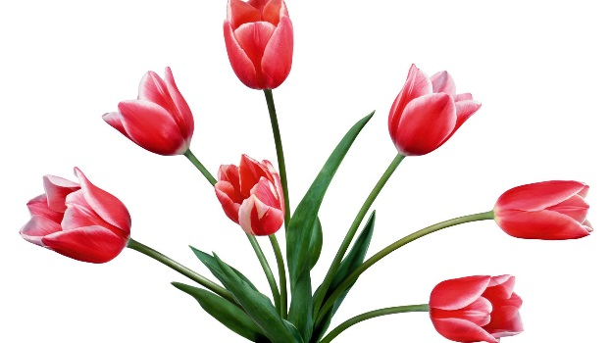

Figure .Tullips flower

In Persia, the gift of a red or yellow tulip was a declaration of love, the flower's black center representing a heart burned by passion. In classic and modern Persian literature, special attention has been given to these flowers and in recent times, tulips have featured in the poems of Simin Behbahani. However, the tulip was a topic for Persian poets as far back as the thirteenth century. Musharrifu'd-din Saadi,[clarification needed] in his poem Gulistan, described a visionary, garden paradise with 'The murmur of a cool stream / bird song, ripe fruit in plenty / bright multicoloured tulips and fragrant roses...'

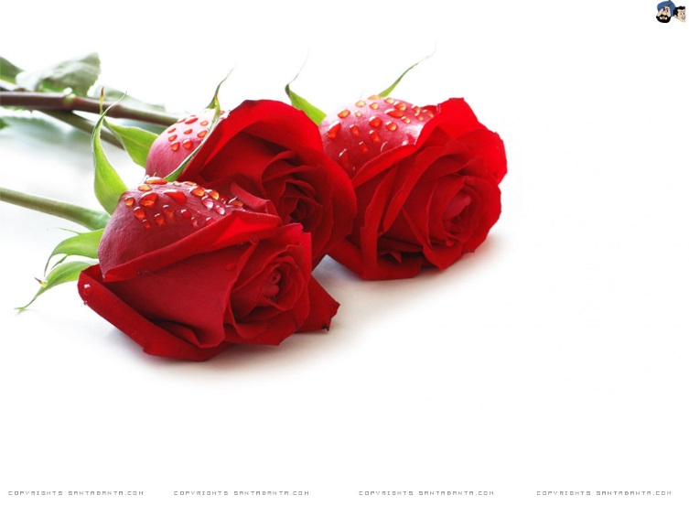

Figure . Red rose

A rose is a woody perennial of the genus Rosa, within the family Rosaceae. There are over 100 species. They form a group of plants that can be erect shrubs, climbing or trailing with stems that are often armed with sharp prickles. Flowers vary in size and shape and are usually large and showy, in colours ranging from white through yellows and reds. Most species are native to Asia, with smaller numbers native to Europe, North America, and northwest Africa. Species, cultivars and hybrids are all widely grown for their beauty and often are fragrant. Rose plants range in size from compact, miniature roses, to climbers that can reach 7 meters in height. Different species hybridize easily, and this has been used in the development of the wide range of garden roses.

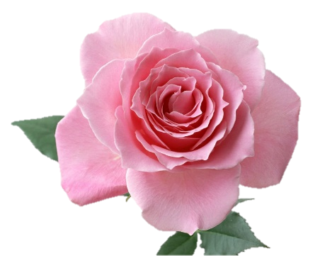

Figure . Ping rose

Roses are a popular crop for both domestic and commercial cut flowers. Generally they are harvested and cut when in bud, and held in refrigerated conditions until ready for display at their point of sale.

In temperate climates, cut roses are often grown in glasshouses, and in warmer countries they may also be grown under cover in order to ensure that the flowers are not damaged by weather and that pests and disease control can be carried out effectively. Significant quantities are grown in some tropical countries, and these are shipped by air to markets across the world

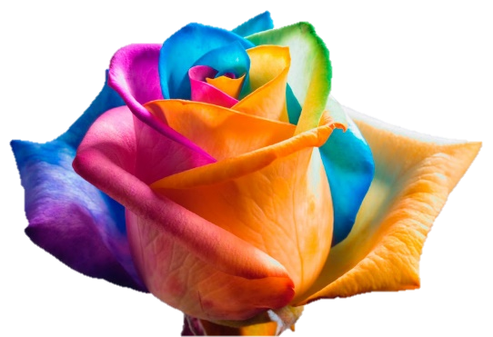

Figure . Rainbow rose

Rose perfumes are made from attar of roses or rose oil, which is a mixture of volatile essential oils obtained by steam distilling the crushed petals of roses. An associated product is rose water which is used for cooking, cosmetics, medicine and in religious practices. The production technique originated in Persia then spread through Arabia and India, and more recently into eastern Europe. In Bulgaria, Iran and Germany, damask roses (Rosa damascena 'Trigintipetala') are used. In other parts of the world Rosa centifolia is commonly used. The oil is transparent pale yellow or yellow-grey in colour. 'Rose Absolute' is solvent-extracted with hexane and produces a darker oil, dark yellow to orange in colour. The weight of oil extracted is about one three-thousandth to one six-thousandth of the weight of the flowers; for example, about two thousand flowers are required to produce one gram of oil.