IDENTITY & ACCESS MANAGEMENT

Secure, centralized access control for GreenNode services
Fine-grained access management for all cloud resources. Manage users, groups, policies, and service accounts from one place.

WHY IAM
Why your organization needs IAM
In the cloud, resources are accessed from anywhere — traditional network-boundary security is no longer enough. IAM fills that gap with identity-first, centralized access control.
Prevent unauthorized access  Only verified identities with explicit permissions can reach your resources. |  | Simplify user lifecycle management  One policy update covers an entire team — onboarding and offboarding in seconds.
Meet compliance & governance requirements  Every access request is logged, giving you a full audit trail on demand. |  | Eliminate credential sprawl with SSO  Connect Azure AD once — your team logs in with credentials they already have.
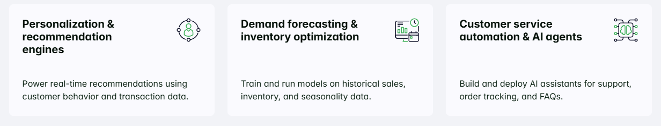
FEATURES
Comprehensive controls for every identity and access management
Four capabilities that cover the full identity and access lifecycle on GreenNode.
Organize users and set permissions by team or role  Create IAM user accounts linked to your root account.  Organize users into groups by team or role — assign one policy to a group and it immediately covers all members, reducing management overhead. |  | Define fine-grained access rules on any GreenNode resource  Write JSON-based policies with explicit allow or deny rules scoped to specific GreenNode actions and resources.  Attach policies to users, groups, or service accounts — giving you precise, auditable control over every permission.
Give applications and pipelines their own secure identity  Create non-human identities for CI/CD pipelines, automation scripts, and Kubernetes workloads (VKS).  Service accounts carry scoped permissions and rotating secrets — no shared human credentials in code or pipelines. |  | Let your workforce log in with credentials they already have  Connect an external identity provider via SAML 2.0 (currently Azure AD).  Federated users are auto-created on first login with no default permissions, keeping the principle of least privilege intact from day one.

USE CASES
Trusted across teams, pipelines, and enterprise directories
Common scenarios where GreenNode IAM adds immediate, practical value.

Onboard dev teams at scale
Create a group per department (e.g. Engineering, Finance), attach least-privilege policies to each group, then add and remove members as staff join or leave — without touching individual service permissions.
Secure CI/CD & Kubernetes workloads
Assign a dedicated service account to each pipeline or VKS cluster with the minimum permissions needed for that job. Rotate secrets independently without affecting other workloads.
Roll out enterprise SSO
Connect your company's Azure AD directory to GreenNode IAM. Employees authenticate with their existing Microsoft credentials — no new passwords, no separate account provisioning.
Pass security audits with confidence
Every login, permission check, and resource access is logged. Produce a full access trail on demand, demonstrate least-privilege compliance, and quickly revoke access when roles change.

Ready to secure your GreenNode environment?
Start with user accounts, create groups, define policies, and connect your identity provider.
→ Set up IAM

CUSTOMER SUCCESS STORIES
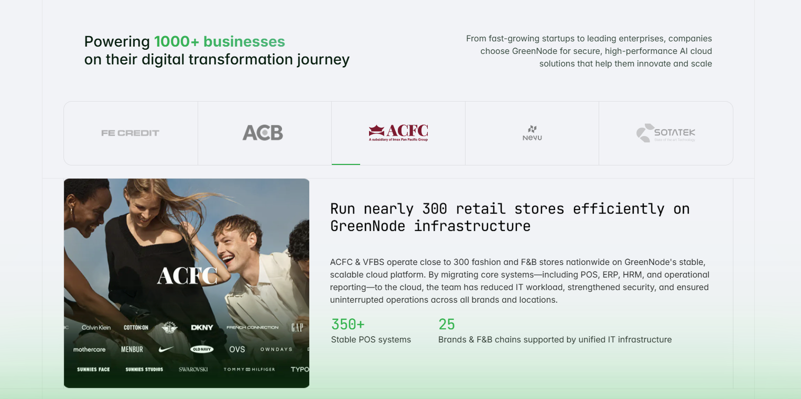

FAQs
Frequently asked questions
What is GreenNode IAM and do I need it?
IAM (Identity and Access Management) is GreenNode's built-in system for controlling who can access your cloud resources and what they can do. It comes included with every GreenNode account at no extra cost. You need it as soon as more than one person — or one application — accesses your GreenNode environment. Without IAM, every team member would need to use the root account credentials, which creates serious security and audit risks.
What are the five identity types in GreenNode IAM?
GreenNode IAM is built around five identity types, each serving a different purpose:
- Root user — The first account created in GreenNode. Has full, unrestricted access to all services by default. Use only for initial setup; avoid using it for day-to-day operations.
- User account — Represents an individual person. Starts with zero permissions — access must be explicitly granted via policies.
- Group — A collection of user accounts that share the same access needs. Assign one policy to a group and it applies to all members instantly.
- Service account — A non-human identity for applications, automation scripts, and Kubernetes workloads (VKS) to call GreenNode APIs securely.
- Identity provider (IdP) — An external directory (e.g. Azure AD) connected via SAML 2.0. Federated users log in with corporate credentials and are auto-provisioned on first login with zero permissions.
What is the difference between a Root user account and an IAM user account?
Root user account is the first account created in GreenNode. It has full, unrestricted access to all products and resources by default. Treat it like a master key — use it only for initial setup and account management tasks, then lock it away. IAM user accounts are created under the root account and have no permissions by default. Access must be explicitly granted through policies. This separation is the foundation of least-privilege security.

How many IAM user accounts and groups can I create?
GreenNode IAM supports creating multiple user accounts and groups under a single root account. The exact limits depend on your account tier. For enterprise-scale deployments, consider using the Identity Provider feature to federate your existing corporate directory instead of creating individual IAM accounts.

Can employees use their corporate Microsoft credentials to log in to GreenNode?
Yes — once Azure AD is configured as an Identity Provider in GreenNode IAM, employees use the VNG Login URL generated during setup. Clicking it redirects them to Microsoft's login page, where they authenticate with their existing corporate credentials. On successful authentication, they are signed into GreenNode without needing a separate password.

Which identity providers does GreenNode IAM currently support?
GreenNode IAM currently supports Azure Active Directory (Azure AD) via the SAML 2.0 protocol. Setup involves exchanging a SAML Entity ID and Reply URL between GreenNode and your Azure AD application.
Support for additional identity providers is on the roadmap. If your organization uses Okta, Google Workspace, or another SAML-compatible IdP, check the latest release notes or contact the GreenNode team for availability.

Does IAM log all access requests for auditing?
Yes. GreenNode IAM records both administrative requests (creating users, attaching policies, modifying groups) and resource access requests (reading from vStorage, starting a vServer instance, etc.). These logs provide a full trail for security audits, compliance reviews, and incident investigation.

BOTTOM CTA

