PRODUCT PAGE CONTENT
vMonitor Platform —

— S1 · HERO —

vMonitor Platform built for observability and optimisation at any scale
Observe, alert, and act across your entire infrastructure to empower your team to resolve issues before users ever notice.

Primary CTAs:
→ [Get Started] → [Talk to an Expert]
Design note: Pair with animated dashboard screenshot to the right of the headline.

— S2 · SOCIAL PROOF BAR —
Trusted by 1,000+ digital businesses across multiple industries in Vietnam and Thailand
Replace placeholder figures with verified numbers before publishing.

—Highlight—
① Complete visibility across your entire stack
② Detect and resolve issues faster
③ Optimise resource utilisation and costs
④ Built for compliance. Backed by local infrastructure.
Visual:
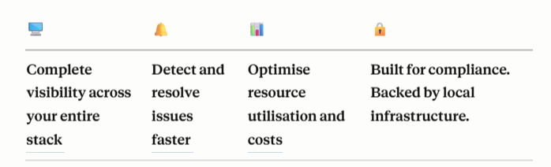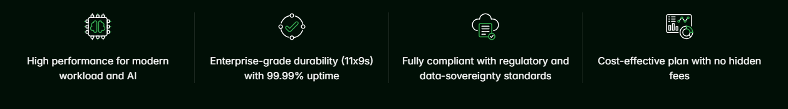
— S3 · CORE FEATURES —

See your full stack in one place
Monitor every resource across GreenNode, on-premise and any cloud provider with real-time data, automated alerts and a single unified dashboard.

Full visibility across every layer of your infrastructurec
Monitor your entire stack from a single platform with three tightly integrated data sources:
- Metrics — Continuously track CPU, RAM, disk, network and custom metrics from servers, containers, Kubernetes clusters and cloud services. Pre-integrated with the full GreenNode ecosystem.
- Logs — Centralise logs from servers, applications and network devices. Full-text search across hundreds of GBs in seconds, alert on log patterns, and maintain complete audit trails for compliance.
- Synthetic — Proactively simulate user behaviour and check APIs from multiple locations before your customers notice an issue. Supports HTTP(S), TCP and Ping protocols.
Visual note: Design each type as a card with a direct CTA to the console.
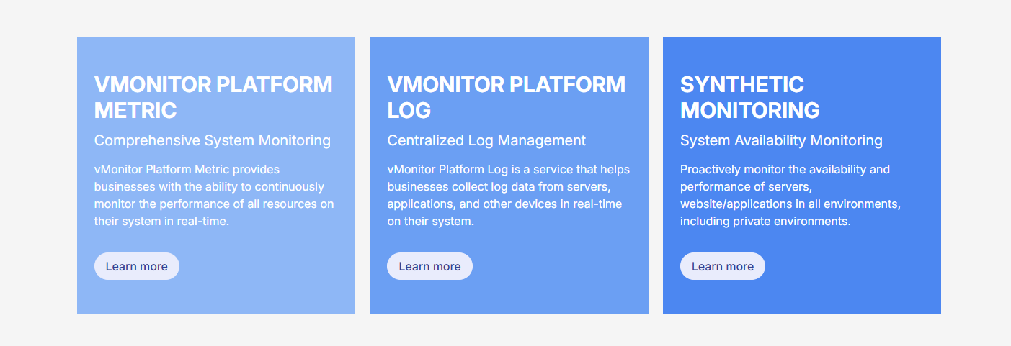

Monitor smarter, respond faster, store longer
From automated alerting and unified dashboards to long-term log retention — everything your team needs to detect, respond and stay compliant, in one place.

Catch every anomaly before it becomes an incident
Set custom alerting thresholds or let the system learn automatically — no manual monitoring required. Alerts are routed to the right person, at the right time, through the right channel.
- Route alerts to the correct person based on on-call schedule, priority and team
- Silence alerts during maintenance windows to prevent notification noise
- Retain full alert history to audit and improve incident response processes

Visualize, alert and escalate across every channel
Build monitoring dashboards your way with drag-and-drop, then share across the team. Connect every notification channel — email, Slack, Microsoft Teams, PagerDuty, OpsGenie, custom webhook — from one place, with automatic escalation when incidents go unresolved.
Visual note: Dashboard mockup screenshot.

Long-term retention built for compliance and auditong-term
Pre-integrated with GreenNode's object storage service to retain monitoring data and logs at optimised cost. Automatic tiering rules move ageing data to lower-cost storage tiers — meeting audit and compliance requirements of up to 5–10 years.
Visual note: KV object storage illustration.

— S4 · INTEGRATIONS —

Connect With Your Existing Stack
vMonitor Platform integrates with over 50 popular data sources and tools — no custom code required. Deploy the agent in minutes and start receiving data immediately.
GreenNode | vServer, vLB (Load Balancer), vDB (RDS), vKubernetes, Object Storage, vCDN, vAS (Auto Scaling)
Cloud Providers | Amazon Web Services (AWS), Google Cloud Platform (GCP), Microsoft Azure — multi-cloud monitoring from one place
Open-Source Stack | Prometheus, Grafana, OpenTelemetry, Fluentd, Logstash, Telegraf, StatsD, collectd
Applications | Nginx, Apache, MySQL, PostgreSQL, Redis, MongoDB, Kafka, Elasticsearch, Node.js, Java, Python
Notification Channels | Slack, Microsoft Teams, PagerDuty, OpsGenie, email SMTP, custom webhook
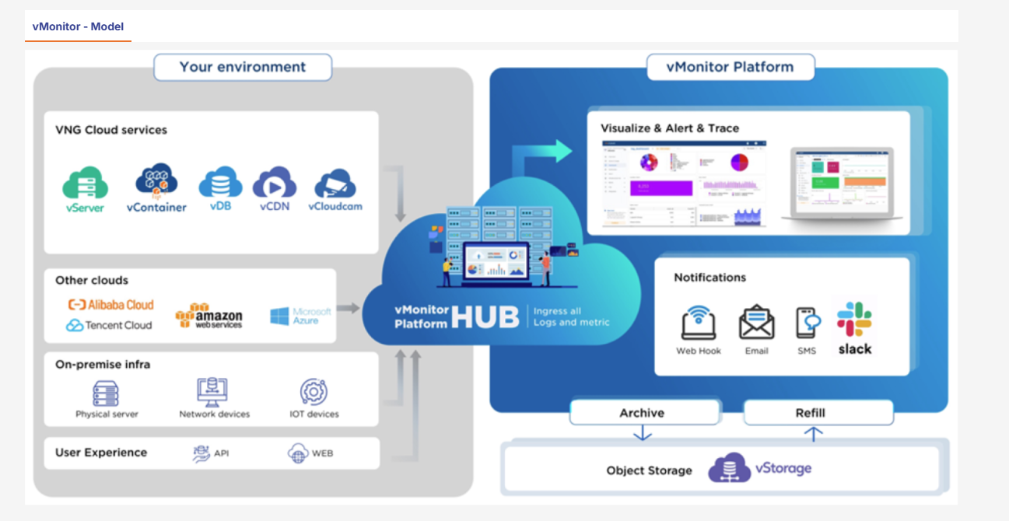

Can't find the integration you need?
vMonitor Platform supports data collection via the StatsD protocol and a custom metric API — you can push data from any source. Our team is ready to advise you.
→ [Talk to an Expert]
Visual note: Consultation banner — styled consistently with the GPU Instances page.

— S5 · USE CASES —

Built for Every Industry
vMonitor Platform is deployed in production across businesses in Vietnam — each sector brings its own monitoring challenges, and vMonitor is ready for all of them.

Application Performance Monitoring
Visualise system-wide performance, set threshold alerts and correlate data to detect and resolve the root cause of issues before end users are affected.
- Run automated end-to-end checkout flow checks every 5 minutes from multiple regions
- Consolidate GMV, order success rates and infrastructure health into a single dashboard
- Detect memory leaks ahead of major sale events — prevent downtime during peak hours
Best fit: E-commerce platforms that need to guarantee a seamless shopping experience during high-traffic sale events.

Root Cause Analysis
Mine system metrics, application logs and user request data to dramatically cut mean-time-to-resolution.
- Retain logs long-term with automatic tiering rules — meeting 5–10 year storage requirements
- Generate SLA dashboards per service and deliver regular uptime reports to leadership
Best fit: Financial institutions and banks that require complete audit trails and compliance reporting for regulators.

Infrastructure Cost Optimisation
Automate capacity planning and eliminate resource waste by triggering actions based on real utilisation thresholds.
- Cross-service log search to debug incidents spanning multiple microservices
- Share dashboards directly with customers — build trust and reduce support tickets
Best fit: Software companies and SaaS providers that must meet service commitments for multiple customers while keeping operating costs under control.

Continuous Availability Checks
Proactively detect service interruptions from the end-user's perspective before receiving a single support ticket. The platform automatically simulates website access and verifies critical endpoints 24/7.
- Instant escalation to an on-call engineer within 30 seconds when a threshold is breached
- Analyse user behaviour logs to detect fraud and fine-tune game balance
- Capacity planning based on real data — scale servers ahead of major events, not after incidents
Best fit: Gaming and media platforms with millions of concurrent users.

— S7 · WHY US —
Section content to be defined — recommend 4–6 differentiator cards aligned with the GreenNode brand pillars (data sovereignty, ecosystem depth, 20-year operational experience, NVIDIA partnership, local language support, certified infrastructure).
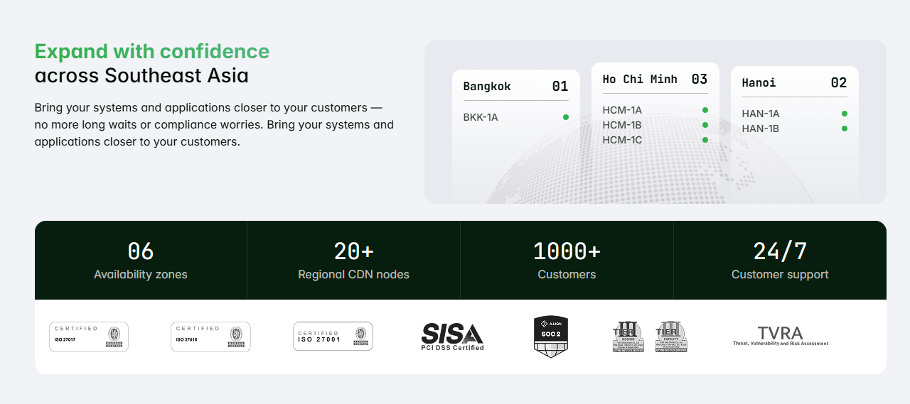
— S8 · CUSTOMER SUCCESS STORY —
Section content to be defined — recommend 1–2 case study cards with: customer logo, business challenge (1 sentence), solution deployed, and 1–2 measurable outcomes (e.g. 'reduced MTTR by 60%', 'zero downtime during 11.11 sale').
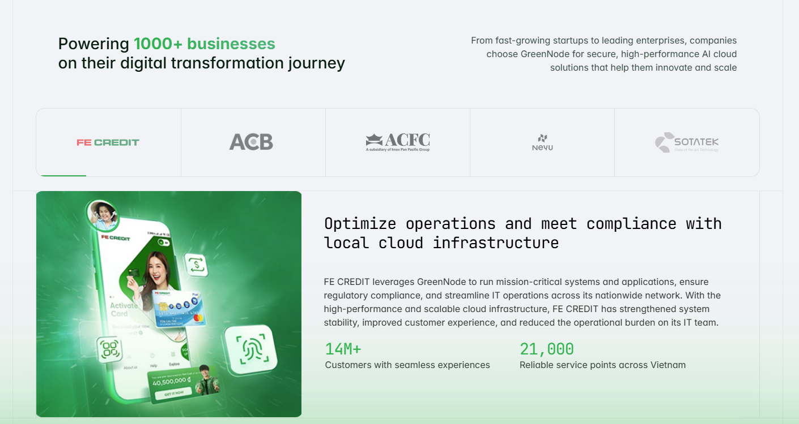
— S9 · FAQs —

Frequently Asked Questions
Q: What is vMonitor Platform and how is it different from self-hosted Prometheus/Grafana?
vMonitor Platform is a fully managed observability service — you do not need to install, operate or scale the monitoring infrastructure yourself.
Unlike self-hosted Prometheus/Grafana, vMonitor provides three pre-integrated pillars (Metrics → Logs → Synthetic), auto-scaling storage, and a 99.9% uptime SLA backed by GreenNode.
Your DevOps team spends less time maintaining monitoring infrastructure and more time improving your product.
Q: Does vMonitor support on-premise environment monitoring?
Yes. The vMonitor Agent can be installed on any server — Linux, Windows or container — in on-premise, hybrid cloud or multi-cloud environments.
All data is encrypted in transit to the vMonitor Platform via HTTPS/TLS.
Q: Can I migrate from Datadog, New Relic or another tool?
vMonitor accepts data via OpenTelemetry and the StatsD protocol — compatible with most popular agents.
The GreenNode technical team provides complimentary migration planning for Enterprise customers.
→ [Contact us for migration advice]
Q: Where is metric and log data stored? Does it meet data residency requirements?
All data is stored on GreenNode infrastructure located in Vietnam, in compliance with local data storage regulations.
vMonitor integrates with GreenNode Object Storage for long-term log retention, with configurable automatic lifecycle policies.
Q: How long does it take to start collecting data?
Under 5 minutes. Install the vMonitor Agent on your server and data will appear on your dashboard immediately.
For GreenNode resources (vServer, vDB, etc.), integration requires only a few clicks in the Console — no agent installation needed.

— BOTTOM CTA —
Start Monitoring Your Resources Today
Talk to our team for a solution tailored to your business.
→ [Talk to an Expert]

This document is intended to support the product page restructuring for vMonitor Platform. Content should be reviewed by the Product and Marketing teams before publishing.

