DEAKIN UNIVERSITY

SIT708
MOBILE APPLICATION
DEVELOPMENT

NAME: TRONG HOANG NGUYEN

STUDENT ID NO.: 222102372

GITHUB FOR THIS TASK: https://github.com/ngtronghoang97/Lost-and-Found

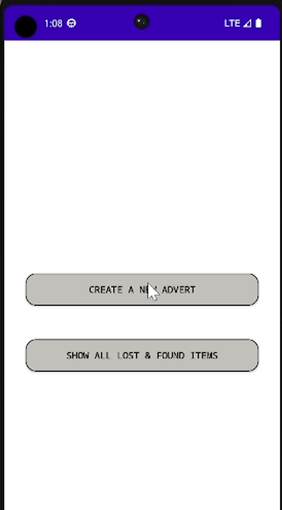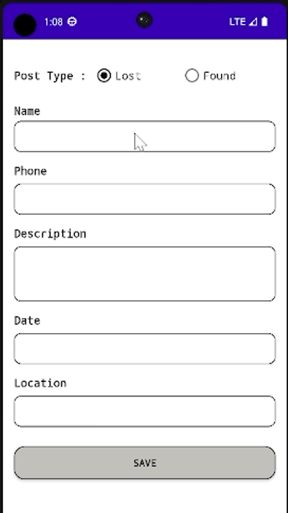
This is the application background
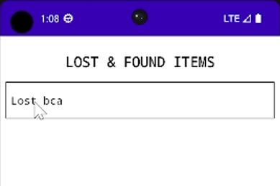
List of lost and found items
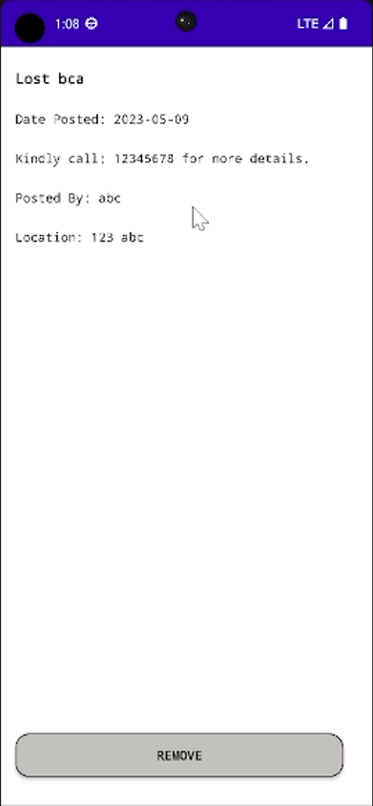This is the details of the lost and found items
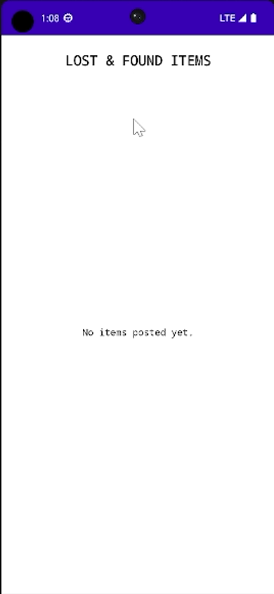After removing the lost and found items

